DRAFT- PLEASE DO NOT COPY OR CITE

The Recursive Outcomes of the Multiracial Movement
& The End of American Racial Categories

Kim M. Williams

Portland State University, Division of Political Science

Mailing Address:
Hatfield School of Government
650-K Urban Center, 506 SW Mill Street, Portland, OR 97201

E-mail Address
kmw3@pdx.edu

Abstract:
After a protracted national discussion about racial mixture in the early 1990s, the Office of Management and Budget (OMB) made the unprecedented decision in 1997 to allow Americans to “mark one or more” (MOOM) racial categories on the 2000 census. A small “multiracial movement” provoked this fundamental change in the way the government collects racial data. However, in order to satisfy civil-rights groups’ pressing demand that MOOM not “drain” numbers from any minority group, the Census Bureau devised and eventually implemented complicated tabulation rules in order to reassign multiple race responses “back” into a single race category for civil-rights purposes. On this basis, alongside extensive Bureau research indicating that the number of Americans likely to mark more than one race in 2000 would not reduce the counts of the major racial or ethnic groups, the OMB and Census Bureau suggested that civil-rights enforcement would remain intact. MOOM was sold publicly as recognition of a right to self-identify and also as a symbolic reform with effects that would scarcely be noticed.
This article shows that those reassurances, twenty years later, are already proving inaccurate. Drawing from Census Bureau data, government documents, and public opinion surveys, I argue that the multiracial movement (a) changed the political opportunity structure for everyone, not just for the activists in the 1990s who started it all; (b) is deeply entwined with demographic and cultural developments that were not considered linked to the multiracial population as conceived in the late 1990s; and (c) may yet be remembered as the beginning of the end of American racial categories as we know them today.

Introduction

The 1990s debate over a multiracial category on the American census opened the most probing examination of race in the United States since the 1960s. The various multiracial activists and organizations involved held divergent goals from the beginning, but they did consistently maintain that the official acknowledgment of interracial love and multiracial people could help American society move beyond divisive and socially constructed racial borders. They also shared the conviction that it was inaccurate and unacceptable to force multiracial Americans into monoracial categories. The multiracialists’ best-known campaign argued for the addition of a “multiracial” category to the 2000 census. While these activists did not get exactly what they wanted, their efforts led to the creation of an unprecedented “mark one or more” (MOOM) option on the 2000 census, allowing individual Americans to identify with as many racial groups as they saw fit.
In general, the odds are against social movements bringing about change at any level of government, yet sometimes they do. In Mark One or More: Civil Rights in Multiracial America, I focused, as most studies of social movements do, on issues of movement emergence and mobilization. Here I focus instead on the outcomes of the multiracial movement. I regard its influence on the state as a “recursive process” involving unintended consequences that continue to reverberate long after the movement itself has faded.
In 1975, in his analysis of social movements, Paul Shumaker advanced five criteria to identify the “types of actions local systems must take in order to be considered responsive” :
1) Access (Are lawmakers willing to listen?)
2) Agenda (Was a bill introduced?)
3) Policy (Was a policy adopted?)
4) Output (How was the policy implemented?)
5) Impact (Did its implementation effectively assuage citizens’ demands?)
Twenty years later, Paul Burstein and Sarah Sausner added the concept of “structural responsiveness” to this method of interpretation, in order to “distinguish between movements that really produce social change and those that win only symbolic victories.”
This article is divided into two parts. The first part offers a brief history of the multiracial movement and then uses Shumaker’s stages of policy responsiveness as a means of assessing the political outcomes of the multiracial movement up through the implementation of MOOM. The second part sets that movement and its consequences in a broader context of change, using Burstein and Sausner’s concept of “structural responsiveness” and Steven Hart’s perspectives on cultural change.
Contrary to the initial portrayal of MOOM by the Office of Management and Budget (OMB) and the Census Bureau as a merely symbolic and negligible policy, I contend that the multiracial movement (a) changed the political opportunity structure (POS) for everyone, not just for the activists themselves; (b) is deeply entwined with demographic and cultural developments that were not necessarily considered linked to the multiracial population as conceived in the late 1990s; and (c) may yet be remembered as the beginning of the end of American racial categorization as we know it today.

PART ONE: THE MULTIRACIAL MOVEMENT, THE POLITICAL PROCESS, AND THE IMPLEMENTATION OF MOOM

I. A Brief History of Racial Categorization and the Multiracial Movement
For most of American history, the U.S. government used racial designations as a tool of dominance, serving to separate and penalize those not defined as white. By the early 1970s, however, the civil-rights movement had turned the oppressive use of racial designations on its head, using racial data to argue for the remedy of past discrimination and to measure the life chances of minority groups. In 1977, after several years of deliberation among representatives of Federal agencies, the OMB standardized ethnic and racial data collection across government agencies in order to meet these new expectations. Statistical Directive No. 15 (OMB 15) mandated that all Federal agencies gathering demographic data must collect and report data on four major racial categories:
White
Black
Asian or Pacific Islander
American Indian or Alaskan Native

Agencies also had to obtain information about people of Spanish origin through one ethnic category inclusive of all races: “Hispanic”. This “ethnoracial pentagon” served as the final word on the administrative collection and reporting of American racial data for the next twenty years.
In 1979, two years after OMB Directive 15 was issued, the first modern-day multiracial organization—Interracial/Intercultural Pride (I-Pride)—formed in San Francisco with a handful of members. Led by Carlos Fernández, a lawyer, the small group sought recognition of multiracial identity and urged progressive local school boards in Northern California to add a multiracial designator on school forms. By 1984, twelve such multiracial groups existed across the country; by 1994 there were twenty, and soon after, forty. Most of these groups began and remained primarily as support networks, while three “umbrella” organizations—A Place for Us Ministries (APFU), The Association for Multiethnic Americans (AMEA), and Project RACE (Reclassify All Children Equally)—focused on political action.
[Figure 1 here]
Ruth and Steve White started APFU in 1986 after their minister would not marry them; he is white and she is black. Eventually, they became ministers themselves and began to provide counseling services, perform marriages, organize workshops, and coordinate Bible studies for interracial Christian couples in Southern California. In Northern California, two years later, Carlos Fernández of I-Pride sought to galvanize pre-existing grassroots groups around a common agenda by founding AMEA. Then, in 1990, finding no suitable category for her son on the census form, Susan Graham of Marietta, Georgia, called the Census Bureau for instruction. “They kept putting me on hold, then coming back. Finally [the Bureau representative] tells me, ‘I got with the supervisor,’ and his voice became very hushed. ‘Your children would take the race of the mother,’ he said. When I asked why, he said, ‘Because in cases like these, we always know who the mother is and not the father’.” Graham, a white woman then in her mid-forties, found this explanation unacceptable. She launched Project RACE in 1991 with the intent of having a multiracial category added to all government forms calling for racial identification.
My fieldwork for this study concentrated on these multiracial advocacy organizations at the height of the movement’s activity, in the late 1990s. All of the multiracial organizations active at that time operated on shoestring budgets, and, gauged by its overall membership base, the multiracial movement involved only about 3,500 adult members across the country. Joined loosely together through the infrastructure depicted in Figure 1, the people involved in multiracial groups were generally more interested in gaining social support than in changing the census. I was surprised to find that few of the adult participants identified as multiracial. It turned out that affluent, well-educated, suburban, white women—married to black men—were leading most of the grassroots groups, on behalf of their children.
Sometimes on their own initiative and sometimes at the urging of multiracial movement leaders—of whom there were only about twenty, nationwide—these people founded support groups, wrote letters to bureaucrats (often including pictures of their children and asking how they, as parents, should classify the children racially), attended demonstrations, supported lobbying efforts, and participated in encounters with local, state, and Federal officials. Multiracial activism involved “collective challenges, based on common purposes and social solidarities, in sustained interaction with elites, opponents, and authorities”; these factors made it a social movement.

II. Are Lawmakers Willing to Listen?: Access Responsiveness, 1992-1997
In 1992, fortunately for multiracial activists, Representative Thomas Sawyer (D-OH), asked OMB to request that Congress hold hearings on the racial and ethnic standards for Federal reporting. The request was prompted by the “growing racial and ethnic diversity of the American population [and] changing attitudes about race and ethnicity”; by longstanding pressure from undercounted minority groups; and by complaints from regular citizens that they could not “find themselves in the choices offered.” AMEA, angling for an invitation to testify, staged its first major event in Washington D.C. that summer to commemorate the twenty-fifth anniversary of the Supreme Court’s decision in Loving v. Virginia, which overturned the sixteen remaining anti-miscegenation laws in the United States. AMEA leaders also met with Congressman Sawyer, who headed the House Subcommittee on the Census, and Nampeo McKinney, who was responsible for racial statistics at the Census Bureau. Congressman Sawyer’s staff director, TerriAnn Lowenthal, told AMEA leaders that she herself had a biracial daughter and was sympathetic to the group’s position. A month later, AMEA received an invitation to participate in the hearings to be held in the following year. AMEA—and the other multiracial organizations that would soon join in—now found itself in an auspicious position. The OMB was openly acknowledging the need for a reassessment of the status quo, and AMEA was part of the process.
Rep. Sawyer opened the hearings on April 14, 1993, explaining why the inquiry was necessary. The existing racial and ethnic categories, he said, “in the view of many, have become misleading over time.” OMB administrator Sally Katzen followed with a case in point. She said she had received “pictures of children with questions. ‘How shall I record this child’s ethnicity?’ ‘How shall I record this child’s race?’ The kids are cute. The questions are real and very pressing.” Carlos Fernández of AMEA also testified before the subcommittee: “The changes we advocate…can be effected immediately with minimal or no adverse impact on anyone or any group and with enormous benefit to everyone.” Yet civil-rights laws require statistics that plainly distinguish between those individuals who are minorities and those who are not. Either multiracial activists did not perceive a civil-rights dilemma in their request for a Federal “multiracial” category, or they refused to come to terms with it.
Meanwhile, those Congressional Democrats who testified did so for specific, constituent-driven reasons. Senator Daniel Akaka (D-HI), for example, called for a new Native Hawaiian and Other Pacific Islander (NHOPI) category. “We have literally fallen through the cracks,” he said, “between definition as Native Americans in many Federal laws and classification as Asian or Pacific Islanders in Federal forms.” Akaka won his argument, and a new NHOPI category was created. Rep. Norman Mineta (D-CA) wanted to put a stop to the Census Bureau’s plan to collapse separate ethnic categories for Asian-Pacific Americans, which would have eliminated the check-off format used previously. Rep. Barney Frank (D-MA) said he “wouldn’t be here…if we knew exactly what percentage” of the people in New Bedford and southeastern Massachusetts were of Cape Verdean ancestry. “People have a problem out there,” he declared. “Are they African-American? Are they Black? Are they Cape Verdean?”
These and other Democrats in Congress, absorbed in other issues, paid little attention to the multiracial category proposal in 1993, and the Republicans paid even less. However, the lone Republican on the subcommittee, Rep. Tom Petri (R-WI), began to mull over the possibilities. He asked civil-rights witnesses on June 30, 1993, “Are you worried that if [a multiracial category were instituted] and you…get into court, if they establish discrimination by comparing with the pool in the community and if it drops from ten percent to eight percent because there’s a new multiracial category, this might somehow make it harder to win a case or something?” Stephen Carbo of MALDEF responded that he understood the question but was “not sure” of the answer. Later Petri opined: “When you create a new category, it may complicate litigation and protection in the civil rights area.” Indeed, the civil-rights groups that testified in 1993—including the National Urban League (NUL), the Mexican American Legal Defense and Education Fund (MALDEF), and the National Council of La Raza (NCLR)—all opposed a multiracial category on the grounds that it would imperil the statistics needed to enforce civil-rights laws. Nevertheless, they found themselves backing a growing chorus for more testing and research. After all, they had insisted for years that the Bureau and the OMB improve the decennial count.
After the hearings, in March 1994, the OMB created the Interagency Committee for the Review of Racial and Ethnic Standards and tasked this group with submitting final recommendations on the racial categories to be used in the 2000 census. The Interagency Committee, in turn, created a Research Working Group comprising statisticians and other experts to outline a research agenda. That agenda in itself represented a victory for multiracial activists, as many of the major issues identified for exploration related to the topic of multiracial identification. The agenda’s creation, along with the 1994 news that AMEA President Ramona Douglass (successor to Carlos Fernández) had been appointed to the 2000 Census Advisory Committee, proved that lawmakers were willing to listen.

III. Was a Bill Introduced?: Agenda Responsiveness, 1992-1998
Between 1992 and 1998, eleven states introduced bills to add a multiracial category on state forms. At the Federal level, in the fall of 1994, the Research Working Group began to execute its research agenda just as Republicans gained control of the House of Representatives for the first time in forty years. House committees were immediately reorganized. The Republican Rep. Petri took this opportunity to propose legislation that would have specified “multiracial,” in the case of a list of racial classifications or “multiethnic,” in the case of a list of ethnic classifications, in the collection of information. After it was tabled, he reintroduced the measure as H.R. 830 and called it the “Tiger Woods Bill”. Though his bill kept the multiracial question in the limelight, his reasons for introducing it were assuredly not those of most in the multiracial movement. It seems probable that Petri, whose voting record on civil-rights-related legislation was poor, saw in multiracial recognition a way to undermine civil-rights enforcement. Petri did not consult multiracial activists before unveiling the “Tiger Woods Bill” and Tiger Woods himself never participated in the multiracial movement, despite fervent efforts to persuade him.
A few years later, in 1996, multiracial activists learned that they would have a final opportunity to assert their views before Congress in a second set of hearings, slated for 1997. At that time Susan Graham of Project RACE happened to live in then-Speaker of the House Newt Gingrich’s district, and she met with him two months before the hearings began. Recounting her meeting with the Speaker, Graham reported that she had waited two years for the opportunity to meet him. “I was told I had TEN MINUTES to talk with him. I quickly outlined the problem… I handed Newt a bound report with the history of the movement and statistics. He quickly flipped through the report, put it aside, and said ‘This is the right thing to do for the children’.” In the eight weeks after his meeting with Graham and before the hearings, Gingrich issued a number of statements in favor of a multiracial category on the 2000 census. The Speaker also testified in person:
We should…stop forcing Americans into inaccurate categories aimed at building divisive subgroups and allow them the option of selecting the category “multiracial,” which I believe will be an important sep toward transcending racial division and reflecting the melting pot which is America.”

In Mark One or More I put forward two theories to explain why government bureaucrats and elected officials listened and acted at this time on this topic. The first theory involved political opportunity structures: “Not only when reform is pending, but when institutional access opens, when alignments shift, when conflicts emerge among elites and when allies become available, will challengers find favorable opportunities.” Access opened in 1992, for example, when the OMB initiated its review of Directive 15. Then, in 1994, shifting alignments in Congress ultimately showed that multiracial recognition appealed, in an era of otherwise sharp partisanship, to elite allies in both major political parties. In my second theory, I used Derrick Bell’s interest-convergence principle: “The interest of blacks in achieving racial equality will be accommodated only when it converges with the interests of whites.” I will return to POS and interest-convergence at the end of the article.

IV. Was a Policy Adopted?: Policy Responsiveness, 1992-2000
By the end of the 1990s, the multiracial movement had amassed an impressive record of policy adoption. Six states—Ohio, Illinois, Indiana, Michigan, Maryland, and Georgia—had passed legislation to add a multiracial designation on state forms, and two (Florida and North Carolina) had added a multiracial designation by administrative mandate. At the Federal level, the Interagency Committee recommended and President Clinton’s OMB adopted the new MOOM policy, announced by OMB Director Franklin Raines on October 30, 1997. Thanks to this policy, there would be no “multiracial” category on the census, but, for the first time ever, starting with the 2000 decennial census and extending to all Federal data systems by 2003, respondents could identify with as many races as they wished. “We are not closing the door on the expression of multiracial heritage. We are allowing people to express their multiracial heritage in whatever way they view themselves,” Raines declared. The OMB announced that five major races would be used in the 2000 census:
American Indian and Alaskan Native
Asian
Black or African American
Native Hawaiian or Other Pacific Islander (NHOPI)
White

As before, agencies also included one ethnic category, Hispanic, involving people who could be of any race.
In some ways, the 1997 decision resembled OMB Directive 15 in 1977, which required all Federal agencies to gather data on four standardized racial categories. But the decision broke conceptually with Directive 15 by allowing respondents to mark more than one race. Although the Interagency Committee had unanimously opposed the addition of a multiracial category, it provided no specific suggestions as to how its proposed—and adopted—alternative could be tabulated. Multiple race responses, one way or another, would have to be put back into a single box in order to produce numbers for the purposes of civil-rights monitoring and for comparison of 2000 data with data from earlier censuses. Stakeholders had to wait until the newly created Tabulation Working Group issued a set of recommendations, which it did in March, 2000, before learning how the policy would be implemented.

V. How Was the Policy Implemented? Output Responsiveness: 1997-2000
The OMB managed to produce its tabulation guidelines only a few weeks before the March 2000 census mailing. The delay stemmed from the demands of civil-rights groups that the OMB (1) keep intact the data infrastructure necessary for civil-rights enforcement and (2) avoid draining minority numbers by tabulating to the minority group when an individual marked a minority race and white. Clinton’s OMB responded favorably on both fronts. OMB Bulletin No. 00-02, issued March 9, 2000, instructed Federal agencies to use the following rules in civil-rights monitoring and enforcement:
- Responses in the five single-race categories are not allocated.
- Responses that combine one minority race and white are allocated to the minority race.
- Responses that include two or more minority races are allocated as follows:
  - If the enforcement action is in response to a complaint, allocate to the race that the complainant alleges the discrimination was based on.
  - If the enforcement action requires assessing disparate impact or discriminatory patterns, analyze the patterns based on alternative allocations to each of the minority groups.

In short, Americans would have the option to identify with multiple races (see Appendix A for a reproduction of the race and ethnicity questions used in 2000 and 2010) and would be counted as belonging to more than one race; but, for purposes of monitoring and enforcing civil rights, any person who marked both white and a non-white race would be allocated to the non-white race. Though this policy contained several controversial elements, its aim was to protect those who have historically experienced discrimination, and the rules satisfied the civil-rights groups’ most pressing demand: that numbers not be “drained” from any minority group.
MOOM appealed to Democrats on principle, as a change reflecting racial sensitivity. It also reflected Democrats’ determination—and legal obligation—to keep intact the data necessary for civil-rights enforcement. Indeed, a multiracial category was rejected in favor of MOOM primarily because the former would have substantially affected counts in the traditional racial groups. Even with MOOM, it was important that the tabulation avoid such a drain, since civil-rights laws require single-race statistics. The OMB’s Tabulation Working Group was careful to ensure that the tabulation policy would comply with those laws. In its tabulation guidelines, the OMB indicated that the data infrastructure would remain whole and suggested, moreover, that the effect of MOOM would be negligible.
Table 1 reports the largest combinations of two races reported in 2000 and 2010.
[Table 1 here]
In 2000, 6.8 million Americans (2.4 percent of the total population) reported multiple races. From this small base, the multiple-race population increased 32 percent in the 2010 census but still represented just 9 million people, or 2.9 percent of the total population. Almost everyone who marked more than one race in 2000 (93.3 percent) and 2010 (91.7 percent) marked only two. In 2010, people who reported being both white and black numbered 1.8 million, up from 784,764 in 2000 (a 133.7 percent increase). The second most common combination in 2010 was white and some other race (1.7 million). Together, the top five combinations, all involving whites, represented 75 percent of the total multiple-race population. In Bureau publications and data releases, these people were reported, as shown in Table 1, as belonging to more than one race. Behind the scenes, however, Federal agencies engaged in monitoring and enforcing civil rights counted them as minorities. This quelled civil-rights advocates’ most immediate worries about dwindling numbers, but the inflation of the minority count was otherwise difficult to justify, and it smacked of the one-drop rule.
It is significant, too, that the Bureau typically reports only the top combinations in its publications, thus providing a simplified version of the country’s racial landscape, though elsewhere it provides data on all the possible racial and ethnic combinations. Allowing people to mark more than one race resulted in a total of 57 possible multiple-race combinations. Add to that the five official single-race categories plus a sixth option, “Some Other Race,” and the tally increases to 63 racial categories. Because each racial category can be divided by a question asking respondents if they are Hispanic, the constellation of race/ethnic mixtures swells to 126 possible combinations. This multiplicity of options demonstrates that the new policy, MOOM, broke down the binary race formulation; but the tabulation scheme, concocted after the decision to enact MOOM, effectively put that binary formulation back in place. Drawing a “Humpty Dumpty” analogy to describe the situation, Roderick Harrison, chief of the racial statistics branch from 1990 to 1997, argued that one-drop redux, inflated minority counts, maximum and minimum counts, and 126 possible racial ethnic “groups,” ran the risk of making race-based public policies even more controversial than they already were. Harrison’s views grew increasingly unwelcome, however, and despite having held a top position in the Census Bureau throughout the 1990s, he was “removed” from the Tabulation Working Group so that the Bureau could “speak with one voice.”

VI. Did Implementation Effectively Assuage Citizen Demands? Impact Responsiveness: 1997-Present
In 1997, when the OMB announced that there would be no multiracial category on the census but that Americans would be allowed to mark as many races as they wanted, most multiracial activists accepted this as sufficient. A few holdouts, however, vowed to continue the fight. In 2000, when the OMB unveiled the tabulation guidelines, the same thing happened: a handful of critics denounced the policy as a violation of the principle of self-identification and as a reformulated “one-drop” rule, but there was no widespread outcry in multiracial circles. This was in part because the Bureau and other agencies published the census data with multiracial people reporting more than one race. Many people did not realize that the data used for civil rights purposes was being tabulated differently within the agencies.
Another reason why first-wave organizations and activists did not mount much of a challenge to the tabulation scheme is that, in the main, the first-wave, grassroots activists did not want lawsuits but rather acceptance. For many, MOOM accomplished that, regardless of its accompanying tabulation guidelines. Even today, though people who identify as multiracial are blazing the second-wave trail, they have not rallied consistently around the tabulation issue. Thus it is arguable that MOOM sufficiently addressed the concern that drove many first-wave activists to band together in the first place.
Nevertheless, an analysis of both the principles and the methods behind the tabulation guidelines and of the census’s system of racial categorization more generally reveals inconsistencies and areas of controversy, which, I argue, all but ensure myriad, and varied citizen demands on the Bureau looking forward. One important example is the Bureau’s ongoing difficulties with Latino racial and ethnic reporting. Current Federal race standards, which define Latino as an “ethnicity” that spans all races, have proven confusing for Latinos and non-Latinos alike. The media, researchers, and the Census Bureau itself often treat “Latino” as a de facto racial category, but “Latino,” like “multiracial,” does not fall comfortably into current understandings of race. Moreover, Latinos’ mixed roots are well documented.
In this light, it is no surprise that in 2000 Hispanics were more likely than non-Hispanics to identify with multiple races (6.3 percent vs. 1.9 percent) and again in 2010 (6.0 percent vs. 2.3 percent). Many Latinos reject the standard racial options altogether and mark “Some Other Race” instead. Just 200,000 Americans chose “Other Race” in 1960. By 1980, that number was 6.8 million. In 2010, 19.1 million Americans (or 6.2 percent of the population) selected the designator “Some Other Race.” To put this in perspective, 19.1 million is larger than the single-race Asian, AIAN, and NHOPI populations combined. Who are these nineteen million Americans of “some other” race? It turns out that almost all of them—97 percent in 2010—are Latinos.
[Table 2 here]
Table 2 documents Latino racial reporting on the census since 1980. More than half of all Latinos (53 percent) identified racially as white in 2010. By comparison, just 2.5 percent identified racially as black. Most of the rest, considered by the Bureau to be Hispanic both ethnically and racially (hence the redundancy of “Hispanic Hispanic” in Table 2), identified as “Hispanic/Latino” in response to the question on ethnicity and as “Some Other” in response to the race question, often writing in a term like “Mexican” on the line provided for explanation. Even though Latinos were offered the option of selecting more than one standard race in 2000, 42.2 percent still opted for “some other race” in that year, and 36.7 percent did so in 2010. This suggests that the “term itself is the problem.”
By early 2014, questions about how the census classifies Latinos were front and center in the research and planning for the 2020 census. In order to “improve the completeness and accuracy of race and Hispanic origin data” the Bureau conducted the 2010 Census Race and Hispanic Origin Alternative Questionnaire Experiment (AQE). The AQE, which sought to “increase reporting in the U.S. OMB race and ethnic categories, lower non-item response, increase accuracy and reliability of the results, and elicit reporting of detailed race and ethnic groups,” tested fifteen experimental questionnaire formats. The results indicated that most of these problems would be ameliorated with the introduction of a combined-format question referring to all six groups, including Latinos, in terms of “race or origin” (see Appendix B).
In an “interesting discovery,” the AQE’s combined-question panels also had a “significantly greater proportion of Two or More Responses than the alternative control…panel,” ranging from 4.2 percent to 6.3 percent. The report called for additional testing to explore the reasons for the increase and speculated that “separate [race] questions are discouraging respondents from reporting their full self-identified race and origin.” In sum, the Census Bureau seems poised to recommend to the OMB a new, combined-question format for the 2020 census (see Appendix B). If the OMB agrees, Latino will become one of six “race” or “origin” options, and multiple-race reporting will probably increase.
The point is this: MOOM was crafted with multiple-race people in mind (see Figure 1) but one wonders whether perhaps it is not multiracials but Latinos who are leading the way in the binary breakdown. In any case, “one race only” conceptions of race may be waning for all Americans to a greater extent than census data (see Table 1) suggests. When a 2009 Pew survey asked respondents to describe their race and gave them the option to identify with more than one racial group, just 1 percent chose to identify with more than one category. Later in the same survey, however, when respondents were asked explicitly if they consider themselves to be of mixed race—fully one in six (16 percent) said they did so identify, including 20 percent of blacks, 8 percent of whites, and 37 percent of Hispanics.” It is obvious from this discrepancy that wording and context plague estimates and projections of the multiracial population; but the discrepancy also indicates a profound uncertainty within the American population about the meaning of multiracialism and about their options in self-identification.

PART TWO: THE LARGER CONTEXT—STRUCTURAL & CULTURAL CHANGES IN AMERICAN PERCEPTIONS OF RACE

I. Kenneth Prewitt and the End of Racial Categories
Political scientist Kenneth Prewitt became director of the Census Bureau in 1998 and served in that capacity throughout the implementation of MOOM. In a recent book informed by his stint of leading the Bureau, Prewitt declares that it is time to “break free of an eighteenth-century race science that has structured how we have understood and experienced race across our history, bequeathing to us the familiar statistical races.” Prewitt reflects on the 2000 census in outlining his plan for the future. The concerns that a number of scholars, including this author, expressed in the mid-2000s about the tabulation guidelines he dismisses as “scattered grumbling that [MOOM] echoed the one-drop rule of the nation’s racist past. But reassignment was politically possible because the multiple-race respondents were fewer than 3 percent of the population and because those politically affected—minorities bringing discrimination complaints to the courts—were protected by the reassignment formulae.” In a poetic turn of phrase, he writes, “Until the multiple-race population grows to a significant percent of the population, 10 percent or so, ‘mark one or more’ will remain a change that points to the future without disrupting the present.” But once ten percent of the population identifies as multiracial, the difficulties of the tabulation guidelines created in 2000 will become overwhelming; finding a new method of assessing America’s racial landscape will become crucial.
Prewitt recommends three steps, carried out over the next half-century, to solve this and other problems by moving Americans toward the end of racial categories as we know them. The first step is to adopt a new, combined-format questionnaire in the 2020 census (see Appendix B, Figure 5c) that would abolish the distinction between “Hispanic origins” and “races” (see Appendix A, Figure 4b). In effect, Prewitt would drop “ethnicity” from the census lexicon and thus make it possible to refer to all six groups (see Appendix B) as “origins” or “races” interchangeably (Prewitt prefers “origins”). At the same time, Prewitt advocates removing the race and origin questions from the decennial census altogether and placing them instead on the American Community Survey (ACS). “The decennial census is not the platform on which to debate the importance of reducing racial inequalities or integrating the foreign born. The decennial census itself should signal that its sole purpose is the constitutional mandate to provide statistics for reapportionment and redistricting. This…does not require race or national origin questions.”
Prewitt’s second step would help to end American racial categorization by using generational turnover strategically. He estimates that racial reassignment will become “technically unworkable or politically unacceptable” within a generation or so. By the time of the 2040 census, he says, any policy use of MOOM will be “easily accepted by the generation that grew up with it.” In order to ease the transition from six statistical races on the decennial census to national-origin statistics on the ACS, Prewitt looks to MOOM as a model. MOOM introduced a major modification in 2000 without disrupting current policy uses; that is its “genius.” He predicts that eventually, with a growing multiracial population, MOOM will disrupt policy, but “by the time there is debate about the policy uses of ‘mark one or more’ statistics, [the] statistics themselves will be taken for granted. This lesson bears directly on how I believe the country can proceed.” By 2040, therefore, Prewitt would drop the race question entirely and use only the national-origin question on the ACS. Presumably, this would spell the end of MOOM, since racial categories would cease to exist.
Looking ahead to 2060, Prewitt calls for research, in the third step of his plan, to determine if the national-origin question is still producing “meaningful statistics.” If and when national-origin statistics cease to inform, then, finally, an America “transformed by immigration, diversity and multiraciality—and one in which cumulative disadvantages will have been erased—will no longer require race statistics.” In this way, contrary to my own forecast in 2006, the Bureau may avoid a day of reckoning on the racial tabulation guidelines. By the time the multiracial population tops 10 percent and reallocation becomes unmanageable, racial categories could be gone!
Although Prewitt no longer represents the Bureau in a formal capacity, he remains influential within it. Indeed Bureau director Robert Groves (2009-12), sworn in less than a year before the 2010 census began, testified that he needed Prewitt’s expertise because the Census Bureau “team [in place had] less senior experience in managing censuses than was true in some past censuses,” and the decennial count was fast approaching. Groves subsequently hired Prewitt as an external consultant for the 2010 enumeration. Prewitt also served as a discussant when, in a 2012 news conference, the Bureau unveiled the results of the 2010 AQE. Whatever the extent of Prewitt’s involvement, the extensive testing being carried out by the Bureau in preparation for this upcoming census is deeply informed by earlier examinations of racial and ethnic categorization, and the changes that the Bureau is considering for 2020 align closely with the recommendations proffered in his book.

II. The Role of the Multiracial Movement in a Larger Pattern of Cultural Change
Cultural change often looks like continuity on the surface. Over time, however, it can—and in this case does—look like real transformation. Consider, for instance, the introduction of the mulatto category on the census in 1850. The category was added initially as a means of testing Josiah Nott’s theory that blacks and whites were separate species. Nott believed the progeny of interracial unions to be frailer and, thus, to live shorter lives. “They will follow the fate of the Indians,” he prophesied. The American Statistical Association and the American Geographical and Statistical Society helped to draw up the census forms that presented Americans with the “mulatto” option in 1850. “Mulatto” appeared on all censuses from 1850 to 1890—at which point “Quadroon” and “Octoroon” made one-time appearances. “Mulatto” was dropped in 1900 and reappeared in 1910. At last, after a final census appearance in 1920, the term was finally abandoned.
The first anti-miscegenation statutes were enacted in Maryland, in 1661, and Virginia, in 1662. Over three hundred years later, as part of a larger system of Jim Crow segregation, laws against interracial marriage were still enforced in at least sixteen American states. State laws that enforced segregation in public education were finally overturned in 1954 (Brown v. Board of Education), but the Supreme Court did not decriminalize interracial marriage until thirteen years later, in 1967 (Loving v. Virginia). Activist Judy McGee told me that she had been arrested and thrown in jail for this “crime” as a young woman, simply because she loved a man who was black. And, as we have seen, the government did not move away from the “absurdity and insult of rules requiring a monoracial response on government forms” until 1997.
Cast in this light, the multiracial movement and MOOM can be seen as part of a larger legal and cultural shift away from state-sponsored and socially enforced segregation and toward a growing acceptance of mixed-race relationships and people. While this visible cultural change in American society is due to a vast range of factors, multiracial activists and the Census Bureau have certainly played prominent roles in legitimizing multiracial identity and in bringing new ideas about race into public view.
In 1996, Steven Hart identified three major perspectives on cultural change: the “Social Psychological” perspective, the perspective of “Cultural Production and Practices,” and the perspective of “Communities and Cultures as Cultural Outcomes.” I will examine in turn each of these perspectives as it relates to the multiracial movement.
Studies that focus on changes in values, beliefs, and opinions are part of what Hart has identified as the “Social Psychological” tradition. For instance, Tom Rochon’s 1988 book, Culture Moves: Ideas, Activism, and Changing Values, fits in this camp. Cultural change, per Rochon, is the product of a “two-step process in which concepts are first created and then spread throughout the society.” In the first step, a “critical community”—comprising a relatively small number of individuals who identify a grievance, analyze its sources, and come up with solutions—generates new, change-oriented ideas and values (see Figure 1). In the second step, social movements help to diffuse these transformative ideas, which may become new cultural values if they are brought to a broader audience, gain widespread acceptance, and thus make people “think in a different way.”
Consider the change in American opinion on interracial marriage over time. In one of the “largest shifts of public opinion in Gallup history,” in 2013 87 percent of Americans approved of marriage between blacks and whites, up from 4 percent in 1958. The steepest increase in this span of nearly half a century, from 48 percent to 64 percent, came at the height of movement activity. When culture is on the move, cultural values tend to experience rapid changes between periods of stability. Figure 2 indicates an increasing acceptance of the sort of families who joined multiracial organizations in the 1990s. It also shows that whites are catching up to the level of black approval—the black-white gap closed to an all-time low of 12 percent in 2013—but have yet to reach it.
[Figure 2 here]
Back in the 1990s, multiracial activists made the lofty claim that the recognition of multiracial identity could help Americans move beyond an impasse of racial strife. In 2008-10, according to a Pew survey, about four in ten Americans (43 percent) agreed that “more people of different races marrying each other” has been a change for the “better” in our society. Fifty-one percent of blacks said it was a change for the better, compared to 48 percent of Latinos (± 3 points). Non-Hispanic whites lagged behind at 40 percent. Overall, the survey found that “being a minority, younger, more educated, liberal and living in the Eastern or Western states are all traits associated with those who think more positively about intermarriage.”
Multiracial identity reemerged as a topic of national discussion in the late 2000s, when candidate Barack Obama catapulted to prominence and then to the White House, thanks in part to a moving story about his mother from Kansas and his father from Kenya. Although he championed multiraciality on the campaign trail and benefited from many Americans’ hopes that his presidency would somehow transcend race, two years into office President Obama chose to mark “black” on the 2010 census. According to a 2009 Pew survey, only about one-quarter (27 percent) of Americans viewed him as a black person, while a majority regarded the president as “mixed race” (52 percent). Again, the results vary notably by race and ethnicity. A majority of Latinos (61 percent) and white Non-Hispanics (53 percent), along with just 34 percent of blacks, said that Obama is of mixed race. Blacks were more than twice as likely (55 percent) as white Non-Hispanics (24 percent) or Latinos (23 percent) to say that Obama is black. This divide in public opinion on Obama’s race could mean that the one-drop definition of blackness, rooted in the institutions of slavery and Jim Crow segregation, today finds most of its support among black people themselves.
Above all, the multiracial activists of the 1990s demanded the right to construct a vocabulary about their experience and to identify as they saw fit. The Bill of Rights for Racially Mixed People, a widely circulated manifesto among first-wave activists, gave voice to these imperatives. It included the right to “change my identity over my lifetime—and more than once.” Indeed, by 2015, almost a third (29 percent) of adults with a mixed racial background said that they had previously thought of themselves as belonging to only one race.
Changes in public opinion are important results of social movements, but they are not the only meaningful outcomes. Scholars in the category that Steven Hart has identified as the “Cultural Production and Practices” tradition regard cultural change from a more symbolic standpoint, exploring visual culture, innovations in language and discourse, and cultural representations in the media, including books and magazines. In the late 1980s, the United Colors of Benetton released provocative magazine and billboard ads, including a much-discussed image of a black woman breastfeeding a white baby, which ushered in a new era of American advertising.
[Figure 3 here]
Before then, the world of American advertising and television had been almost entirely white. Since then, marketers have increasingly sought to profit from the diverse, global marketplace.
The evolution of books about interracial relationships also serves as a case in point. As late as the 1980s, some retailers “refused to sell romance fiction with African Americans on the cover, much less interracial covers. The latter are now showing up with more frequency, though they are still considered too edgy by a few retailers.” A July 2015 Amazon.com book search for “interracial marriage” generated 7,173 results, including academic titles like Interracial Intimacies: Sex, Marriage, Identity, and Adoption (2004); self-help publications, including Intercultural Marriage: Promises & Pitfalls (2008); children’s books like Black, White, Just Right (1993) and I Love Saturdays y Domingos (2002); and romance novels such as His Chocolate Obsession, a title in the black women/white men “billionaire romance” series. As interracial relationships and marriages grow more common, the market for related cultural products, including books, will continue to grow.
Meanwhile, on television and in advertising, ambiguous racial identities and interracial relationships are now commonplace. Although “racial and ethnic stereotypes are still present in the media,” writes Charles Gallagher, the “degrading imagery that was a ubiquitous mainstay of most television programming history has been replaced by a multiracial approach to entertainment. America’s racial ‘presentation of self’ in the mass media is overwhelmingly depicted as an integrated, multiracial environment where individuals consume products in a post-race, color-blind world.” Indeed, racially ambiguous individuals, along with interracial families, relationships, and sex, appear nowadays in everything from racy television shows like Scandal to commercials selling breakfast cereal. Arguably, such advertisements and shows, depicting either groups of people who are of different identifiable races or individuals who are themselves mixed/ambiguous, speak to the same trend: images and overtones of close contact across racial groups, once taboo, now proliferate and help to generate corporate profits.
Finally, what Steven Hart identifies as the “Communities and Cultures as Cultural Outcomes” approach to analyzing social movements emphasizes the development of new and distinct collective identities. This often involves creating a new sense of “us” and “them,” but in the case of multiracialism, activists sought to promote a community that straddles boundaries and validates mixture. At the same time, activists embraced the idea of race as a cultural construct. In this sense, multiracialism is similar to panethnicity, in that both involve a shift in the scale of identification from a smaller group boundary to a larger one, or, in the case of multiracial people, from any boundary to no boundary. What makes Puerto Ricans “Latinos” or Vietnamese “Asians”? Panethnicity focuses attention on the ways in which previously diverse or unrelated groups can identify common interests and assume a shared identity.
A fundamental tenet of panethnicity is that “external” defining processes reinforce “internal” solidarity. In short, unless subgroups look alike from the perspective of the outsider, panethnic affiliations are not likely to thrive. Hence the question of whether or not the growing number of Americans who identify as multiracial will gel as a community because others define them as racially mixed. Second-wave multiracial organizations like the Mavin Foundation and Swirl, websites like Mixed Race Studies and the Multiracial Network Blog, college groups, and college courses like “Betwixt and Between” all endeavor to affirm pan-multiracial alliances and attest to the potential for community building.
A 2015 Pew survey adds new elements to the still unfolding story of pan-multiracialism. A basic question for any community concerns its size, and estimates of the multiracial population vary widely. By taking into account how adults describe their own race as well as the racial backgrounds of their parents and grandparents—which the census, in contrast, does not do—a June 2015 Pew Research report estimates that “6.9 percent of the U.S. adult population could be considered multiracial,” compared to the “census’s estimate that 2.1 percent of the adult population is multiracial.” However, only “a third (34 percent) of all multiracial Americans think they have a lot in common with other adults who are the same racial mix that they are, while only half as many (17 percent) think they share a lot with multiracial Americans whose racial background is different from their own.” Notably, multiracial adults who are perceived as white experience less discrimination than their counterparts who are perceived as black or Latino. None of this bodes well for cultivating a common identity across the vast span of multiracial experience, though there is hope in the fact that mixed-race identities, appearances, groups, and relationships are finding more acceptance and affirmation in American culture today than ever before.
In sum, the multiracial movement and MOOM are part of a larger structural and cultural process in which Americans are inching away from the black/white, “one-race-only” divide, but they are doing so in ways that often evoke the old, familiar racial hierarchy. If Americans were moving away from the one-race-only divide in ways that did not call to mind the old hierarchy then one might expect that positive attitudes about interracial marriage would be more evenly distributed (but see Figure 2) and that public opinion on Obama’s racial identity would not vary much by race (but see above). One might also expect that interracial marriages would grow more prevalent at about the same rate across all different race and gender combinations. Finally, multiracial people might be inclined to mark more than just two races (but see Table 1).

CONCLUSION
I have argued in this paper that the multiracial movement of the 1990s produced notable social change in three major ways: (1) it transformed the political opportunity structure for everyone, not just for the activists themselves; (2) it is deeply entwined with demographic and cultural developments that in the 1990s were not considered to be linked to the multiracial population; (3) it may yet be credited as the beginning of the end of American racial categorization as we know it, as seen, for example, in Prewitt’s incremental plan of eliminating racial-identification questions on the census.
The multiracial movement of the 1990s sought and ultimately attained Federal recognition of multiple races, through the implementation of MOOM on the census. This change in policy came after a probing and lengthy bureaucratic examination that brought with it prolonged media attention and multiple opportunities for public comment. Throughout, civil-rights advocates worried that MOOM would compromise civil-rights enforcement, but they found it awkward to defend monoracial categories too strenuously and impossible to avoid the logic of more testing. The attention granted to the multiracial activists set an encouraging precedent for current and future challengers seeking to change the categories.
Bureau director Robert Groves (2009-12) explained to a reporter why ongoing change in the census’s racial categories is warranted, and indeed necessary: “As new immigrant groups came to this country decade after decade, how we measure ethnicity changed to reflect the changing composition of the country. Since that change is never ending and America gets more and more diverse, how we understand and tabulate the information has to be continually open to change.” Such an attitude indicates both a cause and a consequence of the multiracial activists’ successful efforts: the Census Bureau is keenly aware of both America’s changing racial landscape and the need to develop new tools to measure and understand it. Thus, while some issues and policies may be especially difficult for movements to influence, the American system of racial categorization is not one of them.
*
The Census Bureau’s difficulties over the past half-century are patently evident. Last-minute changes imposed by Congress, lawsuits over undercounted minority populations, litigation between the Bureau and its parent agency over the use of sampling to remedy undercounts, assailable definitions of racial and ethnic groups—many of the Bureau’s biggest problems since the 1970s have revolved around race. In this context, it is plausible that OMB and Census bureaucrats might regard Kenneth Prewitt’s plan as a welcome escape from the contentious business of counting by race, assuming that the Bureau still provides a means of monitoring discrimination, via the gathering of national-origin data on the ACS.
In any case, in an effort to measure the rapidly changing concepts of race and ethnicity, the Bureau has reviewed racial identity and categorization every twenty years since the 1970s, and there is every reason to expect that this cyclical program of testing will continue. Note, too, that Nicholas Jones, a self-identified multiracial man and a protégé of former AMEA president Ramona Douglass, currently holds the position of Chief of Racial Statistics, Roderick Harrison’s former job.
It seems clear that MOOM tabulation will become difficult to sustain once the multiracial population constitutes 10 percent or more of the country’s total population. Recent estimates of the U.S. adult multiracial population range from 2 to 7 percent to 16 percent, depending on question wording and other variables. One thing is certain: the bulk of the multiracial population is young and growing rapidly. Moreover, if the OMB moves toward making Latino a “race or origin” in 2020, as seems likely, then we can expect an additional and substantial increase in multiracial reporting.
Most Americans are probably at least somewhat aware that the nation’s racial and ethnic mix is changing quickly. Around 2050, we are told, whites will become a numerical minority. Yet if increasing numbers of people identify as both white and something else, then the boundaries of whiteness may expand. It would not be the first time; the boundaries of whiteness have changed before, as in the early twentieth century, when people of Irish and Italian origin came to be thought of as white. Alternatively, perhaps by the time we get to 2050, class and skin-tone will trump race as a method of social categorization. Whatever happens, the nature of American racial categorization in the future will be fluid rather than static, and some of the change in the future will have stemmed from the relatively small beginnings of multiracial activists and MOOM. This calls to mind the growing “policy feedback” literature, where we often find accounts of big beginnings that taper off. Here, by contrast, the story is of small beginnings with a big impact over time.
There are of course many unknowns in the near future. Will second-wave multiracial activists seize the occasion of the 2020 census to challenge the tabulation guidelines created in 2000 and/or to weigh in on other matters? Will the federal government move away from collecting racial statistics? Derrick Bell’s interest-convergence principle—“the interest of blacks in achieving racial equality will be accommodated only when it converges with the interests of whites”—begs a difficult question: is multiracial recognition a step in the direction of blacks’ achieving racial equality? Roderick Harrison thought not. He surmised that MOOM and its tortured tabulation scheme would destabilize racial categorization and thus, in the long run, jeopardize laudable social-justice efforts.
Writing about the Supreme Court’s landmark decision in Brown v. Board of Education in 1954, Bell voiced a similar concern. Equality as a goal can be made vulnerable by reliance on court orders and racial classification:
The danger with our commitment to the principle of racial equality is that it leads us to confuse tactics with principles. The principle of gaining equal educational opportunity for black children was and is right. But our difficulties came when we viewed racial balance and busing as the only means of achieving that goal. At a much earlier point than we did, we should have recognized that our tactic was making it harder rather than easier to reach our goal. I fear that the tactic of using racial classifications as the vehicle for affirmative action programs will endanger those programs, if not by the Court, then by the political process.”

Bell’s concerns were prescient with respect to affirmative action and impinge also on a wide array of policy issues that depend upon racial and ethnic statistics. The research connected with such issues relies heavily on racial statistics but tends to neglect inquiries into the political process behind the categories themselves. Given the controversies surrounding the principles and methods of the government’s system of racial categorization, it seems clear that the system deserves more thorough attention from researchers, especially since the stakes are potentially so high.
In Mark One or More, I argue that the interests of whites helped to explain the multiracial movement’s emergence and success. Here I posit that the interests of whites may also profoundly shape the recursive outcomes of the multiracial movement. We need to ask when and if whites will perceive personal benefit in an ability to claim multiple heritages and/or in the idea of multiracialism. Some whites, for instance, might regard multiracialism as a panacea for the nation’s age-old divisions or as a way to avert their eyes from the distressing realities of ongoing racial inequality. Others might embrace a multiracial heritage in an effort to benefit from affirmative-action programs. Multiracialism could also appeal to some whites as a way to demonstrate feelings of solidarity with minorities or to reject the privilege that comes with being white. Especially in light of the ubiquitous advertising that now depicts multiracialism in positive ways, young whites in particular may find “positive cachet” in social circles and more success in online dating by identifying as multiracial. Older white politicians with non-white relatives—from progressive New York City Mayor Bill de Blasio to GOP presidential candidate Jeb Bush—have already seen a benefit in featuring their mixed families on the campaign trail, as a way to reach minority voters.
In conclusion, and within the larger structural and cultural shifts currently shaping the ways that Americans think about race, MOOM can be seen as both an example and an agent of change; ultimately, it may have marked the beginning of the end of American racial categories. Civil-rights groups received assurances in the 1990s that civil-rights enforcement would remain intact with MOOM, yet one wonders who will step in to defend the accompanying tabulation guidelines in the years to come if the OMB, creator of those guidelines, backs away from its own directive. Older white conservatives like Tom Petri and Newt Gingrich, who would scrap racial categorization and civil-rights enforcement altogether under the guise of promoting colorblindness, will not defend them. More significantly, current and future generations of multiracial activists and other young people who grew up with MOOM will most likely not defend them either. A high percentage of the constituencies that Latino, Asian, and Native American civil-rights groups claim to represent already identify with multiple races, and those numbers are projected to increase. Looking ahead to the middle of the twenty-first century, one can imagine a scenario in which older white and black liberals split into two camps: colorblind optimists on the one hand, and racial-discrimination skeptics on the other. In this situation, black interests surrounding American racial categorization are, however defined, unlikely to drive the political process. In the name of enforcing laudable civil-rights goals, blacks, especially those who will be senior citizens thirty or forty years hence, could be the last people left standing to defend the eighteenth-century practice of categorizing Americans by race.
Endnotes
Table 1. Two or More Races Population by Specific Combination: 2000 and 2010
 | 2000 |  | 2010 |  | Change,  2000 to 2010
Race Combination | Number | Percentage of Two or More Races Population | Number | Percentage of Two or More Races Population | Number | Percent
Two or More Races Population | 6,826,228 | 100 | 9,009,073 | 100 | 2,182,845 | 32.0
Population of two races | 6,368,075 | 93.3 | 8,265,318 | 91.7 | 1897,243 | 29.8
White; Black | 784,764 | 11.5 | 1,834,212 | 20.4 | 1,049,448 | 133.7
White; AIAN | 1,082,683 | 15.9 | 1,432,309 | 15.9 | 349,626 | 32.3
White; Asian | 868,395 | 12.7 | 1,623,234 | 18.0 | 754,839 | 86.9
White; NHPI | 112,964 | 1.7 | 169,991 | 1.9 | 57,027 | 50.5
White; SOR | 2,206,251 | 32.3 | 1,740,924 | 19.3 | -465,327 | *-21.1
Black; AIAN | 182,494 | 2.7 | 269,421 | 3.0 | 86,927 | 47.6
Black; Asian | 106,782 | 1.6 | 185,595 | 2.1 | 78,813 | 73.8
Black; NHPI | 29,876 | 0.4 | 50,308 | 0.6 | 20,432 | 68.4
Black; SOR | 417,249 | 6.1 | 314,571 | 3.5 | -102,678 | *-24.6
AIAN; Asian | 52,429 | 0.8 | 58,829 | 0.7 | 6,400 | 12.2
AIAN; NHPI | 7,328 | 0.1 | 11,039 | 0.1 | 3,711 | 50.6
AIAN; SOR | 93,842 | 1.4 | 115,752 | 1.3 | 21,910 | *23.3
ASIAN; NHPI | 138,802 | 2.0 | 165,690 | 1.8 | 26,888 | 19.4
ASIAN; SOR | 249,108 | 3.6 | 234,462 | 2.6 | -14,646 | *-5.9
NHPI; SOR | 35,108 | 0.5 | 58,981 | 0.7 | 23,873 | *68.0

*The percent change for race combinations that include “Some Other Race” are noted with an asterisk and should be assessed with caution because they may be impacted by an error in the Census 2000 “Two or More Races” data. In Census 2000 an error in data processing resulted in an overstatement of the “Two or More Races” population by about 1 million people (about 15 percent) nationally. Changes in specific race combinations not involving Some Other Race, such as White and Black or Black and Asian, should generally be more comparable.

AIAN refers to American Indian and Alaska Native; Black refers to Black or African American; NHPI refers to Native Hawaiian and Other Pacific Islander; and SOR refers to Some Other Race.

Source: Nicholas A. Jones and Jungmiwha Bullock, The Two or More Races Population: 2010 (Washington, DC: U.S. Census Bureau, 2012).

Table 2. Racial Composition of the Hispanic or Latino Population, 1980-2010
 | 1980 | 1990 | 2000 | 2010
White Hispanic | 9,397,240  (63.7 %) | 11,776,701  (53.9 %) | 16,907,852  (47.9%) | 26,735,713  (53.0 %)
Hispanic Hispanic | 4,979,240  (33.7 %) | 9,426,634  (44.2 %) | 14,891,303  (42.2%) | 18,503,103  (36.7 %)
Black Hispanic | 388,240  (2.6 %) | 633,516  (2.9 %) | 710,353  (2.0 %) | 1,243,471  (2.5 %)
Two or More Races | ---- | ---- | 2,224,082  (6.3%) | 3,042,592  (6.0%)
Total Hispanic | 14,764,720  (100 %) | 21,836,851  (100 %) | *35,305,818  (100 %) | *50,477,594  (100 %)

*Including Hispanics/Latinos who identified racially as AIAN, Asian, or NHOPI.
Sources:
- 1980 and 1990: John Logan, How Race Counts for Hispanic Americans (Albany, NY: Lewis Mumford Center for Comparative Urban and Regional Research, 2003).
- 2000: U.S. Department of Commerce, 2000.
- 2010: U.S. Department of Commerce, 2010.

Figure 1. Multiracial Organizations at the Height of Movement Activity
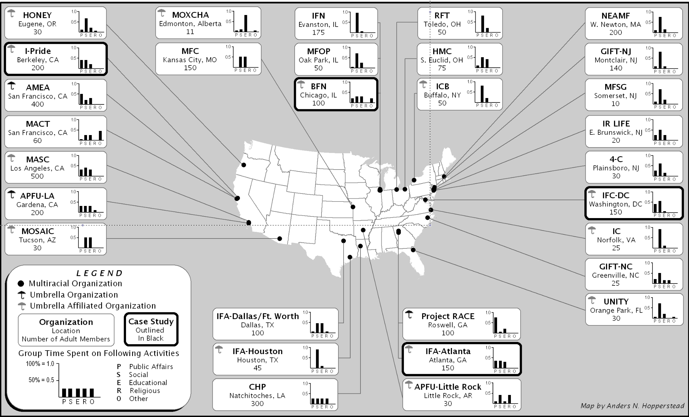
Source: Williams, Mark One or More, 8.

Figure 2. Approval of Black- White Marriage Among Whites and Blacks: 1969-2013
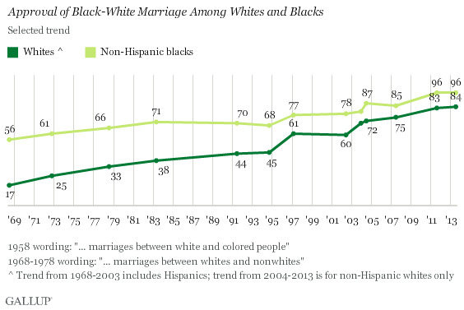
Source: Newport, “In U.S., 87 Percent Approve”

Figure 3: United Colors of Benetton Advertisement, 1989
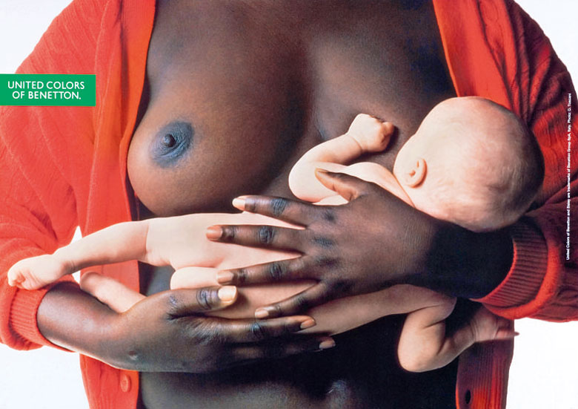

Appendix A: Race and Ethnicity Questions on the 2000 and 2010 Censuses
Figure 4a. 2000 Census Figure 4b. 2010 Census
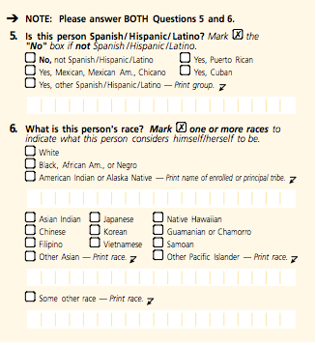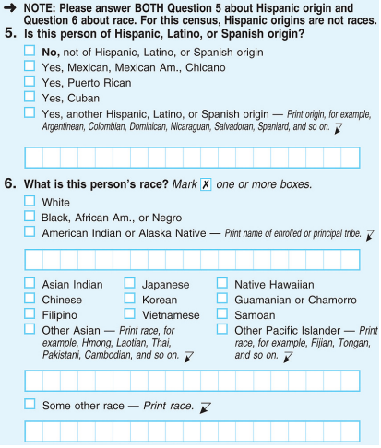

Source: U.S. Census Bureau

Appendix B: Possible Formats for 2020
The Census Bureau tested fifteen experimental questionnaire panels and two control questionnaire panels (including Figure 4b) in the mail-survey portion of the 2010 AQE. Four options under serious consideration for 2020 appear below. All would combine previously separated race and Hispanic origin questions (see Figures 4a and 4b), albeit in different ways.

Figure 5a: The Detailed Approach
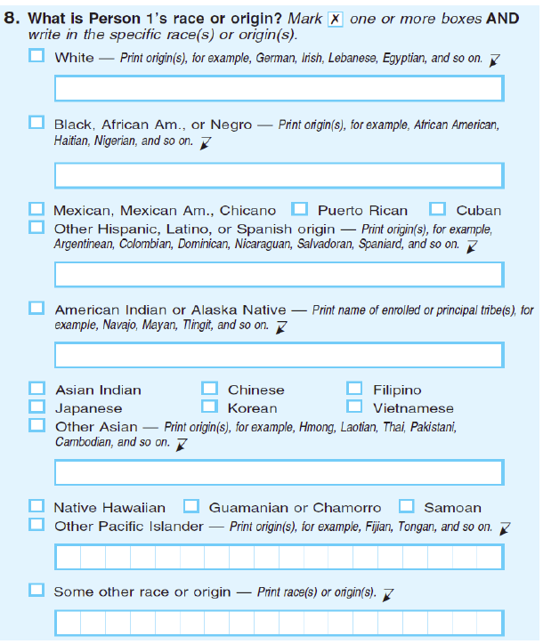

Figure 5b: The Streamlined Approach
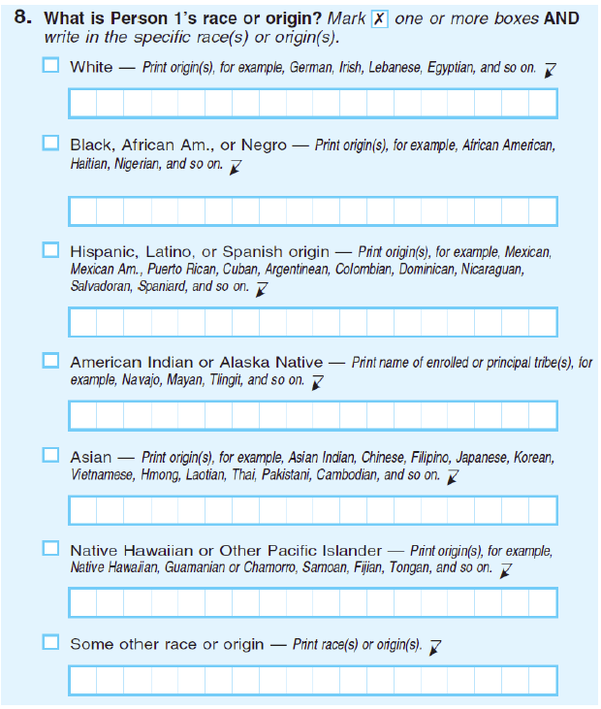

Figure 5c: The Very Streamlined Approach (Prewitt’s Proposed Format)
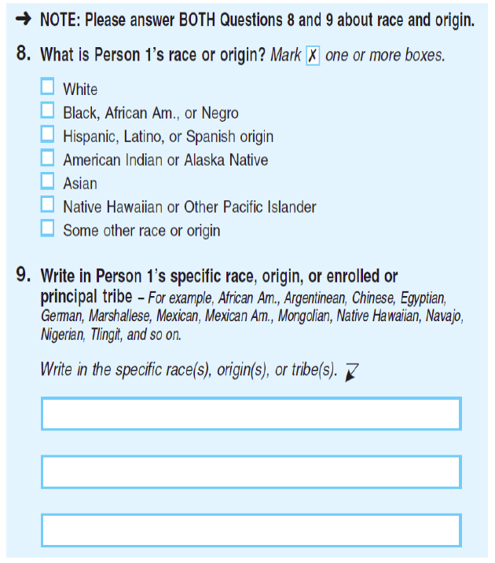

Figure 5d: The Alternative Control Approach
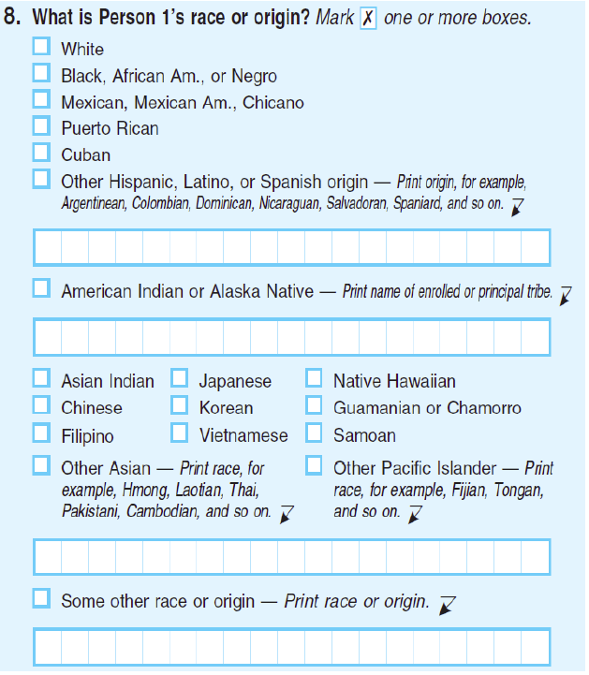

SOURCE: Compton et al., 2020 Census Race and Hispanic Origin.

Kim M. Williams, Mark One or More: Civil Rights in Multiracial America (Ann Arbor, MI: University of Michigan Press, 2006); Rainer Spencer, Spurious Issues: Race and Multiracial Identity Politics in the United States (Boulder, CO: Westview Press,1999).
For more information on the intended and unintended consequences of social movements, see Edwin Amenta, Neal Caren, Elizabeth Chiarello and Yang Su, “The Political Consequences of Social Movements,” Annual Review of Sociology 36:10 (2010): 289; Marco G. Giugni, “Was it Worth the Effort? The Outcomes and Consequences of Social Movements,” Annual Review of Sociology 24 (1998): 371-393; Marco G. Giugni, Doug McAdam and Charles Tilly, eds., How Social Movements Matter (Minneapolis, MN: University of Minnesota Press, 1999); Sarah A. Soule and Brayden King, “The Stages of the Policy Process and the Equal Rights Amendment, 1972-1982,” American Journal of Sociology 111:5 (2006): 1871-1909; Hugh Davis Graham, Collision Course: The Strange Convergence of Affirmative Action and Immigration Policy in America (New York: Oxford University Press, 2002); Doug McAdam, Sidney Tarrow and Charles Tilly, Dynamics of Contention (New York: Cambridge University Press, 2001).
Paul D. Schumaker, “Policy Responsiveness to Protest-Group Demands,” Journal of Politics 37:2(1975): 494.
Paul Burstein, R.L. Einwohner and J.A. Hollander, “The Success of Political Movements: A Bargaining Perspective,” in The Politics of Social Protest, eds. Craig Jenkins and Bert Klandermans (Minneapolis: University of Minnesota Press, 1995): 283.
Stephen Hart, “The Cultural Dimension of Social Movements: A Theoretical Assessment and Literature Review,” Sociology of Religion 57 (1996): 87-100.
Office of Management and Budget, Exhibit F: Race and Ethnic Standards for Federal Statistics and Administrative Reporting (Washington, DC: Executive Office of the President, May 3, 1974, Revised May 12, 1977).
David A. Hollinger, Postethnic America: Beyond Multiculturalism (New York: Basic Books, 1995).
In earlier eras, starting around 1890, the Manasseh Society formed in Milwaukee, Wisconsin, as a support group and community resource for people in interracial relationships. The Society was active for over thirty years and eventually expanded to other cities. Later other groups formed, including the Penguin Society (est. 1936), Club Internationale (est. 1947), the Miscegenation Club (1940s), and the Club of Tomorrow (1950s). See St. Clair Drake and Horace C. Clayton, Black Metropolis: A Study of Negro Life in a Northern City (Chicago: University of Chicago Press, 1945); G. Reginald Daniel, More Than Black?: Multiracial Identity and the New Racial Order (Philadelphia: Temple University Press, 2002).
Susan Graham, In-Person Interview with Kim M. Williams, April 16.1998.
In 1997-98 I conducted a survey of thirty group leaders across the country and planned to select a few of the affiliates of each umbrella organization (AMEA, Project RACE, and APFU) for case-study analysis. However, further investigation revealed that the only organization with an active network of affiliates at the time of my research was AMEA. Accordingly, the local organizations involved in my case studies—fifty interviews with board members of the four most politically active local groups—were all AMEA affiliates. Altogether, I conducted eighty interviews, including interviews with movement leaders and with board members of the four local groups.
Williams, Mark One or More, Chapter 5.
Sidney Tarrow, Power in Movement: Social Movements and Contentious Politics (Revised and Updated Third Edition, New York: Cambridge University Press, 2011), 9.
See Harvey M. Choldin, Looking for the Last Percent: The Controversy over Census Undercounts (New Brunswick, NJ: Rutgers University Press, 1994); Katherine A. Wallman, Suzann Evinger and Susan Schechter, “Measuring Our Nation's Diversity: Developing a Common Language for Data on Race/Ethnicity,” American Journal of Public Health 90 (2000), 1704.
U.S. House. Subcommittee on Census, Statistics, and Postal Personnel. Hearings on the Review of Federal Measurement of Race and Ethnicity, 103rd Congress, 1st Session (Washington DC: Government Printing Office, 1993), 128.
U.S. House, Hearings on the Review of Federal Measurement, 214.
U.S. House, Hearings on the Review of Federal Measurement, 127.
U.S. House, Hearings on the Review of Federal Measurement, 199.
In the 2000 census, 874,414 individuals identified themselves as belonging in the NHOPI category.
U.S. House, Hearings on the Review of Federal Measurement, 211.
U.S. House, Hearings on the Review of Federal Measurement, 192-94.
U.S. House, Hearings on the Review of Federal Measurement,193.
U.S. House, Hearings on the Review of Federal Measurement, 192-94.
See Choldin, Looking for the Last Percent.
The advisability of combining the race and Hispanic-origin questions (thus dropping the distinction between racial and ethnic groups) was another major research focus. Provisions for writing in nationalities/ethnic identities were also studied and tested. See Williams, Mark One or More, Chapter 3.
H.R. 3920 was an amendment to the Paperwork Reduction Act during the 104th Congress.
Williams, Mark One Or More, 57.
Susan Graham, “Multiracial Life after Newt,” accessed November 22, 1998. http://www.projectrace.home.mindspring.com/director.html.
U.S. House. House Subcommittee on Government Management, Information, and Technology. Committee on Government Reform and Oversight. Hearings on Federal Measures of Race and Ethnicity and the Implications for the 2000 Census, 105th Congress, 1st Session (Washington, DC: Government Printing Office, 1997), 660.
Sidney G. Tarrow, Power in Movement: Social Movements and Contentious Politics (New York: Cambridge University Press, 1994), 81.
Derrick A. Bell. “Brown v. Board of Education and the Interest-Convergence Dilemma,” Harvard Law Review 93 (1980): 518-533.
At the state level, in most cases, a few vocal parents raised the issue with their state representative and helped to push the bills through. With the exceptions of the Michigan House and the Ohio Senate, the successful bills passed with strong, bipartisan consensus (Williams, Mark One Or More, 68). Only in Michigan did I find evidence of black opposition (Williams, Mark One Or More, 71). Muted or nonexistent black resistance at the state level was probably due to the fact that neither funding nor the composition of legislative districts was at risk. Though it did not seem that adding the option would lead to any material legislative changes, however, it did grant legitimacy to multiracial identity and provide visibility and momentum for the movement’s larger effort to get a multiple-race option on the decennial census.
Faye Fiore, “Multiple-Race Choices to be Allowed on 2000 Census,” Los Angeles Times, October 30, 1997.
See Williams Mark One Or More, 60-62 for elaboration of the most seriously considered options.
Office of Management and Budget, Guidance on Aggregation and Allocation of Data on Race for Use in Civil Rights Monitoring and Enforcement: Bulletin 00-02 (Washington, DC: Executive Office of the President, OMB Office of Information and Regulatory Affairs, 2000).
Interestingly, the OMB’s creation of the NHOPI category in 2000 also stemmed from both identity and civil-rights claims. See Kenneth Prewitt, What Is Your Race: The Census and Our Flawed Efforts to Classify Americans (Princeton, NJ: Princeton University Press, 2013), 131.
Office of Management and Budget, Provisional Guidance on the Implementation of the 1997 Standards for the Collection of Federal Data on Race and Ethnicity (Washington, DC: Executive Office of the President, OMB Office of Information and Regulatory Affairs, 2000).
Almost all of these people reported as “Hispanic” on the Hispanic origin question, suggesting that a large majority of Hispanic people view “Hispanic” as a racial rather than an ethnic designator.
Roderick J. Harrison, “Inadequacies of Multiple-Response Race Data in the Federal Statistical System,” in The New Race Question: How the Census Counts Multiracial Individuals, ed. Joel Perlmann and Mary Waters (New York: Russell Sage Foundation, 2002), 137.
F. James Davis, Who is Black? One Nation’s Definition (University Park: Pennsylvania State University Press, 1991/2001).
See Reynolds Farley, “Identifying with Multiple Races: A Social Movement that Succeeded but Failed?” in The Changing Terrain of Race and Ethnicity, ed. Maria Krysan and Amanda E. Lewis (New York: Russell Sage Foundation, 2004). Farley claims the movement failed because it provoked neither litigation nor bitter redistricting controversies.
See, for example, Mary Bernstein and Marcie de la Cruz, “Goal of the Multiracial Hapa Movement,” Social Problems 56:4 (2008): 722-745; Kristen Renn, Mixed Race Students in College: The Ecology of Race, Identity and Community on Campus (Albany: State University of New York Press, 2004).
See, for example, Mary E. Campbell and Christabel Rogalin, “Categorical Imperatives: The Interaction of Latino and Racial Identification,” Social Science Quarterly 87:5(2006): 1030-1052; David R. Harris and Jeremiah J. Sim, “Who is Multiracial? Assessing the Complexity of Lived Race,” American Sociological Review 67:4 (2002): 614-627; Steven, J. Hitlin, Scott Brown, and Glen H. Elder Jr., “Measuring Latinos: Ethnic Classification and Self-Understandings,” Social Forces 96:2 (2007): 587-611; Joane Nagel, ”Constructing Ethnicity: Creating and Recreating Ethnic Identity and Culture,” Social Problems 41:1 (1994):152-176; Silvia Pedraza, “Beyond Black and White: Latinos and Social Science Research on Immigration, Race, and Ethnicity in America,” Social Science History 24:4 (2000): 697-726.
See, for example, Frank D. Bean and Jennifer Lee, “Plus ca Change...? Multiraciality and the Dynamics of Race Relations in the United States,” Journal of Social Issues 65:1(2009),14; Eduardo Bonilla-Silva, “We Are All Americans!: The Latin Americanization of Racial Stratification in the USA,” Race & Society 5(2002): 3-16; Luis R. Fraga, John A. Garcia, Rodney E. Hero, Michael Jones-Correa, Valerie Martinez-Ebers and Gary M. Segura, “Su Casa es Nuestra Casa: Latino Politics Research and the Development of American Political Science,” American Political Science Review 100:4 (2006): 515-521; Ian Haney-Lopez, White by Law: The Legal Construction of Race (New York: New York University Press, 1996); Jennifer L. Hochschild, Vesla M. Weaver and Traci R. Burch, Creating a New Racial Order: How Immigration, Multiracialism, Genomics, and the Young Can Remake Race in America (Princeton: Princeton University Press, 2012); Jennifer Lee and Frank Bean, “America's Changing Color Lines: Immigration, Race/Ethnicity, and Multiracial Identification,” Annual Review of Sociology 30 (2004): 221-242; Suzanne Oboler, Ethnic Labels/Latino Lives: Identity and the Politics of (Re) Presentation in the United States (Minneapolis: University of Minnesota Press, 1995); Clara Rodriguez, Changing Race: Latinos, the Census and the History of Ethnicity (New York: New York University Press, 2000).
See for example, Anani Dzidzienyo, “Coming to Terms with the African Connection in Latino Studies,” Latino Studies 1:1(2003): 160-167; Maria P.P. Root, ed., Racially Mixed People in America (Newbury Park, CA: Sage Publications, 1992); Silvio Torres-Saillant, “Inventing the Race: Latinos and the Ethnoracial Pentagon,” Latino Studies 1:1(2003): 123-151; Naomi Zack, ed. American Mixed Race: The Culture of Microdiversity (Lanham, MD: Rowman & Littlefield Publishers, Inc., 1995).
Karen R. Humes, Nicholas A. Jones and Roberto R. Ramirez, Overview of Race and Hispanic Origin: 2010 (Washington, DC: U.S. Census Bureau, 2011).
Multiple-race responses in 2000 and 2010 involving “Some Other Race” (SOR) were subject to editing and assignment decisions based on complicated algorithms. If a respondent marked SOR and wrote in a phrase that indicated a Spanish origin, that person remained in the SOR group. If the person marked SOR and the write-in involved a country of origin, the race of that country’s largest group was used. For example, someone from a 90-percent black African or Caribbean nation might be coded to black, while someone from Europe, Australia, or Canada might be coded to white (unless they indicated First Peoples or Aboriginal identities). Those indicating national origins where populations were more evenly divided remained in SOR.
Kenneth Prewitt, “Fix the Census’ Archaic Racial Categories,” New York Times, August 21, 2013.
Elizabeth Compton, Michael Bentley, Sharon Ennis and Sonya Rastogi, 2020 Census Race and Hispanic Origin Alternative Questionnaire Experiment (Washington, DC: U.S Census Bureau, 2013), 3.
Compton et al., 2020 Census Race and Hispanic Origin, vi.
Compton et al., 2020 Census Race and Hispanic Origin, 38-44.
Compton et al., 2020 Census Race and Hispanic Origin, 43-44.
Compton et al., 2020 Census Race and Hispanic Origin, 44.
Even if Hispanic origin is kept separate, it is likely that the Bureau will recommend that the OMB allow multiple Hispanic reporting. (In 2000 and 2010, it was not possible for an individual to identify as both Cuban and Mexican, for example.) This stems in part from bureaucratic decisions made in the late 1990s. In keeping with the “1997 standards, agencies cannot collect multiple responses and then report and publish data using only the five single race categories. Agencies are expected to provide as much detail as possible on the multiple race responses” (Office of Management and Budget, “Provisional Guidance on the Implementation of the 1997 Standards,” 7). Fifteen years later, soliciting greater detail in race reporting—now an institutionalized agency objective (see Compton et al., 2020 Census Race and Hispanic Origin)—has become the main justification that the Bureau offers for including write-in lines for all groups in 2020.
The exact wording of the question was as follows: “Which of the following describes your race? You can select as many as apply. White, Black or African-American, Asian or Asian-American, or some other race.” The question also included a “Hispanic/Latino” option, but it was provided separately. Pew Research Center, “A Year After Obama’s Election Blacks Upbeat about Black Progress, Prospects,” (Washington, DC: Pew Research Center for the People and the Press, 2010).
The exact wording of the question was as follows: “Please tell me which of the following, if any, apply to you. Do you consider yourself to be black; white; Asian, some other race; of mixed race?”
Note, too, the rise of DNA ancestry kits (Hochschild et al., Creating a New Racial Order, 99-100) that allow Americans to discover on an individual level what geneticists have already established: that genetic variations within “races” are greater than those between (see Natalie Angier, “Do Races Differ? Not Really, Genes Show,” New York Times, August 22, 2000).
Prewitt, What Is Your Race, 195.
Prewitt, What Is Your Race, 200.
Prewitt, What Is Your Race, 200.
To provide second-generation statistics, Prewitt would also add “parental place of birth” to the immigration questions.
Prewitt, What Is Your Race, 197.
Prewitt, What Is Your Race, 200.
Prewitt, What Is Your Race, 198.
Prewitt, What Is Your Race, 200.
In an important exception, Prewitt would “retain the option of a separate question for African Americans and/or for American Indians…if analysis on racial disparities seems to require that” (Prewitt, What Is Your Race, 207). Prewitt’s plan is predicated on a reduction in racial and ethnic differentials as a necessary condition before he would eliminate racial categories altogether. This stands in contrast to the position of Republican conservatives like Gingrich and Petri who argued that ignoring racial and ethnic differentials would make them go away.
Prewitt, What Is Your Race, 207.
Prewitt, What Is Your Race, 207.
U.S. House. House Subcommittee on Federal Financial Management, Government Information, Federal Services and International Security. 2010 Census: A Status Update of Key Decennial Operations, 111th Congress (Washington, DC, Government Printing Office, 2009).
See Karen Humes and Howard Hogan, “Measurement of Race and Ethnicity in a Changing, Multicultural America,” Race and Social Problems 1:3 (2009): 111-131; Prewitt, What Is Your Race.
Joseph Margulies, What Changed When Everything Changed: 9/11 and the Making of National Identity (New Haven, CT: Yale University Press, 2013).
Margo J. Anderson, “Counting By Race: The Antebellum Legacy,” in The New Race Question, 270.
Rachel F. Moran, Interracial Intimacy: The Regulation of Race and Romance (Chicago: University of Chicago Press, 2001), 19.
Judi McGee, In-Person Interview with Kim M. Williams, June 12,1998.
Carlos Fernández, “Government Classification of Multiracial/Multiethnic People,” in The Multiracial Experience: Racial Borders as the New Frontier, ed. Maria P.P. Root (Thousand Oaks, CA: Sage Publications, 1996), 16.
Hart, “The Cultural Dimension of Social Movements,” 88-89. Also see: Jennifer E. Earl, “The Cultural Consequences of Social Movements,” in The Blackwell Companion to Social Movements, ed. David Snow, Sarah Soule and Hanspeter Kriesi (Oxford, UK: Blackwell, 2004), 508-550.
Thomas R. Rochon, Culture Moves: Ideas, Activism, and Changing Values (Princeton: Princeton University Press, 1988), 22.
Rochon, Culture Moves, 21.
Frank Newport, “In U.S., 87 Percent Approve of Black-White Marriage, vs. 4 Percent in 1958,” accessed January 13, 2014. http://www.gallup.com/poll/163697/approve-marriage-blacks-whites.aspx.
Rochon, Culture Moves, Chapter 6.
Forty-four percent of Americans said it made “no difference,” and 11 percent said it had been a change for the “worse.” Paul Taylor, Wendy Wang, Kim Parker, Jeffrey S. Passel, and Seth Motei, “The Rise of Intermarriage: Rates, Characteristics Vary by Race and Gender,” (Washington DC: Pew Research Center for the People and the Press, 2012), 33.
See Taylor et al., The Rise of Intermarriage; Hochschild et al. Creating a New Racial Order, 113-138.
The exact phrasing of the question was as follows: “Do you mostly think of Obama as a black person or mostly as a person of mixed race?” Pew Research Center, “A Year After Obama’s Election.”
Davis, Who is Black?
Root, The Multiracial Experience, 7.
Over two-thirds of the respondents (69 percent) said they had always thought of themselves as belonging to two or more races. Pew Research Center, Multiracial in America: Proud, Diverse and Growing in Numbers (Washington, DC: Pew Research Center for the People and the Press, 2015).
See, for example, William A. Gamson and Andre Modigliani, “Media Discourse and Public Opinion on Nuclear Power: A Constructionist Approach,” American Journal of Sociology 95:1 (1989): 37; Doug McAdam, Freedom Summer (New York: Oxford University Press, 1988); Doug McAdam, “Culture and Social Movements,” in New Social Movements: From Ideology to Identity, ed. Enrique Larana, Hank Johnston and Joseph R. Gusfield (Philadelphia: Temple University Press, 1994): 36-57; John R. Oldfield, Popular Politics and British Anti-Slavery: The Mobilization of Public Opinion Against the Slave Trade, 1784-1807 (Manchester: Manchester University Press, 1995); Berniece A. Pescosolida, Elizabeth Grauerholz, and Melissa A. Milkie, “Culture and Conflict: The Portrayal of Blacks in U.S. Children’s Picture Books through the Mid-and-Late-Twentieth Centuries,” American Sociological Review 62 (1997): 443-464.
William K. Darley and Jerome D. Williams, “Methodological Issues in Ethnic Consumer Survey Research: Changing Consumer Demographics and Implications,” in Marketing and Multicultural Diversity, ed. C. P. Rao (Hampshire, UK: Ashgate Publishing Group, 2006), 93-120.
Andrea Sachs, “Steamy Romance Novels Flush with Color,” Time Magazine, May 14 2014.
Today, however, the world of children’s literature remains a bastion of whiteness. See Christopher Myers, “The Apartheid of Children's Literature,” New York Times, March 15. 2014. For related data, which, unfortunately, does not include a category for children’s books by or about multiracial people, see Kathleen T. Horning, Children’s Books by and about People of Color Published in the United States (Cooperative Children’s Book Center, School of Education: University of Wisconsin-Madison, 2014). Accessed May 22, 2015. http://ccbc.education.wisc.edu/books/pcstats.asp.
Charles A. Gallagher, “Color-Blind Egalitarianism as the New Racial Norm,” in Theories of Race and Ethnicity: Contemporary Debates and Perspectives, eds. Karim Murji and John Solomos (New York: Cambridge University Press, 2015), 48.
Francesca Polletta and James M. Jasper, “Collective Identity and Social Movements,” Annual Review of Sociology 27 (2001), 283-305.
Rick Fantasia, Cultures of Solidarity: Consciousness, Action, and Contemporary American Workers (Berkeley: University of California Press, 1989), 232-233.
David Lopez and Yen Espiritu, “Panethnicity in the United States: a Theoretical Framework,” Ethnic and Racial Studies 13:2 (1990), 198-224.
See, for example, Andrew Garrod, Robert Kilkenny and Christina Gomez, eds., Mixed: Multiracial College Students Tell their Life Stories (Ithaca, New York: Cornell University Press, 2013); Natalie Masuoka, “Political Attitudes and Ideologies of Multiracial Americans: The Implications of Mixed Race in the United States,” Political Research Quarterly 61:2 (2008), 253-267; Renn, Mixed Race Students; Kerry Ann Rockquemore, David L. Brunsma and Daniel J. Delgado, “Racing to Theory or Retheorizing Race? Understanding the Struggle to Build a Multiracial Identity Theory,” Journal of Social Issues 65:1 (2009), 13-34.
Pew Research Center, Multiracial in America, 6-7.
Pew Research Center, Multiracial in America, 9.
Pew Research Center, Multiracial in America, 58.
See, for example, Bean and Lee, Plus ca Change?; Bonilla-Silva, We Are All Americans!; Herbert J. Gans, “‘Whitening’ and the Changing American Racial Hierarchy,” Du Bois Review: Social Science Research on Race 9:2(2012), 267-279; Hochschild et al. Creating a New Racial Order; Kathleen Odell Korgen, ed., Multiracial Americans and Social Class: The Influence of Social Class on Racial Identity (London and New York: Routledge, 2010); Jennifer Lee and Frank Bean, The Diversity Paradox: Immigration and the Color Line in Twenty-First Century America (New York: Russell Sage Foundation, 2010).
But see Jennifer Lee and Frank Bean, “A Postracial Society or a Diversity Paradox? Race, Immigration, and Multiraciality in the Twenty-First Century,” Du Bois Review: Social Science Research on Race 9:2 (2012), 419-437; Pew Research Center, “A Year After Obama’s Election”; Taylor et al., “The Rise of Intermarriage.”
Hope Yen, “Census Seeks Changes in How it Measures Race,” The Seattle Times, August 9, 2012.
See, for example, Jennifer L. Hochschild and Breanna Marea Powell, “Racial Reorganization and the United States Census 1850-1930: Mulattoes, Half-Breeds, Mixed Parentage, Hindoos, and the Mexican Race,” Studies in American Political Development 22 (2008), 90.
Roderick Harrison kindly read a draft of this paper and disagreed with me on this point. He told me that most “professionals at the Census Bureau and the overwhelming majority of social scientists believe that data on race and ethnicity is absolutely necessary for understanding the unequal socio-economic, health, etc., conditions of populations that have historically been excluded from full and equal participation in society on the basis of socially defined race.” In Harrison’s opinion, “Prewitt’s visions are realized only at substantially lower levels of inequality, achieved at paces far outstripping the progress of the best of decades.” Harrison added that the “civil rights community…will guarantee substantial, if not fierce, resistance to visions like Prewitt’s” (Roderick Harrison, e-mail message to author, August 19, 2015). I concur that opposition would be fierce in some quarters, but I am not convinced that fierce opposition, particularly if it comes predominantly from black people, would make a difference in the long run. Qualitative research on the OMB and Census Bureau would help us better understand current and future bureaucrats’ dispositions.
But Jones has been “faithful to the need to preserve the standard categories for civil rights and social trend measurements. I doubt he’d want to pursue Prewitt’s vision either” (Harrison, e-mail message to author).
Prewitt, What is Your Race?
Pew Research Center, Multiracial in America.
See, for example, Hochschild et al. Creating a New Racial Order; Susan Saulny, “Black? White? Asian? Young Americans Choose all of the Above,” New York Times, January 29, 2011.
Compton et al., 2020 Census Race and Hispanic Origin.
Jeffrey S. Passel and D’Vera Cohn, “U.S. Population Projections: 2005-2050,” (Washington, DC: Pew Research Center for the People and the Press, 2008).
See, for example, Haney-Lopez, White By Law; Matthew F. Jacobson, Whiteness of a Different Color: European Immigrants and the Alchemy of Race (Cambridge, MA: Harvard University Press, 1998); Joel Perlmann, Italians Then, Mexicans Now: Immigrant Origins and Second-Generation Progress, 1890 to 2000 (New York: Russell Sage Foundation, 2005).
Kenneth Prewitt kindly read a draft of this paper. I thank him, here and elsewhere, for his insights.
D’Vera Cohn, “Millions Of Americans Changed their Racial or Ethnic Identity from One Census to the Next,” (Washington, DC: Pew Research Center for the People and the Press, 2014).
See, for example, Christopher Bonastia, Knocking on the Door: The Federal Government’s Attempt to Desegregate the Suburbs (Princeton NJ: Princeton University Press, 2006); Eric Patashnik and Julian E. Zeilzer, “The Struggle to Remake Politics: Liberal Reform and the Limits on Policy Feedback in the Contemporary American State,” Perspectives on Politics 11:4 (2013): 1071-1087.
See, for example, Andrea L. Campbell, “Politics Makes Mass Politics,” Annual Review of Political Science 15:1 (2012): 333-51.
Derrick A. Bell, Silent Covenants: Brown v. Board of Education and the Unfulfilled Hopes for Racial Reform (Oxford: Oxford University Press, 2004), 189.
But see, for example: Haney-Lopez, White by Law; Hochschild et al., Creating a New Racial Order; Hollinger, Postethnic America; Perlmann and Waters, eds., The New Race Question; Prewitt, What is Your Race?; Yehudi O. Webster, The Racialization of America (New York: St. Martin’s Press, 1992); Williams, Mark One or More; Tukufu Zuberi, Thicker Than Blood: How Racial Statistics Lie (Minneapolis: University of Minnesota Press, 2001).
One example of this seeming eagerness to ignore racial inequality took place during Obama’s first campaign, when whites chanted “Race doesn’t matter!” on the night of the 2008 South Carolina primary, just blocks from where the Confederate flag then flew over the capitol.
Saulny, “Black? White? Asian?”; also see Ken Hou Lin, Celeste Curington and Jennifer Lundquist, “Positioning Multiraciality in Cyberspace: Treatment of Multiracial Daters in an Online Dating Website,” (American Sociological Review, Forthcoming).

