Donald Trump’s Lack of Appeal to the Millennial Generation
in the 2016 Election: Causes and Consequences

Patrick Fisher

Department of Political Science
Seton Hall University
South Orange, NJ 07079

patrick.fisher@shu.edu

Paper Presented at the Annual Meeting of the
Western Political Science Association
Vancouver, British Columbia
April 13-15, 2017

Donald Trump’s Lack of Appeal to the Millennial Generation in the 2016 Election:
Causes and Consequences

Abstract

After Barack Obama’s victories in the 2008 and 2012 presidential elections it had been argued that any potential Republican nominee for president would have to do considerably better among Millennials than John McCain and Mitt Romney to have a chance of winning the general election. Donald Trump, however, did only marginally better among the youngest generation of American voters than the previous two Republican presidential nominees. Trump’s lack of appeal to Millennials, after Obama so successfully wooed them, may be a defining characteristic of contemporary American politics. Trump’s message of “Make America Great Again” suggests that his campaign stoked fears about generational societal change, which was a poor match for the Millennial generation. Consequently, Trump has consistently been extremely unpopular among Millennials, both in terms of his own personal approval was well as in terms of his policy positions. The huge generation gap that has emerged in the 2016 presidential election suggests that there is an emerging realignment of the electorate along generational lines. The long-term consequences of Trump’s generational gap distinctly favor the Democratic Party.

Donald Trump’s Lack of Appeal to the Millennial Generation in the 2016 Election:
Causes and Consequences

The presidential election of 2016 was unlike any presidential election before it. Donald Trump, who few saw as a serious candidate when he announced he was running for president, astounded the political establishment by not only winning the Republican nomination but also winning the Electoral College vote in the general election. He did so despite the fact the fact that he had never held political office before and had the lowest recorded favorability rating of any major party presidential nominee in history, with exit polls indicating only 38 percent of the 2016 electorate had a favorable impression of him.
Trump won the presidency by presenting himself stylistically as a completely different candidate from previous presidential candidates. Trump’s bluntness and lack of “political correctness” clearly appealed to many more voters than was imagined by the media and the political establishment when Trump first announced his run for the presidency. Trump victory was the result of him being able to make inroads in winning the support of some demographic groups to a greater degree than previous Republican candidates. The unique nature of Trump’s unconventional campaign begs the question as to whether or not his appeal was the result of a generational transformation in the American electorate.
Barack Obama’s victories in the 2008 and 2012 elections were in a large part due to his overwhelming success among newly enfranchised voters of the Millennial Generation. Republicans lack of support among Millennials was thus seen to be a key factor in the Party’s losses to Obama. Without the Millennial vote, in fact, Obama would have lost reelection in 2012. After Obama’s victories it had been argued that any potential Republican nominee would have to do considerably better among Millennials than John McCain and Mitt Romney to have a chance of winning the general election. Donald Trump, however, did only marginally better among the youngest generation of American voters than the previous two Republican presidential nominees. Trump’s lack of appeal to Millennials, after Obama so successfully wooed them, may now be a defining characteristic of contemporary American politics.

Generation and Political Behavior
The learning of specific orientations to politics and experiences with the political system is extremely important to one’s political maturity. People develop values and assign priorities to their values that are shaped in a large part from the socio-economic conditions that they cultivate during their formative years from childhood to early adulthood. Due to the changing nature of society’s socio-economic conditions over time, people from different generations emphasize different political values. Changes in societal experiences, therefore, may alter citizens’ political orientations. The result is that different generations have distinct political leanings that they will maintain over their lifetimes.
Consequently, the generation one comes of age politically is an important determinant in one’s political identity. Though a political generation gap is not a perpetual feature of the American political landscape, one’s generation can be a noteworthy influence on partisan and ideological leanings. Not only may there be a divergence between different generations’ vote in a particular election, but also there exists the possibility of long-term generational effects on political behavior. The generation in which one comes of age politically can play an important role in structuring one’s political views their entire life. There is therefore a short-term generation gap—the difference between how different generations vote in a particular election—and a long-term generation gap—the difference between how distinct generations behave politically over the course of their lives.
This study will compare the political behavior of the youngest generation of American adults—the Millennial Generation—to that of older generations of Americans. The generational names we have chosen are the handiwork of popular culture, with some being drawn from a historic event, others from social or demographic change, and others from a turn in the calendar. Generational analysis in not an exact science and the years and terms that are used to define generations will vary from study to study. Our study thus utilizes those generational boundaries and conceptions that are widely—though not universally—accepted. From oldest to youngest the generations will be defined by the following parameters:
- The Silent Generation. Those born from 1928 through 1945. This label refers to their conformant and civic instincts. These are children of the Great Depression and World War II who came of age during the transition between the war years and the counter-culture revolution of the 1960s.
- The Baby Boomers. Those born from 1946 through 1964. These are children of the prosperous post-War era. The label of this generation is derived from the great spike in fertility that began after World War II. Baby Boomers are often associated with a redefinition of traditional values. They are the first generation to grow up in the television era as well as the first generation where many grew up in the suburbs.
- Generation X. Those born from 1965 through 1980. This generation was originally referred to as the “baby bust” generation due to the drop in the birth rate following the baby boom. The “X” label refers to the social change that occurred during this generation’s childhood in the late 1960s and 1970s.
- The Millennial Generation. Adults born after 1981. The label refers to the first generation of adults to come of age in the new millennium. Millennials are civic minded and technologically savvy, embracing the internet and new technology for multiple modes of self-expression.
According to the social-psychological conception, partisan identities are adopted in early adulthood stabilize quickly, and thereafter become highly resistant to more than transient change.
The influences of the political environment are most noticeable among younger voters. Political events and personalities therefore have the greatest and most lasting influence during the stage of life when partisan identities are being formed. For example, throughout their lives, Baby Boomers have expressed more libertarian attitudes than their elders and less respect for authority, religion, and patriotism. On the other hand, Generation X has an extremely personal and individualistic view of politics.
Political leanings can thus be quite consistent as people age. As a result, there is a disparity of the vote choice among different generations. There are distinct partisan trends among generations, with some generations leaning Republican and others Democratic depending upon the political climate in which they developed their formative political views. This is related to who was president when one comes of age politically. Popular presidents are associated with above-average levels of party support among the generation that came of age during their time in office, whereas unpopular presidents are associated with below-average ones. Due to George W. Bush’s low levels of popularity for much of his presidency, for example, those who became adults during his administration have consistently been associated with relatively low levels of Republican identification.
Although there is a stereotype that younger Americans are more liberal than older Americans are, this is not necessarily the case. Younger voters have tended to disproportionately support the Democratic nominee for president, but this is more pronounced in some years than in others. In fact, in some years younger voters support more conservative candidates than older voters do. This was the case, for example, when Ronald Reagan won reelection by a landslide in 1984. In the seventeen presidential elections from 1948-2012, voters under 30 years-old voted only slightly more—three percent—Democratic than the electorate as a whole. Under-30 voters, in fact, were not the most distinct age cohort: those in their 60s were four percent more Republican than the electorate as a whole. Prior to the George W. Bush administration, most presidential elections since the advent of polling did not have much of an age gap, and by the 1990s there was evidence that the age gap on public policy issues that had grown in the 1960s and 1970s was shrinking. At the end of the Twentieth Century, in fact, it was probably more accurate to view the country’s oldest citizens as products of the New Deal, voters whose earliest memories lead them to have a lasting faith in the government activism and those more supportive of the Democratic Party. In the 1992 and 2000 presidential elections, for example, those 60 and older were actually the age group most likely to vote Democratic.

The Generation Gap in 2016
Today, however, generational political leanings do indeed fit the historical stereotype: younger Americans are notably more Democratic-leaning than older Americans are (see Figure 1). In the 2016 presidential election the Silent Generation and the Baby Boomers gave a plurality of their votes to Trump, while the least supportive generation of Trump by a good margin were the Millennials. Since Millennials have achieved adulthood and gained the right to vote the generation has consistently been a generational outlier. Hillary Clinton’s 17-point margin among Millennials, in fact, is actually the lowest plurality the generation has given a Democratic presidential candidate.

______________________________________________________________________________
Figure 1
The Generation Gap 1980-2016
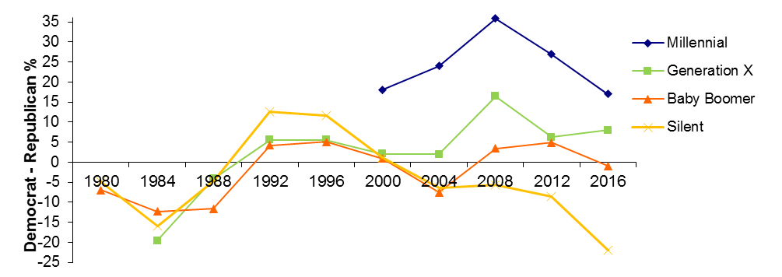
_____________________________________________________________________________________________
Source: American National Election Studies1980-2016

It was probably unrealistic for Hillary Clinton to expect to do as well among Millennials as Barack Obama: younger Americans support for in Obama’s victorious elections in 2008 and 2012 were unprecedented in their magnitude. The youth vote’s movement toward the Democrats began in 2004, when the Millennial vote went for John Kerry by a 18-point margin, by far his best generation (though Millennials were only a small share of voters at the time). This, however, pales in comparison to Barack Obama’s margins in 2008 and 2012. Obama won a staggering two-thirds of the Millennial Vote in 2008 and maintained his strength among younger voters by getting more than three-fifths of this generation’s vote in 2012. Obama’s strength among Millennials, in fact, was critical to his margin of victory in 2008 and 2012. In 2008 the vote among those aged 30+ was basically a dead heat. In 2012, though Obama won the Millennial vote by a smaller share than he had in 2008, the generation was even more critical in his reelection as he lost older generations by a total of a couple of percentage points.
Hillary Clinton’s defeat in 2016 can thus be attributed in part due to the fact that even though the Millennials were by far her best generation, her vote share among the generation was notably lower than Obama’s. Clinton, however, lost considerable ground compared to Obama with other generations as well. Similar to the generation gaps of 2008 and 2012, the generation gap in 2016 was linear, with each older age cohort giving the Republican nominee a higher share of its vote. She, however, did notably worse among her and Trump’s Baby Boomers, and she especially underperformed previous presidential nominees among the Silent Generation. While Obama did poorly among older voters, winning less than 45 percent of the Silent Generation in both 2008 and 2012, Clinton’s share of the Silent Generation’s vote was worse, as the generation supported the Republican nominee for president by a greater margin than they had in any election since 1980. On the other hand, compared with Obama’s showings, Hillary Clinton actually gained support among those of the Generation X even as she was losing relative support among the other generations. Overall, even though her showing among younger Americans was not as impressive as Obama’s, her poor performance among older voters resulted in an enormous generational gap that was comparable in scope to those of 2008 and 2012.
Yet it is essential to note that the 2016 generation gap was not uniform across the nation and varied considerably from state to state. Clinton tended to win the Millennial vote in strongly blue states by overwhelming margins—she won the Millennial vote in California and New York, for example, by more than 40 points (see Table 1). Conversely, Trump’s support among Millennials in states that he won varied considerably. Trump won two of the most critical swing states in recent presidential elections—Florida and Ohio—in 2016, but his support among Millennials in these states were markedly different: while he lost the Millennial vote by 18 points in Florida, he just barely lost this generation in Ohio.
________________________________________________________________________________
Table 1
Millennial Democratic Plurality in 2016 Presidential Election by State

Clinton Landslide % Trump States with % Trump States with %
States Larger Plurality Smaller Plurality

California 45 Georgia 20 Ohio 2
New York 42 Florida 18 South Carolina -1
Illinois 32 North Carolina 15 Utah -3
Washington 30 Michigan 12 Missouri -5
Oregon 25 Pennsylvania 11 Indiana -7
New Jersey 24 Texas 11 Iowa -8
________________________________________________________________________________
Source: Compiled by author from 2016 Exit Polls. Not all states had large enough sample sizes in exit polls to be statistically significant. Only states with published exit polls are included in table.
Note: Positive % denotes Hillary Clinton plurality, negative % denotes Donald Trump plurality.

The state variation in the generation gap in 2016 is especially notable when comparing the state vote of Millennials to the overall state vote (see Table 2). Georgia and Texas have long been red states, but in 2016 Clinton did 25 points better in Georgia and 20 points better in Texas among Millennials than she did in the state overall. This suggests that these populous states, long Republican bastions, may be trending toward the Democrats. Other populous states where Millennials were considerably more Democratic than the overall electorate in 2016 were Florida and North Carolina. At the other extreme, Iowa was a state that Obama won solidly twice and that from 1988-2012 supported the Democratic nominee for president in six out of the seven elections. In 2016, however, it swung strongly to the Republicans in a large part because Trump did impressively well among Iowa Millennials, a group he won by 8 points, only 1 point less than he won the state as a whole. This suggests that Iowa’s move toward the Republicans may not be a fluke and could be enduring. Other states where the Millennial vote was not notably different from the overall electorate include a mixture of red and blue states, including Kentucky, Maine, and Minnesota.
________________________________________________________________________________
Table 2
Largest and Smallest State Generation Gaps in 2016 Presidential Election

Larger Generation Gaps % Smaller Generation Gaps %
Georgia 25 Iowa 1
Texas 20 Maine 2
Florida 19 Kentucky 4
North Carolina 19 Minnesota 6
Arizona 16 Colorado 8
Illinois 16 New Hampshire 8
Utah 16 Ohio 10
________________________________________________________________________________
Source: Compiled by author from 2016 Exit Polls. Not all states had large enough sample sizes in exit polls to be statistically significant. Only states with published exit polls are included in table.
Note: Figures (%) represents the plurality for Hillary Clinton among Millennials relative the state’s plurality for Hillary Clinton among all voters.

These trends suggest that if younger Americans follow other generations in keeping the same partisan voting patterns throughout their lives, the nation as a whole could become progressively become more Democratic, with many blue states becoming even bluer and some red states becoming potentially more competitive. An electoral realignment may be occurring that will reinforce recent Democratic gains. Unquestionably, the Millennial vote broke overwhelmingly against Trump. Figure 2 displays the Electoral College map of the Millennial vote in 2016. Such a map represents a stark contrast from the red-blue map that emerged in 2016. If the electorate were limited to only Millennials, Trump would have lost the 2016 presidential election in a landslide, winningly only 132 Electoral College votes to Clinton’s 406.
________________________________________________________________________________
Figure 2
Electoral College Map of 2016 Presidential Election
Millennial Vote
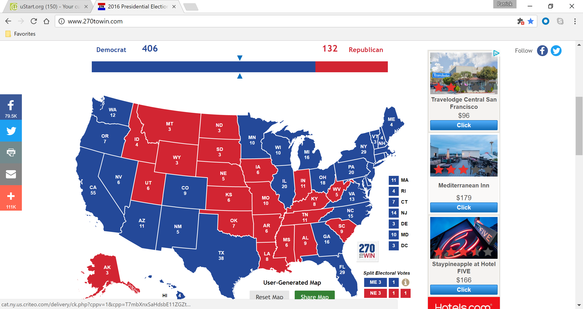
________________________________________________________________________________
Source: 2016 state exit polls. States without exit polls are assumed to have voted in congruence with the overall population.

For the next generation, Donald Trump emerges as a narrow loser in the Electoral College in a hypothetical Generation X electorate, winning 252 electors to Clinton’s 286 (see Figure 3). Particularly important from an Electoral College standpoint, Trump lost the critical swing states of Florida, Pennsylvania, and Wisconsin among Gen Xers, though he did win the Gen X vote in the swing states of Michigan, Ohio, and North Carolina.
________________________________________________________________________________
Figure 3
Electoral College Map of 2016 Presidential Election
Generation X Vote
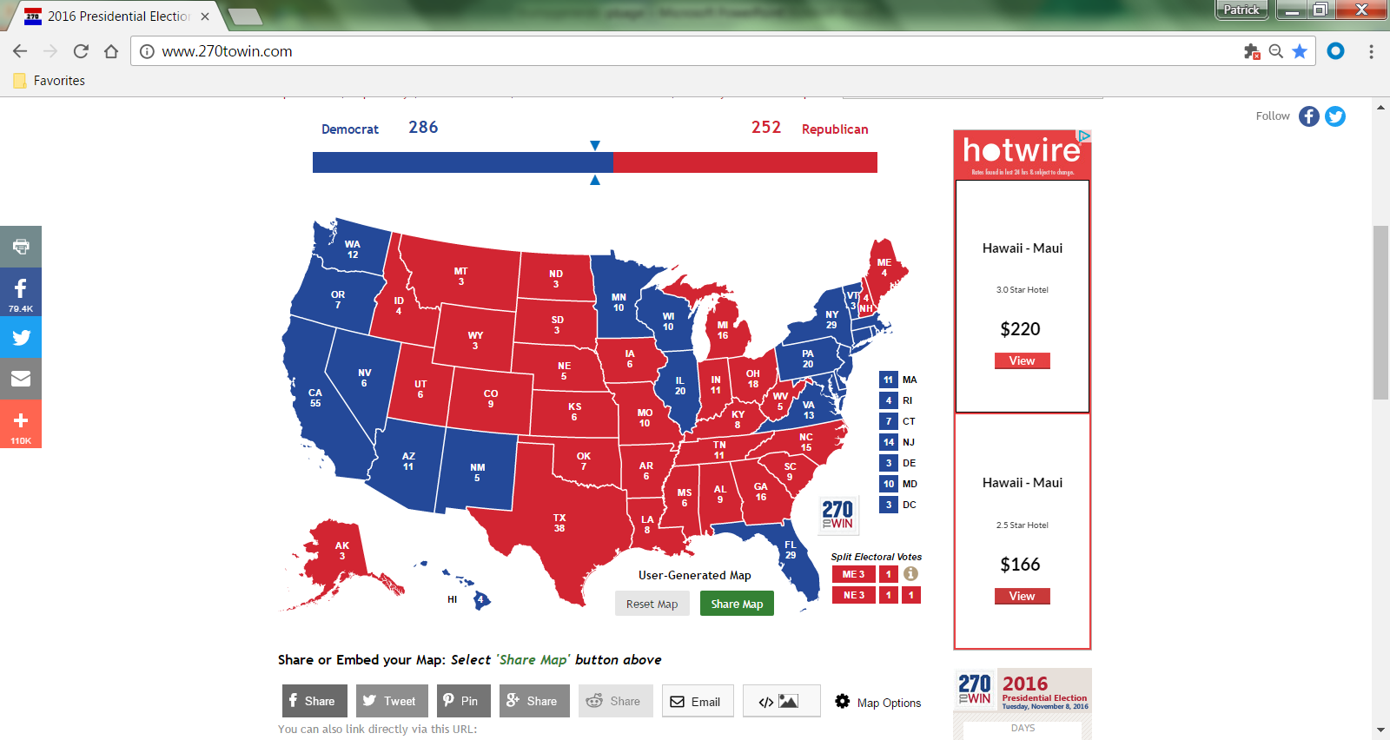
________________________________________________________________________________
Source: 2016 state exit polls. States without exit polls are assumed to have voted in congruence with the overall population.

Among older generations, on the other hand, Trump wins hypothetical Electoral College matchups by convincing margins (see Figure 4). If the electorate consisted only of Baby Boomers and the Silent Generation, Trump would have easily won the presidency with 358 Electoral College votes, notably more than the 306 electors he actually won. The only states that Trump lost among Baby Boomers and the Silent Generation were generally the bluest of the blue, and among Baby Boomers and the Silent Generation he even won the strongly Democratic states of Illinois and Minnesota. Clinton, in fact, won no Midwest state among post-Generation X generations.
________________________________________________________________________________
Figure 4
Electoral College Map of 2016 Presidential Election
Baby Boomer and Silent Generation Vote
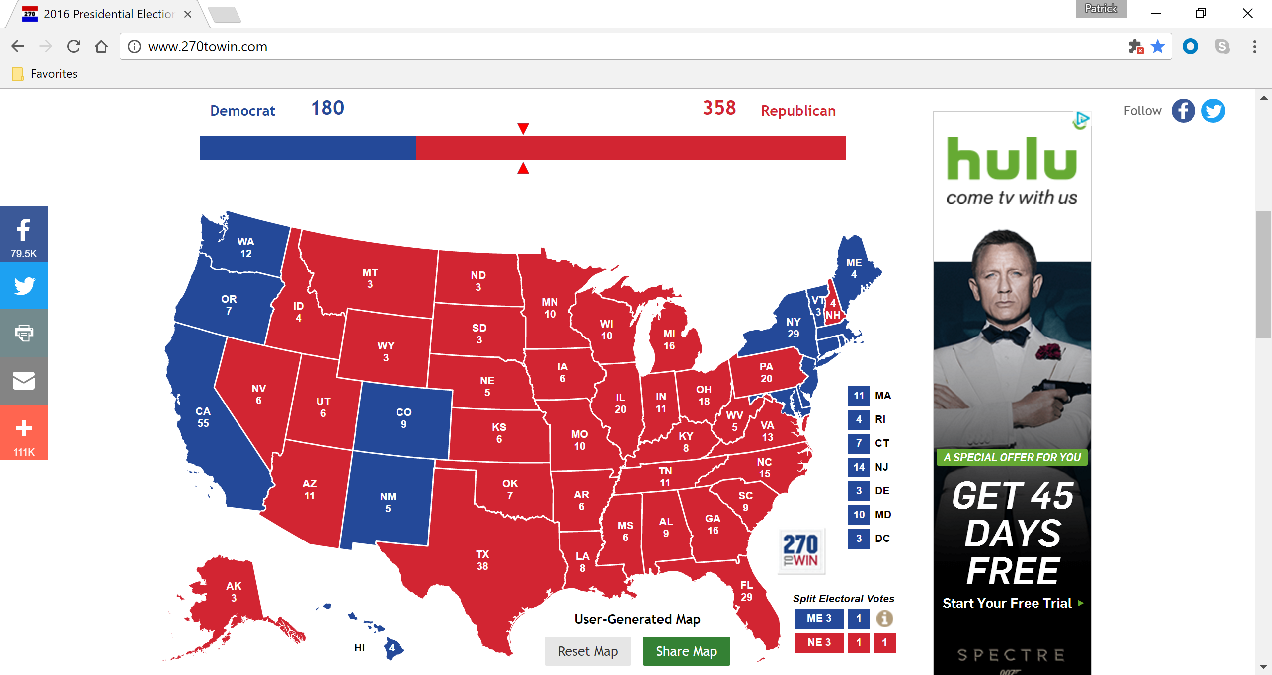
________________________________________________________________________________
Source: 2016 state exit polls. States without exit polls are assumed to have voted in congruence with the overall population.

As noted previously, it is important to stress that to a considerable degree the large generational gap that characterizes Trump’s support in 2016 unquestionably predates his candidacy. Recent trends unambiguously indicate that Millennials tend to be more supportive of Democratic candidates than other age generations as the generation holds a markedly more positive view of Democrats than they do of Republicans. Millennials today are the most Democratic age group in the nation by a substantial margin in due to the partisan cycle of American politics. In general young voters tend to react to the successes or failures of the first politicians they know. Millennials movement of toward the Democrats begun as soon as a substantial number of the generation became enfranchised in 2004, but John Kerry’s support among Millennials was to a considerable degree a function of their contempt for Bush rather than of strong support for Kerry himself. This, however, was not the case in 2008 and 2012 as Obama himself was enormously popular among Millennials from the outset of him announcing his candidacy in 2007. The relative strength of Barack Obama’s and Hillary Clinton’s support among different generations in the 2008 Democratic primaries, in fact, goes a long way in explaining the political dynamics of the 2008 Democratic nomination. Thus, the strong pro-Democratic vote of the Millennials in 2016 has its roots in the generation being both very pro-Obama and very anti-Bush.
The generation gap in 2016, however, was not simply a consequence of Millennials positive feelings toward the Obama administration and negative attitudes toward the Bush administration. Trump himself has been extremely unpopular among Millennials, both in terms of his own personal approval was well as in terms of his policy positions.
How was Donald Trump therefore able to prevail in the Electoral College despite faring so poorly among Millennials? One factor is even though Millennials may have been strongly anti-Trump, the generation did not support Clinton to the degree that they supported Obama. In part this is due to the fact that even though Trump himself was extremely unpopular among Millennials, Hillary Clinton did reap the full benefits of his unpopularity as a number of Millennials decided to vote for a third party candidate or to sit the election out. In fact, an important generational dynamic to the 2016 presidential election was in regards to vote for third party candidates, particularly Gary Johnson of the Libertarian Party and Jill Stein of the Green Party. Millennials were much more like to support third party candidates for president than other generations: 9 percent of Millennials voted for third party candidates, compared to 6 percent of Generation Xers, 4 percent of Baby Boomers, and only 1 percent of the Silent Generation (see Figure 5).
________________________________________________________________________________
Figure 5
Third Party Presidential Vote in 2016 by Generation

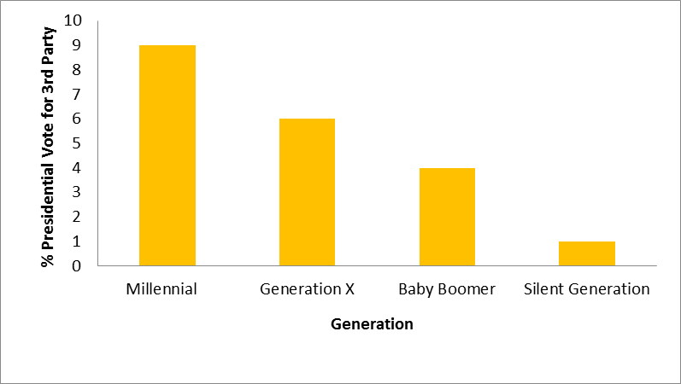
________________________________________________________________________________
Source: American National Election Studies 2016

Overall, support for third party candidates was higher in 2016 than in any presidential election going back to 1996, when third party candidates led by Ross Perot won a combined 10 percent of the vote. The relatively high showing for the non-major party candidates was a symptom of the perceived malaise of the American political system—especially among Millennials—which Donald Trump so adroitly exploited. In general, high aggregate-levels of political distrust are necessary for a strong third-party showing. Support for a third party candidate is thus the result of a deep cynicism about American politics. Younger Americans often are more cynical about politics and stronger support of younger voters for third party candidates is nothing new, as they have long been more likely to support third party candidates. That Millennials, however, were more than three times more likely to vote for third party candidates than those born before the mid-1960s was much larger than what is typical support for younger Americans for third party presidential candidates.

The Generational Gap of Trump’s Populism
Both Donald Trump and Bernie Sanders campaigned for the presidency by coming across as anti-establishment and as a departure of politics-as-usual. In this regards, the candidacies of Trump and Sanders typify populist protests that have a long history in the United States. They expressed, however, extremely different populist impulses. Trump rode a reactionary populism to the Republican nomination, echoing earlier reactionaries by exploiting nativist and racial resentments and prejudice among whites. Sanders, on the other hand, launched a strong challenge for the Democratic nomination with a consistently progressive populist message. Sanders’ populist pitch unquestionably resonated much more among Millennials than did Trump’s.
Support for Trump was motivated by something beyond the more conventional view of conservatism in which economic freedom and small government as well as social and fiscal responsibility are prized. In fact, Trump’s populist orientation regularly came to the defense of some elements of the welfare state (such as Social Security and Medicare) that benefited Trump’s disproportionately older supporters. Whereas the politics of Trump’s supporters is conservative, their material commitments and aspects of their rhetoric place them in a liberal genealogy since it defends interests that are a New Deal inheritance.
Trump’s populist campaign in 2016 was in many regards a poor match for the Millennial generation. Trump tended to do best in counties where white identity mixes with long-simmering economic dysfunctions. Significant share of his supporters were from areas of the county that largely missed the transition of the United States away from manufacturing and into a diverse, information-driven globalized economy. An economic pitch to such voters, however, was definitely not tailored toward the Millennial generation. Younger Americans have been exposed to much more of the world, both in terms of technology and in terms of personal travel and are much more likely to have a global outlook that Trump disdains.
Trump did better in areas of the country with high concentrations of whites without a high school diploma, in areas of those that self-describe themselves as ancestrally “American,” and areas with high percentages living in a mobile home. Counties with relatively large shares of such people are located disproportionately in Appalachian coal counties and in rural parts of the Deep South, areas in which Trump performed strongly. They also tend to be considerably older than the country as a whole, with relatively few Millennials. Trump has tended to do poorly, on the other hand, in what have been termed as “ideopolises,” new-growth cities where Millennials are plentiful and have been thriving. Ideopolises are built upon some combination of light industry, soft technology, university and research centers, and growing retail and service sectors. Trump overwhelmingly lost ideopolises such as Orange County, NC, Dane County, WI, and
Travis County, TX even as he was winning those respective states.
The emerging importance of occupation in the voting habits of wealthier Americans may be due to the development of partisanship as a form of social identification and parties as extensive political networks. Just as a membership in an environmental group or an African-American’s heightened racial consciousness predisposes an individual to identity with the Democrats, so does being a doctor, lawyer, or teacher. Education levels therefore are increasingly becoming a proxy for cultural hegemony. Academia, the news media and the arts and entertainment sectors are increasingly dominated by people with a liberal, multicultural perspective, and jobs in these sectors usually require college degrees. Trump’s campaign may have represented a backlash against these cultural elites. Since education levels are strongly correlated with education—the Millennials are a well-educated generation—the education gap goes hand-and-hand with the generation gap in American politics.
Unquestionably, educational levels were the critical factor in predicting shifts in the vote from 2012 to 2016. While Clinton’s vote share surged in the 50 most educated counties compared to Obama’s share in 2012, her vote share plummeted in the 50 least educated counties. Donald Trump substantially improved on Mitt Romney’s performance among voter without college degrees, especially white voters without college degrees. Hillary Clinton, on the other hand, actually improved on Barack Obama’s performance with college-educated voters. The link between education levels and the shift in the vote is robust, even when controlling for other factors, such as income levels. This is in part due to educational attainment now potentially being a better indicator of long-term economic well-being than household incomes. Unionized jobs in the auto industry, for example, pay reasonably well even if they don’t require college degrees. But they are also potentially at risk of being shipped overseas or automated. From a generational perspective this is important because Millennials are less likely to be working in jobs that are at risked of leaving the country. Again, given the generational divide in education levels, this suggests that Trump’s populist strategy was counterproductive to appealing to Millennials.
Trump’s poor performance among the Millennial Generation is also a consequence of the generation’s relative social liberalism and lack of religiosity. Millennials are consistently to the left of older Americans, on some social issues (e.g. gay marriage) by huge margins. Younger Americans today say that Democrats, rather than Republicans, come closer to sharing their moral values. Millennials with comparatively liberal social views are unlikely to see themselves in a party in which large and vocal segments favor constitutional bans on abortion and same-sex marriage, reject evolution, and deny the reality of human-induced global warming. Since the 1990s there has been a greater emphasis placed on cultural issues by candidates and other political elites. As a result, moral traditionalism has exerted a greater effect on vote choice through party identification and there has been a process of realignment in the electorate along a moral traditionalism divide. This insinuates a widening and deepening of a cultural-values-based realignment of the American electorate.
Despite Trump’s poor showing among Millennials, he did of course win the election. Trump’s victory was largely seen as a result of his riding a tide of discontent among white working-class voters to the presidency, especially in industrial Midwest that had consistently supported Democratic presidential candidates since the 1990s. Prior to 2016, the Democratic Party outside of the South had been successful in maintaining support among low income whites. A class-based explanation, however, offered only a partial explanation for the Democratic advantage in party identification outside of the South. Ideological realignment also expanded the Democratic base among middle and high income moderates and liberals. Consequently, before 2016 the Democratic Party outside the South not only survived but prospered, and was widely seen to give the party a decided advantage in national elections. After 2016, however, the demographic shifts that led to the destruction of the “Blue Wall” in the Electoral College suggests that Trump may have found an alternative path for Republicans to consistently win future presidential elections. This notion, however, ignores the generational dynamics of the vote in the Midwest. Clinton lost considerable ground compared to Obama among Millennials in Iowa and Ohio, suggesting a potential long-term movement toward the Republicans in these states. But in the other swing in the region that she lost (Michigan, Wisconsin, and Pennsylvania) Clinton won the Millennial vote by a double-digit plurality, indicating Republican presidential candidates may have difficulty replicating Trump’s success in these states in the future.

Generation, Race, and “Make America Great Again”
Trump’s campaign slogan “Make America Great Again” suggests that his campaign stoked fears about generational societal change. Many Trump supporters were deeply concerned that the country they live in is not the country of their youth and that they themselves were no longer represented by the U.S. government. Support for Trump was thus related to patriotism as Trump’s supporters asserted their “Americanness” as a distinct form of nationalism. Trump’s appeal could thus be seen as more about a general intolerance of “others” and a rejection of out-groups than ideology and party identification. As Figure 6 displays, the Millennial Generation is considerably more diverse than older generations, especially the Baby Boom and Silent Generations. The generational gap in the 2016 presidential election was thus in part due to a reaction to older generations of the racial and ethnic diversity of the Millennial Generation and the change that signified. But at the same time, it was a result of younger Americans being repelled by this message. Trump’s poor performance among Millennials, therefore, should not be surprising as it can be regarded as a symptom of him actually running against what the younger generation of Americans represented.

________________________________________________________________________________
Figure 6
Race-Ethnic Profiles by Generation

Source: Author’s analysis of 2010 Census data

An especially controversial aspect of Trump’s populism that did not resonate with Millennials was the racial overtures of his appeals. The explicit racial nature of Trump’s campaign was not a new approach in American politics. Trump’s racist appeals were consistent with his anti-intellectualism, a disparagement of the complexity associated with intellectual pursuits as a conservative form of populism that many Republicans have adopted since the 1960s. Since Barry Goldwater won the Republican presidential nomination in 1964, Republicans have used race and increasingly immigration to attract white voters, especially working class whites. This has led to an increasingly racially polarized polity and notable success appealing to older white Americans.
Trump in many ways represented the identity politics of the right that is the legacy of cultural populism that originated with segreationist George Wallace, former governor of Alabama who ran for president in 1968 and 1972. Wallace’s technique of “positive polarization”—pitting his supporters against the dominant cultural establishment—branded him as the “authentic” candidate. Supporting this theory is the fact that Trump did considerably better in areas that supported George Wallace in the presidential election of 1968. This idea of Trump being the authentic anti-elitist truth teller appealing to older white voters was a crtiical component to his success in 2016. In all states with primary exit polls, Donald Trump overwhelming won the vote of voters who said the top candidate quality was to “tell it like it is.”
Trump’s strong advancement of an authoritarian type of politics suggests that part of his appeal may be based on the desire for a more authoritarian style of government. Support for authoritarianism, however, proved to be weak predictor of Trump support. Rather, it was racial resentment that was tightly linked to Trump’s supporters. Racial divisions in partisanship and voting have increasingly outweighed divisions by class, age, gender, and other demographic measures and Trump exploited this to his benefit among older voters in 2016.
As Figure 7 displays, however, white Millennials were much less likely to be receptive to Trump’s pitch. While African-Americans and Latinos of all generations voted overwhelmingly against Trump, among white voters there is a stark generation gap in Trump’s support. Though Trump did managed to win a pluarity of white Millennials in 2016, his margin of white Millennials was considerably smaller than it was for whites of other generations. The difference among whites in the Millennial and Silent Generations is especially notable: whites in the Silent Generation voted for Trump at a clip of more than 30 points higher than that of white Millennials. Millennials lack of support for Trump, therefore, was not just a symptom of the generation’s diversity.
________________________________________________________________________________
Figure 7
Generational Vote by Race in the 2016 Presidential Election
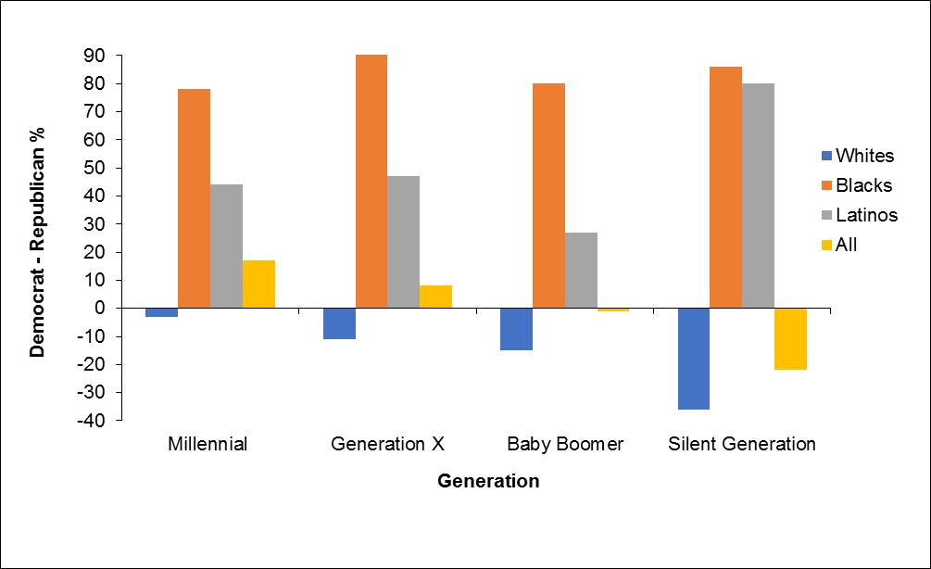________________________________________________________________________________
Source: American National Election Studies 2016

Potentially part of the reason white Millennials were less supportive of Trump than older whites was due to their more tolerant attitudes toward immigration. Trump’s anti-immigration rhetoric was also perceived to be a critical component of his success among older voters, but repelled many in the diverse Millennial generation. There was a strong relationship between the proportion of native born and support for Trump: relatively few people in the places where Trump was strong in 2016 were immigrants. White Americans’ concerns about Latinos and immigration have led to support for Trump’s less generous and punitive policies that conflict with the preferences of much of the immigrant population. The country’s growing racial diversity, therefore, is leading to a greater racial divide in politics. As whites move to the right of the political spectrum, racial minorities strongly support the left. White Millennials, however, appear to have been relatively immune to adopting conservative attitudes in response to an immigration backlash.
Another factor in white Millennials relative lack of support for Trump is the generation’s favorable attitudes toward the Obama administration. Unquestionably a critical component of Trump’s campaign message in 2016 was a deep loathing of President Obama. Trump criticism of Obama included him becoming the most prominent adherent of the so-called “birtherism” movement that claims that Obama was not born in the United States, and thus was ineligible to be president. As a result, Trump’s success has been perceived to be a political reaction to President Obama. For supporters of the Trump, as for many Americans, Obama’s election symbolized the culmination of generation change. Obama ran on an explicit platform of change, in campaign that appealed to the young and reached out to racial and ethnic minorities. For Obama’s supporters, especially Millennials, this is a matter of hope and pride. For many Trump supporters, however, the change Obama represented provoked deep anxiety.

Generational Replacement and the Changing American Electorate
Baby Boomers and the Silent Generation are distinctly to the right of the general population. In the past, older Americans have not necessarily been ideologically more conservative than their younger counterparts. Democratic candidates in the past have long relied on seniors who cherished their Social Security and Medicare. The movement of older Americans toward the Republican Party is largely a result of generational change. As the Greatest Generation—who came of age politically during the New Deal Era and was overwhelmingly Democratic—dies off, the elderly—who are now comprised of Baby Boomers and the Silent Generation—have become more Republican.
The fact that Baby Boomers were the biggest source of support for Trump flies in the face of many of the stereotypes of the generation. As Washington Post columnist Dana Milbank noted, “The idealists of the 1960s have come a long way from Woodstock. After a quarter-century of mismanaging the country, they have produced Donald Trump, who with his narcissistic and uncompromising style is a bright orange symbol of what went wrong with the massive generation.” Trump’s style and tactics—as well as his political message—thus encourages a widening of the generational gap in American politics.
On the other hand, the unpopularity of Trump among the Millennial Generation, combined with the tremendous support Obama managed to garner among Millennials has created a new overwhelmingly Democratic generation of voters. As the political power of Millennials grows in stature through generational replacement, long-term demographic trends appear to favor the Democrats. The Democrats, in fact, have probably not been in as strong of a position with young voters since at least the Lyndon Johnson administration and quite possible the Franklin Delano Roosevelt administration.
The huge generation gap that has emerged in the 2016 presidential election suggests that there is an emerging realignment of the electorate along generational lines. The long-term consequences of Trump’s generational gap distinctly favor the Democratic Party. While 19 percent of Clinton’s vote was from18-to 29-year-olds, only 10 percent of Trump’s vote came from the same demographic. If history is any guide, as younger voters mature they will vote at increasingly higher rates and they will generally maintain their original partisan loyalties. Since the vote preferences of previous generations are relatively stable this suggests a long-lasting preference of the Millennials towards the Democrats, possibly altering the partisan balance of American politics as this new generation of voters matures and becomes a larger segment of the American electorate.
The political power of the Millennial Generation will only increase as their voting turnout rates increase as they age. Even though the differences in the vote preferences vary from generation to generation, voting behavior is pretty clear cut in regard to whether or not people vote: turnout goes up dramatically as citizens get older. There is therefore a consistent generation gap when it comes to voter turnout. As Millennials age, more will become eligible to vote and those who are eligible to vote can be expected to cast ballots in increasing numbers. The potential political heft of the Millennials can be seen in Figure 8. Millennials made up 29 percent of the electorate in 2016 but this figure can be expected to go up steadily in subsequent elections.
______________________________________________________________________________
Figure 8
Eligible Voters by Generation
Source: Pew Research Center

In 2016, the number of eligible Millennial voters was almost the same as it was for Baby Boomers. Thus with generational replacement, Millennials will be the generation with the largest number of eligible voters by 2020. When you combine the Millennial Generation with Generation X, the generational changing of the American electorate can really be appreciated. Both the ranks of the Millennial and Generation X eligible voters have been growing, thanks to the aging-in of the Millennials and naturalizations among foreign-born adults. As Figure 9 displays, combined these generations now surpass Baby Boomers and prior generations as a share of the electorate.
________________________________________________________________________________
Figure 9
The Generational Change in Presidential Votes Cast
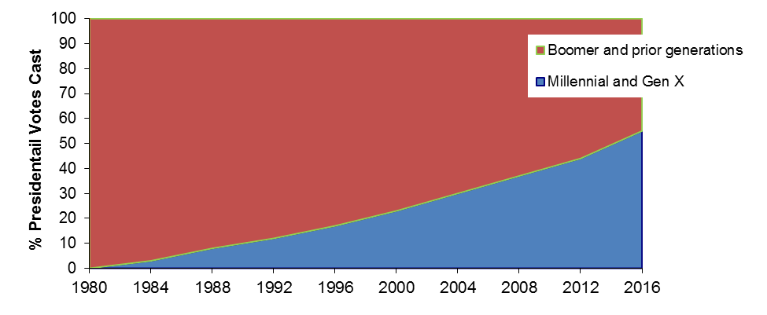
________________________________________________________________________________
Source: Pew Research Center and 2016 Exit Polls

Another trend that works in favor of the Democrats over the long-run is the increasing diversity of the American electorate. Millennials today are more ethnically diverse than other generations. Hispanics in particular make up a larger portion of Millennials than the general population as a whole. Trump’s lack of appeal to racial and ethnic minorities, therefore, may not have prevented his victory in 2016 but has the potential to considerably harm future Republican candidates as it suggests that as a more diverse Millennial Generation matures the Democrats are poised to pick up more votes.
Americans partisan identities motivate them far more powerfully than their view about issues. Although Americans may insist in the importance of values and ideologies in their vote choice, they actually care less about policy and more that their party wins. Though it is possible that Trump could help ideologically redefine the Republican Party in a way that appeals to more voters in the future, Trump’s lack of appeal among younger Americans poses considerable risk for Republicans long-term. There is the distinct possibility that Trump’s agenda may be too backward looking to win new supporters. His call to “Make America Great Again” appealed openly to nostalgia. He won in 2016 by maximizing the support in decisive states among declining segments of the electorate: older, rural, white, non-college-educated voters. In other words, Trump’s base of support was everything that the Millennial Generation is not. It is thus unlikely that his 2016 strategy—in which Trump still lost the popular vote by 2.9 million—is a sustainable path to victory for future Republican candidates.

Notes

Gabriel Almond and Sidney Verba, The Civic Culture (Boston: Little, Brown, 1965).
Ronald Inglehart, Cultural Shift in Advanced Industrial Societies (Princeton, NJ: Princeton University Press, 1990).
Patrick Fisher, “The Emerging Age Gap in U.S. Politics,” Society 45 (2008): 504-511.
? Patrick Fisher, “The Emerging Age Gap in U.S. Politics,” Society 45 (2008): 504-511.
Pew Research Center, “The Millennials: Confident. Connected. Open to Change,” February 24, 2010.
Gary C. Jacobson, “The Effects of the George W. Bush Presidency on Partisan Attitudes,” Presidential Studies Quarterly 39 (2009): 172–209.
Robert D. Putnam, Bowling Alone (New York: Simon and Schuster, 2000), 257–261.
Nate Silver, “Bush May Haunt Republicans for Generations.” www.fivethirtyeight.com May 9, 2009.
Calculated by author from the 1948-2004 American National Election Studies Cumulative Dataset and the 2008 American National Election Dataset.
Researchers at the National Opinion Research Center were most concerned with the apparent generation gap that was evident in the years 1973, 1985, and 1997, and used the General Social Survey of 3,000 adults to analyze the trend. By comparing about twenty variables such as abortion, economic conditions, and civil rights, the researchers found that the gap has fallen from an average of 19.4 percent in 1973, to 16.7 percent in 1985 and finally to 15.2 percent in 1997.
Patrick Fisher, “The Emerging Age Gap in U.S. Politics,” Society 45 (2008): 504-511.
Patrick Fisher, “The Gapology of the Obama Vote in the 2008 Democratic Presidential Primaries,” Society 48 (2011): 502–509.
Jeffrey W. Koch, “Political Cynicism and Third-Party Support in American Presidential Elections,” American Politics Research 31 (2003): 48-65.
Ron Formisano, “The Populist Tsunami of the Second Gilded Age,” The Forum 14 (2016): 281-294.
Lisa Disch, “Tea Party Movement: The American ‘Precariat’?” Representation 47 (2011): 123-135.
Neil Irwin and Josh Katz, “The Geography of Trumpism,” New York Times March 12, 2016.
John Judis and Ruy Teixeira, The Emerging Democratic Majority (New York: Scribner, 2002).
? Andrew J. Taylor, “Occupation and the Attenuation of the Relationship between Income and Party Voting,” paper presented at the 2014 Annual Meeting of the American Political Science Association, Washington, DC August 28-31.
Nate Silver, “Education, Not Income, Predicted Who Would Vote for Trump,” fivethirtyeight.com November 22, 2016.
? Nate Silver, “Education, Not Income, Predicted Who Would Vote for Trump,” fivethirtyeight.com November 22, 2016.
? Nate Silver, “Pollsters Didn’t Talk to Enough White Voters without College Degrees,” fivethrityeight.com December 1, 2016.
? Nate Silver, “Education, Not Income, Predicted Who Would Vote for Trump,” fivethirtyeight.com November 22, 2016.
Patrick Fisher, Demographic Gaps in American Political Behavior (Boulder, CO: Westview Press), chapter 6.
Adam Nagourney and Megan Thee, “Young Americans Are Leaning Left, New Poll Finds,” New York Times, June 27, 2007.
Gary Jacobson, “The Effects of the George W. Bush Presidency on Partisan Attitudes,” Presidential Studies Quarterly 39 (2009): 172–209.
Thomas E. Mann and Norman J. Ornstein, It’s even Worse Than it Looks: How the American Constitutional System Collided with the New Politics of Extremism (New York: Basic Books, 2012).
? Jonathan Knuckey, “The Survival of the Democratic Party outside the South: An Update and Reassessment,” Party Politics 21 (2015): 539-552.
Colleen J. Shogan, “Anti-Intellectualism in the Modern Presidency,” Perspectives on Politics 5 (2007): 295-303.
Zoltan Hanjal and Marisa Abrjano, “Trump’s All Too Familiar Strategy and Its Future in the GOP,” The Forum 14 (2016): 295-309.
Steve Fraser and Joshua B. Freeman, “In the Rearview Mirror: History’s Mad Hatters: The Strange Career of Tea Party Populism,” New Labor Forum 19 (2010): 75-81.
Neil Irwin and Josh Katz, “The Geography of Trumpism,” New York Times March 12, 2016.
“Trump and the Economy,” The Economist September 3, 2016.
? “Trump and the Economy,” The Economist September 3, 2016.
? Marisa Abrajano and Zoltan L. Hajnal, White Backlash: Immigration, Race, and American Politics (Princeton, NJ: Princeton University Press, 2015).
Patrick Fisher, Demographic Gaps in American Political Behavior (Boulder, CO: Westview Press), chapter 5.
Neil Irwin and Josh Katz, “The Geography of Trumpism,” New York Times March 12, 2016.
Marisa Abrajano and Zoltan L. Hajnal, White Backlash: Immigration, Race, and American Politics (Princeton, NJ: Princeton University Press, 2015).
Dana Milbank, “It’s Time to Kick the Baby Boomers out of Power,” Washington Post October 26, 2016.
? Lilliiana Mason, “Why People Vote Republican but Support Liberal Policies,” The Washington Post November 21, 2014.
John Harwood, “Why Trumpism May Not Endure,” New York Times January 21, 2017.

