Economic Performance and Presidential Vote for Obama:
The Underappreciated Influence of Race

Patrick Fisher

Department of Political Science
Seton Hall University
South Orange, NJ 07079

patrick.fisher@shu.edu

Paper Presented at the Annual Meeting of the
Western Political Science Association
Seattle, Washington
April 17-19, 2014

Abstract

National economic conditions have a considerable influence on the outcomes of presidential elections. Studies have consistently found that there is a strong relationship between annual real disposable income and the vote of the president’s party (Tufte 1978; Bartels and Zaller 2001). Based on historical economic performance models, the 2008 and 2012 presidential elections went largely the way they was supposed to, with a generic Democrat being expected to win under the country’s economic conditions in those years (as a challenger to the party controlling the White House in 2008 and as the incumbent party in 2012). On the face of it, therefore, models that predict incumbent vote share based on the country’s economic performance seemed to be as accurate as ever, giving credence to those who argue that economic performance is by far the most important fact determining a presidential candidate’s success or failure. These traditional economic performance models, however, fail to accurately account for the role of race in the 2008 and 2012 presidential campaigns. A number of studies (Piston 2010, Lewis-Beck et al. 2010, Tien et al. 2012) have found that Obama lost a sizeable number of potential votes based on his race that he may have won if he were white. In fact, if one looks at national economic conditions and the vote of only whites (as opposed to all voters), 2008 and 2012 are outliers: Obama did significantly worse among white voters than previous economic models would predict. This may simply be a consequence of Obama’s candidacy; as the first major party African-American nominee Obama a number of whites who would normally be willing to vote Democratic for president may not have done so. But this also suggests that traditional economic performance models may fail to account for the increasing importance of race as the non-white share of the electorate grows. As a result, economic performance models may be poorer predictors of presidential vote choice than they have been in the past.
Economic Performance and Presidential Vote for Obama:
The Underappreciated Influence of Race

It is widely assumed that economic conditions have a strong influence on voting behavior in democracies. In the United States, national economic conditions have been found to have a considerable influence on the outcomes of presidential elections. Voters react to the perception of whether the nation’s economy is doing well and penalize or reward the president’s party accordingly. Consequently, there is a strong relationship between the economic growth rate and the vote of the president’s party. Thus, how voters will cast their ballots can be predicted accurately based at least in part on economic conditions that are known long before Election Day.
The United States, in fact, ranks relatively high in the importance of the economy on vote choice and the economic vote is more prominent in the United States than that in most Western democracies. Outside of the United States, country-specific studies of aggregate and individual-level economic voting suggest considerably more variation. In almost no country is there anywhere near the economic voting that characterizes the United States.
The economy unquestionably played an important role in both the 2008 and 2012 presidential elections. In both elections the economy was much on voters’ minds and in 2008 economic issues helped to decide the election for Obama. Based on historical economic performance models, the 2008 and 2012 presidential elections went largely the way they was supposed to, with a generic Democrat being expected to win under the country’s economic conditions in those years (as a challenger to the party controlling the White House in 2008 and as the incumbent party in 2012).
On the face of it, therefore, models that predict presidential vote share based on the country’s economic performance seemed to be as accurate as ever, giving credence to those who argue that economic performance is by far the most important fact determining a presidential candidate’s success or failure. Obama’s vote share in both 2008 and 2012 were unremarkable in that they were extremely consistent with what would be expected from the economic conditions of previous presidential elections.
Traditional economic condition forecast models, however, fail to accurately account for the role of race. A number of studies have found that Obama lost a sizeable number of potential votes based on his race that he may have won if he were white. In fact, if one looks at national economic conditions and the vote of only whites (as opposed to all voters), 2008 and 2012 are outliers: Obama did significantly worse among white voters than previous economic conditions models would predict. Obama’s presence on the ballot in 2008 and 2012 unquestionably heightened the importance of race as a vote determinant, mitigating to some degree the importance of national economic conditions.

The Importance of Economic Conditions
Economic conditions have a substantial impact on the outcomes of presidential elections.
This is especially the case when an incumbent president is seeking reelection. When an incumbent is running retrospective economic voting is strong. When there is no incumbent, however, economic voting is prospective, not retrospective. Thus, incumbents are accorded full credit for a good economy and full blame for a bad one, but non-incumbents or successor candidates of the in-party vote are held only partially accountable for economic conditions. At the same time, the state of the economy may substantially affect how voters react to noneconomic matters. In a strong economy, the public may be more optimistic, less inclined to favor change, and more disposed to believe the best about the in-party candidates whose party has presided over good economic times.
Partisanship, however, can distort economic perception, exaggerating the real connection between vote choice and national economic perceptions. The extent of perceptions of the economy between Democrats and Republicans has increased since the 1960s. Voters are less willing to vote based on past performance but more willing to offer evaluations that, even if inaccurate, fit their partisan predispositions and vote choices. The pattern of partisan response suggests partisan differences in perceptions of the economic competence of the parties. Economic conditions, however, clearly matter for voters. Once causality concerns are taken into account, the impact of economic perceptions even emerges as larger than commonly thought.
There is of course a plethora of economic variable that can be used in forecasting models. For the sake of simplicity, we will focus on one simple measure of how well the economy is doing: the Gross Domestic Product (GDP) growth rate. The GDP growth rate provides a gauge of national economic conditions and is commonly used by political scientists as a broad measure of the economy. Political scientists such as Alan Abramowitz, who has published numerous models forecasting election outcomes, have long concentrated on GDP growth because it is “a very broad measure of the performance of the economy that correlates with a lot of other things.” Though our study will focus on GDP growth rates, it is important not to overstate our case and to stress that economic conditions are only one of the factors that influence voters’ evaluations of the incumbent president’s performance.
Abramowitz has found the GDP growth rate to be an extremely good single predictor for presidential vote choice: for every additional one percentage point of real annual GDP growth during the second quarter of an election year, the candidate of the president’s party can expect to receive an additional 0.6% of the vote. Another study found that a one percent change in annual real disposable income produces a two- to four-percentage-point increase in support for the incumbent presidential party. Interestingly, the converse is also true: the timing of elections exerts a significant influence on quarterly real GDP growth.
Figure 1
Incumbent Party Share of Vote and GDP Growth, 1972-2012
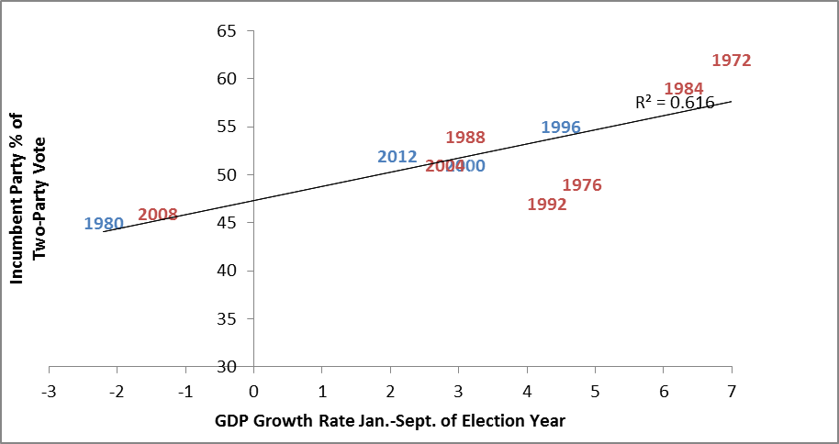
Source: Exit Polls 1972-2012 and Bureau of Economic Analysis

Starting with the presidential election of 1972—chosen because it was the first presidential election with exit poll data as well as the fact that it marks the first election in which African-Americans who were previously disenfranchised voted in large numbers due to full implementation of the Voting Rights of 1965—it is clear from Figure 1 that GDP growth in the first three quarters of a presidential election year is a good indicator of the presidential incumbent party’s share of the vote. Each year in Figure 1 represents the incumbent party’s vote share in that election, with years where a Republican was the incumbent in red and years with a Democratic incumbent in blue. Overall, this simple measure has a r-squared of .616 and no elections are obvious outliers—1992 is the principal outlier, a result of the prominent role third-party candidate Ross Perot played that year.
Based on GDP growth, 2008 and 2012 went largely as expected on economic grounds. A quick glance at Figure 1, if anything, seems to point to the accuracy of GDP growth as a simple predictor of the incumbent party’s vote share in presidential elections. From an economic perspective, the 2008 and 2012 elections appear to have gone almost exactly as they should have.
A traditional economic retrospective voting theory—voters disapprove of past economic conditions and vote against the government—serves well as an explanation for Obama’s 2008 victory. According to 2008 exit polls, those who believed that they were better off than they were four years previously voted 60 percent for McCain, while that who believed that they were worse off voted an overwhelming 71 percent for Obama. Of those that were “very worried” about the direction of the nation’s economy the next year, 60 percent voted for Obama while those that were “not too worried” voted 69 percent for McCain. As the voter’s assessment of national economic conditions in 2008 migrated from “ok” to “much worse,” the probability of an Obama vote rose as much as 43 percent, given conscious attribution of economic responsibility to the Republican incumbent. Further evidence of economic voting in 2008 can be seen with voters’ views of the importance of unemployment. Those who saw unemployment as a high priority overwhelmingly supported Obama. Those who give it a low priority, on the other hand, supported McCain by a large margin. This is consistent with the finding that higher unemployment tends to increase the vote shares of Democratic candidates.
As the incumbent president with a muddling economy in 2012, however, economic conditions worked against Obama: of the more than three-fourths of the electorate that said that the economy was either “poor” or “not so good,” he won only 38 percent of the vote. Many political pundits across the political spectrum predicted that Barack Obama’s reelection was in trouble in 2012 because of the sluggish state of the economy. After Obama won reelection, many of these same pundits argued that Obama won despite the economy because of better adds, a better “ground game,” a better candidate, or successful appeals to a racially diverse electorate. Yet, using an economic model predicting an incumbent’s share of the vote based on GDP in the first three quarters of the election year, Obama’s share of the two-party vote (a bit more than 51 percent) was almost exactly what the model predicted.
The continued strength of economic conditions as a predictor of presidential election vote share seems to contradict the commonly held belief that elections in the United States are more likely to be determined on the basis of social issues—such as the polarizing issues of abortion and gay marriage—than economic issues. It is clear, however, that economic issues continue to have a strong influence on presidential elections. At the individual level, income is an important predictor of how Americans vote, as it has been for decades. Political divisions on the basis of income are a consequence of the Republican and Democratic parties differing sharply in their concern for class issues. High-income voters’ tendency to identify with and vote with the Republican Party relative to low-income Americans, who disproportionately support the Democrats, is an aftereffect of the different fiscal policies favored by the parties. Though this has been the case since the Great Depression, as the parties have become more differentiated in economic policies they have cued the voters to vote more on the basis of income. The parties are now ideologically further apart on economic issues than they have been at any time since World War I. That the United States has smaller class divisions than might be expected is partly due to the individualistic nature of American political culture. Relatively speaking, the less affluent are not negative about their situation in the American economy.
An ironic feature of the income gap in the United States is the difference between individual and aggregate behavior. At the individual level the more income one makes the more likely he or she is to vote Republican. But this is not the case at the aggregate level: it is the Democrats who do better in wealthier states. Blue states have higher average incomes than red states. This does not mean however that wealthier people are more Democratic. Democrats win the rich states, but rich people tend to vote more Republican. While the rich states have become more strongly Democratic over time, rich voters have remained consistently more Republican than voters on the lower end of the income scale.
In low-income states such as those in the South, richer people are significantly more likely to vote Republican. In richer states, however, income is not as strong of a predictor of individual votes. Within any state, Republican support increases with income; at the same time, the Democrats do better in richer states. This is due in part to the fact that wealthy people in wealthy states are socially and economically more liberal than rich people in poor states. In poor states, rich people are very different from poor people in their political preferences. The cultural differences among the states are a result of the differences among the richer people in these states. Being in a red or blue state, therefore, matters more for rich than for rich than poor voters. As a result, economic issues are more salient in poorer states. Conversely, in richer states, voters are more likely to follow noneconomic cues. Thus, contrary to public perception, it is richer Americans in richer parts of the country that are most likely to vote based on cultural issues. Culture and religion are in fact more important predictors of vote choice among the rich than the poor. The country is thus polarized in two ways: economically between the rich and poor, and culturally between upper-income Americans in red and blue areas.

The Importance of Race
Despite the accuracy in the past of traditional economic conditions models, important dynamics of vote choice may be hidden in such a simplistic approach to election forecasting. In fact, many election forecasts include other factors than economic measures, including presidential approval ratings, wartime deaths, and the length of time a party has controlled the White House. What even the most sophisticated models tend to underestimate, however, is the role of race.
Among whites, economic status has become more important in structuring presidential voting behavior over the past half-century: the gap in Democratic support between upper-income whites and lower-income whites has increased since the 1950s. White voters in the bottom third of the income distribution have become more loyal in their support of Democratic presidential candidates over the past half-century while those in the higher third have become more likely to support Republicans. This suggests that while Democratic presidential candidates have lost support among white voters over the past half-century, those losses have been concentrated among relatively affluent white voters. While the erosion of Democratic identification among low-income whites is entirely concentrated in the South, the growing disparity in Democratic attachments between lower-income whites and higher-income whites appears in both the South and in the rest of the country.
If one looks just at white voters, the relationship between incumbent party share of the vote and GDP growth from 1972-2004 closely resembles the relationship among all voters (see Figure 2). The relationship is a bit weaker (an r-squared of .519 as opposed to .616) but certainly not anything that would suggest that economic growth is a not major factor in vote choice for white voters. Other than 2000, when Al Gore did notably worse among white voters than would be projected by the model on the basis of election year GDP growth, there are no obvious outliers.
Figure 2
Incumbent Party Share of White Vote and GDP Growth, 1972-2004
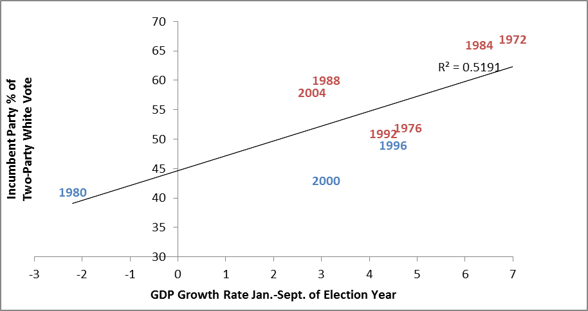
Source: Exit Polls 1972-2012; Bureau of Economic Analysis

Once one adds the 2008 and 2012 elections to the model, however, the picture changes markedly (see Figure 3). With Obama as the Democratic nominee for president, economic growth is a much poorer predictor of the vote for president among whites. For 2012 the model estimates that Obama should have won about half of the two-party white vote; instead he won only two-fifths. This was similar to the relationship in 2008, where Obama won 45 percent of the white vote when the model predicted at 55 percent vote share.

Figure 3
Incumbent Party Share of White Vote and GDP Growth, 1972-2012
Source: Exit Polls 1972-2012; Bureau of Economic Analysis

Thus, the white vote for president in both 2008 and 2012 was notably less than what would have been historically expected given the state of the economy. To put it in perspective, in 1980, when the Democrat Jimmy Carter was running for reelection he won about the same percentage of the white vote that Obama did running for reelection even though the election year GDP in 1980 was -2.2% and in 2.1 it was 2.1%. The white vote, in fact, has been remarkably consistent in recent years regardless of the state of the economy. Despite considerable variations in the state of the economy in election years, Obama’s deficit among white voters was remarkably similar to other recent Democratic presidential nominees: in every presidential election since 1988 Democrats have consistently won between 39 percent (Obama in 2012) to 44 percent (Clinton in 1996) of the overall white vote.
Obama, therefore, was able to win the presidency twice because of the huge margins he won among nonwhites despite the fact that he did even worse among whites than economic growth would suggest a generic Democrat would in 2008 and 2012. The strong racial component of the presidential vote certainly predates Obama. The race gap in the 2008 and 2012 presidential elections fit the pattern since the Civil Rights Movement: the Democrat presidential nominee overwhelmingly won the black vote while also winning the Hispanic vote, and the Republican presidential nominee won a majority of the white vote. The minority vote was thus obviously critical to both of Obama’s victories: minority voters made the difference in Obama’s victory margin in nine states in 2008 and fourteen states in 2012, including Florida, Ohio, and Pennsylvania both years.
Figure 4
White Vote for Obama in 2008 and African-American Percentage by State
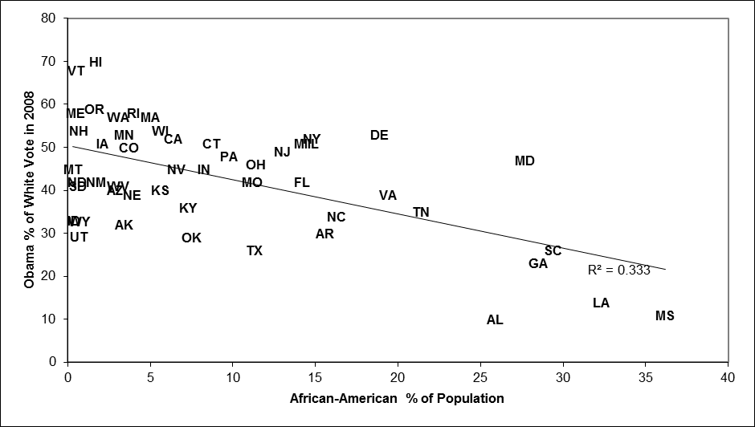
Source: 2008 National Election Pool exit polls and 2000 U.S. Census

Barack Obama particularly lagged among white voters in the Deep South. In 2008 (there were not exit polls taken in all 50 states in 2012) there was a very strong relationship between the percentage of the vote that Obama received among white voters in a state and the percentage of whites in the overall population (see Figure 4). Simply put, the larger the African-American population in a state, the stronger the white vote tended to vote against Obama. This simple measure, in fact, has a slightly stronger correlation for white share of the presidential vote than does GDP growth in an election.
In 2008, of the six states where African-Americans consisted of more than one-fourth of the population, Obama won 26 percent or less of the white vote in five (the exception being Maryland, where Obama won 47 percent of the white vote). On the other hand, in the two states—Maine and Vermont—where whites made up 95 percent or more of the population, Obama easily carried the white vote. There is no denying that racial attitudes still have a significant influence on Americans’ behavior at the ballot box. Racial prejudice was strongly related to the state-level nonblack vote in the 2008 presidential election. In fact, the influence of racial attitudes on voting was on par with the influence of partisanship and ideology. Prejudice does not have a pervasive influence on political behavior and opinion; rather, the effect appears to have been triggered by Barack Obama on the ballot.
The importance of race vis-à-vis economic growth in 2008 appears to be even more pronounced when comparing state African-American proportion of the population to state economic growth in the two years leading up to the election. None of the economic problems that shadowed the 2008 presidential election were distributed evenly throughout the nation. Some places fared poorly while others were comparatively untouched. For example, the nation’s housing crisis was not geographically uniform because the rapid rise of housing prices was uneven. Also, the national jobless rate reached a much higher level than the national average in some locales. A retrospective model for vote choice would hold that states with a more dramatic downturn in the economy would be more likely to vote against the incumbent party while states that weathered the recession relatively well would be less willing to abandon the incumbent. This relationship, however, adamantly did not exist in 2008 (see Figure 5). There was virtually no relationship at all between Obama’s share of the white vote in a state and the state’s GDP growth rate for 2007 and 2008. For white voters at least, the retrospective model finds no support in Obama’s initial election.

Figure 5
White Vote for Obama in 2008 and State GDP Growth Rate 2007-2008
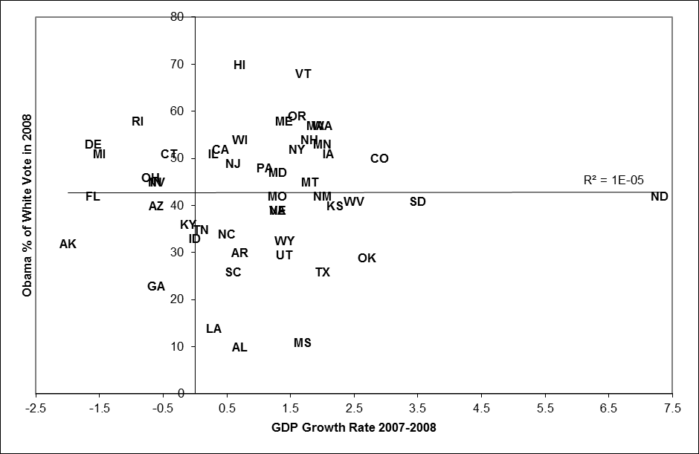
Source: 2008 National Election Pool exit polls; Bureau of Economic Analysis

Obama’s poor showing among whites in the South—regardless of the state’s economic growth rate—has deep historical roots. The divisions of the Civil War are still remarkably evident in Obama’s elections. In every state that was part of the Confederacy, the Republican presidential nominee in 2008 and 2012 won a larger share of the white vote than he did nationwide. On the other hand, in 2008 Obama won every state that Lincoln carried in 1860 and all but one (Indiana) in 2012. Obama’s share of the white vote in a state in his initial election, in fact, is strongly correlated with Abraham Lincoln’s share of the state vote in 1860 (see Figure 6). States where Lincoln did well in 1860 were states where nearly a century and a half later that Obama tended to win relatively easily, while states where Lincoln did poorly (he was not even on the ballot in most of the South, thus he received no votes in many states) were states where Obama generally fared poorly. The cultural divides of the Civil War on racial grounds can thus still be considered to be influencing American political culture a century and a half later. The strength of the relationship between Lincoln’s and Obama’s vote can be demonstrated by the fact that Lincoln’s best state in 1860 was Vermont, which so happened to be Obama’s best state in the contiguous United States.
Figure 6
Obama White Vote in 2008 and Lincoln’s Vote in 1860 by State
Source: 2008 National Election Pool exit polls and David Leip’s Atlas of U.S. Presidential Elections.
Given the fact that Barack Obama was attempting to become the first African-American elected president, race was perceived by many to be a significant factor in the 2008 campaign. Yet, of those who voted, 80 percent said that race was not a factor at in their vote, while only two percent said that race was the single most important factor. Of those who said that race was the single most important factor, Obama won 58 percent of the vote, while he won 51 percent of the vote of those who said that race was not a factor at all. White voters who acknowledged that race was important voted by McCain by a two-to-one margin, meaning that one-third of white voters who said Obama’s race was the single most important factor actually voted for Obama.
Those who voted for Obama were much more optimistic about the future of race relations in the country. According to exit polls, of the nearly one-half of the voters who thought that race relations would get better in the next few years, 70 percent voted for Obama. Of the one in six voters that thought that race relations would get worse in the next few years, on the other hand, 70 percent voted for McCain.
Yet, there is evidence to suggest that negative stereotypes about blacks significantly eroded white support for Barack Obama. Racial stereotypes did not predict support for previous Democratic presidential candidates or other prominent Democrats, indicating that white voters punished Obama for his race rather than his party affiliation. Interestingly, prejudice had a particularly large impact on the voting decisions of Independents and a substantial impact on Democrats, but very little influence on Republicans. Racial prejudice was especially a factor in limiting support for Barack Obama among white voters in the South and Border States.
Thus, despite the fact Obama ended up winning the votes of enough whites to win in 2008 and 2012, it is possible that race prevented Obama from winning a landslide victory. In a racially blind society, Obama may have won by a considerably larger margin. White vote support for the Democratic presidential candidate barely increased from 2004 to 2008 even in the face of economic and political woe without precedent in the post-World War II period. Those who believed that blacks are worse off because of the continuing effects of racism were more likely to have voted for Obama, thus offsetting those who voted against him because he was perceived as favoring African-Americans. The negative interaction effect of the economic vote received, however, is not balanced by a positive one. That is, those who were more sympathetic toward blacks were no more likely to convert their economic discontent into an Obama vote. Thus, racial esteem in 2008 did not cancel out racial prejudice. Similarly, it appears that race may have also cost Obama in his reelection bid in 2012: one study found that Obama lost more than three percent of the vote from racially intolerant voters who otherwise would be expected to support him.

The Non-White Vote: Overwhelming Democratic
African-Americans’ distinctive voting behavior is a consequence of their sharing of a unique political culture within the United States. The development and continuing strength of uniquely black institutions is an important reason for black political distinctiveness. Many African-Americans receive politically relevant information from indigenous black media and churches. African-Americans are a very cohesive group, with extremely high levels of identification. So strong, in fact, that sometimes it becomes difficult using survey research to track differences in black public opinion. African-Americans whose individual economic interests might be better served by the Republican Party continue to support the Democratic Party because they prioritize group needs over their individual self-interest.
African-American support for Democrats, however, is more than merely symbolic: it is unquestionably also issue-based. The Democratic Party is perceived by many as the pro-minority party while the Republican Party is alleged to be less helpful to minorities. For more than a half-century after the Civil War, blacks who were allowed to participate in politics overwhelmingly supported the Republican Party, the anti-slavery party of Abraham Lincoln. Blacks did not begin supporting Democratic candidates in large numbers until they began doing so in support of the economic policies of Franklin Roosevelt’s New Deal. As late as 1960 Richard Nixon received over one-fifth of the African-American vote. This changed in 1964 when 94 percent of African-Americans voted for Lyndon Johnson in his landslide victory over Barry Goldwater, the Republican presidential nominee who ran on a states’ rights anti-Civil Rights platform. Ever since, the African-American vote has been overwhelmingly Democratic, becoming even more Democratic in 2008 and 2012 as they supported Barack Obama in record numbers.
On economic issues in particular, there is a strong relationship between race and policy preferences. African-Americans and Latinos tend to be to the political left of whites on economic issues, sometimes substantially so. Whites are therefore consistently more conservative on economic issues than blacks and Hispanics on government spending and there is no evidence of significant changes in mass opinion of whites since the 1980s. The relative conservatism of whites is derived in part from the perception that they are less likely to benefit from an increase in government services. On government services, health care, aid to the poor, and Social Security privatization, African-Americans are significantly more liberal than whites.
In contrast to other major social groups in the country, however, partisanship for African-Americans remains rooted in group identity rather than ideology. Many African-Americans, however, undoubtedly are attracted to the Democratic Party because blacks as a group are disproportionately of lower socioeconomic status. Many race-related issues—affirmative action, welfare, Medicaid, subsidized housing, etc.—are now perceived to be questions of redistribution, not overtly race. The overwhelming African-American identification with the Democrats, however, outweighs the effects arising from the changes in the income distribution of blacks.
Hispanics, though historically strong supporters of Democratic candidates, are not as overwhelmingly Democratic as African-Americans. In the 2004, for example, George W. Bush received more than two-fifths of the vote among Hispanics in his reelection bid, the largest ever recorded by a Republican presidential candidate. The 2004 presidential election suggested that the Republicans may have possibly turned the corner in making gains in the Hispanic vote. The 2008 elections, however, dispelled this belief as Obama won the Hispanic vote by a two-to-one margin, a margin he actually improved upon in 2012. Obama won eight of the ten states with the highest proportion of Hispanics in 2008 and 2012 (losing only Texas and Arizona). Hispanic voters shifted in significant numbers away from the Republicans to vote for Barack Obama. His ability in 2008 and 2012 to win Colorado, Nevada, and New Mexico—states that all voted for Bush in 2004—was largely due to his strong support among Latinos in these states. Maybe Obama’s most impressive gains among Hispanics, however, took place in Florida. Obama did very well for a Democrat among Hispanic voters in Florida, where he was the first Democratic presidential nominee to carry the Hispanic vote since exit polls have been conducted in the state. South Florida’s large Cuban-American population has remained Republican-leaning and due to the slow process of immigrant political incorporation they are expected to remain so in the foreseeable future. Obama strength among Latinos in Florida was mainly a result of a growing group of Puerto Rican voters in Central Florida who tend to be strongly Democratic-leaning.
The White Vote: Republican but Shrinking
White Americans, on the other hand, are consistently less likely to support Democratic candidates than African-Americans and Hispanics and have moved toward the Republican Party since the 1960s. The last Democratic presidential nominee to have won a majority of the white vote was Lyndon Johnson in 1964. The movement among whites away from the Democrats began in the 1960s as the Democratic Party came to be identified with the civil rights movement. This was especially true in the South. As late as 1960, native-born southern whites were more Democratic in their partisan affiliations than were blacks. By 1968, however, this had thoroughly been reversed.
A critical component of the race gap in the United States is that the race gap is not uniform across the country (as Figure 4 demonstrated earlier). Outside of the South, Democrats are generally competitive among white voters. In the South, however, the Democratic share of the white vote has steadily become smaller and smaller as the Democratic Party has experienced a major loss in support among white voters in the South since the 1960s. The catalyst of the movement of southern whites toward the Republican Party were race issues, as southern whites strongly opposed the national Democratic Party’s pro-civil rights agenda.
Race issues have long been regarded as being important in shaping white political attitudes in the South. Racism, therefore, could be a major influence on the behavior of whites in the South, especially lower-income whites. At the same time, however, class divisions are a steadily increasing source of political disagreement in the region as affluent whites in the South have become increasingly supportive of the Republican Party because they find its positions more compatible with their interests. This suggests that race issues have not suppressed class divisions by pulling lower income whites away from the Democratic Party. Yet, the class division argument is unquestionably limited as an explanation for southern political exceptionalism. The problem with the class division argument as an explanation for the Republican Party’s dominance in the South is that overall the South is much poorer than the rest of the country and poor whites in the South are much more likely to vote Republican than poor whites elsewhere in the country.
The impact of a person’s ideology on vote choice grew in magnitude from the 1970s to the 1990s, but these changes were not felt uniformly throughout the electorate, as southern whites exhibited the greatest changes. In the case of southern white males, racial issues now appear to be related to their party identification. The racial divide in some parts of the South is now so great that the Republican Party has come to be viewed as the white political party and the Democratic Party as the black political party. This was the ultimate goal of Richard Nixon’s so-called “Southern Strategy” and it would be difficult to argue for the four decades after this strategy was implemented in Nixon’s 1968 presidential run that it was not an overwhelming success for the Republican Party, at least at the presidential level. As African-Americans have become overwhelmingly Democratic since the Civil Rights Movement, Republicans have more than held their ground as whites have become more Republican.
The potential problem for the Republican Party is even though they continue to do well among white voters, as the demographics of the country changes the Southern Strategy may no longer be viable. The U.S. electorate has become significantly less white over the years and is projected to become notably less white in the future. In particular, the Hispanic vote has become much more politically important with the rapid growth of the Hispanic population in the United States. In the two decades from 1990-2010, the Hispanic population more than doubled from 22 million to 50 million. Hispanics are by far the fastest growing segment of the American population. While Latinos today comprise less than one-tenth of Americans aged 65 and older, they are almost a quarter of Americans under the age of five. Approximately 12 million Hispanics went to the polls in 2012, an increase of more than 25 percent from 2004. The geographic concentration of Latino voters, particularly in swing-states such as Colorado, Nevada, New Mexico, and Florida, substantially increases the likelihood that Hispanic voters will have a significant impact in determining presidential elections.
Figure 7 displays the Republican share of the white vote for president and the white share of the electorate. As the white share of the electorate has shrunk from 90 percent in 1972 to 72 percent in 2012, the Republican share of the white vote for president has over the long haul not changed much. If anything, 2012 really highlights the problem for Republicans as the white share of the electorate decreases: in 2012 Obama won a lower share of the two-party white vote for president than any other victorious Democrat in history. As the Republicans continue to lose the votes of non-whites by large margins, the critical question for the Republicans then becomes what exactly is the floor for the Democratic white vote? Obama did worse in 2012 among white voters than any Democratic presidential candidate other than George McGovern in 1972 and Walter Mondale in 1984, both who only won one state in their respective elections. It would be impossible to have such a landslide victory for a Republican today unless the candidate did significantly better among non-whites than recent Republican presidential candidates. The math just does not work for the Republicans: as the white share of the electorate decreases and they continue to do poorly among non-whites, the only route to victory is to win the white share of the vote by increasingly larger margins. Unless the Republicans can do significantly better among minority voters, therefore, there pathway to victory will become increasingly narrow.

Figure 7
Republican Share of White Vote for President and White Share of Electorate, 1972-2012
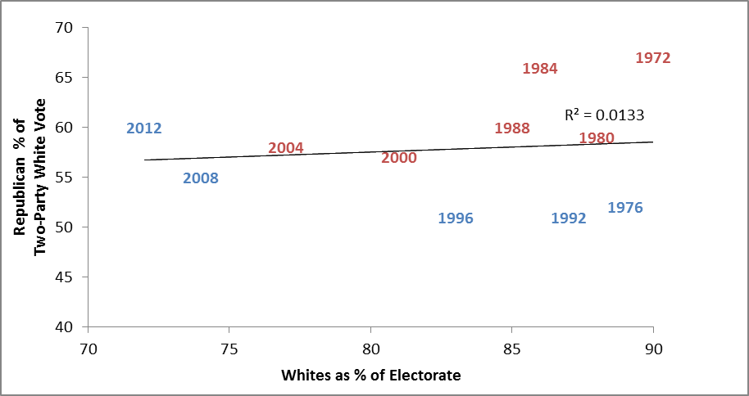
Source: Exit Polls 1972-2012

Conclusion
In 2008 and 2012 economic models predicting presidential vote share only seemed to be relatively accurate because of Obama’s overwhelming support by non-white voters. If one looks at election year GDP growth rate and the vote among white voters, economic predictors fair considerably worse than they do for the electorate as a whole. Race trumps economic factors as an indicator of presidential vote preferences. This is not to say that economic models predicting presidential vote share have no utility; rather, their utility is limited by the magnitude of race.
This begs the question of whether or not the 2008 and 2012 elections were a fluke because of Obama’s presence on the ballot. Though race appeared to be slowly declining in its importance from 1980-2004, Obama’s presence on the ballot was a catalyst to making race an extremely strong predictor of one’s vote: of all the gaps in 2008 and 2012, race had by far the strongest correlation with presidential vote choice. Thus, despite all of the talk of Obama’s victory representing a new post-racial era in the United States, race was as important as ever.
The fact that traditional economic condition models were relatively poor predictors of the white vote in 2008 and 2012 may simply be a consequence of Obama’s candidacy: as the first major party African-American nominee Obama failed to garner the votes of a number of whites who would normally be willing to vote Democratic for president. It remains to be seen whether or not this is simply an “Obama Effect” or is a long-term trend. But this also suggests that traditional economic performance models may fail to account for the increasing importance of race as the non-white share of the electorate grows. As a result, economic performance models in the future may be poorer predictors of presidential vote choice than they have been in the past. If the importance of race continues in future elections without Obama on the ballot national economic conditions may become less important in presidential vote choice as the electorate becomes more racially diverse.

As the United States becomes less white as a nation, the changing demographics of the electorate inevitably will affect future elections. Obama’s victories in 2008 and 2012 were due in part to the gradual transformation of the electorate over the past two decades. In 2012, whites accounted for 72 percent of the overall electorate, a 13 point drop from 1988. Obama’s overwhelming support of nonwhites was thus crucial to both of his victories. If the racial composition of the electorate had been the same in 2008 and 2012 as it been in 1988, McCain and Romney would have defeated Obama. Yet in 2012, despite losing to Romney among whites by more than 17 million votes, Obama won the election by carrying nonwhites by more than 20 million votes.
Of particular importance in the changing demographics of the American electorate is the increasing number of Hispanic voters. Obama’s ability to win so many nonwhite votes is in a large part due to the growing numbers of Hispanics in the electorate. As recently as the first election of Bill Clinton as president in 1992 Hispanics only made up two percent of the electorate, far smaller than their ten percent share of the electorate in 2012. The changing demographics of the American electorate pose a dilemma for the Republican Party. Nearly 90 percent of McCain’s and Romney’s total vote came from whites. Obama’s electoral coalition, on the other hand, was much more diverse: in 2012 56 percent of his supporters were white, nearly one-quarter black, and about one-sixth Hispanic.
It is important to stress, however, that the increasing diversity of the American population is not simply a reflection of immigration from Latin America. The number of Americans who identify as Asian and as multiracial has also been steadily increasing and both of these groups have become solidly Democratic constituencies. Asian-Americans gave Obama 62 percent of their vote in 2008, a figured that increased to 73 percent in 2012. Those who identify themselves as multiracial tend to develop political opinions that parallel with their minority counterparts. Multiracial Americans consistently adopt political attitudes that reveal they are more aware of a racialized experience than their monoracial counterparts. As a result, multiracial Americans have become strongly Democratic in their vote preferences. This will be important has the multiracial proportion of the American population increases.
The Republican Party potentially faces electoral peril unless they do a better job in the future of winning the votes of minorities. Increasing the Republican share of the nonwhite vote, however, will probably require the party to move closer to the ideological center on issues such as government services, health care, and immigration. Such a shift would certainly arouse intense opposition from conservative activists. In fact, led by Tea Party activists, the Republican Party appears to be moving in the opposite direction. Tea Party supporters have been found to exert a strong authoritarian pulse and Tea Party members’ judgments about aid to the poor are influenced considerably by racial attitudes. Racial resentment stokes Tea Party fears about generational societal change, and fuels the Tea Party’s strong opposition to Obama. Many Tea Partiers are deeply concerned that the country they live in is not the country of their youth and that they themselves are no longer represented by the U.S. government. Republican leaders therefore will inevitably face a difficult choice between reaching out to nonwhite voters or continuing to cater to their party’s shrinking base.
The only way Republicans can continue to be competitive without increasing their vote totals among nonwhites is to win the votes of whites by even greater margins. This, however, is probably not a viable strategy as younger whites are more willing to support Democratic candidates than older whites. If the Republicans continue to fail to make inroads in winning the votes of nonwhites as younger whites become increasingly Democratic in their vote preferences, the Republicans are indeed in trouble.

Endnotes

Alan I. Abramowitz, “Forecasting the 2008 Presidential Election with the Time-for-Change Model,” PS: Political Science and Politics 41 (2008): 691-695.
Edward R. Tufte, Political Control of the Economy (Princeton, NJ: Princeton University Press, 1978) and Larry M. Bartels and John Zaller, “Presidential Vote Models: A Recount,” Political Science and Politics 34 (2001): 9-19.
Racy C. Fair, “The Effect of Economic Events on Votes for President.,” Review of Economic Events on Votes for President 60 (1978): 159-172; Michael S. Lewis-Beck add Tom W. Rice, Forecasting Elections (Washington, DC: Congressional Quarterly Press, 1992; Christopher Wlezien and Robert S. Erickson, “Temporal Horizons and Presidential Election Forecasts,” American Politics Quarterly 24 (1996): 492-505; Douglas A. Hibbs, “Bread and Peace Voting in U.S. Presidential Elections,” Public Choice 104 (2000): 149-180.
Raymond M. Duch and Randolph T. Stevenson, The Economic Vote (New York: Cambridge University Press, 2008).
Spencer Piston, “How Explicit Racial Prejudice Hurt Obama in the 2008 Election,” Political Behavior 32 (2010): 431-451; Michael S. Lewis-Beck, Charles Tien, and Richard Nadeau, “Obama’s Missed Landslide: A Racial Cost?” PS: Political Science and Politics 43 (2010): 69-76; Charles Tien, Richard Nadeau, and Michael S. Lewis-Beck, “Obama and 2012: Still a Racial Cost to Pay?” PS: Political Science and Politics 45 (2012): 591-595.
Richard Nadeau and Michael S. Lewis-Beck, “National Economic Voting in U.S. Elections,” The Journal of Politics 63 (2001): 159-181.
James Campbell, The American Campaign (College Station: Texas A&M Press, 2008), chapter 6.
Ibid., pp. 138-140.
Michael Lewis-Beck, Richard Nadeau, and Angelo Elias, “Economics, Party, and the Vote: Causality Issues and Panel Data,” American Journal of Political Science 52 (2008): 84-95.
Mike Dorning, “Obama Holds Slim Re-Election Edge with Slow GDP Growth,” Bloomberg Businessweek July 27, 2012.
Alan I. Abramowitz, “Forecasting the 2008 Presidential Election with the Time-for-Change Model,” PS: Political Science and Politics 41 (2008): 691-695.
Ibid.
Edward R. Tufte, Political Control of the Economy (Princeton, NJ: Princeton University Press, 1978) and Larry M. Bartels and John Zaller, “Presidential Vote Models: A Recount,” Political Science and Politics 34 (2001): 9-19.
Kevin Grier, “US Presidential Elections and Real GDP Growth,” Public Choice 135 (2008): 337-352.
? Michael S. Lewis-Beck and Richard Nadeau, “Obama and the Economy in 2008,” PS: Political Science and Politics 42 (2009): 479-483.
John R. Wright, “Unemployment and the Democratic Electoral Advantage,” American Political Science Review 106 (2012): 685-702.
For example, the American Enterprise Institute’s Michael Barone in a National Review post on November 5, 2012 predicted that Mitt Romney would prevail with 315 Electoral College votes because of the “very sluggish economic recovery.”
Patrick Egan in Joshua Tucker’s “More Evidence that Obama’s Victory Reflects the Economic Fundamentals,” The Monkey Cage (www.themonkeycage.org) November 8, 2012.
Jeffrey M. Stonecash, “The Income Gap,” PS: Political Science and Politics 39 (2006): 461-465.
John W. Burns and Andrew J. Taylor, “A New Democrat?: The Economic Performance of the Clinton Presidency,” The Independent Review 5 (2001): 387-408.
Keith T. Poole and Howard Rosenthal, Congress: A Political-Economic History of Roll Call Voting (New York: Oxford University Press, 1997).
Mark D. Brewer and Jeffrey M. Stonecash, Split: Class and Cultural Divides in American Politics (Washington: CQ Press, 2007), chapter 4.
Andrew Gelman, Red State, Blue State, Rich State, Poor State (Princeton, NJ: Princeton University Press, 2008).
Ibid.
Larry Bartels, Unequal Democracy (New York: Russell Sage, 2008), chapter 3.
Benjamin Highton, “Prejudice Rivals Partisanship and Ideology When Explaining the 2008 Presidential Vote across the States,” PS: Political Science and Politics 44 (2011): 530-535.
Chuck Todd and Sheldon Gawiser, How Barack Obama Won (New York: Vintage House, 2009), p. 41.
? Spencer Piston, “How Explicit Racial Prejudice Hurt Obama in the 2008 Election,” Political Behavior 32 (2010): 431-451.
Alan I. Abramowitz, The Disappearing Center (New Haven: Yale University, 2010), p. 116.
Michael S. Lewis-Beck, Charles Tien, and Richard Nadeau, “Obama’s Missed Landslide: A Racial Cost?” PS: Political Science and Politics 43 (2010): 69-76.
Charles Tien, Richard Nadeau, and Michael S. Lewis-Beck, “Obama and 2012: Still a Racial Cost to Pay?” PS: Political Science and Politics 45 (2012): 591-595.
? Hanes Walton and Robert Smith, American Politics and African American Quest for Universal Freedom (New York: Pearson Longman, 2006).
Michael S. Lewis-Beck, William G. Jacoby, Helmut Norpoth, and Herbert F. Weisberg, The American Voter Revisited (Ann Arbor: University of Michigan Press, 2008), pp. 322-323.
Donald Kinder and Lynn Sanders, Divided by Color: Racial Politics and Democratic Ideals (Chicago: University of Chicago Press, 1996).
Hanes Walton and Robert Smith, American Politics and African American Quest for Universal Freedom (New York: Pearson Longman, 2006), p. 126.
Larry Bartels, Unequal Democracy (New York: Russell Sage, 2008), chapter 3.
Patrick Fisher, Demographic Divides in American Political Behavior (Boulder, CO: Westview, 2014).
Nolan McCarty, Keith T. Poole, and Howard Rosenthal, Polarized America (Cambridge, MA: MIT Press), p. 90.
Benjamin G. Bishin and Casey A. Klofstad, “The Political Incorporation of Cuban Americans: Why Won’t Little Havana Turn Blue?” Political Research Quarterly 65 (2012): 586-599.
Donald Kinder and Lynn Sanders, Divided by Color: Racial Politics and Democratic Ideals (Chicago: University of Chicago Press, 1996), pp. 217-218.
Alan Abramowitz and H. Gibbs Knotts, “Ideological Realignment in the American Electorate: A Comparison of Northern and Southern White Voters in the Pre-Reagan, Reagan, and Post-Reagan Eras,” Politics and Policy 34 (2006): 94-108.
Mark D. Brewer and Jeffrey M. Stonecash, “Class, Race Issues, and Declining White Support for the Democratic Party in the South,” Political Behavior 23 (2001): 131-155.
William D. Schreckhise and Todd G. Shields, “Ideological Realignment in the Contemporary U.S. Electorate Revisited,” Social Science Quarterly 84 (2003): 596-612.
Alan I. Abramowitz, The Disappearing Center (New Haven: Yale University, 2010), p. 73.
Alan I. Abramowitz, “Beyond 2010: Demographic Change and the Future of the Republican Party” www.centerforpolitics.org March 11, 2010.
Matt Barreto et al., “Should They Dance with the One Who Brung ‘Em? Latinos and the 2008 Presidential Election,” PS: Political Science and Politics 41 (2008): 753-760.
Patrick Fisher, Demographic Divides in American Political Behavior (Boulder, CO: Westview, 2014).
? Natalie Masuoka, “Political Attitudes and Ideologies of Multiracial Americans,” Political Research Quarterly 61 (2008): 253-267.
Kevin Arceneaux and Stephen P. Nicholson, “Who Wants to Have a Tea Party? The Who, What, and Why of the Tea Party Movement,” PS: Political Science and Politics 45 (2012): 700-710.
Vanessa Williamson, Theda Skocpol, and John Coggin, “The Tea Party and the Remaking of Republican Conservatism,” Perspectives on Politics 9 (2011): 25-43.
Alan I. Abramowitz, “Beyond 2010: Demographic Change and the Future of the Republican Party,” Center for Politics www.centerforpolitics.org March 11, 2010.
Patrick Fisher, “The Emerging Age Gap in U.S. Politics,” Society 45 (2008): 504-511.

