The 2014 Texas Gubernatorial Election and Making Texas a Battleground State

Presented by:
Brian W. Smith
St. Edwards University

Thomas J. Beech
Bemidji State University

Presented at the Annual Meeting of the Western Political Science Association
Las Vegas, NV
April 2015
Abstract

For the better part of a generation, Texas has voted Republican at the state and national levels. It last elected a Democratic governor in 1990 (Ann Richards), a Democratic Senator in 1988 (Lloyd Bentsen), and gave its electoral votes to a Democratic Presidential candidate in 1976. At the state district level, the Republicans have controlled the Texas Senate since 1996, the Texas House since 2002, and have controlled all state wide elected offices since 1998.

In the 2014 gubernatorial election, State Senator Wendy Davis attempted to reverse this Republican trend and provided the Democrats with optimism after she attracted national attention during her 2013 filibuster on reproductive rights. On Election Day, however, Davis fared worse than 2010 Democratic nominee Bill White.

We begin our analysis by providing a brief history why the Democratic Party became the minority party in one generation. Next, using multivariate analysis of the previous three gubernatorial elections (2002, 2006, 2010), we examine voting in statewide elections to examine why this emerging group has not yet been able to turn the state Blue. We conclude by examining the 2014 governor’s race to understand the demographic, attitudinal, and behavioral factors that influenced vote choice. We conclude by speculating on the implications of this election and why Davis fared no better than previous Democratic challengers did.

For the last generation, Texas has been among the most reliable of “red states.” Since the election of Jimmy Carter in 1976, no Republican has failed to carry the state. It last elected a Democratic governor in 1990 (Ann Richards), and a Democratic Senator in 1988 (Lloyd Bentsen). At the state level, Republicans have controlled the Texas Senate since 1996, the Texas House since 2002, and have held all state wide elected offices since 1998.
Given its population, the state is especially important to the Republican Party. Of the 11 most populous states, which, taken together, have enough electoral votes to elect a President, only Texas and Georgia have gone Republican in each of the last two Presidential elections. Conversely, large states such as California, New York, Illinois, and Pennsylvania, have seen pluralities for the Democratic candidate in each of the last six Presidential elections. This “blue wall” gives the Democratic presidential nominees an Electoral College advantage in each election. Were the Democratic Party to make enough headway to turn Texas blue, it would present an almost insurmountable obstacle to future Republican presidential candidates.
We begin, by describing how the Democratic Party became the minority party in Texas. Next, we develop a model to examine the potential success of the effort to “turn Texas blue” by examining the three gubernatorial elections prior to 2014. In each of these elections, Rick Perry was seen as a vulnerable candidate, yet he prevailed on each occasion. We conclude by analyzing the 2014 gubernatorial election featuring Democrat State Senator Wendy Davis, and Republican Attorney General Greg Abbott. This election attracted national attention from both parties, with the Democrats optimistic that this could form a solid building block for future electoral efforts in the state. This included the formation of a political entity called Battleground Texas, founded by Jeremy Bird, who served as the National field Director of President Obama’s 2012 campaign. Yet, Abbott defeated Davis by 20 points and turnout was actually down from 2010. We will examine these results to see how the Democrat’s objectives were not met as well as examine if they provide a bellwether for the next Presidential election. We conclude with the obstacles faced by the Democratic Party, and, why, despite massive spending and outreaches to the rapidly expanding Latino population, Texas did not turn blue.
The Decline of the Texas Democratic Party
Like most Southern states, Texas was a one-party Democratic state for most of its’ political history (Key 1949). The Texas House of Representative had a Democratic majority from 1870 to 2002, the Texas Senate until 1996, and the Texas Democratic Congressional delegation produced three Speakers of the House (Garner, Rayburn and Wright) and a Senate Majority Leader (Johnson). Presidentially, in the 27 elections between 1872 and 1980, the Republican candidate received a plurality of Texas votes on four occasions (Hoover in 1928, Eisenhower in 1952 and 1956, Nixon in 1972). Finally, Democrats held the Governorship from Reconstruction until 1978. Despite becoming more Republican in presidential elections in the 1970’s the state remained majority Democratic in the U.S. House and in the state legislature until the end of the Twentieth Century.
Graph 1
Change in Democratic Legislative seats in Texas 1991-2015
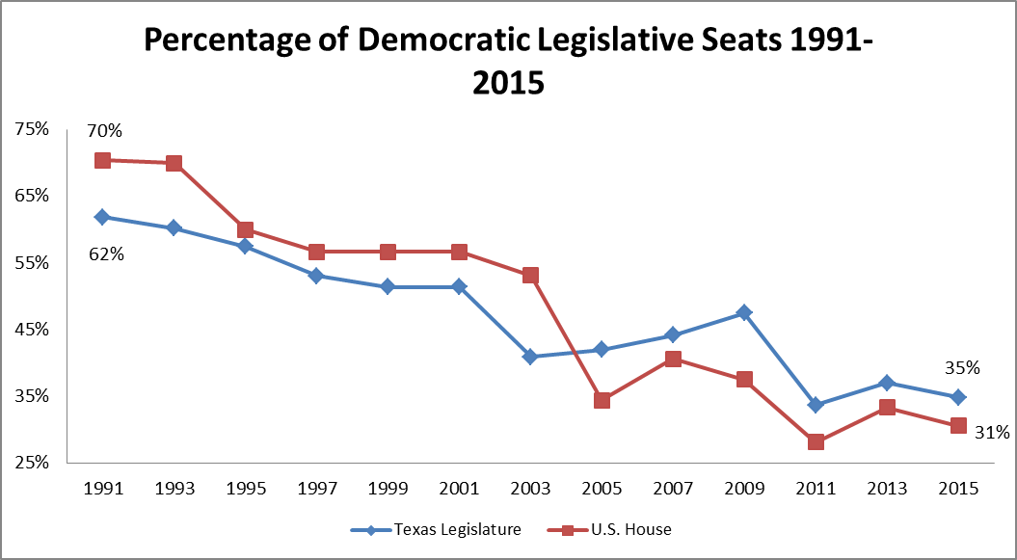

The Republican’s had some success in the 1960’s and 1970’s, electing John Tower as U.S. Senator and Bill Clements as governor. Moreover, they benefited from Democrats like John Connally Allan Shivers and Phil Gramm switching to the Republican Party (Frontline). Reagan’s election in 1980 began the Republican rise, with his coattails sweeping away established Democratic House Members like Bob Eckhart. The Republican trend continued in 1984 with the election of six freshman congressmen dubbed the “Texas six pack” This group included Tom DeLay, Dick Armey and Joe Barton (Dunham). Through a combination of retirements, redistricting, and partisan shifts, the Republicans became the majority party in the state and national legislature following the 2004 elections.
Statewide, the Democrats went from dominating major statewide offices in 1990, to not holding any since 1998. From 1990 to 2014, the quality of Democratic challengers for statewide office declined as well. Using Jacobson (1989) we measure quality challengers as those who have held elective office. In 1990, all Democratic candidates running for the six major statewide races either were incumbents or had held an elected office in the past. This number decreased in each election cycle and in 2006 and 2010 only two of the six Democratic candidates had held previous office. The number rebounded slightly in 2014 with two state senators and one mayor running.
Graph 2
Democratic Quality Challengers for Statewide office in Texas 1990-2014
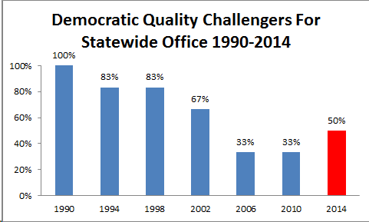

Using Squire’s (1992) ranking of challenger quality, of the 23 Democratic candidates since 2002, former Congressman and 2006 gubernatorial candidate Chris Bell ranked highest among these candidates, but still below a statewide office holder. Of all Democratic candidates since 2002, none are in Squire’s “highly prestigious” category, or were proven statewide vote getters.
Coupled with the decline in challenger quality was a decline in Democratic support at the statewide level. From 1990 to 2010, Democratic support fell from 55% to below 40% in 2010 and 2014.
Graph 3
Average Vote for Democratic Candidates in Texas Statewide Elections 1990-2014
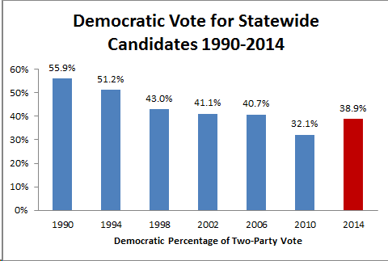
If Texas is to become a competitive state, the Democrats need to run better challengers and contest every office.
Previous Attempts At Turning the State Blue
After losing all six statewide offices in 1998, the Texas Democratic Party believed that they would be able to turn the state Blue in successive elections beginning in 2002. In this section we examine the 2002, 2006 and 2010 Texas gubernatorial elections to examine Democratic support, and why the state remained safely Republican.
The 2002 Election: Running a Latino Candidate
The first attempt to turn Texas back to blue was 2002, following the loss of all six statewide offices and the Texas Senate in 1998. Among those Republicans, winning in 1998 were Rick Perry who was elected Lieutenant Governor and George W. Bush who was reelected Governor. Following the 2000 Presidential Election of Bush, Perry assumed the governorship. The Democratic Party believed that they could unseat the appointed Republican governor in 2002.
This election proved to be one of the nastiest and most expensive elections in Texas history. Democrat Tony Sanchez, a wealthy Laredo businessman, was the first Latino nominated by either major party for the governorship. Latinos comprised 32% of the state’s population in 2002, but historically had a substantially lower rate of voter turnout than either Whites or African Americans. (Velasquez Institute) It would be part of the “dream” to see these numbers increase and to break the recent Republican monopoly on statewide offices.
Negative ads dominated the airwaves with Sanchez attacking Perry for accepting contributions from Enron leaders and Perry implying Sanchez had ties to drug dealers. Sanchez’s lack of political experience was evident throughout the campaign. Through his business, he contributed money to both parties, including some $300,000 to George W. Bush’s gubernatorial and presidential campaigns. (New York Times, March 12, 2002). Despite higher than normal midyear turnout Perry defeated Sanchez; by 17.6 percentage points. The two advantages that the Sanchez possessed: his wealth and the potential to mobilize Latino voters, proved to be insufficient. His estimated spending of $67 million was almost 2.5 times that of the Perry campaign. Sanchez spent $36.82 per vote received compared to $10.64 for Perry. Latino turnout also increased markedly in 2002, 10 full points above the 1998 election and 5 points above 2006. In the end, Sanchez’s inexperience and Perry’s aggressive campaign prevailed. The Republicans kept all six statewide offices and gained control of both branches of the Texas legislature.
2006 The Four-Way Race
In 2006 the Democrats hoped that a unique four-person race for governor and the toxic national political climate for Republicans would help them electorally. Challenging incumbent Republican Rick Perry for governor were Democratic nominee Chris Bell and two more colorful candidates. Bell, a former U.S. Congressman was redistricted into a majority-minority African American district in 2004 where he lost in the primary. The second challenger was country musician and author Richard “Kinky” Friedman who hoped to emulate the successful campaign of Minnesota Governor Jesse Ventura. Like Ventura, Friedman hoped to fuse celebrity and a unique campaign to mobilize new voters and attract voters dissatisfied with the current party system and its candidates. Despite the initial similarities to Ventura, Friedman finished in fourth place. Incumbent State Comptroller Carole Keeton Strayhorn’s presence further complicated the election. Unlike Friedman, she was not a political amateur having held elected office as both a Republican and as a Democrat. Strayhorn ran a media-centered campaign hoping to gain Anti-Perry Republicans and Independents. Despite her fundraising and political experience, she finished in third place.
The campaign finance rules of Texas were a major institutional advantage for the Republican Party. Partin (1995) demonstrates that incumbents have fundraising advantages over their challengers and Perry confirmed this. Texas campaign finance laws enable candidates to raise and spend unlimited amounts of money and lack individual contribution limits to campaigns. Without these encumbrances, total spending on the Texas race reached 46 million dollars with Perry spending nearly $23 million, Strayhorn $12.6 million, Chris Bell spending $6.5 million; and lastly Friedman, with nearly $3.8 million (Selby, B1).
On Election Day, strategic voting played a role in the Perry victory as both Strayhorn and Friedman declined in the last weeks of the campaign as voters began to view their presence as wasted votes (Duverger, 1963; Riker 1982; Cannon 1990; Lijphart 1994). Friedman was unable to overcome doubts about the seriousness of his campaign and struggled to find his footing on policy thus rendering him a sideshow in the election. Strayhorn’s name recognition and spending had her as the second place candidate through early fall polling, but following the traditional third-party support pattern, her support fell off on Election Day as well. Chris Bell’s strong performance in the debate, coupled with increased name recognition and late fundraising enabled him to present himself as a legitimate challenger to Perry but was ultimately unsuccessful. For Chris Bell, the nationwide anti-Republican tides that enabled the Democrats to retake the U.S. House and Senate did not trickle-down to Texas. President Bush remained popular in the state, and the war in Iraq was a national rather than a state issue. Although Bell made the election close, he could not overcome the Republican partisan advantage. Perry’s 39% of the popular vote was enough to get him reelected, and deny the Democrats another opportunity to begin turning the state Blue. They once again lost all six statewide offices and gained five seats in the Texas House, and two in the U.S. House of Representatives.
2010 A Return to Two-Party Politics
Buttressed by the 2008 election, where the Democratic Party came within 2 seats of winning the Texas House, Texas Democrats hoped to build upon these gains. In 2010, the Democrats believed that they had a capable challenger in Bill White to contest Perry’s bid for a fourth term. A lawyer and Deputy Energy Secretary during the Clinton administration, White was also a popular Houston mayor. In his two Mayoral elections, he received more than 85% of the votes before stepping aside due to term limits. Despite early predictions of a close race, Perry never trailed in the opinion polls and won by a margin of 13 points. The excitement in this race happened in the Republican primary, where Perry defeated US Senator Kay Bailey Hutchison.
Perry’s general election message was twofold; firstly, to paint White as a surrogate for President Obama, who was deeply unpopular in the state. Secondly, Perry argued that Texas had largely survived the economic turmoil of the recession through his leadership. In tying White to Obama, Perry spent much of the campaign criticizing Obama and christened White as “Liberal Bill”. In the latter stages of the campaign, Perry would often not even mention White by name, instead focusing his attacks on Washington. Seeking to avoid any catastrophic errors, he did not debate White, nor did he meet with the editorial boards of the major newspapers in the state.
In contrast, White struggled to find a unifying theme to his campaign. He tried a series of attacks on Perry, but none gained traction. Democratic strategist Chuck McDonald complained: “You tell me what Bill White’s message is because, nobody knows it. You say Rick Perry, the voter says jobs. You say Bill White and the voter says Mayor of Houston, which is where he started.” (Root, 2011). Campaign finance once again hurt Democrats as Bill White spent 24.8 million dollars in 2010, which was far short of the 41.7 million spent by Perry.(Associated Press). As late as October of 2010, Perry’s approval ratings were below 50%, dangerous numbers for an incumbent. (Houston Chronicle, October 26, 2010) Throughout the campaign, White remained within single digits of Perry; yet Perry won the election by 13% (55% to 42%) and took 226 of the state’s 254 counties. The Democrats failed to gain any statewide offices and lost 3 seats in the U.S. House and 25 seats in the Texas House.
Turning Texas Blue, a Model of Voter Support
In this section, we develop a simple model of voter support in which we examine the results of these three elections. To test our hypotheses we use Texas Exit Poll Data from the 2002, 2006, and 2010 Governor’s elections. Our dependent variable for each election uses the question “In today’s election for Governor, who did you just vote for”. In the case of 2006 we exclude minor party voters and only examine respondents who supported a major party candidate. We choose the governor’s race because it has the highest turnout and represents the most visible state election. Because these are two-candidate races, we used binomial probit for our analysis. In this model, positive signs indicate greater probability of supporting Democratic candidates.
Race, Ethnicity, Age and Education
For Texas Democrats to succeed, they need to maximize their support among the fastest growing groups in the population and those groups that traditionally support Democratic candidates at the national level. As Caucasian voters have left the Democratic Party, Latino voters have filled the void and in increasing numbers (DeSipio 1996). We include dummy variables for Whites as well as Latino voters. For the Democrats to succeed, at present, they cannot gain Latino voters at the expense of White voters. For this reason, we expect that Democratic success is tied to insignificant coefficients for white voters. The gender gap is well-documented in the literature with women more likely to support Democratic candidates (Chaney, Alvarez, and Nagler 1998; Kaufmann and Petrocik 1999; Norrander 1999). We expect that women will be more likely to support Democratic candidates as Rick Perry’s record as governor on capital punishment, education, and gun control may not be as appealing to women (Box-Steffensmeier, De Boef, and Lin 1998). Concerning age, we expect that voters under 45 should be more likely to support Democratic candidates. Judis, and Teixeira (2002) develop the idea of the emerging Democratic majority which includes highly-educated, creative workers as part of the new coalition. In the book, they highlight Austin as one such “ideopolis” crucial to the new majority. For this reason, we expect Democrats to fare better with people with post-graduate degrees.
Ideology and Partisanship
Party identification is an important determinant of vote choice at the state level (Atkeson and Partin 1995; Squire 1992; King 2001). For the Democrats to win in Texas, they need to win the support of political independents to reinforce their partisan support. Borrowing from Lacy and Monson (2002), we also include an ideological variable for self-identified politically moderate as well. We include this variable as approximately one-half of all Democrats considered themselves politically moderate, and an additional 20% saw themselves as conservative.
Presidential Approval
Carsey and Wright (1998) argue that short-term presidential approval can influence state elections, so we include a variable measuring presidential approval. We expect that voters approving of President Bush will support the Republicans in 2002 and 2006, and voters supporting President Obama in 2010 will support the Democrats.
Issues
The major issues of each election were different, so we include an issue variable for each. Previous research shows that voters view governors as responsible for statewide economic conditions (Atkeson and Partin 1995; Partin 1995) so we include an economic variable measuring voter evaluations of the national economy (Carsey and Wright 1998; Niemi, Stanly and Vogel 1995) for 2002. We anticipate favorable economic views will lead to less support for the Republicans. For 2006, we include a variable measuring support for the Iraq War, with greater support for the war leading to less support for the Democrats. For 2010, we include two variables that measure support for what should be done with the Affordable Care Act (expand or keep it as it is)
Results of the Model
The results of our model showed some weaknesses in Democratic support in Texas that we believe extend beyond candidate and election specific factors. In the table, positive coefficients indicate an increased predicted probability of supporting the Democratic candidate.
TABLE 1 ABOUT HERE
In our model, Latino voters have an increased probability of voting for Democrats in the 2002 election. It is not significant in either 2006 or 2010. Consistent with Barreto (2007), in 2002 Tony Sanchez’s ethnicity and his attempts to mobilize Latino support proved to be successful in gaining Democratic support. White voters, however, were significant for Republican support in both 2002 and 2010. This demonstrates that the growing Latino population remains elusive for the Democrats. In none of the elections was female support significant. None of the elections focused on specific gender issues nor were any female candidates on the ballot for governor. In 2002 and 2006, there was no significant relationship between party support and post-graduate education. In 2010, a relationship emerged with respondents with a significant relationship with this group and Democratic support. In none of the elections were voters under 45 significant.
The partisanship variable did not appear to be significant in the model. Political independents were not significantly likely to support either party. This disadvantages the Democrats more than the larger Republican Party. Moderate voters, however, were significant to Democratic support in all three elections. This is important, as there are not enough self-identified liberals in the state to the sizable conservative population.
Striking in all three elections was the influence of presidential specific factors. In none of the elections did these necessarily favor the Democrats. Presidential approval remained a strong predictor of support in every election. The Republicans benefited from the post- 9/11 popularity of George W. Bush. Voters who approved of George W. Bush’s job as President increased the probability of voting Republican given Bush’s popularity as Governor and his continued popularity among Texans. In 2006, President Bush’s low popularity ratings hurt the Republican Party nationwide, but he had a favorable rating of 53% in Texas. Voters who approved of Bush were more likely to support the Republicans. Bush lacked the unfavorable ratings in the state to make this a referendum on his performance was the nationwide case. In 2010, those approving of President Obama’s job as president had a greater probability of supporting the Democrats. With more than 60% of the sample disapproving of the President, this again helped the Republicans.
Election-specific factors also favored the Republicans. In 2002, voters who saw the national economy as “excellent or good” had a greater probability of supporting Perry. This supports the literature in that incumbents are rewarded for positive economic conditions. In 2002, the nation began to recover from the dot-com crash and the economic downtown following 9/11. Although the War in Iraq was the top national issue, but Texas were more supportive of the War than the rest of the nation. This issue hurt Republicans running for national office, but the effects did not trickle down to state races in Texas. Lastly, in 2010 the Affordable Care Act proved to be the top policy issue and the law proved to be very unpopular in Texas. Although supporters of the law were significantly more likely to vote Democratic, 58% of Texans in the survey wanted to repeal the law.
The 2014 Election: Abbott versus Davis
2014 seemed to be the most promising gubernatorial election year for Democrats in Texas in the past two decades. The previous July, Governor Rick Perry announced that he would not seek reelection, this would mark the first time in twenty years that there would not be a Republican incumbent on the ballot. The Democrats had a high profile candidate in State Senator Wendy Davis, who had achieved national prominence in 2013 by filibustering a bill seeking to place new restrictions on abortions. Finally, in 2013, the organization Battleground Texas was created to elect Democrats and increase turnout. Yet, Davis lost the election by 20 points and turnout actually declined from the 2010 elections.
The Republicans nominated Greg Abbott, who had been Texas’ Attorney General since 2002. A Houston lawyer, Abbott had also served on the Texas Supreme Court from 1995 to 2001, when he resigned to begin his campaign for Attorney General. Abbott is a paraplegic and has been confined to a wheelchair since a tree fell on him while jogging in 1984. This would impact the campaign (see below). Abbott was not seriously challenged in the Republican Primary, he received 91.5% of the votes cast and was able to amass a significant campaign war chest, which would serve him well in the general election.
Wendy Davis was the State Senator from the 10th District. She had earlier served as a member of the Fort Worth City Council, and, after briefly practicing law, worked in her husband’s title business. Davis presented a very compelling biography, a single mother who, after a brief teenage marriage, worked her way through TCU and Harvard Law School. During the campaign, this story would come under some scrutiny, and not to her advantage. In January of 2014, Wayne Slater of the Dallas Morning News argued that while the fundamentals of her biography were correct, the details were somewhat more complicated. Davis had remarried in 1987 and her husband had paid her tuition for her last two years at TCU, he had also cashed in his 401K and taken loans to pay her tuition at Harvard. He also cared for her daughter from a previous marriage, as well as they child they had together, while she was at Harvard. Supporters of each candidate reacted predictably to this story, those who favored Davis thought it was a Sexist hit piece that would not have been targeted at a male candidate. Those who favored Abbott believed their perceptions of Davis as a self-aggrandizing opportunist to have been confirmed. The Slater piece, and those that followed, at the very least, placed qualifications on Davis’ most compelling message, her rise from teenage poverty to a Harvard Law Degree.
Buoyed by the nationwide results of 2012 and the excitement generated by the Davis campaign, the Texas Democratic party undertook steps to turn the state to a battleground state in 2014 with the long-term goal of making the state Democratic once again. At the forefront of this effort was “Battleground Texas” a Political Action Committee led by Jeremy Bird, former Field Director for President Obama’s 2012 reelection campaign (Burns). The name came from the idea that Texas will become a battleground state by treating it like one. In addition to a massive fundraising effort, the organization promised to focus on mobilizing “unmarried women, people of color and millennials who are the fastest growing segments of the population” (Stanford). Additionally, the organization had the announced goal of increasing turnout and mobilizing crossover voters, soft suburban Republicans. The group believed that they could not wait for the Latino vote to emerge and need to build the infrastructure now.
From its inception, the leadership of the organization stated that this would be a multi-election effort (Hamilton, 2014), whose success would not be determined by 2014 alone. Yet, the initial results were disappointing in any context. They viewed White’s election numbers as a floor, which could only be increased. This did not happen and there was a great deal of acrimony between the local Democratic organizations and Battleground, with the former seeing the latter as usurping local volunteers and resources and not delivering any improvement in results (Hooks, 2014). Bird also made a bold, and erroneous, statement about increased turnout prior to the election that was based on flawed data. (Hooks, 2014). Battleground also proved to be reluctant to share data with the local organizations and there were persistent suspicions that this was a dry run for a Hillary Clinton Presidential campaign in 2016.
The race would prove to be a very expensive, Abbott spent a little over $57 million and Davis spent roughly $31.5 million. (Austin American Statesman). While Davis came close to matching Abbott’s fundraising during the campaign ($30.5 million vs $36.1 million from July 1, 2013 to Election Day). Abbott began the campaign with a $20 million war chest, and Davis was unable to make up that ground. Roughly 21% of Davis’ contributions came from out of state ($6.2 million), with nearly 30,000 individual donations from individual donors in other states. Abbott received roughly $1.4 million from out of state, less than 4% of his total, but was more than made up this gap with contributions from inside the state. Davis received more small donations, but both had large ticket contributors. Abbott’s top individual donor, Harold Simmons of Dallas, donated $900,000 before his passing in December of 2013. Davis received more than $1 million from Planned Parenthood and from Emily’s list, and Personal Injury Attorneys Steve and Amber Mostyn gave her nearly $2 million. (all numbers from Austin American Statesman 10/25/2014). This was a very expensive race and Davis proved unable to surmount Abbott’s early fundraising lead.
The campaign itself was acrimonious and, in October, Davis aired an ad featuring an empty wheel chair that presented Abbott as a hypocrite for collecting benefits from his accident while later, in his roles as a jurist, and as Texas Attorney General, seeking to limit the awards of other claimants. Predictably, Republicans argued that the ad violated the bounds of good taste, while the Davis campaign argued that it was legitimate criticism of his record. (The New York Times, 10/13/2014).
Throughout the campaign, Abbott led in the opinion polls, by October of 2013, he had a double digit lead in poll averages, a lead that he never relinquished. Abbott took a majority of men, women, and took 44% of the Hispanic vote, emphasizing throughout the campaign that his wife would be the first Latina first lady of Texas. The election results were similar to the previous three Governor’s races, suggesting that there is still much work to be done to turn Texas into a “battleground.”
At the time of this paper, individual-level exit poll data were unavailable. For our analysis, we use an October 2014 University of Texas/Texas Tribune survey of 1200 registered voters. Conducted one month before the election, the survey underestimates Abbott’s victory by 3%. It is not an exit poll, so our dependent variable asks “If the 2014 general election for Governor were held today, would you vote for the Democrat Wendy Davis, the Republican Greg Abbott, the Libertarian Kathie Glass, the Green Party candidate Brandon Parmer, or haven’t you thought about it enough to have an opinion.” We recoded the variable to only Davis and Abbott supporters giving us a sample of 1044 valid responses.
Model of 2014 Support
As this is not an exit-poll, we chose to run a separate model because of sampling and question wording differences. We used, however, many of the same variables and we predicted the same outcomes.
TABLE 2 ABOUT HERE
Demographic and Education Variables
For 2014, we included demographic variables measuring race (White and Latino), age and gender. In our analysis, only Whites proved to be statistically significant and more likely to favor Abbott. Despite massive outreaches to the Latino community, this variable is not significant for Davis support. Similarly, Female voters were not statistically different in the election, even with the Davis campaign’s efforts to target women voters. In this model, we unwrapped the dichotomous age variable (above/below 45), and created a three-category age variable measuring 18-29 year olds, 30-44 year olds, and 45-64 year olds. We did this with expectation that the youngest voters would be more likely to support Davis. From our analysis, none of the age variables proved significant for either candidate. College graduates were also no more likely to support either candidate.
Partisanship and Ideology
Identifying as a moderate was significant in 2002, 2006, and 2010 for Democratic support, but it was not significant in 2014. Encumbered by her liberal policy positions, she was unable to convince moderates to support her. There was no statistically significant relationship between self-identified political independents and support for either candidate.
Candidates and Issues
As with the 2010 election, President Obama played a role in candidate support with a statistically significant relationship between respondents approving of President Obama claiming that they would vote for Davis in November. This survey included more Texas-specific questions than did the exit polls, so we included three policy variables in our model. Survey respondents rated border security as the most important problem in the state so we included a variable measuring opposition to Governor Rick Perry’s decision to send Texas National Guardsman to the US-Mexico border. This variable was significant for Davis support with those respondents opposing the border troops being more likely to say they would vote for Davis on Election Day. Respondents were asked whether Texas was heading in the right direction or was on the wrong track. There is a statistically significant relationship between Respondents saying that Texas was on the wrong track and support for Davis. The final issue we examined was Abortion. This issue, which catapulted Davis to national prominence, proved to be statistically significant with pro-choice voters more likely to say they would vote for Davis in the upcoming election.
Conclusions
In this paper, we created two simple models for Texas Democrats need to expand if they want to make the state electorally competitive. These results revealed the disadvantages that the Democratic Party failed to overcome in the four elections in our study. The results of the 2014 model demonstrate that the party lost ground and will have to reevaluate its campaign strategy going forward.
Democratic Disadvantage: Demographics
Latinos are an increasingly important part of the nationwide Democratic coalition, and represent the greatest area for growth for the Democrats in Texas.
Graph 4
Projected Change in White and Latino Population in Texas 2010-2050
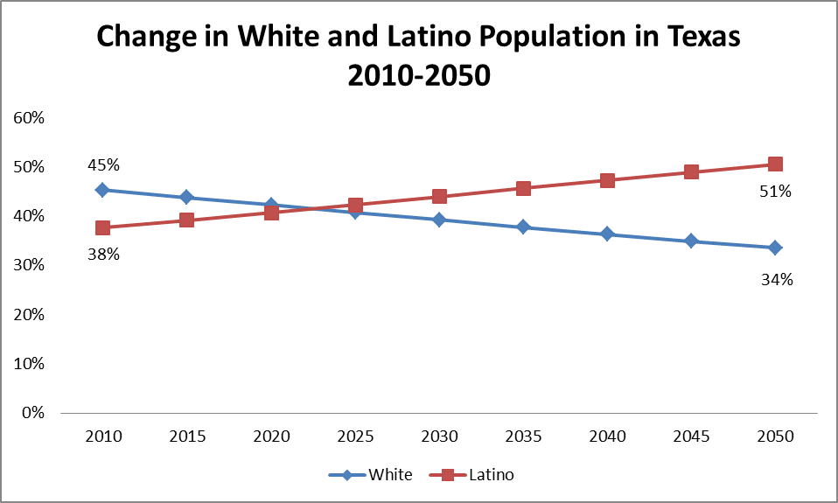
Data from the Texas State Data Center http://txsdc.utsa.edu/Data/TPEPP/Projections/Index.aspx
Latinos are expected to outnumber Whites in Texas 2023 and be a majority of the population in 2047. This growth in this area should help the Democratic Party, but it has not materialized. Our results show that a Latino candidate for the governorship increases support significantly among Latinos, but the variable is not significant when the party runs white candidates. More importantly, Latino candidates do not guarantee victory as the Democrats ran Latinas for Lieutenant Governor in 2006, 2010 and 2014, but none were successful. In 2014, Wendy Davis was unable to make inroads with Latino voters despite her outreach and registration efforts. In the 10 largest Texas counties that are at least 25% Latino, Democratic support dropped in every county but Travis and she was only able to win five of these counties.
Table Three
Ten Largest Counties with at least 25% Latino Population
County | Percentage of Davis Vote in County | Percentage Latino in County | Democratic Change in Support 2010-2014
Harris | 47.8 | 40.8 | -3.25
Dallas | 55.5 | 38.3 | -0.89
Tarrant | 41.8 | 26.7 | -0.43
Bexar | 49.3 | 58.7 | -0.96
Travis | 64.9 | 33.5 | 3.02
El Paso | 61.8 | 82.2 | -0.72
Hidalgo | 64.3 | 90.6 | -3.47
Cameron | 56.9 | 88.1 | -1.50
Nueces | 44.5 | 60.6 | -1.63
Brazoria | 32.3 | 27.7 | -4.72

For the Democrats to be successful, they need substantial Latino support from the large counties in Texas. Hurting the Democratic Party further is that white voters supported the Republican Party candidates at statistically significant levels in all four of our models. Increasing Democratic support from Latinos may be at the expense of white voters.
A stricter approach to immigration issues has not moved Latinos into the solid Democrats either. In 2011, the Republican dominated legislature passed a strict immigration law and a stringent voter id law in 2013. In 2014, former Governor Perry deployed 1000 National Guard troops to the border. This harder line on immigration did not hurt the Republican Party in 2014, but a continuation of restrictive immigration policy coupled with the demographic changes in the state could help the Democrats in the future.
In the first model (2002-2010), the gender gap is not statistically significant in our model and we attribute this to the absence of female candidates for governor and gender issues. Even with the backlash to the 2013 restrictive abortion law and the Davis candidacy gender was not significant. The pro-choice abortion view was significant, but in conservative Texas, it was not the modal policy position. These factors did not advantage Democrats with women in 2014 and the emergence of a permanent gender gap in Texas, similar to the national trend, would advantage the party. As with Latino voters, this support has not materialized for the party in at least four elections.
Democratic Disadvantage: Turnout
Turning Texas blue requires higher voter turnout. Since 1990, midyear turnout peaked in 1994 at 33.6% and presidential turnout never reached 50%. Additionally a full quarter of the voting aged population is not registered to vote.
Graph 5
Voter Turnout in Texas Elections 1990-2014
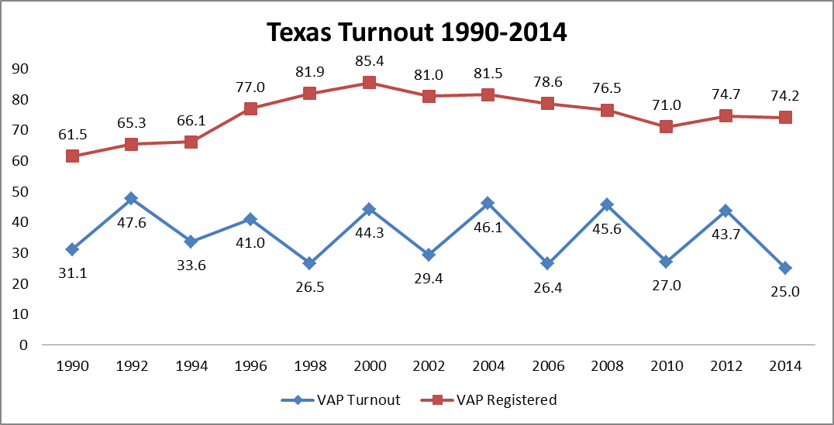
http://www.sos.state.tx.us/elections/historical/70-92.shtml

In the four elections in our study, the Democrats sought to mobilize voters who do not traditionally vote and those who are not registered. Problematic for the Democratic Party is that statewide elections are in midyear elections which feature less media attention and excitement than presidential years In 2014, Democratic mobilization strategies were ineffective as turnout in seven of the ten largest counties declined and only one had more than 40% turnout. There was a 17 month delay between the Davis filibuster and Election Day resulting in a decline in excitement. Until the Democratic Party is able to increase turnout in Democratic voting areas, they will remain the second party in the state.
Table 4
Change in Voter Turnout in 10 Largest Texas Counties 2010-2014
County | Population | Voter Turnout | Change in Turnout 2010-14 | Percentage of Davis Vote in County
Harris | 4092459 | 33.0 | -7.6 | 47.8
Dallas | 2368139 | 33.8 | -3.2 | 55.6
Tarrant | 1809034 | 37.3 | 0.2 | 41.8
Bexar | 1714773 | 31.4 | -2.1 | 49.3
Travis | 1024266 | 40.9 | 1.5 | 64.9
El Paso | 800647 | 19.9 | -3.4 | 61.8
Collin | 782341 | 36.5 | -0.3 | 33.2
Hidalgo | 774769 | 25.2 | 0.5 | 64.3
Denton | 662614 | 35.4 | -0.4 | 33.5
Fort Bend | 585375 | 36.5 | -8.5 | 43.5

Democratic Disadvantage: Short Term Factors
In each of the four elections, two short-term factors advantaged the Republican party; first was presidential approval. In 2002 and 2006 President Bush retained his popularity within the state such that these midyear elections did not serve as negative referendums on his performance. In 2010, however, the election served as a decidedly negative referendum on President Obama. In 2014, President Obama remained unpopular among Texas voters harming Democratic candidates. For the Democratic Party to benefit from presidential approval ratings in 2018, there needs to be a very popular Democratic president or an extremely unpopular Republican president who does not have Texas roots. A “Texas free” Republican may prove difficult with Ted Cruz, Rand Paul, Rick Perry and Jeb Bush among the 2016 GOP presidential hopefuls.
Issues are the second short term factor hurting the Democrats. In each election, the most important issues hurt the Democratic candidate for governor. In 2002, the economy helped Republicans in Texas, while in 2006, the War in Iraq remained popular in Texas despite nationwide disapproval. In 2010, opposition to the Affordable Care Act hurt Democratic candidates nationwide and in Texas. In 2014, a combination of issues including the strong Texas economy, beliefs on border security and abortion policy all favored the Republicans. For the Democrats to increase their standing in Texas, the important electoral issues need to favor that party.
Democratic Disadvantage: The Republicans
The obvious obstacle facing the Democratic quest to turn the state is the Republican Party. Texas is not a battleground state looking turn blue; rather it has been safely Republican for more than a decade. Republicans have controlled the statewide offices since 1998 and both branches of the legislature since 2003. Democrats have not been competitive in statewide elections with their average support below 45%. Presidentially, the state has voted Republican in ten of the previous 11 elections.
Graph 6
Average Democratic Vote by Office 1990-2014
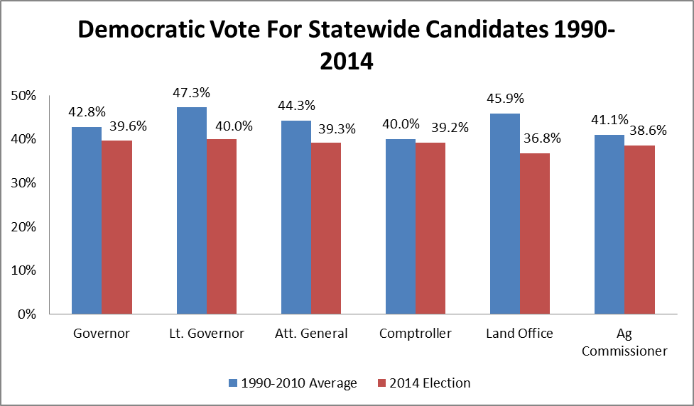
Republicans continue to have a partisan advantage in the state. In each of the elections we examine, Republican was the modal partisan affiliation and the Republican candidate never received less than 90% of the GOP vote. The Republicans continue to run incumbent candidates or those with previous political experience, while the Democrats run political amateurs. In 2014, the Democratic candidate for Agriculture Commission did not campaign or spend any money. The Republicans also have a monetary advantage over the Democrats. Of the Democratic candidates for Governor in our model, only Tony Sanchez’s self-financed campaign outspent the Republican challenger. The current Republican fundraising advantages will enable the party to counter the Democrat’s grassroots efforts for the foreseeable future. Lastly, Democrats have made their plans to make Texas competitive, and we cannot expect the Republicans to passively accept a Democratic majority.
In 2013, with the presence of an open-seat for governor, an exciting challenger, and an energized base, the Democratic Party seemed poised to make Texas more competitive. This did not happen, and the party continued to perform poorly at the statewide level. This setback does not mean that the Democratic Party is finished. The Democratic Party has been unlucky with short term factors in the previous four elections, but this cannot go on forever. More importantly, the long term changing demographics within the state favor the Democrats. Lastly, every two years brings another election and another opportunity. For this reason alone, the Texas Democratic Party, should find some solace in the Brooklyn Dodgers rallying cry of “Wait ’til next year!”

Table 1

Probit Estimates for the 2002, 2006 and 2010 Texas Governor’s Elections

(Republican Coefficients Normalized to Zero)
Variable | 2002 | 2006 | 2010
White | -0.80* | -0.10 | -0.63**
 | (.279) | (.255) | (.233)
Latino | 0.71* | 0.24 | -0.03
 | (.322) | (.326) | (.273)
Under 45 | -0.01 | 0.03 | 0.09
 | (.154) | (.161) | (.149)
Female | -0.25 | -0.05 | -0.16
 | (.145) | (.143) | (.135)
Post-Graduate Degree | 0.03 | 0.18 | 0.37*
 | (.166) | (.156) | (.154)
Approve of President | -1.72** | -1.70** | 1.41*
 | (.188) | (.185) | (.171)
Moderate Ideology | 0.44** | 0.45** | 0.47**
 | (.149) | (.155) | (.143)
Political Independent | 0.04 | 0.05 | 0.08
 | (.178) | (.169) | (.148)
National Economy Good/Very Good | -0.52**
 | (.149)
Approve of War in Iraq |  | -0.68**
 |  | (.180)
Expand Affordable Care Act |  |  | 1.26**
 |  |  | (.185)
Keep Affordable Care Act as it is |  |  | 0.46*
 |  |  | .204
Intercept | 1.62 | 0.92 | -.095
 | .388 | .246 | .269
Log pseudolikelihood | -250.437 | -286.321 | -279.037
Wald Chi-Square | 177.89 | 278.55 | 290.83
Number of Cases | 649 | 824 | 828
Note: Maximum-likelihood estimates with their standard errors in parenthesis below. *indicates an estimate significant at the p<.05 level. **indicates an estimate significant at the p<.01 level.

Table 2

Probit Estimates for the 2014 Texas Governor’s Elections

(Republican Coefficients Normalized to Zero)
Variable | 2014 Vote
White | -0.41*
 | (.182)
Latino | 0.23
 | (.259)
Age 18-29 | -0.15
 | (.243)
Age 30-44 | -0.14
 | (.225)
Age 45-64 | -0.10
 | (.188)
Female | 0.15
 | (.141)
College Graduate | 0.04
 | (.176)
Approve of President Obama | 1.80**
 | (.176)
Moderate Ideology | 0.17
 | (.171)
Political Independent | 0.05
 | (.167)
Texas on the Wrong Track | 1.00**
 | (.158)
Disapprove of Sending Troops to the Border | 1.21**
 | (.188)
Pro-Choice on Abortion | 1.13**
 | (.156)
Constant | -1.85
 | (.244)
Log pseudolikelihood | -193.17218
Wald Chi-Square | 305.58
Number of Cases | 808
Note: Maximum-likelihood estimates with their standard errors in parenthesis below. *indicates an estimate significant at the p<.05 level. **indicates an estimate significant at the p<.01 level.

Works Cited
Alvarez, R. M. and Bedolla, L. G. (2003), “The Foundations of Latino Voter Partisanship: Evidence from the 2000 Election”. Journal of Politics, 65:31–49.

Alvarez, R. Michael, and Jonathan Nagler. 1995. “Economics, Issues and the Perot Candidacy: Voter Choice in the 1992 Presidential Election.” American Journal of Political Science. 39:714-744.

Alvarez, R. Michael, and Jonathan Nagler. 1998a. “Elections, Entitlements, and Social Issues: Voter Choice in the 1996 Presidential Election.” American Journal of Political Science. 42:1349-1363.

Associated Press. "Perry Spent $41.7 Million To Keep His Job." 19 Jan. 2011. http://dfw.cbslocal.com/2011/01/19/perry-spent-41-7-million-to-keep-his-job/>.

Atkeson, Lonna Rae and Randall W. Partin. 1995. “Economic and Referendum Voting: A Comparison of Gubernatorial and Senatorial Elections” The American Political Science Review. 89, (1) pp. 99-107.

Barone, Michael, Richard Cohen and Charles Cook. 2001. The Almanac of American
Politics: 2002. Washington: The National Journal.

Barreto, Matt. 2007. ‘‘Sı´ Se Puede! Latino Candidates and the Mobilization of Latino Voters.’’ American Political Science Review 101 (3): 425–41.

Burns, Alexander. "Democrats launch plan to turn Texas blue." POLITICO. Accessed January 5, 2014. http://www.politico.com/story/2013/01/democrats-launch-plan-to-turn-texas-blue-86651.html.

Carsey, Thomas M. and Gerald C. Wright. 1998 “State and National Factors in Gubernatorial and Senatorial Elections” American Journal of Political Science, Vol. 42, No. 3 pp. 994-1002

Chaney, Carole K., R. Michael Alvarez, and Jonathan Nagler. 1998. “Explaining the Gender Gap in the U.S. Presidential Elections, 1980–1992”.Political Research Quarterly 51: 311–40.

DeSipio, Louis. 1996. Counting on the Latino Vote: Latinos as a New Electorate. Charlottesville, NC: University of Virginia Press.

Downs, Anthony.1957. An Economic Theory of Democracy. New York: Harper and Row.

Dunham, Richard. 2011 “Ronald Reagan: How he changed Texas Politics forever”. The Houston Chronicle. February 6th.
Duverger, Maurice. 1963. Political Parties. New York: John Wiley and Sons.

Flanigan, William H. and Nancy H. Zingale. 2000. Political Behavior in Midterm Elections. Washington D.C.: CQ Press.

Fiorina, Morris P. 1981. Retrospective Voting in American National Elections. New Haven, CT: Yale University Press.

Hamilton, Reeve. 2014 “What Went Wrong With Battleground Texas?” The Texas Observer.
11/5/2014.

Hooks, Christopher. 2014. “Losing Ground.” The Texas Observer, 12/30/2014

Kirk, Michael (Writer and Director) 2005. “Karl Rove The Architect”. [Television series episode]. Frontline. Airdate April 12, 2005.

Key, V.O. [1949] 1984. Southern Politics in State and Nation. Reprint. Knoxville: University of Tennessee Press

King, James D. 2001. “Incumbent Popularity and Vote Choice in Gubernatorial Elections” The Journal of Politics. 63 (2). pp. 585-597.

Jacobson, Gary G. 1989. "Strategic Politicians and the Dynam- ics of U.S. House Elections, 1946-86." American Political Sci- ence Review 83:773-794.

Judis, John B. and Ruy Teixeira. 2002. The Emerging Democratic Majority. New
York: Scribner.

Kaufmann, Karen M., and John R. Petrocik. 1999. “The Changing Politics of American Men: Understanding the Sources of the Gender Gap.” American Journal of Political Science 43: 864–887.

Keeter, Scott, Juliana Horowitz, and Alec Tyson. “Young Voters in the 2008 Election”
Pew Research Center for the People & the Press.

Lacy, Dean, and Quin Monson. 2002 “The Origins and Impact of Votes for Third-Party Candidates: A Case Study of the 1998 Minnesota Gubernatorial Election.” Political Research Quarterly 55 (2): 409-37.

Lem, Steve B. and Conor M. Dowling. 2006. “Picking Their Spots: Minor Party Candidates in Gubernatorial Elections”. Political Research Quarterly 59(3): 471-480.

Long, J. Scott 1997. Regression Models for Categorical and Limited Dependent Variables.London: Sage Publications.

McConnaughy, Corrine M., Ismail K. White, David L. Leal and Jason P. Casellas. 2010. “A Latino on the Ballot: Explaining Coethnic Voting Among Latinos and the Response of White Americans.” Journal of Politics 72(4):1199–1211.
McDonald, Christian, J. David McSwane and Jonathan Tilove. 2014. “Where Wendy Davis and Greg Abbott draw their fundraising support.” Austin American Statesman. 10/25/2014

Montgomery, David. 2014. “An Ad With a Wheelchair Shakes Up the Texas Governor’s Race.” The New York Times. 10/13/2014

Niemi, Stanley, and Vogel. 1995. “State economies and state taxes: Do voters hold governors accountable?” American Journal of Political Science. 39 (4) pp 936-957.

Norrander, Barbara. 1999. “The Evolution of the Gender Gap.” Public Opinion Quarterly 63: 566–576.

Partin, Randall W. 1995. “Economic Conditions and Gubernatorial Elections” American Politics Quarterly. 23:81-95

-----------------------2002. “Assessing the Impact of Campaign Spending in Governors’ Races”. Political Research Quarterly. 55 (1). pp. 213-233.

Riker, William H. 1982. “The Two-Party System and Duverger’s Law: An Essay on the History of Political Science”. American Political Science Review 76:753-66.

Rosenstone, Stephen J, Roy L. Behr and Edward H. Lazarus. 1993. 2d ed. Third Parties in America. Princeton: Princeton University Press.

Root, Jay. 2011 “Texas Governor’s Race” in Pendulum Swing, ed. Larry J. Sabato. 389-94. Boston: Longman.

Selby, W. Gardner. 2007. “Final governor's race tally: Almost $46 million”
Austin American Statesman. B01 1/19/2007

Slaytor, Wayne. 2006. “Perry, Strayhorn pour funds into late TV ads”. The Dallas
Morning News. 10/30/2006

Slaytor, Wayne. 2014. “As Wendy Davis touts life story in race for governor, key facts blurred.”
The Dallas Morning News. 1/18/2014

Squire, Peverill 1992. Challenger Profile and Gubernatorial Elections. Western Political Quarterly 45 (March): 125-142.

Stanford, Jason. "Texas Democrats Lost in the Wilderness, but There's a Way Out." Accessed January 5, 2014. http://www.huffingtonpost.com/jason-stanford/texas- democrats_b_2228145.html.

Box-Steffensmeier, Janet M., Suzanna De Boef, and Tse-min Lin. 2004 “The Dynamics of the Partisan Gender Gap” The American Political Science Review, Vol. 98, No. 3 (Aug., 2004), pp. 515-528.

“Texas Election Returns”, Texas Secretary of State. 20 Feb. 2015 http://www.sos.state.tx.us/elections/historical/index.shtml.

University of Texas / Texas Tribune Texas Statewide Survey , October 2014.

