Who Believes In 2020 Election Conspiracies? Do They Correlate with Support For Election Reforms?

Scott Lasley
Western Kentucky University
Scott.lasley@wku.edu

Johnnie Boswell
Western Kentucky University
johnnie.boswell299@topper.wku.edu

Joel Turner
Western Kentucky University
joel.turner@wku.edu

Jeffrey Kash
Western Kentucky University
jeffrey.kash@wku.edu

Prepared for presentation at the 2023 Annual Meeting of the
Western Political Science Association, San Francisco, CA

Introduction
For decades, conspiracy theories have been a topic of controversy and conversation in American society. Many of these conspiracies involve far-out claims about the U.S. government and powerful entities with little to no basis of fact. For example, conspiracy theorists and internet users have spent countless hours circulating claims that the moon landing was fake, terrorist attacks are set up, and routine vaccinations are unsafe. However, in recent years, these conspiracies have surrounded a new facet of American life: free and fair elections.
Election related conspiracy theories are not new, but have grown in popularity in the past two decades. Perhaps most prevalent have been the conspiracies following the 2020 presidential election between Democrat Joe Biden and Republican Donald Trump. With the global COVID-19 pandemic forcing millions of Americans to vote early, by mail, or both, the stage was set for election deniers to peddle unfounded claims. In fact, many of those running for office themselves have begun to use such rhetoric to mobilize their bases and support more restrictive voting measures. Republican candidate for Arizona Governor, Kari Lake, recently told an audience of supporters, “We had November 3, 2020, that was called incompetency 101,” (Reston, 2022) After realizing that her own election results were not looking good for her 2022 campaign, Lake claimed, “The system we have right now does not work,” (Reston, 2022). On a national level, 139 members of the U.S. House of Representatives decided not to certify then President-Elect Joe Biden’s victory on January 6, 2021 (Wilson, 2023). Many of them, mostly the right-wing of the Republican party, have since spread falsehoods about the election results online and in public spaces.
As conspiracy theories began to grow in 2020, public opinion shifted, with a greater number of Americans buying into election related conspiracy theories. A 2022 poll by Monmouth University revealed that 61% of Republicans do not think that President Joe Biden legitimately won his election (Murray, 2022). The same poll also showed that only 63% of Americans believe that President Joe Biden won in a fair manner (Murray, 2022). While such data displays the deep partisan divide surrounding these unfounded claims, it is fascinating that such a large number of Americans are concerned that their elections are not free, fair, or both.
Following the 2020 presidential election, and the years leading up to it, many electoral reforms have been introduced or implemented across the country. The most controversial facets of these bills surround the right to vote early or by mail, two things that are often cited by conspiracy theorists and election deniers as leading to large-scale fraud. However, these bills vary greatly in whether they aim to expand or restrict such abilities when casting a ballot. While federal legislation has been more supportive of voting early or by mail, many states across the South have now been working for years to roll back or eliminate such rights.
On a national level, Democrats in the U.S. House of Representatives introduced H.R. 1, the For The People Act, on January 4, 2021 (117th Congress, 2021). The bill included many measures, including automatic and same-day voter registration, expanded early voting and casting a ballot by mail, and limiting the removal of names from voter rolls. Also included in H.R. 1 were measures pertaining to congressional redistricting, campaign finance laws, and the required disclosure of tax returns from certain candidates seeking public office. Democrats also introduced H.R. 4, the John Lewis Voting Rights Advancement Act, in August of 2021 (117th Congress, 2021). The bill was largely aimed at restoring and strengthening key parts of the Voting Rights Act of 1965, following the Supreme Court decision in Shelby County vs. Holder in 2013. This bill would reinstate oversight and require federal approval before altering election laws, which was struck down in the 2013 ruling.
Conversely, many states across the South have spent their efforts moving in a more restrictive direction. According to the Brennan Center for Justice, 8 states have enacted 11 restrictive voting laws, while 7 states have enacted 12 election interference laws (Berry et al., 2023). Georgia’s S.B. 202, also known as the Election Integrity Act of 2021, is a key example of these efforts (Fowler, 2021). The bill claims to raise the standards for voting in the state to preserve and protect election security. While some facets of the bill are supported by most of the general public, such as requiring a photo ID to vote, other measures have been condemned (Fowler, 2021). This includes only allowing those with a legitimate excuse to vote by mail, as well as restrictions on sharing water to those standing in notoriously long lines (Fowler, 2021). When Governor Brian Kemp signed the bill into law, many election deniers saw it as a victory, while voting rights activists felt it as an attack on democracy. Thus, conspiracy theorists and everyday Americans alike continue to ponder how safe and secure their elections really are. While many argue that electoral reform to promote access and security is important, it is vital that these policies be influenced by fact and not unfounded claims on the internet. Below we use data from voters across Kentucky to explore two questions. What factors shape one’s belief in 2022 election conspiracy theories? And, how does the believe in conspiracy theories influence support for electoral reforms?

Literature Review
In a post-Trump America, unfounded claims regarding electoral fraud have led to troublesome outcomes. The widespread introduction of mail-in ballots and early voting have recently inspired conspiracies stating that American democracy has fallen prey to large-scale electoral fraud. Despite the most popular conspiracies surrounding the 2020 election being debunked, a large portion of the United States now believes that their elections are not free, fair, or both (Cohen, 2021). Several states across the southern portion of the U.S. have passed new restrictive voting laws in response. The rise in conspiracy theories and decline in public trust in democratic institutions is also being exaggerated by polarization and an increase in echo chambers in the media and online.
Fortunately for those covering this, conspiracy theories, democratic institutions, and echo chambers are all well-researched topics in the field of political science. It is evident that belief in conspiracies is detrimental to societal and individual health, both physically and mentally (van Prooijen & Douglas, 2018). For example, simply sharing anti-vaccine conspiracy theories has the potential to drastically reduce the number of parents willing to vaccinate their children (Jolley & Douglas, 2014). Exposure in conspiracy theories, and subsequent belief in them, can also lead to ostracization from society (Harambam & Aupers, 2014). Some argue that while causal relationships could be better explored, it is clear that interpersonal functioning is harmed by belief in conspiracies (van Prooijen & Douglas, 2018). This puts factual information and function in society at risk. Democracy, of course, has the potential to follow suit.
Some studies have found that conspiracy theories exist on both sides of the political spectrum and across demographics (Min, 2021). This complements the core argument that conspiracies are universal, affecting those of every race, ethnicity, and culture (van Prooijen & Douglas, 2018). However, it does appear that conservative conspiracy theories are more popular than liberal ones (Min, 2021). This is especially true among white men with a conservative and Protestant belief system (Min, 2021). Strengthening the effect of conspiracy theories is the existence of a homogenous social media network (Min, 2021). Digging deeper into social media, research does argue that many platforms are a risk to democracy (Deb et al., 2017). One study reveals that 73% of Americans believe that social media and the Internet are responsible for the rise in conspiracies (Uscinski et al., 2022). Algorithms are increasing the existence of polarization and echo chambers, allowing misinformation to spread. In fact, social media has played a large part in forming the conspiracy theories following the 2020 general election. Many concerns about voter fraud, fueled by misinformation, found their origin online. Finally, some research has pointed to factors such as race and religion as being major determinants in one’s belief of election related conspiracies. One of these studies claims that 74% of white evangelical Republicans believe that claims of 2020 election fraud is mostly or completely accurate (Cox et al., 2022). However, that drops to 54% when interacting with Republicans that are not evangelical (Cox et al., 2022).
There are two main areas that have not been adequately addressed in currently available research. First, it would be interesting to get more data on who believes in election conspiracy theories and what factors influence that belief the most. With the recent polarization of American politics, it is likely that factors such as education level and party identification will be the most significant drivers of this. Secondly, after identifying who believes in conspiracy theories, it is important to study how conspiracy theories are shaping public opinion regarding election reform. There is evidence that everyone is susceptible to falling into the rabbit hole of conspiracies shared in the media and online. Still, one must identify the key correlations between belief in conspiracy theories and preferred electoral reforms. Free and fair elections have always been a cornerstone in American democracy. However, with conspiracies promoting policies that threaten election access, what began as misinformed internet chatter has the potential for voter suppression. By examining survey data from voters in Kentucky, this paper will reinforce who believes in conspiracy theories and how those beliefs correlate with public opinion on election laws.

Data and Methods
The data used for this examination were drawn from a 2021 survey conducted by the Political Behavior Lab at Western Kentucky University. The survey featured a representative sample of 755 participants collected through Qualtrics. This survey is well-suited for our purposes for several reasons. Most importantly, it provided measures of support for our key dependent variables of interest. In addition, this survey included questions about the political and socio-demographic characteristics of our respondents, which provided a wealth of potential independent variables.

Descriptive Analysis
There were eight election related conspiracy theories that were included in the survey sent to Kentucky residents. Each of them have circulated on the internet, and oftentimes, from right-wing politicians themselves. The results show a fairly large number of respondents believing in these conspiracies, with percentages ranging from 19.7% to 45.6%. The most popular conspiracy theory, according to survey results, is the claim that thousands of ballots were cast in the names of dead people. It is possible that the 45.6% of belief is due to the fact that this claim has been circulating for longer than most other election related conspiracy theories. However, newer conspiracy theories such as the idea that mail-in ballots were shipped in bulk from China also have a large percentage of support at 19.7%.
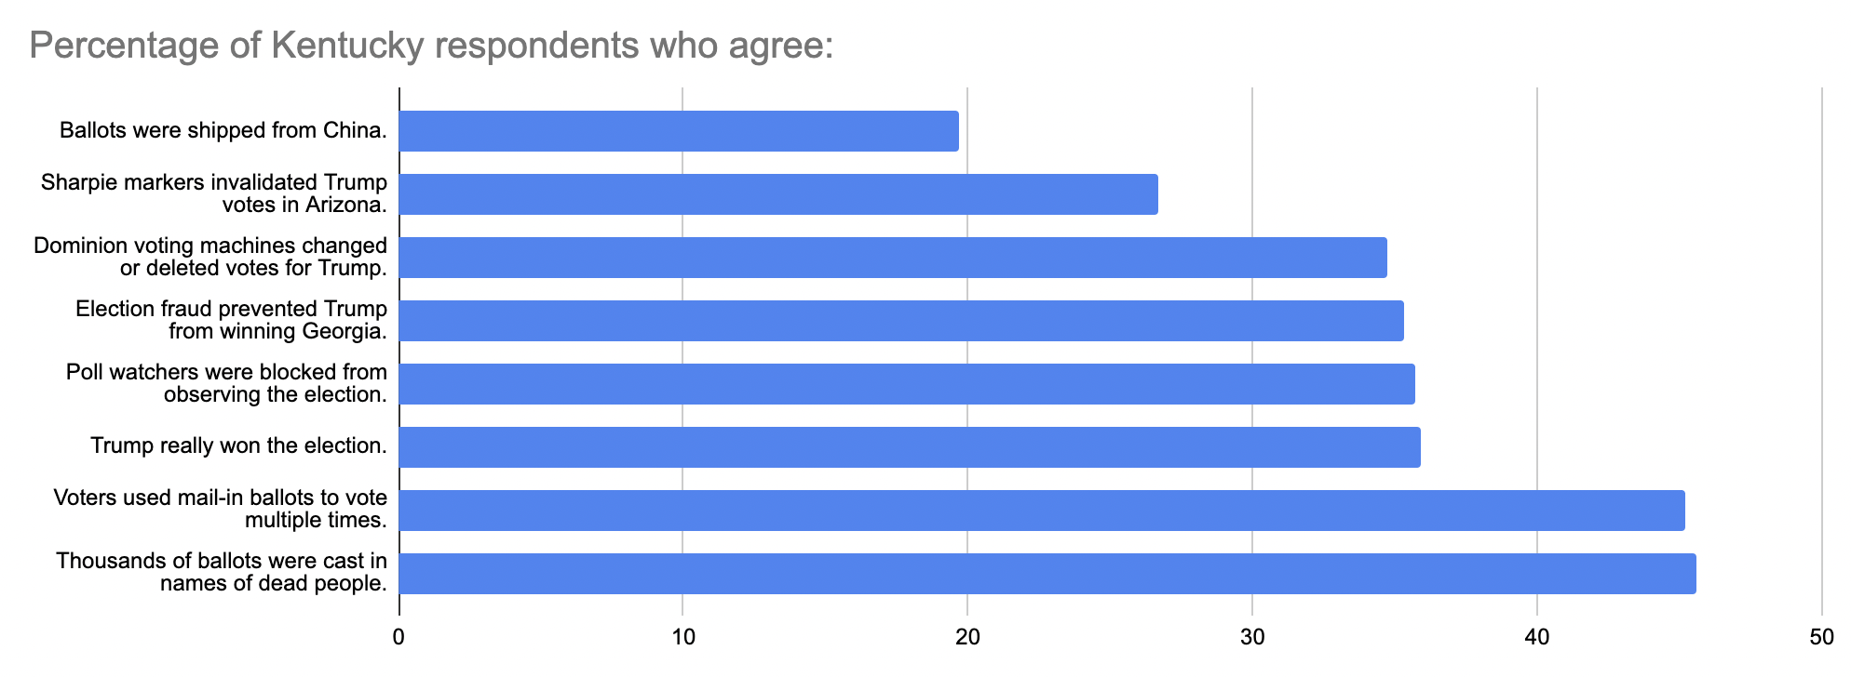
When breaking down the results from respondents on party lines, a massive partisan gap becomes evident. For example, when looking at the most popular conspiracy theory, 70.3% of Republicans believe that thousands of ballots were cast in the names of dead people. On the same survey question, only 20.5% of Democrats agreed. In fact, this is the conspiracy theory most likely to be believed by Democrats. Unsurprisingly, there is also a large gap in the percentages of partisans who believe Trump really won the election. 60.4% of Republicans agreed with this statement, while only 8.7% of Democrats bought into one of the most heated election related conspiracy theories.
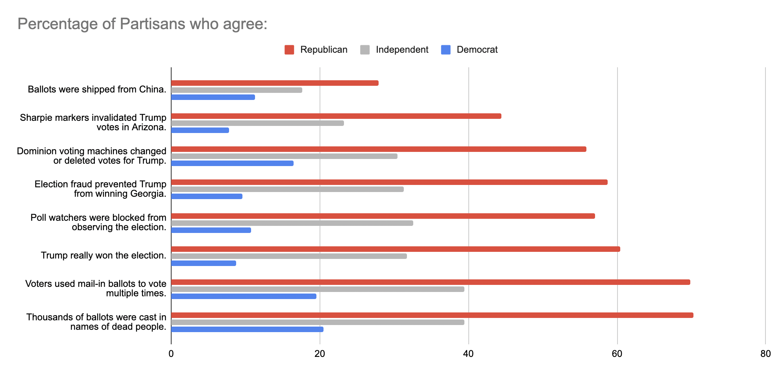
Multivariate Analysis
There are sixteen total dependent variables utilized in this analysis. Eight dependent variables are examined in the first model and deal with respondent belief in a variety of political conspiracy theories. Each dependent variable measures a respondent’s level of agreement with whether he or she believes in each of the following proposed political conspiracy theories associated with 2020 Presidential election: individuals submitted multiple mail-in ballots, ballots imported from China were used in the election, dead people voted in the election, poll watchers were prevented from supervising the election, fraud in Georgia cost Trump a victory, Dominion voting machines discounted votes for Trump, sharpies nullified Trump votes in Arizona, and finally that Trump actually won the election. These were each coded as a 0-4 variable, with 0 signifying strong disagreement with the statement, 2 signifying that the respondent neither agrees nor disagrees with the respondent, and 4 signifying strong agreement with the statement.
The eight dependent variables are examined in the second model measures a respondent’s level of support for various electoral reform proposals. These reforms include: making Election Day a holiday, universal vote by mail, photo ID, same day registration, voting receipts, allowing felons to vote, establishing 24 hour vote centers, and expanding opportunities for early voting. These were each coded as a 0-4 variable, with 0 signifying strong opposition for the proposal, 2 signifying that the respondent neither supports nor opposes the proposal, and 4 signifying strong support of the proposal.
Eight independent variables were utilized in the first model. The main variables of interest are party identification measures, so a dichotomous measure of Democrat and Republican were included with Independent serving as the comparison category. Additional control variables include gender, age, income, race, education, and whether the respondent resided in a rural area. A ninth independent variable, conspiratorial beliefs, was included in the second model. This was a 0-8 variable which simply measure the number of proposed conspiracy theories the respondent agreed with.
Results
The model in Table 1 illustrates the level of agreement with each proposed political conspiracy theory regarding the 2020 election. Because the dependent variable ranges from 0 to 4, an ordered logit model was estimated.
(Insert Table 1 here)
The results demonstrate that, as expected, party identification exhibits a strong, consistent effect on a respondent’s propensity to agree with political conspiracy theories. The results also indicate a strong partisan divide on these theories. In each instance, Republican identification had a significant positive effect, indicating a greater propensity to believe each of these conspiracy theories. In contrast, Democrat identification had a significant negative effect, indicating a greater propensity to not believe in each of these conspiracy theories. Additionally, across all proposed theories education has a significant negative effect, indicating that those with more years of formal education are less likely to believe in these conspiracy theories. The only other variables to reach statistical significance in any of the categories were age and living in a rural location, as older respondents were less likely to believe conspiracy theories about Chinese ballots, fraud in Georgia, sharpies in Arizona, and that Trump actually won the election than their younger counterparts, and rural residents were more likely to believe that fraud occurred in Georgia, Arizona, and that Trump actually won the election.
Logit coefficients are informative in regard to the direction of, and the statistical significance of, the effect of independent variables. However, they are difficult to interpret and provide little information regarding substantive impact. Therefore, predicted probabilities were calculated in order to highlight the actual difference in levels of agreement with each proposed conspiracy theory between Republicans and Democrats.
(Insert Table 2 here)
As Table 2 illustrates, there is a .77 probability that Republicans will believe in at least one of the eight political conspiracy theories analyzed. Also, there is a .17 probability that they will believe in all eight of them, and only a .24 probability that they will not believe in any of them. By contrast, there is a .56 probability that Democrats will not believe any of the political conspiracy theories we examined, only a .44 probability they will believe in at least one and only a .05 probability that they will believe all eight of them.
Having established the prevalence of conspiratorial thinking with regard to the 2020 election, we now examine whether this had any impact on the level of agreement with each proposed political electoral reform. Once again, because the dependent variable ranges from 0 to 4, an ordered logit model was estimated.
(Insert Table 3 here)
The results demonstrate that conspiratorial thinking exhibits a strong effect on respondents’ level of support for six of eight proposed electoral reforms. This variable has a positive effect on photo ID and voting receipts, indicating support for these measures. Conspiratorial thinking has a negative effect on same day registration, mail in ballots, allowing felons to vote, and expanding opportunities for early voting. This variable has no impact on making Election Day a national holiday, and the creation of 24 hour vote centers.
With regard to other variables, party identification has a significant impact in several instances. Republicans are significantly less likely to support mail-in ballots as well as expanding opportunities for early voting. Democrats are more supportive of early proposed reform except for photo ID. Perhaps surprisingly, older voters oppose several reforms (making Election Day a holiday, allowing felons to vote, getting a voting receipt, same day registration, and 24 hour vote centers), and are only supportive of requiring photo ID. Other findings of note are that men are less supportive of making Election Day a holiday, while those with higher levels of education are more supportive of it. White respondents are more likely to oppose mail-in ballots, while those with higher income and education levels are more likely to support photo ID laws. Male and white respondents are less likely to support a voting receipt, and white respondents are also less likely to support allowing felons to vote. Lower income and non-White respondents are more likely to support same day registration, and finally those with higher levels of education are more likely to support 24-hour vote centers and expanded early voting.
Conclusion and Implications
The analysis of the data supports our hypothetical expectations while provide interesting insights into both the level of political conspiratorial thinking regarding the 2020 election, and what impact that thinking may have on support for electoral reforms. With regard to conspiratorial thinking, clear patterns emerge. Republicans are by far the most likely to buy into the proposed theories, while Democrats are the least likely to buy into them. While there are other variables that have influence in some instances, such as age, education, and living in a rural area, party identification was by far the biggest driver of belief in, or disbelief in, these political conspiracy theories.
Secondly, belief in political conspiracy theories has a tangible impact on level of support for proposed electoral reforms. Of the eight proposed electoral reforms, conspiratorial thinking has an influence on each except for making Election Day a holiday and the creation of 24-hour vote centers. The more conspiracies one beliefs in, the more likely they are to support photo ID requirements and voting receipts. Additionally, they are less likely to support same day registration, expanding early voting, mail-in ballots, and allowing felons to vote. In each of these cases the effect is both statistically significant and substantively meaningful.
The results from this analysis indicate fairly broad belief in political theories and that this belief has a tangible effect with regard to support for public policy proposals. Three questions for future exploration are generated from these results. The first question asks whether those who support political conspiracy theories are also likely to believe in non-political ones, such as whether the moon landing was faked. The second question asks whether those who believe in political conspiracy theories have psychological characteristics that make them different from the average respondent, which has implications for scholars of political psychology. The final question asks whether belief in conspiracy theories has broader policy support implications beyond voting reform proposals. The pursuit of these questions would expand our insight and knowledge of importance of belief in political conspiracy thinking.

References
Berry, Patrick, Michael Waldman, Robyn Sanders, Sara Loving, and Eliza Sweren-Becker. 2023.
“Voting Laws Roundup: December 2022.” Brennan Center for Justice. February 23. https://www.brennancenter.org/our-work/research-reports/voting-laws-roundup-december-2022.
Fowler, Stephen. 2021. “What Does Georgia's New Voting Law SB 202 Do?” Georgia Public
Broadcasting. March 27. https://www.gpb.org/news/2021/03/27/what-does-georgias-new-voting-law-sb-202-do.
“H.R.1 - 117th Congress (2021-2022): For The People Act of 2021.” 2023. U.S. Congress.
Accessed February 26. https://www.congress.gov/bill/117th-congress/house-bill/1.
“H.R.4 - 117th Congress (2021-2022): John R. Lewis Voting Rights ...” 2023. U.S. Congress.
Accessed February 26. https://www.congress.gov/bill/117th-congress/house-bill/4.
Murray, Mark. 2022. “Poll: 61% of Republicans Still Believe Biden Didn't Win Fair and Square
in 2020.” NBCNews.com. NBCUniversal News Group. September 27. https://www.nbcnews.com/meet-the-press/meetthepressblog/poll-61-republicans-still-believe-biden-didnt-win-fair-square-2020-rcna49630.
Reston, Maeve. 2022. “Kari Lake Raises Unfounded Doubts about Election Results in Arizona
Governor Race That's Too Early to Call | CNN Politics.” CNN. Cable News Network. November 9. https://www.cnn.com/2022/11/09/politics/kari-lake-arizona-governor-race/index.html.
Wilson, Christopher. 2023. “Numerous Election Deniers Help Lead New GOP Congress.”
Yahoo! News. Yahoo! January 10. https://news.yahoo.com/numerous-election-deniers-help-lead-new-gop-congress-201012187.html?guccounter=1&guce_referrer=aHR0cHM6Ly93d3cuZ29vZ2xlLmNvbS8&guce_referrer_sig=AQAAALY05ei4X_jTYEbNKf0p13r1EtIYZYYy7FpHRFSVDqvZLFCZHOJOqk3Dd3_gwW8iIf11vdX8YZ74xUIz6LxbohMDhXAMwDMK1P4UrBlCgQTbHdDHLghwR9Notr8incdJX4R9NmuojYbJFhX05clEc8Rx012A20DphGch2NcMekU8.
Cohen, Li. 2021. “6 Conspiracy Theories about the 2020 Election – Debunked.” CBS News. CBS
Interactive. January 15. https://www.cbsnews.com/news/presidential-election-2020-conspiracy-theories-debunked/.
Cox, Daniel A., Lindsey Witt-Swanson, Brent Orrell, and Karlyn Bowman. 2022. “Rise of
Conspiracies Reveals an Evangelical Divide in the GOP.” The Survey Center on American Life. April 7. https://www.americansurveycenter.org/rise-of-conspiracies-reveal-an-evangelical-divide-in-the-gop/.
Deb, Anamitra. 2017. “Is Social Media a Threat to Democracy?” Global Investigative
Journalism Network. October 31. https://gijn.org/2017/10/31/is-social-media-a-threat-to-democracy/.
Harambam, Jaron, and Stef Aupers. 2014. “Contesting Epistemic Authority: Conspiracy
Theories on the Boundaries of Science.” Public Understanding of Science 24 (4): 466–80. doi:10.1177/0963662514559891.
Jolley, Daniel, and Karen M. Douglas. 2014. “The Effects of Anti-Vaccine Conspiracy Theories
on Vaccination Intentions.” PLoS ONE 9 (2). doi:10.1371/journal.pone.0089177.
Min, Seong Jae. 2021. “Who Believes in Conspiracy Theories? Network Diversity, Political
Discussion, and Conservative Conspiracy Theories on Social Media.” American Politics Research 49 (5): 415–27. doi:10.1177/1532673x211013526.
Uscinski, Joseph, Adam Enders, Casey Klofstad, Michelle Seelig, Hugo Drochon, Kamal
Premaratne, and Manohar Murthi. 2022. “Have Beliefs in Conspiracy Theories Increased over Time?” PLOS ONE 17 (7). doi:10.1371/journal.pone.0270429.
van Prooijen, Jan-Willem, and Karen M. Douglas. 2018. “Belief in Conspiracy Theories: Basic
Principles of an Emerging Research Domain.” European Journal of Social Psychology 48 (7): 897–908. doi:10.1002/ejsp.2530.

Table 1. Demographic Characteristics by Level of Agreement with Political Conspiracy Theories

Mail Fraud Chinese Ballots Dead Votes Poll Watchers GA Fraud Vote Machine Fraud AZ Sharpies Trump Won
Age .052 -.177 -.111 .039 -.139** -.057** -.144** -.116**
(.065) (.068) (.066) (.066) (.067) (.066) (.067) (.069)

Sex -.028** .133 -.055** -.155** -.02** .072** .136** .057**
(.13) (.129) (.126) (.128) (.128) (.127) (.129) (.133)

Income .019 -.103 -.026 .038** .138 -.049* -.033 -.043**
(.053) (.054) (.053) (.534) (.534) (.053) (.055) (.055)

Rural .148 .079 .2 .158* .303 .175 .252 .309**
(.139) (.141) (.138) (.14) (.141) (.139) (.142) (.143)

White/Nonwhite -.289 -.076 -05.** -.532 .080 -.209 .066** .264**
(.195) (.195) (.194) (.196) (.197) (.197) (.203) (.21)

Education -.149 -. 223 -.140 -.107** -.146 -.169* -.235 -.208**
(.049) (.051) (.04) (.051) (.05) (.049) (.052) (.052)

Republican 1.18 .807 1.22 .979* 1.24 1.05 1.28 .938**
(.172) (.171) (.172) (.172) (.173) (.170) (.176) (.173)

Democrat -1.29 -1.05 -1.18** -1.3 -1.42 -1.05 1.22** -1.68**
(.18) (.182) (.18) (.181) (.183) (.179) (.184) (.189)

N = 755 N = 755 N = 755 N = 755 N = 755 N = 755 N=755 N=755
LR Chi2 = 2.98 LR Chi2 = 1.55 LR Chi2 = 214.7 LR Chi2 = 196 LR Chi2 = 268 Chi2 = 171 Chi2 = 246 Chi2=322
Pseudo R2 = .014 Pseudo R2 = .07 Pseudo R2 = .09 Pseudo R2 = .08 Pseudo R2 = .11 Pseudo R2=.07 Psuedo R2=.11 Psuedo R2=.14

*p<.10
**p<.05
Standard errors in parentheses

Table 2. Predicted Probabilities of Conspiracy Beliefs by Party Id

None One All

Republican .24 .77 .17

Democrat .56 .44 .05
Table 3. Demographic Characteristics by Level of Agreement with Electoral Reforms

Holiday Vote by Mail Photo ID Same Day Reg Vote Receipt Felons Vote Vote Centers Early Vote
Age -.283 -.081 -.328 -.054 -.345** -.432** -.226** .023**
(.066) (.065) (.076) (.066) (.065) (.066) (.066) (.065)

Sex -.452** .057 -.197** -.314** -.711** .126** .08** .114**
(.128) (.126) (.146) (.127) (.128) (.126) (.125) (.127)

Income -.01 -.046 .152 .019** -.023 -.10* -.042 -.038**
(.053) (.053) (.066) (.055) (.054) (.053) (.052) (.054)

Rural -.071 -.114 .081 -.003* .211 -.028 -.07 -.088**
(.139) (.139) (.161) (.141) (.14) (.138) (.14) (.139)

White/Nonwhite -.213 -.385 -.041** -.360 -.319 -.377 .006** -.287**
(.196) (.191) (.203) (.193) (.18) (.196) (.192) (.193)

Education .083 .044 .102 .046** .045 -.036* .183 .134**
(.049) (.048) (.059) (.049) (.049) (.049) (.049) (.048)

Republican .179 -.288 .719 .124* -.288 .04 -.037 -.282**
(.172) (.172) (.205) (.176) (.173) (.171) (.173) (.171)

Democrat .511 .768 -.137** .398 .383 .898 .466** .698**
(.18) (.175) (.187) (.177) (.174) (.175) (.176) (.177)

Conspiracy Beliefs .002 -.231 .226** .124 -.049 -.045 -.004** -.148**
(.025) (.026) (.031) (.026) (.025) (.025) (.025) (.026)

N = 755 N = 755 N = 755 N = 755 N = 755 N = 755 N=755 N=755
LR Chi2 = 44 LR Chi2 = 212 LR Chi2 = 180 LR Chi2 = 41 LR Chi2 = 65 Chi2 = 113 Chi2 = 37 Chi2=137
Pseudo R2 = .02 Pseudo R2 = .09 Pseudo R2 = .11 Pseudo R2 = .02 Pseudo R2 = .03 Pseudo R2=.05 Psuedo R2=.02 Psuedo R2=.06

*p<.10
**p<.05
Standard errors in parentheses

