WPSA MEETINGS IN HOLLYWOOD, CALIFORNIA
MARCH 2013

Democratization and the Arab Spring: Does the Arab Spring Portend Another Wave of Democratization?

Sunday P. Obazuaye, Ph.D.
Cerritos College
Norwalk, CA

Democratization and the Arab Spring: Does the Arab Spring Portend Another Wave of Democratization?
“It is not revolutions and upheavals that clear the way to new and better days but … someone’s soul, inspired and ablaze.” (Russian Poet Boris Pasternak)
The above statement has implication for the countries of the Middle East and North Africa (MENA) in terms of what might become the outcome of the Arab Spring.
This paper focuses on the consequence of the Arab Spring for democratization and the flow of FDI in the MENA, and in Egypt in particular.
Is the Arab Spring a precursor to democratization in the Middle East and North Africa (MENA)? What events triggered the mass protests that were later dubbed the Arab Spring? What has been the impact of these events on the political and economic development, particularly the flow of foreign direct investment (FDI) in the region? What has been the reaction of corporate foreign investors to the events in the MENA? These are important questions that deserve answers in light of the global nature of politics and economics in the twenty first century.
Citizens in Arab countries seem to believe that democracy is the best form of government. According to Arab Barometer surveys in 2006 and 2010, over 75 percent citizens across the region believe that democracy is the best form of government. (Lust 2013, page 248-249) It is therefore not surprising that in the wake of the Arab Spring, some observers of politics in the MENA were quick to conclude that the events portend agitation for democracy. But scholars have different opinions as to what spurs democratization. Some claim that the demand for a better economic condition or economic development is a cause for the demand for democratic transition (Inglehart and Welzel, 2005; Boix and Stokes, 2003; and Acemoglu and Robinson, 2006). Others like Przeworski et al (2000) disagree that economic development contributes to the demand for democracy. They however claim that economic development helps existing democracies to survive. Yet others focusing on the massive wave of democratization in the former communist bloc argue that it was a desire to get rid of a system that was oppressive to human liberty. In other words, it was a desire for freedom rather than economic redistribution that is the driving force behind democratization (Hofferbert and Klingemann, 1999). The question is could it be both the desire for economic wellbeing and freedom that motivate citizens to demand for a change in regime?
Recent surveys by the World Bank and other foreign investment institutes found that while the perception of political risk during the mass protests deterred FDI flow, the expectation of transitions to democratic government coupled with political stability as a consequence of the Arab Spring could promote FDI flow and help contribute to economic development in the region. We will examine this claim to see if there is any relationship to the real demand of the protesters. In other words, were the protesters demanding for transition from authoritarian to democratic regime or simply a change of administration?
CAUSES OF THE ARAB SPRING
Democratization is the transition from any form of governmental system other than democracy to a democratic system of government. According to Richard Rose (2009), the process of democratization is a change from an undemocratic to a democratic regime. And according to Samuel Huntington (1991), elections, open, free, and fair are the essence of democracy, the inescapable sine qua non. However, William Hudson (2013) postulates that there is no single authoritative blueprint for how democracy can be achieved. Instead, democratic politics involves a constant discussion among citizens about how best to organize their political life.
Despite a huge volume of research on the subject of democratization, there is no overall consensus on causative factors. The recent protests in the Arab world that have been dubbed the Arab Spring may be traced back to the unfortunate event of December 17, 2010 in Tunisia. The self-immolation of street vendor Mohammed al-Bouazizi in Tunisia set off the wave of protests that led to the fall of President Zine El Abidine Ben Ali and catalyzed the Arab Spring. By October 2011 free and fair elections were held, and by January 2012 there was a constituent Assembly seated. Thus Tunisia became the first electoral democracy in the Arab world since the mid-1970s, with the complicated exception of Iraq. Less than a month of the fall of Tunisia’s President Ben Ali from power, Egypt’s President Hosni Mubarak was forced to step down by protesters in Tahrir Square after 30 years in power. A successful transition to democracy in Tunisia and Egypt could provide pivotal examples for the rest of the region (RAND, 2012: xix)
In Egypt, economic grievances, especially widespread perception of inequalities were one driver of the revolution. The regime’s legitimacy had been based on a social contract that included extensive state employment, food subsidies, and considerable social welfare spending. In many countries that experienced political transitions, deterioration of economic conditions and consequent public discontent played a role in precipitating the transition. These include Eastern European countries, in which poor economic performance undermined the fragile legitimacy of authoritarian regimes. In Indonesia, severe economic hardship that resulted from the 1997 Asian financial crisis triggered popular unrest, contributing to Suharto’s fall. Many countries in sub-Saharan Africa suffered economic stress in the early 1990s, leading to public protests and some regime changes.
According to Lisa Anderson (2011), president of the American University in Cairo, the Arab Spring may be attributed to a shared “common call for personal dignity and responsive government” in Tunisia, Egypt and Libya. However, there are divergent economic grievances and social dynamics, which reflect the legacies of their diverse encounters with modern Europe and decades under unique regimes. Anderson warns against a simplistic assumption that the uprisings constitute “a cohesive Arab revolt.” In other words, while the actions of the protesters may look alike, there are different motives and desired end results. In Tunisia, the protesters called for the restoration of the country’s suspended constitution. These protesters were mostly young people who are “principally concerned with receiving what they see as their share of the country’s wealth and employment opportunities.” In Egypt, citizens rose in revolt as strikes across the country brought daily life to a halt and toppled the government. Anderson sees the military in Egypt more likely to emphasize movement toward democratization than economic reform. Because of its enormous influence in Egyptian society as well as the domestic economy, the military is hostile to economic liberalization. In Libya, Anderson sees a yearning for state formation rather than democratization or economic reform. This is a consequence of the lack of social and governmental cohesion, which Qaddafi had created to foster his strategy of divide and rule. Thus, there are critical distinctions between Tunisia, Egypt, and Libya that will shape the outcomes of their respective movements. While Tunisia and Egypt grapple in their own ways with building political institutions such as constitutions, political parties and electoral systems, Libya will need to begin by constructing the rudiments of a civil society. While Egypt struggles with the long shadow of military rule, Tunisia and Libya will need to redefine the relationship between their privileged capital cities and their sullen hinterlands. Tempting as it is to treat the Arab uprisings as a single movement, their causes and future missions demonstrate the many variations between them. (Anderson, 2011) Democratization is a complex, multidimensional process and one must beware of rules of thumb and simplified predictions regarding how political change will occur in the Arab world. (RAND, 2012)
A 2012 survey of Muslim nations find that democracy is preferable in some of those countries. According to the survey conducted by the Pew Research Center, 67 percent of Egyptians and 63 percent of Tunisians say ‘democracy is preferable;” 84 percent of Lebanese and 71 percent of Turks say “democracy is preferable” (AFP: Google.com, July 2012)
ARAB SPRING AND FOREIGN DIRECT INVESTMENT IN MENA
Before the Arab Spring in 2011, countries in the Middle East and North African (MENA) region had already experienced decline in the aggregate flows in foreign direct investment (FDI) as a result of the 2008 global financial crisis. FDI in the region dropped from $83.9 billion in 2009 to $64.3 billion in 2010. (ScandinavianMideast.com News, July 2011) The events of 2011 accelerated the further decline in FDI flows into MENA. According to Central Bank reports from Tunisia and Egypt, in the first quarter of 2011, FDI flows turned negative in both countries. Egypt is said to have suffered the biggest decline. (David Rosenberg/Media Line, 2011) According to reports by Egypt’s Ministry of Investment, net FDI flow into Egypt increased from $509.4 million in FY 2000/01 to a high of $13.2 billion in 2007/08, falling to $8.1 billion in 2008/09, $6.8 billion in 2009/10, $1.6 billion in Q1 of FY 2010/11, $2.2 billion by the end of FY 2010/11, and $2.5 billion by the end of FY 2011/12 (Central Bank of Egypt, November 2012; Egypt’s FDI questEgypt - Zawya). The prospect for political stability seems to have attracted increased FDI in FY 2012. (See Table 1 below)
Figure 1. Trends in Net FDI from FY 2004/05 to Q1 of FY 2010/11
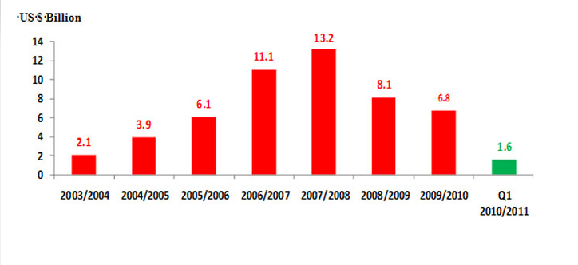
Table 1. Egypt's Gross External Financial Needs and Sources (USD BN)
 | FY05 | FY06 | FY07 | FY08 | FY09 | FY10 | FY11 | FY12
FDI | 3.9 | 6.1 | 11.1 | 13.2 | 8.1 | 6.8 | 2.2 | 2.5
Sources: Barclays Capital, International Monetary Fund, Central Bank of Egypt (November 2012)

The World Bank forecasted a decline in FDI flows into MENA in 2012 while it anticipates growth in 2013. This expected growth is contingent on the conditions of improved governance, successful democratic transition, coupled with political stability. (Columbia FDI Perspectives, May 2012) Thus on the long run, the Arab Spring may boost FDI flows into the MENA countries and help contribute to economic development in the region.
Surveys conducted by foreign investors in 2011 found that the Arab Spring did have a significant impact on corporate investors' investment intentions concerning MENA: about 25 percent of investors put their plans on hold; about 18 percent reconsidered; 11 percent canceled; 6 percent withdrew investments while about 33 percent did not alter their investment plans. (See Figure 2. below) The study found that the turmoil in the Arab countries has stressed existing investment and dampened plans for expansions and new investments. Civil disturbance and to a lesser extent war and terrorism, ranked particularly high as the risk of most concern as did government’s abilities to honor sovereign financial obligations. (Columbia FDI Perspectives, May 2012; MIGA-WIPR Report 2011:26)
Figure 2. Effect of the recent turmoil in MENA on investment plans in the region (Percent of respondents)
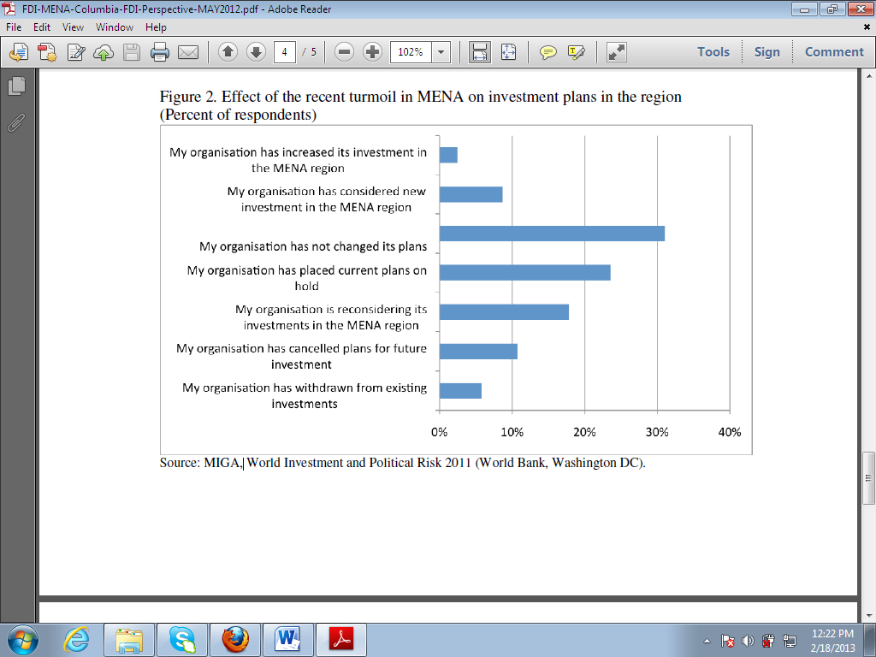
The survey also found that over half of the firms surveyed would invest in MENA, assuming there is at least a year of stability under a democratic government. Nearly half of the firms in the survey said they would decrease investments should there be a significant and persistent instability, even in the presence of democratically elected government. Only 8 percent of the firms would increase their investments under such circumstances. The worst-case scenario would be a period of prolonged and significant instability, where nearly half of the firms surveyed said they would substantially decrease investments. In the event of a non-democratic regime that nevertheless succeeds in stabilizing the country for at least a year, 44 percent of the firms surveyed claimed that they would not change their plans for investment, essentially adopting a “wait and see” approach. (Columbia FDI Perspectives, May 2012) Thus it is apparent that political stability, regardless of regime type, is a bigger attractor of FDI in MENA.
An analysis by Michael O’Sullivan of 83 cases over 53 years show that regime change is not only good for civil liberties, it is also good for the economy. (CFA Institute, March 2012) According to O’Sullivan, before and after data for selected regime changes reveal that the rank of these countries in terms of GDP per capita tends to move up within 5-10 years. Their growth rates increase, unemployment and inflation diminish, and FDI and market capitalization rise.
ATTRACTING FOREIGN DIRECT INVESTMENT TO MENA
O’Sullivan has proposed seven ideas to help spur economic revival in the Arab Spring countries:
- Make use of finance through Islamic finance and a Mediterranean Investment Bank.
- Unlock human capital by having more women join the work force.
- Get more out of social media and mobile technology.
- Invest in infrastructure including rail and shipping links.
- Boost trade
- Develop a pan regional body to help protect the region from financial crisis.
- Set up new institutions for arbitration and harmonization of different laws.
In 2012, Ernst and Young conducted a Middle East Attractiveness survey which produced some features similar to O’Sullivan’s above for attracting FDI to Arab countries: 46 percent of the investors surveyed points to large market size and high purchasing power as the region’s key feature; 37 percent consider infrastructure investment programs as a key attractiveness asset; while 30 percent finds access to natural resources as the most competitive feature in the region; however, 6 percent finds the region’s lack of technological readiness unattractive. David Rosenberg asserts, the return of FDI to MENA depends on the prospect for a return to stable security environment; market friendly policies and stable and democratic government.
SOURCES OF FDI to MENA
The primary sources of FDI projects to MENA are Western Europe and North America. However, intra-regional investments have gained momentum over the past few years. (Ernst and Young, page 4)

CONCLUSION
While there has been an adverse effect of the turmoil on investment intentions by investors however, there is a noticeable difference in opinion between investors who are already doing business in the Middle East and those who are not yet operating there. Those who are already there seem to be more optimistic about the region’s future and are more aware of the internal conditions than those who are not yet there. (MIGA-WIPR Report 2011:27) For instance, Ernst and Young reports in 2012 that 83 percent of companies already established in the region believe that the Middle East’s attractiveness will increase in the next three years while only 54 percent of companies not yet there think so. (Ernst and Young 2012 Middle East Attractiveness Survey, page 5) In the same report they found that investors considered three of the Gulf Cooperative Council countries (GCC countries - the United Arab Emirate; Saudi Arabia; and Qatar) to be more attractive to invest than other Middle Eastern countries. In fact, 81 percent of companies already established in the region favor GCC countries.
The long term impact of the Arab Spring on democratization and FDI inflow to MENA and particularly Egypt will depend on how well the political leaders respond to the demand of the protesters; and how quick they are able to establish a stable economic environment that will attract foreign investors. Thus two years after the revolutions that birth the Arab Spring, the question remains as to whether the nascent political leaders and protesters can cooperate to achieve a common goal of establishing the rule of law and creating a more just and democratic society that promotes economic opportunity for all its citizens.

Works Cited
Acemoglu and Robinson (2006) in Democratization, Oxford University Press, 2009 (page 5
AFP: Google.com, July 2012
Anderson, Lisa “Demystifying the Arab Spring” in Foreign Affairs (May/June 2011)
Boix and Stokes (2003) in Democratization, Oxford University Press, 2009 (page 5)
Central Bank of Egypt, November 2012
Columbia FDI Perspectives, No. 67 May 7, 2012
Ernst and Young, 2012 Attractiveness Survey: Middle East
Hofferbert and Klingemann (1999) Democratization, Oxford University Press, 2009 (page 5)
Hudson, William E. American Democracy in Peril: Eight Challenges to America’s Future, SAGE/CQ Press, 2013
Huntington, Samuel The Third Wave: Democratization in the Late Twentieth Century, University of Oklahoma Press, 1991
Inglehart and Welzel (2005) in Democratization, Oxford University Press, 2009 (page 5)
Lust, Ellen (editor) Middle East Politics, CQ Press, an Imprint of SAGE Publications, Inc. 13th edition 2014 (Pages 248-249)
MIGA-WIPR Report 2011
O’Sullivan, Michael, CFA Institute, March 29, 2012
RAND National Defense Research Institute Democratization in the Arab World: Prospects and Lessons from Around the Globe, 2012
Rose, Richard in Democratization, Oxford University Press, 2009
Rosenberg, David “Foreign Investment Outlook Dims on Arab Spring”, The Media Line, 12/17/2011
ScandinavianMideast.com News, July 2011
Zawya.com, November 11, 2012

