Residential Displacement in Gentrifying Urban Neighborhoods: A Statistical Analysis of New York City’s Housing Characteristics

Taylor Wahe Roschen
California Polytechnic State University
San Luis Obispo, CA

Abstract

The more recent “New Urbanist” and “Smart Growth” approaches to urban development have marked a rejection of suburban lifestyles and instead have promoted a massive in-migration of wealthy upper- and middle-class families into downtown cores. With an influx of financial capital and demand for luxury housing, developers have found their niche in the inner-city where, traditionally, vacancy rates are high, housing prices are low, and opportunities for improvement are endless. Following this trend, residents of these previously low-income areas are at risk of being displaced. This paper identifies the impact of gentrification on neighborhood characteristics, most specifically its displacing effects on low-income urban populations. Additionally a series of commonly employed policy alternatives intended to reduce this displacement within several inner-city boroughs of New York City are evaluated for their effect.
Table of Contents
I. Introduction……………………………………………………………………………….......5-6
II. Literature Review…………………………………………………………………………...6-16
A. Gentrification: Definition, Historical Context and Consequences……...……….…6-11
1. Definition……………………………………………………………………..6-7
2. Historical Gentrification in Urban America………………………………….7-9
3. Externalities of Gentrification………………………………………………9-11
B. Low-Income Residential Displacement…………………………………………...11-12
C. Case Study: Gentrification and Displacement in New York City………………...12-13
D. Indicators of Displacement…………………………………………………….……..13
E. Common Policy Interventions…………………………………………………….14-16
III. Research Design………………………………………………………………………….16-25
A. Methodology……………………………………………………………………….…17
B. Research Hypothesis……………………………... ………………………………17-18
C. Variables………………………………………………………………………..…18-22
1. Dependent Variables……………………………………………………….18-19
2. Economic Adjustments……………………………………………………19-20
3. Independent Variables……………………………………………………..20-21
4. Variable Map………………………………………………………………21-22
D. Data Gathering & Analysis Procedures...…………………………………………22-23
Data Gathering…………………………………………………………………...22
Data Analysis Procedures……………………………………………………..…23
E. Evaluation of Reliability & Validity………………………………………………23-25
IV. Data Analysis……………………………………………….……………………………25-34
A. 2008 & 2011 Populations……………………………………………….………...25-28
B. Hypothesis Testing……………………………………………………………...…28-34
1. Bronx: 80-20 Inclusionary Zoning………………………………………...30-31
2. Brooklyn: Rent Stabilization…………………………………......................…31
3. Manhattan: Public Subsidies………………………………………………31-32
4. Queens: Third Party Transfer Program……………………………………32-33
5. Staten Island: Public/Private Legal Services………………………………33-34
V. Discussion…………………………………………………………………………………34-43
A. Policy Analysis……………………….…………………………………………...34-40
1. 80-20 Inclusionary Zoning……………………………………………………35
2. Rent Stabilization……………………………………………………….....35-36
3. Public Subsidies……………………………………………………………36-37
4. Third Party Transfer Program…………………………………………….…..37
5. Public/Private Legal Services………………………………………….…..37-38
6. Assessment…………………………………………………………….…..38-40
B. Broader Significance………………………………………………………….…...40-41
1. Self-identified Gentrification-related Displacement………………….…...40-41
2. Generalizability of Findings…………………………………………………..41
C. Research Limitations……………………………………………...……………....41-42
D. Future Research……………………………………………………………...……42-43
VI. Conclusion…………………………………………………………...…………………........43
VII. References………………………………………………………………...……………..44-47
VII. Appendix…………………………………………………………………………….….48-54

I. Introduction
Following the establishment of the textile industry in the 1880’s, New York City’s SoHo (South of Houston Street) encompassed an enormous commercial slum consisting of sweatshops and factories. In 1962, the City Club of New York published a report defining SoHo as the “wasteland of New York City” (Petrus, 2007). The creation of the Holland Tunnel (which linked the outer neighboring boroughs to the heart of New York City) and favorable re-zoning codes attracted new residents, local artists, high-end boutiques and business entrepreneurs--in effect, dramatically converting this previously industrial slum into attractive residential units. Today, this “wasteland” is one of the most sought after enclaves in NYC (Rendon, 2012). SoHo’s dynamic developmental history exemplifies the hundreds of places in which gentrification has dramatically altered the characteristics of urban neighborhoods and their residents.
In the late 1990s and early to mid-2000s, the “New Urbanist” and “smart growth” approaches to urban development marked a rejection of suburban lifestyles and instead, promoted a massive in-migration of wealthy upper and middle-class families into urban cores (Bloom & Old, 2007). With an influx of financial capital and growing demand for luxury housing, developers found their niche within the inner-city where traditionally, vacancy rates are high, housing prices are low, and the opportunities for improvement are nearly endless. Reinvestment in these areas has triggered rising market values, higher rent burdens, landlord harassment, eviction, and private conversion of rental units (Bloom & Old, 2007). These factors have, thus, made the displacement of original low-income residents of these areas inevitable. These activities are notable consequences of “the metamorphosis of deprived inner-city neighborhoods into new prestigious residential and consumption areas” (Van Criekingen & Decroly, 2003, 2452). As urban centers continue to represent an important part of the rapidly evolving American landscape, this “economic, social and cultural phenomenon” of gentrification has potentially devastating effects on the affordable housing stock in city centers (Hamnett, 1991). In consideration of this reality, it is necessary that we evaluate gentrification more comprehensively and adopt development and housing policies that are in accordance with our findings.
The existing empirical literature, from planning, sociological and policy perspectives, has failed to provide a holistic definition of gentrification that includes its displacing effects on low-income communities. Likewise, while a series of mitigation policies have been explored by city managers, developers, non-profit agencies, and academics, few studies have verified how a variety of policy tools directly relate to changes in residential displacement rates. Additionally, to date, little reliable evidence has been developed regarding the extent to which this issue can guide relevant stakeholders. The challenge policy-makers now face is: How to control for residential displacement as a specific negative externality of gentrification so that original low-income residents can also benefit from localized urban revitalization? In essence, how can we maintain the American city as a livable environment for all socio-economic classes? The purpose of this study is therefore to identify the impact of gentrification on neighborhood characteristics--more specifically its displacing effect on low-income urban populations. A series of common policy alternatives intended to reduce displacement in several inner-city boroughs of New York City will also be examined for their effects.

II. Literature Review
The following review will discuss the various definitions of gentrification, its historical presence in the US and NYC, and the various externalities that accompany these efforts. More specifically, this section will explore gentrification’s relation to low-income residential displacement, identifying displacement according to a series of neighborhood changes which follow gentrification. Additionally, it will evaluate how residential characteristics have reacted to commonly-employed policy interventions which aim to reduce displacement rates. An evaluation of current and past studies will serve as evidence that there is a lack of linkage between indicators of displacement and their measurements prior to and following the implementation of policies, providing a further need for the following study.

Gentrification: Definition, Historical Context, and Consequences
Definition
The presence and effects on residential conditions from gentrification have been major themes in urban studies, planning, sociology and geography since the term was first coined by Ruth Glass in 1964 to describe the inflow of the middle-class into urban neighborhood centers (Atkinson, 2004). As a consequence, “students of the city now view the gentrification phenomenon as one of the most pervasive processes of social change operating to restructure the contemporary inner city,” (Bourne, 1993, 45). Due to the sheer volume of studies published on this issue and the breadth of its application to various subfields, the conclusions yielded are often diverse, complex and inconsistent.
This inconsistency is seen within the contemporary definition of the “gentrification” process. Several subfields (e.g. housing, sociology, planning and urban economics), associate gentrification with their respective areas of study; the result is many individualized definitions of the process and its components. For example, housing-centered policy analysts may seek to interpret gentrification in the context of the housing market (Jerzyk, 2009; Freeman, 2002; Wyly & Hammel, 1998). In comparison, sociologists note that any definition of gentrification must include its propensity to produce widespread demographic changes in metropolitan areas with racial and socioeconomic implications (Schaffer & Smith, 1979; Vigdor, 2002; Ugenyi, 2011).While these definitions have utility in their corresponding fields, they identify gentrification as a “chaotic concept of many interrelated events and processes that have been aggregated under a single (ideological) label and have been assumed to require a single causal explanation” (Beauregard, 1986, 40). This short-sighted interpretation of the term further complicates the understanding of this process holistically. To avoid this limitation, this study will define gentrification objectively and comprehensively, noting all of its externalities, as follows:
An inflow of financial capital in a previously poorly maintained, highly impoverished neighborhood with the intention of residential and commercial redevelopment for mid to upper-income consumers and potential residents

Historical Gentrification in Urban America
It is with this holistic definition in mind, that the pervasiveness of gentrification is most identifiable with the latter half of the 20th century and continues today. Prior to the 1980s, gentrification efforts had been limited in scope focusing on individual districts within cities. The trend of inner-city neglect by local governments, planners and developers dramatically reversed in the 1990s as the privatization of downtown development responded to the housing needs of middle and upper-class households thereby enticing them to return in force to the city and actively gentrify.
In response to the advent of industrialization and mass immigration in the 1880s and 1890s, increasing social stratification, overcrowding and negative milieus (e.g. sanitation issues, water shortages, noise pollution, and fire hazards) became associated with the “city” (Nolte, 2011). Tenement housing, failed reform efforts, and the lack of long-term strategic planning requirements exacerbated issues associated with low-income neighborhoods and perpetuated the development of pockets of poverty in urban cores such as Manhattan, Chicago, and Boston (Day, 1999). The economic depression of the late 1920s and early 1930s resulted in the further degradation of American inner-cities, reducing the health and affordability of housing for low-income communities. Slum clearance and gentrification only existed on a project-specific basis at the local level from 1920 to 1954. The economic prosperity that followed World War II supplied local governing bodies with greater financial capital to more frequently and systematically gentrify slums but did not, however, mandate strategic planning of these efforts, thereby perpetuating the displacement of slum residents into denser pockets of poverty throughout inner-cities. (Bloom & Old, 2007). The crumbling of downtown centers was only made worse by the flight of the upper and middle class baby boomer generation into the suburbs, which placed significant financial strains on local governments in the 1980s (Wharton, 2009). This sprawl disseminated residents and economic ventures to the suburbs, leaving a “donut-like hole with little economic activity in the center but booming economic activity around the outside” of the city (Clark, 1995, 2). This decades-long cumulative neglect of inner-cities was eventually addressed in the 1990s as gentrification efforts formally aligned local government resources with private developers’ interests.
Seeking to attract affluent residents and businesses back into the city to increase the tax base and attract greater commercial activity, local governments, private developers and city planners utilized a variety of tools and policies to gentrify rundown inner-city cores. First, taking advantage of the renewed financial solvency of local governments, city officials embarked on an effort to “clean up the streets” targeting drug and violent activities as deterrents for middle and upper-class residency (Nolte, 2011).
Second, due to a growing demand in the housing market and incentives by local governments, the private sector was enticed to revitalize inner-cities for the growing middle class. Both the consumption-side and production-side theories of gentrification explain what prompts and sustains efforts in inner-city neighborhoods. Neil Smith (1979 & 1996), a staunch advocate for the production-side theory, notes that the growing rent gap of the 1990s provided a window for developers to attain profit margins in the renewal of older city buildings rather than develop new structures on the outskirts. This theory postulates that a series of larger economic and social changes within the U.S. served as impetuses for gentrification. This movement derived its power from massive suburbanization, the deindustrialization of downtown America in the 20th century, and the profit potential available to developers (Smith, 1996). Therefore, housing projects and industrial buildings, in which low-income communities both resided and worked, became attractive venues for gentrification.
David Ley (1996), a proponent of the consumption-side theory, advocates that a new breed of consumer (seeking to spend) has served as the motivation for gentrification. This theory focuses on social changes, particularly the massive growth of the middle class and the subsequent consumerism, as foundational motivations for gentrification. The growing middle class contained an especially powerful sub-group termed the “creative class” by Richard Florida (2002), consisting of university teachers, artists, media workers, certain business owners, and finance professionals seeking shortened communities and the amenities of downtown life. Van Criekingen and Dercloy (2003) further define this process as a general “yuppification” or movement of young middle-class professionals into repurposed urban neighborhoods.
New Urbanism and Smart Growth, popular planning trends which emphasize aesthetics, mixed-use and sustainability, place value in “infill” rather than developing new spaces (i.e. sprawl). Infilling can be financially advantageous for cities, reducing costly construction of infrastructure to new areas (Hosansky 1999). Additionally, New Urbanist values target older buildings for renovation, transforming them into mixed-use sites which include open space, residential homes, and retail services (Nolte, 2011). This has the effect of increasing property values, attracting different socioeconomic groups, and converting living spaces sizes, thereby reducing the total number and affordability of units. The amalgamation of these efforts has resulted in unprecedented gentrification of downtown centers.

Externalities of Gentrification
Beyond establishing the causes of gentrification in American cities, it is also necessary to identify the consequences of this process on neighborhood characteristics and residents.
The more recent academic debate surrounding gentrification has pitted policy advocates, scholars, developers, and municipal government officials against one another. Whilst some associate gentrification with improvements in the city tax base and a renewal of the built environment, others contend that it has massive social and cultural costs and it also has profound impacts on the original low-income residents of these changing territories. It is these externalities which complicate the idea of gentrification and reveals the complexities of this process.
Functioning as a corrective measure for disinvestment in American cities, proponents of gentrification efforts have argued several reasons as to why this revitalization is both beneficial to disadvantaged neighborhoods and serves as viable sources of income for cities
Firstly, one of the most significant results of gentrification is the increase in local tax revenues that are acquired from reinvestment. Not only does urban renewal provide motivation for wealthy residences to return to the inner-city core, but it also incentivizes commercial and retail mixed-use to follow, increasing local revenue for cities (Duany, 2001). Proponents of gentrification profess that this increase in municipal revenue from sales and property taxes allows for the funding of city improvements, which are otherwise financially infeasible, in the form of improved schools, safety, middle-class job opportunities, parks, and retail markets ((Davidson, 2009; Ellen & O’Reagan, 2007; Formoso et. al, 2010). In short, should economic theories prevail, gentrification is an effective method for cities to sustain long-term growth. Secondly, tax revenues are greatly increased by the increase in property values achieved through renewal. Through the rehabilitation of the physical fabric of neighborhoods, homeownership rates increase, vacancy rates drop and the city is a more “attractive” environment with parks, greenbelts and safe public spaces (Nolte, 2011; Slater, 2009; Wyly & Hammel, 1999). Atkinson (2004) claims that this reinvestment has the secondary effect of reducing urban sprawl in part by infill and the renewal of structurally-sound buildings. Finally, advocates claim that these neighborhoods are examples of successful mixed-income developments which promote cultural diversity and are responsible for the de-concentration of poverty (Smith & LeFaivre, 1984).
While the positive externalities associated with gentrification are noteworthy, critics of the process claim that they do not capture the social costs imposed on the original residents of changing neighborhoods, specifically the higher rent burdens, less access to services and amenities, the loss of social networks, and residential displacement. Empirical research has shown that gentrification is directly correlated with an increase in housing prices, and as living expenses skyrocket, households who suffer from a higher rent burdens are influenced to move from the area (Wright, et. al, 1995; Newman & Wyly (2004; Formoso et. al, 2007; Jerzky, 2009). This is problematic as the loss of affordable housing units caused by exponential rent increases and price-shadowing reduces an already depleted low-income housing stock, inhibiting the ability of low-income households to reside within the city (Smith, 1979; Shaw, 2002). Furthermore, as perceptions of the poor change, studies show the level and quantity of service provision dramatically reduce and low-income communities are further disadvantaged (Tobin & Anderson, 1982; Wyly & Hammel, 1999, Freeman, 2009). Additionally, while proponents claim that gentrification creates mixed-income communities, Walks and Maaranean (2008) claim instead that this effect is temporary until low-income renters are driven out and rather, gentrification is followed by cultural homogeneity “as critical community networks and cultures are dismantled” (Newman & Wyly, 2006). Finally, an entire subfield of literature has been devoted to identifying the residential displacement of low-income households as the most significant negative externality of gentrification, which is the focus of this study.

Low-Income Residential Displacement
According to Freeman (2005), “displacement is generally understood as the process whereby current residents are forced to involuntarily move out of their homes because they can no longer afford to reside there,” (463). Due to the increase in housing and private rental prices and the general decrease of the affordable housing stock in gentrifying areas, financially-precarious communities such as the elderly, female-headed households, and blue-collar workers can no longer afford to live in renewed spaces (Schill & Nathan, 1983, Atkinson, 2000). These conditions perpetuate a series of secondary effects including higher commuter cost, the potential for job loss as industrial and commercial spaces are converted to high-end residences, and finally, the destruction of neighborhood social connections (Schaffer & Smith, 1979; Newman & Wyly, 2003). As greater numbers of American cities are pursuing renewal projects under the banner of an “urban renaissance,” the residential displacement of low-income residents has only recently been considered an externality that requires attention. Therefore, “forced migration of low-income households to margins of the large metropolises has become an inevitable feature of today’s housing landscape” (Randolph & Holloway, 2007).
The identification of low-income displacement following gentrification and its denotation as a negative externality has been contested by several scholars. On the one hand, some claim displacement cannot be tied to the definition of gentrification and rather it is a secondary side-effect of a city’s cyclical developmental process (Freeman, 2005). Accordingly, the inclusion of displacement within the broader movement towards gentrification muddles policy decisions and incorrectly assigns only problems to this process, disregarding its positive effects (Marcuse, 1985; Freeman, 2002; Freeman & Braconi, 2004; Vandergrift, 2006). Newman and Wyly (2006) found that poorer groups, particularly low-income households, are in fact less likely to leave gentrifying areas. On the other hand, Freeman and Braconi (2004) counter these findings claiming that these residents tolerate higher rent burdens at a loss of other expenditures (i.e. food, clothing, education). For these researchers, any description of the gentrification process must include displacement as an observed and predictable consequence (Schaffer & Smith, 1986). They argue that urban renewal includes a variety of social costs incurred specifically by low-income communities, the most devastating being displacement. Regardless of the academic debate, this study seeks to conceptualize displacement as an externality of gentrification from an objective perspective without evaluation of its positive or negative effect.

Case Study: Gentrification and Displacement in New York City
Nowhere has gentrification been more rapidly implemented and displacement more readily observable than in the boroughs of New York City. As the fifth densest populated city in the U.S. (with over 25,000 people per square mile), gentrification has become a commonality within the inner-city, as evidenced by the renewal of 25,023 to 46,606 households per year. This occurrence can also be observed through changes in city vacancy rates and monthly rent. Median monthly gross rent in a variety of boroughs increased by 60 percent between 1991 and 2005 (Newman & Wyly, 2006). Additionally, downtown vacancy rates in gentrifying neighborhoods fell from staggering peak of 22.8% in 1993 to 8.2% in 1998 (Wyly & Hammel, 1999). These figures denote that both gentrification and subsequent displacement of low-income communities is a reality. Lower Park Slope, Brooklyn is a notable example of just such a phenomenon. Originally home to Italian and Puerto Rican immigrant families, the redevelopment of Fifth Avenue brought a “new breed of middle-class brownstone owners” which were then followed by private commercial developments (Carlson, 2003, 27). According to the 2001 NYC Rent Guidelines Board, from 1990 to 2000 rent had increased by 37-48% annually and housing values skyrocketed which further depleted the affordable housing stock for low-income communities (Carlson, 2003). These renewals have also had a tremendous price-shadowing effect on the adjacent Prospect Heights neighborhood where rent has increased exponentially (Smith, 1993). While the low-income community has mobilized against gentrifyers, little progress has been made. Therefore, in developing policies to mitigate for displacement, it is necessary to first identify this phenomenon by measurable values.

Indicators of Displacement
This study seeks to identify and measure indicators of displacement and determine how they change following gentrification. While the literature is fairly split on the relationship between gentrification and displacement, the findings of seminal studies have identified the changes in major neighborhoods characteristics which signify displacement. These characteristics will be used as indicators of low-income community displacement caused by gentrification and include changes in: monthly housing costs, concentration of poverty, level of ethnic diversity, and annual household income.
Contemporary studies identify changes in monthly housing cost as the foremost condition indicating gentrification-related displacement (Ellen & O’Regan, 2010; Walks & Maaranean, 2008; Mallach, 2008). This feature is the most tangible metric for measuring neighborhood changes and is accompanied by changes in housing cost burden, the ratio of rental tenure to homeownership rates, and the stock of affordable housing (Hodge, 1981). The level of concentrated poverty is also indicative of residential displacement in changing neighborhoods. Studies show that the percentage of impoverished residents in a community (defined by the national poverty line) alters dramatically following gentrification (Mallach, 2008). Furthermore, ethnic diversity has been largely used in planning, sociological and anthropological studies as an indicator of displacement. Following the neighborhood changes in East and Central Harlem, Cardasco and Galatioto (1971) noted that the level of racial diversity present is used as an indicator that displacement of minorities in an area experiencing gentrification. A variety of studies have followed suit noting the demographic shifts associated with gentrification in urban neighborhoods (Schill & Nathan, 1983; Freeman, 2005; McKinnish, et. al, 2010; Vigdor, 2002). Finally, changes in household income are also significant indicators of gentrification used within the academic literature (Walks & Maaranan, 2008; McKinnish, et. al, 2010). According to Hodge (1981), change in household income is also a “likely indicator that gentrification has occurred and the secondary effects of displacement of low-income households is occurring” (192). All of these indicators will be utilized as dependent variables in this study.

Common Policy Interventions
A variety of policy options used to address the externality of gentrification-related displacement. The policy alternatives identified in this study are the most common techniques employed by NYC to regulate displacement in gentrifying boroughs. These policies represent both consumption- and production-side theory solutions, as well as a grassroots attempt to address this issue. Indicators of displacement and policy interventions have largely been studied independently, and therefore, the linkage between the following policies and their effect upon indicators of displacement remains widely unexplored. The following policy interventions to be discussed correspond to a particular theoretical explanation for gentrification and low-income residential displacement:
(1) “80-20” Inclusionary Zoning (production-side)
(2) Third Party Transfer Initiative (production-side)
(3) Public subsidies (consumption-side)
(4) Rent stabilization (consumption-side)
(5) Legal services (grassroots efforts)
The first policy to be examined, Inclusionary Zoning or “80-20,” is as a production-side theory response to the call for mixed-income communities absent in gentrified areas. Dictated by local housing authorities (LHAs) and the Urban Revitalization Demonstration Program in NYC, this regulatory method allows community boards and city planners to play an active role in providing fair housing opportunities to all residents (Newman & Wyly, 2006; Marcuse, 1984). Inclusionary zoning dictates that any new development must consist of at least 20 percent low-income “affordable” housing and have been implemented in hundreds of communities throughout the U.S. (Grant, 2001, Haugley, 2002). Due to the proliferation of the affordable housing crisis, this program has recently re-surfaced within the policy community. The first inclusionary zoning program in NYC began in 1987, and is in effect overwhelmingly within Manhattan. The program has produced close to 1,900 affordable units since 2005 (NYC Department of City Planning, 2012).
The Third Party Transfer Initiative is the newest method to mitigate for gentrification-related displacement in NYC. To combat the effects of residential vacancies, Local Law 37, adopted in 1996 by the City of New York, provides affordable housing by changing the property tax law to avoid foreclosure on abandoned buildings (Koppell, 2003). Instead, the city uses the “in-rem” foreclosure process to transfer ownership of buildings designated as “abandoned” or in back taxes to Local Housing Authorities and third-party owners who will rent out to new households. The collected rent then subsidizes the development of low-income housing units in the area (Alfred, 2000). This has been identified as a cost-effective method for both cities and developers to deal with building vacancies and simultaneously provides affordable housing to city residents. A Third Party pilot program in South Bronx has shown a positive impact on the affordable housing stock in the area (Michaels, 2008).
Public subsidies are the most common consumption-side mechanisms used by cities to offer protection from displacement to low-income residents. These subsidies include: Section 8 housing vouchers, federal public housing, and specifically for New York City residents, the Mitchell-Lama Housing program for moderate to low-income renters (Williamson, 2011, Brooks, et al., 2011, Reynolds, 1963). Qualifying based on income levels, candidates for program subsidies identified as spending greater than 30 percent of gross annual income on housing, are overburdened financially and entitled to supportive subsidies (Erickson, 2006).
Rent stabilization is yet another consumption-side policy intervention response used in NYC. This mechanism limits the amount a landlord may increase rent on a sitting tenant and between tenants for a given housing unit (Basu & Emerson, 2000; Newman & Wyly, 2006; Clark, 1982). In New York City, home of the largest running rent control program in the country, over one million apartments are currently rent regulated. The implementation of this program has been administered by the NY State government since the 1950s and includes standards and qualifications outlined by the NYC Rent Guidelines Board and within the Rent Act of 2011. Figure 1 notes the number and percentage of rent stabilized units in NYC from 2002 to 2011.
 | 2002 | 2005 | 2008 | 2011
Type | Units | Units | Units | Units
Non-regulated | 665,000 | 697,400 | 772,700 | 849,800
Rent-Controlled | 59,300 | 43,300 | 39,900 | 38,400
Rent Stabilized Pre-1947 | 773,700 | 747,300 | 717,500 | 743,500
Rent Stabilized Post-1946 | 240,300 | 296,300 | 305,800 | 243,300
Other Regulated | 346,500 | 308,000 | 308,600 | 297,600
TOTAL | 2,085,000 | 2,092,000 | 2,144,000 | 2,173,000
Figure 1: Rent Stabilization in New York City from 2002-2011 (Furhman Center, 2012)

Finally, the Rent Regulation Act of 1943 seeks to protect the rights of tenants, reducing instances of landlord harassment, unlawful eviction, and excessive rents (Dulchin, 2003). Therefore, by providing public or private legal information and representation, tenants are protected from abuse or neglect, which reduces underreporting of tenant rights violations. This grassroots policy includes several stakeholders such as tenant associations, community board meetings, and union or city-provided legal services (Leavitt & Lingafelter, 2005, Seron, et al., 2001, Newman & Wyly, 2006). This measure is essentially intended for neighborhoods in which market-based incentives have little to no power to influence developers to build and maintain affordable units. Therefore, in concert with the foundational policies for housing assistance, non-profits or local governments organize tenant associations and develop legal protections for these residents. Several community groups within NYC for example have used these protections afforded by these services to institute “displacement-free” zones with the assistance of the Urban Justice Center (Freeman, 2002).
While the effectiveness of these policy interventions has been developed broadly, there has not yet been quantitative data collected which supports their implementation in New York City and demonstrates their relationship to changes in indicators of displacement. Since displacement is most visible by an increase in household income, a decrease in ethnic diversity, an increase in monthly housing costs, and a decrease in the number of residents living below the poverty line, an intervention that addresses one or several of these changes is considered successful. In conclusion, the contemporary literature reveals a limited understanding of the association of displacement and gentrification and a lack of linkage between the indicators of this displacement and how they may change prior to and following the implementation of policies. This void within the academic research further provides the need for the following study.

III. Research Design
As discussed, this paper will illustrate the effects of gentrification on low-income households. The specific geographical areas of the study include five boroughs of New York City, NY: the Bronx, Brooklyn, Manhattan, Queens, and Staten Island. Figure 2 represents the geographical parameters of each borough. As some of the most populous areas in the U.S. where infill and urban renewal have become key development strategies, the results yielded from this geographical area are generalizable to other growing metropolitan cities, including Los Angeles, San Francisco, Chicago, and Houston, as well as smaller cities facing displacement pressures caused by local gentrification.
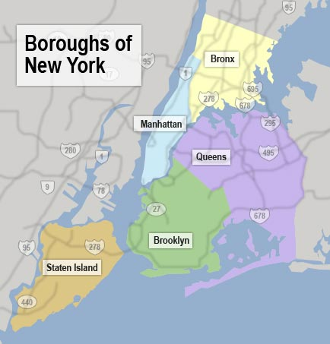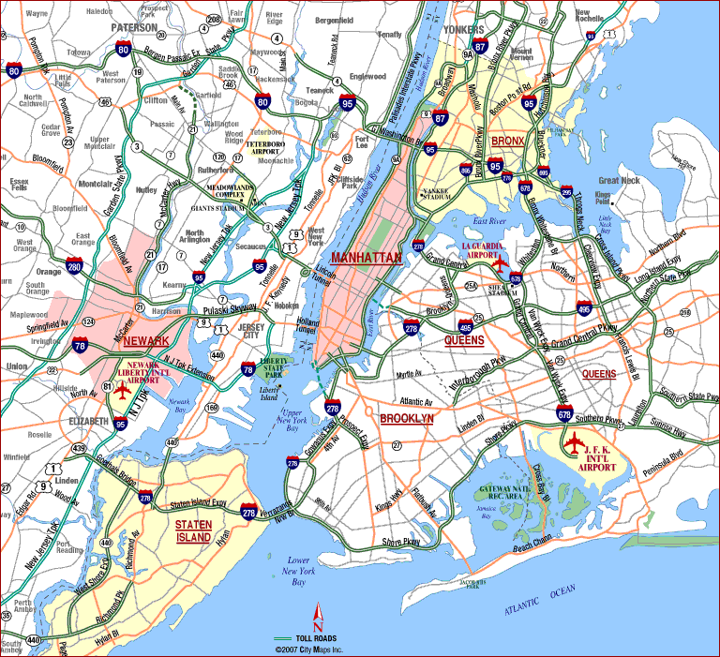
Figure 2: Boroughs of New York City
Methodology
This research utilizes a quantitative methodological design for performing secondary analysis of pre- and post-test data produced by the 2008 and 2011 New York City Housing Vacancy Survey. By using a quantitative design, this study has the advantage of providing statistical objectivity, generalizable findings, and analyzes of a unique data source to determine correlation between variables. This design allows for the identification of important indicators of displacement associated with gentrification, and proves or disproves relationships between these indicators and specific policies.

Research Hypothesis
This study generally explores the effects of a variety of policy interventions on indicators of displacement in gentrifying communities. Based on literature and policies related to gentrification, it is expected that the imposition of the independent variables (policy interventions) will result in changes in the dependent variables (indicators of displacement), thereby showing a statistically significant relationship. Policy interventions include: 80-20 Inclusionary zoning, rent stabilization, public subsidies, the 3rd Party Transfer Program, and public or privately-provided legal services. Indicators of displacement include changes in: minority status, household income, monthly housing costs & poverty status

Variables
The following variables and their attributes are presented in Appendix A. Following the inclusion of the dependent and independent variables, additional variables may be added following further exploration of the 2008 & 2011 New York City Housing Vacancy Survey data sources.
Dependent Variables
For the purpose of this study it is necessary to translate the attributes of residential displacement into a series of well-defined measures that are both empirical and observable. One method is to compare the characteristics of in-movers and out-movers and determine if any discrepancies exist (Henig 1980 and Spain, et al. 1980). Another method is to retroactively ask residents why they had moved providing gentrification-related displacement pressures as a response option (Newman & Olsen 1982, Grier & Grier 1978). Both measures are used to determine if changes occur within indicators of displacement in three categories: housing, demographic and economic imputations. Dependent variables include:
1. Monthly housing costs
Representing the effects of gentrification on the affordable housing market, this variable will measure changes in monthly contract rent (which may or not be subsidized by federal or state funding), mortgage payments and condominium fees (whichever are appropriate) per household.
2. Ethnicity of household respondent
This variable will determine the ethnicity of each household (to be recoded as “non-minority” (white) or “minority” (non-white)).
3. Annual household income
This variable will measure the changes in the annual household income which includes all income sources from all members within a single household.
4. Number of households in poverty
This measure determines the poverty level of households according to a threshold established annually by the U.S. Department of Health and Human Services.
In this study, dependent variables are measured prior to and following the implementation of policies (IVs) aimed to reduce low-income in gentrifying neighborhoods (2008 and 2011, respectively).
Economic Adjustments
Due to the complex nature of the U.S. housing market and changes in inflation rates between 2008 and 2011, this study can only account for general economic fluctuations that occurred from 2008 to 2011 by controlling for the effect of inflation on household incomes and for the effect of the consumer price index on monthly housing costs. Changes in the dependent variables ethnicity and poverty status that are caused by economic fluctuations between boroughs could not be controlled for.
When adjusting for changes in household incomes between the two sample years that may be caused due to the increasing inflation rate, the following equation was used to re-calculate annual household incomes for 2011:
Adjusted Household Income=2011 Total H.I. – (2011 Total H.I. * 0.029)
This equation results in total household income figures that are adjusted for the changes in the U.S. inflation rate from 2008 to 2011 which was calculated as 2.9%. This was determined by noting the difference in the inflation rate for 2008 (0.1%) and 2011(3.0%) according the U.S. Bureau of Labor Statistics.
The consumer price index, another statistic used by U.S. Bureau of Labor Statistics to determine annual inflation, measures changes in the price of consumer goods over time and has a specific price index for owner-occupied dwelling expenses for the New York City-Northern New Jersey area. The following charts notes the overall changes in total CPI for the area from 2010 to 2013.
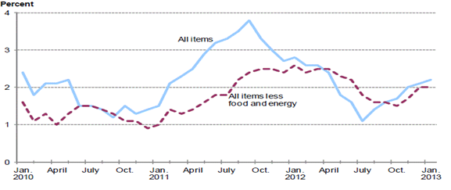
Figure 3: New York City-Northern New Jersey CPI (U.S. Bureau of Labor Statistics, 2013)
This study uses the owner-occupied dwelling CPI to account for any changes in monthly housing costs between boroughs, that may be explained by inflation of consumer prices. The following equation was used to re-calculate monthly contract rent and mortgage payments for 2011:
Adjusted Monthly Contract Rent= 2011 Contract Rent – (Contract Rent * 0.044)
Adjusted Monthly Mortgage= 2011 Mortgage Payments – (Mortgage *0.044)
Because the NYCHVS coded condiminuium fees in 2008 and 2011 as ordinal variables, the raw data, which would show exact costs for each respondent, is not available and therefore, the variable cannot be controlled for by the CPI.
Independent Variables
The contemporary academic literature reveals that the following five specific policy alternatives, which aim to effect indicators of displacement, as the most commonly implemented in New York City boroughs. These will be dictated as the independent variables in this study and include: (1) 80-20 inclusionary zoning, (2) rent stabilization, (3) public subsidies, (4) 3rd Party Transfer Program and (5) Public or privately provided legal services. Each policy alternative is represented by a proxy variable, measured by a borough surveyed in New York City. These proxies are appropriate as each borough overwhelmingly utilizes one of these policy alternatives.
1. 80-20 Inclusionary Zoning
Manhattan, NYC will be used as a proxy to represent the implementation of this policy intervention. This area is identified geographically in Appendix B.
2. Rent Stabilization
Staten Island, NYC will be used as a proxy to represent the implementation of this policy intervention. This area is identified geographically in Appendix C.
3. Public Subsidies
The Bronx, NYC will be used as a proxy to represent the implementation of this policy intervention. This area is identified geographically in Appendix D.
4. 3rd Party Transfer Program
Queens, NYC will be used as a proxy to represent the implementation of this policy intervention. This area is identified geographically in Appendix E.
5. Public or Privately-Provided Legal Services
Brooklyn, NYC will be used as a proxy to represent the implementation of this policy intervention. This area is identified geographically in Appendix F.
Variable Mapping
The following map depicts how the independent and dependent variables will be measured in relation to one another. For illustrative purposes, Figure 4 below displays the relationship between the set of dependent variables and only one independent variable (Inclusionary Zoning/Manhattan). Please note that the same relationships between the other independent and dependent variables are measured similarly.
1. 80-20 Inclusionary Zoning (Manhattan)

2. Rent Stabilization (Staten Island)

3. Third Party Transfer Initiative (Bronx)

4. Public Subsidies (Queens)

5. Public-Private Legal Assistance (Brooklyn)
Monthly Housing Costs

(Contract Rent)
(Mortgage Payments)
(Condominium Fees)

Household Income

Poverty Status

Minority Status
Independent Variables (Borough Proxy)
Dependent Variables
Economic Adjustments
U.S. Inflation Rates (2008 & 2011)
Consumer Price Index-Shelter (2008 & 2011)
Figure 4: Variable Map

Data Gathering and Analysis Procedures
Data Gathering
This study will utilize the results from the 2008 and 2011 New York City Housing Vacancy Survey (NYCHVS), a triennial survey conducted by the New York Housing Authority (NHA) that fulfills the City’s research responsibilities under various rent control and stabilization laws. The NHA has retained the U.S. Census Bureau to conduct this comprehensive survey of the NYC housing market. While rental vacancy rates are the primary focus of the survey, it also covers characteristics of the City’s housing market population, demographics of households, the housing stock, and descriptors of gentrifying neighborhoods. Both the 2008 and 2011 NYCHVS use a simple-random sample survey of 19,000 household units as representative of five NYC boroughs (Bronx, Brooklyn, Manhattan, Queens, and Staten Island). Each responding household represents 170 similar units in the NYC area. The distribution of the 2008 and 2011 NYCHVS were followed by a phone interview to verify responses with a response rate of 98 percent.
In order to ensure consistent information, a variety of procedures are used to reduce error. The data collection procedure of this study accounts for variation between the 2008 and 2011 questionnaires by only comparing responses to the same questions from both surveys (see Appendix A). Any variable that includes additional response options within the 2011 survey not available in the 2008 survey will be recoded to account for reliability of the data used. The results from both surveys are available in three formats: a set of tabulations, a public-use micro-data file containing non-confidential individual housing unit records, and layout records of codes that are used in variable labeling. These codes for the 2008 and 2011 surveys are available within the “Attachments” sections of this report. Finally, the NHA makes their findings available to the public so that relevant agencies can amend housing policies as necessary. Therefore, the NYCHVS results are regarded as highly-reputable and up-to-date.

Data Analysis Procedures
This study will be quantitative in nature which will allow for the findings to verify or reject the presented hypotheses. A series of variables (survey responses) have been re-coded in order to test for significant relationships between variables. The five boroughs which are sampled from in the 2008 and 2011 NYCHVS serve as proxy variables representing a particular policy intervention. The dependent variables, which serve as indicators of displacement, correspond to a specific question within the survey. Change in housing costs and household income are continuous variables while change in ethnicity and poverty have been transformed into dichotomous categorical variables. All recoding and statistical procedures will be processed after collection using IBM SPSS version 20, a computer program used for statistical analysis. With this program the original data sets and results are managed, stored and accessed throughout and following the conclusion of the study.
Firstly, descriptive statistics were used to summarize the collection of data for all variables and include measures of central tendency (mean, minimum, and maximum), measures of dispersion (standard deviation and normal distribution). These observations are available both numerically and graphically.
Secondly, inferential statistics were used to determine, with statistical accuracy, conclusions about the strength and direction of relationships between variables. Affirming the assumptions of t-test, a series of independent samples t-tests were run to determine whether a relationship between the means of the independent variables (policy interventions) and dependent variables (changes in monthly housing costs and household income) were statistically significant before and after the implementation of policies. Thirdly, a chi-square test will be run between the independent variables and dependent variables (minority and poverty status) to test for statistical significance.
These tests measure if the dependent and independent variables are statistically related and are most appropriate due to each variable type and their ability to determining both the existence and then strength of any relationship between variables.

Evaluation of Validity and Reliability
In terms of validity, the results, variables, methodology and research design method used within this study were evaluated based on face, content, construct, internal and external validity and are found to be both the most appropriate and accurate application. Based on previous seminal studies and rational expectations of relationships between the independent and dependent variables, the following design and data source utilized throughout this study demonstrates facial validity. Additionally, due to the comprehensive nature of all of the variables used including five independent and four dependent, the full dimension of gentrification related displacement is measured. Both the dependent and independent variables evaluated in this study are supported as standard measures used by the past academic literature. The policy interventions serving as proxy independent variables (NYC boroughs) are imperfect but adequate measures to test whether movement was initiated as a reaction to gentrification-related displacement pressures. The particular policy intervention associated with each borough proxy is the most commonly-employed mitigation technique currently used within that borough. Based on the analysis, these proxy variables are expected to closely relate to any change that occurs in the dependent variables. It is important to note that the objective of this study is to prove the existence of statistically significant relationships only. If future research seeks to determine causality, amendments to the current research design must be made. Finally, to ensure internal and external validity, it is assumed that changes in the dependent variables are strongly related to the imposition of the independent variables. Therefore, this study’s results can be generalized to other urban environments currently employing these policy interventions. In responding to the research question, the use of these variables and data sources are the most appropriate for reaching valid conclusions.
The research design also demonstrates reliability. Both the 2008 and 2011 NYHVS are conducted and managed by the U.S. Census Bureau—the foremost reliable surveying agency in the nation. Because of the high-quality of data collection and management procedures practiced by the Census Bureau, it can be assumed that this data set is comprehensive, accurate, and reliable. Also, while this study only evaluates changes within a three-year time frame and may not reflect changes in displacement indicators that have yet to occur, there has yet to be another data source established to collect this specific information. Therefore, the results of the NYCHVS are the most significant and reliable sources. Additionally, the regularity with which this data is used by planners, policymakers and scholars makes it a reliable source with which to measure displacement. Finally, the consistency of how and where the surveys were conducted throughout New York City (regarding both the questions within the surveys and the households surveyed), assures that this is a reliable data source for examining the effects of policy interventions on displacement rates. Further, this methodology can be replicated following the release of the 2013 NYCHVS results. Finally, while the samples in the 2008 and 2011 NYCHVS suffer from admitted under-coverage, the Census Bureau has developed statistical procedures to mitigate for this common error in demographic surveys. Based on the data source and methodology used within this study, the findings are both valid and reliable.

IV. Findings
2008 & 2011 Populations
In the interest of evaluating the effect of the independent variables (policy alternatives) on the dependent variables (indicators of displacement) it is helpful to first discuss the descriptive characteristics of both the 2008 and 2011 sample populations of the NYCHVS and preliminarily discuss any significant changes that have occurred. These characteristics include all four dependent variables: race/ethnicity of the household respondent, total household income, monthly housing costs (mortgage payments, condo fees, and contact rent), and poverty status.
With regard to the racial composition of the City, all boroughs saw a marginal increase in residents who identified as “Caucasian” and a general decrease of those whom identified as “Hispanic/Spanish” and “African American”. The following table denotes changes from 2008 to 2011 in the frequency and percentage of minority and non-minorities by borough.
 | Minority (2008) | Non-Minority (2008) | Minority (2011) | Non-Minority (2011) | Change from “Minority”
Bronx | 2456 (84.1%) | 466 (15.9%) | 1414 (55.7%) | 1123 (44.3%) | (-28.4%)
Brooklyn | 2908 (59.3%) | 2000 (40.7%) | 2152 (45.9%) | 2534 (54.1%) | (-13.4%)
Manhattan | 1994 (43.9%) | 2552 (56.1%) | 1367 (31.6%) | 2956 (68.4%) | (-12.3%)
Queens | 742 (66.5%) | 374 (33.5%) | 1727 (43.8%) | 2218 (56.2%) | (+22.7%)
Staten Island | 378 (30%) | 882 (70%) | 151 (17.4%) | 716 (82.6%) | (-12.6%)
Table 1: Household Ethnicity Descriptives 2008 & 2011
While all boroughs follow the general trend of lower minority residency from 2008 to 2011, Queens is a particularly interesting case to examine with an overall increase in non-minority (“Caucasian”) by 22.7%. As the academic literature suggests that an indicator of residential displacement following gentrification is the reduction of ethnic diversity in neighborhoods, these findings may suggest that such an event is occurring, specifically in Queens where the independent variable, public subsidies, are most in use.
Additionally, the change in the frequency of households in poverty (calculated according to the national poverty line) from 2008 to 2011 may also be an indicator that gentrification is being followed by low-income residential displacement. While analysis of total populations suggest that the poverty rate has risen by 1.1% from 2008, the cross tabulations of poverty and individual boroughs are more illustrative of gentrification-related neighborhood changes. The following table shows the descriptives for households in poverty by borough and overall change between sampled years.
 | 2008 Impoverished (#/%) | 2011 Impoverished (#/%) | Change (#/%)
Bronx | 949 (32.5%) | 744 (29.3%) | -205 (3.2%)
Brooklyn | 904 (18.4%) | 917 (19.6%) | +13 (1.2%)
Manhattan | 819 (18.0%) | 617 (14.3%) | -202 (3.7%)
Queens | 182 (16.3%) | 518 (13.1%) | -336 (3.2%)
Staten Island | 120 (9.5%) | 92 (10.6%) | -28 (1.1%)
Table 2: Household Poverty Status 2008 & 2011
A negative figure in the “Change” column signifies that the overall percentage of households considered in poverty dropped, in effect, neighborhoods are becoming less impoverished. The academic literature suggests that this condition may signal changes in neighborhood demographics that follow gentrification—i.e. low-income residents are forced out as wealthier residents move in and gentrify.
It is interesting to consider the potential relationship between changes in ethnic diversity and changes in poverty levels. While the literature notes that displacement is most readily evidenced by a decrease in poverty levels and ethnic diversity, this study’s findings imply that in Brooklyn and Queens an inverse reaction is occurring. Specifically, in Queens ethnic diversity is increasing while poverty is decreasing and in Brooklyn ethnic diversity is decreasing while poverty is increasing. The relationship of these statistics to affordable housing policies will be discussed in further throughout this section.
Furthermore, measurements of household income were particularly reflective of the socio-economic diversity present between all NYC boroughs. While no other boroughs showed dramatic changes in household income figures, respondents from Queens noted a marked increase in annual household income by over $10,000. The 2008 mean household income in Queens was $55,663.27 compared to $66,570.13 in 2011. As a borough’s mean household income increases, it can be assumed that some level of residential renewal (i.e. gentrification) may be responsible for attracting wealthier residents. Beyond this finding, Queens continued to be the least wealthy borough in terms of household income with Manhattan’s 2008 and 2011 mean household income the highest at $126,782.47 and $125,161.13, respectively.
Finally, monthly housing costs, which are defined by monthly mortgage payments, condominium fees and contract rent, generally increase from 2008 to 2011 within all boroughs. The following table denotes changes in the mean costs between populations.
 | 2008 Mean | 2011 Mean | Mean Change
Mortgage Payments | $3,289.59 | $2,125.43 | -$1,164.16
Condominium Fees | $700-799 | $800-899 | $100-199
Contract Rent | $1,132.17 | $1,252.49 | $120.32
Table 3: Change in Mean Monthly Housing Costs from 2008 to 2011
Moderate increases in mean contract rent and mean condominium fees follows as expected with general economic fluctuations, but the decrease in mean mortgage payments from 2008 to 2011 has implications about the decrease of the NYC housing rental market. At the height of a hot housing market in 2008, the $3,289.59 monthly payments are indicative of the effects of the housing bubble. As that bubble burst, the demand for housing and values decreased dramatically, and households refinanced their existing debt obligations, average mortgage costs decreased, as is evidenced by the 2011 mean of $2,125.43. Due to the generally insignificant changes in monthly housing costs and the impact of the housing market, no assumptions can be made regarding residential displacement from this information.
The aforementioned section merely distinguishes the two different populations of my sample (both 2008 and 2011 respondents) and does not hold in statistical verifiability regarding the relationships between indicators of displacement and the effect of policy interventions.

Hypotheses Testing
The following discusses the relationship between indicators of low-income residential displacement (DVs) and policy interventions (IVs) which correspond to specific NYC boroughs surveyed. The level of correlation found between the variables, based on tests which determine statistical significance, allows for the acceptance or rejection of the null sub-hypotheses. A series of chi-square tests for goodness-of-fit, for both minority status and poverty dependent variables, and independent t-tests, for household income and monthly housing costs, were performed to determine if such correlation exists. The following are equations for both tests:
Chi-Square Test:
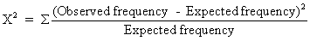
A Chi-square goodness of fit test is conducted between a categorical independent variable and a dichotomous categorical dependent variable, and is used to test the difference between the actual samples and another hypothetical distribution such as that which may be expected due to chance or probability. When the chi-square tests revealed a statistically significant relationship, Cramer’s V (or φc) determined the relative strength of these associations.
Independent Samples T-test:
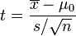 =sample mean, s=standard deviation, n=sample size
An independent samples t-test is conducted between a categorical independent variable and a continuous dependent variable, and is used to compare the means of two different groups of data. This helps to determine if the means are statistically different from one another and determine if the manipulation of the independent variable has an effect on the dependent variable being measured.

The following table illustrates the statistical outputs from both t-tests and chi-square tests measuring the degree of association between each independent variable and dependent variables:

Statistical Outputs for Relationships between IVs (Policies) and DVs (Indicators of Gentrification-related Displacement)
 |  |  | Bronx-Inclusionary Zoning | Brooklyn-Rent Stabilization | Manhattan-Public Subsidies | Queens-3rd Party Transfer | Staten Island-Pub/Private Legal Services
Minority Status |  |  | 66.202 ***  (.000) | 0.579  (>.05) | 13.201 ***  (.000) | 33.008 ***  (.000) | 43.525 ***  (.000)
(Chi-Square/Cramer V) |  |  | 0.11 |  | 0.04 | 0.08 | 0.14
Household Income |  |  | $1,604.23 (>.05) | -$2,302.56 **  (.027) | $5,251.01 **  (.025) | -$8,976.33 **  (.001) | $9,221.45 (>.05)
(T-test)
Monthly Housing Costs
(T-test) |  | Contract Rent | -$30.75 ***  (.000) | -$270.49 ***  (.000) | -$778.29 **  (.002) | -190.32 ***  (.000) | -$195.46 **  (.002)
(T-test) |  | Mortgage Payments | -$2,203.19 (>.05) | -$2,021.53 **  (.004) | -$1,342.46***  (.000) | $941.11  (>.05) | $844.10 **  (.001)
(T-test) |  | Condo Fees | -$73.30 **  (.003) | -$63.20 **  (.004) | -$73.80 ***  (.000) | -$67.60 **  (.011) | -$57.20  (>.05)
Poverty Status |  |  | 6.305 **  (0.012) | 2.062  (>.05) | 22.882 ***  (.000) | 7.37 **  (.007) | 0.677  (>.05)
(Chi-Square /Cramer V) |  |  | 0.03 |  | 0.05 | 0.04
Table 4: Statistical Outputs
**=statistical significance at .05 < p >.000
***= statistical significance at p=.000

The chi-square tests measured the relationships between borough policies and minority and poverty status, and are reported by both the chi-square statistic and its corresponding p-value, which suggests the level of statistical significance of each relationship. The outputs suggest that the higher the chi-square statistic, the greater the probability that any change within minority and poverty status between the 2008 and 2011 samples are explained as the policy’s effect. Also included is Cramer’s V or often referred to as “phi” (φc), which further measures the degree of association between variables, following a statistically significant chi-square result. The φc values range from 0 to 1, with 1 corresponding to complete association and 0 corresponding to no association between the variables. As chi-squared values tend to increase with the sample size (as may be the case), the φc serves as additionally strong evidence of meaningful correlation. This value is only noted on the table above where the chi-square test has determined that a statistically significant relationship exists between the variables.
The independent samples t-tests measured the relationships between borough policies and household income and monthly housing costs. These results are reported by the difference in means between the 2008 and 2011 annual income/housing costs and the corresponding p-values, which suggest the level of statistical significance of each relationship. The difference in means illustrates the magnitude of each policy’s effect on the indicators of displacement (annual household income and monthly housing costs). A statistically significant negative difference in means suggests a decrease in either annual household income or monthly housing costs in the 2011 sample, when compared to the 2008 sample, and may be related to the implementation of each borough policy. Inversely, a statistically significant positive difference in means suggests an increase in annual household income or monthly housing costs in the 2011 sample, when compared to the 2008 sample, which may be related to the imposition of each borough policy.

Bronx: 80/20 Inclusionary Zoning
This output demonstrates the effect of 80-20 Inclusionary Zoning on indicators of displacement investigating if and how:
Inclusionary Zoning affects monthly housing costs (monthly contract rent, mortgage payments & condo fees), annual household income, the ethnicity of householders & poverty

Generally, the findings suggest that there is a statistically significant relationship between minority status, contract rent, condo fees and poverty levels and the implementation of 80-20 inclusionary zoning in the Bronx and no significant relationship found between the policy and household income and monthly mortgage payments.
More specifically, the relationships between inclusionary zoning and poverty and minority statuses were found to be strongly significant. As the high chi-square statistic and Cramer’s V suggest a higher level of probability that the change in the DVs are related to the imposition of the IV, the findings suggest that change in minority status (x²=66.202) is more closely related to the policy’s implementation than is poverty status (x²=6.305). Therefore, following this policy in the Bronx, a marked decrease was seen in both the number of minority and impoverished in the area, and may be caused by the policy itself. Additionally, the findings suggest that there were statistically significant differences in means between the policy and monthly contract rent and condo fees between 2008 and 2011, at -$30.75 and -$73.30 respectively. This suggests that the policy does have an effect on decreases in housing costs which may be related to inclusionary zoning. Finally, there was not however, a statistically significant difference between the mean household income in 2008 and in 2011, which increased $1,604.23, and mean monthly mortgage payments, which decreased -$2,203.19. These findings denote that inclusionary zoning does not have an effect on increased household income and decreased mortgage payments occurring in this time period.

Brooklyn: Rent Stabilization
This output demonstrates the effect of rent stabilization on indicators of displacement investigating if and how:
Rent Stabilization affects monthly housing costs (monthly contract rent, mortgage payments & condo fees), annual household income, the ethnicity of householders, & poverty

Generally, the findings suggest that there is a statistically significant relationship between household income, monthly housing costs (including contract rent, mortgage payments, and condo fees) and the implementation of rent stabilization policies in Brooklyn and no significant relationship between the policy and rent stabilization, minority, and poverty statuses.
Firstly, the relationships between the policy and household income and monthly housing costs were found to be strongly significant. In terms of the change in annual household income between 2008 and 2011, the independent samples t-test revealed that there was a statistically significant difference between the mean total household income of 2008 and that of 2011 totals at -$2,302.56. This is a substantial amount of change in average household income which may be related to the implementation of rent stabilization policies. Additionally, the imposition of this policy was shown to be significantly related to changes in all three facets of monthly housing costs (contract rent, mortgage payments and condo fees). The -$270.49 difference in mean monthly contract rents between 2008 and 2011 signifies that this policy was statistically related to this cost change. Because rent stabilization only applies to rental property rates, the statistical relationships between the policy and the remaining monthly housing costs (mortgage payments and condo fees) are largely inapplicable to this study’s purpose. Finally, there was not a significant relationship between the policy’s effect on minority and poverty statuses, which had fairly low chi-square statistics, at X²=0.579 and X²=2.062, respectively.

Manhattan: Increased Public Subsidies
This output demonstrates the effect of public subsidies on indicators of displacement investigating if and how:
Public subsidies affect monthly housing costs (monthly contract rent, mortgage payments & condo fees), annual household income, the ethnicity of householders, & poverty

Generally, the findings suggest that there is a statistically significant relationship between minority status, household income, monthly housing costs (including contract rent, mortgage payments, and condo fees) and poverty, and the implementation of public subsidies in Manhattan.
As this policy was statistically related to all of the indicators of displacement, it is helpful to consider the level statistical significance found between relationships and the magnitude of change in the dependent variables related to the increase in public subsidies. Firstly, changes in both minority and poverty statuses from 2008 to 2011 were found to be related to this policy. More specifically however, the relatively low Cramer V’s note that the policy’s associations to changes in minority and poverty statuses are weak (at 0.04 and 0.05 respectively). Following the implementation of this policy, decreases in the number of minorities and the number of impoverished residents were found in Manhattan, which may be related to the policy itself. Furthermore, the independent samples t-test results noted that the policy was also significant related to the changes in annual household income between 2008 and 2011. This value increased $5,251.01 following the policy’s imposition. Monthly housing costs responded to the policy similarly. All three facets (contract rent, mortgage payments and condo fees) saw a decrease in monthly costs, which may be related to increased public subsidies. Contract rent and mortgage payments most notably saw a substantial decrease in mean costs by $778.29 and $1,342.46. These findings denote that increased public subsidies are significantly related to changes in all indicators of displacement occurring in this time period in Manhattan.

Queens: 3rd Party Transfer Program
This output demonstrates the effect of Third Party Transfer initiatives on indicators of displacement investigating if and how:
Third Party Transfer Program affects monthly housing costs (monthly contract rent, mortgage payments & condo fees), annual household income, the ethnicity of householders, & poverty

Findings suggest that there is a statistically significant relationship between minority status, household income, monthly housing costs (including contract rent and condo fees) and poverty, and the implementation of the Third Party Transfer Program in Queens and no significant relationship found between the policy and mortgage payments.
The chi-square tests between minority and poverty statuses and the Third Party Transfer Program suggest that there is a statistically significant relationship between the increase in minority residents and decrease in poverty levels in Queens and the policy--with increases in minorities more strongly associated with the policy than the decrease in poverty (Cramer’s V values are 0.08 and 0.04). The high chi-square statistic (X²=33.008) and very significant p-value (.000), suggest that there is a high probability that the increase in minority populations within this borough is related to the imposition of this policy. Similarly, the $8,976.33 decrease in mean household income was found to be statistically related to the Third Party Transfer policy. Finally, the dimensions of monthly housing costs varied in their statistical relationship to the policy’s implementation following 2008. While decreases in mean contract rent and condominium fees (-$190.32 and -$67.60) were found to be statistically related to the policy, the decrease in mean mortgage payments (-$941.11) was not. These findings denote that increased public subsidies are significantly related to changes minority and poverty statuses, household income, monthly contract rent, and condominium fees.

Staten Island: Public/Private Legal Services
This output demonstrates the effect of public/private legal services on indicators of displacement investigating if and how:
Public/Private legal services affect monthly housing costs (monthly contract rent, mortgage payments & condo fees), annual household income, the ethnicity of householders, & poverty

The findings suggest there is a statistically significant relationship between minority status, household income and monthly housing costs (including contract rent and condo fees), and the implementation of publicly or privately-provided legal services in Staten Island and no significant relationship found between the policy and household income, monthly condo fees, and poverty status.
More specifically, the chi-square goodness-of-fit test revealed there is a high probability that the decrease in the number of minority residents in Staten Island from 2008 to 2011 is related to the availability of public/private legal services to residents as evidenced by the 43.525 chi-square value. The high 0.14 Cramer’s V signifies that decreases in minority populations were more strongly associated with this policy, than any other borough policy. The same could not be said for the decrease in poverty levels in Staten Island in this period which is statistically unrelated to this policy. Additionally, the $9,221.45 increase in the mean household income between 2008 and 2011 and the -$57.20 decrease in monthly condominium fees were also found to be unrelated to the imposition of this policy. Finally, the mean decreases in monthly contract rent and mortgage payments were however related to the policy and resulted in -$195.46 decrease and $844.10 increases in average costs. These findings denote that increased available of public and private legal services to Staten Island residents are significantly related to changes in minority status, decreased monthly contract rent and increased monthly mortgage payments.

V. Discussion
Overall, the findings show that every policy (identified by NYC borough) was statistically related to changes in at least three indicators of displacement from 2008 to 2011. This is not to say these changes exclusively reflect the policies’ themselves, or the effect of housing variables, market influences and neighborhood characteristics. The following section analyses the effect of each of the policies in responding to gentrification-related displacement.
Policy Analysis
Each policy corresponds to specific changes in indictors of displacement which may be the result of the interaction between the policy and unique neighborhood characteristics of each borough. The following discusses the potential effect of each policy by identifying changes found in indicators of displacement. The following table identifies the statistically significant impacts of each policy on indicators of displacement and their corresponding levels of effectiveness. A statistically significant relationship is denoted by an “X” and the subsequent arrows “↑ and ↓” note the direction of change each indicator experienced between 2008 and 2011, which may be related to the imposition of each policy.
 | Minority Status | Household Income | Monthly Housing Costs |  |  | Poverty Status
 |  |  | Contract Rent | Mortgage Payments | Condo Fees
80-20 Inclusionary Zoning Impacts | X | X ↑ | X ↓ |  |  | X
Rent Stabilization Impacts |  | X ↓ | X ↓ | n/a | n/a
Public Subsidies Impacts | X | X ↑ | X ↓ | X ↓ | X ↓ | X
3rd Party Transfer Program Impacts | X | X ↓ | X ↑ |  | X ↓ | X
Legal Services Impacts | X | X ↑ | X ↑ | X ↓
Table 5: Policy Impacts on Indicators of Displacement

80-20 Inclusionary Zoning in the Bronx
80-20 Inclusionary Zoning was related to changes in minority status, increases in household income, decreases in monthly contract rent, and change in household poverty in the Bronx. These findings seem initially contradictory, in that an increase in poverty does not typically occur simultaneously with an increase in annual household income. However, this may be explained by the increasing socioeconomic stratification found in the Bronx, with the incoming gentrifyers’ higher income levels augmenting household income levels as low-income households slip into poverty. Surprisingly, inclusionary zoning may also have had the effect of increasing minority populations and decreasing the average monthly contract rent prices from 2008 to 2011 by -$30.75. This may indicate that the policy had the effect of reducing monthly housing costs for specifically low-income renters by providing additional affordable units, or the falling housing values caused by the economic recession and the housing bubble forced landlords to reduce rent to avoid vacancies and foreclosures. This however, is a relatively small decrease and therefore, the effects of this policy on the Bronx rental stock prices could be considered minimal. There was no relationship found between changes in mortgage payments or condominium fees and 80-20 Inclusionary Zoning, which may mean that this policy is more closely addresses renter-specific concerns of displacement. These findings verify that 80-20 Inclusionary Zoning is, to some extent, has an effect on changes in minority status, monthly rental prices and annual household income levels present in the gentrifying Bronx.

Rent Stabilization in Brooklyn
The imposition of rent stabilization policies, commonly-employed in Brooklyn, was shown to have little relation to changes in ethnicity and poverty statuses, but some association to decreases in annual household income and monthly housing costs. In comparison to Inclusionary Zoning, which was found to be related only to changes in contract rent, rent stabilization was initially associated with decreases in all three housing cost categories: contract rent by -$270.49, mortgage payments by -$2,021.53 and condominium fees by -$63.20. Unfortunately, as this policy only applies to rental housing stock, its relationships to reduced mortgage payments and condominium fees are not indicative of the policy’s effect. In addition, the average annual household income within Brooklyn dropped by $2,302.56 between 2008 and 2011 and may be explained by the attraction of low-income residents to the area, as the policy addresses gentrification’s effect on housing prices. This policy had no association with changes in minority populations (an increase of non-minority residents by 13.4%) and in the level of poverty (increased by 1.2%) in the borough. It can be determined that rent stabilization policies are limited in their application to the diverse housing market of Brooklyn, and therefore, have an inadequate capability to effect all of the facets of displacement-related gentrification.

Public Subsidies in Manhattan
Public Subsidies was the only policy intervention explored throughout this study that was found to be statistically associated with changes in all six dependent variables. The policy’s association to both minority and poverty status suggests that there is a probability that the decrease in the number of residents in poverty and minorities is related to the increase in public subsidies. While subsidies are employed in all boroughs of NYC, they and affordable housing developments are not uniform. In fact, according to a recent report published by the Association for Neighborhood and Housing Development, four of the five new areas in which subsidized units were constructed in the last five years in NYC are within Manhattan (Hu, 2013). This may have had the subsequent effect of increasing subsidies provided to residents (in the form of Section 8 housing, rental assistance and supportive services) by way of these units and thereby decreasing displacement pressures. Likewise, this policy was found to be associated with an increase in household income and a decrease monthly housing costs in all dimensions. More specifically, contract rent reduced by $778.29, mortgage payments by $1,342, and condo fees dropped $73.80. This borough saw the largest amount of statistically significant change in both contract rent and mortgage payments in comparison to other NYC boroughs. The findings of increased income and decreased housing costs may be inter-related in that public subsidies supplement housing costs, which would otherwise be paid for through annual household income. As contract rent, mortgage payments, and condominium fees are reduced, an inverse effect occurs in household income. These findings suggest that public subsidies has an effect on changes in all of the indicators of displacement in gentrifying Manhattan.

Third Party Transfer Program in Queens
The Third Party Transfer Program instituted in Queens was found to be related to changes in almost all categories, except increases in monthly mortgage payments. In terms of changes in minority populations, this policy was shown to be associated with an increase to the number of minority residents from 2008 to 2011. General descriptive statistics of Queens present (unlike a marked decrease in other boroughs), a 22.7% increase in the number of residents who identified as ethnic minorities. This may be the result of the influx of non-Hispanic Whites into the city core (Manhattan, South Bronx, and North Brooklyn) and the subsequent movement of minority populations into outer boroughs, like central and northern Queens. Likewise, this policy was strongly associated with decreases in annual household income levels by -$8,976.33 and a decrease in impoverished populations. This change may be explained by the in-movement of recently displaced residents from other boroughs that are not considered impoverished, and caused a decrease in the mean household income and a decrease in poverty levels. Finally, this policy was also related to decreases in monthly contract rent by -$190.32 and condominium fees by -$67.60, which may be explained by the increase of subsidized affordable housing properties developed by this program. Overall, the Third Party Transfer program somewhat effects changes in displacement indicators in gentrifying Queens.

Public/Private Legal Services in Staten Island
Lastly, public and privately-provided legal services in Staten Island were found to be related to changes in minority status and some monthly housing costs (i.e. monthly contract rent and mortgage payments). This policy had no relation to increases in annual household income, changes in poverty status, or decreases in monthly condominium fees. This policy was associated with a decrease of minority populations by 12.6% from 2008 to 2011. While this decreases was minimal in comparison to minority population changes in other boroughs, this policy was the most strongly associated with change. This trend may be explained by the increase in non-minority populations entering NYC, seeking residence closer to the city core. This decrease in diversity within Staten Island may be indicative of the failure of public and private legal services to protect minority residents from gentrification-related displacement. Additionally, this policy was found to be related to a decrease in average contract rent by -$195.46 and an increase in monthly mortgage payments by $844.10. As this policy is intended mostly for renters, the decrease in mean contract rent may indicate that this intervention is somewhat effective at regulating for general increases of contract rent in gentrying areas. The increase in mortgage costs in the borough from 2008 to 2011 may be the effect of the passage of the 2010 FHA Reform Act which allows the Federal Housing Authority to increase premiums (i.e. mortgage insurance) on loans by 2.25%. This would have the effect of higher mortgage payments once increased premiums were factored in. Public and privately-provided legal services therefore, only minimally effects changes in annual household income, poverty status or condominium fees, which may have occurred due to gentrification.

Assessment
In the context of gentrification, the findings reflect that gentrification-related residential displacement related to gentrification, particularly of low-income communities, is in fact happening in New York City. In agreement with gentrification scholars Carlson (2003) and Newman & Wyly (2006), all boroughs included in this study are generally experiencing an influx of white, educated, middle class households into previously low-income areas. Changes in indicators of displacement from 2008 and 2011 suggest that on average, household incomes are rising, monthly housing costs are increasing, the level of poverty is decreasing, and ethnic minorities are leaving inner-city boroughs, all serving as evidence of low-income displacement. With the increase of re-development and urban renewal in downtown NY neighborhoods, as noted by the academic community, it can be inferred that low-income displacement and downtown gentrification are related (Ellen & O’Reagan, 2010; Mallach, 2008; McKinnish, et. al., 2010; Walks & Maaranan, 2008).
The findings further supported the use of all policy intervention options as somewhat effective at prompting changes in one or more indicators of displacement (Basu & Emerson, 2000; Dulchin, 2003, Seron, et. al., 2001; Freeman, 2002). Following individual results, public subsidies were the only policy option however, which had a measureable association to all five indicators of displacement and is therefore, has the largest effect on low-income residential displacement changes in the face of gentrification within Manhattan.
Because several of these policies overlap in each borough (for example public subsidies are used within every borough), it is difficult to isolate the effect of a single policy. Rather, this study understands that each policy responded to a very unique set of neighborhood conditions, and some may be better suited at effecting for particular indicators of displacement more so than others. In this respect, it is significant to identify that in areas where minority populations and contract rent prices have decreased, 80-20 Inclusionary Zoning had the strongest relationships to these changes. Therefore, it can be inferred that the implementation of inclusionary zoning is helpful in mitigating for impacts of gentrification on monthly housing costs and neighborhood diversity. Additionally, as average household income generally declined from 2008 to 2011 in applicable boroughs, the Third Party Transfer Program had the strongest association with a similar decrease in Queens. This may mean that this policy provides greater opportunity for cities to foreclose on or repossess vacant buildings and increases subsidized housing units for low-income groups. This effect is outwardly expressed by a decrease in average household income. Finally, increased public subsidies had the strongest association to decreases in mortgage payments, condominium fees, and the number of impoverished residents from 2008 to 2011. The decrease in poverty levels is particularly interesting to consider and has two potential explanations: (1) gentrification efforts have led to the replacement of impoverished households with mid and high-income households, or (2) the level of poverty has decreased because the increase in subsidized units created by this policy has reduced the rent burden on low-income households and fewer are slipping below the poverty line. The latter explanation supports the Third Party Transfer program’s implementation while the former rejects it. Therefore, this information cannot be used to appropriately evaluate this policy.
The additional value of this study may be found also in suggesting how to best pair and implement grassroots, consumption-side, and production-side policy responses to address gentrification-related displacement, based on the evidence gathered of each policy’s independent effects. This information is helpful to policy-makers when considering the specific characteristics of the municipality or citizenry that they serve. For example, in an area that is experiencing an extreme increase in monthly contract rents following gentrification, a city manager may choose to implement both inclusionary zoning and increase public subsidies in tandem to regulate for the secondary effect of displacement. The same may be said for an area which is dealing with an increasing socio-economic stratification. In this instance, the imposition of a rent stabilization policy and a program similar to the Third Party Transfer Program may assist in increasing opportunities for low-income and middle-class households to reside in the area. Specific policies to be matched and utilized in each respective area however, must be predated by an in-depth analysis of the effects of gentrification on displacement indicators to ensure their effectiveness.

Broader Significance
Self-identified Displacement
While the policy interventions discussed have the intention of combating gentrification-related displacement, the original 2008 and 2011 NYCHVS from which the sample population was taken from, also asks residents to identify the reason why they moved, allowing for public and private gentrification as a response option. In analyzing the frequency of respondents who marked gentrification as the impetus for displacement, it is surprising to find that only 54 respondents in 2008 and 59 respondents in 2011 (both 0.3% of total sample) responded in this manner. This finding has several interpretations. It might indicate that gentrification-related displacement in NYC is not as prevalent as the literature denotes. Due to the sheer number of gentrified units in NYC and extensive academic exploration of the issue, this interpretation may not best explain the low-response rate. Rather, this statistic might be the effect of a limited public understanding of gentrification or difficulty in identifying this phenomenon. As a complex process, identifiable by many facets (changes in housing stock, jobs, and commercial development), residents may identify one of these aspects, rather than gentrification, as the reason for their displacement. For example, when including other response options that may be associated with gentrification (i.e. seeking cheaper housing costs, landlord harassment, etc.), the 0.3% response rate discussed previously increases to 4.9%. The broader implication of this finding is that residents are uninformed about the presence of gentrification and its effect on housing costs, service provisions, and neighborhood diversity. Should all stakeholders be more appropriately informed about the process, there may be an increase in the identification of gentrification-prompted displacement.

Generalizability of Findings
When considering the implications of these findings, in responding to low-income residential displacement, the best approach may be to incorporate all of these policies simultaneously. New York City’s complex housing market, diverse population needs, and highly-active private and public development, would allow for such an occurrence and may result in a more comprehensive approach to dealing with gentrification-related residential displacement. While the breadth and depth of the NYC housing market may be unlike any other municipality, other cities may benefit from using two or more of these policies concurrently, with one addressing the renter-specific market (for example 80-20 Inclusionary Zoning), and the other mitigating for demographic changes in income and ethnicity (such as increased public subsidies). Additionally, there is a common misconception that inadequate housing is a limitation of local governance. This study’s findings suggest that grassroots projects, developed and promoted by non-profits and private agencies (i.e. public and private provided legal services) can also effect change in gentrification-related displacement characteristics. Finally, it is also worth noting that an extensive assessment of the current and projected housing and service needs of a city must be completed prior to the implementation of any one of these policies. Without this information, the imposition of any of these policies would be unfounded, predicated on unreliable assumptions of the current housing market which may not account for the role of gentrification.

Research Limitation
Although this report did produce conclusive results and implications about gentrification and residential displacement, its findings were plagued by multiple limitations. Firstly, as the samples consisted of two years of responses from the NYCHVS there was a lack of ability to prove that the implementation of policies had a causal relationship with indicators of displacement. This also disallowed the study from producing results that would facilitate forecasting of future effects. Rather, this study could only present this data as pre- and post-tests utilizing chi-square tests and t-tests in analysis, allowing only for results which suggest statistical relationships between policies and changes in displacement. Though several relations were found to be statistically significant with high chi-square test statistics, it should be noted that this may be the result of a large sample population rather than a high probability of association. Though Cramer’s V statistic was used to approximate the degree of association between variables, all of them were considerably low, which are contrary to the high chi-square values. Secondly, the uniqueness of the NYC housing market and the degree of gentrification within each respective borough makes the generalizability of findings to other areas particularly difficult. Both respondents and neighborhood characteristics within each borough are highly individualized and identifying a comparable would be near impossible. This shortcoming may also be exacerbated by this study’s inability to develop meaningful control variables to account for economic and housing trends of each borough. Though the U.S. inflation rate and the Shelter CPI were adequate to control for national trends, they cannot mitigate for differences between boroughs. Finally, this study does not include all policy interventions aimed to reduce displacement or all indicators of displacement to measure their relationships to one another. While the policy measures were determined by the literature as the commonly-employed in each borough, many of them overlap, which doesn’t allow for the results to isolate and illustrate the effects of a specific independent variable on the dependent variables. Furthermore, there may be more appropriate indicators of displacement which would have served as better cues that residential displacement was occurring in gentrifying areas.

Future Research
The methods and findings of this report provide a natural guide for future research. Following the release of the next set of NYCHVS data in 2014, this study’s methodology could be repeated to report more recent changes in displacement. Furthermore, with the inclusion of another sample year, the methodology could be re-worked to allow for a time-series analysis to measure the effect of each policy on the changes in indicators of displacement rather than association. Additionally, future endeavors can use the results provided here to prompt further empirical evaluation of the existing policies in New York City boroughs and determine if there are policy options that are more effective in meeting the needs of specific boroughs. Finally, residential mobility emerged as a common trend throughout this study’s samples, in that the reduction of certain populations within one borough was found to be strongly related to an increase of that population in another borough. In this respect, residential movement needs to be understood beyond the traditional sense of in-movers and out-movers to account for the frequency of intra-borough movement when measuring for gentrification-related displacement. The pursuit of these aforementioned research goals has the potential to develop more meaningful and significant results in the field.

VI. Conclusion
This study set out to explore the effects of a series of policy interventions, commonly-employed in NYC boroughs undergoing gentrification, on changes that occur in indicators of low-income residential displacement. It was the intention of this research to illustrate not only the changing socio-economic conditions and demographics of inner-city neighborhoods in the midst of urban renewal, but also if and how policies aimed at curbing displacement relate to those changes.
The main findings of this report note that each policy has a relationship to specific changes in neighborhood characteristics that serve as indicators of displacement. Each policy is responding to a very unique set of conditions, and some may be better suited at mitigating for particular indicators of displacement more so than others. In this vein, in areas where minority populations and contract rent prices have decreased, 80-20 Inclusionary Zoning had the strongest relationships to changes. As average household income generally declined in applicable boroughs, the Third Party Transfer Program had the strongest association to this change. Finally, increased public subsidies had the largest relationship to decreasing mortgage payments and condominium fees, and the reduction of impoverished residents from 2008 to 2011. The syntheses of these conclusions suggest that no one policy is definitively effective at mitigating for the all of the effects of gentrification on low-income residents in NYC boroughs and adds to a growing body of literature of this field.
The samples and methodology limited this study’s capacity to determine if these associations between policies and changes in boroughs were statistically correlated or causal in nature. Additionally, because of the strong effect of the NYC housing market and borough-specific economic trends, it is difficult to assess if changes in indicators of displacement are the isolated effect of the policies. These shortcomings may prompt future researchers to pursue these goals to further the understanding of gentrification-related displacement and produce more meaningful results.
References
Allred, C.J. (2000). Breaking the cycle of abandonment. Presented at the Department of Housing Preservation and Development Forum, New York City, NY.
Atkinson, R. (2003). Introduction: Misunderstood savior or vengeful wrecker? The many meanings and problems of gentrification. Urban Studies, 40(12), 2343-2350.
Atkinson, R. (2004). The evidence of the impact of gentrification: new lessons for urban renaissance? European Journal of Housing Policy, 4(1), 107-131.
Bailey, N., Robertson, D., (1997) Housing renewal, urban policy and gentrification, Urban Studies, 34, 4, pp.561-78.
Basu, K., & Emerson, P.M. (2000). The economics of tenancy rent control. The Economic Journal, 110(466), 939-962. Retrieved from: http://www.jstor.org/stable/2667859
Beauregard, R. (1986). "The Chaos and Complexity of Gentrification." Pp. 35-55 in Neil S. Smith and Peter Williams, Eds. Gentrification of the City. Boston, Mass: Allen and Unwin.
Bloom, A. & Old, J.P. (2007). Reconstructing the Vale of Paradise: A return to the City Beautiful Movement. The South Shore Journal, 2, 30-68. http://www.southshorejournal.org/archive/documents/Vale%20of%20Paradise.pdf
Bourne, L.S. (1993). “The demise of gentrification? A commentary and prospective view.” Urban Geography. 14 (1): 95–107.
Brooks. F., Lewinson, T., Aszman, J., & Wolk, J. (2011). Vouchers users and revitalized public-housing residents 6 years after displacement. Research on Social Work Practice, 22(10), Retrieved from: http://rsw.sagepub.com/content/22/1/10
Cardasco, F., & Galatioto, R.G. (1971). Ethnic displacement in the interstitial community: The East Harlem (New York City) experience. Journal of Negro Education, 40(1):56-65. Retrieved from: http://www.jstor.org/stable/2966926
Carlson, N. (2003). Urban gentry. Ford Foundation Report, 34(2): 24-31
Clark, C.S. (2007). Revitalizing the cities: Is regional planning the answer? CQ Researcher 5(38): 1-37.
Davidson, Mark. 2009. Displacement, space and dwelling: Placing gentrification debate. Ethics, Place and Environment 12(2): 219-234.
Day, J. N. (1999). Urban Castles: Tenement Housing and Landlord Activism in New York City, 1890–1943. New York: Columbia University Press.
Duany, A. (2001). Three cheers for gentrification. The American Enterprise. 12(3):36-39.
Dulchin, B. (2003). Organizing against gentrification fighting the free market: Displacement-free zone campaign. Social Policy, 34(2).
Ellen, I.G. and O’Regan, K. (2008). Reversal of fortunes? Lower-income urban neighborhoods in the US in the 1990s. Urban Studies 45: 845-869.
Erickson, D.J. (2006). Community capitalism: How housing advocates, the private sector and government forged new low-income housing policy 1968-1996. Journal of Policy History, 18(2), 167-204.
Formoso, D., Weber, R. & Atkins, M. 2010. Gentrification and urban children’s well-being: Tipping the scales from problems to promise. Society for Community Research and Action 46: 395-412.
Freeman, L. (2002). Gentrification and displacement. “Housing Planning and Economic Development in New York”. The Urban Prospect. 8(1):1-4.
Freeman, L. (2009). Neighborhood diversity, metropolitan segregation and gentrification: What are the links in the US. Urban Studies 46(10): 2079-2101.
Freeman, L., & Braconi, F. (2004). Gentrification and displacement: New York City in the 1990’s. Journal of American Planning Association, 70(1), 39-52.
Furhman Center for Real Estate and Urban Policy. (2012). Fact brief: Rent stabilization in New York City. Retrieved from: http://furmancenter.org/files/publications/HVS_Rent_Stabilization_fact_sheet_FINAL.pdf
Grant, G. F. (2001). Housing mobility and mixed income housing: An assessment of current urban poverty de-concentration strategies. Harvard Law Review, 161(1), 90-106.
Grier, G. and Grier, E. (1980) Urban displacement: A reconnaissance, Chapter in; S. Laska and Spain, D. Back to the City: Issues in Neighborhood Renovation, Oxford: Pergamon Press, pp. 252-268.
Hamnett, C. (1991). The blind men and the elephant: The explanation of gentrification. Transactions of the Institute of British Geographers , 16(2): 173-189. http://www.jstor.org/stable/622612
Hartman, C. (1979) Comment on ‘Neighborhood revitalization and displacement: A review of the evidence’, Journal of the American Planning Association, 45, 4, pp. 488-491.
Haughey, R. M. (2002). Workforce housing: Barriers, solutions and model programs. Presented at the Urban Land Institute Workforce Housing Forum, Washington, DC.
Hodge, D.C. (1981). Residential revitalization and displacement in a growth region. Geographical Review, 71(2), 188-200. http://www.jstor.org/stable/214187
Hosansky, D. (1999). Traffic congestion. Congressional Quarterly 9(32): 729-752.
Hu, W. (February 13, 2013). Some ‘Affordable’ Units Too Costly, Report Says. New York Times, A22. Retrieved from: http://www.nytimes.com/2013/02/14/nyregion/report-cites-shortcomings-of-affordable-housing-plan.html?_r=1&
Jacobs, J. (2004). Dark Age Ahead. Toronto: Random House of Canada.
Jerzyk, M. (2009). Gentrification’s third way: An analysis of housing policy & gentrification in Providence. Harvard Law & Policy Review. 3:413-429. http://www.hlpronline.com/Vol3_2-Jerzyk_HLPR.pdf
Kennedy, M. & Leonard, P. (2001). Dealing with neighborhood change: A primer on gentrification and policy choices. A paper presented to the Brookings Institution Center on Urban and Metropolitan Policy. http://www.brookings.edu/~/media/research/files/reports/2001/4/metropolitanpolicy/gentrification
Koppell, G. O. (2003). Review of the Department of Housing Preservation and Development’s Article 7A Program. New York, NY: City of New York Independent Budget Office.
Leavitt, J., & Lingafelter, T. (2005). Low wage workers and high housing costs. Labor Studies Journal, 30(2), 41-60.
Ley, D. (1996) The New Middle Class and the Remaking of the Central City. Oxford: Oxford University Press.
Lyons, M. (1996) Gentrification, socioeconomic change, and the geography of displacement, Journal of Urban Affairs, 18(1): 39-62.
Mallach, A. (2008). Managing neighborhood change. A framework for sustainable and equitable revitalization. Presented for the National Housing Institute, Montclair, NJ. Retrieved from: http://www.mayorsinnovation.org/pdf/ManagingNeighborhoodChange.pdf
Marcuse, P. (1985). Gentrification, abandonment, and displacement: Connections, causes and policy responses in New York City. Journal of Urban and Contemporary Law, 28(195): 195-240.
Marcuse, P. (2009). Dual city; a muddy metaphor. International Journal of Urban and Regional Research. 13(4):697-708.
McKinnish, T., Walsh, R., & White, T.K. (2010). Who gentrifies low-income neighborhoods? Journal of Urban Economics, 67(2), 180-193
Michaels, D. (2008). The third party transfer program: A tool Buffalo can use to reduce property abandonment. A paper presented to the University Of Buffalo Law School.
Newman, K. & Wyly, E.K. (2006). Gentrification and displacement revisited. Center for Urban and Community Studies. Rutgers University. www.urbancentre.utoronto.ca.
New York City Department of City Planning. (2002). “Inclusionary Housing Program”. Zoning Tools. http://www.nyc.gov/html/dcp/html/zone/zh_inclu_housing.shtml
Nolte, (2011). Mitigating displacement of low-income residents: A practical ideal model for cities. (Master’s Thesis). Texas State University, TX.
Petrus, S. (2007). From gritty to chic: The transformation of New York City’s SoHo, 1962-1976. (Doctoral Dissertation). University of New York, NY.
Randolph, B. & Holloway, D. (2007) Where Do Low-income Private Renters Live? Melbourne: AHURI.
Rendon, J. (2012, January 29). So you’re priced out. What now?. New York Times. Retrieved from: http://www.nytimes.com/2012/01/29/realestate/so-youre-priced-out-now-what.html?pagewanted=all
Reynolds, H.W. (1963). Population displacement in urban renewal. American Journal of Economics and Sociology, 22(1), 113-128. Retrieved from: http://www.jstor.org/stable/3484324
Schaffer, R., & Smith, N. (1986). The gentrification of Harlem. Annals of the Association of American Geographers, 76(3): 347-365.
Schill, M.H. & Nathan, R.P. (1983). Revitalizing America’s cities: Neighborhood reinvestment and displacement. Albany, NY: SUNY Press.
Seron, C., Frankel, M., Ryzin, G.V., & Kovath, J. (2001). The impact of legal counsel on outcomes for poor tenants in New York City’s housing court: Results of a randomized experiment. Law & Society Review, 35(2), 419-434.
Slater, T. (2009). Missing Marcuse. Taylor and Francis, 13(2-3): 293-311.
Shaw, K. (2002), Culture, economics and evolution in gentrification. Just Policy, 28(42):50
Smith, N. (1979) ‘Towards a Theory of Gentrification. A Back to the City Movement by the Capital not the People’, Journal of American Planners Association 45: 538–48.
Smith, N. (1987) ‘Of Yuppies and Housing: Gentrification, Social Restructuring and the Urban Dream’, Environment and Planning D: Society and Space, 5: 151–72.
Smith, N. (1992) ‘New City, New Frontier: the Lower East Side as Wild West’, in M. Sorkin (ed.) Variations on a Theme Park: the New American City and the End of Public Space. New York: Hill & Wang.
Smith, N. (1993). Gentrification in New York City. In H. Häußermann & W. Siebel, eds. Struktureneiner Metropole. Frankfurt am Main: Suhrkamp, pp. 182-204.
Smith, N. (1996) The New Urban Frontier: Gentrification and the Revanchist City. London and New York: Routledge.
Smith, N. & LeFaivre, (1984) A class analysis of gentrification. 43-63 In Palen, J.J. & London, B. Gentrification, Displacement and Neighborhood Revitalization. Albany: New York Press.
Tobin, G.A; Anderson, B.D. (1982) Will public schools benefit from urban redevelopment? Urban Education; 17(1):73-96.
U.S. Census Bureau, Housing and Household Economic Statistics Division (2008). New York City.
U.S. Census Bureau, Housing and Household Economic Statistics Division (2011). New York City.
Van Criekingen, M., & Decroly, J. (2003). Revisiting the diversity of gentrification: Neighborhood renewal processes in Brussels and Montreal. Urban Studies, 40(12), 2451-2468.
Vandergrift, J. (2006). Gentrification and displacement. Urban Altruism. Calvin College Publication. Retrieved from: www.calvin.edu/~jks4/city.
Vigdor, J.L. (2002). “Does gentrification harm the poor?” Brookings-Wharton Papers on Urban Affairs. 7, 133-182.
Wagner, George R (1995) Gentrification, reinvestment, and displacement in Baltimore, Journal of Urban Affairs, 17(1): 81-96.
Walks, R. A., & Maaranen, R. (2008). Neighborhood gentrification. (Doctoral Dissertation). University of Toronto, CAN.
Wharton, J. (2009). "Gentrification: The New Colonialism in the Modern Era", Journal of the Oxford University Round Table: Forum on Public Policy, Summer 2008 ed.
Williamson, A.R. (2011). Can they afford the rent? Resident cost burden in low income housing tax credit developments. Urban Affairs Review, 47(775).
Wright, P., Betancur, J. J., Leachman, M., Miller, A., & Walker, D. (1995). Development Without Displacement. Chicago: University of Illinois at Chicago.
Wyly, E. K., & Hammel, D. J. (1998). Modeling the context and contingency of gentrification. Journal of Urban Affairs, 20(3), 303-326.
Wyly, E.K., & D.J. Hammel (1999). Islands of decay in seas of renewal: Housing policy and the resurgence of gentrification. Housing Policy Debate, 10(4): 711-771.
Appendix A: Table of Variables
 | Concept | Question/Label Item | Variable Type
IV (Policy Interventions)
 | 80-20 Inclusionary | Borough Proxy 1 (Bronx) | Dichotomous
 | Rent Stabilization | Borough Proxy 2 (Brooklyn) | Dichotomous
 | Public Subsidies | Borough Proxy 3 (Manhattan) | Dichotomous
 | 3rd Party Transfer Program | Borough Proxy 4 (Queens) | Dichotomous
 | Legal Services | Borough Proxy 5 (Staten Island) | Dichotomous
DV (Indicators of Displacement)
1 | Monthly Household Costs (2008) | Monthly gross rent, condo fees or mortgage payments | Continuous
1 | Monthly Household Costs (2011) | Monthly gross rent, condo fees or mortgage payments | Continuous
2 | Household Income (2008) | Total household income recode | Continuous
2 | Household Income (2011) | Total household income recode | Continuous
3 | Poverty Status (2008) | Household below specified income level recoded | Dichotomous
3 | Poverty Status (2011) | Household below specified income level recoded | Dichotomous
4 | Minority Status (2008) | Race and Ethnicity of Householder | Dichotomous
4 | Minority Status (2011) | Race and Ethnicity of Householder | Dichotomous
Economic Adjustments
 | Annual Inflation Rate 2011 | 2011 Total Household Income Adjusted for Inflation | Continuous
 | Consumer Price Index-Shelter 2011 | 2011 Contract Rent and Mortgage Payments Adjusted for Inflation | Continuous

Appendix B: Manhattan, NY
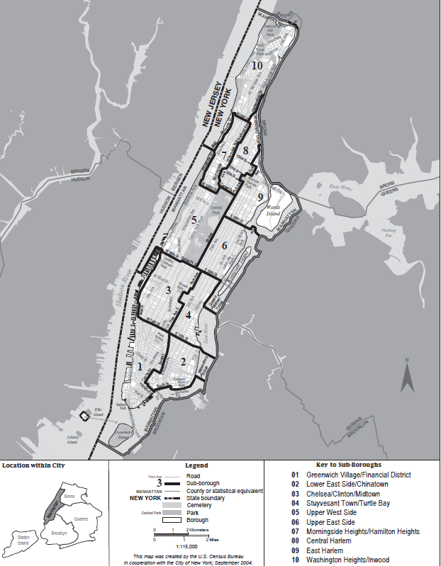

Appendix C: Staten Island, NY
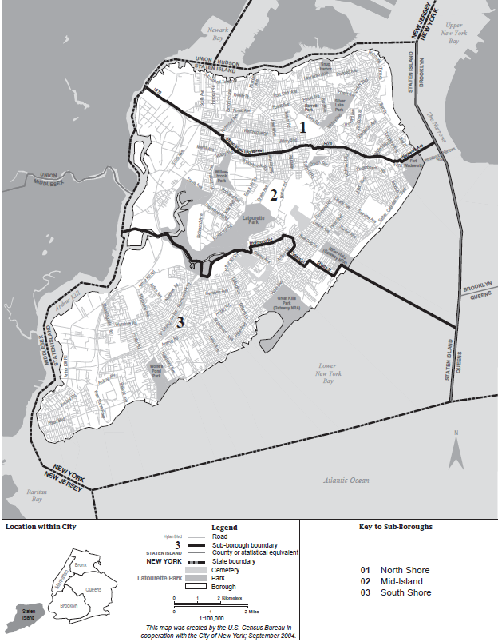

Appendix D: Bronx, NY
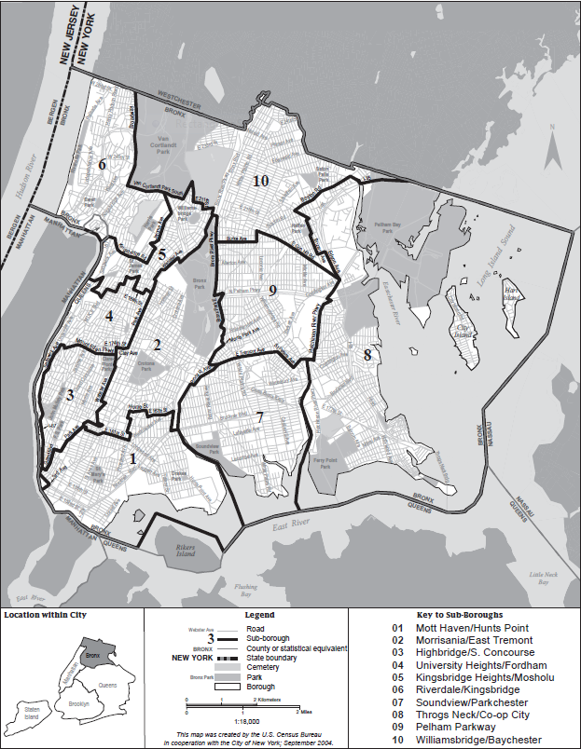

Appendix E: Queens, NY
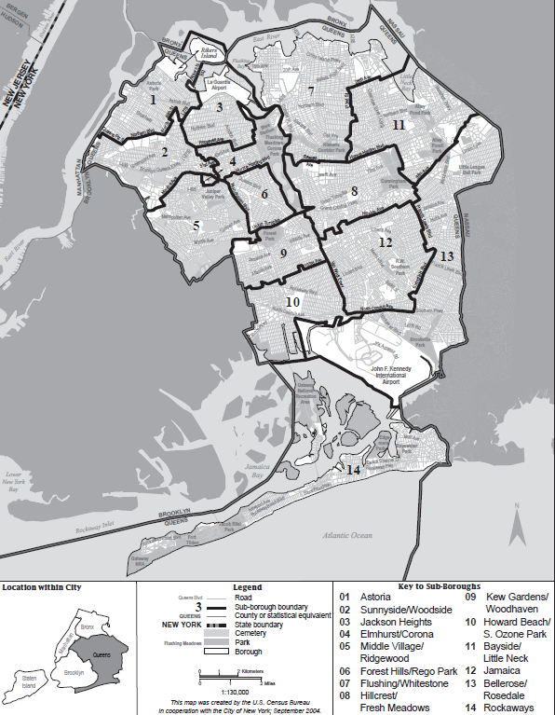

Appendix F: Brooklyn, NY
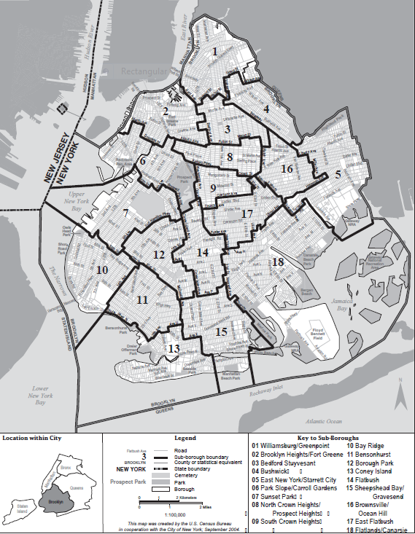

Price shadowing refers to the after effects of gentrification on adjacent neighborhoods, specifically resulting in an increase of housing costs
“in rem” foreclosure-occurs if a number of tax bills and outstanding charges are not addressed by the owner of a property and therefore the City places a lien on the property to collect back taxes
All dependent variables are measured in two dimensions (2008 pre-test) and (2011 post-test) and are representative of responses to the same survey questions in the 2008 and 2011 NYCHVS.
The concepts and processes of each of these policy interventions are described within the “Policy Interventions” section of this report’s literature review.
It is significant to note that several of these policies interlap in different boroughs of NYC but because of the overwhelming use of a specific policy to mitigate for displacement, the appropriation of policies to boroughs is appropriate. More discussion about the combination of policies will be discussed in the “Assessment” section.
Both of these surveys are available in the “Attachments” section of this report
Because of the confidential nature of all surveys conducted by the U.S. Census Bureau, specific information which may identify the names of survey respondents are not made available for 72 years following the survey implementation. All guarantees of non-disclosure related to individuals are also enforced by Title 13 of the U.S. Code which mandates penalties for the disclosure of this information.
The 2008 and 2011 NYCHVS are similar in questionnaire design, concept, definitions and data procedures. The 2011 survey includes several new questions which were not used within this study. Additionally, information for housing units, were obtained from the 2000 and 2010 Census master files as well as the 2007 and 2010 American Community Surveys.
For the particular studies which utilize these variables to measure for displacement see the “Indicators of Displacement” section for the dependent variable and the “Policy Interventions” section for the independent variables.
Gentrification was phrased as public renewal and private gentrification action within the NYCHVS

