Does Mindful Leadership Matter?
A Study of Legislators’ Decision Making

Alison J. Battaglia, Ph.D.

ABSTRACT

The foundation of our society depends on the proper legislative leadership making well-deliberated decisions and tough choices on policy on behalf of its citizens. The impact of faith or spirituality is an essential influence on legislative decision-making. This paper will explore whether mindfulness originating from the practice of spirituality influences the legislative development of policy making and legislative effectiveness. In addition, it will consider the role of gender and mindful decision-making. The effect of gender in particular on leadership and judgment has shown differences in style, ethics, and values of legislators and in turn in the policy-making process. The goal of this study is to understand if mindfulness is a practice used by state legislators and whether it improves the quality of confidence of legislative decision-making, and it will engage in this exploration with awareness of the gender differences of legislators. The research comprises a qualitative study with 31 state legislators of various backgrounds, tenure and leadership roles within their party. The study found that legislative mindful decision-making has a significant impact on the outcomes of legislative deliberation and that there were differences in the process used by male versus female legislators in the deliberative process.

Keywords: Legislators, mindfulness, decision making, leadership
INTRODUCTION

The topic of leadership is among the most well researched and published in any field. A Google Scholar search for the term produces 3,500,000 results. These results are not surprising; the very structure of society depends on the proper leadership making important decisions and tough choices.
People are interested in leadership because there is a deep need in human nature to trust that the leaders in one's society are on the right track. It is difficult to overestimate the importance of faith vested in public and private institutions for the effective functioning of society (Gillespie & Mann, 2004; Burke, Sims, Lazzara, & Salas, 2007). It is also important to note, however, that the cynicism that can result from disappointment and betrayal of trust can be divisive and damaging to society, eating away at its confidence and even its very identity.
As we look at the past research and findings regarding influencing factors on legislative decision-making, the impact of faith or spirituality is a critical component not only in order to understand what factors impact decision-making but also in order to appreciate how faith or spirituality as a deliberative process can increase decision-making confidence (Battaglia 2015). Past research shows evidence of business leaders engaging in religion-based workplace spirituality as part of their decision-making process (Fernando & Jackson, 2006). Although these leaders have a plethora of leadership and decision-making tools that have proven successful, in the most challenging times, their connection to their faith, God, or a higher power was a source of solace, guidance, and inspiration to their critical decision-making (Fernando & Jackson, 2006). This paper will explore whether mindfulness originating from the practice of spirituality influences the legislative process of policy making and the performance of the legislator.
This investigation will also consider the role of gender in this process. The effect of gender in particular on leadership and judgment has become a popular source of research. Many studies have considered the ability of women to lead. Through research, some compelling information related to gender and leadership has emerged (Glover, Bumpus, Sharp, & Munchus, 2002; De Acedo Lizarraga, de Acedo Baquedano, & Cardelle-Elawar, 2007; and Kawakami, White, & Langer, 2000).
The collection of studies outlined in this paper represents a sampling of the thinking in the areas of leadership, decision-making, and gender and suggests through their juxtaposition an exciting opportunity to investigate a point of intersection among these three areas. Based on a plethora of research, there is reason to think of women as more moral decision makers than men; there is also an avenue to be made involving the mindfulness of leaders regardless of gender. What is lacking among these studies is an exploration of the role of mindfulness in decision-making differences in gender. If women are making more mindful and more moral decisions, at least one aspect of the unique traits of female leadership could be investigated and possibly established as a significant quality.
Research Questions
Does mindful leadership decrease the stress during intense legislative logjams and increase the effectiveness of important policy decisions affecting constituencies? Is there a difference between male and female legislators tendency to use mindfulness in policymaking? How does practicing mindfulness affect decision-making confidence?

Definitions
Mindfulness: The meaning of mindfulness is explored and refined throughout this paper, but an understanding of the term can begin with Merriam-Webster’s definition: “1. The quality or state of being mindful; 2. The practice of maintaining a nonjudgmental state of heightened or complete awareness of one’s thoughts, emotions, or experiences on a moment-to-moment basis; also: such a state of awareness.” (n.d.). The renowned nonviolent advocate and Buddhist monk Thich Nhat Hanh’s Plum Village meditation center’s website describes it simply as “the energy of being aware and awake to the present moment” (Plum Village, n.d.). “It is the continuous practice of touching life deeply in every moment of daily life,” the site continues. “To be mindful is to be truly alive, present and at one with those around you and with what you are doing” (Plum Village, n.d.).
Mindful Leadership: We define mindful leadership as legislators recognizing their influence or leadership in terms of service to others. It is creating a setting to cultivate self-awareness and compassion, and leading with authenticity in a way that inspires others. Doing this in the legislative paradigm can transform our communities and the world (Mindful Leadership Summit, 2017).
The calm and centered space which Buddhist meditation practices are intended to achieve, combined with an awareness of the suffering of the world and the need to position oneself with respect to it, is presented as a tool by which contemporary politics may reform (Karafin, 2009).
Managing Stress: We define managing stress as how legislative members cope with “the serious impact of performance of policy makers (Preston, 2012). Managing stress in the legislative environment can be deemed power stress, “the unique brand of stress that is a basic part of being a leader (Boyatzis, R., & McKee, A. 2013, p.7).” This form of stress comes from leading and making choices that are not always clear and are complex in policy (Boyatzis, 2012). Coping or managing stress is employed in this paper as a way to counter the “negative incapacity of not just a democracy, but of our democracy, to solve social problems” (Jack, Friedman, Boyatzis, & Taylor, 2016).
Decision-Making Confidence is defined as: “The process of mapping the likely consequences of decisions, working out the importance of individual factors, and choosing the best course of action to take” (“Definition of decision making - a practical variation.” n.d.). Decision-making confidence in the legislative body is the self-assurance that the legislator possesses and the ability to elucidate or defend the decision to any party or stakeholder.
Effective Legislative Decision-Making: This phrase is defined as the advancement of a member’s agenda items through the legislative process and into law (Volden & Wiseman, 2009, p.327). Additionally, it is used to describe traits that make a legislator successful and valuable to their district and constituents. These traits include drive, the desire to lead, honesty/integrity and self-confidence, cognitive ability, and knowledge of the business (Kirkpatick & Locke, 1991).
Spirituality: Spirituality is not confined to religion. The word spirituality has evolved in a way that transcended formal religious tradition and is used in a more broad sense (Paloutzian & Park, 2014). Spirituality and the practice of mindfulness have been related as mindfulness came from the spiritual practice or Buddhism and Christianity.
Mindfulness can be used for effective legislative leadership and policy decision-making. In 2014, in the U.K, an all-party parliament group was launched to make the “right” or most appropriate legislative decisions (MAPPG, 2015). This group used meditation and mindfulness as an approach to dealing with stressful and critical social decisions by parliament.
This groundbreaking practice in legislation also decreased the amount of stress and anxiety that comes with leading and setting policy that personally affects so many people in the U.K. Mindfulness is a skill that trains one to quiet the incessant noise or thoughts that wreak havoc in the brain in order to bring clarity and calm, even in stressful times (Epstein, 1999). When brains are clearer, so are decisions, choices, and the priorities that people set.
Using mindfulness in the decision-making process will not only give careful deliberation to the critical decisions under review but can also help legislators to become even clearer thinkers and sound leaders.
There is little scholarly research that addresses the effects of the practice of mindfulness in the legislature: specifically, whether there is a difference between male and female legislators’ use of mindfulness or if mindfulness increases confidence and a sense of clarity during decision-making on polarizing policy issues. Exploration into this open field of study will give advocates and researchers a look into mindfulness as a new tool to increase confidence and relieve stress. The results of the study will provide an understanding of the impact of mindfulness on policymaking and legislation development and specifically explore policy making using mindfulness not only as a tool for decision-making and processing but in order to provide clarity and confidence in decision-making. It will also provide some new perspective on the ways in which women are uniquely suited to leadership roles.
PROBLEM OF PRACTICE, GOAL OF STUDY
Some earlier research shows that as workloads in the legislature increase towards the end of a legislative session, logjams ensue and legislators make hasty decisions regarding policies in order to move them through the legislative process quickly. It has been noted that “in the midst of this confusion, legislators vote wildly and blindly on countless measures they do not know a thing about” (Tucker, 1985). This can have deleterious results for advocates trying to educate and receive support from legislators on their issues of importance. Annual vs. bi-annual budgets are more chaotic, as there is less time to make decisions on a large amount of legislation within a shorter window (Tucker, 1985).
Findings in Battaglia’s (2015) qualitative research shows that many legislators vote on legislation where the subject matter is new and policy changes are voted on without any experience or knowledge of the impact to the constituents of within their state or country. Often legislators rely on their colleagues who have more experience in some policy matters. This kind of voting stresses the value of mindful leadership not only for the legislator that is unfamiliar with a particular subject but for the legislator that is familiar with the subject as their colleagues depend on their sound judgment and expertise.
The goal of this study is to understand if mindfulness is a practice used by legislators, how it is used in legislative decision-making and whether it improves the quality of confidence of legislative decision-making. The results of this study may direct scholarship to a new theory about the need and potential system that encourages mindfulness as a positive means to internal and external success.
Spirituality and Decision-Making and Leadership
In a study of spirituality and leadership by Fernando and Jackson (2006), spirituality was established as being defined by religious faith. Decision-makers experience pressures, and internal and external demands come from different directions (Fernando & Jackson, 2006). This includes pressures that emerge from the relationships and beliefs of their colleagues and leaders within the organization. This research links to Battaglia’s (2015) research insomuch as legislators must consider colleagues' interests, leadership position, and constituent needs simultaneously.
Legislators in particular are expected to guide and develop policy based on their personal areas of expertise and skills, or their relationships with leadership as a representative, committee member, and policy development leader. Battaglia’s (2015) research shows that personal values have a direct relationship to decision-making. Personal values of legislative decision-making are driven by religious values (Battaglia, 2015). Research suggests that these values initiate the influential factor of decision-making: “It is highly probable that religion could play a significant role in the decision outcomes of individuals whose personal characteristics are shaped by their religious orientation” (Fernando & Jackson, 2006, p.8).
Religious based decision-making has been linked to intuitive decision-making. Intuitive decision-making has five different components all of which are believed to influence effective decision-making (Fernando & Jackson, 2006). These components are subconscious mental programming, values or ethics decisions, experience-based decisions, affect-initiated decisions and cognitive-based decisions (Fernando & Jackson, 2006, p. 8).
In one recent study, spirituality or religious beliefs was found to positively increase leadership decision-making performance and decision-making confidence and leadership attributes (Battaglia 2015). Fernando and Jackson (2006) found that religion increases leaders’ desires to make the “right” decision. Leaders’ reference points in “right” decision-making are likely to influence their behavior by reinforcing moral guidelines (Fry, Vitucci, & Cedillo, 2005). This theory is a link to the faith-based legislator who also has a high values driver in decision-making (Battaglia, 2015).

THEORETICAL FRAMING AND LITERATURE REVIEW
Mindfulness
Mindfulness is grounded in the act of awareness. It is a discipline and an attitude and a state of mind. Its basic premise is to bring awareness and thought into one’s life to be useful in any situation, including critical moments of complex decision-making. Mindfulness is often used as a tool to manage difficult issues or decisions and to reduce the stress that follows these situations. One scholar describes its efficacy by stating that “Mindfulness informs all types of professionally relevant knowledge, including propositional facts, personal experiences, processes, and know-how, each of which may be tacit or explicit” (Epstein, 1999, p.33). Epstein (1999) explains that mindful practitioners engage in self-monitoring as a way to be aware of both their personal knowledge and deeply held values to take in and be aware of new information and different perspectives. A mindful practitioner is self-aware and present in everyday experiences including “actions, thoughts, sensations, images, interpretations and emotions” (Epstein, 1999, p.835). The practice of mindfulness is aware of the ordinary, the obvious, and the present and traces back from a philosophical-religious tradition. “The underlying philosophy is fundamentally pragmatic and is based on the interdependence of action, cognition, memory and emotion,” according to Epstein (1999, p.835).
Mindful Leadership and Decision-Making
Mindfulness in leadership is area ripe for deeper investigation. Researchers are increasingly aware of leaders without a sufficiently mindful being and the consequences of that deficit. Consequently, there is a growing body of literature supporting the value of mindful leadership in precise ways. It is easy to say that a leader ought to be thoughtful and present in important times of engagement, but this is often dismissed as a trite cliché without data to back it up. Data and analysis are growing that support this critical facet of leadership, including research considered here (Kawakami, White, & Langer, 2000; Karelaia, 2014).
Much of the literature in this area of leadership studies has focused on business leadership. To be sure, this is a critical component of society, and there are tremendous benefits to be reaped from a more mindful business leadership. The political field has received less attention, relatively speaking, in these unique areas. The idea of politicians practicing mindful leadership may seem counterintuitive, as people often consider political decisions to be narrowly calculated based on popularity, but it should be taken seriously as a practice to be documented and studied. There are practical benefits to inserting this dimension into the conversation about legislating. The disappointment many people feel about politicians should not dissuade people from attempting to envision a more effective way of leading through legislating. In fact, the more people are troubled by the way in which politics happens in society, the more it should be systematically analyzed, with alternatives and ideas for improvement considered and set on a solid foundation where practicable.
Research on mindful leadership increases one's understanding of the psychological processes involved with, and a clear understanding of, critical judgment consistencies (Weber & Johnson, 2009). Weber & Johnson (2009) discuss some alternatives that include interventions created to overcome undesirable judgments in decision-making. Early analysis on judgment and decision-making used mathematics as the starting point for decisions. More recently, it is understood that people make financial decisions based on variables such as beliefs, choice, and internal and external social factors. This transition in the study of decision-making that shifts to mindfulness and decision-making that is closely related to cognitive psychology and research (Weber & Johnson, 2009). This mindful leadership research in the area of psychology focuses on the characteristics of a person’s average or typical behaviors. The exceptions are the decisions that are particularly risky and carefully calculated by the long-term effect of the decision. Individual and cultural differences of a decision maker are mediated by two variables: differences in values and goals, and differences in cognitive capacity, education, or experience (Weber & Johnson, 2009).
Mindfulness, Managing Stress and Well-Being
Mindfulness can be described as “a state of being attentive and aware of what is taking place in the present (Brown & Ryan, 2003).” It can also be described as an inherent state of consciousness. Although research has shown that mindfulness has positive outcomes for individual well-being, more research is necessary to show that mindfulness is a naturally reoccurring characteristic. Brown & Ryan (2003) studied the interpersonal variances in the ability for one to be present and the importance of forms of psychological well-being. In other words, they examined the direct link between mindfulness and well-being. Mindfulness takes “the quality of consciousness” that is described by the transparency of the current experience or operation that comes from habit and not simply clarity of the moment. It makes an individual break the cycle of habitual thoughts and decision-making and pushes an individual to healthy, constructive patterns into positive decisions and thus an improvement in well-being. Mindfulness can create a clear thinking and deliberative process that facilitates a natural condition of “relaxed attention” (Brown & Ryan, 2003 p. 823). This clear thinking or state of conscious attention relates to introspection and conscious thinking which increases well-being. This increase in well-being is through the conscious enjoyment of taking in or embracing the moment in its glory. Well-being includes enjoying food, company, work, and clear decisions. The appreciation of all these experiences in turn increases well-being. Brown & Ryan proved that “mindfulness is a reliably and validly measured characteristic that has a significant role to play in a variety of aspects of mental health” (2003, p.844).
Mindfulness and high performing organizations
While researching the similarities in high-performance reliability organizations (HRO), it was discovered that there are many factors that are parallel for these organizations, including the concept and use of mindfulness. It is the ability of mindfulness to overcome inertia in a corporate context that connects these studies to the mainstream of organizational theory (Boin, 2008). The organizations in this study are high performance and critical groups that include military, space stations, and submarine operations. These groups develop or use diverse but secure cognitive processes that are associated with high-reliability organizations. One area of exploration is how high functioning organizations interrelate in the services of the discovery of information and the correction of errors (Boin, 2008). “When people in HRO’s focus on failures, tendencies to simplify, current operations, capabilities for resilience, and temptations to over structure the system…these separate concerns are tied together by their joint capability to induce a rich awareness of discriminatory detail and a capacity for action” (Boin, 2008). They label this capability mindfulness. Capability mindfulness is an increased awareness triggered by the potential disaster that assists in the construction, discovery, and correction of unexpected events that could escalate into bigger problems (Boin, 2008).
Boin (2008) suggests that the close relationship to the practice of mindfulness is what separates out their success. Mindfulness is as much about the quality of the deliberation process as it is the final decision. In other words, what people do with the things that they are observing or understanding is as important as noticing the activity. (Boin, 2008) sees mindfulness as less about decisions and more about the considerations and processes that take place in evaluating internally and externally the points to consider for a quality decision and confidence. The state of mindfulness in HROs is developed using five processes that were investigated by Boin (2008). These are preoccupation with failure, reluctance to simplify interpretations, sensitivity to operations, commitment to resilience and under specification of structures (Boin, 2008).
Mindfulness Decision-Making and Gender
The connections between women and moral or ethical decisions are bridged by studies such as the one conducted in 2000 by Kawakami, White, and Langer. In this research, female leaders who displayed masculine traits and were mindful, as defined operationally in the study, were shown to men as they spoke on a video, as well as less mindful versions of the videos. Men were also shown videos of women displaying traditionally feminine traits in both a mindful and less mindful fashion. The men found the mindful leaders, both masculine, and feminine in behavior, to be better leaders. They also found women who were less mindful but congenial in a way that is considered feminine to be more effective leaders than the both cool and less mindful alternatives (Kawakami, White, and Langer, 2000). What this study suggests is that mindfulness may be perceived as a transcendent factor, even by men who might otherwise be resistant to women as leaders.
In a recent article on mindfulness and leadership, the author points out that there is an increasing awareness of the role of mindfulness in leadership (Karelaia, 2014). At the same time, its benefits seem to be a source of great interest to scholars, who are building a substantial collection of research clarifying its role in decision-making. Importantly, the article notes that the mindful leader tends to seek feedback before making decisions, a step often ignored by leaders (Karelaia, 2014), who may even think that it runs counter to the masculine stereotypes that are associated with leadership. There is also a slowness to judgment associated with mindfulness that might run counter to stereotypes of the strong leader but which has a demonstrable benefit to the decision maker. Above all, there is the trait of framing the decision, which is where ethics come into consideration. Here, the link between mindfulness and morality, which, when combined with the prior study in which the mindful female leader is preferred regardless of traits, opens an avenue of possible exploration in which there is a connection between female leadership and mindful leadership.
In a study on gender and deliberation, Fowler (2005) looked at the difference in how women and men deliberated on juries and made decisions on guilt or innocence. Looking at data and considering the historical context of decades of women being restricted from serving on juries and the easing of that bar as women’s rights evolved, Fowler (2005) discovered differences between decisions and gender in simulated jury trials. Historically, there have been views that women and men do not have different perspectives; women’s approaches to decision-making were simply labeled as inferior (Fowler, 2005). Her work outlined the history of jury selection when women were not allowed to serve on a jury, when their rights changed, and the impact of the different deliberation outcomes of each gender. She contributes to theory and social science by showing that counter to past views, men and women have differences in deliberation, and their cognitive processes are different.
As part of Fowler’s (2005) research, she outlines the results of Carol Gilligan’s research and her theory of moral reasoning. Gilligan’s first study looked at both males’ and females’ views of themselves as it related to morality when presented with moral conflicts and life choices. Gilligan interviewed males and females in college, then again five years later after a variety of real-life experiences. The second study looked at women considering an abortion in their first trimester and then again one year later. The third study used interviews of men and women at the same age, social class, education and employment about their conceptions of self, morality, moral conflict, and experiences of moral conflict and choices through hypothetical moral dilemmas (Fowler, 2005). Gilligan found that we need to recognize that “two modes of morality exist” (Fowler, 2005, p. 19). Additionally, Gilligan found the differences in moral decisions or moral understandings, for example, relationships (women) and a hierarchy of values (men) in one study confirm that although there are differences in men and women, they are not opposing but complimentary. In Gilligan’s second study regarding the life decision of abortion, women confused the idea of being responsible with the responsibility of people in their social network and thus disregarded their sense of self. Gilligan shows that it is important to understand that there are two different approaches to reasoning. She argues that men and women communicate differently or “speak two different languages because they have different feelings about self and their relationships with their networks.” In short, if men and women have different approaches and life experiences they bring a different type of reasoning to, for example, jury deliberations about moral issues.
Women and Politics
The exploration of the role of women in politics should be carefully studied. There has certainly been an increasing presence of women in politics in the past half-century, much as there has been in business, yet women have had a disproportionately small number of leadership positions (Glover, Bumpus, Sharp, & Munchus, 2002). This is in part prejudice, and the more the quantity and quality of objective research enumerating the advantages of women in leadership positions that can be produced, the closer society is likely to come to accepting the equality of the genders in leadership.
In a study of female politicians in Santa Clara County, Janet Flammang found that women in the elected office were more effective in community organizing and building relations with community groups and that their attitudes on issues differ from men (1985). This stemmed from the women’s networks and groups that supported the increase and development of female elected officials. These groups include parent-teacher associations, the League of Women Voters, and women’s political caucuses, among other groups. This grassroots relationship building that includes community activism develops a higher recognition of reputation, constituent support, and expertise for women. In Flammang’s qualitative study of female office holders, she found that women’s participation in these organizations helped them develop the skills needed to make decisions on a legislative level (1985). Their management and organization within their advocacy group made them confident that “[t]heir non-traditional recruitment via women’s groups and neighborhood organizations provided bona fide organizational skills for public office.” (Flammang, 1985, pg. 101). This is in contrast to men who build their support through their education and relationships through their professional careers (Flammang, 1985). This supports the view that women have different approaches to leading in public office.
Flammang discusses that women have two significant differences in holding public office: distinct differences on their policy positions and in the way they conduct or manage politics (Flammang, 1985). Battaglia’s (2015) research supports these findings identifying women as communal decision-makers. Elected women see decision-making in an approachable, cognitively collective, inclusive, constituent based, empathetic, responsive and persistent manner. They were less authoritarian and more supportive during deliberation. Flammang found that in controversial budgetary issues that could negatively affect women’s issues, morals and ethics were paramount to female leaders (1985). Flammang demonstrated this in a quote from one female leader saying “we are morally and legally obligated” to cut optional programs. This too supports Battaglia’s (2015) research that demonstrated that morals, family values, and ethics are the primary influences in elected official’s decision-making. Additionally, women have more liberal attitudes when voting on welfare or social service policies than men. As expected, this gap is bigger with Republican women and is driven by moral and ethical beliefs (Poggione, 2004).
Women feel more comfortable making contentious decisions because as a minority there is less to lose or less risk as women are often not posturing or playing a “career game” (Welch, 1985, p., 127) in the same way men are. Welch (1985) found that women are not positioning themselves for higher office as often as men. For this reason, women feel liberated in their individuality and are more willing to take risks in decision-making and policy-making. Additionally, women felt obligated and drawn to support their female constituents knowing they have a shared minority struggle.
Gender and Decision-Making
One 2007 study administered a decision-making questionnaire designed to evaluate the importance an individual places on factors such as consequences, social pressure, and time/money constraints when making a decision. The study engaged 589 Spaniards across an age gamut that ran from 18 to 80 and a roughly equal number of men and women. The study used the naturalistic theory of decision-making, which explores decisions used in everyday contexts, instead of the rigorously controlled environment of a laboratory (de Acedo Lizarraga, de Acedo Baquedano, and Cardelle-Elawar, 2007). The study found that women ascribed more importance than men to uncertainty, time/money constraints, consequences, emotions, and social pressure. Men placed greater emphasis on information and goals, motivation, and work pressure. For this study, it may be that the emphasis on consequences is the most significant, as this implies a moral component to decision making. The factors of cognition, self-regulation, and the environment were not significantly different between the two groups. There were few relevant differences in comparing age groups, with the youngest prioritizing emotion and social pressure and the oldest emphasizing uncertainty, among other results (de Acedo Lizarraga, de Acedo Baquedano, and Cardelle-Elawar, 2007).
It has been observed that women tend to be more risk adverse in decision-making than men. When dissecting this observation, it seems women view risk to be greater in all ways except their social environment. This difference in risk taking is not biological but stems from the deep-seated effects of risk taking from being in a society where the female gender is viewed as having a lower social status in society (Slovic, 1999). “Risk assessment is inherently subjective and represents a blending of science and judgment with important psychological, social, cultural, and political factors,” according to Slovic (1999, p. 689).
Gender and Ethical Decision-Making
In a 2002 journal article by Glover et al., the results of a study of the differences between men and women in making ethical decisions were explained. The introduction and review of literature that paved the way for the study and its results do an effective job of encapsulating much of the research on women and ethics in business. The context within which the study takes place is a social climate in which the public believes the need for ethics in business and government is at least as important as it ever has been and also has very little faith in leaders in these environments to conduct themselves ethically. The morals and ethics ratings for leaders are, according to one study in the report, at their lowest point in nearly 50 years (Glover, Bumpus, Sharp, & Munchus, 2002). In other words, we can confidently say there is a gender leadership crisis, based on this study.
Literature supports the idea that placing more women in positions of leadership tends to increase the degree to which ethical considerations are translated into decision-making (Glover, Bumpus, Sharp, & Munchus, 2002). The study cites a series of reports which take the question from some different angles but all reach the same conclusion: When more women are leaders, organizations and institutions become more ethical in their behavior. The study's review of literature falls short of flatly stating that the extant research supports the statement that women are more ethical than men. Some studies find very similar results between men and women when testing ethical inclinations. Research points to the context within which people make decisions as the influential element in ethical decision-making. One study suggests that women are more influenced by situations in a way that leads to ethical outcomes, as opposed to being inherently more ethical (Glover, Bumpus, Sharp, & Munchus, 2002). The Glover, et al. study hypothesized that women would be more likely than men to favor ethical decisions over unethical decisions. Junior and senior business majors comprised the study population, and 367 subjects with a median age of 21 years were engaged. The test employed four work scenarios in a laboratory format (Glover, Bumpus, Sharp, & Munchus, 2002). The results reflected what many would consider evidence of ethical strengths in both genders. Overall, men had a higher workplace score for fairness, while women scored higher for concern for others and honesty/integrity. Women made the more ethical choice in the four scenarios more often than their male counterparts (Glover, Bumpus, Sharp, & Munchus, 2002).
Ethics, family values, and faith or religion were the most identified influencers of legislative decision-making in Battaglia’s (2015) qualitative research study. Those results led to the inclusion of religion or spirituality in Battaglia’s (2016) quantitative research with the results positively influencing legislative decision-making performance and confidence. Studies focusing on value systems have also attempted to differentiate between the responses of men and women, but have found other factors at play instead. Men and women respond similarly in these studies, suggesting that they possess similar value systems. In some studies, the difference was found based on the nationality of participants, rather than gender (Glover, Bumpus, Sharp, & Munchus, 2002). Research shows that ethics continued to be in the foreground, and a direct link has been demonstrated between an increase of woman in the workplace and an increase in ethics (Glover et al., 2002).
Testing-based studies document women making ethical choices more often but not reveal the mechanics behind those choices, making them a helpful but partial piece of the picture. Investigating how people make choices and separating those elements out by gender is another approach. A 2013 study exploring the gender differences in decision-making processes predicted that men would not spend as much time as women in observing options. The study engaged 232 university students and recorded the amount of time spent picking a food line in the cafeteria. Male students moved more quickly into a line than female students when participants were in a comfortable environment. On the other hand, when the environment was less familiar, selection time did not significantly vary between the two genders (Reiter, 2013).
This level of specificity in examining behavior involving decision-making is an important element in understanding the ethical choice. Still, there will often be some degree of inference that is necessary to develop a total explanation for behavior. This study suggests that men might be less likely to reflect in comfortable environments regarding their choices, yet what accounts for that difference?
Battaglia’s (2015) research about public leader’s perception of commitment and the importance of ethics shares the same concern. Glover et al. show the positive and significant influence of ethics when the number of women in an organization or the workforce is at higher levels. Consistent with social role theory as previously mentioned, Eagly (1987), found that men and women conduct themselves in ways that mirror their social role (gender) stereotypes. Battaglia’s (2015) findings support this with men making agentic decisions and women making communal decisions. Research comparing the leadership styles of women and men is reviewed, and evidence is found for both the presence and the absence of differences between the sexes. In contrast to the gender-stereotypic expectation that women lead in an interpersonal-oriented style and men in a task-oriented style, female and male leaders did not differ in these two styles in organizational studies. However, these aspects of leadership style were somewhat gender stereotypic in the two other classes of leadership studies investigated, namely (a) laboratory experiments and (b) assessment studies, which were defined as research that assessed the leadership styles of people not selected for occupancy in leadership roles. Consistent with stereotypic expectations about a different aspect of leadership style, the tendency to lead democratically or autocratically, women tended to adopt a more democratic or participative style and a less autocratic or directive style than men. This sex difference appeared in all three classes of leadership studies, including those conducted in organizations. These and other findings are interpreted regarding a social role theory of sex differences in social behavior (Eagly & Johnson, 1990) and mirror the ethical response of caring. Singhapakdi, Vitell, & Franke (1999) found that women are more apt to recognize moral or ethical issues in a business setting because of their increased ethical caring. This is particularly true for women who have not had significant business experience. “When individuals adopt the ethic of caring, they base their judgments and actions on their relationships with, and responsibilities to other individuals” (Forsyth, Nye, Kelley, 2001). As we have shown through previously described research, this adoption of ethics and decision-making has been a part of women’s judgments and decisions in their legislative or policy considerations.
Therefore, if gender has a positive impact on ethical decisions in the workplace, one can consider that the impact of women’s mindful leadership will have a positive impact on sound policy decisions in times of critical issues and personal and political stress. One can further posit that there will be a difference in gender response and decision through their ethical deliberations and mindful leadership.
Methods

This research used semi-structured interviews using two policy and decision-making scenarios to develop grounded theory as the primary means of data collection and analysis. Grounded theory approach in social sciences is a way to systematically organize data through which coding is used to better understand complex psychological and social scientific phenomenon. Grounded theory takes facts and constant comparative analysis and develops theory from the results. It reveals information and raises new questions (Charmaz, 2006) that can also influence future research. This research method helps the researcher reveal the meaning of events, situations, experiences, and the comprehensive nature of the participant’s inner and outer worlds (Charmaz, 2006). Collections of narratives are analyzed to derive theory from lived experiences to discover new concepts and ideas that will help contribute to both the practitioner and academic communities.
Grounded theory is appropriate for this proposed research as there are no comprehensive studies in the U.S. about legislators being mindful while making decisions and voting on complex issues; particularly in the area of decision-making. To gain new and uncontaminated insights from the interviews, the research team will respect the standard principles of grounded theory research. The interview process will not be influenced by the reviewed literature and theories nor biased by preconceived notions or opinions gathered through preliminary interviews or practitioner experience. Interviews will include open-ended questions that will optimize opportunity for compelling insight and experiences from legislators. The interview protocol can be seen in the Appendix in Figure 1.
______________________
Insert Figure 1 About Here
______________________
Sample
This research included interviews with 31 current or former legislators, mostly from the Mid-West. It includes a mix of political party, gender (nine women and 11 men) and varied levels of leadership and experience. The researcher used non-probability methods, which included chain-referral methods such as the snowball method (Heckathorn, D. D.2002). This technique is used for hard-to-reach sample populations such as drug users, respondents participating in studies regarding a sexual activity, or other challenging sample populations, often reluctant due to privacy concerns (Heckathorn, D. D.2002). Legislators, particularly current legislators, leading up to and during the most contentious Presidential race in history, are wary of such studies. Although they are guaranteed anonymity, the public nature of their role increases skepticism and trust (Battaglia, 2015). If the interviews were ever to become public, they might negatively affect the legislator’s career or reelection.
Scholars describe the process of securing interviewees as a kind of cascading gathering: “This data sampling technique originates with a small number of peers, (called seeds) and expands through successive ‘waves’ of peer recruitment. First-wave respondents recruit second-wave respondents, second-wave respondents, in turn, recruit the third-wave, and this continues until the desired sample size is reached. Respondents recruit those with whom they have a preexisting relationship.” (Quader, A. S., Heckathorn, D. D., McKnight, C., Bramson, H., Nemeth, C., Sabin, K., Des Jarlais, D. C., 2006 p., 1). This sample and technique started with the researcher's network and then moved forward using the snowball technique, which produced 31 interviews, within a 30-day timeframe. The commitment of anonymity and consent forms were distributed and signed by the respondents before all interviews.
To compare and analyze decision-making: effective legislators and other mainstream legislators, we included an “exceptional or effective legislative” sample of ten legislators in our study. These legislators were selected by their peers. After interviewing 20 respondents, the research team asked them who they regard as decision-making: effective legislators and why? The team then approached the legislative offices of those legislators who were identified at least two times by their peers. Some of the recommendations were for legislators that were coincidently interviewed. Those legislators and the additional peer selections were used to create the “exceptional legislator” sample for comparative analysis. The sample demographics chart can be seen as Table 1 in the Appendix.
______________________
Insert Table 1 About Here
______________________
Data Collection

All interviews were collected between October 2016 and November 2016 and audio-recorded with permission and later transcribed for analysis.
In person or phone semi-structured interviews lasting approximately 60 minutes were conducted and audiotaped and guided by an interview protocol. The location of the interview was determined by the proximity of the legislator and their personal preference. The questions focused on mindful leadership during policy development and deliberations. The questions were asked with reference to two different scenarios with different intensity and complexity based on public policy issues. The responses to the scenarios will inform our themes and in turn, findings. The first scenario involves the issue of gun violence and the initial decision-making process a legislator would implement after a shooting in their district. The second scenario is a request by a colleague to identify additional budget funds for veteran’s services. Differences in the initial decision-making process were analyzed, along with managing the stress of such a contentious issue (gun violence) and the widely supported issue (funding veteran’s services). The analysis probed for mindful leadership attributes and analyzed any differences in men and women.

Data Analysis
Consistent with a grounded theory approach, data analysis will begin simultaneously with data collection. The analysis will involve both manual coding and the use of qualitative data analysis software. Throughout this process, the researcher will compose interpretative memos (Charmaz, 2006) and notes reflecting “the mental dialog between the data and the researcher” (Corbin, 2008).
The audio recordings of each interview was listened to several times, and the transcripts of each interview read repeatedly. The first part of the coding process of the transcripts is “open-coded,” a process that requires the researcher to identify every piece of data with potential interest. This process is also identified as “1st-order analysis, which tries to adhere faithfully to informant terms, we make little attempt to distill categories (Gioia, D. A., Corley, K. G., & Hamilton, A. L. (2013).” These are identified, labeled and compared to and categorized with similar parts from other interviews. In the second phase of coding (“axial coding”), these categories are further redefined as ideas and themes begin to emerge from the data. It is in this phase that “we start seeking similarities and differences among the many categories, a process that eventually reduces the germane categories to a more manageable number (Gioia, 2013).” The third phase (“selective coding”), also referred to as 2nd-order theoretical themes, and describes what is emerging from the data (Gioia, 2013).” This is the focus on key categories and emergent themes that yield our findings. It is at this point in the analysis that aggregate dimensions develop. Aggregate dimensions involve computing all the data relationships for one or more dimensions. A developed data structure table provides clarity and depth of the coding process. “The data structure not only allows us to configure our data into a sensible visual aid, but it also provides a graphic representation of how we progressed from raw data to terms and themes in conducting the analyses- a key component of demonstrating rigor in qualitative research (Gioia, 2013).” After this data is compiled, we created a Data Structure Table which is seen below in Figure 3.

Figure 3: Data Structure Table
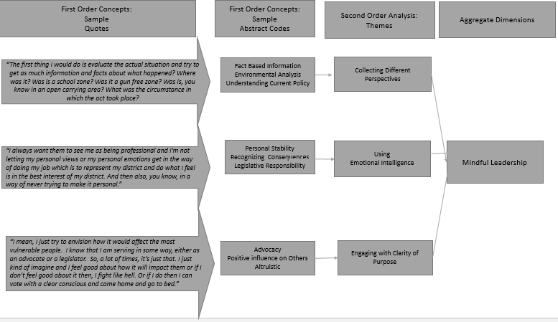

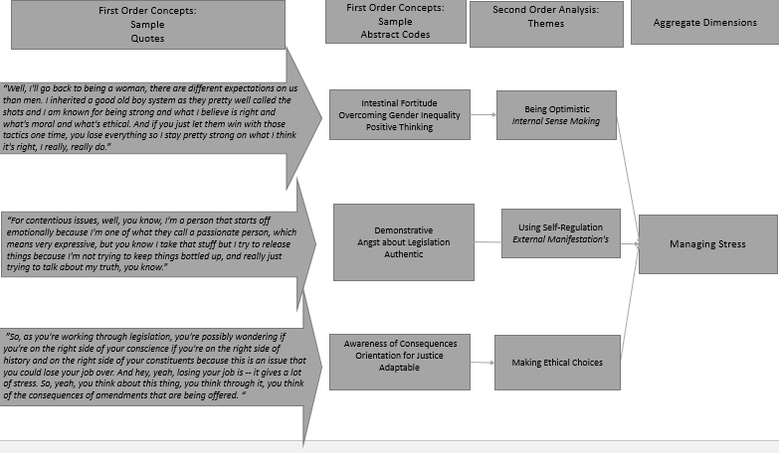

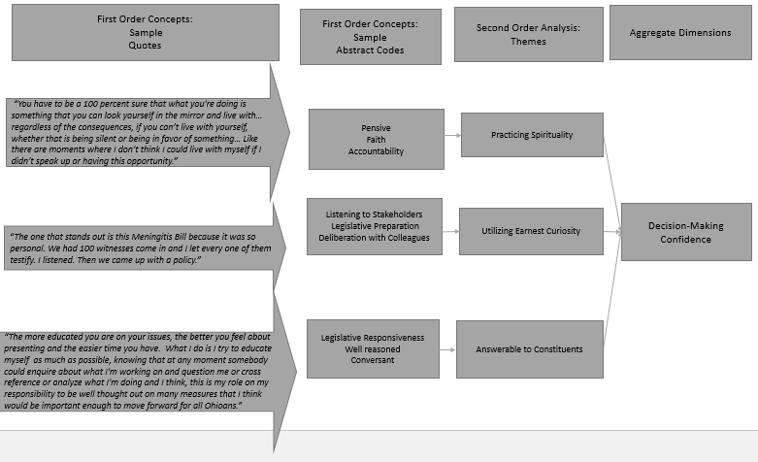

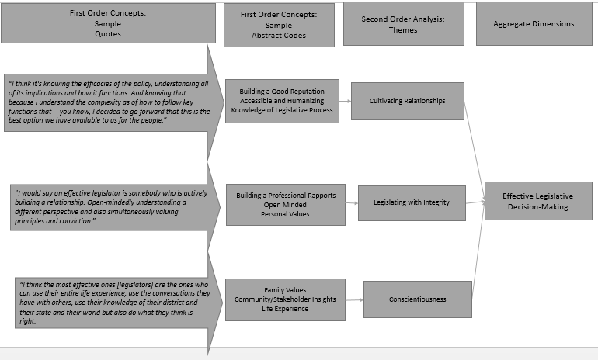

Our analysis of-of our coded results are twofold: a Data Results Table that shows the number of instances coded for each aggregate dimension, the calculated percentage and the bifurcation of data by gender. Furthermore, our analysis probed into the differences in our aggregate dimensions between all 31 of our respondents and ten peer selected exceptional legislators. The Data Results Table is shown below in Table 2.
Table 2: Data Results
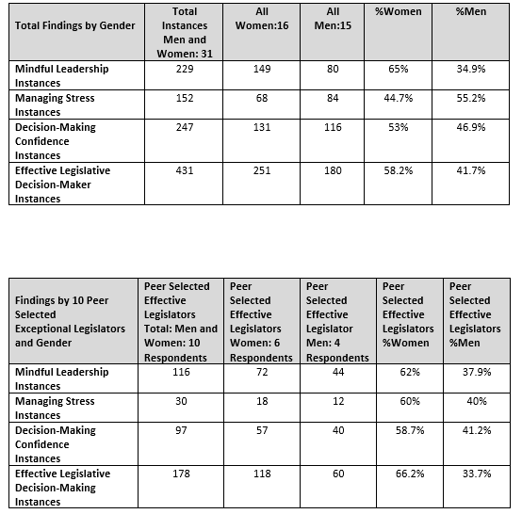
Lastly, to neither confirm nor indicate significant statistical differences in men and women throughout our aggregate dimensions, we conducted a chi-square test based on gender and our qualitative code count occurrences. This analysis and counting of occurrences in each dimension adds to the rigor and analysis of testing of gender as we argue that mindfulness is more predominant with women (Hildebrand, Ott & Gray, 2005). In testing for Chi Square, we evaluated the pvalue at the 90% and 95% confidence level. The significant results from the Chi
Square Test is below in Tables 3, 4, 5, 6.

Tables 3, 4, 5, 6: Chi-Square Test Significant Results.

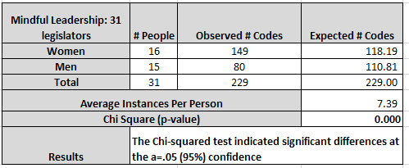

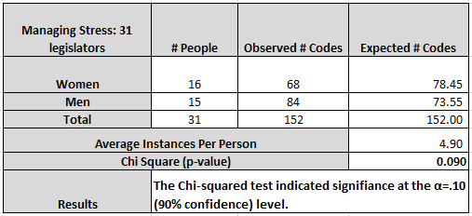

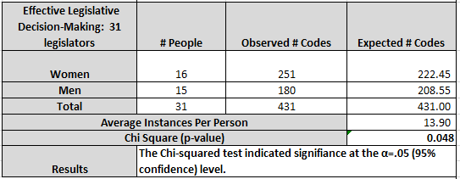

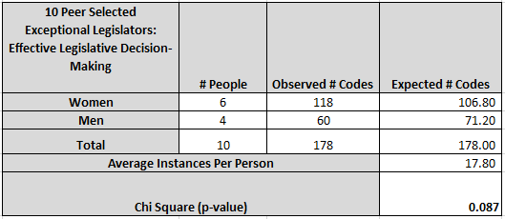

FINDINGS
Finding 1: Mindful Leadership Increases the Effectiveness of Policy Decisions.
Applying mindful traits to the decision-making process enhances effectual decisions within the legislative body. Peer-selected exceptional legislators in this study focused on the depth of knowledge they developed while deliberating the points of policy. Respondents shared that cultivating relationships, listening, leading with integrity, and being conscientious are recognized personally, and through observation of others, as decision-making traits to emulate.
NIDF5 “And I read my emails, I read the paper, I read other news sources that -- I tried really hard to make sure I am doing my job and knowing the facts. And there is no human way that any persons can have all that knowledge, so when you have constituents that approach you that have problems have concerns that just don’t seem right, you need to be willing to listen, you need to be able -- the follow up with the appropriate individuals to make sure that what you're doing will benefit the constituents and it's the right thing to do.”

NIDM10: “A lot of real training and knowledge and then the grassroots organization, you're communicating with voters about a position and activating them to make a change.”

Finding 2: Mindful Leadership Increases Decision-Making Confidence.
Applying mindful traits intensifies confident decision-making. Legislators in this study described these mindful traits that contribute to increased confidence as their practice of spirituality, listening to stakeholders, having a well-reasoned justification for their vote. Critical to these traits is legislative responsiveness. Legislators are more likely to get constituent support if they are approachable and provide clear and direct answers to concerns.
NIDF5: “I think it's really important to always be willing to listen, as a legislator, you're expected to have every expertise and everything from insurance to job and family services. And there is no human way that any persons can have all that knowledge, so when you have constituents that approach you that have problems, have concerns that just don’t seem right, you need to be willing to listen, you need to be able to follow up with the appropriate individuals to make sure that what you're doing will benefit the constituents and it's the right thing to do.
NDM9: “So, 90% to 95% of the votes were no-brainers. There was probably another 5% that would give you pause; you had to think about, you got to consider your district, you had to consider the state, you had to consider the politics of your vote. And once you did that -- I did that, I’ve never had a problem making decisions and living with it, for better or for worse. So, I never had a problem with that. I really -- I didn’t have any sleepless nights.”

Finding 3: Mindful Leadership Decreases Decision-Making Stress of Policy Decisions.
Applying mindful traits to decision-making reduces stress and anxiety in policy deliberations, voting, and personal anxiety associated with the policy process. Legislators in this study described these traits as having a positive attitude, being authentic, aware of consequences, and adaptable.
NIDF5: “We're elected to make the hard decision, and you won't make everyone happy all the time, you just can't, but that's -- in your heart, you're doing what you believe is best for the people that you represent and you've done your research, and you have your facts, you have to be respected for what you're doing there.
“You do your best, but they follow you around. They install a camera on your face or track you from behind or try to get some unflattering angle. And they get your schedule, and they just -- they're showing up and following you. And you either are ignoring some of these questions and looking like you're ignoring it or you're answering it, which can usually get even worse. I just had to forge ahead and to try to keep the focus on the task at hand.”

Finding 4: Female Legislators Have a Higher Rate of Frequency of Mindful Leadership Female respondents communicated more mindful traits than men in mindful leadership. These traits include communal deliberation, the ability to acknowledge anxiety, and letting go of negative feelings. Additionally, they address the importance of using internal and external points of information as well as environmental considerations.
NIDF4: “And many people that do call you up are emotional about something, and I learned early on you can't go with your heart, you have to go with your brain. And so I've tried to do that. So, naturally, people come to you and let's say, they want more laws on guns because you’ve used the example of guns. You have to look at the situation, the person that was killed, how were they killed, who had the guns? Was it an illegal gun that they had? Those kinds of things have to play a part in that, and so I would first talk to those people, but then I would also go and talk to the county sheriff who I have a good relationship with.”
EIDF2 “It may not be in your community today, but it could be there tomorrow, so you've got to stay up on the issues so that you can be proactive and prevent, or you can put up the reaction and prevent. Then I think you have to be willing, we have to be open enough to understand that there's not just one way to address issue A, B, and C. We're not all knowledgeable, you know. We are individuals just like our constituents who come with different skill levels, different areas of expertise, different passions. And so, we can't disrespect or disregard our colleagues simply because they don't have the same passions, the same areas of expertise, the same level of knowledge about an issue. We've got to understand that all of us have learning to do and we can listen to each other. We may not agree, we can listen, and we can probably make our bills better if we come to compromise, you know, that way we don't go too far to the left, we don't go too far to the right.”
Our Chi-Square test for mindful leadership supports our findings and indicates significant differences at the a=.05 at the 95 percent confidence level. This means that men and women differ in frequency of Mindful Leadership with women having a higher number of observed codes.
Finding 5: Female Legislators Have a Higher Rate of Frequency of Managing Stress Through Mindful Leadership.
Female respondents communicated more mindful traits than men in managing stress. These characteristics include meditation, introspection, understanding constituent needs, separating from chaos, and calming both internal thoughts and external responses.
EIDF1: “I have a meditation practice. Especially when days are very crazy in the legislature, I will take at least five minutes, step into my office and just try to ground myself and clear my mind and to be able to go on because there is way too much stuff that's coming at us, and sometimes the piece of it is so crazy especially in the moment you look back on it at the end of the week and go, well, why did that seem so crazy on Wednesday? But on Wednesday in the middle of it, it's like being in the middle of a tornado, and so there are definitely times when I just tell my aide I'm going to be in my office for five minutes, no phone calls, no nothing, and then I'll be out. And that is very, very helpful.”
EIDF2: “You understand that your constituents, particularly the family members and friends in the community where it happened are going to be more emotional and angrier and hurt, you don't want to exacerbate that in any way. So, you've got to think with a calm head and yes, you know, you're going to be angry too, you're going to be upset, you're -- particularly when there are children involved or innocent victims that are involved in a shooting. But you have to measure that anger, you have to measure that hurt, disappointment, you know, pain.”
Our Chi-Square test for Managing Stress supports our findings and indicates significant differences at the a=.10 at the 90 percent confidence level. This means that men and women differ in frequency of managing stress through mindful decision-making with women having a higher number of observed codes.
Finding 6: Female Legislators Have a Higher Rate of Frequency of Effective Legislative Decision-Making.
Female respondents communicated more mindful traits than men in mindful decision-making and effectiveness. These characteristics include time and attention to their district, voting on bi-partisan legislation, and understanding the political and process nuances of the decision-making process.
EIDF3: “I think somebody that is very committed to putting in the time and the work and the energy to get something done. I mean, we just have to work across the aisle, I was working across -- I mean, you just have to do that and build a reputation. The other thing though I think that sometimes is that you have to understand the process. So, there are opportunities that present themselves, and unless you know it when you see it, you lose it.”
Our Chi-Square test for Decision-Making: Effective Legislator supports our findings and indicates significant differences at the a=.048 at the 95 percent confidence level. This means that men and women differ in frequency of decision-making: effective legislator with women having a higher number of observed codes.
Additionally, we performed a Chi-Square test on Mindful Decision-Making: Effective Legislators for our 10 Peer Selected Exceptional legislators. We found that Chi-Square indicates indicated significance at the α=.10 (90 percent confidence) level. This means that men and women within the 10 Peer Selected Exceptional legislators differ in the frequency of decision-making: effective legislator with women having a higher number of observed codes.
Discussion
The extent to which women who pursue office are incorporating mindful leadership into their work as legislators suggests that mindfulness may be a quality that is even more disproportionately present among women than moral and ethical calculus. A gender differences model showing the impact that women, who practice mindfulness, have on effective legislative decision-making is seen below in figure 4.

Figure 4: Gender Differences: The Impact of Mindful Women in the Legislature.
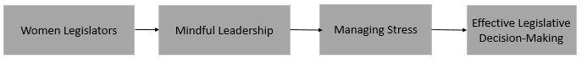
Studies suggest that women draw upon their entire life experience and worldview in reaching the point at which they engage mindful decision making using a moral compass. Given the close relationship between mindfulness and ethical decision-making, one can consider the possible implications of this study in ways that transcend narrowly defined instances of mindful decision making.
Mindfulness is often shoehorned by mainstream society into activities like yoga and meditation. Without question, these practices have tremendous impact on the lives of those who engage in them, but there is a much more practical way of looking at mindfulness, as reflected in these results. Decisions made through mindful leadership were less stressful for the people who made them, male or female. They bolstered confidence. Perhaps most importantly, they got results. All of this suggests that mindful leadership can be discussed both as a spiritual practice in the way that legislators have reported using their religious belief systems in the past (Fernando & Jackson, 2006) while at the same time helping them to achieve the practical goals that constituents and colleagues expect from them (Battaglia 2015). A model showing the impact of mindful decision-making on confidence, lowered stress and in turn, effective legislators is seen below in Figure 5.

Figure 5: Mindful Decision-Making Legislative Benefits
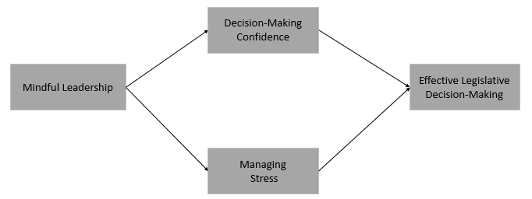
Women must be at the forefront of this effort. Not only are women legislators more likely to engage in mindful practice in the process of reaching decisions, but the emphasis that many women put on moral and ethical decision-making means that they are able to reach out to those colleagues who are making decisions with some spiritual guidance already and focus that guidance into a more ethical and practical direction. The tendency of men to use relationships and pedigree to navigate their careers (Flammang, 1985) suggests that a shift in worldview would be necessary in order for men as a group to give appropriate priority to mindful leadership, regardless of its benefits.
Limitations
Consistent with previous studies, the sample size is a barrier to rigorous quantitative analysis (Battaglia 2015) due to apprehension by legislators. The trepidation comes from the uncertainty of privacy and anonymity with the ability of technology to be used to obtain information and risk of exposure. The researcher is grateful that most legislators that were invited to participate in this investigation accepted the invitation. Due to the time commitment of qualitative inquiry, the dataset is still smaller than desired. Ideally, a larger sample size, within a qualitative study, will provide a greater depth and soundness that would help substantiate the findings and uncover new information. Increased participation from party leadership will give a better dimension to areas of decision-making, specifically in managing stress with party pressure to secure votes. As mentioned in past research (Battaglia, 2015) and this study, party leadership has a profound impact on decision-making. Further exploration into leadership pressure from party leadership itself will bring new light to the matter.
Future Research
Through legislative interviews, this study learned that women in the legislature are expected to be strong, unwavering in their decisions, and congenial, simultaneously. This expectation is consistent with social role theory (Eagly, 1987) and affects women who are campaigning for office as well. Future research on gender expectancies and the impact they have on women’s leadership would be a compelling addition to this ongoing legislative inquiry. Legislators also spoke of areas that need to be studied. In other words, when asked “if there was anything I may have overlooked,” there are areas that “are not often considered” when trying to understand the legislature. The themes were twofold: Legislators make decisions based on financial support or influence, and the pressure to support the party under extreme circumstances is considerable.
“Some legislators, the vast majority of the people I serve with, Republicans and Democrats, truly agonized over trying to do the right thing. I think that too many constituents, too many people out there, take a very skeptical view of elected officials and think that we make our decisions based on who wrote us the latest campaign check. I really don't know anybody that operates that way on either side of the aisle. The people that I know work really hard to try to do the right thing.”
Battaglia’s (2016) previous quantitative research examined this question. Due to the reluctance of legislators to complete electronic surveys, the sample size was too low for a rigorous analysis. A qualitative study with a deeper investigation into the influence of financial contributions would be an apt addition to this work. Not only will a qualitative interview process facilitate increased participation, but it will allow probing into responses to gain better clarity not only for candidates and legislators but for constituents and advocates to understand.
“Sometimes the pressure to be loyal to your party, and vote with your party, even if you personally might want to vote another way for your district can be intense pressure to vote based on supporting a party.”

In Battaglia’s (2015) research, one finding was the proudest moment for a legislator is when they vote in a bipartisan way. Voting against the party caused criticism and punishment by the party leadership. Punishment included removal from a committee, curtailment of leadership roles or lack of monetary support by the party during legislators’ reelection. This issue can be examined and shown in a way that helps legislators manage the anxiety that comes with those decisions.
“I don’t know if there's any one way to mitigate it as much as it is sometimes an additional factor you have when making decisions. And it's just kind of another variable that you would toss into this soup that you have to manage when making decisions. So, we sometimes had to make hard votes that would be harmful politically or potentially for certain people and be harmful or perhaps even just not good for their district. There is a lot of pressure put on people in the name of party loyalty.”

There is much to look forward to in terms of further examination in these areas of gender, negative constituent impressions of legislators’ decisions and party influence on voting.

IMPLICATIONS FOR PRACTICE
The most important practical implications of our work are for the practitioners’ use, not only for their role as advocates but in a broader sense for voting for candidates with diametrically different views. The first step in advocacy is to get to know legislators and to understand the depth of the issue as it relates to educating those legislators. Advocates often plan government relations strategy around the impact of the issue on the constituents that legislator represents. As we continue to learn the legislator’s personal values, decision-making styles and motivators, and specifically their faith and religious beliefs, we are closer to developing strategies in helping these leaders better understand the policy issues from a perspective that they will appreciate. Furthermore, these findings force advocates and constituents to examine how policy may be affected long-term with a particular candidate’s representation. Understanding the importance of the practice of spirituality or faith and its impact on policy may help policy makers’ better compromise and work together. Understanding these similarities and differences can be central to legislators as they need to find common ground to reduce polarization of complicated, divisive issues.
CONCLUSION
How one picks a leader who will do that which is right is a topic of conversation that could be as old as conversation itself. As soon as human beings decided they would be better off together as a society rather than on their own, managing the various personalities and priorities of that earliest community was doubtless as challenging as it is today.
In our aggressive, materialistic culture, hallow words are often paid to the virtues of thoughtful deliberation and ethical behavior, but the politicians who can get things done, regardless of how they do them, often are most richly rewarded. Likewise, the institutions that groom these leaders tend to be similarly biased in favor of the tired notion of the alpha male as leader. In such a climate, it might seem as though carving out a place for these priorities – ethics, mindfulness, even righteousness – is a lost cause.
In the midst of this moral ambiguity, women have succeeded in maintaining a moral compass and a mindful approach to decision-making that are revealing objectively discernible differences in their work as legislators. This research focuses on the benefits of mindful leadership and enumerates the practical, measurable presence of this approach and some of its advantages. The benefit to having women take their rightful place as peers to men in the political realm is made very practically clear through this research.
While it is possible to measure these differences in legislators' decision-making practices, there remains a substantial lack of such research in the fields that intersect on this topic. There is a robust literature on women as business leaders, and there is a mass of data confirming the value of mindful decision-making. There is also a good deal of scholarship that has been produced about women in politics. All of this is essential work and should continue. The voices that are affirming the value of the uniquely feminine method of leadership and decision-making, however, must be added to those that find ways to measure that work. This will pave the way for a clearly discerned methodology of feminine leadership.
This scholarship reveals both practical benefits of the feminine leadership method, such as calmer decision-making during high-pressure moments in the legislative session and an increase in efficacy regarding maneuvering bills through the process. It also reveals, particularly, in the discussions about why certain decisions are made the way they are, that there is a tremendous potential for the reorientation of modern American politics through an emphasis on feminine mindful leadership. The civic health of the country can only be strengthened through the continued exploration of these topics.

REFERENCES
Abdul‐Quader, A. S., Heckathorn, D. D., McKnight, C., Bramson, H., Nemeth, C., Sabin, K.,Des Jarlais, D. C. (2006). Effectiveness of Respondent-Driven Sampling for Recruiting Drug Users in New York City: Findings from a Pilot Study. Journal of Urban Health : Bulletin of the New York Academy of Medicine, 83(3), 459–476.
Battaglia, A.J. (2016). Legislators as Leaders: Investigating and Elucidating the Influence of Gender, Religious Beliefs, and Mindfulness on Legislative Decision Making (Unpublished doctoral dissertation). Case Western Reserve University, Cleveland, Ohio.
Boin, A. (2005). The politics of crisis management: Public leadership under pressure. Cambridge University Press.
Boyatzis, R., & McKee, A. (2013). Resonant Leadership: Renewing Yourself and Connecting with Others Through Mindfulness, Hope and Compassion. Harvard Business Press.
Brown, K. W., & Ryan, R. M. (2003). The benefits of being present: Mindfulness and its role in psychological well-being. Journal of Personality and Social Psychology, 84(4), 822–848.
Burke, C. S., Sims, D. E., Lazzara, E. H., & Salas, E. (2007). Trust in leadership: A multi-level review and integration. The Leadership Quarterly 18, 606-632.
Charmaz, K. (2006). Constructing grounded theory: a practical guide through qualitative analysis. London ; Thousand Oaks, Calif: Sage Publications.
Corbin, J. M. (2008). Basics of qualitative research: techniques and procedures for developing grounded theory (3rd ed). Los Angeles, Calif: Sage Publications, Inc.
De Acedo Lizarraga, M. L. S., de Acedo Baquedano, M. T. S., & Cardelle-Elawar. (2007). Factors that affect decision making: Gender and age differences. International Journal of Psychology and Psychological Therapy 7(3), 281-391.
Eagly, A. H. (1987). Sex Differences in Social Behavior: A Social Role Interpretation. Hillsdale, NJ: Lawrence Erlbaum.
Epstein, R. M. (1999). Mindful practice. Jama, 282(9), 833-839.
Fernando, M., & Jackson, B. (2006). The influence of religion-based workplace spirituality on business leaders’ decision-making: An inter-faith study. Journal of Management & Organization, 12(1)
Flammang, J. A. (1985). Female Officials in the Feminist Capital: The Case of Santa Clara County. The Western Political Quarterly, 38(1), 94.
Forsyth, D. R., J. L. Nye and K. Kelley: 1988, ‘Idealism, Relativism, and the Ethic of Caring’, The Journal of Psychology 122, 243–248.
Fowler, L. (2005). Gender and jury deliberations: The contributions of social science. Wm. & Mary J. Women & L., 12, 1.
Jack, A. I., Friedman, J. P., Boyatzis, R. E., & Taylor, S. N. (2016). Why do you believe in God? Relationships between religious belief, analytic thinking, mentalizing and moral concern. PLoS ONE, 11(3).
Fry, L. W., Vitucci, S., & Cedillo, M. (2005). Spiritual leadership and army transformation: Theory, measurement, and establishing a baseline. The Leadership Quarterly, 16(5), 835–862.
Gillespie, N. A., Mann, L. (2004). Transformational leadership and shared values: The building blocks of trust. Journal of Managerial Psychology, 19, 588–607
Gioia, D. A., Corley, K. G., & Hamilton, A. L. (2013). Seeking qualitative rigor in inductive research: Notes on the Gioia methodology. Organizational Research Methods, 16(1), 15-31.
Glover, S. H., Bumpus, M. A., Sharp, G. F., & Munchus, G. A. (2002). Gender differences in ethical decision making, Women in Management Review, 17(5), 217 – 227.
Heckathorn, D. D. (2002). Respondent-driven sampling II: deriving valid population estimates from chain-referral samples of hidden populations. Social problems, 49(1), 11-34.
Hildebrand, David K, Ott, Lyman, & Gray, J Brian. (2005). Basic statistical ideas for managers (Vol. 1): South-Western Pub
Karafin, B. (2009). Book Review: Mindful Politics: A Buddhist Guide to Making the World a Better Place.
Karelaia, N. (2014). Why mindful individuals make better decisions. INSEAD Knowledge. Retrieved from http://knowledge.insead.edu/leadership-management/why-mindful-individuals-make-better-decisions-3479
Kawakami, C., White, J. B., & Langer, E. J. (2000). Mindful and masculine: Freeing women leaders from the constraints of gender roles. Journal of Social Issues 56(1), 49-63
Kirkpatrick, S.A. and Locke, E.A. (1991) Leadership Do Traits Matter Academy of Management Executive, 5, 48-60.
Merriam-Webster. (n.d.). Mindfulness. Retrieved from https://www.merriam-webster.com/dictionary/mindfulness
O'Neil, D. A., & Bilimoria, D. (2005). Women's career development phases: Idealism, endurance, and reinvention. Career development international, 10(3), 168-189.
Paloutzian, R. F., & Park, C. L. (2014). Handbook of the Psychology of Religion and Spirituality. Guilford Publications.
Plum Village. (n.d.). Mindfulness practice. Retrieved from plumvillage.org/mindfulness-practice/
Poggione, S. (2004). Exploring Gender Differences in State Legislators’ Policy Preferences. Political Research Quarterly, 57(2), 305.
Preston, T. (2012). The president and his inner circle: Leadership style and the advisory process in foreign policy making. Columbia University Press.
Reiter, K. K. (2013). Gender differences in decision making when faced with multiple options. Poster presented at Scholarship & Creativity Day, Saint John's University, Collegeville, MN.
Singhapakdi, A., Vitell, S. J., & Franke, G. R. (n.d.). Antecedents, consequences, and mediating effects of perceived moral intensity and personal moral philosophies. Journal of the Academy of Marketing Science, 27(1), 19–36.
Slovic, P. (1999). Trust, emotion, sex, politics, and science: Surveying the risk-assessment battlefield. Risk Analysis, 19(4), 689–701.
The Mindfulness All-Party Parliamentary Group (MAPPG). (2015). Mindful nation UK. The Mindfulness Initiative.
Tucker, H. J. (1985). Legislative Logjams: A Comparative State Analysis. The Western Political Quarterly, 432–446.
C Volden, AE Wiseman, DE Wittmer. American ... AE Wiseman. The Journal of Politics 71 (3), 998-1014, 2009.
Weber, E. U., & Johnson, E. J. (2009). Mindful Judgment and Decision Making. Annual Review of Psychology, 60(1), 53–85.
Welch, S. (1985). Are Women More Liberal than Men in the U. S. Congress? Legislative Studies Quarterly, 10(1), 125.
APPENDIX

Table 1: Sample Demographics Chart

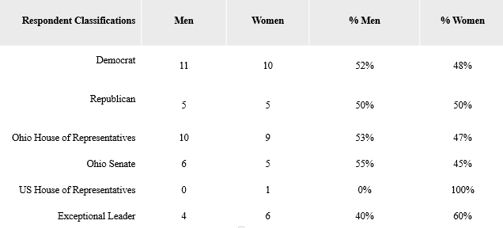

Figure 2: Interview Protocol

Legislators as Leaders:
Understanding Mindful Leadership in the Legislature
Qualitative Interview Protocol

Step 1: Introduction and Explanation

Purpose of meeting: “I am exploring how legislators deal with difficult choices and challenging decisions in the legislative process.” This includes not only the process but the effects from tension and stress given a contentious issue “I would like us to focus on your decision-making processes and experiences. Please be as specific as you can and provide as much detail as you can remember.

Confidentiality: “Everything you share in this interview will be kept in strictest confidence, and your comments will be anonymously transcribed – omitting your name, any names you refer to in this interview, as well as the name of your current organization and past organizations. Your interview responses will be aggregated or listed anonymously with all the other interviews I conduct."

Permission to Audio Record: “To help me capture your responses accurately and without being overly distracted by taking notes, I would like to record our conversation with your permission. Again, your responses will be kept confidential. If at any time, you are uncomfortable with this interview, please let me know, and I will turn the recorder off.”

Format of Interview: “I will describe two legislative scenarios and ask a series of open-ended questions related to your decision-making process. I will also ask a few follow-up questions, if necessary, as you respond. The hypothetical decision-making scenario I describe will serve more as a guide to our conversation. The interview will last approximately 60 minutes. I am looking forward to our conversation together.”

Step 2: Scenario One:
You are inundated with pleas to maintain the right to bear arms while a recent shooting was in your district. Advocacy groups, lobbyists, and survivors are putting pressure on you and your office to vote new laws into place. As gun violence in the US continues to dominate as a national policy issue, particularly as mass shootings have been increasing, new legislation is drafted.
What are the first steps you would take in tackling this decision-making process?
Your constituents are contacting your office to voice how they want you to vote. You are the deciding vote for this public and contentious issue.

Step 3: Scenario Two
Caring for our veterans and ensuring rights for their service to our country is something that Americans care about. All critical stakeholders are supporting upcoming legislation to increase budgetary support for supportive and job development services. You have been asked by a colleague if you will vote for this increase in services.

Questions for Scenario One and Two:
What are the first steps you would take in tackling this decision-making process?
- Tell me about how you would begin to concentrate and become engaged in the issue.
- How would you respond to unpleasant experiences that develop during these hard decisions (e.g., Disagreements with colleagues, threats, wanting to please everyone, and the unknown results of your decision, other important work for your constituents)?
- What would you do to balance the political and policy stress of it all? What do you do to mitigate the physical or emotional stress that comes with navigating such emotionally charged issues?
Probing questions:
In the above scenarios,
- When knowing the details are important and understanding the needs of your constituents is always on your mind, how would you look at the full picture at a high level? Can you also give me a real life example of this?
- What do you do to feel more confident in your decision-making process?
- What in your opinion makes an effective legislative decision-maker?
- Who do you think is the most decision-making: effective legislator is that you have worked with?
- Can you tell me about a time when your faith helped manage the stress or anxiety?
Step 4: Closing
That concludes our interview. Thank you for your time with me. Are there any other questions or insights you think I have missed regarding mindful leadership? If I need to clarify anything we’ve discussed, would it be okay for me to follow through with a brief phone call or email?

FIGURE 2: CODING TREE
