Twitter Wars: The Use of Twitter as a New Policymaking Tool for the President

Dr. Ryan Lee Teten
Associate Dean/Associate Professor
University of Louisiana at Lafayette
Email: rlt5683@louisiana.edu

This paper was prepared for the Annual meeting of the Western Political Science Association, San Francisco, California, March 29-31, 2018
Abstract:
During the 2016 Presidential Campaign, President Donald Trump often turned to Twitter to issue statements regarding other candidates, his positions on current events, and personal defenses and attacks. This utilization of Tweets did not change with his election as President of the United States. From commentary on players in the NFL kneeling and the "Rocket-man" leader of North Korea, to criticism of major corporations such as Amazon and attacks on “fake news” sources, Trump has used twitter to attempt to influence his followers and chart a course of public policy, much the way presidents of the past have done in their State of the Union Addresses. This paper looks at Trump's use of Twitter as a new form of the Bully Pulpit, the frequency with which he actually makes policy commentary, if Twitter can be seen as a 24/7 State of the Union Address, and what its use may mean for future Presidents.

“What FDR was to radio and JFK to television, Trump is to Twitter, Instagram, Facebook, Snapchat, et al.”

Neal Gabler, 2016

“The Fake News Media hates when I use what has turned out to be my very powerful Social Media - over 100 million people! I can go around them”

@realDonaldTrump, June 16, 2017

Presidential officeholders and candidates have always sought to connect with voters and their supporters using all of the available means possible for their times. From editorials in the Massachusetts Spy to whistle-stop tours via trains to Franklin Delano Roosevelt’s fireside chats, using any technological means possible to add weight to the Bully Pulpit is a commonality among all politicians and presidents. With the rise of New Media and Social Networking Sites (SNS) in the late 2000’s, there were even more ways to communicate with the electorate. Candidates and politicians started with creation of their own websites through which they could get their messages and policy priorities out. However, interactivity was limited and it was more of a one-way provision of information than a true back and forth between elected and electors. Facebook’s creation opened the door to a brave new world of immediate dissemination of information as well as and ability for users to “like,” “share,” or “comment” on the items that politicians posted to their feeds. Barack Obama is largely seen as the pioneer in utilizing Facebook not only for communication with the public, but fundraising, campaigning, and policy discussions. Truly, the “Bully Pulpit” and “Going Public” had evolved into the “Bully Post” and “Going Viral.”
Regardless of the success that Obama may have demonstrated in using Facebook for electoral and informational victories, SNS’ were largely viewed as a novel offshoot of traditional politician and presidential communication as opposed to an important addition to the canon of official political rhetoric. It wasn’t until the highly contested presidential campaign of 2016 succeeded by the victory of Donald Trump, his continuous use of Twitter throughout the race, and then into his actual term of office that this “non-traditional” form of communication was forced to be accepted as a new campaigning and policymaking tool. This study specifically examines the tweets of President Donald Trump from his election day victory through February 2018 to examine whether or not these 140 character (changed on November 7, 2017 to 280 due in no small part to Trump’s use of that SNS) messages can be considered as influential and similar in their form and function as traditional presidential outlets like the constitutionally mandated State of the Union Address.
Although Twitter began as a social networking site for users to be able to update their statuses regarding everything from what they ate for dinner to how they felt about movies, Trump’s consistent use of Twitter to convey everything from his personal thoughts to policy priorities has forced them into the limelight as a viable rhetorical tool for presidential messaging. Tweets from Trump that may have been considered dismissible during the campaign take on a totally different character (pun intended) when originating from the leader of the free world. “Shoot-from-the-hip tweets that came from a reality television star campaigning for president have an entirely different effect when they come from the president of the United States.” (Korte 2017) Indeed, “The White House later acknowledged that Mr. Trump’s tweets were official statements” (Miller 2017). Consistent with his Facebook use, “Mr. Obama was the first president to use social media but used it far less than Mr. Trump” (Miller 2017).
In addition, Trump’s tweets are not only part of his overall communication strategy, but they are also his primary rhetorical weapon by which to announce policy. Therefore, Trump’s rhetorical stance “has some real policy implications” and represents a real change in the field of presidential communication (Thompson, 2018). Similarly to the manner in which Trump used Twitter to gain exposure and media coverage during his campaign, “Trump uses social media as a weapon to control the news cycle. It works like a charm. His tweets are tactical” (Lakoff, 2018). Trump and his team use Twitter to make the entire news cycle about exactly whatever they want it to be on instead of what was happening before, releasing a tweet to regain control over the media (Schwab 2018).
Trump’s tweets are not just part of strategy, however, but are a very real way that he, as president, issues policy statements and attempts to influence national and international policy initiatives. Just as the white house considers his Tweets to be the official statement of the president (Chappell, 2017), “Already, though, the foreign officials who spoke with VOA said Trump's use of rhetoric and social media has impacted the way they prepare their heads of state and other officials for trips to Washington” (Seldin 2017). He also uses Twitter as a way to float policy “weather balloons” as well, without formally making changes yet. Trump has tweeted about policies before the official announcement of his final decision regarding specific issues. In this way, the president was able to gauge public opinion and possibly change his decision based on the reaction to it. At the outset of 2018, Trump tested the Twitter waters regarding a possible importation of trophy regulation change in the Department of the Interior. “The move comes as celebrities, politicians and even some Trump supporters had intensely criticized the administration's decision earlier this week to again allow the importation of elephant parts from Zambia and Zimbabwe” (Trump Tweets 2017). Although initially insinuating that he would allow the ban on elephant trophy importation to be lifted, he reversed his position after significant Twitter backlash.
Legally, Trumps Tweets also carry the weight of executive law that proclamations and executive orders marshal. It makes it especially important to evaluate the presidential Twitter posts not only for their policy implications, but also for their appropriateness for the policy-making process. “A federal judge in Maryland cited Mr. Trump’s tweets as an example of bad policy-making, even going so far as to put screen captures of three tweets in his opinion halting the president’s policy against transgender troops serving in the military” (Dinan 2017). This quote shows that Trump’s tweets, no matter how the president himself or the discipline may view them, are taken seriously in regards to judicial decisions.
Trump’s use of twitter has not been embraced unequivocally as a viable means of executive communication universally, even if he himself does so. Internationally, “Chinese officials and the state news media want Mr. Trump to know that their leaders prefer doing diplomacy the old-fashioned way, behind closed doors and muffled in platitudes.” (Buckley 2017). In addition, proposing policy in only 280 characters may lead to vagaries that can confuse of be easily misinterpreted. Regarding the ban on transgender military personnel, Senator John McCain, the chairman of the Senate Armed Services Committee, said Trump’s policy pronouncement was “unclear” and that he should let the policy reviews into the issue proceed as planned” (Ward 2017). Another concern surrounds studies that have proposed that Twitter posts may not be subject to presidential immunity and open to charges of libel (McKechnie 2017).
Also, when Trump retweets other users’ posts that may not be accurate, there is immediate backlash for the presidency and America that occurs because the account is seen as the president’s official word. As an example, Trump used his account to retweet anti-Muslim videos from a British far-right account run by Jayda Fransen, the deputy leader of Britain First. “Trump's retweets were leading several major British news websites Wednesday morning, and officials condemned him on Twitter” (Landers 2017). The videos were later even shown to have been staged or altogether faked. This creates a conundrum under which the electorate is unsure whether Trump’s tweets are serious lawmaking and policymaking rhetoric, or still just sidelight commentary not to be viewed as official. "I don't think he's going to be involved in the daily administration of government the way previous presidents have been. I think he's going to be more of a showman" (Seldin 2017).
In the end, it appears as though Trump walks a fine line between personal commentary and official presidential rhetoric. His use of Twitter is not unexpected, as Obama before him utilized the SNS, and whatever candidate could also have won in 2016 would probably continue its employment. “All of us in leadership have to find ways in which we can re-create a common space on the internet” but “one of the dangers of the internet is that people can have entirely different realities. They can be cocooned in information that reinforces their current biases” (Miller 2017). Trump “has to remember that tweet is read not simply by, say, a political base within the United States but is read all around the world” (Shapiro and Haas 2018). This study will compare the language commonly used by presidents in State of the Union Addresses, as well as the number of policies they proposed and the way they proposed them and compare these with Trump’s Tweets to determine more concretely whether or not Twitter is indeed similar in nature to traditional executive rhetoric and should be given the gravity of such. We also look at whether or not the murky mixing of personal and policy posts suggest that Twitter, though a preferred method of communication of Trump, cannot be realistically seen as official presidential policymaking or a new weapon of the rhetorical presidency.

Politician Communication and the Rise of New Media 2.0
Since the inception of New Media, and especially the launch of Facebook in 2004 and Obama’s use of the internet in his 2008 presidential bid, politicians and political scientists alike have tried to gauge the usefulness of the internet and social networking sites for the overall impact on the citizenry, and how they could be used to increase presidential visibility, issue executive policy statements, and influence constituent political participation and efficacy. Because of the exponential increase in Social Media memberships as well as constant evolving innovations in technology each year, it is essential that our scholarship constantly evaluates the new ways that politicians and the people interact via these Social Networking Sites (SNS). This study attempts to fill the gap in scholarship that proposes that “how technologies such as Twitter, Facebook and other new web features may affect strategies represent important areas for future work” (Druckman 2013, 18) and evolve “the internet politics research agenda [that] is still in a fledgling, pre-paradigmatic stage” (Karpf, 2013, 414). Here, we hope to “advance new studies that help us answer practical questions about what Twitter…can do to act as good corporate citizens,” especially regarding national policy and executive power (Karpf 2013, 12). We build on work that prioritizes the need to add “understanding how candidates who adopt the technology actually use it as a campaign tool and what their objectives are for doing so” as it “can offer insight into the ways social media are changing how congressional campaigns are waged today” (Gulati and Williams 2015, 35).
Primarily, this study extends the traditional examination of Social Networking Sties use in congressional and presidential campaigns to its actual and frequent use as a rhetorical and policy tool for a sitting executive (see Sanchez-Gimenez and Tchubykalo, 2018, Ott, 2017, Liu, 2016 and the studies above for a Twitter examination during Trump’s campaign, for example). For many scholars, Obama’s success in 2008 at securing the presidency began a new era of examination of his garnering both fundraising and networking support through Internet and Social Networking Site (SNS) use. Social media is relatively new to the world of political science, campaigns and elections, and policymaking. Indeed, even though Barack Obama’s campaign is often studied as the first to heavily use the internet, Howard Dean is usually noted as one of the first successful users in 2004 in general for fundraising and communication purposes.
Since Dean’s race in 2004, we have seen the development of Facebook, Instagram, Twitter, Snapchat, Pinterest, and literally thousands of other social networking sites. It was Obama, however, that used a fuller breadth of the internet to spread his message than previous politicians had done (Bimber and Davis 2003; Carr and Stelter 2008; Druckman 2013; Farrar-Myers and Vaughn 2015; Foot and Schnieder 2006; Lentz 2002; Miller 2008). “Next to his own website, Obama used fifteen Social Media sites to run his campaign” (Effing 2011, 26). Facebook, with its nearly 1.55 billion active monthly users, is by far the largest of these sites, accounting for over half of all social media site visits (Smith (b) 2015; Number 2015). Twitter is the second largest with 330 million users each month, however. “Social media also played a major role in the 2012 U.S. presidential election, with Facebook citing nine million of its users voting in the November elections” (Carlisle 2013, 883; Farrar-Myers and Vaughn 2015).
The importance of Facebook, Twitter and social networking to politicians cannot be understated. “The networked population is gaining greater access to information, more opportunities to engage in public speech, and an enhanced ability to undertake collective action (Shirky 2011, 29). There is also an “increasing tendency for politicians to focus on mobilization via such sites, as has been evidenced in particular by the overwhelming success of the Obama-Biden campaign” (Dalsgaard 2008, 8). The value of social network study also stems from its potential for interactivity, as “activities on SNS are largely communal, interactive and directed by users” (Conroy, Feezell, and Guerrero 2015, 182; Tedesco 2007).
Until the rise of Social Networking Sites like Twitter, candidates utilized their campaign websites as the best way to disseminate candidate rhetoric, presentation of self, and attempted interaction with potential voters. Although “utilizing interactive web technologies introduces significant risk because candidates lose message control,” Almost every politician seeking and within office must embrace the New Media technology and its interactive possibilities, in some way, to be successful (Druckman 2009, 345; Chadwick 2006; Eveland and Dunwoody 2002). The potential value of a using SNS sites for maintaining communication with constituents cannot be minimized. “Political sites have notable direct effects on voters and can generate engagement and social interaction” (Druckman 2013, 2; Gibson and McCallister 2006, 2009).
The rise of Twitter presented presidential and congressional candidates with an even more fluid, interactive environment that provided all of the same opportunities for information sharing, and also a new interactivity that was absent from traditional candidate websites. Scholars such as Gulati and Williams (2011, 2012, 2015), have suggested that SNS are the “new,” 2.0 versions of candidate websites, which are quickly becoming viewed as static and less interactive campaign sources. They found that among congressional candidates in 2010, “82% had a presence on Facebook” (Gulati and Williams 2015, 32; 2011). Others have also shown that Congressional incumbents and challengers, men and women candidates alike, although to varying degrees (Evans et al, 2014), have embraced Twitter use. This study’s research extends and evolves from “which candidates were more likely and less likely to use Facebook during their campaigns and…explores how the candidates tend to use Facebook as a campaign communication tool” (Gulati and Williams 2015, 33; see also Gulati and Williams, 2008) to an examination of how a successful presidential candidate continues the employment of SNS, and specifically Twitter, throughout his tenure in office.
With Facebook, “the capacity to tie tailored messaging to specific target voters can increase the amount of issue and biographically-based information that campaigns communicate” (Hall-Jamieson 2013, 430). We agree with the monumental shift candidates have embraced towards daily interactivity with the electorate and believe that social networking sites are better suited at gauging politician communication and behavior, interacting with voters, and providing a longitudinal measure of candidate decision-making.
Because of the changing capability of technology and SNS like Twitter, it is no longer true that “technologies, at least in terms of the web, do not seem to have fundamentally changed…campaign approaches” (Druckman 2013, 18). Instead, similar to Gulati and Williams, we suggest that Twitter is becoming the new standard over traditional websites, even those like whitehouse.gov, in terms of quickly and cost-effectively spreading message, and setting policy priorities. “We should expect that all candidates and political parties will use social media sites to create enthusiasm in their troops, raise funds, and influence our perception of candidates” (Metaxas and Mustafaraj 2012; see also Frum, 2014). In fact scholarship suggests that “we have reached the point where having a social media presence via a website, Facebook page, and Twitter account is a necessary means to be an effective political communicator” (Farrar-Myers and Vaughn 2015, 2; Gulati and Williams 2011, 2012, 2015; Kreiss and Welch 2015). In addition, the preponderance of SNS use in 2016 congressional and presidential elections show that politicians realize that “social media platforms have an agenda-setting impact and constitute a powerful arena for constructing and maintaining a candidate’s image” (Enli, 2017). Donald Trump, however, is really one of the first presidents to embrace Twitter as, not only a campaign tool, but also the main source of informing his followers on a daily, and usually hourly, basis.
Even though presidential and congressional campaigns have garnered significant attention in the field, there has been little study on SNS use by sitting presidents as a policy or rhetorical communication tool. Social networking sites present politicians with new ways of examining the same issues of “going negative, issue ownership, and position taking” with which the scholarship has been long engaged (Druckman 2009, 343; Franklin 1991; Lau and Pomper 2004; Petrocik 1996). In addition, Twitter posts and social networking feeds provide a real time analysis of how much “competition and incumbency influence rhetorical choices” (Druckman 2009, 343; Kahn and Kenny, 1999; Militia et al 2014; Trent and Friedenberg 2008). Far from being an isolated “.com” that existed and then passed into history (as did MySpace for example), Twitter has established itself as a new medium of importance. “The most profound technologies are those that disappear. They weave themselves into the fabric of everyday life until they are indistinguishable from it” (Bimber, Flanigan and Stohl 2012, 54-55). It is no longer a mundane and “novel platform” (Bimber and Copeland 2013; Karpf 2013, Druckman 2013), but instead embracing new media is becoming indispensable because “politicians can use technology to promote democracy and change. And, for effective change to happen, campaigns must learn all facets to the rhetorical emerging media” (Johnson, 2012).
Indeed a study by Bond (2012) suggests that SNS platforms like Twitter and Facebook not only connect with the average American with a frequency that New Media has never seen, but also have the potential to increase turnout and political participation. In fact, historically, these kinds of “interpersonal appeals increase the likelihood of voting” (Hall-Jamieson 2013, 429; Farrar-Myers and Vaughn 2015; Green and Gerber 2008; Gulati and Williams 2011, 2012, 2015; Rosenstone and Hansen 1993) and SNS applications are a contemporary way, domestically and internationally, to issue these appeals to reach voters (Spierings and Jacobs, 2014; Elson et al, 2012). Another important reason for examination of Twitter and SNS use is that, in terms of political efficacy and interaction, studies have suggested that “political technology has a positive effect on traditional, offline participation” (Conroy, Feezell, and Guerrero 2015; Karpf 2013, 416; Boulianne 2009). Politicians can encourage activity through Twitter posts that will immediately be transmitted, free-of-charge, to their followers. Whether this is political protest and organization or voting encouragement, Twitter is the new standard in connectivity. Recent studies have found concretely that established SNS sites like Twitter and Facebook illustrate that “political activity is correlated with increased political action offline” (Macwilliams 2015, 580; Conroy, Feezell, and Guerrero 2015; Park, Kee and Valenzuela 2009; Vesnic-Alujevic 2012).
In fact, others have discovered that “those who are more active in political online groups are more politically active offline, with online group membership mimicking some of the positive effects of offline group membership” (Conroy, Feezell, and Guerrero 2015, 186; Conroy, Feezell, and Guerrero 2012). Another study discovered that Twitter was utilized to begin candidate and issue conversations and debate current political issues as opposed to existing as a static virtual bulletin board where interactivity was rare or non-existent (Tumasjan et al, 2010). The social engagement and inspired political activity of SNS may provide benefits that suggest “virtual bowling” may be as useful as Putnam’s “bowling in leagues” (2001) for political socialization. Contrary to a traditional view of virtual interaction, scholars have found that “political participation on Facebook has a statistically significant effect on attending a rally, participating in a boycott, and signing a petition” (Conroy, Feezell, and Guerrero 2015, 193). Not embracing this technological advance not only leaves politicians in the minority, it has the potential to miss opportunities for increasing political engagement and feelings of political efficacy.
Newer studies also show that nearly 63% of Twitter and Facebook members are using the site as their source for news and other information traditionally gleaned from network or cable television news sources (Barthel 2015). “For today’s young people some form of digital instrument often serves as the gateway to both traditional and new forms of print media” (Roberts 2008). Social media “is indeed delivering—through tweets, Facebook posts blogs and the like—a large volume of information and opinion on newsworthy events and other subjects” (Chandrasekhar 2013). In a study in 2015, the Pew Research Center for Journalism and Media found that over half of SNS users were getting their news regarding Sports, National News, National and International Politics, Local Government and Politics, Crime, and Health and Medicine from social network feeds or online news organizations that they were following (Barthel 2015). Further, nearly 70% of users looked for their news and information regarding Entertainment and Local news about Events and People in their Community from SNS feeds (Pew). Another study “found that 45% of youth reported getting news at least once a week from family and friends via Twitter and Facebook” (Kahne 2012, 53-54).
Studies found that nearly as many Americans were getting their Political news from SNS sites (48%) as they were from their local broadcast television news (49%) (Mitchell 2014). Pew concluded that more Americans who utilized the internet were getting their political news from SNS sites than even CNN (44%), Fox News (39%) or NBC news (37%) (Mitchell 2014). This increased news consumption occurs across demographics as well and grew among both males (44% to 61%) and females (49% to 65%) over the last two years (Duggan 2015). A recent survey found that an increasing 65% of Americans got their information and news from SNS sites like Twitter (Gottfried and Shearer, 2016). Conclusively, SNS sites and the news and politics provided therein, have become an increasing authority and source for Americans as opposed to traditional outlets in television, newspaper, radio, or even other websites.
SNS sites also allow individuals to engage secondary groups and news organizations that can be followed; this seems to have a direct effect on the desire of the user to engage in political discussion and debate. This “online” discussion of information seems a simple adaptation of Katz and Lazarsfeld’s findings that “mass media alone do not change people’s minds; instead, there is a two-step process. Opinions are first transmitted by the media, and then they get echoed by friends, family members and colleagues…access to information is far less important, politically, than access to conversation” (Shirky 2011, 34-35). Twitter users frequently harness news information from their feeds, especially information regarding political stories, and then share this news/opinion/issue with others to whom they are connected. “With the changing Internet environment, there are opportunities to involve and empower citizens in campaigns and work of representatives and government” (Effing 2011, 27). According to a recent Pew study, nearly 32% of SNS users regularly post about political issues (Mitchell 2014). The significant danger here is the potential for “fake news” to be presented via SNS sites as official information, thereby misleading and confusing the citizenry in both campaigns and during governance (See Alcott and Gentzcow, 2017; Ehernberg, 2012; Metaxas and Mustafaraj, 2012).
There is also no political or economic cost to participating in discussions on Twitter. “New media lowers the cost of accessibility to political information thereby making it more likely that people are willing and able to invest themselves politically” (Carlisle 2013, 884). “Posting” to a social networking site means the creation of original comments and content by the user themselves, discussing or engaging a topic of the day. Studies have shown that this kind of activity can “propel individuals into political life especially in terms of allowing them to gather political information, connect with others, mobilize, and recruit individuals to causes and actions because the Internet can significantly reduce the costs of participating” (Carlisle 2013, 884).
This is purposeful and active political engagement that can be clearly differentiated from activity such as a simple “like” click of a political story. “Participation seems to be the key concept that explains the difference between ‘old’ web and ‘new’ Social Media…Social Media is a new stage of development where users are more actively participating than ever” (Effing 2011, 28;30). One study of elections in the Netherlands found that “Politicians with higher Social Media engagement got relatively more votes within most parties” (Effing 2011, 31). Twitter is indeed being recognized as a political tool and “mobilization has become so popular that politicians as a category now have specific kinds of profiles, where they have ‘supporters’ instead of ‘friends.’ Here it is not votes that strengthen the politician, but relationships” (Dalsgaard 2008, 12). In a 2013 study, Strauss et al found that Congressional candidates have attempted to maintain the connection with their constituents by establishing Twitter and SNS accounts that provide information even outside of campaigns.
Each contemporary president attempts to be in touch with the electorate in new and ever-more-current ways that no president of the distant past, and very few of the recent past, have imagined. From the internet to e-mail, and from 24 hour cable news networks to social networking (see Rosenblatt 2010; Owen and Davis, 2008; Owen, 2010; Gulati 2010; Wayne 2011; Hershey 2010; Iyengar 2011), today’s president is seemingly always discovering new ways of those to whom he can propose initiative, as well as citizens who may be possible voters for his next term in office. During his candidacy, Obama seized on these technological changes and moved with a message that proposed that “the center of gravity in politics had shifted toward younger-thinking Americans who are much more comfortable…with a new media approach to processing information” (Steinhorn 2010, 145). In fact, “Obama’s campaign was particularly adept at employing cutting-edge strategies for voter outreach” (Owen 2010, 169). He offered identification with the public and everything he did was “geared toward building relationships between supporters and his campaign and each other” (Steinhorn 2010, 150). Alan Abramowitz suggests that this “growing Democratic identification within the electorate” was, indeed, one of Obama’s keys to victory (Abramowitz 2009, 41). However, even though SNS use in presidential and congressional races has seen recent examination, presidential use of Twitter is still largely unexplored, and almost completely absent in its possible effects when used by an executive as his main form of electoral communication. This study attempts to bridge that gap by comparing how Trump talks and what he substantively says via Twitter with the State of the Union speeches of presidents in the past.

Presidential Popular Address Rhetoric in the Twitter Era

When studying presidential speech and its interaction with the public, it is important to observe the rhetorical shifts that take place in the president’s language for varied effect and in order to employ a certain type of power and argument. Popular Address rhetoric can be employed in the simple manipulation of different pronouns. In effect, the executive uses different kinds of words, different pronouns, and different kinds of speech to speak as one of the people, to the people, in reference to the people, or as the president. “Politicians make use of pronouns to good effect: to indicate, accept, deny, or distance themselves from responsibility for political action; to reveal ideological bias; to encourage solidarity; to designate those who are supporters (with “us”) as well as those who are enemies (against “us”) and to present specific idiosyncratic aspects of the individuals and personality” (Wilson, 1990, 76). In addition, “the meanings of selected pronouns shift and change depending on the way in which they are textually employed…selectional choices such as those which operate between exclusive and inclusive ‘we’ for example, offer politicians ways of directing attention towards or away from their own existential center, i.e. themselves” (Wilson, 1990, 76). The president uses these variations in his rhetoric to account for the many different interests of his audience as well as different environmental contexts he may face. Wayne Fields remarks that, in presidential speech, the president “must manage to be both apart and included, must be at once particular and universal, present challenges that do not necessarily confront Congressmen or Senators… The job is always, as Washington foresaw, the difficult business of building affection, affection for one another and for the union itself” (Fields, 1996, 16; 228).

In her study on national identity, Vanessa Beasley observes that “however mythic and outdated, such clear distinctions…between “them” and “us” still persist in presidential talk” (2004, 90). Among many public speakers, the president is not alone in utilizing rhetoric to create and forge different audiences that would be more receptive to his proposals; he is very aware that “a democracy must also have strong and generous words for its common life and common words” (Rodgers, 1987, 222). Wayne Fields remarks that in the presidential address, the president “must manage to be both apart and included, must be at once particular and universal, present challenges that do not necessarily confront Congressmen or Senators… The job is always, as Washington foresaw, the difficult business of building affection, affection for one another and for the union itself” (Fields, 1996, 16; 228). The president attempts to accomplish this inclusion and unification through a manipulation of the ways in which he speaks to, for, and about his audience using identification rhetoric, authority rhetoric, and directive rhetoric (Teten 2011; 2007).
The first type of popular address rhetoric that I will look at will be coined “Identification Rhetoric.” In Vanessa Beasley’s book (2004), much of what she seeks to find in creating a national identity, involves the use of presidential speech that create a similar identification of president with them, and they with him. She illustrates that 9/11 brought this very theory to life. “The events of September 11th and their aftermath have demonstrated…how powerful the felt communion of a national ‘we’ can be” (Beasley 2004: 4). According to Beasley, presidents use the State of the Union Address to mold the American people into one body that can come together in support of policy and action. “In other words, for there to be an American nation, or an American ‘we,’ or even an American presidency at all, U.S. presidents must find ways of breathing life into the otherwise abstract notion of American political community” (Beasley 2004: 8). In order to pass policy and gain support from the electorate, “chief executives clearly had a great interest in making sure that the American people feel united, even if citizens’ actual demographic, economic, and psychological differences would suggest otherwise…by creating an American identity based on such abstractions, presidents have been able to offer their diverse constituents ways of viewing themselves as a united group” (Beasley 2004: 46, 63).
It is by the use of certain rhetoric that the president is able to speak to the people and also seek to convince them that he is on their side, on the same page with them, and has the interests of the greater whole in mind. Through the use of identification pronouns (words such as “our,” “We,” and “us”) both presidents and the common man place themselves in masse with the larger group in question (Teten 2011). “We are attempting to control our environment in particular ways by promoting an identification with other people or by persuading other people” (McGee 1998b: 127). Identification rhetoric is used traditionally within State of the Union Addresses in order to make the public, or the listening audience, feel that the president is indeed one of those to whom he speaks. In his 2003 State of the Union Address, George W. Bush used identification rhetoric to get the people on his side regarding the cause and course of war. He proposed that “We will not deny, we will not ignore, we will not pass along our problems to other Congresses, to other presidents, and other generations. We will confront them with focus, and clarity, and courage.” This was an exercise in the use of identification rhetoric. George W. Bush portrayed himself as one of those in America and in government who would confront the problems of the country and work toward their correction. This constant repetition of “we” is the president’s attempt to build consensus and agreement by creating identification between the citizens of the United States and himself; if they identify with what he speaks, he will receive greater support and have the ability to proceed further with policy objectives. This is reminiscent of Roosevelt’s “fireside chats” that made the American people feel as though the president really did care, and really was one of them.
The second rhetorical label that will be used here is that of authority rhetoric. Authority rhetoric is usage of the words “I,” “me,” and “my” within the State of the Union Address. This category is recognized by Tulis, among others, who suggest that “authoritative speech combines the power of command with the power of persuasion (or force of argument)” (1987: 81). By using specific pronouns, the president is attempting to exert the power of his station and the power of the presidency to propose policy and programs. Because of their position, “the spoken remarks of presidents exert influence not found in the speeches of others” (Hart 1987: 79). In fact, “the speech of presidents is more powerful than most This power derives in part from the office of the presidency, but it also derives from the attitudes the presidents have toward the speech act itself” (Hart 1987: 110). It is the president’s use of pronouns such as “I,” “me,” and “my” in the State of the Union Address that objectify him as commander in chief, and suggest that his rhetoric holds value largely because of that position alone. “It is through the example, the rhetorical leadership, the moral correctness of the leaders of state, and their ability to inspire self-sacrifice, that the power of a state is mobilized” (McGee 1998: 127). Authority rhetoric offers “the suggestion that leadership stems from a person’s formal position…with an officially sanctioned title, the holder of that title can legitimately direct others for the achievement of a goal” (Dorsey 2002, 4; See also Teten 2011).
We see illustrations of authority rhetoric yet again in 2003, when George W. Bush proposed numerous policies regarding the environment, stating that “I have sent you a comprehensive energy plan to promote energy efficiency and conservation, to develop cleaner technology and to produce more energy at home. I have sent you Clear Skies legislation that mandates a 70 percent cut in air pollution from power plants over the next 15 years. I have sent you a Healthy Forests Initiative, to help prevent the catastrophic fires that devastate communities, kill wildlife and burn away millions of acres of treasured forest. I urge you to pass these measures, for the good of both our environment and our economy. Even more, I ask you to take a crucial step, and protect our environment in ways that generations before us could not have imagined. Tonight I am proposing $1.2 billion in research funding so that America can lead the world in developing clean, hydrogen-powered automobiles.” This repetition of the word “I” in the midst of policy proposals sends a message to Congress that the President has been active on certain issues and has certain policies that he would like to see activity on by the Congress. In addition, this use of authority rhetoric reminds the people of the United States that the President is working hard towards many different environmental goals, and that Congress only need approve his plans to get the protection that the President sees as necessary. It is this flexing of the muscle of the power of the presidential position that makes authority rhetoric effective.
In much the same way that the president uses “I,” “me,” and “my” to exercise his presidential authority, he can also use his station to give commands and place the need for performance on his audience. The third classification of rhetoric is that of directive rhetoric (Teten 2011). This type of rhetoric employs the words “you,” “yours,” and “your.” These three words are labeled directive rhetoric because they are used to send a direct command of action to the audience, whether it is Congress or the people. The examples from the 2003 address for authority rhetoric above also show how these many different types of rhetoric are often closely associated. The 2003 State of the Union Address also saw George W. Bush address Congress with this directive rhetoric: “You, the Congress, have already passed all these reductions, and promised them for future years.. I ask you to end the unfair double taxation of dividends…Even more, I ask you to take a crucial step, and protect our environment in ways that generations before us could not have imagined.” These policies are not simply suggestions that the President is giving for directions the country could take. These are commands from the president himself framed in the format of a request that combines both authority and directive rhetoric. Bush uses “I ask you” to convey the point that the President of the United States is asking the Congress of the United States to follow his policy initiatives. He does not simply hope they examine his policy; he wants the Congress to act as he has requested on the issues he has discussed.

Research, Methodology and Findings
The central method by which the presidential State of the Union Addresses will be compared to the Tweets of President Donald Trump is by a line-by-line content analysis of all of the State of the Union Addresses in presidential history as well as all Trump Tweets. To engage the issues discussed above, we began by collecting all state of the Union Addresses as well as all of the Twitter posts by Donald Trump from the date of his presidential victory on November 9th, 2016 through March 1st, 2018. In all, there were 227 State of the Union Addresses and 3110 Twitter Posts. After collecting the data, it was then examined for different variables. Each post was coded independently by three different researchers so that there would be as much confidence in the findings and results as possible. After all of the posts were coded, the three data sets were compared and any discrepancies or oversights that may have led to variation were examined and resolved unanimously. Inter-coder reliability for the study was 95%.
Figure 1: The Presidents and Number of Speeches Included in the Study
Speech Type | Presidents  Included | Years | Number of Speeches/Posts | Number of Words
State of the  Union Address | Washington-Trump | 1790-2018 | 229 | 1,868,334
Trump Tweets | Trump | 2016-2018 | 3110 | 66,144

Scholars describe many possible pitfalls in presidential content analysis research such as small sample size, generalizations made from addresses in differing contexts, and comprehensiveness of study (King, 1993; Edwards and Wayne, 1983; Krippendorff, 1980; Carney, 1972). However, I propose that content analysis in this manuscript has many benefits in providing a valid and reliable study from which to make inferences and generalizations relating to presidential rhetoric. The extensive content analysis that I will conduct is a thorough and cautious line-by-line examination and reading of each State of the Union Address and Tweet in order to determine policy proposition, word usage, political activity, and context. A simple word count or use of a content analysis program which could detail frequencies or occurrences of specific words tends to miss many implicit suggestions for policy. My line-by-line reading remedies this issue because of the thorough qualification that can be given to each word or policy proposal to assure its proper inclusion and intent.
The first examination is the comparison of the percentage of identification rhetoric in presidential State of the Union Addresses with the percentage of identification rhetoric used by Trump in his Tweets. This is the frequency, in effect, of the use of the words “we,” “our,” and “us” within these two forms of executive speech.
Figure 2:
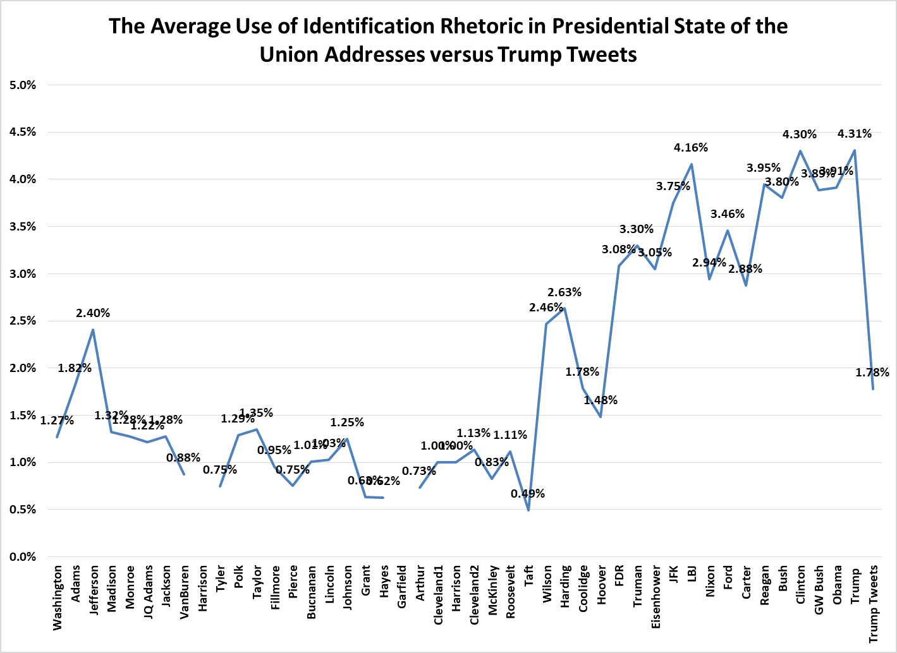
There are several interesting things that are illustrated within the findings displayed in figure 2. Firstly, as noted in previous research, there is a consistent increase in the percentage use of identification rhetoric of the presidents of the 20th and 21st centuries in the State of the Union Address (Teten 2011). In effect, presidents in the 21st century use nearly triple the percentage of identification rhetoric in their State of the Union speeches than did presidents of the founding and 19th centuries. This can be explained because these presidents delivered ever-lengthening State of the Union Addresses in written instead of orally delivered form. This combination of written transmission to Congress of the State of the Union Address as well as the increasing length (from 3224 words with Jefferson to 25518 with Taft) consistently decreased the percentages of identification rhetoric used, as it was lost in enormous speeches that dealt with everything from trade to the borders and longitudes and latitudes of newly created national parks. .
We can say with confidence that contemporary presidents use identification rhetoric in amounts never before seen in the State of the Union Address. The president has a larger audience than ever before, and increasingly attempts to portray himself as one of them in order to garner support and further his policy goals. In his State of the Union Address, Trump, as president, continues the general trend of contemporary presidents to use the Address to attempt unification with the people and the Congress. In fact, he uses the highest levels of identification rhetoric in the history of the State of the Union Address (4.31%) and levels that double the overall average use by all presidents (1.9%). This can be easily seen at the very outset of his State of the Union, where he states, “Over the last year, we have made incredible progress and achieved extraordinary success. We have faced challenges we expected and others we could never have imagined. We have shared in the heights of victory and the pains of hardship. We have endured floods and fires and storms. But through it all, we have seen the beauty of America's soul and the steel in America's spine [emphasis added]” (Trump 2018). In each of these rhetorical instances, Trump uses identification rhetoric to set the tone that he is a fellow member of the country and has experienced its ups and downs along with the rest of the population.
A completely different story seems to emerge when Trump’s tweets are examined for their use of identification rhetoric and comparability against presidential State of the union Addresses. Within his Twitter posts, on the average, Trump uses less identification rhetoric (1.78%) than any other president of the 20th or 21st centuries besides Herbert Hoover (1.48%) utilized in their State of the Union addresses. Just as there are variations among presidents in their State of the Unions, there are indeed tweets that do contain identification rhetoric in levels that are much higher than that average. For example, on January 16, 2018 President Trump tweeted that “We must have Security at our VERY DANGEROUS SOUTHERN BORDER and we must have a great WALL to help protect us and to help stop the massive inflow of drugs pouring into our country!”
Although identification rhetoric is, on the whole, used in lower levels overall than is seen in contemporary state of the union addresses, this can be attributed less to a neglect of identifying with the American people and more to the fact that the Tweets that Trump posts are on topics that vary from congratulating NBA championship winners to DACA reform. A State of the Union address sees a constant audience and is given during a specific time each year. Twitter is open for posting and social networking twenty-four hours a day and seven days a week. In fact, our analysis found that almost 92% of Trump’s 3110 tweets were NOT policy related. The picture changes dramatically when we look at the level of identification rhetoric in Trump’s tweets that were policy related (in a similarity to State of the Union content). In these policy specific statements, Trump uses an average of 2.5% identification rhetoric, which is a higher level than the average of all presidential state of the union addresses (1.9%) as well as much more similar to the State of the Union Addresses of the 20th and 21st centuries which had 3.1% identification rhetoric overall.

Figure 3:
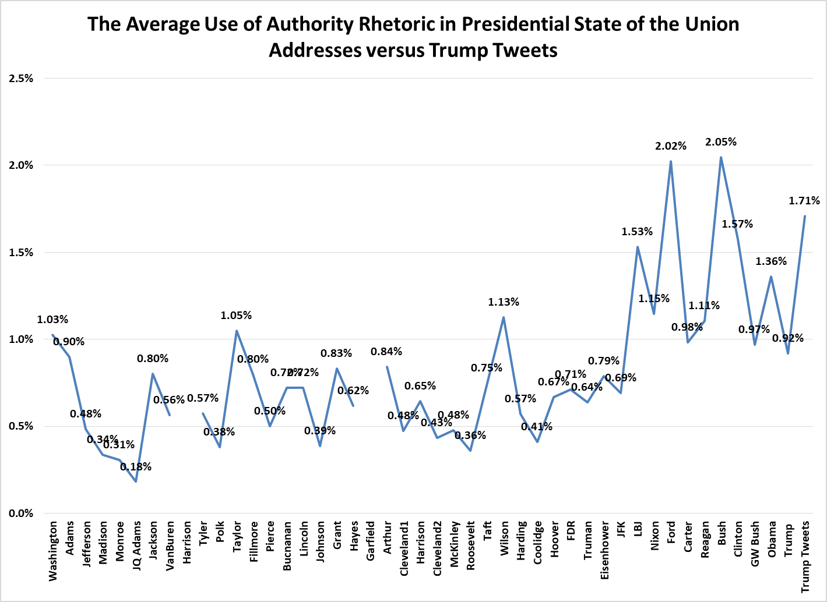

Figure 3 is an examination of the average use of authority rhetoric in State of the Union
Addresses as well as the Tweets of Donald Trump during his presidency. Once again, this graph shows a tale of two Trumps. In his State of the Union Address, he uses a lower level of the words “I” “me” and “my” (.92%) than any other president since Kennedy (.69%). However, in his tweets overall, Trump uses a level of authority rhetoric (1.71%) that has not been seen since the State of the Union Addresses of George H. W. Bush (2.05%). Indeed, in his State of the Union Address, authority rhetoric use is few and far between, but still exists. For example, he states in 2018 that “as President of the United States, my highest loyalty, my greatest compassion, my constant concern is for America's children, America's struggling workers, and America's forgotten communities. I want our youth to grow up to achieve great things. I want our poor to have their chance to rise [emphasis added].” Authority rhetoric in Trump’s State of the Union is consistent with past presidents who utilize that rhetoric to use the weight of the office to suggest policy proposals predominantly with terms such as “my administration will” or “I ask Congress to.”
As we saw above with identification rhetoric, when Trump actually utilizes SNS for policy proposal, the language that he uses closely resembles traditional language of policy proposal as used in state of the union addresses. Although there is a difference in authority rhetoric use by Trump in policy versus non-policy tweets, the overall average percentage of authority rhetoric that is used by Trump in his tweets is not significantly different from the average levels used by presidents in their State of the Union Addresses since LBJ (1.4%). In addition, 20th and 21st century presidents show a significant variation between their averages; they range from .41% use by Coolidge to 2.07% use by George H.W. Bush. If we examine the use of authority rhetoric and its use only in those tweets that are policy related, his average (.92) exactly resembles the authority rhetoric format of his State of the Union Address. On January 12, 2018, for example, Trump Tweeted “I want a merit based system of immigration and people who will help take our country to the next level. I want safety and security for our people. I want to stop the massive inflow of drugs. I want to fund our military.” This tweet firstly shows the way in which presidents in their state of the union addresses, and Trump in his tweets, can mix forms of popular address rhetoric to pursue policy goals, as his authority rhetoric is here paired with identification rhetoric as well. More importantly, it also clearly demonstrates that Trump is attempting to exert his influence as president and executive officeholder to present his vision for what is right for the country. Trump’s authority rhetoric, therefore, is not a significant departure from State of the Union Addresses given by contemporary presidents, and, in tweets that contain policy proposals, closely resembles State of the Union formats by Trump himself and many presidents past.

Figure 4:
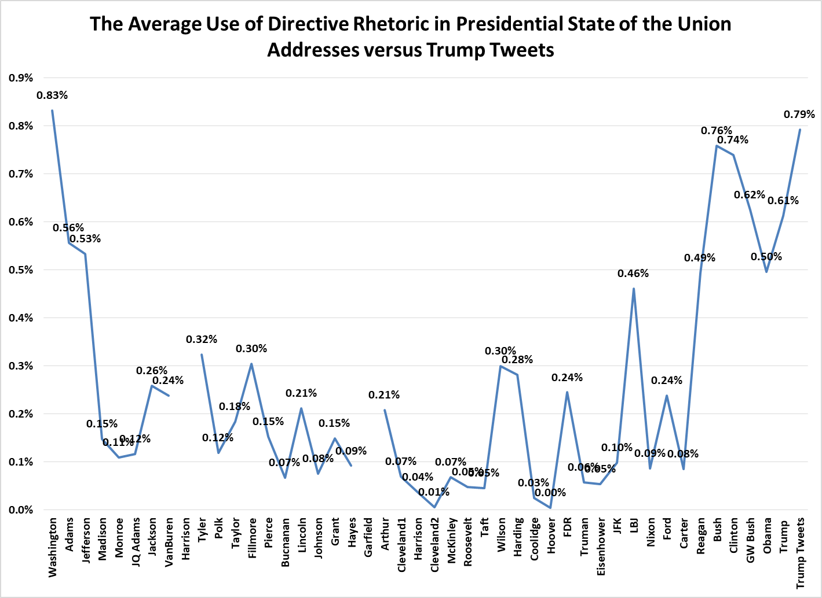
Figure 4 examines the inclusion of directive rhetoric, on the average, by each president in their state of the union address as well as the average of directive rhetoric in the twitter posts by President Donald Trump. First, it should be noted that presidents use directive rhetoric with a much smaller frequency than the other two forms of popular address rhetoric. Trump’s State of the Union Address exhibits directive rhetoric percentages (.61%) that are similar to that utilized by presidents since Reagan (.62%). The presidents after 1980, including Trump, display a level of directive rhetoric in their State of the Union Addresses that is well above the overall presidential average (.24%) and even above the other presidents of the 20th century (.27%).
Trump and other presidents use directive rhetoric in two distinct ways in their State of the Union Addresses. The first use is in addressing the American people in the context of policy proposal. In 2018, Trump addresses “every citizen watching at home tonight, no matter where you've been or where you've come from, this is your time. If you work hard, if you believe in yourself, if you believe in America, then you can dream anything, you can be anything, and together, we can achieve absolutely anything [emphasis added].” Once again, we see the ways that presidents often mix the three types of popular address rhetoric in their State of the Union address; the transition to “we” at the end of the statement suggests that the president and the people are working together in progression towards the goal at hand. The second use of directive rhetoric in State of the Union Addresses is when the president speaks directly to Congress regarding items he would like to see accomplished or policies he would suggest that they engage. In 2015, Obama did just that when he commented that “I ask you to join me in the work at hand. If you disagree with parts of it, I hope you'll at least work with me where you do agree. And I commit to every Republican here tonight that I will not only seek out your ideas, I will seek to work with you to make this country stronger [emphasis added].” It is here that directive rhetoric addresses the other audience of the State of the Union Address than the American public; namely, the actual members of the House and Senate in attendance.
When Trump’s tweets are compared to the levels of directive rhetoric in the presidential State of the Unions, he exhibits a higher percentage use than (.79%) than any other president in history besides George Washington (.83%). However, this number may be misleading as the use of directive rhetoric used in his policy related tweets is only .44%. This low number is not only significantly below the percentage Trump utilized in his State of the Union Address, it more closely resembles the overall presidential average of all State of the Union addresses. On the whole, the data shows overall that within state of the union addresses as well as Tweets, “you” and “your” is rarely used.
Paralleling State of the Union speeches, there are two major Twitter uses of directive rhetoric, the first of which addresses members of Congress or the people directly. In an immigration tweet on September 7, 2017 Trump said “For all of those (DACA) that are concerned about your status during the 6 month period you have nothing to worry about - No action!” Secondly, and similarly to the way in which almost half of the directive rhetoric incidents in State of the Union Addresses occur, almost half of the directive-rhetoric-containing tweets contain “thank you” messages to a particular group or individual. On June 14, 2017, Trump posted a “Happy birthday to U.S. ARMY and our soldiers. Thank you for your bravery sacrifices & dedication. Proud to be your Commander-in-Chief!” Thanking groups or individuals, or showing support for them (tweets expressing support for hurricane ravaged states, for example) is a prominent use of directive rhetoric in Trump’s tweets that parallels its (and Trump’s) use in State of the Union Addresses as well.

Figure 5: Total policy proposals
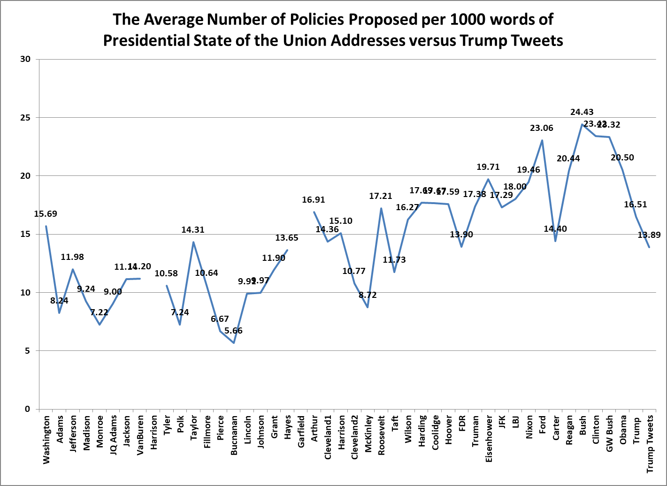
Figure 5 looks at the average number of policies that were proposed, on the average, in each president’s State of the Union address as well as the Tweets that Trump issued since being elected president. First, Trump’s State of the Union address average for policy proposal was 16.51 policies per 100 words. This is above the total presidential State of the Union Address of 14.4 policies, and slightly lower than the average of the 20th and 21st centuries of 18.6 policies per 1000 words; however, neither difference is significant. Recent presidents have moved towards a more efficient average of policy proposal in their state of the union addresses, seemingly doing more with less words. Traditionally, presidents tend to also follow the formats of their predecessors and vary their State of the Union styles throughout their presidencies. Therefore, Trump’s State of the Union both resembles the policy proposal activity of presidents of the past, and has the opportunity to change and evolve over the course of his presidency, which may change his average policies proposed in his addresses.
As discussed above, a significant number of Trump’s tweets (92%) are not germane to policy proposal. Overall, he proposes an average of 13.89 policies per 1000 words of his tweets. However, if we examine the tweets that are policy related, Trump’s policies jump to 50.56 policies proposed per 1000 words. Just as the contemporary presidents proposed more policies in fewer words in their state of the Union Addresses, when Trump seeks Twitter as an outlet for policy proposal or endorsement, he does so with a frenetic speed; he is, after all, limited to 240 characters. Most of these posts list different aspects of policies that he would like to see enacted and often do not even use complete sentences to do so. For example, on October 12, 2017 Trump tweeted “We need a tax system that is FAIR to working FAMILIES & that encourages companies to STAY in AMERICA GROW in AMERICA and HIRE in AMERICA!” In a tweet that only has 26 words, he proposes 4 separate policies. He asks for a tax system that 1) is fair to working families, 2) encourages companies to stay in America, 3) grow in America 4) and hire in America. In the end, Trump does use Twitter for policy proposals, but these Tweets pale in comparison to the number of posts that are not policy related.

Conclusions
As technology has advanced, politicians have made every attempt to utilize the new media tools at hand for campaigning and governing purposes. Trump embraced Twitter as a candidate, and continued its employment during his presidency as a way to comment on policy, comment on politics, and comment on everything in between. In doing so, and similarly to the ways presidents have spoken in their State of the Union Addresses, we see clear uses of identification, authority and directive rhetoric. Identification rhetoric has, by far, the highest percentage of use in State of the Union as well as Trump’s twitter posts. Even though Obama largely eschewed the use of Twitter in favor of Facebook, Sousa and Ivanova found, in much the same way Trump’s do, that Obama’s tweets illustrated “a predominant choice of the inclusive and proximal over exclusive and distal” (2012). Although Twitter may be a new medium, presidents Obama and Trump have seen its possibility to identify with voters and the electorate through posts that used “we” “our” and “us” to build a sense of community.
Just because it is a newer Social Networking Site, and this study found tweets to resemble State of the Union Addresses in some rhetorical and content aspects, this does not necessarily mean that it is an appropriate way to convey presidential positions. "There's something about the platform of Twitter, the ease of access, the lack of time it requires and the simplicity of creating the message that encourages impulsiveness." (Watson 2017). A significant concern is that, because Trump uses Twitter for so much non-policy related material, there is a danger that “The President’s behavior does not add value to US public diplomacy in the social media…it erodes social capital and reduces both trust and intercultural communication” (Sanchez-Gimenez and Tchubykalo 2018).
We cannot dismiss, however, despite the dangers, that the findings above relating to popular address, and specifically identification rhetoric, indicate important changes in the understanding of presidential communication. This study suggests that Trump’s Tweets contain information and rhetoric consistent with former presidents in their uses of identification, authority and directive rhetoric in State of the Union Addresses. These findings suggest that Twitter may operate as a new “bully pulpit” through which presidents can instantaneously “go public” to express their opinions on anything. Although, once in office, presidential use of popular address rhetoric, “has waxed and waned depending on strategic circumstances and the proclivities of individual presidents” (Laracey 2002, 171), Trump appears to utilize popular address rhetoric constantly in Twitter, even if his own state of the union address is more formal and traditional compared to other presidents.
The recognition of the individual contribution of each president to the concept and powers of the “Chief Executive” is of utmost importance in the research of the presidency. “The presidency is less an outgrowth of the constitutional design and more a reflection of ambitious men, demanding times, exploited opportunities, and changing international circumstances…The presidency has been shaped by the varied individuals, operating within a dynamic system under changing circumstances.” (Genovese, 2001, 14; 16) Indeed, in both State of the Union Addresses and Tweets, Trump constructs his own messaging though the lens of his own ambition and capabilities, as well as his own goals. “A rhetorical context is a unique array of forces—rhetorical, historical, sociological, psychological, strategic, economic, and personal—that exists at any given moment in time and that impacts the speakers selection and presentation of topics” (Medhurst, 1996, xviii). Despite the penchant to summarily dismiss Twitter as a method of communication with less intrinsic value, unless Trump suddenly eschews its use, it appears as though it must be looked at as a new outgrowth of the rhetorical presidency that is being used for policy, to talk to the people, and in ways not previously examined in our discipline. As Trump said in a tweet on July 1st, 2017, “My use of social media is not Presidential - it’s MODERN DAY PRESIDENTIAL. Make America Great Again!”

Works Cited

Abramowitz, Alan. 2009. The 2008 Elections. New York, NY: Pearson Education.

Allcott, Hunt, and Matthew Gentzkow. “Social Media and Fake News in the 2016 Election.” The Journal of Economic Perspectives, vol. 31, no. 2, 2017, pp. 211–235. JSTOR, JSTOR, www.jstor.org/stable/44235006.

Associated Press. “Trump Tweets That He'll 'Be Very Hard Pressed' to Change His Mind on Elephant Trophy Import Ban.” Los Angeles Times, Los Angeles Times, 19 Nov. 2017, 3:57 p.m., www.latimes.com/politics/la-pol-updates-everything-president-trump-says-he-ll-be-very-hard-pressed-1511138582-htmlstory.html.

Barthel, M., Shearer, E., Gottfried, J., & Mitchell, A. (2015, July 14). News Use on Facebook and Twitter is on the Rise. Retrieved from http://www.journalism.org/2015/07/14/news-use-on-facebook-and-twitter-is-on-the-rise/

Beasley, Vanessa. 2004. You the People: American National Identity in Presidential Rhetoric. College Station, TX: Texas A&M University Press.

Bimber, B. & Davis, R. (2003). Campaigning Online. New York: Oxford University Press.

Bond, R., Fariss C., Jones, J., Kramer, A., Marlow, C., Settle, J., & Fowler, J. (2012, September 12). A 61-million-person experiment in social influence and political mobilization. Nature, 489, 295-298. Retrieved from http://www.nature.com/nature/journal/v489/n7415/full/nature11421.html

Boulianne, S. (2009). Does Internet Use Affect Engagement: A Meta-Analysis of Research. Political Communication, 26.2, 193-211.

Buckley, Chris. “Enough With the Tweets, China's State Media Tells Trump.” The New York Times, The New York Times, 4 Jan. 2017, www.nytimes.com/2017/01/04/world/asia/china-xinhua-donald-trump-twitter.html.

Carlisle, J. E., & Patton, R.C. (2013). Is Social Media Changing How We Understand Political Engagement? An Analysis of Facebook and the 2008 Presidential Election. Political Research Quarterly, 66.4, 883-895.

Carr, D., & Stelter, B. (2008, November 2). Campaigns in a Web 2.0 World. New York Times.

Chadwick, A. (2006). Internet Politics: States, Citizens, and New Informational Technologies. New York: Oxford University Press.

Chandrasekhar, C.P. (2013). The Business of News in the Age of the Internet. Social Scientist, 41.5/6, 25-39.

Chappell, Bill. “'Declaration Of War' Means North Korea Can Shoot Down U.S. Bombers, Minister Says.” NPR, NPR, 25 Sept. 2017, www.npr.org/sections/thetwo-way/2017/09/25/553475174/declaration-of-war-means-north-korea-can-shoot-down-u-s-bombers-minister-says.

Conroy, M., Feezell, J. & Guerro, M. (2015). Terms of Engagement: Online Political Participation and the Impact on Offline Political Participation. In J. Vaughn, & V. Farrar-Myers (Eds.), Controlling the Message: New Media in American Political Campaigns. New York: New York University Press, 181-199.

Conroy, M., Feezell, J. & Guerro, M. (2012). Facebook and Political Engagement: A Study of Online Political Group Membership and Offline Political Engagement. Computers in Human Behavior, 28.5, 1535-1546.

Dalsgaard, S. (2008). Facework on Facebook: The Presentation of Self in Virtual Life and Its Role in the US Elections. Anthropology Today, 24.6, 8-12.

Dinan, Stephen. “Courts Use Trump's Pontificating to Rule against His Policies.” The Washington Times, The Washington Times, 21 Nov. 2017, www.washingtontimes.com/news/2017/nov/21/donald-trumps-tweets-are-liability-in-court/.

Dorsey, Leroy G. 2002. “Introduction,” In Leroy G. Dorsey, ed., The Presidency and Rhetorical Leadership. College Station, TX: Texas A&M University Press.

Druckman, J., Kifer, M., & Parkin, M. (2014). U.S. Campaign Communications in an Internet Age. Journal of Elections, Public Opinion and Parties, 24.1, 20-44.

Druckman, J., Kifer, M., & Parkin, M. (2009). Campaign Communications in U.S. Congressional Elections. American Political Science Review, 103, 343-366.

Duggan, M., Ellison, N.B., Lampe, C., Lenhart, A., & Madden, M. (2015, January 9). Demographics of Key Social Networking Platforms. Retrieved from http://www.pewinternet.org/2015/01/09/demographics-of-key-social-networking-platforms-2/

Effing, R., van Hillegersberg, J., Huibers, T. (2011). Social Media and Political Participation: Are Facebook, Twitter, and YouTube Democratizing Our Political Systems? In E. Tambouris, A. Macintosh, & H. de Brujin (Eds.), Electronic Participation. (pp. 25-35). Delft, The Netherlands: Springer Berlin Heidelberg.

Ehrenberg, Rachel. “Social Media Sway: Worries over Political Misinformation on Twitter Attract Scientists' Attention.” Science News, vol. 182, no. 8, 2012, pp. 22–25. JSTOR, JSTOR, www.jstor.org/stable/23351069.

Elson, Sara Beth, et al. “Background on Social Media Use in Iran and Events Surrounding the 2009 Election.” Using Social Media to Gauge Iranian Public Opinion and Mood After the 2009 Election, RAND Corporation, Santa Monica, CA; Arlington, VA; Pittsburgh, PA, 2012, pp. 11–22. JSTOR, www.jstor.org/stable/10.7249/tr1161rc.10.

Enli, G. (2017). Twitter as arena for the authentic outsider: Exploring the social media campaigns of Trump and Clinton in the 2016 US presidential election. European Journal of Communication, 32(1), 50-61.

Erlanger, Steven. “Trump's Twitter Threats Put American Credibility on the Line.” The New York Times, The New York Times, 7 Jan. 2018, www.nytimes.com/2018/01/07/world/europe/trump-tweets-american-credibility.html.

Evans, Heather K., et al. “Twitter Style: An Analysis of How House Candidates Used Twitter in Their 2012 Campaigns.” PS: Political Science and Politics, vol. 47, no. 2, 2014, pp. 454–462. JSTOR, JSTOR, www.jstor.org/stable/43284570.

Eveland, W.P., & Dunwoody, S. (2002). An Investigation of Elaboration and Selective Scanning as Mediators of Learning from the Web and Print. Journal of Broadcasting and Electronic Media, 46, 34-53.

Fields, Wayne. 1996. Union of Words: A History of Presidential Eloquence. New York: The Free Press.

Green, D.P., & Gerber, A.S. (2008). Get out the vote: How to Increase Voter Turnout. Brookings Institution Press.

Farrar-Myers, V., &Vaughn J. (2015). Controlling the Message: New Media in American Political Campaigns. New York: New York University Press.

Foot, K., & Schneider, S. (2006). Web Campaigning. Cambridge, Mass: MIT Press.

Franklin, C.H. (1991). Eschewing Obfuscation? Campaigns and The Perception of U.S. Senate Incumbents. American Political Science Review, 85, 1193-1214.

Frum, David. “Crashing the Party: Why the GOP Must Modernize to Win.” Foreign Affairs, vol. 93, no. 5, 2014, pp. 37–46. JSTOR, JSTOR, www.jstor.org/stable/24483301.

Gibson, R.K., &McAllister, I. (2009). Revitalizing participatory policies. Paper presented at the American Political Science Association Meeting, Toronto.

Gibson, R.K., &McAllister, I. (2006). Does cyber-campaigning win votes? Journal of Elections, Public Opinion and Parties, 16, 243-264.

Gabler, Neal. “Donald Trump, the Emperor of Social Media.” April 29, 2016. Billmoyers.com.

Gottfried, Jeffrey, and Elisa Shearer. “News Use Across Social Media Platforms 2016.” Pew Research Center's Journalism Project, 26 May 2016, www.journalism.org/2016/05/26/news-use-across-social-media-platforms-2016/.

Gulati, Girish J. 2010. “No Laughing Matter: The Role of New Media in the 2008 Election,” in The Year of Obama. Larry J. Sabato, ed. New York, NY: Pearson Education, Pp. 187-203.

Gulati, G., & Williams, C. (2015). Congressional Campaigns’ Motivations for Social Media Adoptions. In J. Vaughn, & V. Farrar-Myers (Eds.), Controlling the Message: New Media in American Political Campaigns. New York: New York University Press, 32-52.

Gulati, G., &Williams, C. (2012). Social networks in political campaigns: Facebook and the congressional elections of 2006 and 2008. New Media and Society, 15.1, 52-71.

Gulati, G., & Williams, C. (2011). Diffusion of Innovations and Online Campaigns: Social Media Adoption in the 2010 U.S. Congressional Elections. Paper presented at the sixth general conference of the European Consortium for Political Research.

Gulati, G. and Williams 2008. What is a Social Network Worth? Facebook and Vote Share in the 2008 Presidential Primaries. In Annual Meeting of the American Political Science Association, 1-17. Boston, MA.

Hart, Roderick P., Deborah Smith-Howell, and John Llewellyn. 1996. “News, Psychology, and Presidential Politics,” In Crigler, Ann N., ed. The Psychology of Political Communication. Ann Arbor: the University of Michigan Press

Hershey, Marjorie Randon. 2010. “The Media: Coloring the News,” in The Elections of 2008. Michael Nelson, ed. Washington D.C.: CQ Press, Pp. 122-144.

Iyengar, Shanto. 2011. Media Politics: A Citizen’s Guide. 2nd Ed. New York, NY: Norton.

Jamieson, K.H. (2013). Messages, Micro-Targeting, and New Media Technologies. The Forum: A Journal of Applied Research in Contemporary Politics, 2.3, 429-435.

Johnson Janet.(2012). Twitter Bites and Romney: Examining the Rhetorical Situation of the 2012 Presidential Election in 140 Characters. Journal of Contemporary Rhetoric. Vol. 2, No.3/4, 2012, pp. 54-64.

Kahn, K. & Kenny, P. (2004). No Holds Barred: Negativity in U.S. Senate Campaigns. Upper Saddle River, NJ: Pearson, Prentice-Hall.

Karpf, D. (2013). The Internet and American Political Campaigns. The Forum: A Journal of Applied Research in Contemporary Politics, 2.3, 413-428.

Karpf, D. (2012a). The MoveOn Effect: The Unexpected Transformation of American Political Advocacy. New York; Oxford University Press.

Karpf, D. (2012b). Social Science Research Methods in an Internet Time. Information, Communication, and Society, 15.5, 639-661.

Korte, Gregory. “Trump and the Twitter Presidency: @RealDonaldTrump's Tweets Often Carry Legal Weight.” USA Today, Gannett Satellite Information Network, 8 Nov. 2017, www.usatoday.com/story/news/politics/2017/11/08/trump-and-twitter-presidency-realdonaldtrumps-tweets-often-carry-legal-weight/815980001/.

Kreiss, D., & Welch, C. (2015). Strategic Communication in a Networked Age. In J. Vaughn, & V. Farrar-Myers (Eds.), Controlling the Message: New Media in American Political Campaigns. New York: New York University Press, 13-31.

Lakoff, George. “Trump uses…” January 2, 2018 @Georgelakoff. Twitter.com.

Landers, Elizabeth. “Trump Retweets Anti-Muslim Videos.” CNN, Cable News Network, 30 Nov. 2017, www.cnn.com/2017/11/29/politics/donald-trump-retweet-jayda-fransen/index.html.

Lau, R., & Pomper, G. (2004). Negative Campaigning: An Analysis of U.S. Senate Elections. New York: Rowman and Littlefield.

Lentz, J. (2002). Electing Jesse Ventura: A Third-Party Success Story. Boulder, CO: Lynee Rienner.

Liu, Chiang. “Reviewing the Rhetoric of Donald Trump's Twitter of the 2016 Presidential Election.” Digitala Vetenskapliga Arkivet, Jönköping University, 1 May 2016, diva-portal.org.

McKechnie, Douglas, @POTUS: Rethinking Presidential Immunity in the Time of Twitter (November 2017). University of Miami Law Review, Vol. 72, 2017.

Macwilliams, M. (2015). Forecasting Congressional Elections Using Facebook Data. PS: Political Science and Politics, 48.4, 579-583.

McGee, Michael Calvin. 1998. “Formal Discursive Theories,” In Carol Corbin, ed. Rhetoric in Postmodern America: Conversations with Michael Calvin McGee. New York: The Guilford Press, pp. 27-62.

McGee, Michael Calvin. 1998. “The People,” In Carol Corbin, ed., Rhetoric in Postmodern America: Conversations with Michael Calvin McGee. New York: The Guilford Press, pp. 115-136.

Merica, Dan. “Trump Tweets That 'Cold' East Coast 'Could Use a Little Bit of' Global Warming.” CNN, Cable News Network, 29 Dec. 2017, www.cnn.com/2017/12/28/politics/trump-global-warming-tweet/index.html.

Metaxas, Panagiotis T., and Eni Mustafaraj. “Social Media and the Elections.” Science, vol. 338, no. 6106, 2012, pp. 472–473., www.jstor.org/stable/41703780.

Milita, K., Ryan, J.B., & Simas, E. (2014). Nothing to Hide, Nowhere to Run, or Nothing to Lose: Candidate Position-Taking In Congressional Elections. Political Behavior, 36, 427-449.

Miller, S.A. “The Match Made in Heaven: Trump and Twitter.” The Washington Times, The Washington Times, 28 Dec. 2017, www.washingtontimes.com/news/2017/dec/28/donald-trumps-twitter-use-changed-presidential-pol/.

Miller, C.C. (2008, November 7). How Obama’s Internet Campaign Changed Politics. New York Times.

Mitchell, A., Gottfried, J., Kiley, J., & Matsa, K. E. (2014, October 21). Section 2: Social Media Political News and Ideology. Retrieved from http://www.journalism.org/2014/10/21/section-2-social-media-political-news-and-ideology/

Ott, Brian. (2017). The age of Twitter: Donald J. Trump and the politics of debasement. Critical Studies in Media Communication. 34. 59-68.

Owen, Diana. 2010. “Media in the 2008 Election: 21st Century Campaign, Same Old Story,” in The Year of Obama. Larry J. Sabato, ed. New York, NY: Pearson Education, Pp. 167-186.

OWEN, DIANA, and RICHARD DAVIS. “Presidential Communication in the Internet Era.” Presidential Studies Quarterly, vol. 38, no. 4, 2008, pp. 658–673. JSTOR, JSTOR, www.jstor.org/stable/41219707

Petrocik, J. (1996). Issue Ownership in Presidential Elections with a 1980 Case Study. American Journal of Political Science, 40, 825-850.

Puschak, Evan. How (And Why) Donald Trump Tweets, December 31 2016. https://www.youtube.com/watch?v=geEVwslL-YY

Rodgers, Daniel. 1987. Contested Truths: Keywords in American Politics and Independence. Cambridge, MA: Harvard University Press.

Rosenblatt, Alan. 2010. “Dimensions of Campaigns in the Age of Digital Networks,” in Campaigns and Elections American Style. James A. Thurber and Candice J. Nelson, eds. Philadelphia, PA: Westview Press. Pp. 207-226.

Rosenstone, S., & Hansen, J.M. (1993). Mobilization, Participation and Democracy in America. New Haven, CT: Yale University Press.

Sánchez-Giménez, Juan Antonio, and Evgueni Tchubykalo. “Donald Trump's Twitter Account: A Brief Content Analysis.” Eurasia Review, Elcano Royal Institute, 15 Feb. 2018, www.eurasiareview.com/18022018-donald-trumps-twitter-account-a-brief-content-analysis/

Schumacher, E. & Maxine Eskenazi, M. (2016) ‘A Readability Analysis of Campaign Speeches from the 2016 US Presidential Campaign’. Carnegie Mellon University

Schwab, Katharine. “Graphic: Trump's Tweets Can Be Reduced To 4 Rhetorical Strategies.” Co.Design, Co.Design, 3 Jan. 2018, www.fastcodesign.com/90155999/graphic-trumps-tweets-can-be-reduced-to-4-rhetorical-strategies.

Seldin, Jeff. “Trump's Tweets, Use of Rhetoric, Keep World on Edge.” VOA, VOA, 11 Aug. 2017, www.voanews.com/a/trumps-tweets-use-of-rhetoric-keep-world-on-edge/3981934.html.

Shapiro, Ari, and Richard Haass. “Foreign Policy Expert Considers Repercussions Of Trump's Twitter Diplomacy.” National Public Radio, 2 Jan. 2018, npr.com.

Shirky, C. (2011). The Political Power of Social Media: Technology, the Public Sphere, and Political Change. Foreign Affairs, 90.1, 28-41.

Smith, A. (2014, February 3). 6 new facts about Facebook. Retrieved from http://www.pewresearch.org/fact-tank/2014/02/03/6-new-facts-about-facebook/

Smith, C. (2015a, December 15). By the Numbers: 200+ Amazing Facebook Statistics (November 2015). Retrieved from http://expandedramblings.com/index.php/by-the-numbers-17-amazing-facebook-stats/

Smith, C. (2015b, December 15). How Many People Use 1000+ of the Top Social Media, Apps and Digital Services? Retrieved from http://expandedramblings.com/index.php/resource-how-many-people-use-the-top-social-media/6/

Smith, K. (2011). Social Media and Political Campaigns. Trace: Tennessee Research and Create Exchange. Retrieved from http://trace.tennessee.edu/cgi/viewcontent.cgi?article=2442&context=utk_chanhonoproj

Sousa, Alcina, and Anna Ivanova. “Constructing Digital Rhetorical Spaces in Twitter: A Case-Study of .” Topics in Linguistics, no. 12, Sept. 2012, pp. 46–55., www.topicsinlinguistics.com/index.php/2012-2/.

Spierings, Niels, and Kristof Jacobs. “Getting Personal? The Impact of Social Media on Preferential Voting.” Political Behavior, vol. 36, no. 1, 2014, pp. 215–234., www.jstor.org/stable/43653399

Straus, Jacob R., et al. “Communicating in 140 Characters or Less: Congressional Adoption of Twitter in the 111th Congress.” PS: Political Science and Politics, vol. 46, no. 1, 2013, pp. 60–66. JSTOR, JSTOR, www.jstor.org/stable/43284280.

Steinhorn, Leonard. 2010. “The Selling of the President in a Converged Media Age in Campaigns and Elections American Style. James A. Thurber and Candice J. Nelson, eds. Philadelphia, PA: Westview Press. Pp. 136-156.

Tedesco, J. (2007). Examining Internet Interactivity Effects on Young Adult Political Information Efficacy. American Behavioral Scientists, 50.9, 1183-1194.

Teten, Ryan Lee. 2003. “Evolution of the Modern Rhetorical Presidency: Presidential Presentation and Development of the State of the Union Addresses,” In Presidential Studies Quarterly. 33: 333-346.

Teten, Ryan Lee. 2007. “ ‘We the People:’ The ‘Modern’ Rhetorical Popular Address of the Presidents during the Founding Period,” In Political Research Quarterly. 60: 669-682.

Teten, Ryan Lee. 2011. The Evolutionary Rhetorical Presidency. New York, NY: Peter Lang Publishers.

Thompson, Derek. “Donald Trump's Language Is Reshaping American Politics.” The Atlantic, Atlantic Media Company, 15 Feb. 2018, www.theatlantic.com/politics/archive/2018/02/donald-trumps-language-is-reshaping-american-politics/553349/

Trent, J., & Fridenberg, R. (2008). Political Campaign Communication. New York: Rowman and Littlefield.

Tumasjan, Andranik, Sprenger, Timm, Sandner, Philipp, AND Welpe, Isabell. "Predicting Elections with Twitter: What 140 Characters Reveal about Political Sentiment" International AAAI Conference on Web and Social Media (2010): n. pag. Web. 4 Feb. 2018

Ward, Alex. “Trump Just Announced a Ban on Transgender Military Service on Twitter.” Vox, Vox, 26 July 2017, www.vox.com/policy-and-politics/2017/7/26/16034008/trump-transgender-troop-ban-twitter.

Watson, George. Twitter Suited President-Elect Trump Perfectly While Lowering the Quality of Public Discourse,” January 19, 2017. Texas Tech Today http://today.ttu.edu/posts/2017/01/trump-twitter

Wayne, Stephen J. 2012. Personality and Politics: Obama For and Against Himself. Washington D.C.: CQ Press.

Wayne, Stephen J. 2011. Is This Any Way to Run a Democratic Election. 4th ed. Washington D.C.: CQ Press.

Williams, B., & Delli Caprini, M. X. (2012). After Broadcast News: Media Regimes, Democracy, and the New Information Environment. New York: Cambridge University Press.

Williams, C., & Gulati, G. Social Networks in Political Campaigns: Facebook and the Congressional Elections of 2006 and 2008. New Media & Society, 15, 52-71.

Wilson, John. 1990. Politically Speaking: The Pragmatic Analysis of Political Language. Oxford: Basil Blackwell

