Reliable Representatives: Racial Minority Interest Group Lobbying
Draft 6
Nhat-Dang Do
February 14, 2024
Trinity College

Abstract: Previous research has shown that the work of interest groups representing marginalized communities is biased in ways that fail to represent the interests of the disadvantaged. Rather than being equal representatives of their group, internal biases lead to disproportionately higher levels of attention to the privileged members within their groups. Are organizations specifically and explicitly representing racial groups also subject to such biases, especially since they are at the heart of policy battles for criminal and justice reforms in the United States? I conceptualize these groups as a separate category of interest groups called racial minority interest groups (RMIGs). Using part of an original dataset of over 250,000 Californian legislative bill analyses over twenty years and a novel survey, I show that RMIGs are generally reliable representatives of their racial groups. They represent the interests of marginalized people as much as the interests of the elites within their groups.

Introduction

Racial minority interest groups (RMIGs), or organizations that lobby for and on behalf of racial minorities, have been at the heart of Black, Latinx, and Asian social movements as channels to secure resources, foster mobilization, and achieve justice for their communities. As products of the social movements of the 1960s, RMIGs, like the National Association of the Advancement of Colored People (NAACP) and the League of United Latin American Citizens (LULAC), have long contended against powerful, well-funded, and established interest groups to ensure the interest of marginalized racial and ethnic groups are heard and represented in policymaking (Hero, Preuhs, Meeks, 2019; Strolovitch 2007). With the current movements for social justice and expanding protections for socially and historically disadvantaged groups, contemporary RMIGs help foster change and have become essential in the policy process for racial minorities (Bonilla and Tillery 2020). RMIGs are responsible for translating the demands of protesters and racial minorities into concrete public policies in the halls of legislatures. As RMIGs transitioned into more formal organizations with established connections and “insider” access to legislatures, questions arose about whether their organizations were reliable representatives of those they purported to help.
Built on foundational theories of representation and intersectionality, there has been a recent interest among scholars to understand the strategies of interest groups representing marginalized communities to achieve their policy goals. Though this literature looks at a variety of venues, like the court system, internal organizational dynamics of policy agenda-setting, and bureaucratic decision-making, few examine RMIGs’ state-level legislative lobbying and assess their reliability as representatives of intersectionally-disadvantaged parts of their groups (Dwidar 2022; Gelbman 2021; Marquez 2021; Hero, Preuhs, Meeks, 2019; Minta 2019). From the view of intersectionality, a “reliable representative” refers to organizations representing the most marginalized members of their subgroups as much as members of the majority and elites (Cohen 1999; Strolovitch 2007; Marchetti 2014). To what degree do RMIGs represent intersectionally marginalized subgroups of their constituencies, and are they “reliable representatives?”
From the perspective of the interest group lobbying literature, I argue that the application of race to the study of lobbying provides unique and understudied insights into how “new interests”—those that have come to new prominence in the last forty years—are integrated into the American political system. RMIGs’ origins are rooted in the civil rights and racial justice movements beginning in the 1960s, and their transformation and trajectory differ dramatically from traditional interest groups (Lê-Espiritu 1992; Smith 1996; Kim 2020). RMIGs are solely dedicated to advocacy in racialized domains, and to understand them, we must re-conceptualize lobbying along racial lines and center race in the empirical analysis. Studying RMIGs’ roles in representation and lobbying fills a gap within the lobbying literature to account for the rise of racial groups and how these uniquely situated groups can assert influence in a competitive and crowded political arena (Walton, Miller & McCormick II 1995). Moreover, it interrogates how groups focused on racial and ethnic advocacy operate at state-level lobbying, which currently few studies do (Marchetti 2014), and provides another starting point for evaluating how lobbying operates for racial groups in the U.S. and the role interest groups play in their representation in American democracy.
Drawing on a new and unique dataset of over 250,000 bill analyses from the California legislature over 21 years, which records the lobbying behavior of interest groups on specific bills, I find that RMIGs are reliable representatives of the communities they claim to represent. Bill analyses are documents produced by legislative committee staff that explain how the bill changes existing law, summarize arguments for and against the bill, and list who supports or opposes the bill. Using these bill analyses, I show that RMIGs are not extremely biased in their lobbying activities through text analysis. They generally do not exclusively advocate for narrow issues that benefit the advantaged-subgroups of their constituency. RMIGs consistently lobby on issues that affect their marginalized members, like women or the poor, and often at high levels compared to the elites of their groups.
Moreover, leveraging RMIGs’ position-taking on bills I estimate their ideal-points to measure the latent policy preferences of RMIGS and compare them to that of an over-sample of racial minority respondents’ estimated policy preferences. The results show an overlap between RMIGs’ ideal points and those of the disadvantaged respondents of their racial groups. Though there is more overlap among the elite respondents, the differences are minimal, indicating that the lobbying of RMIGs matches those they purport to represent. Altogether, the results reveal how lobbying can serve as an effective form of representation for voters of color; it also broadens our definition of how we conceive representation that goes beyond the confines of the ballot box to explore a critical dimension of the political process—lobbying.

Assessing Bias Among Advocacy Organizations and RMIGs
In evaluating RMIGs’ role as provides of crucial representation for their communities, this research engages with the robust literature on interest groups’ ability to represent the disadvantaged. Previous scholars note that interest groups tend to skew toward the interests of the advantaged-subgroup (Schlozmand and Burch 2009). For example, liberal groups mainly focus on issues that matter only to the middle class, like environmental issues, at the expense of the poor (Berry 1999; Skocpol 2003; Schlozman 1984). They focus resources on wide-ranging issues that matter to the majority and elite parts of their constituents and avoid issues that only affect the minority, which is often the poorest and weakest among them (Kollman 1998; Kingdon 1995). These actions come from strategic concerns in maintaining the competitiveness of the organization and continued support of financial backers (Gray and Lowery 1996).
The literature also offers evidence of persistent bias in interest groups representing marginalized communities. In her foundational work Affirmative Advocacy, Strolovitch (2007) convincingly demonstrates that organizations representing marginalized groups are more likely to dedicate more significant resources and attention to issues that their advantaged-subgroups care about than the issues of disadvantaged-subgroups. Building from the theoretical framework of intersectionality, where individual characteristics—like class, race, sexuality, and gender—overlap to form multiple modes of compounding inequalities and discrimination (Crenshaw 1991), Strolovitch (2007) shows that the issue choices of organizations who purport to represent the marginalized can reinforce intersectional oppression. These organizations perpetuate bias by fixating on a single axis of discrimination often determined by the advantaged segments of their constituency. An example of such possible bias is illustrated in Strolovitch’s (2007) discussion of the National Council of Women’s Organizations (NCWO) myopic focus on gaining access to all-male golf courses in the early 2000s at the expense of other pressing issues that matter to disadvantaged women. There are many similar instances of how advocacy organizations can ignore intersectionally marginalized members of their group, like when mining labor unions deemphasized the voice of working-class women during labor negotiations (Beckwith 2014) or the more contemporary critique of women’s organizations’ primary focus on white women’s issues (Dwidar 2022a).¹
Other scholars have further documented these biases in different venues. English (2019) found that though women’s organizations mention intersectionally marginalized women in their comments submitted to bureaucratic rule-makers, they often neglect other intersectional subgroups like race, ethnicity, nationality, and socioeconomic status. Similarly, Marchetti (2014) documented widespread neglect of intersectional issues related to gender, race, and disability in state-level lobbying. Using a survey of state-level organizations in fourteen states, Marchetti (2014) shows that these groups often disproportionately advocate more on some intersectional identities at the expense of others. For these scholars, the bias towards the elite and advantaged-subgroup is centered on strategic concerns at choosing “winnable” issues while also appealing to the funders and active segments of their constituencies. The complexity of intersectional issues and lack of resources may push organizations to ignore them in favor of advantaged issues. Marchetti (2014) explains, “Instead, it is generally in a group’s best interest to cater to the less-complex preferences of individuals who are able to strengthen the organization through resource contribution.” Do RMIGs suffer from the same biases documented within the literature representation and lobbying? RMIGs claim to represent the interests of their racial group wholly. For example, the RMIG, Asian Americans Advancing Justice, claims to “advance civil and human rights for Asian Americans”², while the Mexican American Legal Defense and Educational Fund (MALDEF) states its commitment to “protect and defend the rights of all Latinos living in the United States and the constitutional rights of all Americans.”³ I build on Strolovitch’s (2007) and other researchers’ conceptualization of representation as mediation (Williams 1998; Urbinati 2000; Young 2000). Within the lobbying arena, I conceptualize RMIG representation as a mediation between their respective racial groups and legislators to reach a preferred policy outcome. Representation, in this sense, has real substantive and concrete outcomes. Hence, there’s a vital responsibility on the part of RMIGs to exercise judgment in anticipation of what their constituents need, especially if they claim to represent the entirety of their racial group (Pitkin 1967). Minority advocacy, in my view, is goal-oriented and intersectional. It is, therefore, crucial to assess their biases in their work as the representatives of their racial and ethnic groups in legislative lobbying. Theoretically, I hope to contribute to how we think specifically about racial minority lobbying by conceptualizing RMIGs as a distinct class of lobbying organization with different strategic benefits and constraints. I join other scholars in arguing that good representation must also be intersectional: the issues that RMIGs choose to mediate or advocate on must consider issues that disproportionately affect their disadvantaged members (Strolovitch 2007; Marchetti 2014; Young 2000). Like other authors, I argue that organizations are strategic in how they engage in lobbying (Marchetti 2014; English 2019). While many argue that such strategic consideration leads to less intersectional lobbying and more emphasis on the elite segments, I find that RMIGs effectively lobby for the disadvantaged segments and show very slight bias towards elite interests.
Theory and Hypotheses: RMIGs as Reliable Representatives
I first contend that RMIGs are a separate category of lobbying organizations. I define racial minority interest groups (RMIGs) as organizations that participate in political activity to influence legislative behavior for the benefit and on behalf of a racial group. In creating a separate space for groups who explicitly focus on racial minority advocacy, I recognize the experiences of RMIGs as wholly unique and that their path through social movements created a consciousness rooted in social struggle which emphasized solidarity and commonality (Lê-Espiritu 1992; Dawson 1994; Smith 1996). Focusing on race offers a sharper understanding of lobbying because of the deterministic nature of race, its historical development, and its saliency in American politics. One’s racial identity in the United States, as many scholars highlight, continues to shape political behavior and outcomes (Omi and Winant 1994; Kim 2003; Tarman and Sears 2005; Lee 2008; Garcia Bedolla 2015; Masuoka and Junn 2013; Lê-Espiritu 1992). My conceptualization of RMIGs places race at the center of group goals, resources, and strategic actions leading to behavior distinctive from traditional lobbying and advocacy organizations.
RMIGs seek policies that selectively target and always affect their racial groups. Their main mission is the explicit promotion of racial interests. The complexity of the advocacy universe has led to more non-RMIGs operating in racialized domains; however, these groups are excluded from my analysis. Though they pursue policies that also affect racial minorities, it is not their primary goal. Organizations like the ACLU may lobby on civil rights issues that matter to racial groups, like expanding voting access, but it does not make them RMIGs (Berry 1977). Their core mission is not to primarily advocate for racial interests.⁴ In seeking benefits for racial minorities, RMIGs are often evaluated along racial lines by legislators and the public in ways that tend to hurt more than help (Henry and Sears 2002; Perez 2016). Like other scholars, I postulate that RMIG actions are perceived through a racialized lens which can often incite opposition or backlash among the public and legislators (Hughey 2014; Abrajano and Hajnal 2015). RMIG actions, like those of individual racial minorities, are often evaluated by the public, policymakers, and other groups through implicit bias and stereotypes (Dovidio and Gartner 2004; White 2007; Mendelberg 2008).
More importantly, RMIGs have a unique history and experiences that stem from the civil rights movements. Most RMIGs, like the NAACP and Mexican-American Legal Defense Fund (MALDEF), were molded by the protests, organizing, and advocacy from the civil rights movement and subsequent Black, Brown, and Yellow Power movements of the 1960s through the 1980s (Van Home 2007; Lê-Espiritu 1992; Gutiérrez 2010). They confronted racial biases and lack of resources head-on, developing strategies that propelled their activism. RMIGs applied their historical experiences to lobbying. The transition of RMIGs from social movements and their trajectory as advocates have shaped their behavior as lobbying organizations. For example, RMIGs’ experiences shape their institutional advocacy routes: whether through the courts or the legislature (Francis 2014). Entrenched organizational structures and procedures built during RMIGs’ formations can weaken their ability to coordinate and mobilize lobbying (Gelbman 2021). Their funders can also limit the issues they pursue (Marquez 2021). Like these authors, I agree that the historical development of RMIGs is crucial in how they operate and what issues they choose. To illustrate, in analyzing the push for passing the 1982 Voting Rights Act, Pinderhughes (1993) noted how organizations, like MALDEF, used the “formal strategies of the civil rights movement or the analogy of racial discrimination to legitimize their own claim for favorable federal legislation.” Specifically, I argue that there may be strategic incentives to represent the marginalized segments of their racial groups. Doing so provides RMIGs with political capital and legitimacy, strengthening their ability to lobby effectively and create coalitions. Though they may be constrained by donors in the issues they can pursue or their limited organizational capacity, the strategic benefit of lobbying for the disadvantaged may overcome this constraint: it allows them to build legitimacy, form broad coalitions, and thereby more effectively lobby. Organizations can exert influence in two ways: pressure through campaign contributions or pressure through information provision, especially concerning the possible electoral consequences of taking a position on a bill (Smith 1996; Powell and Grimmer 2016; Kalla and Broockman 2016). More importantly, Interest groups can also provide information about the possible electoral consequences of taking a position on a bill (Ainsworth, 1993; Austin-Smith 1993). My theory draws on this latter strain of the lobbying literature—that RMIGs’ main mode of lobbying influence is via strategic informational signaling rather than exerting pressure through money. Elected officials are uncertain about electoral and policy outcomes, and interest groups exploit this uncertainty by strategically providing information to influence legislators' behavior. The informational theory of lobbying argues that providing information reduces uncertainty for legislators, allowing interest groups to gain influence in the policy process (Austin-Smith and Wright, 1992). They may create credible claims of electoral salience and exaggerate the effects of policy decisions. The key point here is that the claims must be credible. Claims of electoral salience, or potential mobilization against a legislator, will have little influence unless they are perceived to be true or likely.
I postulate that RMIGs are reliable representatives of their racial constituency since their ability to persuade depends on being credible and viewed as true voices of their racial minority groups. Again, I define a “reliable representative” as an organization that can represent the disadvantaged members of their subgroup as much as those of the advantaged members or the majority (Strolovitch 2007). Advocating for a disadvantaged sub-group shows insiders and outsiders that their organization advocates for the entire racial group and is genuinely representative of the group (Cohen 1999). Within lobbying, I propose that legitimacy is central to RMIGs’ credibility and whether they are credible sources of information when legislators consider decisions. Legitimacy is the belief in the rightfulness of the RMIG as a representative for a racial group, and the validity of the organization and its activities (Pitkin 1967; Arnensen and Peters 2019). Previous political science research has shown that not all interest groups are viewed equally and that some have more credibility than others. For example, a study on tobacco regulatory lobbying found that legislators saw non-profit organizations and health agencies as more credible and legitimate than tobacco companies and their lobbyists (Cohen et al. 1997). Similarly, legislators’ evaluation of the legitimacy of interest groups when they lobby has some effect on their decisions (Ambrosius and Welch 1988; Abney 1988).
Having legitimacy is essential to send credible lobbying signals, but it is also an especially high priority for racial minorities engaging in politics. Scholars show that racial demands for policy change are often dismissed or perceived as threatening or illegitimate (Tillery 2019; Kinder and Sears 1981; Gilens 1999; Perez 2016). Racial minorities must work harder to demonstrate that their claims or policy demands are legitimate and deserving. Gause (2022) showed they could demonstrate strong credibility or legitimacy through costly actions, such as protests. Using this insight, I make similar claims to lobbying. Advocating for the interests of the disadvantaged segments of their constituency, thereby potentially angering their elite supporters or incurring backlash, is a costly action that RMIGs choose to bear because it enhances their legitimacy.
Moreover, expanded access to public records online and relatively easy access to recorded lobbying positions allow legislators and constituents to evaluate RMIGs’ legitimacy. The public nature of RMIG position-taking creates documentation of their lobbying activity akin to that of a legislator’s voting record. RMIGs’ reputation and claims to be legitimate representatives of their racial group can be measured against the types of issues that they choose to lobby on and the positions they take on these issues. The ease of accessing these records is compounded since most states, like California, make them available through a website equipped with a specific legislative search engine to find these records. Video testimony archives, submitted testimony, position letters, and other forms of interest group position-taking can be readily found on state legislatures’ websites. Such access creates an accountability mechanism that allows legislators and RMIGs’ constituents to evaluate their legitimacy as representatives of their group.
By choosing to engage in marginalized issues of their subgroups, RMIGs are essentially signaling to the legislator that they deem these issues necessary enough to pursue and are willing to bear the costs to raise the issue. Focusing on marginalized issues shows legislators that RMIGs are not beholden to a single interest but strive to be a true representative of their racial group. They are connected to the needs and interests of those they purport to represent. Hence, I would expect RMIGs to devote as much attention or more to the issues that affect their disadvantaged-subgroups compared to their advantaged subgroup and majority:
H1: RMIGs lobby on disadvantaged-subgroup issues as much as advantaged-subgroup and majority issues, within the sphere of issues presented to the legislature in this period.
As RMIGs transitioned from social movement organizations to lobbying ones, they carry strategies and histories of cooperation into their work in state legislatures. A key characteristic of this transition is the ability of RMIGs to build lasting cooperation more easily. Race's centrality and racial minorities’ shared experiences in U.S. politics led RMIGs to develop a strong sense of linked fate across racial groups, with other similarly politically marginalized organizations, and within ranks. The political importance of race in U.S. politics has created a commonality that RMIGs can use to create coalitions with each other. Like Dawson’s (1994) theory of linked fate, I contend there is a rational belief among RMIGs that their fates are intertwined with each other and similarly situated groups. The nature of the racialized constraints on their advocacy work reinforces the sense of linked fate between the organizations and those they advocate for. This sense of linked-fate should express itself in the policy preferences of RMIGs as reflecting that of the disadvantaged segments, similar to how it is manifested in their voting behavior (Dawson 1994, Simien 2005). The latent policy preferences of racial minorities should reflect those of the disadvantaged segments of their racial group:
H2: RMIGs’ latent policy preferences, as expressed through their estimated ideal point distribution, should reflect the latent policy preferences of the disadvantaged sub-groups more or as much as the advantaged sub-group.
For RMIGs, the racial connection is more intersectional than other dimensions, like class or gender. It does not mean gender, class, and other identities are less significant axes of oppression, but rather that race is a powerful vehicle for political identification (Gay and Tate 1998; Frasure-Yokley 2018). Given the historical constraints, struggles for equity, and shared experiences among RMIGs with their constituents and across RMIG organizations, recognition of overlapping biases is more prevalent among RMIGs (Masuoka and Junn 2013; Kaufman 2003; Telles and Rivera-Salgado 2011) than it is for non-RMIGs. Recent work in the sociology literature shows that RMIGs and organizers of color are keenly aware of the importance of intersectional advocacy and actively engage in it. Women of color, for example, have vigorously worked on issues related to reproductive rights and racial issues (Luna 2016; Roberts & Jesudason 2013; Zavella 2017; Roth 2021). This recognition of linked-fate and the embeddedness of race in other identities can be exemplified in an RMIG organization’s self-description, “We are SisterSong because we are women of color from many cultures and orientations who may sing different songs, yet we all sing the women’s song in harmony, from the same score, on the same sheet of music” (Luna 2016). The more pronounced awareness of intersectionality predisposes RMIGs to pursue practices centered on their most marginalized constituents, leading to better advocacy for these groups (Tungohan 2015).
Research Design and Data
I compiled an original dataset of California bill analyses from 1997 to 2018 and surveyed racial minority respondents’ policy positions to test these two hypotheses. The bill analyses data contains 256,522 bill analyses for 55,786 legislative bills proposed to the California state legislature. These bill analyses contain information on the bill’s topic, the author, descriptions of the proposed change, date of submissions, and a listing of organizations that formally sent letters supporting or opposing bills. More importantly, these listings record an act of lobbying by an interest group. When an organization sends a letter, it signals approval or disapproval of a policy idea to the legislator. Legislators and their staff see and often respond seriously to these signals throughout the legislative process. Members often want to know who supports and opposes a bill before voting. They often scroll through these lists at their desks on the floor. These letters also go together with other lobbying activities. Interest groups and their lobbyists will personally hand-deliver these letters during office visits. Using these listings, I identify and analyze the bills RMIGs signaled their support and opposition on to describe their lobbying trends.
RMIG signals were identified based on the name of the organization. Groups that explicitly identified themselves as representatives of Latinx, Black, or Asian interests and sent a letter supporting or opposing a bill are recorded as a lobbying signal. For example, the organization “Asian Health Services" explicitly advocates for the public health of Asian Americans and has the word “Asian" in its name. It would be recorded as an Asian RMIG. If it sent a letter supporting or opposing a bill, it also sent a lobbying signal. Similarly, I identified RMIGs that may not explicitly have racial or ethnic groups in their name, like the National Council of La Raza or the Urban League. For over a year, undergraduate research assistants combed through every interest group name and coded them based on their mission statements. A group that explicitly stated they worked for a racial/ethnic group was coded as an RMIG. We identified 1,887 distinct RMIGs who lobbied during this period. From 1997 to 2018, RMIGs supported 2530 bills and opposed 512, or roughly 5% of bills considered during this period.
This data can potentially answer many fruitful questions on racial minority advocacy. In addition to answering questions concerning representation in lobbying, the data can be used to study the conditions that may increase RMIGs’ chance of successfully influencing policy. It can be used to track supported and opposed bills. Combined with other data, it may offer insights into how RMIGs can successfully lobby and elucidate determinants for coalition-building among RMIGs and similarly situated organizations (Lorenz 2020).
Despite the clear advantages of my data, including its depth and breadth of information, I recognize challenges to generalizability. Among these challenges is that I draw data primarily from the California legislature. Are my findings particular to this state? I argue that regardless of political context, my theory on racial minority interest groups can be applied across different states. California reflects the future of states across America regarding its diversity, the types of groups that routinely lobby in its politics, and the policy issues they confront. The 2020 census found that the population growth of racial minorities occurred not only in urban centers but also in coastal suburbs, manufacturing towns, and midwestern farming counties.⁵ The interplay of RMIGs in the context of a very diverse state like California will play out in rapidly diversifying states. More importantly, race and its implications for racial minorities are not bounded by state lines. The same barriers faced by RMIGs in California can be found in other states. American history and a large body of political science show that race profoundly affects political behavior and outcomes (Lee 2008; Hutchings and Valentino 2004; Omi and Winant 2015; Alexander 2010; Pérez 2013). The disparities in political participation, financial resources, educational attainment, health outcomes, and other factors are present in California, just as in states across the country (Thernstrom and Thernstrom 1997; Smelser et al. 2001). RMIGs who represent these marginalized communities, as theorized, would face the same problems related to lobbying systems where political status and financial resources dominate. I contend that the mechanisms relating to race and lobbying would still be at play. At the very least, insights gleaned from California allows us to understand and evaluate RMIGs’ representational choices.
California’s legislature is also an example of a modern state legislature with relatively easy-to-access legislative records. Its choice of listing the positions of interest groups on their bill analyses allows the public, including researchers, to evaluate the lobbying records of these groups. For RMIGs, California’s open and accessible record makes it easier to appraise their legitimacy. Leveraging the state as a case helps underscore this vital feature of RMIG lobbying. RMIGs maintain their position as legitimate representative of their groups because it enhances their influence with policymakers. Legislators and their racial minority constituents can then weigh this legitimacy through the public record.
To assess the degree to which RMIGs represent their marginalized subgroups and test H1, I categorize and count the number of times they signaled support or opposition on issues identified by Strolovitch (2006) as being important to marginalized subgroups for their racial group. I compare my findings against Strolovitch’s (2006) policy typology, focusing on the categories of disadvantaged and advantaged-subgroup issues. Within this policy typology are four categories that correspond to the types of issues that affect the constituency of the organization: 1) Universal issues, which are the issues that theoretically affect the population as a whole; 2) Majority issues or issues that affect the constituency relatively equally; 3) Disadvantaged-subgroup issues “which only affect a subgroup of an organization’s members who are disadvantaged economically, socially, or politically compared to the broader membership”; and 4) Advantaged-subgroup issues “which also affect a subgroup of an organization’s members, but one that is relatively strong or advantaged compared to the broader membership” (Strolovitch 2007). From these categories, Strolovitch identifies the main disadvantaged-subgroup issue for each RMIG type (Table 1). I used these issues to evaluate whether RMIGs are representative of their subgroups. Strolovitch’s typology of the policy issues that matter to each sub-group for every RMIG organization type (Asian, Black, and Latinx) are identified and counted in my data to determine how often each RMIG is actively lobbying for disadvantaged-subgroups vs. advantaged-subgroups.
[Table 1 near here.]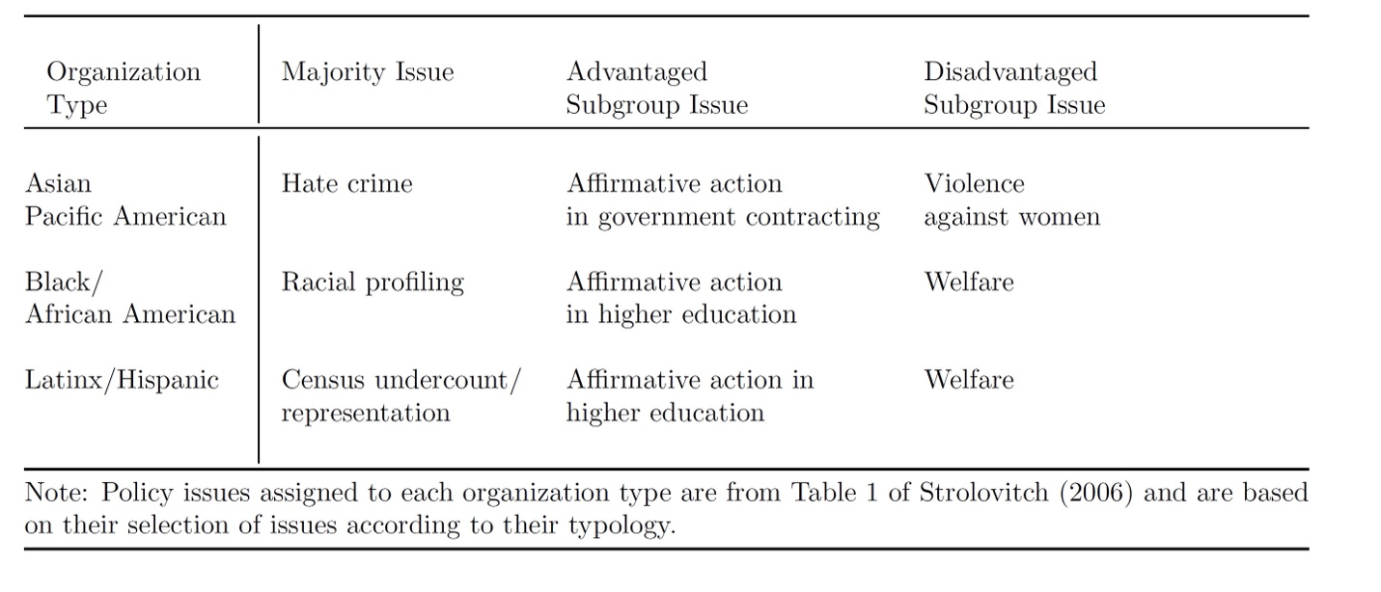
Table 1. Specific Policy Issues Used in Survey of National Economic and Social Justice Organizations (SNESJO) Questions by Racial Organization Type and Issue Category (Strolovitch 2007)

For example, Strolovitch (2007) identifies violence against women as a disadvantaged-subgroup issue for Asian/Pacific American organizations. Using my data, I can count and compare the number of times Asian RMIGs have lobbied on disadvantaged-subgroup issues compared to their advantaged-subgroup issue of affirmative action in government contracting. Each bill was examined closely through its title, digest, text, accompanying bill analysis, and lobbying letters to determine if it dealt with the subgroup issue.⁶ If RMIGs are reliable representatives, we should observe equal signaling activity on disadvantaged and advantaged-subgroup issues.
In the paper, I claim that RMIGs are more reliable representatives of their respective groups by showing that they lobby on disadvantaged-subgroup issues as much as the advantaged or the majority sub-group issues. Another way to potentially test whether RMIGs represent the intersectionally marginalized members of their group is to assess RMIGs’ group policy preferences compared to their disadvantage-subgroup (H2). To what extent do the revealed preferences of RMIGs reflect that of the disadvantage-subgroups compared to the advantaged-subgroups? To test H2, I leverage RMIGs’ position-taking on bills to estimate their ideal-points. Like other ideal-point estimates like DW-NOMINATE, I measure the latent policy preferences of RMIGs on the range of bills they lobbied to ascertain their positions relative to each other (Poole and Rosenthal 1991; Crosson, Furnas, and Lorenz 2020). I then asked 2000 respondents’ positions on a sample of nineteen policy questions that reflect bills lobbied on by interest groups.
Using two separate item-response theory (IRT) models, we estimate the ideal points for our survey respondents and select California interest groups. Because the issues used to train the models were the same for each type of observation (i.e. survey respondents were asked their opinions on actual pieces of legislation that received interest group signals of support or opposition), we could place both sets of actors on a single latent scale. The nineteen issue questions were first sorted out to be non-California specific or issues that could be taken up in other states, like a state-sponsored single-payer healthcare system (see appendix for questions) then randomly selected. The two IRT models are mathematically identical and differ only in the input data. We used a three-level ordinal scale for the outcome: “Support”; “Don't Know” (for survey respondents)/ “Abstain” (for interest groups), and “Oppose” for each issue. Because the nineteen issues were hand-picked, we could code the ideological direction before fitting the models, which, along with tight priors, helps ensure model identification. To calculate the fit of RMIG preferences to those of their respective group members, we calculated the overlap between their two ideal-point distributions. An overlap score can be calculated by measuring the area intersected by the density distributions (Pastore 2018). Higher overlap indicates closer similarity in preferences across these nineteen representative bills. If RMIGs are reliable representatives and do represent the interests of the intersectionally marginalized parts of their group (H2), then the distribution of RMIG ideal-point scores should be aligned at similar levels to the advantaged subgroup (Crosson, Furnas, and Lorenz 2020). The overlap score between RMIGs’ ideal-point distribution and respondents identifying as disadvantaged members (lower SES) should be higher or close to that between RMIGs’ ideal-point distribution and respondents identifying as advantaged members (higher SES).
Results
RMIGs Advocate More on Disadvantaged-subgroup Issues
In support of H1, Figures 1 to 3 indicate that RMIGs seem to be just as active if not more active on issues that matter to disadvantaged-subgroups than the majority or advantaged-subgroups. For each RMIG type, I find that the number of lobbying signals on disadvantaged-subgroup issues is as much or greater than the number of signaling on advantaged-subgroup issues. Note that roughly 2% to 9% of support and opposition signals from RMIGs were sent to bills dealing with disadvantaged-subgroup issues. It also seems to be the case that Latinx RMIGs seem to be most active on these issues, followed by Black RMIGs, then Asian RMIGs. Interestingly, issues that were determined to be in favor of advantaged-subgroups were less than 2% for all three RMIG types.
Moreover, the proportion of advocacy on disadvantaged-subgroup issues is significantly different from the proportion of advocacy on advantaged-subgroup.⁸ Overall, these patterns suggest very little to no bias towards advantaged-subgroups, and that RMIGs seem to be devoting substantial effort in lobbying on disadvantaged-subgroup issues. This finding supports the hypothesis that RMIGs lobby as much or more on issues that matter to their disadvantaged members (H1).
In the case of Asian-American RMIGs, their disadvantaged-subgroup issue is violence against women, while its advantaged-subgroup issue is affirmative action in government contracting. For Asian-Americans, the majority issue is racial discrimination (see Table 1). I find that roughly 2% of all Asian-American RMIG signals of support and opposition are to bills that relate to domestic violence or violence against women, while about 0.6% dealt with state contracting for minority businesses. Roughly 2% of all bills dealt directly with issues of racial discrimination or hate crimes (Figure 1).
[Figure 1 near here.]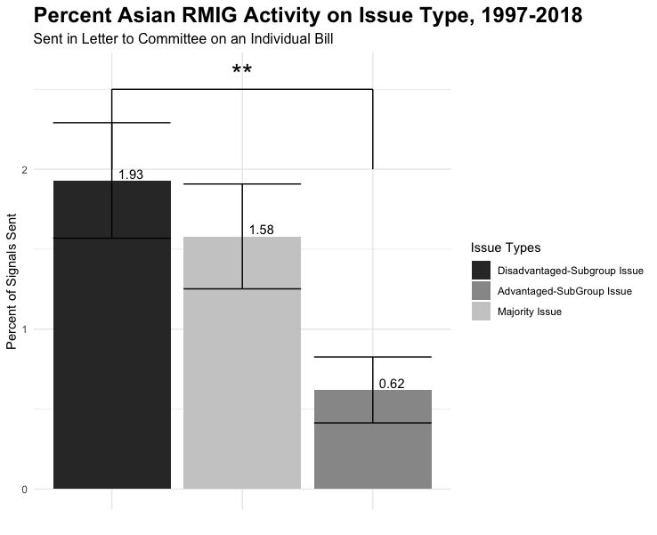
Figure 1. Percent of Asian RMIG Activity on Disadvantaged-Subgroup Issues vs. Advantaged-Subgroup Issues vs. Majority Issues.

Disadvantaged-subgroup issues for Black people deal with welfare, while the advantaged-subgroup issues pertain to affirmative action in higher education (Figure 2). The majority issue for Black RMIGs is racial profiling. Signals on the disadvantaged-subgroup issue of welfare makes up 5% of total signals sent, compared with only 2% of signals on the advantaged-subgroup issue. Signals on the majority issue make up 4% of Black RMIGs’ total signals. Like Black RMIGs, the disadvantaged-subgroup issue for Latinx RMIGs is welfare, while affirmative action in education is their advantaged-subgroup issue. The majority issue for them is the census undercount. Since the period of the data covers only two census counts, I also included issues that dealt with underrepresentation of the Latinx community in state statistics and other similar issues. Latinx RMIGs focus a substantial amount of their signaling on the disadvantaged-subgroup issue, about 9% of total signals. They devote less than 1% of their signaling towards the advantaged-subgroup issue, and even less towards issues pertaining to the majority issue of census undercount or underrepresentation (Figure 3).
[Figure 2 near here.]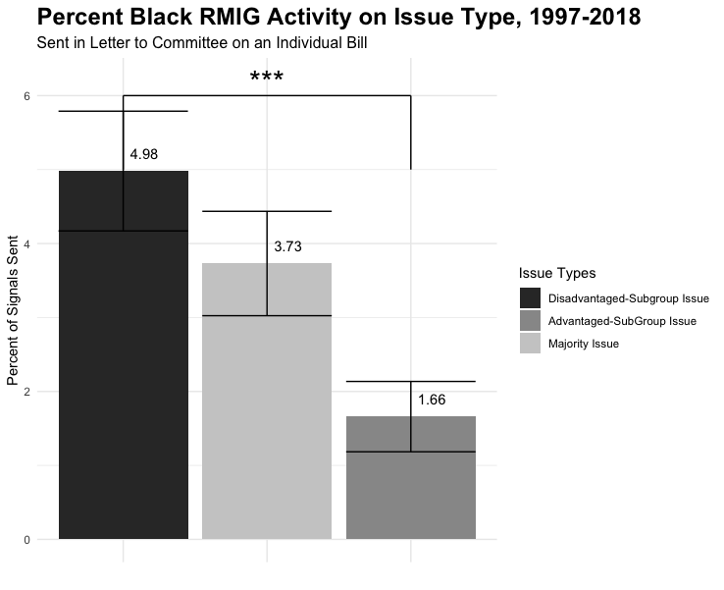
Figure 2. Percent of Black RMIG Activity on Disadvantaged-Subgroup Issues vs. Advantaged-Subgroup Issues vs. Majority Issues.

[Figure 3 near here.]
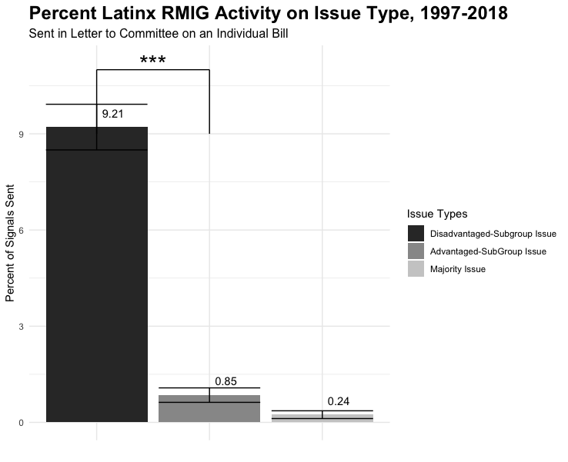
Figure 3. Percent of Latinx RMIG Activity on Disadvantaged-Subgroup Issues vs. Advantaged-Subgroup Issues vs. Majority Issues.
Though the counts for these are low, a cursory look at the general topics shows that most of their lobbying efforts focus on healthcare access, expanding educational access, reforming prison, and law enforcement, and expanding welfare programs (Figure 7 and Figure 8). Such topics contain bills aimed at improving the lives of disadvantaged populations within their racial groups. A clear illustration of this is evidence of lobbying by RMIGs on LGBTQ+ issues. In this period, RMIGs from each racial group supported legislation that prevented discrimination based on sexual identity. There were also prolonged activities to support policies that expanded same-sex couples' rights, revised school curricula to raise awareness about LGBTQ+ identities and teach tolerance and expanded HIV testing. Such lobbying activities were far from one-offs; they occurred throughout this period. The data reveal that RMIGs were highly active in supporting the interests of intersectionally marginalized folks in their group, compared to their majority or advantaged groups.
Recognizing that using Strolovitch’s (2007) typology of issues may be too narrow, I expanded the range of issues that fall under the definition of disadvantage-subgroup, advantaged-subgroup, majority, and universal issues. Many more issues could be considered one of these types. All bills within my dataset were coded using Strolovitch’s (2007) definition. Disadvantaged subgroup issues are issues which unequally likely to affect a subgroup of a racial group who are disadvantaged economically, socially, or politically compared to the broader group. Advantaged subgroup issues are issues that are unequally likely to affect a subgroup of a racial group that is advantaged economically, socially, or politically compared to the broader group. Majority issues are those that affect the majority of the racial group. I re-tested H1 with this expanded coding; the results support my main finding. Figures 4 to 6 show a statistical difference between advocacy levels on disadvantaged and advantaged groups, though the difference has narrowed. Overall, RMIGs seem more active on disadvantaged issues than advantaged ones.
[Figure 4 near here.]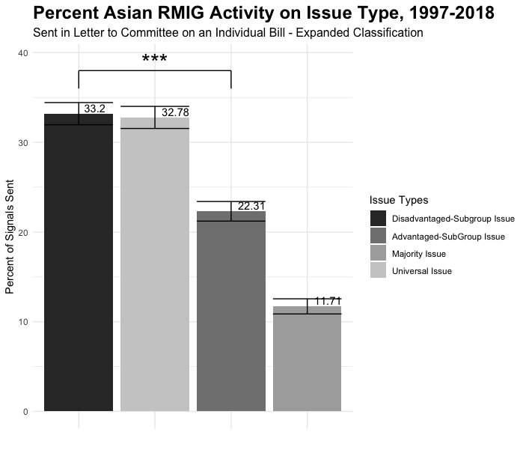
Figure 4. Expanded Classification: Percent of Asian RMIG Activity on Disadvantaged-Subgroup Issues vs. Advantaged-Subgroup Issues vs. Majority Issues vs. Universal Issues.

[Figure 5 near here.]
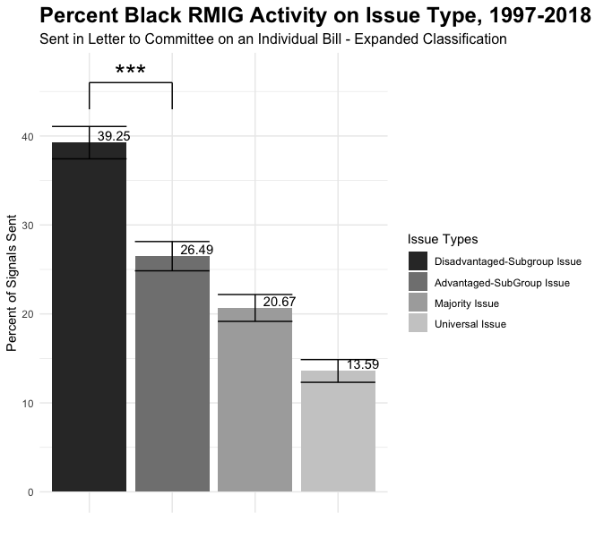
Figure 5. Expanded Classification: Percent of Black RMIG Activity on Disadvantaged-Subgroup Issues vs. Advantaged-Subgroup Issues vs. Majority Issues vs. Universal Issues.

[Figure 6 near here.]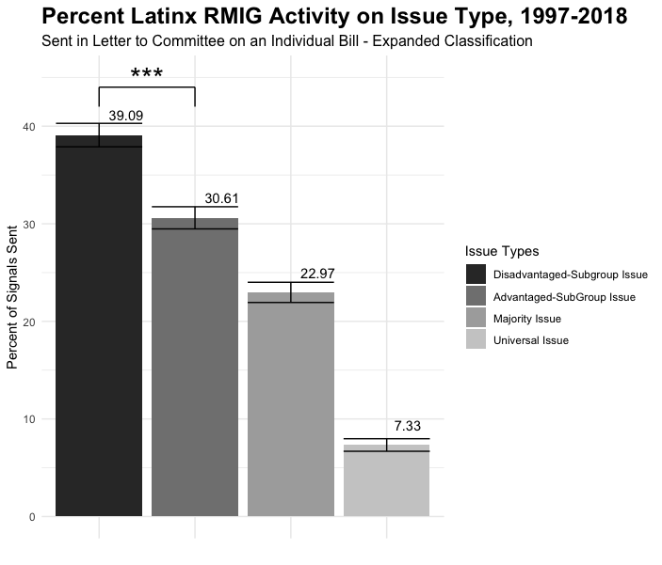
Figure 6. Expanded Classification: Percent of Latinx RMIG Activity on Disadvantaged-Subgroup Issues vs. Advantaged-Subgroup Issues vs. Majority Issues vs. Universal Issues.
There Is Not a Major Skew Towards the Elite Sub-Group in RMIGs’ Revealed Preferences
The data show that RMIGs’ latent policy preferences are slightly more reflective of higher SES respondents in our survey, though the overlap difference is very small. In estimating the overlap between the estimated ideal point distribution of RMIGs and that of survey respondents on the same policy questions, I find that there is variation in how strong the overlap is among Black, Latinx, and Asian RMIGs, especially among gender lines. Recall that H2 suggests that RMIGs’ latent policy preferences should reflect the latent policy preferences of the disadvantaged sub-groups more or as much as the advantaged sub-group. The overall finding supports this hypothesis.
Figure 7 shows the distribution of RMIG scores, compared with the revealed preferences of female, racial minority respondents who indicated less college education (a proxy of socioeconomic status). The overlap between the distribution of preferences among respondents with three intersectionally marginalized identities (gender, race, and class) and that of RMIGs is relatively higher than that of upper-class racial minority women, though the difference is small. Lower SES racial minority women have an area overlap score of 0.473 versus 0.446 for higher SES racial minority women.
[Figure 7 about here]
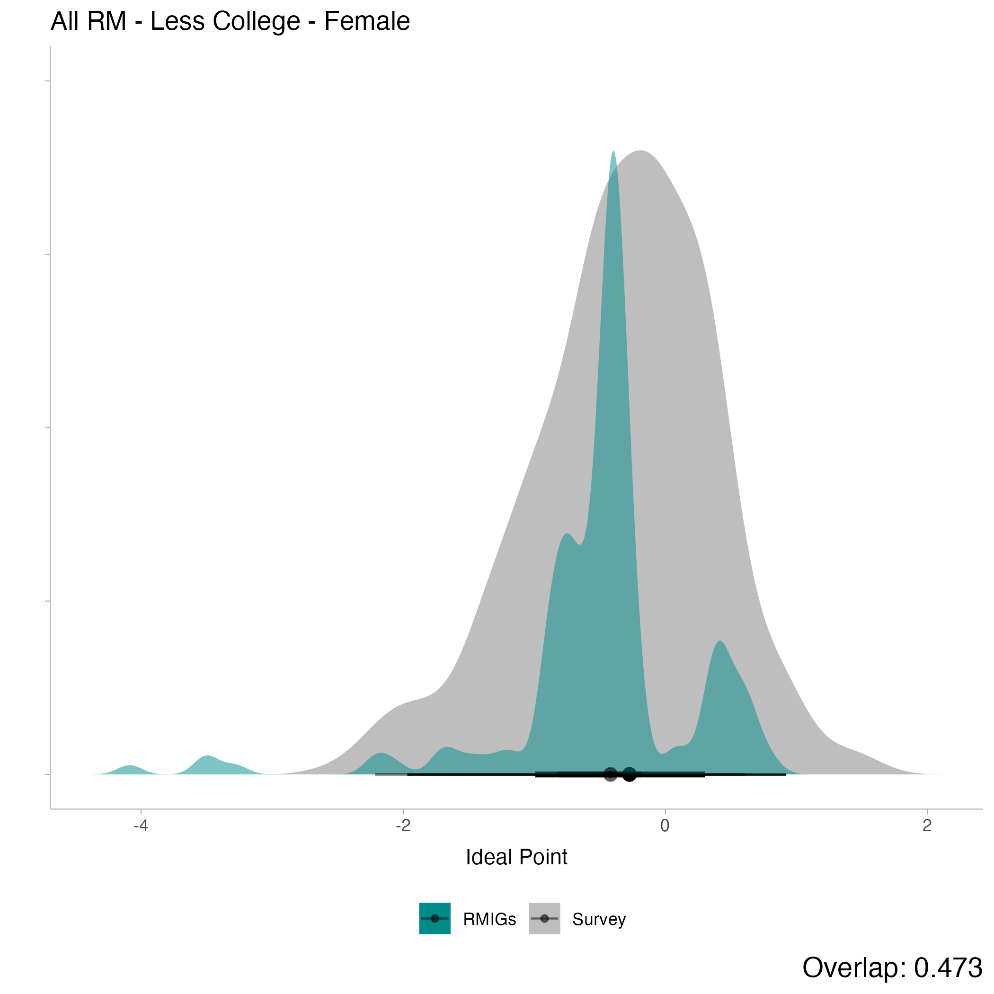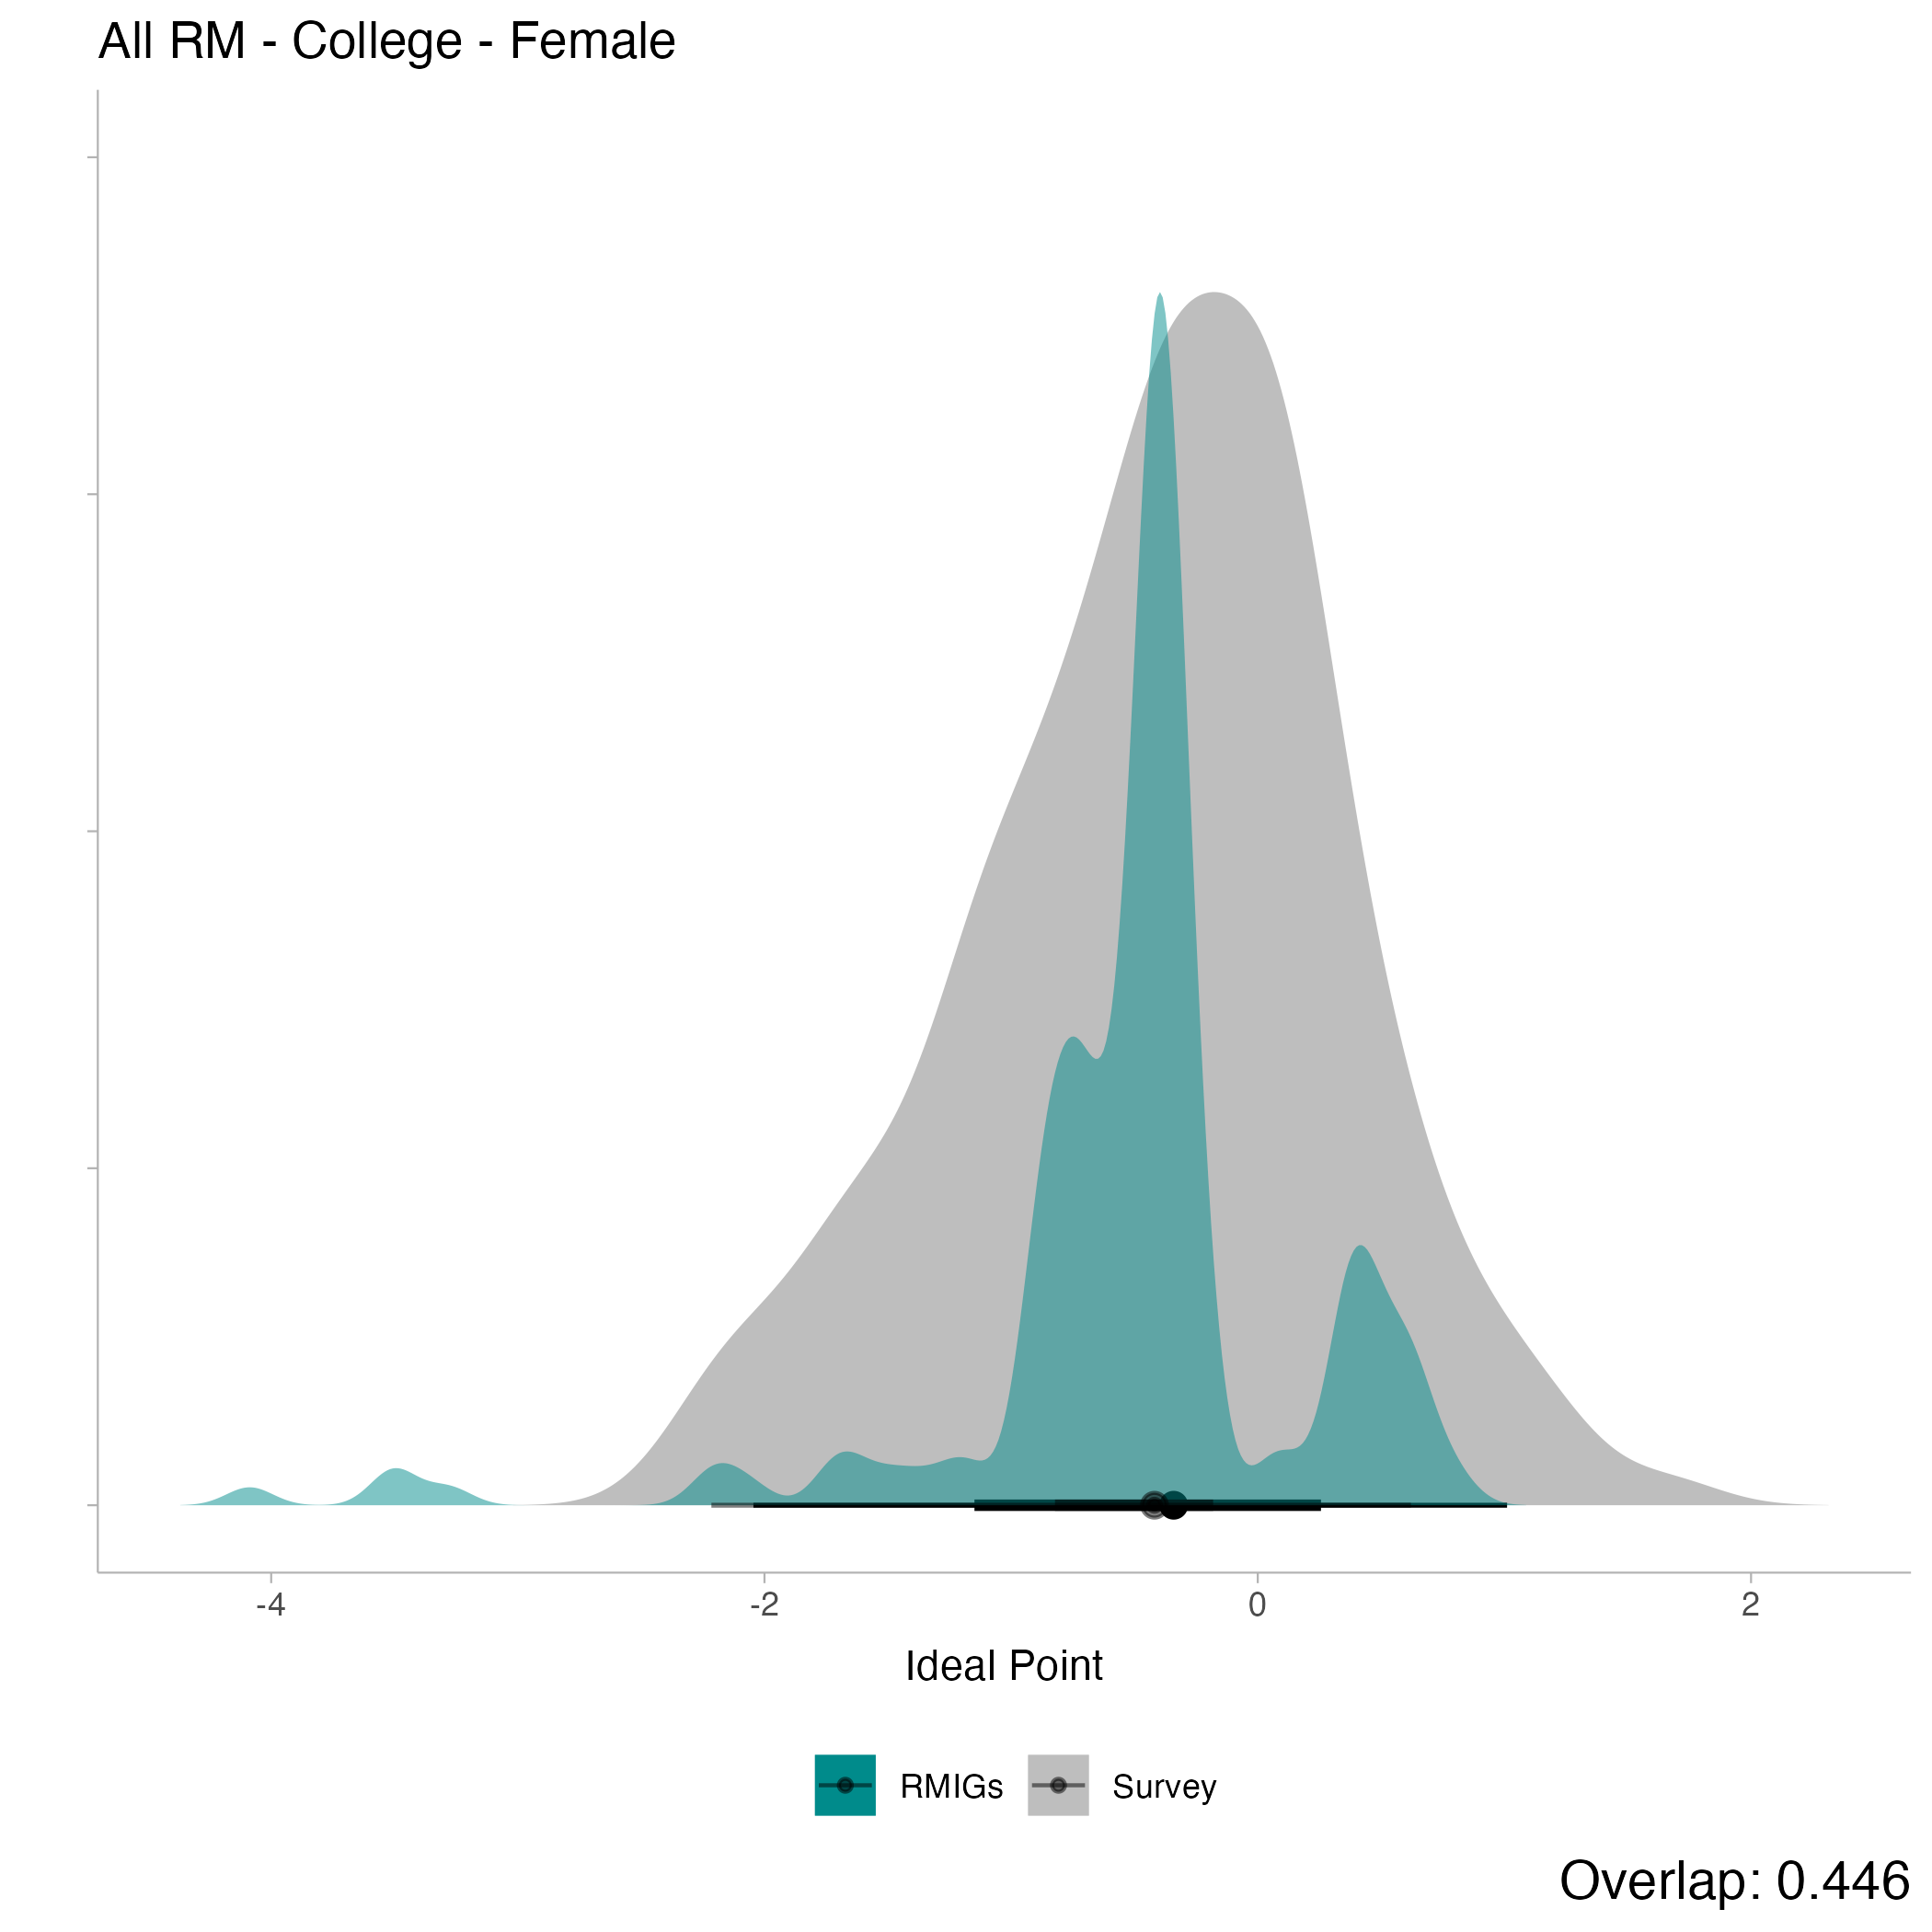
Figure 7. Distribution of RMIGs’ and Racial Minority Female Respondents’ Ideal-Point Scores.
We see similar patterns when broken down by racial group, compared to the corresponding RMIG type. Table 2 shows the overlap score of their respective racial minority interest group by gender, education, and race.
[Table 2 about here]
 | Male Respondent |  |  | Female Respondents
 | Black | Asian | Latinx | Black | Asian | Latinx
Lower College Education (SES) | 0.685 | 0.467 | 0.397 | 0.687 | 0.48 | 0.423
Higher college Education  (SES) | 0.773 | 0.453 | 0.423 | 0.705 | 0.483 | 0.36
Table 2. Comparison of RMIG overlap scores by race, gender, and SES to their corresponding racial group.
The overlap in the preferences of Black, Asian and Latinx respondents and that of their respective RMIGs are highly similar along our proxy for SES, though it slightly skews toward higher SES respondents. Black RMIGs have the highest overlap. However, there’s evidence of more substantial overlap with higher SES respondents’ ideal-point distributions. The differences are not very large though present. Latinx RMIGs seem to do a better job in representing lower SES female Latina respondents compared to their higher SES counterparts. However, their preferences are slightly skewed towards high SES for male Latino respondents. Asian RMIGs seem to better reflect their marginalized members than other RMIGs. Along the female respondent dimension, the overlap between Asian RMIGs and lower SES respondents is almost the same. We see more overlap for Asian RMIGs and lower SES Asian men than higher SES Asian men.
Together, this new finding sheds clearer light on the ability of RMIGs to represent their respective groups. Though there is more substantial overlap toward higher SES or more elite segments of the racial group, the differences are minor to negligible. As one might expect from the literature, there is not a significant skew towards the elite segments of their racial group. The ideological leaning of RMIGs, as expressed through their lobbying, seems to closely overlap with those they purport to represent—at least across a sample of RMIG lobbied positions.
Discussion
Though scholars have noted biases in the activities of advocacy organizations that represent marginalized communities, I find evidence that racial minority interest groups (RMIGs) are reliable representatives of their communities. I develop the concept and theory of RMIG advocacy as a separate, distinct, and under-studied category of interest groups. RMIGs’ unique role in racial/ethnic domains and historical birth from social movements provide them with distinct motivations and constraints. It also shapes their strength toward cooperative behavior and coalition-building. In analyzing the actual lobbying activity of RMIGs through support and opposition letters in the form of formal letters, I find that RMIGs represent the interests of disadvantaged-subgroups as much as advantaged-subgroups and the majority.
Other parts of the literature, like Strolovitch (2007) and Marchetti (2014), found that advocacy organizations favor elite interests. RMIGs, as I have shown, generally buck this trend. They do so because they are uniquely positioned to be highly aware of the intersectional nature of their advocacy. They recognize that race is central to almost all other important issues like social status, economic interests, gender, and sexuality. RMIGs pursuit of the axis of race must consider other intersections. Race in American politics is so highly salient that it bleeds into other aspects of politics. America’s history of slavery, xenophobia, and racism has produced a system that places people of color at the bottom of American society. In pursuing racial interests, RMIGs also seek issues that matter to their disadvantaged subgroups. The disadvantaged segments of advocacy organizations representing marginalized groups, in other words, are often racial groups. This fact is keenly clear to RMIGs at the frontlines of advocacy, especially since theories of linked-fate point to how a deep sense of connectedness focused on race can shape behavior that crosses socioeconomic lines (Dawson 1999). On reexamination, since the civil rights movement, RMIGs may be leaning into such practices since it may lead to more success in their lobbying efforts. I may be capturing a more recent push among race-based organizations to make concerted efforts to represent their marginalized segments. Figure 8 shows a general uptick in the later 2000s in disadvantaged issues when I expand the typology beyond Strolovitch’s (2007) categorization. This finding can explain why I see RMIGs more active in representing the disadvantaged: it may be a temporal shift in interest group advocacy.
[Figure 8 about here]
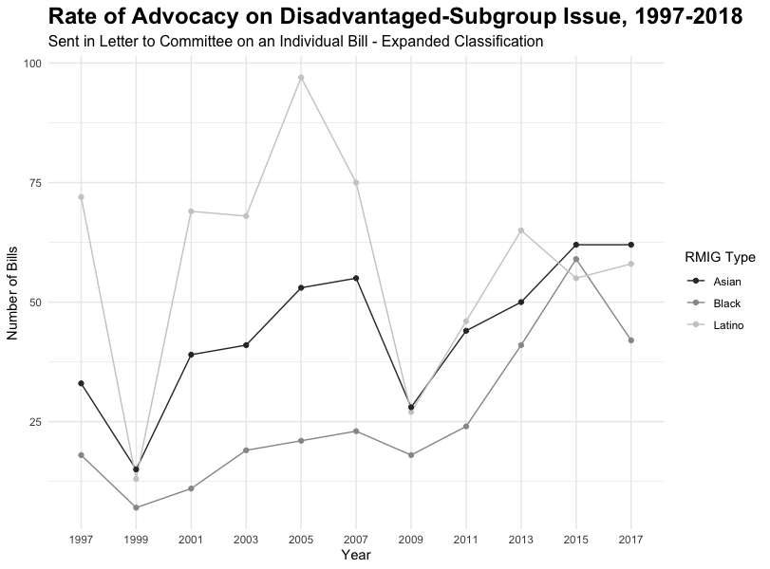
Figure 8. RMIG Advocacy on Disadvantaged Issues Over Time (Expanded Classification)
Second, the benefits of advocating for the disadvantaged outweigh its potential repercussions. Pursuing disadvantaged issues may lead important parts of their constituency, like elite donors or the majority, to withdraw their financial support. There might be the potential to alienate allies, the public, or prospective members. Though these outcomes may limit RMIGs’ ability to influence policy or operate in the short term, I argue that pursuing issues that matter to the disadvantaged raises their legitimacy and credibility, making them more effective in lobbying especially when it can be easily checked in the public record. Doing so shows that they are not beholden to a segment of their constituency but advocate for all.
Furthermore, lobbying on issues that include the disadvantaged allows them to form new bonds and collaboration with other groups whose focus might be along those axes (economic interest groups, gender organizations, environmental groups, etc.). These bonds create more powerful coalitions that increase lobbying influence. Altogether, the benefits of lobbying for the disadvantaged make RMIGs more influential and attractive in lobbying, allowing them to claim legislative victories, strengthening their organization.
A key difference in my findings versus other established research is that my data looks at lobbying through position signaling on legislative bills instead of survey responses, comments, and interviews (Strolovitch 2007; Marchetti 2014; Dwidar 2022b; English 2019). By closely examining legislative politics, I can capture lobbying representation more finely. At the same time, an institutional effect may be at play. Moving from state to national politics may require more strategic positioning, leading to biases toward elites. This study also opens a new avenue of exploration into how racial minorities build coalitions and cooperate to reach their legislative goals. Moreover, it shows that RMIGs are different from traditional lobbying organizations. The recognition and re-conceptualization of racial minority interest groups as a distinct type, with separate motivations, constraints, and incentives, allow a better understanding of how weak, marginalized groups can create policy change. Beyond this, I introduce exciting new data and identification strategies for studying interest group lobbying from a racial perspective that can elucidate marginalized groups' positions on policy issues, their political ties to legislators, and the topics they tend to lobby for and against. Future race and ethnic scholars and interest group lobbying researchers can use this data to push the frontiers of research on how racial and ethnic groups use their organizations to influence policymaking and the legislative process.

Endnotes:
- Dwidar (2022a) refers to a piece in The Lily that documents the lack of action among top women’s organizations on issues concerning the intersectionally disadvantaged. https://www.thelily.com/how-many-women-of-color-have-to-cry-top-feminist-organizations-are-plagued-by-racism-20-former-staffers-say/
- Asian Americans Advancing Justice mission statement. 2020. Accessed Jan 2020. www.advancingjustice-aajc.org/who-we-are/about-us
- Mexican-American Legal Defense Fund mission statement. 2020. Accessed Jan 2020. www.maldef.org/about/
- The ACLU’s mission is to “defend and preserve the individual rights and liberties guaranteed to all people in this country by the Constitution and laws of the United States.” American Civil Liberties Union (ACLU) mission statement. 2022. Accessed October 2022. https://www.aclu.org/faqs
- US Census Bureau. 2021. “2020 Census Illuminates Racial and Ethnic Composition of the Country". https://www.census.gov/library/stories/2021/08/improved-race-ethnicity-measures-reveal-united-states-population-much-more-multiracial.html
- A team of ten undergraduate research assistants was trained to assess whether each bill would be unequally likely to benefit or harm a disadvantaged/advantaged membership. Coding was then mutually audited and discussed to increase precision.
- See U.S. Bills Dataset from the Policy Agendas Project. E. Scott Adler and John Wilkerson, Congressional Bills Project: (2019), NSF 00880066 and 00880061.
- Calculated t-test for difference in proportions are significant at the 0.01 level.

References:
Abney, G. 1988. Lobbying by the Insiders: Parallels of State Agencies and Interest Groups.” Public Administration Review, 48(5), 911.
Abrajano, Marisa and Zoltan Hajnal. 2015 White Backlash: Immigration, Race and American Politics. Princeton University Press.
Alexander, Michelle. 2010. The New Jim Crow: Mass Incarceration in the Age of Colorblindness. New York, The New York Press.
Ambrosius, M.M. and Welch, S., 1988. “State Legislators' Perceptions of Business and Labor Interests.” Legislative Studies Quarterly, pp.199-209.
Arnesen, Sveinung, and Yvette Peters. 2018. “The Legitimacy of Representation: How Descriptive, Formal, and Responsiveness Representation Affect the Acceptability of Political Decisions.” Comparative Political Studies, 51(7), 868–899
Austin-Smith, David, and John R. Wright. 1992. “Competitive Lobbying for Legislative Votes." Social Choice and Welfare 9: 229-57.
Berry, Jeffery M. 1977. Lobbying for the People: The Political Behavior of Public Interest Groups. Princeton: Princeton University Press.
--1999. The New Liberalism: The Rising Power of Citizen Groups. Washington, DC: Brookings Institution.
Berry, J.M. and C. Wilcox, 2015. The Interest Group Society. New York. Routledge.
Bonilla, T., and A. B. Tillery. 2020. “Which identity frames boost support for and mobilization in the# BlackLivesMatter movement? An experimental test”. American Political Science Review, 114(4), 947-962.
Cohen, C. J. 1999. The Boundaries of Blackness: AIDS and the Breakdown of Black Politics. Chicago: University of Chicago Press.
Cohen, J. E., Goldstein, A. O., Flynn, B. S., Munger, M. C., Gottlieb, N. H., Solomon, L. J., & Dana, G. S. 1997. “State Legislators' Perceptions of Lobbyists and Lobbying on Tobacco Control Issues.” Tobacco Control, 6(4), 332–336.
Crenshaw, Kimberlé. 1991. “Mapping the Margins: Intersectionality, Identity Politics, and Violence against Women of Color”. Stanford Law Review, 43(6), 1241–1299.
Dawson, Michael C. 1994. Behind the Mule: Race and Class in African-American Politics. Princeton: Princeton University Press.
Dovidio, J. F. and S. L. Gartner. 2004. “Aversive racism.” In M. P. Zanna (Ed.), Advances in Experimental Social Psychology Vol. 36: 1-52.
Downs, Anthony. 1957. An Economic Theory of Democracy. New York: Harper Collins.
Dwidar, M. A. 2022a. “Diverse Lobbying Coalitions and Influence in Notice‐and‐Comment Rulemaking.” Policy Studies Journal, 50(1), 199–240.
--2022b. “Coalitional Lobbying and Intersectional Representation in American Rulemaking.” American Political Science Review, 116(1), 301–321.
English, A. 2019. Implementing Intersectionality: Women’s Organizations’ Representation of Women of Color and Poor Women during Two Rulemakings. Politics, Groups, and Identities, 9(4), 739–758.
Francis, M. M. 2014. Civil Rights and the Making of the Modern American State (1st ed.). Cambridge University Press.
Frasure-Yokley, L. 2018. “Choosing the Velvet Glove: Women Voters, Ambivalent Sexism, and Vote Voice in 2016.” Journal of Race, Ethnicity, and Politics 3 (1): 3-25.
Gay, C., and K. Tate. 1998. “Doubly Bound: The Impact of Gender and Race on the Politics of Black Women.” Political Psychology, 19(1), 169–184.
Gause, L. 2022. “Revealing Issue Salience via Costly Protest: How Legislative Behavior Following Protest Advantages Low-Resource Groups.” British Journal of Political Science, 52(1), 259-279.
Gelbman, S. 2021. The Civil Rights Lobby: The Leadership Conference on Civil Rights and the Second Reconstruction. Temple University Press.
Gilens, M. 1999. Why Americans Hate Welfare: Race, Media, and the Politics of Antipoverty Policy. Amsterdam University Press.
Gray, Virginia and David Lowery. 1996. The Population Ecology of Interest Representation: Lobbying Communities in the American States. Ann Arbor: University of Michigan Press.
Gutiérrez, José Ángel. 2010. “The Chicano Movement: Paths to Power,” The Social Studies 102, no. 1 (2010): 25–32.
Henry, P.J., and D.O. Sears, 2002. “The Symbolic Racism 2000 Scale.” Political Psychology 23 (2), pp.253-283.
Hero, Rodney E., Robert R. Preuhs and Olivia M. Meeks. 2019. “Are these Friends also ‘Friends of the Court’? Examining Minority Legal Advocacy Organization Coalitions in Amicus Brief Filings.” Politics, Groups, and Identities 7 (3): 489-508.
Hero, Rodney and Robert Preuhs. 2013. Black-Latino Relations in U.S. National Politics: Beyond Conflict or Cooperation. New York: Cambridge University Press.
Hojnacki, M., 1997. “Interest Groups' Decisions to Join Alliances or Work Alone.” American Journal of Political Science 41 (1): 61-87.
Hojnacki, Marie and David C. Kimball. 1999. “The Who and How of Organizations’ Lobbying Strategies in Committee.” Journal of Politics. 61:999-1024.
Hutchings, V.L. and Valentino, N.A., 2004. “The Centrality of Race in American Politics.” Annual Review of Political Science 7:383-408.
Kaufmann, K. M. 2003. “Cracks in the Rainbow: Group Commonality as a Basis for Latino and African-American Political Coalitions.” Political Research Quarterly 56 (2), 199-210.
Kalla, Joshua L., David E. Broockman. 2016. “Campaign Contributions Facilitate Access to Congressional Officials: A Randomized Field Experiment.” American Journal of Political Science 60:545-58.
Kim, Claire. 2003. Bitter Fruit: The Politics of Black-Korean Conflict in New York City. New Haven, Yale University Press.
Kim, Jae Yeon. 2020. “How Other Minorities Gained Access: The War on Poverty and Asian American and Latino Community Organizing.” Political Research Quarterly 75(1)L 89-102.
Kinder, D. R., & Sears, D. O. 1981. “Prejudice and Politics: Symbolic Racism versus Racial Threats to the Good Life.” Journal of personality and social psychology, 40(3), 414.
Kingdon, John W.1995. Agendas, Alternatives, and Public Policies. 2nd edn. New York: HarperCollins.
Kollman, Ken. 1998. Outside Lobbying: Public Opinion and Interest Group Strategies. Princeton: Princeton University Press.
Lê Espiritu, Yến. 1992. Asian American Panethnicity: Bridging Institutions and Identities. Temple University Press.
Lee, Taeku. 2008. “Race, Immigration, and the Identity-to-Politics Link.” Annual Review of Political Science 11: 457-478.
Lorenz, Geoffrey M. 2020. “Prioritized interests: Diverse Lobbying Coalitions and Congressional Committee Agenda Setting.” Journal of Politics 82 (1): 225-240.
Luna, Zakiya. 2016. “Truly a Women of Color Organization”: Negotiating Sameness and Difference in Pursuit of Intersectionality. Gender & Society, 30(5), 769–790.
Márquez, Ben. 2021. The Politics of Patronage: Lawyers, Philanthropy, and the Mexican American Legal Defense and Educational Fund. University of Texas Press.
Masuoka, Natalie, and Jane Junn. 2013. The Politics of Belonging: Race, Public Opinion, and Immigration. University of Chicago Press.
Marchetti, Kathleen. 2014. “Crossing the Intersection: The Representation of Disadvantaged Identities in Advocacy”. Politics, Groups, and Identities, 2(1), 104–119.
McAdam, D. 1982. Political Process and the Development of Black Insurgency, 1930-1970. 2nd ed. Chicago: University of Chicago Press.
McCarthy, John D. and Mayer N. Zald. 1977. “Resource mobilization and social movements: a partial theory.” American Journal of Sociology 82 (6): 1212-1241
Mendelberg, T. 2008. “Racial Priming Revived.” Perspectives on Politics, 109-123.
Minta, M. D. 2019. “Diversity and Minority Interest Group Advocacy in Congress.” Political Research Quarterly, 73(1), 208–220.
Omi, Michael and Howard Winant. 1994. Racial Formation in the United States. New York: Routledge.
Pastore, Massimiliano. 2018. “Overlapping: A R package for Estimating Overlapping in Empirical Distributions.” Journal of Open Source Software, 3(32), 1023.
Perez, Efren. 2016. Unspoken Politics: Implicit Attitudes and Political Thinking. New York: Cambridge University Press.
Pitkin, Hanna Fenichel. 1967. The Concept of Representation. Berkeley and Los Angeles: University of California Press.
Powell, E.N. and J. Grimmer, 2016. “Money in Exile: Campaign Contributions and Committee Access.” The Journal of Politics 78(4): 974-988.
Roth, Silke. 2021. “Intersectionality and Coalitions in Social Movement Research—A Survey and Outlook.” Sociology Compass 15 (e12885).
Schlozman, Kay Lehman. 1984. “What Accent the Heavenly Chorus? Political Equality and the American Pressure System.” Journal of Politics 46 (4): 1006-32.
Schlozman, Kay Lehman and Traci Burch. 2009. “Political Voice in an Age of Inequality”. In America at Risk: The Great Dangers, ed. Robert F. Faulkner and Susan Shell. Ann Arbor: University of Michigan Press.
Simien, Evelyn. 2005. “Race, Gender, and Linked Fate”. Journal of Black Studies, 35(5), 529–550. http://www.jstor.org/stable/40034336
Skocpol, Theda. 2003. Diminished Democracy. Norman: University of Oklahoma Press.
Smith, Robert G. 1996. We Have No Leaders: African Americans in the Post-civil Rights Era. Albany, New York: SUNY Press.
Strolovitch, Dara Z. 2007. 2007. Affirmative Advocacy: Race, Class, and Gender in Interest Group Politics. Chicago: University of Chicago Press.
Strolovitch, Dara Z. and David M. Forrest. 2010. “Social and Economic Justice Movements and Organizations.” In The Oxford Handbook of American Political Parties and Interest Groups edited by L. Sandy Maisel, Jeffrey M. Berry, and George C. Edwards III. New York: Oxford University Press.
Tarman, Christopher, and David O. Sears. 2005. “The Conceptualization and Measurement of Symbolic Racism” The Journal of Politics 67(3): 731-761.
Telles, E., Sawyer, M., & Rivera-Salgado, G. 2011. Just Neighbors? Research on African American and Latino Relations in the United States. Russell Sage Foundation.
Tillery, A. B. 2019. “What kind of movement is Black Lives Matter? The view from Twitter. Journal of Race, Ethnicity, and Politics, 4(2), 297-323.
Thernstrom, Stephan, and Abigail Thernstrom. 1997. America in Black and White: One Nation, Indivisible. New York: Simon & Schuster.
Tungohan, E. 2015. “Intersectionality and Social Justice: Assessing activists’ use of intersectionality through grassroots migrants’ organizations in Canada.” Politics, Groups, and Identities, 4(3), 347–362.
Urbinati, Nadia. 2000. “Representation as Advocacy: A Study of Democratic Deliberation.” Political Theory 28:258–786.
Walton Jr., Hanes, Cheryl M. Miller, and Joseph P. McCormick II. 1995. “Race and Political Science: The Dual Traditions of Race Relations Politics and African-American Politics." In Political Science in History: Research Programs and Political Traditions, eds. James Farr, John S. Dryzek.
Williams, Melissa S. 1998. Voice, Trust, and Memory: Marginalized Groups and the Failings of Liberal Representation. Princeton, NJ: Princeton University Press.
Winston A. Van Home, “The Concept of Black Power: Its Continued Relevance,” Journal of Black Studies 27, no. 3 (2007): 365–89.
White, Ismail K., 2007. “When Race Matters and When it Doesn't: Racial Group Differences in Response to Racial Cues.” American Political Science Review, 101 (2): 339-354.
Young, Iris M. 2000. Inclusion and Democracy. New York: Oxford University Press.
Figures:
Figure 1. Percent of Asian RMIG Activity on Disadvantaged-Subgroup Issues vs. Advantaged-Subgroup Issues vs. Majority Issues.
Figure 2. Percent of Black RMIG Activity on Disadvantaged-Subgroup Issues vs. Advantaged-Subgroup Issues vs. Majority Issues.
Figure 3. Percent of Latinx RMIG Activity on Disadvantaged-Subgroup Issues vs. Advantaged-Subgroup Issues vs. Majority Issues.
Figure 4. Expanded Classification: Percent of Asian RMIG Activity on Disadvantaged-Subgroup Issues vs. Advantaged-Subgroup Issues vs. Majority Issues vs. Universal Issues.
Figure 5. Expanded Classification: Percent of Black RMIG Activity on Disadvantaged-Subgroup Issues vs. Advantaged-Subgroup Issues vs. Majority Issues vs. Universal Issues.
Figure 6. Expanded Classification: Percent of Latinx RMIG Activity on Disadvantaged-Subgroup Issues vs. Advantaged-Subgroup Issues vs. Majority Issues vs. Universal Issues.
Figure 7. Distribution of RMIGs’ and Racial Minority Female Respondents’ Ideal-Point Scores.
Figure 8. RMIG Advocacy on Disadvantaged Issues Over Time (Expanded Classification)
Tables:
Table 1. Specific Policy Issues Used in Survey of National Economic and Social Justice Organizations (SNESJO) Questions by Racial Organization Type and Issue Category (Strolovitch 2007)
Table 2. Comparison of RMIG overlap scores by race, gender, and SES to their corresponding racial group.

