Sargis Karavardanyan
California State University, Northridge
“The Political Discourse of Dictatorship and Democracy”

Introduction
The orientation of political discourse can be a crucial determinant for deciding whether dictatorship or democracy has been prevailing in a society. The political dialogue of the government or the ruling entity within a society is very important to classify the status of leadership under either democracy or dictatorship. The two different types of political discourse, distancing and ordinary, will be described and supported in this paper with thorough examination of historical data. In order to form a better understanding of the argument, the focus of the analysis will be concentrated around two key hypotheses. The first hypothesis is looking into whether discursive distancing initiates dictatorship through principles of elongation, elevation and enlargement. The second hypothesis articulates is whether the disappearance of these principles in the political discourse creates a pattern for democracy or maintains dictatorship. The catalyst of the discussion will be an articulation of the evidence from different articles that may broaden up various opposing and parallel perspectives in relation to these two hypotheses. The conclusion of the paper will assert that the elements of elongation, elevation and enlargement in the political discourse will play a significant role in identifying the extent of dictatorship in a society, and contrariwise, principles of democracy will arise if the discursive cues are decreased.
The Political Discourse of Pre-1915 Era
The first hypothesis can be tested by investigating the political discourse of various civilizations before and after 1915. It was not until that time period when the first notions of democracy began to originate in various societies. The origin of the political discourse traces back its roots to pre-historical and historical eras. Throughout most of the human history dictatorship has occurred as a natural phenomenon. Specifically, that phenomenon was the dictated by human nature derived from the instinct of survival of the fittest. The position of the discourse that rulers practiced in with their subjects played a significant role in this process.
The Latin language has been a crucial paradigm for religious and political activities in Europe for most of its ancient and medieval history. After the emergence of distinctive dialects all around the European continent, the Roman Empire began to collapse because religious, political, social and cultural tasks were not executed via Latin (Fisher 1987, 5).
Elevation in Political Discourse
According to the assumption made by Kahane and Kahane, there are two general elevations of prestige languages, "high and low." These two variations of the language represent the social ranks of the society where "high" is associated with the symbol of power and rule, and "low" with subjects who are under that rule (Kahane and Kahane 1987, 183). One of the several instances of decline in prestige languages was impacted by rise of Latin when it overpowered the Greek dialect that was considered to be the prestige language during the early 2nd and late 3rd centuries A.D. (Kahane and Kahane 1987, 184). Recitations of religious literature in Latin by ancient Roman clergy influenced the decline of Greek language, which was the "higher" language indicating the upper status of a citizen. Since the Latin was emerging as the more popular form of dialect in Europe, the majority of educated Christians became strong proponents of Latin (Kahane and Kahane 1979, 184). This may be interpreted as an elevation principle of social ranks separating those who were knowledgeable in Latin and those who spoke less influential dialects such as Greek.
In eastern parts of the large Roman Empire, Latin was the language of aristocracy and upper class. The notions of spatial cues that represented the age and distinctiveness of the language are evident in practice of Latin in Byzantium. "Latin was the language symbolizing the heritage of Rome" meaning that by speaking Latin the rulers of Byzantine Empire connected their identities to greatness of Roman Emperors (Kahane and Kahane 1979, 185). It was also a language used in the past indicating distancing cues in time widening the gap between Latin speaking authorities and Latin-Greek bilingual society.
The appearance of French vernacular in the discourse of Germany during 16th century and its interpretation as a prestige language had mixed opinions and responses among the contemporaries of that time period. The French dialect replaced German as the primary discourse in German courts and gained reputation among upper class bourgeoisies and nobles eventually becoming the tongue of educated (Kahane and Kahane 1979, 188). However, the sentiment of German nationalism, ongoing hatred between French and German people, and criticism of Frenchmen and their language generated the discouragement and eventual decline of the French language that implied a "higher" social status (Kahane and Kahane 1979, 189).
Dictatorship and repression in England were maintained not only by class differentiations, but also by the language that was practiced in various ranks of English society (Anderson 2013, 4:7). Repressed populations that mainly consisted of peasantry and townspeople were distanced from the repressors generally because they spoke different languages/dialects (Anderson 2013, 4:14). One reason was that the English (Gaelic) speakers of one country never met each other as a result of restrictions on resettlements imposed by Norman repressors (Fisher 1992, 1169). Restrictions were imposed in order to separate populations sharing common dialects and prevent possibility of mobilization that could turn into an uprising. Another reason was that Anglo-Norman aristocracy spoke French ever since the Norman Conquest, while the peasantry spoke Old English (Fisher 1992, 1170). In order to maintain a dictatorship, the rulers made themselves linguistically different and distant from their subjects.
The Norman rulers effectively used elevation metaphor to create dictatorial regime in England because they were able to successfully implement elements from Anglo-Norman language to rule over masses that spoke English dialects. In 1381 A.D. the repressors of King Richard II beheaded Wat Tyler who was the leader of the Peasant Revolt and put his head on a poll in order to warn his followers (Anderson 2013, 4:19). By heading Wat Tyler the repressors used an elevation of discursive cues (Anderson 2013, 4:21). In other words, the poll represented something higher (elevation) than the society below and the head of Tyler was intended to “translate” into a discursive cue to illustrate the political power of minority in charge. Another method that Anglo-Norman rulers of England exercised to uphold a dictatorial regime was the implementation of foreign terminology in already transforming English dialect in 1422 A.D. (Fisher 1987, 15).
However, the alteration of English dialect was not able to prevent the mobilization of peasantry that became possible with translation of the Bible into English organized by John Wycliffe in 1370 A.D. (Anderson 2013, 4:18). This had a significant impact on the decline of Norman repression because previously the Bible was only available in Latin, a language distinctive from regular townspeople, and obtainable by the ruling class (Anderson 2013, 4:18). Since, the church had major political and social power; the translation of the Bible into English narrowed the gap of discursive distancing between population and religious clergy.
Elongation in Political Discourse
The political discourse can transmit different meanings depending on the cues that are being interpreted. In the 8th century when Muslim Arabs invaded Spain several Latin-speaking local populations moved to northwestern parts of the region and established new settlements. In order to have a stable refuge they created forts that became known as castella (Lloyd 1989, 363). The fact that they separated themselves from other societies of Spain represented an elongation factor because their settlements that were built on higher altitudes indicated a spatial metaphor. Nevertheless, statements such as this are debatable and open to various interpretations. This is one way of interpreting.
The settlers later became identified as Castilians and their settlements acquired the name Castile (Anderson 2013, 5:16). They developed a unique dialect different from the Latin spoken in the capital (Anderson 2013, 5:17). Since the demographic position of Castile was distinctive from their counterparts in Spain, their identity also illustrated a "high" (or distant) discursive cue to other Spanish populations. For example, the population of Kingdom of Leon viewed the character of Castilians as "arrogant, rambunctious upstarts who did not show proper respect for their betters" (Lloyd 1989, 365). Another point that can be articulated is the elongation of self-identity that Castilians entitled themselves based on their discourse. They viewed Basque and Latin as dialects inferior to their own language and considered those solely "as household tongue useful only for standard discourse" (Lloyd 1989, 366).
The representation of an older discourse can be assessed as “higher” or “distant” increasing the sentiment of power. In 1085, when Castilians conquered Toledo under the leadership of King of Leon, Alfonso the VI, the occupation was labeled "reconquering" (Spanish, reconquista) indicating that Castilians have captured Toledo before (Fisher 1987, 13). However, there is a dilemma in this terminology of the capture. Since Castilians were newly emerging society it follows that they did not capture Toledo before 1085 simply because they did not exist as a distinct population before that time period. By labeling the capture of Toledo as reconquista Castilians intended to preserve themselves as a society "older" than they appeared to be. In other words, they wanted to illustrate to other societies that they go back in their existence further than many believed to be the case (Fisher 1987, 13).
Among many aspects, preservation of dictatorial power requires continuous renovation of discursive distancing or alteration of the political discourse while maintaining it as distant from the regular population as possible. A similar renovation was organized by Alfonso X who initiated translation of Arabic writings into Castilian (Fisher 1987, 14). One reason that particular change was significant was because the survival of his strong rule was very much dependent upon composing a new distancing discourse through elongation. Another possible reason might be that the incorporation of a new idiom into Castilian dialect made it almost incomprehensible for other societies of southeastern parts of Spain (Fisher 1987, 15-16). Similar to integration of foreign terminology into the English discourse by Anglo-Norman rulers - the implementation of Arabic and Greek terminologies for translations of official documents initiated by Alfonso X was an illustration of discursive cues via the elongation of the discourse (Anderson 2013, 5:24).
In order to transform the political discourse into distancing cues repressors usually use metaphorical expressions or change the vernacular in a way that the words may represent an alternate meaning. The emergence of culta latiniparla in Spain at the end of the 15th century changed grammatical composition of the language (Anderson 2013, 5:25). In order to use words more effectively as metaphors for creating an elongation of expressions, verbs were moved to the end of the sentence (Anderson 2013, 5:26). This was fundamental for later transformations that occurred in the 18th century when Spain was ruled by Bourbon dynasty member of which were tracing their roots back to France.
Enlargement in Political Discourse
Political discourse is not necessarily expressed solely through speaking and similarly action is not always a physical endeavor. The earlier principles of enlargement and elevation can be found in ancient symbolic scripts and characters of Uruk, Sumerian and Akkadian societies. One element that is common among all three cultures was the idea of "bigness." The notion of bigness was represented by combination of a standard (or a poll) and characters that illustrated the ranks of rulers or people of different authority. When investigating figures in table 1 that Szarzynska provides, it becomes evident that the idea of enlargement was widely used in these scripts (Szarzynska 1996, 3, 5).
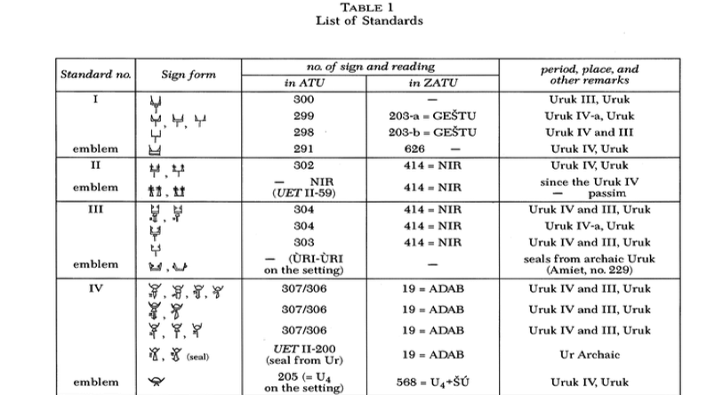
More particularly, the figure 302 in the table -1 appears only once for the category of "emblem II" and as Szarzynska suggests it can stand for a "prince" and "lofty" (Szarzynska 1996, 9). Interestingly enough, the possible vocal pronunciation of the emblem (NIR) consists of a horizontal line with two smaller lines attached at the two ends of the line, and the entire line standing on the poll (Szarzynska 1996, 9). This can be interpreted as a metaphorical connection of the symbol with words "high" and "hero" (Szarzynska 1996, 9-10). Those two meanings are representations of the idea for enlargement in political discourse because whoever is in possession of the title that "the symbol 302" represents is virtually distant from other people of lower ranks.
A sensible correlation can be drawn between "the notion of a standard and a symbol ascribed to it" - that was popularly practiced in ancient civilizations around 3000 BCE - and the horrific incident of beheading Wat Tyler that was mentioned earlier. The parallel between these two examples is that similar to the idea of self-distinctness and self-enlargement through using symbols representing something "big" or "high" in Sumerian and Akkadian texts; the beheading of Wat Tyler by Anglo-Norman rulers of England was also a metaphorical representation of a standard (poll) and a symbol (his head) attached to it.
Elements of the icon that represent an authority are also very important for identifying the rank of the person who is entitled to that icon. For example, the difference between Sumerian lu-gal and sub-lugal which represent the ruler and the soldier, respectively, is differentiated by an additional character (Anderson 2013, 6:21). That character is composed of two slightly bended lines attached to another line at each end. However, the significance of that extra character is that it is attached behind the symbol that represents the poll/standard. One interpretation of this idea is rooted in the principle of "L shaped" representation of power/authority that was popular in many ancient civilizations (Anderson 2013, 6:19-20). This model insists that the ruler stands for a 'vertical line' and repressed are the 'horizontal line' (Anderson 2013, 6:35). In the same manner, the extra character of sub-lugal can be interpreted as representing someone lower than the ruler who stands behind the power.
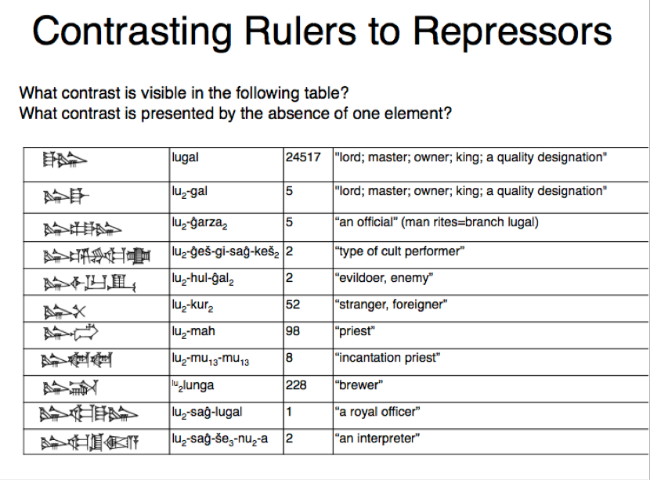
The political discourse of Arabs in pre-Middle ages was closely associated with the religious language and doctrines advocated by Islam (Gutas 2005, 102). The political importance of Quran was that it was written and interpreted exclusively in Arabic. The aignificance was to indicated that religious rules and dogmas of Quran applied solely to Arabic speakers (unless converted), who at that time (7th-8th centuries) were generally followers of the Prophet Muhammad (Gutas 2005, 104). In other words, the discourse of Quran stimulated social, religious, military and political authority in the Islamic world and did not approve any participation from non-Arabic speakers in administrative procedures (Gutas 2005, 105).
For instance, in the 8th century A.D. during the rule of Umayyad Dynasty the Arabic was declared the official language of the government replacing Greek language spoken in several provinces of Arabic Empire (Gutas 2005, 106). Arabic became the imperial language while the administration drew itself apart from Persian speaking society (Gutas 2005, 106-107). Consequently, the main purpose of those transformations was not to impose Arabization or Islamization over subjects of newly conquered lands, but to maintain a strong and legitimate rule by making Arabic discourse distinctive from other languages.
When Abbasid Caliphate emerged as the dominating house of Arabian Empire, the change in power was achieved through the change of discourse (Gutas 2005, 107). Abbasid rulers conducted massive translations of various political and social scripts. They proclaimed themselves as righteous heirs of all empires that preceded in Mesopotamia and Near East" (Gutas 2005, 108). This notion of distancing of their identity and appearing "bigger" or "older" helped them to establish legitimate dictatorial government (Anderson 2013, 6:35).
The local vernacular in medieval Russia, the Old Church Slavonic, was comprehensible by common populations living in Eastern, Southern and Western regions of the country (Unbegaun 1973, XIX). Similar to Latin, the Old Church Slavonic became the language of the Church because regular people have spoken it for several generations (Unbegaun 1973, XIX). However, unlike Latin, the Old Church Slavonic never succeeded in becoming the political and administrative language of Russia (Unbegaun 1973, XXI). The reason was that the administrative sphere was functioning through the use of non-literary discourse (Unbegaun 1973, XXIII). The Church Slavonic, on the other hand "moved away from both non-literary administrative and spoken idiom" creating a distinctive self-identity for those who exercised it (Unbegaun 1973, XXI). The Church Slavonic spoken in Southern and Eastern Russia was different and created discursive gap between populations of those two regions (Unbegaun 1973, XXII).
The political discourse in medieval Russia was expressed through importation of ancient archaisms as sources of their titles (Anderson 2013, 6:44). For example, the ruler of a city in Russia was referred to as kniaz, which derived from Proto-Germanic title of similar meaning kuningaz (Anderson 2013, 6:44). By 1547 this title was replaced by another title of archaic meaning, Tsar, which gave the bearer greater and more powerful identity because it originated from ancient Roman name Caesar (Anderson 2013, 6:44-45). There is nothing 'vertical' in the word Tsar, but it is distant (larger or bigger) in a same way that the vertical is different from horizontal. In order to impress its readers, Russian newspaper Pravda used components of “Church Slavonic to describe the landing of Soviet astronauts” (Unbegaun 1973, XXIV).
For thousands of years Chinese rulers had successfully preserved authority on their subjects even though “Chinese as a language implies nothing about dictatorship or democracy” (Anderson 2013, 7:37). Part of their success was that the government used a discourse that people were not familiar with. Similar to ancient Sumerians, Chinese rulers also applied titles that transformed their identity and embodied them "bigger" in character (Anderson 2013, 7:14). In order to better understand this distinction it will be important to examine the "Table 1 - Ranks of Principality" borrowed from Gassmann's article. In this table Dáfú (counselor), Qínq (minister) and Jún (prince) are all depicted as people possessing authority (Gassmann 2000, 350). In order to find the notion of enlargement in this resemblance of Dáfú (big-man) standing higher than others it will be helpful to compare this concept to the Sumerian symbol of Lu-Gal (big/tall man). Similar to the ancient Sumerian symbols, ancient Chinese characters not only represented part of the word but stood for an entire character.
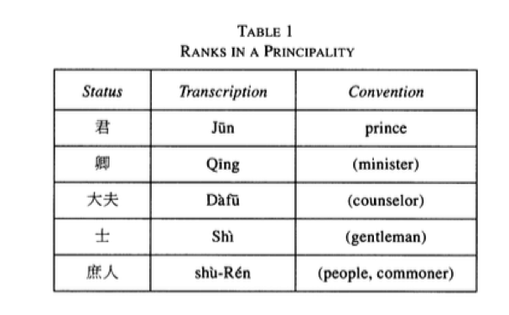
Another evidence of vertical-horizontal distinction between social classes in ancient Chinese society can be found in the earlier Chinese characters symbolizing the ruler. The character wang was composed of 4 lines, 3 horizontal ones standing for humanity, the earth and the sky from bottom to top, respectively, and a vertical line depicting the ruler who represented a bond between those three hierarchies of life (Anderson 2013, 7:9). Other representations of enlargement were the characters of Zhong and Huang-di. "Zhong" was illustrated as a banner on a standard similar to the Sumerian symbol for a ruler, whereas, "Huang-di" was an archaism recreating the character of ancient Chinese authorities (Anderson 2013, 7:13, 16). It was an indication of spatial cues because the archaism represented a distant time. So the principles of enlargement and elevation of rulers' identities ensured persistence of authority (Anderson 2013, 7:17).
One event that demonstrated a change of distancing cues in dictatorship occurred in Soviet Romania during Ceausescu's final address on 21 December 1989 (Rogoveanu 2013, 13) During his annual address to the people, former President of Romania Nicolae Ceausescu constantly referred to gatherers as "comrades" (Rogoveanu 2013, 13). In order to encourage people to unite and mobilize them to support his position he used expressions such as; 'We must act in the spirit...', 'our firmness and the unity of our people...', 'we must act firmly to achieve..' and 'we shall do everything to defend the integrity and sovereignty of Romania...' (Rogoveanu 2013, 14-15). He attempted to engage the crowd to compromise and feel part of positive reforms that according to Ceausescu awaited Romania. He also tried to convince them that uprising in Timisoara that happened days earlier wou ld not have a negative impact on the population (Rogoveanu 2013, 18). However, the main point at stake in this incident was that most of the participants of the meeting were forced to participate by the authorities “by being threatened to be fired” (Rogoveanu 2013, 22).
However, the crowd unexpectedly began to boycott and went out of control (Rogoveanu 2013, 20). Typically, during peaceful political speeches the crowed behaves in a coherent manner and stays organized (Rogoveanu 2013, 22). One of the plausible explanations for why Ceausescu's propaganda speech went out of control is that he was misinformed about his popularity among the crowd. Another interpretation is that Ceausescu's strategy failed to reduce the growing tension generated by difficult political situation in Europe. Nevertheless, it will be more accurate to say that his strategy backfired. People were not used to the type of political discourse exercised by Ceausescu; therefore they became suspicious and fearful which was natural because for generations they lived under a communist regime and repression. In other words, the unexpected reduction of discursive cues from the political discourse of President Ceausescu created a sense of panic because the population was not used to being identified as comrades and friends of the government.
In medieval Japan, the problem with political discourse was that written form and spoken forms of the Japanese language were considerably different (Twine 1978, 333). As the gap expanded between written and spoken forms of discourse in Japan (as a result of implementation of Chinese and Korean styles of vernaculars); the written form gained popularity among Japanese intellectuals (Twine 1978, 333-334). The government officials considered the written form to be a prestigious style, thus kept it separate from the ordinary oral Japanese (Twine 1978, 345). Before the Meiji Restoration similar to the case in England the Japanese farmers were also restricted from inter-state travel. The restriction was the reason behind the emergence of satobigoto or "village speech”(Anderson 3013, 8:13). During the Tokugawa period the emphasis was still on Chinese style of writing in order to maintain the spatial distinctiveness between educated and uneducated sectors of the society (Twine 1978, 339-340).
It was only with the late stage of Meiji restoration (19th century) that changes in spoken and written discourses occurred in Japan. The main objective of Meiji Restoration, which also instigated the Genbunitchi Movement, was to combine the reading and writing through eliminating the use of old kana with incorporation of a new kana (Twine 1978, 335-36). Most important transformation that occurred during Genbunitchi period was the overthrow of shogun (ruler-warriors or samurais) (Twine 1978, 337). The reason is that the overthrow of shogun authority in Japan was important because the written language became more simplified and comprehensible by larger masses of the population since there were lesser distinctions between the written and spoken forms of Japanese (Twine, 337-38). The abolishment of restrictions on inter-travel allowed the freedom of communication between ordinary people (Twine 1978, 338). Another crucial innovation that helped to narrow discursive gaps was the widespread use of newspapers that replaced public announcements of news which was a popular method of sharing public information before 1870s (Twine 1978, 339-40). The discourse of Japanese government became closer to the dialect of ordinary people because newspapers were helpful for political parties to gain support among population and connect with voter more promptly (Twine 1978, 341). However, there was still a tension between practitioners of kogobun - the newspaper language, and army officials speaking futsubun (Twine 1978, 354-55).
For most of its history the Latin American politics has been dominated by bureaucratic authoritarianism or repressive dictatorships. As a result of hard-reachable terrains of South American landscape, the language has also developed differently in each settlements establish by Spaniards or Portuguese Crowns (Morse 1955, 523). For instance, the European origin Peninsulares spoke popularismo or Castellano, whereas, Mestizos, Negros and Creoles spoke mostly vulgarismo, or Spanish that has been developed in Latin America (Anderson 2013, 8:28). When there was a tumultuous political situation in Spain during 18th and 19th centuries wealthy Creoles organized an uprising against the Spanish crown (Morse 1955, 529). One interesting fact about the revolt was that Mestizos and Negros, who spoke different Indo-Spanish dialects, supported Creoles who in their turn promised them voting rights (Morse 1955, 528). However, the Creole discourse remained authoritative because they adapted archaic "terminologies of - Picardy, Anjou, Poitou, Ile-de-France and Normandy - from 16th and 17th centuries" (Morse 1955, 536).
The problem in both Japan and Latin America was that the language that voters used was not the language of government. The Japanese changed the written rules because the old regulations in old dialects were not representative of new discursive distancing (Anderson 2013, 8:33). In Latin America a similar reason made Creoles to intermarry with Mestizos as a result of lack of immigration from Europe (Anderson 2013, 8:26). There were many conflicts between identities in both Japan and Latin America. Those conflicts derived from the fact that failed political promises and ineligibility of women to vote in most of Latin America generated military coups (Anderson 2013, 8:30). Similarly, the conflicts of identities between speakers of kogobun and futsubun produced military coup in Japan (Anderson 2013, 8:33).
Failed Democracies
Several instances of failed democracies occurred in Germany and Kenya. In post-war era, Germany had democratic elections but the Parliament did not have any significant control over the government. As Childers highlights, each political party exercised a special discourse which became the primary reason for the failure of liberal democratic ideologies and the emergence of Nazi occupation in Germany (Childers 1990, 332). The distinctiveness of identities between people who belonged to Stand, and those who were not members of that social group created a discursive gap (Childers 1990, 333-34). The reason was that the spoken discourse belonging to Mittlestand people was elevating in relation to languages spoken by lower-class-farmers Bauern (Childers 1990, 335,337). Distinction of political discourse between the government and population also created civil conflicts in Kenya (Mohochi 2003, 87). The local dialects in Kenya were considered low rank, thus, in order to make themselves different and more influential, politicians communicated with their voters in English (Mohochi 2003, 88). The continuous use of English by the media generated a sense of social exclusion among the members of Kenyan society (Mohochi 2003, 90-91). Ineffective democratic approaches resulted in the inability of general population to identify itself with discourse of the government regardless of the fact that there were democratic elections (Mohochi 2003, 92). The voters were not able to identify themselves with the discourse of political parties in both Germany and Kenya.
The Ordinary Discourse of post-1915 Era
When the gap between ordinary and distancing discourses narrows the democracy overcomes dictatorial principles prevailing in the society. In the early1990s that sort of distancing in Russia was replaced by the newly structured and expressive political discourse that drew politics closer to the constituencies who began share common identities with political candidates (Anderson 2013). In order to better understand this claim it will be necessary to examine the Table-1 borrowed from the article by Richard D. Anderson, Jr. The Table-1 illustrates that there were two main changes in political discourse of Russia that instigated the emergence of democratic principles (Anderson 2013). Part of the first change began in 1989 when the regularity of spatial-elongation metaphors and the length of clauses in political discourse have decreased (Anderson 2013, 129). 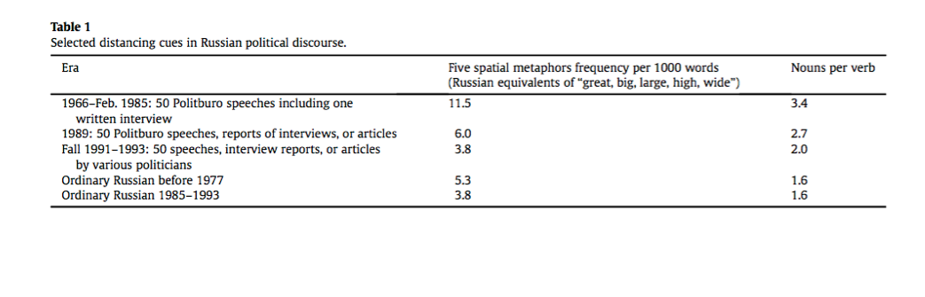
The second part of that change continued between the Fall of 1991 and December 1993. The bearers of old-communist identities were exposed to a new type of discourse that expressed less discursive distancing and was more definitive in a sense that it incorporated closeness of ordinary cues (Anderson 2013, 129). The second important change was that Mikhail Gorbachev successfully founded himself at the center of leftist (old-communist) party and the rightist (popular-nationalist) party (Anderson 2013, 134). The crucial point of that change was that Gorbachev's centering was a transformation of spatial metaphor, a notion that did not exist during Soviet Union (Anderson 2013, 132-34) This principle paved the way for emergence of democracy in post-Soviet Union Russia since every member of the society was able to vote regardless of the fact that many claimed elections to be corrupt and unfair (Anderson 2013, 134). Most importantly, the political discourse during Boris Yeltsin's presidency, which succeeded Gorbachev’s leadership in Russia, became more ordinary because it offered a possibility of choice by merging together the identities of politics and voters (Anderson 2013, 130).

Similarly, the pattern to democratization in Norway and Taiwan involved a similar course of political and linguistic transitions. Comparable to Russia's case described above, Norway and Taiwan have also experienced emergence of democratic principles which were generated bye the reduction of discursive cues that represented elongation, elevation and enlargement between their political and ordinary discourses. In Norway, the unification of two different forms of discourse, all-Norwegian (1864-73) and revised-Danish (1856-81) initiated by Ivar Aasen and Knut Knudsen, respectively, allowed composition of a popular-national language called Riksmål (Haugen 1959, 10). The next significant step was instigated by the Storting (Parliament) that ordered the Ministry to compose a permanent Language Board - Spraknemnd (Haugen 1959, 12). The Spraknemnd created conditions that extended the use of Bokmål (bok-book, mål-language, 1929) and Nynorsk (Norwegian Language) - two parliamentary sponsored discourses - to the academic sphere uniting them under the main language of education (Haugen 1959, 13). When looking at "Four Passages of Norwegian Language" it becomes evident that regardless of the transformation of dialects in those passages, there were very few grammatical differences between Bokmål and Nynorsk (Haugen 1959, 16, 17). This suggests that prospects for democracy emerge when there is a one-national-language with minimal discursive distancing between the discourses of the government and its subjects, the ordinary population.

The fusion of local dialects in Taiwan produced the same outcome as Bokmål and Nynorsk in Norway. The Table-1 in Todd L. Sandel's article presents the point that the aboriginal dialects Tai-gi and Hakka in Taiwan were not interrupted by other dialects since the late Ming Dynasty of 1368 until today; whereas, the national language has been consecutively succeeded by Dutch (1624-61), Mandarin-Chinese (1661-1895), Japanese (1895-1945) and Mandarin in 1945 (Sandel 2003, 527). As the Table-1 borrowed from Sandel’s article reveals, the Mandarin language became blended with aboriginal dialects in 1949.

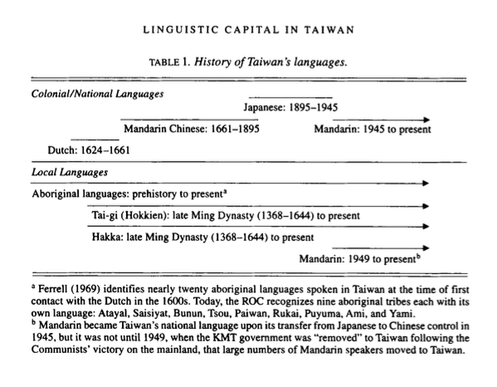

The two crucial changes that influenced the further unification and development of the national language in Taiwan were the sanctioning of DPP in 1986 (oppositional Democratic Progressive Party) and abolishment of punishments on students who spoke local dialects fangyan in 1987" (Sandel 2003, 530). Comparable to the notion of having a choice, as well as, the disappearance of distancing cues in political discourse of post Soviet Union Russia, a similar principle emerged in Taiwan as the voters had a choice between different political parties in elections. In other words, the ordinary national language unified voters and political parties into shared common identities.

Conclusion
Based on assessments regarding the formation and development of the political discourse found in different societies, it is logical to suggest that the evidence covered in this paper may not be enough to prove the hypotheses to be absolutely accurate for all occasions. However, all evidences discussed are sufficient enough to conclude that the pattern of dictatorship and democracy is profoundly affected by the orientation of political discourse. In other words, relying on the instances of alteration in political discourse analyzed in this paper; when the discourse includes notions of - elevation, elongation and enlargement - the dictatorship prevails in the society as the gap between identities widens. Conversely, when the government encourages a unification of several dialects or decreases discursive cues between bearers of social and political identities, principles of democracy will emerge. Reasonably, “the prestige languages” as some people refer to the discourse of minorities in higher ranks, do not die or reemerge, but simply get replaced. As a closing remark, the changes in any society greatly reflect the modification of political discourse. Although not covered in this paper, a more careful examination of those changes will be necessary to harvest specific elements of transitions and their possible outcomes. This will also help to grasp the essence and purpose of metaphors and cues rooted in the political discourse of various societies that existed during different civilizations.

Bibliography

Anderson, Richard D., Jr. 2013. "Discourse and Strategic Continuity from Gorbachev Through Putin." Communist and Post-Communist Studies 46, no. 1 (March).
Anderson, Richard D., Jr. 2013. Lectures for PS 163.
< https://moodle2.sscnet.ucla.edu/course/view/13F-POLSCI163-1 >
Childers, Thomas. 1990. "The Social Language of Politics in Germany: The Sociology of Political Discourse in the Weimar Republic." The American Historical Review 95, no. 2 (April).
Fisher, John H.1987. "European Chancelleries and the Rise of Standard Written Languages.”
Proceedings of the Illinois Medieval Association 3.
Fisher, Henry H., 1992. "A Language Policy For Lancastrian England" PMLA 107, 5 (October).
Gassmann, Robert H. 2000. "Understanding Ancient Chinese Society: Approaches to Rén and Min." Journal of The American Oriental Study 120, no. 3 (July-September).
Gutas, Dimitri. 2005. "Language and Imperial Ideology in Late Antiquity and Early Islam." In Bloomer W. Martin eds., The Contest of Language: Before and Beyond Nationalism (Notre Dame, Ind.: University of Notre Dame Press).
Haugen, Einar. 1959. "Planning for a Standard Language in Modern Norway." Anthropological Linguistics 1, no. 3 (March).
Kahane, Henry and Rene Kahane. 1979. "Decline and Survival of Western Prestige Languages." Language 55, no.1 (Urbana-Champaign: IL, LSA).
Lloyd, Paul M. 1989. "Where Spanish Came From: The Birth of Castile." Proceedings of American Philosophical Study 133, no. 3 (September).
Morse, Richard M. 1955. "Language as a Key to Latin American Historiography." The Americas 11, no. 4 (April).
Mohochi, E.S., 2003. "The Language Choice for Development: The case for Swahili in Kenya." Journal for African Cultural Studies 16, no. 1(June).
Rogoveanu, Raluca. 2013. "Lecture for PS 163." (Guest Lecturer, Fulbright Visiting Scholar).
Sandel, Todd L,. 2003. "Linguistic Capital in Taiwan: The KMT's Mandarin Language Policy and Its Perceived Impact on Language Practices of Bilingual Mandarin and Tai-gi Speakers." Language in Society 32, no. 4 (September).
Szarzynska, Krystyna. 1996. "Archaic Sumerian Standards." Journal of Cuneiform Studies 48.
Twine, Nanette. 1978. "The Genbunitchi Movement. Its Origin, Development, and Conclusion." Monumenta Nipponica 33, no. 3 (Autumn).
Unbegaun, B.O. 1973. "The Russian Literary Language: A Comparative View." The Modern Language Review 68, no. 4 (October).

The following are the notes from Professor Anderson’s lecture series that explain the concept of culta latiniparla. “Verbs were moved from the second element in the sentence to the end, in supposed imitation of classical Latin (which however had not been necessarily verb-final). Words could be used only in metaphors, prompting an Italian to comment: “For no Spaniard… could anything be simply black or white; it must be at least blacker than tar or whiter than snow.” Such metaphors elongated expressions. Change of discursive cues evokes a new political identity, paralleling transformations of discourse by Alfonso VI and Alfonso X.”
These characters alternated with the word gal, meaning “big,” which appeared in numerous terms relevant to rule. Lu-gal – “man big” meaning ‘ruler”. The sign GAL for “big” may itself have begun as a picture of a standard (Szarzynska 2-5) abstracted to a new meaning.
Huangdi was both elevating and elongating. Huang and di were archaisms alluding to the earliest Chinese rulers (long in time). Huangdi exercised a monopoly of all power. He chose to bear the label that a predecessor had used to assert his monopoly of power.
Notes from Rogoveanu Lecture series: The interaction between Ceausescu and the crowd was a game of power, a play upon reversing domination relation. The first stage was a relation top-down during which Ceausescu is imposing his discourse. The crowd is subdued; state of acceptance on the part of the crowd; they play their part as expected. The second stage was a bottom-up relation. The crowd becomes boisterous, star hissing and vociferating; people begin jeering, booing, hissing. Finally, the third stage was concession-making. In an attempt to calm the rioting Ceausescu proposes a set of populist measures which aim to decrease the discursive gap between him and the crowd; however, his objective fails as the crowd no longer shows cooperation..
“In 1868 the Tokugawa shôgun ("great general"), who ruled Japan in the feudal period, lost his power and the emperor was restored to the supreme position. The emperor took the name Meiji ("enlightened rule") as his reign name; this event was known as the Meiji Restoration.” See the source here: <http://afe.easia.columbia.edu/special/japan_1750_meiji.htm>
“The Genbunitchi movement, which lasted from the early nineteenth century until 1946 when the draft of the new constitution was published in colloquial style, was a long drawn-out battle to replace the difficult literary styles used in the tokugawa period with a simple style which approximated the spoken language” (Twine, 1987).
For the differences and definitions between Old and New Kana see “Ancient Scripts” available here: http://www.ancientscripts.com/japanese.html
Formal/proper dialect.
Vulgar/improper dialect
The following are the notes from Professor Anderson’s lecture series. “Repressors motivated by contrasting identities engage in conflicts that undermine dictatorship by changing discourse. Conflict between ranked identities under dictatorship generates discursive change.”
The following are the notes from Professor Anderson’s lecture series. “Germany 1918-1932 allows all adults to vote in elections for a parliament called the Reichstag. An elected President appoints leader of party with most seats as Kazler heading a government that a majority of the Reichstag can remove. Childers argues that each party in the republic practiced the discourse of Berufstand, “occupational estate”. Beruf menaing “calling”, “vocation”, or “profession”, and Stand meaning “estate,” a right to representation as a group. Stand is a metaphor of elevation. It has the same source as English “stand,” Latin status, German stehen “to stand”, old Russian star’st meaning “elder”.

