The Emergence of the Regime Complex for Conserving Migratory Shorebirds in the Western Hemisphere

Eduardo Gallo-Cajiao* (School of Marine and Environmental Affairs, University of Washington), Nives Dolšak (School of Marine and Environmental Affairs, University of Washington), Isadora Angarita-Martinez (Manomet), Taej Mundkur (Wetlands International), Spike Millington (International Crane Foundation), Nick Davidson (Charles Sturt University), and Brad Andres (U.S. Fish and Wildlife Service, retired)

*egallo@uw.edu

Abstract

Solving issues that require international cooperation have become increasingly addressed through sets of multiple institutional arrangements, understood conceptually as a regime complex. Within this context, a central research question is what explains their emergence including temporal, spatial, and political patterns. The governance for conserving migratory species provides a fertile ground to address these questions, as these animals move across multiple political jurisdictions. Here, we present a case study on the emergence of a regime complex for the conservation of migratory shorebirds in the Western Hemisphere. These species, many of which have declining populations, complete their annual cycle by breeding at high latitudes in the Northern Hemisphere and migrating south to lower latitudes, and even to high latitudes in the Southern Hemisphere. We conducted 83 semi-structured interviews and conducted participant observation at 27 events with a focus on identifying all institutional arrangements for migratory shorebird conservation and understanding how they emerged over time. We found a regime complex for the conservation of migratory shorebirds in the Western Hemisphere, which includes at least 30 parallel, nested, and overlapping institutional arrangements that address the main threats to shorebirds. The regime complex started emerging in the early 1900s, and its rate of institution building peaked in the 1990s. Spatially and politically, the regime complex originated in North America, from where it expanded hemispherically overlapping with global institutional arrangements. Since the mid-2000s, homegrown institutional arrangements have emerged in South America, which are restricted to this region and are generally non-state centric. The regime complex emerged initially as state-centric, with participation of non-state actors beginning in the mid-1980s and intensifying since the 2000s. Of all institutional arrangements, a small proportion (13%) are specifically and exclusively focused on migratory shorebirds, whereas nearly half (46%) are concerned with issues beyond migratory birds. Our preliminary analysis suggests that institutional proliferation has been enabled by policy diffusion, issue linkage, and pre-existing institutional arrangements, while driven by biogeography of migratory shorebirds, governance deficits of existing institutional arrangements, as well as heterogenous solution preferences and interests among actors.

Introduction

Biodiversity, as an issue area within global governance has remained for most black-boxed within the Political Science literature. With the exception of forest and fisheries governance, other dimensions and components of biodiversity have received relatively little consideration. An important component of biodiversity warranting attention by global governance scholarship is migratory species. These animals do not constitute a single group, but rather a myriad of species with various phylogenetic affiliations, as migration has evolved multiple times. Consequently, migration is a trait of the life history strategy of animals ranging from invertebrates (e.g., lobsters, dragonflies, butterflies) to vertebrates (e.g., tuna, salmon, sea turtles, albatross, caribou). Noteworthy, many migratory animals are very important to humans through consumptive (e.g., subsistence hunting) and non-consumptive uses (e.g., ecotourism). Despite their importance, migratory species have been declining around the world, some even to extinction due to overexploitation (e.g., hunting) and externalities (e.g., habitat loss). In response to such declines, governance responses have emerged, which generally straddle international borders due to the long-range movements undertaken by some of such species (Shuter et al. 2011).

Within this context, even though efforts for conserving migratory species have resulted in multiple institutional arrangements, little research has been conducted to understand the corresponding governance systems (e.g., Gallo-Cajiao et al. 2019). As conserving migratory species requires governance approaches that account for their entire life cycle, the conservation of some migratory species is frequently underpinned not by a single institutional arrangement but instead by sets of them. This is particularly the case for migratory species with long-range movements, which can straddle multiple countries. Hence, governing their conservation through a single institutional arrangement may not be likely as having multiple countries with oftentimes disparate capacities, interests, and power, makes reaching agreement particularly challenging. Generally speaking, such systems of international institutional arrangements active in a particular issue area have been conceptualized as a ‘regime complex’ (Raustiala and Victor 2004), and while they have been the subject of intensive research in other issue areas of environmental problems, such as climate change and forest, there has been little scholarship focused on migratory species conservation (Gomez-Mera et al. 2020). Addressing this knowledge gap is not only important to potentially help advance governance practice, but also to contribute more generally to the global governance literature as this is a fertile ground given by intense governance activity involving multiple countries.

With this backdrop, here we explore the question of how regime complexes emerge and evolve through the empirical lens of migratory species conservation. We do so specifically by focusing on the conservation of migratory shorebirds in the Americas, also referred to as the Western Hemisphere. Hence, our overall research question is as follows: what explains the emergence and evolution of the regime complex for conserving migratory shorebirds in the Western Hemisphere? We specifically ask what explains: (i) the institutional multiplicity, (ii) the institutional diversity, and (iii) the change-stasis dynamics?

Theoretical background

The solution to many collective action problems requiring actors straddling beyond single countries is no longer the domain of single institutional arrangements but rather sets of them. The suite of institutional arrangements, which are partially overlapping and non-hierarchical, involving actors in more than one country and active in a particular issue area has been conceptualized as a ‘regime complex’ (Raustiala and Victor 2004). The overlapping nature of those arrangements can be given by membership, spatial coverage, or mandate specificity. This observation was initially theorized in relation to plan genetic resources governance and has since been applied to the understanding of institutional multiplicity in the international system in relation to the governance of a wide array of issues, from environmental, to security, intellectual property, and trade, to name but a few (Gomez-Mera et al. 2020). The ontology of such ‘regime complexes’ has been debated as being primarily analytical, while others have considered them to be empirically grounded given by the mandate and prescriptions of institutional arrangements active in a particular issue area. Furthermore, the bounds of the constitutive elements of any given ‘regime complex’ remains debated too. For some, a ‘regime complex’ is formed by intergovernmental institutional arrangements, while for others it can take on a broader understanding of institutional arrangements to include those that involve actors beyond the nation-state (Keohane and Victor 2011, Gomez-Mera 2021, Alter and Raustiala 2018). For the purpose of our study, we consider a ‘regime complex’ as empirical phenomena and encompassing institutional arrangements beyond those involving strictly the nation-state.

A central question on ‘regime complexes’ is what explains their origin and evolution, which is the central question of this study. Even though ‘regime complex’ theory is considered to be incipient and far from unified, it is generally accepted that ‘regime complexes’ are the result of problem diversity within the issue area at hand, increased institutional density across overlapping issue areas, cost-benefit uncertainty for relevant actors, incomplete problem definition, and dissimilar interests and preferences among actors, which can include power asymmetries (Keohane and Victor 2011, Gomez-Mera 2021, Alter and Raustiala 2018). Within this context, the temporal dimension of how ‘regime complexes’ evolve is also an active area of research, which focuses on whether they emerge incrementally or given by punctuated equilibrium (Colgan et al. 2012). Central to understanding the evolution of ‘regime complexes’ is institutional layering, which can be given by heterogeneous preferences or high transaction costs for problem-solving through existing institutional arrangements.

Case study

Many shorebird species complete their life cycle across the Americas. Shorebirds are a group of birds that includes all families with non-web-footed species within the order Charadriiformes (van de Kam 2004, Hayman et al. 1986). In the Americas, they primarily breed in the Arctic and boreal regions across Canada and the US, including Alaska, migrating through Central America and the Caribbean, where they stop to rest and refuel at coastal habitats known as stopping sites. Non-breeding areas encompass mainly coastal and inland wetlands, as well as grasslands, across South America. This entire region, known as the Americas Flyway (Figure 1), spans 40 range states through which 56 species migrate (Figure 2), which could be regarded as a complex social-ecological system (Berkes et al. 2003). This flyway in the Americas is one of the four recognized global waterbird migratory flyways, the others being: Africa-West Eurasia Flyway, Central-Asian Flyway, and the East Asian-Australasian Flyway (CMS 2014).

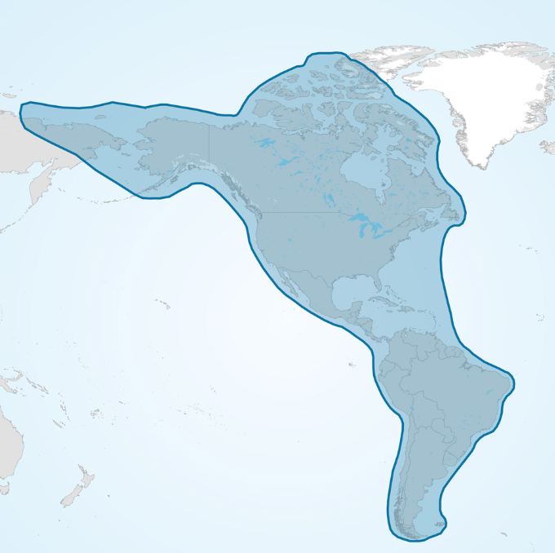
Figure 1. Map of the Americas Flyway through which 56 species of migratory shorebirds complete their life cycle.

Migratory shorebirds have been declining in the Americas Flyway as a result of various human activities despite the existence of institutional arrangements for their conservation. Population declines of migratory shorebirds in this flyway have been pervasive, particularly along the Atlantic coast and the midcontinent region. These declines have included in at least one species, the Eskimo curlew, now likely extinct. Threats to these species have included habitat loss, overexploitation of key resources on migration, and overhunting. Importantly, the occurrence and severity of each of those threats have varied spatially across the region, as well as present various uncertainty levels. Alongside these population declines, an international governance system for their conservation has emerged. However, no research to date has focused on how such a system has emerged and evolved over time.

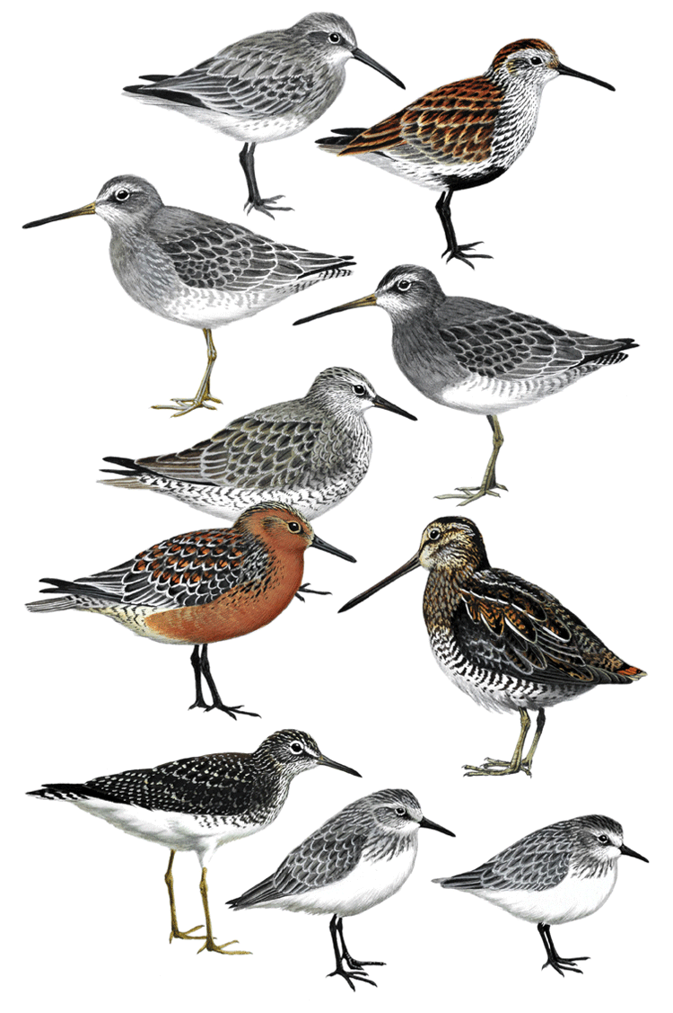
Figure 2. Sample of species of migratory shorebirds that occur in the Americas Flyway.

Research method

Data collection

We used a single case study design to answer our research questions using a mixed-methods approach. We conducted 83 semi-structured interviews and conducted participant observation at 27 events with a focus on identifying all institutional arrangements for migratory shorebird conservation and understanding how they emerged over time. This study has been conducted under ethics approval issued by the University of Washington (STUDY00013131).

Data analysis

We developed an analytical framework based on the study by Colgan et al. (2012) on the emergence and evolution of the energy regime complex (Figure 3). Our model follows a demand-supply logic, whereby institutional arrangements are developed in response to a demand. In this case, the demand is driven by any of the following proxies: population declines (either perceived or observed), identified threats, listing of species as threatened, and novel ecological knowledge. Such a demand can come from various types of actors. In turn, stasis or change in the regime complex is given by the satisfaction or dissatisfaction of actors with the existing institutional arrangements to address conservation concerns for migratory shorebirds. The final outcome of change in the regime complex is mediated by the agenda setting process, what type of actor supplies the governance, and the degree of agreement on the solution preferences among interested actors. The codebook used for the analysis of our interviews was derived from this analytical framework.

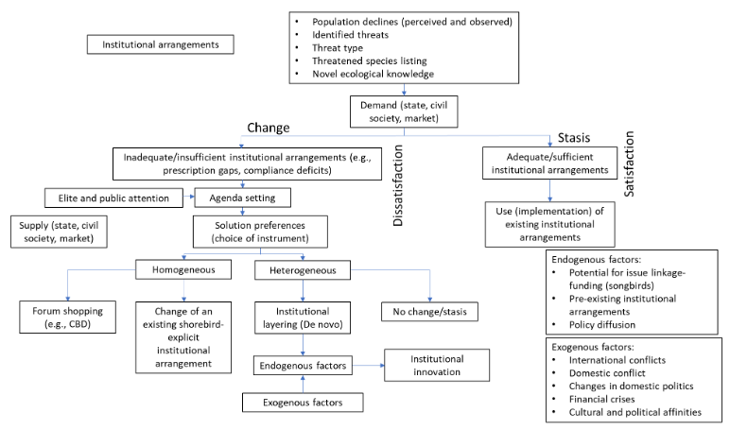
Figure 3. Analytical framework developed for our study on the emergence of the regime complex of migratory shorebird conservation in the Americas Flyway.

Results

While we have now completed the data collection process of this study, analysis is still ongoing. Hence, some of the results presented in this section are preliminary and subject to calibration and even reinterpretation. We found a regime complex for the conservation of migratory shorebirds in the Americas, which includes at least 30 parallel, nested, and overlapping institutional arrangements that address the main threats to shorebirds (Appendix). Temporally, the regime complex started emerging in the early 1900s, and its rate of institution building peaked in the 1990s with some periods of inactivity in the 1920s and the 1960s (Figure 4). Institutional arrangements have entered the regime complex via three possible pathways: (i) di novo institutional arrangements negotiated regionally with migratory shorebird conservation as part of their mandate, (ii) institutional arrangements that do not include migratory shorebird conservation within their original mandate but have become relevant through forum shopping, and (iii) global institutional arrangements that include migratory shorebird conservation as part of their mandate and overlap with the region.

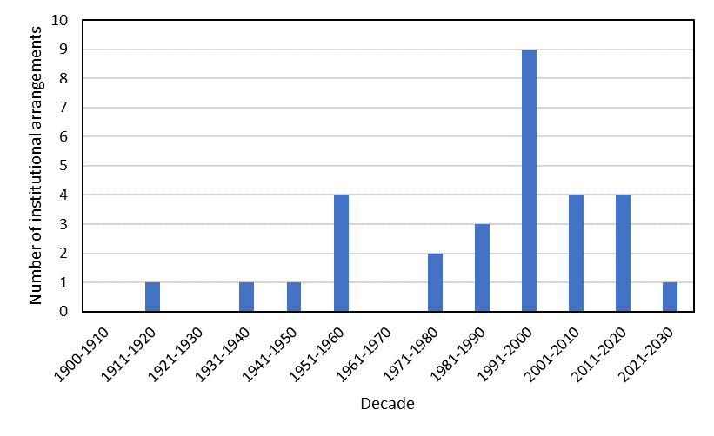
Figure 4. Temporal emergence of institutional arrangements of the regime complex for migratory shorebird conservation in the Americas Flyway.

The membership to institutional arrangements of the regime complex is mainly restricted to state actors (e.g., Ramsar Convention), with some having multi-actor membership (e.g., Western Hemisphere Shorebird Reserve Network) and a few being restricted to non-state actors (e.g., initiative for the conservation of coastal wetlands in the arid coast of South America) (Figure 5). While the regime complex includes many institutional arrangements whose membership is restricted to state actors, it was notable how the US government has developed multiple institutional arrangements (e.g., US Forest Service-led Copper River Migratory Bird Conservation Initiative) to engage with Latin American countries through NGOs, instead of through intergovernmental processes. The total number of actors that are members to, or part of, these institutional arrangements are subject to ongoing analysis, as we are still determining the membership of some of the institutional arrangements for which this information is not readily available. The spatial scope of institutional arrangements within the regime complex is dominated by those restricted to North America, followed by South America, the entire hemisphere, and global in nature but with overlap in the Americas. There were fewer institutional arrangements restricted to the circumpolar region, the Caribbean, and with South-North linkages. Importantly, there was not a single institutional arrangement restricted to Central America (Figure 6). The regime complex emerged initially as state-centric, with participation of non-state actors beginning in the mid-1980s and intensifying since the 2000s (Figure 7). Of all institutional arrangements, a small proportion (13%) are specifically and exclusively focused on migratory shorebirds, whereas nearly half (46%) are concerned with issues beyond migratory birds.

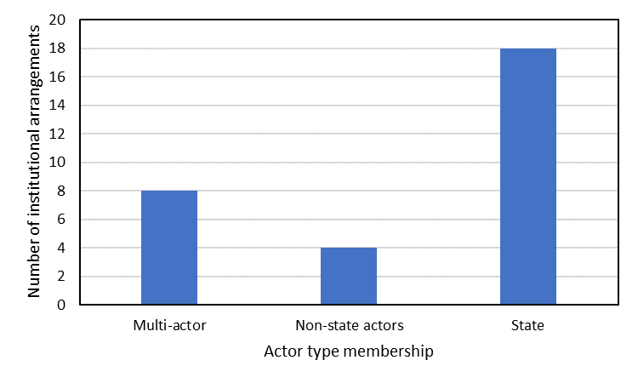
Figure 5. Number of institutional arrangements according to the type of actors accepted as members.

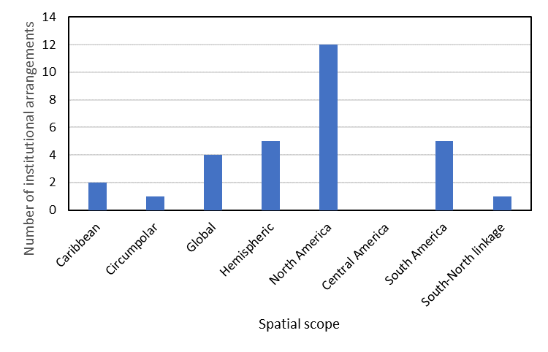
Figure 6. Number of institutional arrangements of the regime complex for migratory shorebird conservation in the Americas Flyway according to spatial scope.

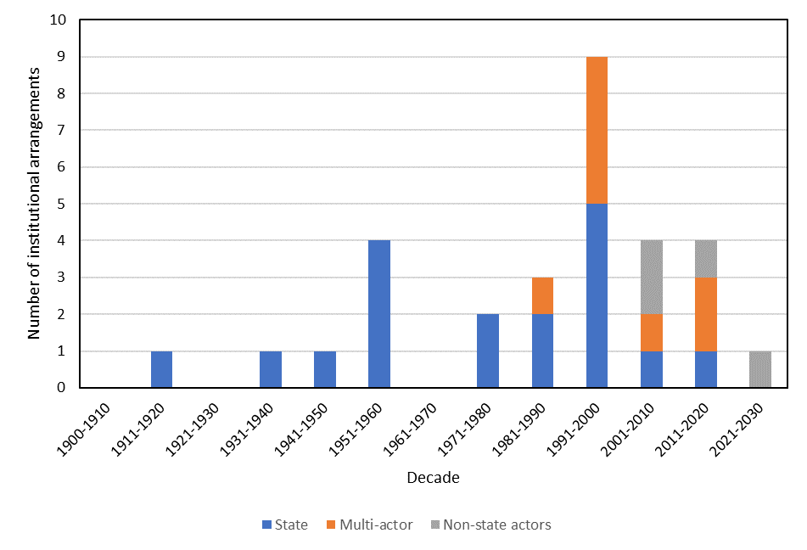
Figure 7. Temporal emergence of the institutional arrangements of the regime complex for migratory shorebird conservation according to the type of actors accepted as members.

Spatially and politically, the regime complex originated in North America, from where it expanded hemispherically overlapping with global institutional arrangements (Figure 8). The earliest institutional arrangements in the Americas Flyway include two to which the US is a member, namely the 1916 US-Canada Bilateral Bird Agreement and the 1936 US-Mexico Bilateral Migratory Bird Agreement. These two agreements were largely driven by an imperative to curtail hunting, which had already resulted in extinctions, such as the Passenger Pigeon. However, many migratory birds are not restricted to North America, which means that their conservation requires international cooperation beyond those three countries. Consequently, the Western Hemisphere Convention on Nature Protection and Wildlife Preservation was negotiated and signed in 1940, which included the conservation of migratory birds. Importantly, the principles to develop this institutional arrangement were underpinned by those used for the previous two bilateral agreements. This institutional arrangement has, however, remained of little importance to actually advance migratory shorebird conservation. Some observers attribute this issue to some proximal causes, such as the lack of a Secretariat and a Conference of the Parties, but the ultimate causes remain unknown. The 1980s saw the eventual development of what has remained the core institutional arrangement for migratory shorebird conservation at hemispheric level, the Western Hemisphere Shorebird Reserve Network (i.e., WHSRN). The spatial design of this institutional arrangement stemmed from these animals’ ecology, which was studied at a large spatial scale using aerial surveys and a network of researchers. This institutional arrangement was developed as a network of actors with direct jurisdiction over the ownership or management of sites that are important for the life cycle of migratory shorebirds in the Americas Flyways. Importantly, WHSRN is non-legally binding and deliberately by-passes the bureaucracies of national governments required for implementation of more formal intergovernmental institutional arrangements.

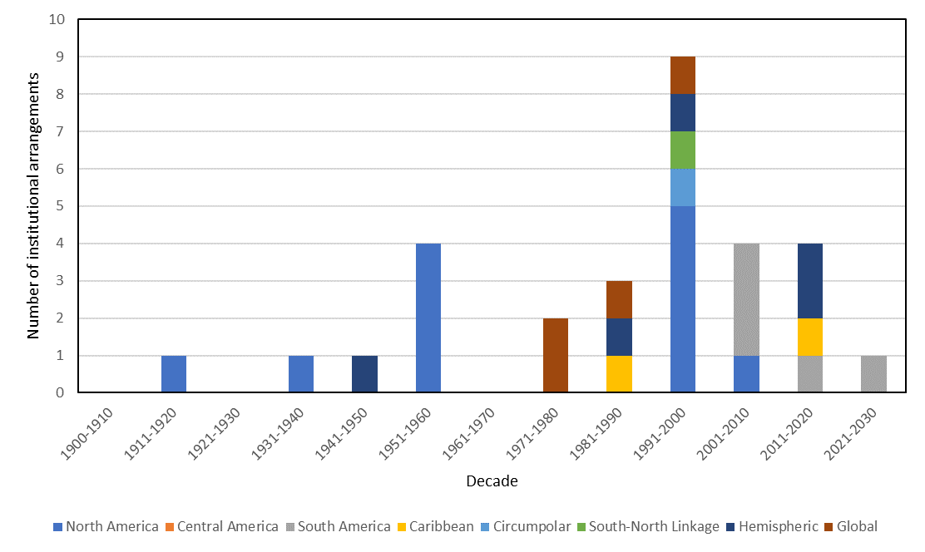
Figure 8. Temporal emergence of the institutional arrangements of the regime complex for migratory shorebird conservation according to spatial scope.

Despite the North American centrism and origin of the regime complex, homegrown institutional arrangements have emerged in South America since the 2000s. These include the ‘Alianza del Pastizal’, or Grassland Alliance, an institutional arrangement driven by bird conservation NGOs across the Pampas region of Uruguay, Paraguay, Argentina, and Brazil for conserving grassland habitats through market-based tools in working lands that are important for, inter alia, migratory shorebirds during their non-breeding season. This institutional arrangement was developed through brokerage led by an international NGO (i.e., BirdLife International) and emerged as a result of demand from South American NGOs concerned with grassland birds that are endemic to South America and use the Pampas region extensively, but that overlap with some species of migratory shorebirds coming from North America and are a concern for US (i.e., US Fish and Wildlife Service, US Forest Service) and Canada (i.e., Canadian Wildlife Service) government agencies. This overlap allowed for issue-linkage enabling resource mobilization from the Global North to the Global South for supporting the development and operations of such an institutional arrangement. Interestingly, the governance model used for the ‘Alianza del Pastizal’ was taken from the Bird Habitat Joint Ventures, a multi-actor model used to implement the North American Waterfowl Management Plan. Additionally, a state-centric institutional arrangement (i.e., the Grassland Birds Memorandum of Understanding), which overlaps spatially with the ‘Alianza del Pastizal’, was developed as a subsidiary agreement under the Convention on Migratory Species with the purpose of bringing national governments together to strengthen the conservation efforts spearheaded by the ‘Alianza del Pastizal’.

We posit that the regime complex has emerged as a result of deliberate institution building in response to concerns for the conservation of migratory shorebirds. That said, the final outcome of the regime complex in terms of institutional multiplicity and diversity has been likely the result of incremental problem definition, political coalitions given by interests beyond environmental concerns, divergence political preferences for problem solving through specific institutional arrangements, and insufficiency of institutional arrangements. In turn, the mechanisms that have allowed the actual development of new institutional arrangements or forum shopping have included policy diffusion, issue linkage, pre-existing institutional arrangements, and personal-level connections of regime entrepreneurs. We still require further analysis to be able to attempt explaining periods of institution building and stasis.

Conclusions

Our research shows that a regime complex for migratory shorebird conservation has emerged in the Americas. This finding underscores the value of migratory species conservation as an important research foci in global governance. Our results expand our understanding of migratory shorebird conservation governance, which has been previously studied in the Asia-Pacific region (i.e., East Asian-Australasian Flyway, Gallo-Cajiao et al. 2019). Our preliminary analysis suggests that institutional proliferation has been driven by demand from conservation actors motivated by an imperative to protect these declining birds. In turn, the process of institutional layering has been given by the need to meet emerging conservation demands for which previously exiting institutional arrangements were not well suited.

Acknowledgements

We are grateful to all the key participants who participated in the semi-structured interviews. Funding support for this research has been provided by the Cedar Tree Foundation and the Society for Conservation Biology through the David H. Smith Conservation Research Postdoctoral Fellowship.

References

Alter, K.J. and K. Raustiala. 2018. The rise of international regime complexity. Annu. Rev. Law Soc. Sci. 14: 329-349.

Berkes, F., Colding, J. & Folke, C. 2003. Navigating social-ecological systems: building resilience for complexity and change. Cambridge University Press: Cambridge.

CMS. 2014. A review of migratory bird flyways and priorities for management. CMS Technical Series No. 27. UNEP/CMS Secretariat: Bonn, Germany.

Colgan, J.D., Keohane, R.O. and T. Van de Graaf. 2012. Punctuated equilibrium in the energy regime complex. Rev. Int. Organ. 7: 117-143.

Gallo-Cajiao, E., Morrison, T.H., Fidelman, P., Kark, S. & Fuller, R.A.. 2019. Global environmental governance for conserving migratory shorebirds in the Asia-Pacific. Regional Environmental Change, 19, 1113–1129.

Gomez-Mera, L. 2021. International regime complexity. Oxford Research Encyclopedia of International Studies.

Gomez-Mera, L., Morin, J.F. and T. Van de Graaf. 2020. Regime complexes. In: Biermann, F. and R. E. Kim (eds.). Architectures of Earth System Governance. Pp. 137-157. Cambridge University Press. Cambridge, UK.

Hayman, P., Marchant, J. & Prater, T.. 1986. Shorebirds: an identification guide to the waders of the world”. Houghton Mifflin Company: Boston.
Keohane, R.O. and D.G. Victor. 2011. The regime complex for climate change. Perspectives on politics 9: 7-23.

Raustiala, K. & Victor, D.G.. 2004. The regime complex for plant genetic resources. International Organization, 58, 277–309.

Shuter, J.L., Broderick, A.C., Agnew, D.J., Jonzén, N., Godley, B.J., Milner-Gulland, E.J. & Thirgood, S.. 2011. Conservation and management of migratory species. In: E.J. Milner-Gulland, J.M. Fryxell & A.R.E. Sinclair (eds), Animal migration, a synthesis. Oxford University Press: New York, pp. 172–206.

Van de Kam, J., Ens, B., Piersma, T. & Zwarts, L.. 2004. Shorebirds, an illustrated behavioural ecology. KNNV Publishers: Utretch, Netherlands.

Appendix. Institutional arrangements of the regime complex for migratory shorebird conservation in the Americas Flyway.

Institutional arrangement | Spatial scope | Year [entry into force] | Actors
US-Canada Migratory Bird Treaty | North America | 1916 | State
US-Mexico Migratory Bird Treaty | North America | 1936 | State
Convention on Nature Protection and Wildlife Preservation in the Western Hemisphere | Hemispheric | 1942 | State
Atlantic Flyway Council | North America | 1952 | State
Mississippi Flyway Council | North America | 1952 | State
Central Flyway Council | North America | 1952 | State
Pacific Flyway Council | North America | 1952 | State
World Heritage Convention | Global | 1972 | State
Ramsar Convention | Global | 1975 | State
Convention on Migratory Species | Global | 1983 | State
Western Hemisphere Shorebird Reserve Network | Hemispheric | 1985 | Multi-actor
Protocol Concerning Specially Protected Areas and Wildlife of the Wider Caribbean Region | Caribbean | 1990 | State
Pacific Bird Habitat Joint Venture | North America | 1991 | Multi-actor
Convention on Biological Diversity | Global | 1993 | State
Arctic Council-Conservation of Arctic Flora and Fauna | Circumpolar | 1993 | State
North American Agreement on Environmental Cooperation | North America | 1993 | State
Trilateral Committee for Wildlife and Ecosystem Conservation and Management | North America | 1996 | State
Chile-Canada Agreement on Environmental Cooperation | South-North linkage | 1997 | State
North American Bird Conservation Initiative | North America | 1999 | Multi-actor
Sonoran Bird Habitat Joint Venture | North America | 1999 | Multi-actor
Copper River International Migratory Bird Initiative | Hemispheric | 2000 | Multi-actor
Alianza del Pastizal (Grassland Alliance) | South America | 2006 | Non-state actors
Rio Grande Bird Habitat Joint Venture | North America | 2006 | Multi-actor
Southern South American Grassland Birds MoU | South America | 2007 | State
Red de Reservas Naturales Urbanas de la Patagonia Austral | South America | 2009 | Non-state actors
Atlantic Flyway Shorebird Initiative | Hemispheric | 2015 | Multi-actor
MoU Related to the Conservation of Shorebirds in the Western Atlantic Flyway | Caribbean | 2017 | State
Pacific Shorebird Conservation Initiative | Hemispheric | 2017 | Multi-actor
Plan de Acción de la Iniciativa Humedales Costeros de la Costa Semiarida de Sur America | South America | 2018 | Non-state actors
Llanos de Moxos Working Table | South America | 2021 | Non-state actors

