Shared Meaning in Collaborative Governance
Melanie Fillmore, PhD Student, School of Public Service, Boise State University
ABSTRACT
Collaborative governance has been used to theorize decision making between intergovernmental, and nongovernmental actors seeking to address complex policy issues situated in cross jurisdictional contexts. Little is known about American Indigenous identified policy initiatives and collaborative governance on cross jurisdictional policy issues. Using the integrative framework for collaborative governance, Emerson, Nabatchi, Balogh (2012) posit successful collaborations are dependent on a criterion of principled engagement, shared motivation, and the capacity for joint action in the governance regime. This study applies the Integrative framework for collaborative governance to conceptualize the collaborative dynamics and employs a survey to capture perceptions of shared meaning on Missing and Murdered Indigenous People (MMIP) in Idaho. Indigenous methodologies are used to contextualize Missing and Murdered Indigenous People as a national and state policy issue. Results from a previous study Fillmore et al. (2021) and legislative policy content analysis, qualitative descriptive data, and survey methods are used to understand perceptions of shared meaning in collaborative dynamics MMIP policy in Idaho.

MMIP MOVING TOWARD A TRIBAL LED COLLABORATIVE GOVERNANCE
Missing and murdered Indigenous persons (MMIP) is a social, political, and policy issue facing tribal, local, state, and federal governments. Related to MMIP, national level research has been able to show Indigenous persons experience the highest rates of victimization compared to any race or ethnicity (Rosay, 2016). The Center for Disease Control and Prevention has reported that murder is the third-leading cause of death among American Indian and Alaska Native women with rates in some locations ten times higher than the national average (Lucchesi & Echohawk, 2018). Idaho became the nineth state to pass legislation recognizing MMIP as a significant policy issue and released its first MMIP Report in October 2021. According to the US Census, American Indians make up 2.5 % of Idaho’s population, and make up the second largest racial minority group in Idaho (US Census Bureau, 2019; Fillmore et al. 2021). In Idaho, a disproportionate percentage of Idaho’s missing persons identify as American Indian/Alaska Native. This average missing Indigenous persons rate is approximately 18.99 per 100,000, 2.1 times their population. Indigenous peoples are disproportionately represented in deaths attributable to assault, 3.05 times their population (Fillmore and Gillespie, 2021: 14).
This paper applies the Integrative Framework for Collaborative Governance to examine missing and murdered Indigenous persons policy in Idaho by describing the system context and the work of tribal and non-tribal communities, governments and agencies working within an existing policy subsystem (Emerson et al, 2012). In this paper, I discuss how tribal communities address systemic violence and jurisdiction in their communities as well as the drivers leading to the development of a collaborative governance regime. This paper draws on an original survey to focus on the collaborative dynamics to better understand principled engagement and shared motivation components of the IFCG.
Framing/Understanding the Problem
Collaborative governance is a new paradigm for governing in democratic systems as it provides opportunities to better understanding patterns of political engagement in public policy (Frederickson, 1991; Jun, 2002; Kettl, 2002; Leach, 2006; Michels, 2011; Emerson et al, 2012). Collaborative governance helps adds to our knowledge of what Wampler et al (2020) describe as a ‘thicker definition democracy’ as “citizens exercise political rights to access constitutionally guaranteed social and civil rights; governments implement social programs designed to fulfill social rights; and bureaucrats deliver the services that help to accomplish these goals” (pg. 8).
Definitions of governance are shaped by proximal place-based definitions of participation. Often these nuances are captured descriptors of nation-state/jurisdictional boundaries, or regime rules founded in legal citizenship rights. However, nation states with a legacy of the settler-colonial legal constructs tend to subsume historical context and explicit rights held by Indigenous/Aboriginal/First Nations communities. Much of the governance literature has failed to incorporate perspectives of governance held by (in this instance) American Indigenous tribal governments as sovereign decision-making entities. Scholarship has started to incorporate tribal communities as contributors to intergovernmental or collaborative relations yet very little literature acknowledges how and why tribal governments have challenged federal and state authority rooted in their own sovereign decision-making abilities (Simpson, 2014; Fredericksen, Witt & Nice, 2016; Berardo, Heikkila & Gerlak, 2014). Consequently, the scholarship fails to adequately address how governance initiatives are pursued when policy issues disproportionately impact American Indigenous communities. Theoretically, the purpose of collaborative governance theory is to help build knowledge of collective authority and recognition based on participating individuals and public institutions. Thus, the purpose of this paper seeks to broaden dialogue and definitions of governance to include Indigenous perspectives of governance and sovereignty when collaborative governance is pursued as a policy process to address complex multi-jurisdictional policy issues.
As the collaborative governance literature continues to grapple with how to identify or include non-state stakeholders or agencies in decision making, literature from deliberative and participatory democracy authors (Fung and Wright, 2001; Nabatchi, 2010; Siriani, 2009; Torres 2003, Wampler 2007 & Wampler et al, 2021; Emerson et al 2012) highlight theoretical components or practices of inclusion in collaboration processes. This literature highlights practices that include or exclude citizens in public decision making with the promise of accountability, transparency, and legitimacy. Defining who is responsible for the ‘collaborative’ in collaborative governance is a significant challenge for contributing scholars (Romzek et al, 2014; Getha-Taylor et al 2019), particularly if collaborative efforts or networks are pursued through policy subsystems outside of formal institutional spaces such as legislatures. Collaborative governance literature could be strengthened by the theoretical and empirical evidence of policy subsystems to understand public perceptions of policy issues or collective efforts by individuals, groups, and agencies to get policy issues recognized in formal institutional spaces. Collaborative governance is increasingly being pursued as a process to address policy issues that cannot be addressed by a single institution. Thus, scholars of collaborative governance need to better grasp who the stakeholders are in collaborative governance processes.
There are two core definitions widely applied in collaborative governance work. Ansell and Gash (2008) contributed a first-generation meta-synthesis of collaborative governance literature, significantly narrowing the collaborative governance definition to public institutions responsible for the collaboration process. A second-generation synthesis of collaborative governance literature formed ‘integrative framework of collaborative governance’ (IFCG) by Emerson et al (2012), define collaborative governance as “the processes and structures of public policy decision making and management that engage people constructively across the boundaries of public agencies, levels of government, and/or the public, private and civic spheres in order to carry out a public purpose that could not otherwise be accomplished” (Emerson, Nabatchi, and Balogh 2012: 2) This framework is definition differs from the narrower version applied by Ansell and Gash (2008) by allowing non-state actors and agencies to center collaborative initiatives with public, private, and citizens. Definitions are critical to the study of collaborative governance and shape assumptions of participation. Few definitions capture how American Indigenous tribal sovereignty, governance, or stakeholder participation impact and shape collaborative governance. I apply Emerson, Nabatchi, and Balogh (2012) Integrative framework for collaborative governance (IFCG) definition as it recognizes non-state stakeholders as drivers of collaborative governance on key policy issues. I choose this definition as a foundation to prompt future conceptual definitions of collaborative governance that center tribal sovereignty and stakeholders as drivers of collaborative governance.
The IFCG, developed by Emerson, Nabatchi, and Balogh (2012) synthesize multiple literatures on collaborative governance. They argue that the purpose of the IFCG identify “how different research streams could illuminate drivers, engagement processes, motivational attributes, and joint capacities that enable shared decision-making, management, implementation, and other activities across organizations, jurisdictions, and sectors” (pg. 5). This framework offers a multilevel arrangement of nested components. The broadest component identifies the system context. Within the system context rests the collaborative governance regime, and finally, inside the collaborative governance regime rests the collaborative dynamics and actions (Emerson et al, 2012: 5-6).
Figure 1
The Integrative Framework for Collaborative Governance

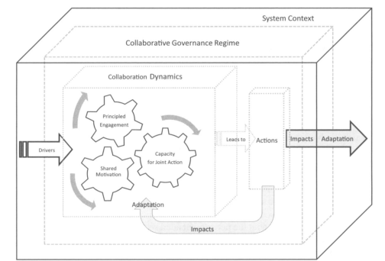
Emerson, Nabatchi, & Balogh, 2012: 6
MMIP in Idaho: SYSTEM CONTEXT & DRIVERS
Emerson, Nabatchi, and Balogh (2012) identify the system context as features that include resource conditions, policy legal frameworks, prior failure to address issues, political dynamics/power relations, network connectedness, levels of conflict/trust, socio-economic/cultural health, and diversity (pg. 7). It is important to provide a brief overview of what the system context and the drivers to address missing and murdered Indigenous persons (MMIP) in Idaho. First, I will provide a brief overview of Idaho’s tribes and demographics. I will then briefly discuss criminal and land jurisdiction as these issues drive the need for multiple agencies to collaborate as they navigate missing persons or persons crime cases that cross multiple jurisdictions. I will then provide a brief timely for policy work and collaborative governance to address MMIP through the formal legislative agenda.
There are five federally recognized tribes within the state boundaries of Idaho: the Coeur D’Alene, Kootenai, Nez Perce, Shoshone-Bannock, and Shoshone-Paiute. Indigenous demographics have been profoundly shaped by the settlement of the United States and Idaho. While 8500 Indigenous people live on reservations the Idaho State MMIP report indicates 78% of Idaho Indigenous peoples live off the reservation (Fillmore & Gillespie, 2022). American Indigenous peoples' access to citizenship and rights is complex due to the nested nature of federal and state laws guiding land and criminal jurisdictions with tribal communities. Authority to respond to a crime is decided by jurisdiction and depends on the location of the crime, and the racial identification of perpetrator and the victim. Tribal, local, state, Bureau of Indian Affairs (BIA) or Federal Bureau of Investigation (FBI) may all have jurisdiction. The IFCG recognizes drivers to be leadership, consequential incentives, interdependence, and uncertainty to be driving forces of collaborative governance. Emerson, Nabatchi, and Balogh (2012) state “uncertainty that cannot be resolved internally can drive groups to collaborate in order to reduce, diffuse, and share risk” (pg. 10). Jurisdiction issues in Indian country and in Idaho are well known to be associated with responding to MMIP cases. The Idaho State Report on MMIP highlighted a quote by a stakeholder
“Tribes were havens for crimes, they were havens for drug trafficking, they were havens for crimes for murdered individuals, for domestic violence and sexual assault, because tribes were not equipped; and not just financially, but they didn’t have the means either, or the infrastructure to hold other non-natives accountable for the crimes that were committed. And that was certainly something that criminals knew. That if they wanted to get away with something, and certainly with Native American women, they could do it right in front of the court's eyes and not be held accountable for their actions.” Stakeholder #1
HCR33 Report: Idaho’s Missing and Murdered Indigenous Persons, Fillmore and Gillespie, 2021: 36

As noted in the introduction, federal and state reports have indicated missing and murdered Indigenous persons is associated with issues of systemic violence including victimization from domestic violence, sexual assault, child abuse, human trafficking, and homicide (Rosay, 2016; Arbuckle et al, 1996; Grant et al; 2021). It is not uncommon for agencies such as domestic violence service providers to engage in research to document or understand the populations they provide services to. Domestic violence service providers are no exception. In 2019, The Idaho Coalition Against Sexual and Domestic Violence (ICASDV) applied for a federally funded Health and Human Services (HHS) grant under Family Violence Prevention and Services Act (FVPSA) to understand the impacts of domestic violence on American Indigenous communities across Idaho. During the time of the research, three of Idaho’s tribes experienced missing persons or murder cases. Below, table 1 shows a brief timeline of important meetings/events discussing MMIP policy as well as participation of public agencies and tribal communities in attendance.
Figure 2
Timeline of MMIP Events: Toward Collaborative Governance
Date | April- August 2019 | October 2019 | December 2019 | February 2020 | October 2020 | October 2021
Event | ICASDV  Conducts  Research | Idaho State Indian Affairs meeting | 1st Summit | HCR33 Legislative Hearing | Ti Novitawai Kocheukaakwe  Virtual MMIP Conference | Summit to release Idaho State Report
Participants: | 3 Tribes  1 Nonprofit | 5 Tribes  State representative  Public attendance | 13 Agencies  Tribal/State/Federal/Nonprofit | 7 Agencies  Public Testimony | 12 Agencies Tribal/state/federal  (Service provision emphasis) | 13 Agencies  Tribal/state/federal  67 surveys  160 zoom participants

The ICASDV research findings were discussed at the October 3rd meeting in Idaho State Indian Affairs Committee. This committee hosts annual meetings between Idaho State legislative representatives and elected Tribal leaders from each of the five tribes that reside in Idaho. In the same October 3rd hearing, the Nez Perce Tribal Chairman made a motion seeking for the creation of a statewide missing and murdered indigenous women’s (MMIW) task force. Tribal leaders from this meeting suggested changing MMIW to MMIP recognizing this issue impacts men and gender diverse individuals. Stakeholders from in the five tribes and outside of the tribes made efforts to seek support for this issue to be brought forward on the Idaho legislative agenda by calling for additional meetings to discuss the policy issues. In December of 2019, the non-profit organization The Idaho Coalition Against Sexual and Domestic Violence (ICASDV) hosted the first Idaho Summit on Missing and Murdered Indigenous People. This effort had the support of stakeholders from the Office of the Governor of Idaho, Idaho State police, Coeur d’Alene Tribe, Shoshone-Bannock Tribe, Shoshone-Paiute Tribe, Nez Perce Tribe, United States Attorney’s Office: Idaho District, United States Department of Justice, Federal Bureau of Investigation, Boise State University, Idaho State house of representatives, Idaho State Senate, Idaho Coalition Against Sexual and Domestic Violence, and the Idaho Council on Domestic Violence and Victim Assistance.
Stakeholders from the first MMIP summit modeled draft legislation for a house concurrent resolution (HCR33) to recognize MMIP on the Idaho state legislative agenda. Republican Representative Caroline Nilsson Troy brought forth the bill as she participated in the summit and works closely with The Coeur D’Alene Tribe which resides within her representative district. In public testimony Representative Nilsson Troy stated:
“What Idaho did, under the leadership of the tribes, was determine that they would take the lead on this, I think that's appropriate. A lot of states have done legislation, they’ve done task forces, but I think this is an issue that we need to listen to the people that are most affected by it.”
HCR33 Report: Idaho’s Missing and Murdered Indigenous Persons, Fillmore and Gillespie, 2021: Forward

The text of the resolution recognizes missing and murdered Indigenous persons as an issue that impacts Idaho. The resolution also recognizes May 5th as a Day of awareness and supports future research and collaboration to further understand the MMIP issues between Idaho’s five Tribes and Idaho jurisdictions. All of Idaho’s tribes had representation in the bill’s hearing and public testimony process including a Tribal prosecutor who stated:
“Many times, the collaboration of these incidents have been positive, with effective communication and collaboration and with successful prosecution through state, federal and/or tribal court.”
HCR33 Report: Idaho’s Missing and Murdered Indigenous Persons, Fillmore and Gillespie, 2021: Forward

Public testimony was provided by a former US Attorney working for the district of Idaho who stated:
“Your challenge is the resolve and the commitment of the local communities to work collaboratively to problem solve. If they want to solve the problem, they don’t need further statutory authority. It is helpful to have peace officer designation for tribal law enforcement, significantly. But if a local community or county is committed and wants to problem solve with tribal members, they can do it. And we have evidence of that going on in several locales.”
HCR33 Report: Idaho’s Missing and Murdered Indigenous Persons, Fillmore and Gillespie, 2021: Forward

Indigenous families who have experienced violence and missing loved ones also provided public testimony. An Idaho Indigenous mother stated:
“I am here today hoping to get support to assist the families of MMIP to help them get answers, to get quicker response time when a person is missing, to get professional and timely investigations, improve communication and coordination across jurisdictions, utilize resources to find the missing.”
Public Testimony, Idaho State Legislature, Senate Affairs Committee, February 12, 2020

These statements provide key insights to understand MMIP broadly in Idaho. First, Idaho’s tribes need to be present to articulate the MMIP policy issues that directly impact tribal communities. Second, stakeholders have provided evidence of collaborations between tribal and non-tribal jurisdictions that have been successful. Finally, there is significant need to address and support families of missing or murdered persons. In October of 2022, the Idaho State legislature released its first report on MMIP in response to the passage of HCR33. The state report officially highlights the scope of the MMIP in Idaho through quantitative administrative data sources within state, federal and non-profit data sources. The report also included qualitative interviews of key tribal and non-tribal stakeholders to understand perceptions of issues associated with MMIP including causal factors and challenges faced by tribal, local, state, federal and non-profit agencies.
COLLABORATIVE DYNAMICS: PRINCIPLED ENGAGEMENT, SHARED MOTIVATION, CAPACITY FOR JOINT ACTION
As the participatory and collaborative governance literature highlight, scholars need to understand who is participating in these institutions and why they are participating. This informs the basis of engagement and motivations for participation. Wampler et al (2020) state “the adoption of participatory institutions leads to a shift in democratic governance as citizens and government officials are induced to engage each other differently” (pg. 8). Additionally, IFCG authors argue that “before specifying the nested elements within principled engagement, it is important to discuss the participants. Who the participants are and who they represent are of signal importance to collaboration” (Emerson, Nabatchi, and Balogh, 2012: 11). And tribal governance and communities are important participants in collaborative governance decisions that impact them. Tribal communities are also connected to one another through interests to learn from other intergovernmental approaches to policy issues such as MMIP. Tribal communities are also connected through federal programming and through national efforts through organizations such as the National Congress of American Indians (NCAI). As such, one purpose of this paper and survey is to better understand and identify who participants are in MMIP collaborative governance in Idaho. The October 2021 release of the Idaho legislative report on MMIP was marked by a MMIP summit meeting hosted again by the Idaho Coalition Against Sexual Assault and Domestic Violence (ICASADV). Presentations were given by researchers, community organizers, and state tribal liaisons, and experts on justice and data systems across the United States.
METHODS
To better understand participants attitudes and behaviors in collaborative governance an original survey was administered through Qualtrics XM, from October 28th -November 17th, 2021. Participants were asked to fill out the survey after the presentation of the Idaho Report on MMIP. The survey was designed to capture collaborative governance stakeholders, but also inclusive to a wider participation including a wider participation of tribal community members and was open to the public. This summit provided an opportunity to learn who stakeholders in Idaho’s MMIP collaborative governance group are through survey research. The survey research was broadly guided by two large questions.
- Who are MMIP collaborative governance stakeholders?
- Do participants share meaning of the policy issues and solutions?
To understand participants attending the Summit to release the Idaho State MMIP Report, the first question was fully supported with follow up question regarding
  - Roles
  - Length of time
  - Participation in MMIP Events (tribal, state, county, federal)
  - Agenda setting
  - Self-efficacy
  - Demographic questions

Emerson, Nabatchi, and Balogh (2012) argue principled engagement requires “four basic process elements: discovery, definition, deliberation, and determination” (pg. 11). The second guiding research question is a preliminary step to understand how participants perceive MMIP policy issues facing Idaho. It also identified congruent perceptions on who or what agency should oversee organizing meetings and future collaborations. These perceptions also inform scholars and practitioners of commitments and resources are necessary to implement collaborations between different agencies. The survey asked specific questions regarding
  - Trust who will do the right thing on MMIP (Tribes, Fed, State Nonprofit, Law enforcement)
  - Who should be responsible for coordinating? (Tribes, Fed, State, county, Nonprofit, Task force)
    - Tribal Law Enforcement/Federal law Enforcement?
    - Tribal law enforcement/county law enforcement
    - Tribal prosecutors/County prosecutors
    - Law enforcement/Victim service providers
  - Perceptions of self-participation in MMIP policy community
    - Improves public safety for MMIP community
    - Improves gaps in data
    - Improves victim services for Indigenous families
    - Improves collaboration between
      - Federal/state agencies
      - Idaho Tribes/State agencies
      - Idaho County/Tribes
      - Nonprofit/Idaho State
      - Nonprofit/Tribes
  - Rate the extent you agree or disagree with narratives shared in public testimony
    - Idaho tribes should be in the lead
    - MMIP is a public safety issue that impacts all Idahoans
    - Communities could solve their problems without state legislative statutory authority
FINDINGS
The results are based on a convenience sample of 67 completed surveys. There were two participants who chose not to answer all the questions on the survey. The survey did not account for participants being able to select multiple agencies. For example, participants can affiliate with a tribal agency and a grassroots organization, which means some of the responses are higher than the actual number of completed surveys. Survey questions could have better explained the differences between non-profit and grassroots organizations. This data shows nonprofit agencies to have a clear presence in the meeting, followed by tribal agencies, state agencies, and grassroots organizations. Collaborative governance literature recognizes getting the right configuration of stakeholders together is necessary. Emerson, Nabatchi, and Balogh (2012) state “inclusion and diversity are valued not only as normative organizing principles, but also for instrumental reasons—they give voice to multiple perspectives and different interests, allowing the development of more thoughtful decisions that take a broader view of who will benefit and who will be harmed by an action” (pg 11). Drawing on Figure 3, the survey found that there is a relative balance among tribal agencies, and nonprofits, and grassroots agencies. The survey also infers lower participation from federal, local, county, and state agencies.
Figure 3.
Participants in October 2021 Summit Meeting
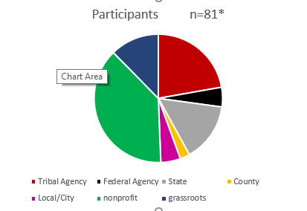

Figure 4.
Years of Experience in Role
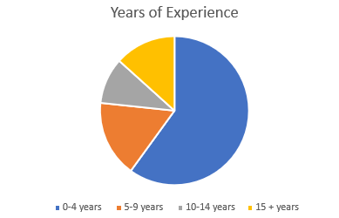
Based on the survey results I infer participation in the MMIP policy subsystem in Idaho has increased since the first Idaho summit in 2019 and the 2020 legislative hearings for HCR33. Twenty-four participants indicated they attended in the Ti Novitawi Kocheukaakwe Virtual Conference hosted by the Idaho Coalition Against Sexual and Domestic Violence (ICASADV) in October 2020 shortly after HCR33 passed the Idaho legislature. At the release of the Idaho State MMIP report, though the survey only shows 67 respondents, the recorded zoom webinar had roughly 160 participants listening to the presentation. Figure 4. Shows how participants in the survey reported years of experience in their roles. This is relevant as stakeholders who have been working in their roles associated with addressing MMIP issues might be new to the policy issues. It could also indicate that MMIP policy subsystem is still nascent policy subsystem in Idaho (Ingold, Fischer, & Cairney, 2017).
Figure 5
The Extent of Trust for Agencies to do the Right Thing on MMIP
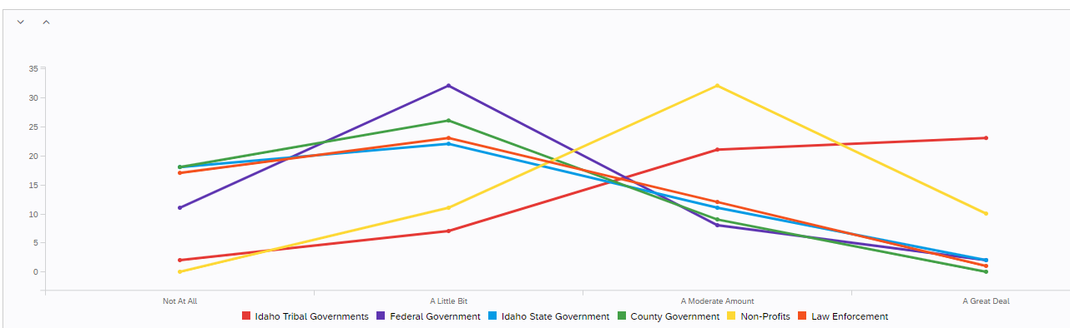

Figure 5 presents perceptions of trust of survey participants on what group will to do the right thing on MMIP. The results are mixed, however, there is a perception that nonprofits and tribes have trust to do the right things on MMIP issues. One explanation for this is indicated by the IFCG which suggests collaborative governance can be impacted by previous conflicts between agencies and actors. Scholars who choose to work on collaborative governance with American Indigenous populations should recognize the historical context of the relationships tribal communities have with states and the federal government. For example, Idaho is a PL280 state which gives Idaho State provisional jurisdiction on tribal land. This law was adopted without the consent of the tribes in 1953 and has been a significant source of tension between tribal, county, and state law enforcement agencies responding to persons crime. Nonprofits and tribal domestic violence service providers are also first responders to families of missing persons cases or murder cases and are often asked to negotiate between law enforcement investigations or advocate for families and victims at the time of an investigation. It should come as no surprise that these organizations would have trust to respond to MMIP issues.
Figure 6.
Who Should Be Responsible for Coordinating MMIP Efforts in Idaho

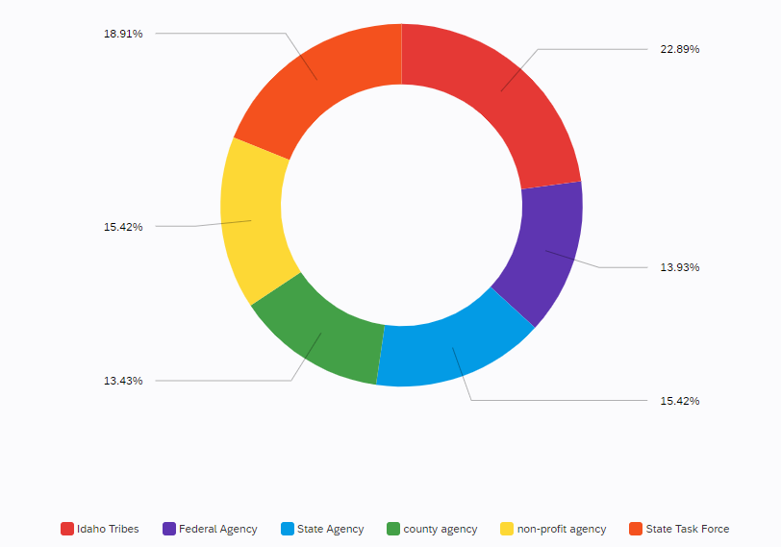
Figure 6 shows the perceptions of survey participants when asked who should oversee collaborations. This was an interest of stakeholders to find out if there is broader support for a state legislative task force or if there was support for nonprofit or tribes to taken on the burden of organizing. Currently, Idaho has not pursued legislatively a taskforce, but the option was included in the survey to see if there would be broader support. One of the most significant challenges to collaborative governance is to understand how to sustain collaborations, or who would oversee sustaining collaborations. This question also highlights how burdens might be distributed between stakeholders and agencies. It is unclear if a single tribe be in charge, or if organizing burdens should it rotate between all the tribes. Likewise, should the organizing burden rest on an institutional role such as a nonprofit organizer, or a legislative representative, or director of a task force. There are discrepancies between the findings of trust from figure 5 that show support for tribes and non-profit being at the center of collaborations. However, figure 6 shows little agreement on who should take on the burden of organizing collaborations. I would argue perceptions of public policy narratives can fill a knowledge gap on the discrepancies between trust and who should be key organizers in collaborative governance.
Figure 7.
Perception of Narratives*

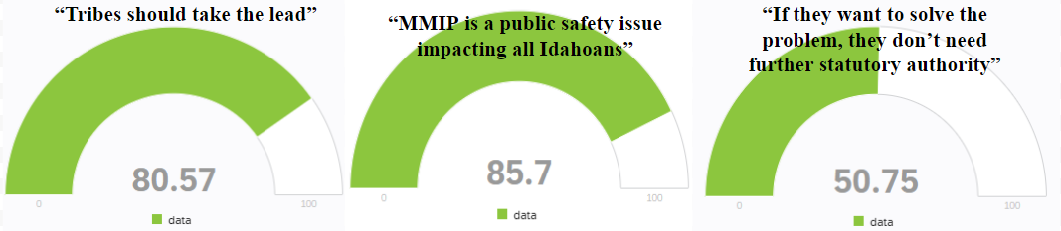
*Agree-disagree scale 0-100, means tested
The survey included statements from public testimony on HCR33 to understand if there were congruent attitudes with statements made about who should be included in policy collaborations, and who MMIP impacts, and what proposed solutions could be. Finding survey participants agreed less with the statement that Idaho would not need further statutory authority to address MMIP was a surprising finding. This statement on statutory authority was made by a former US Attorney who worked for the District of Idaho. This individual is an expert on jurisdiction issues Idaho tribal and non-tribal communities faces. What this indicates is that participants in the policy subsystem believe statutory authority will be needed to address key issues facing local communities, including law enforcement collaborations and agreements such as MOUs.
DISCUSSION
The survey tells us many of the stakeholders participating in the October 2021 meeting are in roles working for tribal agencies and nonprofits. Though some survey participants identified working in local, state, and county jurisdictions these numbers are much lower than stakeholders from tribal and nonprofit agencies. The Idaho State MMIP report’s qualitative section with stakeholders captured some acute needs of collaborations between tribal, local, and county agencies
“Let's say, somebody goes missing off of the [reservation]. The tribal police, you know, would be heavily engaged in conducting that investigation. But once the investigation leaves the [reservation], then the question becomes what kind of collaborative cooperative working relationships does the tribal police department have with, you know, the [county sheriff's office] or you know, wherever that may lead. And as soon as that leads to another state, it becomes further complicated because […] literally every day we are inundated with new problems and new things that require our immediate response. And so how seriously is the jurisdiction off of the reservation going to take that request? What steps are they going to take? And the tribal police has no ability to force them to investigate and the tribal police has no jurisdiction to go to their county or city and conduct their own investigation off of the reservation and so jurisdiction becomes important.” Stakeholder #4
HCR33 Report: Idaho’s Missing and Murdered Indigenous Persons, Fillmore and Gillespie, 2021: 38

When MMIP cases cross jurisdiction, these cases directly impact tribal, county, and state law enforcement agencies. These agencies are often first responders to missing persons and murder cases. MMIP cases that occur in cities are addressed by local jurisdictions and the Idaho State Report on MMIP shows a relatively high percentage of unknown racially identified missing persons cases. Additionally, collaborations between tribal, county, and federal court systems are necessary to make administrative and jurisdictional decisions regarding the adjudication of crimes involving federally recognized American Indian individuals. In all the collaborative meetings to date, the lowest participation has been with county and state agencies. This finding may also be connected to the lower score survey participants assigned to the policy narrative that statutory authority would not be required for collaboration. This finding may also suggest why the current Idaho strategy has been split into two parts. First, the office of the Governor of Idaho created a MMIP subcommittee under the Idaho Criminal Justice Committee to make recommendations to law enforcement agencies. Second, tribal domestic violence service providers continue to organize with a wide range of actors to help build capacity for local level agreements between tribal, local, and county law enforcement agencies. Both groups are seeking for engagement with county and state agencies in ways that will build state-wide continuity and long-term collaborations between all participants.
CONCLUSION
The Integrative Framework for Collaborative Governance (IFCG) shows how the inclusion of tribal communities helps to explain collaboration on policy issues that disproportionately impact American Indigenous populations. The IFCG, as a multi-level model allows for system context and drivers to explain collaborative dynamics between tribal and non-tribal agencies and communities seeking to address MMIP issues. While MMIP is complex, multiple sources of data including meetings, public testimony, the legislative report, and the survey results indicate support for collaboration. It is important to highlight that these sources also indicate the need for tribal communities to be present to articulate policy issues and needs. There is also support for tribal communities and non-profits to be at the center of collaboration. This could be understood in multiple ways, including the need for tribes and non-profits to take on the financial and organizing burdens of collaborative governance. This survey indicates support for a task force as a process that could be beneficial to support ongoing tribal, local, state, federal collaborations. However, even with support for a task force, it is still unclear if the group will have enough support to translate that into a legislatively funded task force. While the MMIP subcommittee under Idaho Criminal Justice Committee (ICJC) has Indigenous stakeholders as part of the committee, it is unclear if the full committee will be willing to engage in the broader policy subsystem actors, grassroots organizations, and the reservation and urban Indigenous communities impacted by MMIP.
Though the convenience sample was not quite enough to allow for significance testing; this survey captures information requested by stakeholders and service providers who continue to work on policy issues related to MMIP. Additionally, research and data with Indigenous communities continues to challenge traditional demographic and probability sampling strategies. These strategies are difficult to use with small populations with diverse gender, racial, and ethnic identities. Survey work with multiple tribal communities of Idaho is important as it can highlight areas of policy congruence between tribal and non-tribal actors on policy issues that disproportionately impacting Idaho American Indian people.
Finally, work on Missing and Murdered Indigenous Persons policy is not possible without the help and support of the Idaho’s tribal communities. This research was pursued through multiple and repeated interactions with Tribal governance representatives, tribal domestic service providers, and listening to the stories of families who have loved ones who are either missing or have been murdered. The Idaho State Report on MMIP emphasizes the need for offering services to families of missing and murdered loved ones. One stakeholder is quoted saying “Families actually came forward. Because what we did is we had shadow people, of the names of the missing and murdered that we had. And the families were surprised that they were remembered. You know, they were saying, “Oh, that's my brother. I thought everyone forgot about my brother” (Fillmore et al, 2021: 41).

Works Cited
Ansell, C., & Gash, A. (2008). Collaborative governance in theory and practice. Journal of public administration research and theory, 18(4), 543-571.

Arbuckle, J., Olson, L., Howard, M., Brillman, J., Anctil, C., Sklar, D. (1996). Safe at home? Domestic violence and other homicides among women in New Mexico. Annals of Emergency Medicine, 27(2), 210-5. doi:10.1016/s0196-0644(96)70325-6

Berardo, R., Heikkila, T., & Gerlak, A. K. (2014). Interorganizational engagement in collaborative environmental management: evidence from the South Florida Ecosystem Restoration Task Force. Journal of Public Administration Research and Theory, 24(3), 697-719.

Emerson, K., Nabatchi, T., & Balogh, S. (2012). An integrative framework for collaborative governance. Journal of public administration research and theory, 22(1), 1-29.

Fillmore, M. L., Gillespie, L. K., Growette Bostaph, L. M., King, L. L., & Gilbert, S. L. (2021). HCR33 Report: Idaho’s Missing & Murdered Indigenous Persons. Submitted to the Idaho Legislature, September 30, 2021.

Frederickson, H. George. 1991. Toward a theory of the public for public administration. Administration & Society 22:395–417

Fredericksen, P., Witt, S. L., & Nice, D. C. (2016). The Politics of Intergovernmental Relations.

Fung, A., and Wright, E.O. (2001). Deepening democracy: Institutional innovations in empowered participatory governance. New York, NY: Verso.

Getha-Taylor, H., Grayer, M. J., Kempf, R. J., & O’Leary, R. (2019). Collaborating in the absence of trust? What collaborative governance theory and practice can learn from the literatures of conflict resolution, psychology, and law. The American Review of Public Administration, 49(1), 51-64.

Grant, E. A., Dechert, L., Wimbish, L., & Blackwood, A. (2021). Missing & murdered Indigenous people: Wyoming statewide report. https://wysac.uwyo.edu/wysac/reports/View/7713

Ingold, K., Fischer, M., & Cairney, P. (2017). Drivers for policy agreement in nascent subsystems: an application of the advocacy coalition framework to fracking policy in Switzerland and the UK. Policy studies journal, 45(3), 442-463.

Jun, J. S., ed. (2002). Rethinking administrative theory: The challenge of the new century. Westport, CT: Praeger

Kettl, D.F. (2002). The transformation of governance: Public administration for twenty-first century America. Baltimore, MD: Johns Hopkins University Press.

Leach, W. D. (2006). Collaborative public management and democracy: Evidence from Western watershed partnerships. Public Administration Review 66:100–10.

Lucchesi, A., & Echo-Hawk, A. (2018). Missing and Murdered Indigenous Women & Girls: A snapshot of data from 71 urban cities in the United States.

Michels, A. (2011). Innovations in democratic governance: how does citizen participation contribute to a better democracy?. International Review of Administrative Sciences, 77(2), 275-293.

Nabatchi, T. 2010. Addressing the citizenship and democratic deficits: Exploring the potential of deliberative democracy for public administration. American Review of Public Administration 40:376–99.

Romzek, B., LeRoux, K., Johnston, J., Kempf, R. J., & Piatak, J. S. (2014). Informal accountability in multisector service delivery collaborations. Journal of Public Administration Research and Theory, 24(4), 813-842.

Rosay, A. B. (2016). Violence against American Indian and Alaska Native women and men: 2010 findings from the National Intimate Partner and Sexual Violence Survey. National Institute of Justice.

Simpson, A. (2014). Mohawk interruptus. Duke University Press.

Sirianni, C. (2009). Investing in democracy engaging citizens in collaborative governance. Washington, DC: Brookings Institution

Torres, L. H. (2003). Deliberative democracy: A survey of the field in a report prepared for the William and Flora Hewlett Foundation. Washington, DC: AmericaSpeaks.

United States Census Bureau. (2019). 2015-2019 American Community Survey 5- Year estimates [data set]. Retrieved from https://www.census.gov/tribal/?st=16&aianihh=0705

Wampler, B. (2007). Can participatory institutions promote pluralism? Mobilizing low-income citizens in Brazil. Studies in Comparative International Development, 41(4), 57.

Wampler, B., Sugiyama, N. B., & Touchton, M. (2019). Democracy at Work. Cambridge Books.

Wampler, B., McNulty, S., & Touchton, M. (2021). Participatory Budgeting in Global Perspective. Oxford University Press.

