The Press as Politicos: Presidential Debates and Moderators and Anchors as Adversaries

Dr. Ryan Lee Teten
Associate Dean/Associate Professor
University of Louisiana at Lafayette
Email: rlt5683@louisiana.edu

This paper was prepared for the Annual meeting of the Western Political Science Association, Vancouver, British Columbia, April 12-15, 2017
Abstract : This paper examines the dramatic shift that has occurred regarding the presidential primary and general election debates of the 2016 election. As opposed to presidential debates of the past that seemed to mandate a policy centered realm of discussion, the 2015 and 2016 presidential primary and general election debates presented the public with moderators who interjected themselves as fact-checkers and protagonists in the action. In addition, these debates witnessed a never before seen height of personal attack, trap and sensationalist questions at the cost of neutral policy centered or differentiating candidate inquiries. In addition, those non-traditional media outlets such as Foxnews and CNN evolved their role to active engagements of the candidates that, through question wording and follow up questions, made debates seem like the media versus the candidates as opposed to candidates’ explorations of each other’s positions. This study performs a line-by-line and question-by-question content analysis of the presidential primary and general election debates of 2008 through 2016 to detail these significant changes in moderator questions, and looks at the new antagonistic role embraced by contemporary media personalities and the possible effects of this on outcome of Election 2016 and future elections.

BLITZER: All right, we're going to -- we're going to come back to this. [applause]
We're going to come back to Cuba, as well. But stand by for that.
We did double-check, just now, Governor, that ad that we talked about, where I quoted you as saying that Speaker Gingrich called Spanish "the language of the ghetto" -- we just double-checked. It was one of your ads. It's running here in Florida in -- on the radio. And at the end you say, "I'm Mitt Romney and I approved this ad."
So it is -- it is here. [booing]
ROMNEY: Let me ask -- let me ask a question.
Let me ask the speaker a question. Did you say what the ad says or not? I don't know.
GINGRICH: It's taken totally out of context.
ROMNEY: Oh, OK, he said it.
GINGRICH: I did not -- no. I did not say it about Spanish. I said, in general, about all languages. We are better for children to learn English in general, period. [applause]
---Republican Primary Debate, January 26, 2012, Hosts: Wolf Blitzer and CNN

The outcome of the 2016 United States presidential election was a seeming surprise to many Americans and political pundits alike. A candidate with no political office holding experience who portrayed himself as the ultimate angry Washington outsider stormed into the presidency on the heels of an election that many have viewed as one of the dirtiest and most controversial in American history. For both parties and all candidates, the election was marked and defined by accusations of e-mail hackery, sexual harassment, the non-release of tax returns, abuse of positions of political office for personal gain, collusion between the parties and the media, responsibility for issues of bankruptcy, and responsibility for overseas casualties and entanglements. In addition, because President Barack Obama had termed out and sitting Vice President Joe Biden declined to run for the ultimate United States political position, it was an open race for both Republican and Democrat contenders alike; many Governors, Congressmen, Senators and American businessmen saw this as an opportunity to secure the Executive office. This was truly a presidential election with many unique variables that had all combined to produce an outcome in which the opinions of the people and the election results (the popular vote and the Electoral College results) differed greatly. It seemed to be a level of political fervor and scandal the likes of which the United States had rarely encountered. Many questions arose on the heels of the event such as “why did this happen the way that it did,” and “what kind of variables factored into the results” and “how was this election truly different from those presidential elections of the past?”
Two of the most important factors in determining not only who would be the presidential nominee from each party, but also for whom the American populous would vote in the General election were the presidential debates that occurred during the primary and general election cycles. Many studies have also shown that these debates provide an important civic education function that enables the voting age population to make informed decisions and establish marked differentiation regarding the many candidates who have sought consideration for the office of the Presidency. (Benoit, Hansen, & Verser, 2003; Druckman, 2003; Holbrook, 1999) “Thus, we can conclude that primary debates are capable of influencing both policy and character impressions of the candidates, as well as changing voting intentions and increasing vote confidence.” (Benoit, 2002)
As important as they are to civic education, however, many citizens and candidates alike suggested that the debates, formats, questions, and moderators of the 2016 primary and general election had a disproportionately antagonistic feel compared with those of the past. The New York Post described the Presidential Debate on October 8, 2016, for example, as one that “may go down as the nastiest presidential debate in modern history.” (Halper, 2016) In fact, a University of Virginia Miller Center scholar viewed it as “the lowest point in presidential debate history, no contest…So far outside the norm that it is hard to position it fully within the history of presidential debates.” Another Georgetown professor saw it as the “lowest point in any debate since the first ones in 1960.” And yet another George Washington University professor viewed it as the “Lowest point of any presidential debate. Ever. It will be talked about for years to come.” It was “a very, very low point in the important and esteemed tradition of public debate between the two candidates for the office of president of the United States.” (Lowest Moment, 2016) In addition, that specific October debate was viewed by scholars and pundits alike as indicative of the cycle overall. Indeed, this was consistent with view that “the 2016 campaign overall is in a very sad state of affairs.” (Lowest Moment, 2016)
As opposed to presidential debates of the past that seemed to mandate a policy centered realm of discussion, this paper examines why the 2016 presidential primary and general election debates presented the public with moderators who interjected themselves as fact-checkers and protagonists in the action who used personal attack, trap and sensationalist questions that came at the cost or policy centered or differentiating candidate inquiries. In addition, I look at those media outlets such as Foxnews and CNN that have evolved their role to active engagements of the candidates that, through question wording and follow up questions, made the 2016 debates seem like the media versus the candidates as opposed to candidates’ explorations of each other’s positions. This study performs a line-by-line and question-by-question content analysis of the presidential primary and general election debates of 2008 through 2016 to detail these significant changes in moderator questions, and looks at the new antagonistic role embraced by contemporary media personalities and the possible effects of this on the outcome and voters of Election 2016 and election ns to come. This study follows the natural next step proposed by McKinney that “debate scholars must continue their investigation of the content and effects of these messages, pursuing programmatic research agendas that examine how particular debate features and viewer responses function across different debates, allowing scholars to build general laws and theories of debate content and effects.” (2013; 256; See also Rowland 2013)

Presidential Debates: Purpose and Power

United States Presidential general election debates have seen an increase in scholarly examination in the last 20 years as the recognition of their role in the candidate selection and electorate informational power has been realized. After the Racine Group (2002) suggested that these events were far from a pro forma hurdle in the presidential election process and should be studied with renewed vigor, scholars began to parse the varying elements and variables surrounding presidential debate for closer dissection. Some studies have continued to look at the educational role that general election debates play in assisting voters in making voting decisions. (See Benoit, 2003; Druckman, 2003; Holbrook, 1999) Others have looked at the way that the candidates themselves have used the opportunities to increase their national standing and also how candidates answer the questions in order to provide information to viewers on their own policy positions, attack opponents, and answer damaging charges leveled by other contenders in the race.
Only recently however, have scholars begun to fully realize the powers held by the news organizations and moderators of the debates themselves on determining performance outcomes for the candidates and changing the tone of presidential races. The debate hosts themselves are currently being examined for the possible impact on the debate content. “For example, media outlets with a publicly traded corporate ownership structure provide less policy campaign news than outlets with fewer commercial pressures” (Dunaway 2008 referenced in Turcotte, 2015; 253; see also Sparrow 2006; Hamilton 2004; Dunaway2008) Disturbingly, “increasing commercial pressures drive heightened emphasis on infotainment, soft news, and electoral strategy—often at the expense of hard news and policy content.” (Turcotte 2015, 239) In addition, the moderator serves as the front line of attack for the priorities of these different news media and have begun to place themselves into the “debate” as it were. The danger may be that “In the context of presidential debates, these professional (and often economic) motivations driving individual journalists may even outweigh the institutional influences of news content.” (Turcotte 2015, 242)
Famously, moderator Candy Crowley, of CNN at the time, was viewed as ground breaking in interjecting her own views and fact-checking into the presidential debate between Mitt Romney and Barack Obama in 2012. She corrected Mitt Romney’s assertion that Obama did not call the attack in Libya terrorism, responding “He did in fact.” (Byers 2012) These four words by Crowley suggested that the role of the moderator, someone whose job used to be quite different, had changed. Bob Schieffer said ““The role of the moderator is to be the referee. It’s not to be the judge…It is the responsibility of the moderator to make sure the truth gets out, but the chief fact checkers should be the candidates themselves.” (Hohmann 2016) Jim Lehrer suggested that “When you moderate…The candidates do the fact-checking back and forth, and the moderator's job is to facilitate that, to encourage it, to get it done. (Guthrie 2016).
Crowley gave evidence to viewers and candidates alike that the moderator had evolved into someone who could not only direct questions to the candidates, but also, seemingly ensure that their answers were consistent with votes, quotes, and quips of the candidates’ past. Lehrer himself, who has moderated 12 presidential debates, has also observed the changing role of the moderator. He stated that “The moderator is the one who alone makes the decision about what the subjects are. The moderator alone makes the decision about what questions will be asked. The moderator alone makes the decision about when to move on and when to stay on a subject — and, yes, has much more power.” (Guthrie 2016). The recognition of this evolving role has injected a renewed study by scholars into what role the moderator serves, what impact they could have on the candidates’ performance, what impact they could have on the perceptions of the debate winners and losers, and what lasting impression was left with viewers regarding the candidates’ policies.
However, as the focus on the moderator is relatively new, two areas of study have been to date largely absent in the examination of moderators’ roles in presidential debates. First of all, and most significantly, nearly all of the study has revolved around the Presidential debates that occur in the fall of the election year; in effect, the lion’s share of work looks only at comparing and investigating the three general election debates and their changes. This study extends examination of presidential debate to the primary debates from 2008 through 2016 in addition to the debates of the general election. “Indeed, debate scholars have increasingly moved beyond the more simplistic question of whether or not debates matter to focusing greater research attention on illuminating the various ways and specific contexts in which they matter.” (McKinney 2013, 239; see also Benoit, McKinney, & Stephenson, 2002; McKinney, Kaid, & Robertson, 2001)
Specifically, when looking at the voters and the ways that they make voting decisions as to whom will become president, it is essential to look at the earliest stages of the process, when there are usually many different candidates from both parties that are all available for possible consideration. McKinney found that “Nearly 60% of primary debate viewers in our study changed their pre-debate candidate preference, including more than one-third of all primary viewers switching their allegiance from one candidate to another, and nearly one-quarter of our primary viewers switching from undecided to a particular candidate following debate viewing. These results suggest primary debates are particularly useful-and much more so than general election debates-in facilitating undecided viewers' vote choice.” (2013, 252) In addition, “combined analysis reveals that primary debate gains in candidate evaluations are substantially greater than general presidential and vice presidential debate increases” (McKinney 2013, 254)
In 2016, there were 1780 candidates who had been ruled eligible by the Federal Election Commission by Election Day. Although 90% of these were third party or independent candidates, Republicans had 17 different contenders and Democrats had a total six candidates a year before the general elections that had to whittle their way down to only one to represent each party. In 2016, this was done through 22 primary debates and 7 “undercard” primary debates for the Republicans for a total of 29 presidential primary debates. The significant number of primary debates versus only three general election debates provides a much wider lens through which to observe more nuanced changes that have occurred in presidential debates. Importantly, because “in the primary campaign phase with candidates who are surfacing and often introducing themselves to a national audience for the first time, with citizens just beginning to pay attention to the emerging presidential race, and with debate viewers forming their initial candidate impressions, we find much greater positive change in primary candidate evaluations.” (McKinney 2013, 254) Although significant study surrounds frontloading, primaries and caucuses, and delegates, very little looks at the only public way that most candidates are able to get their name, message and policy out to the voters who consider them on primary ballots; namely, presidential primary debates fall into this research void.
The second area of study which presents itself for increased inquiry is the examination of the questions that are asked by the moderators themselves. If debates are to serve educational purposes for the electorate, are the debates providing important differentiation points on candidates’ policies that can help voters determine where their support may go? Also, does combining the evolving role of increased moderator intervention and the focus for some news organizations on advertising, result in different debate formats and questions that move the theme of the debates from proposed policies to personal attacks and inter-candidate squabbling which is not related (or only tangentially related) to national policy plans and proposals? Functional Theory suggests that candidates in debates choose to either acclaim, attack, or defend when making a decision on how to answer a question (Glantz 2013; Benoit 2007). This theory is dramatically shifted if the questions posed by the moderators themselves force the candidates into the latter choices and never allow the former. This paper attempts to provide a closer look into these issues through a close examination of the primary and general election presidential debates and the questions that moderators ask at these events for the number of neutral policy related versus personal attack related questions that are included in debates from 2008 through 2016.

Research Methodology and Design

As the basis for the examination, this study utilized the transcripts of primary debates and presidential general election debates from 2008-2016 from the American Presidency Project, created and maintained by Gerhard Peters and John T. Woolley. Each of these debates was first coded for basic information that included the date of the debate, the candidates present at each debate, the news organization or channel that hosted the debate, and the moderator of the debate. In addition, the party affiliation of the debates was noted. The 2016 cycle saw the rise of such a large number of presidential candidates from the Republican Party that there were also seven “undercard” debates held at the same venue and on the same date as an additional Republican debate that followed shortly thereafter. The candidates were determined to be included in the primetime debate based upon the national polling data averages decided upon by the news organizations conducting the debates. Although not examined here, further research should absolutely look at the ways that the candidate selection for the primetime debates, as well as the new policy of podium placement relative to the center of the stage based upon candidate standing in the polls, affected the national image of the candidates as well as their potentials to run a successful campaign for serious contention for president of the United States.
The total number of primary debates examined for 2008 included the 13 Republican primary debates beginning in August 2007. There were actually three earlier debates in 2007, unbelievably early, on May 3, May 15, and June 5 of 2007, but they were not included because they occurred so early in the cycle that there was no clear indicator of who would be actually campaigning for election 2008 (candidates participated in some of these as weather balloons for their own consideration of presidential runs). The sample also included 14 primary debates beginning with the August 19th, 2007 event. The Democrats also had earlier debates beginning on April 26th, 2007, but these five were not included for the same reason listed above. For the 2012 presidential election cycle, the last 14 Republican primary debates (beginning with those in October) were selected, with the six previous Republican debates occurring from June through October excluded for the reason of candidate uncertainty discussed above. There were no primary debates for the Democrats in 2012 because incumbent President Barack Obama was unchallenged by his own party for the nomination. In 2016, the sample consists of all 12 primetime Republican debates (with no undercards), and all 10 Democratic primary debates. The three presidential general election debates from 2008, 2012, and 2016 were also included in this study for comparison purposes.
In addition to the descriptive variables collected above, each debate then received a line-by-line reading to look for several things. The first point of examination was the number of questions that was asked by the moderator during each debate. As this paper looks at the possible changing influence and role of the moderator in the debates, as well as the tenor of the questions asked, questions that candidates asked each other, largely through uncontrolled and untimed interactions, were not included. To whom the question was directed, was also noted. (Although not yet examined in this study, early indicators that suggest that the leading polling candidates received almost 90% of the questions in 2016 as opposed to evenly divided questions between all candidates in 2008 and 2012; this should be a fertile future examination with significant implications as it speaks directly to literature that examines frontrunners and darkhorses and how these are established in each election cycle.)
The questions were also separated into two different categories. The first category included questions which were neutral in tone, and sought policy prognostications or proposal clarifications from the candidates. These were coded as “NEUTRAL POLICY” questions. An example of this would be Tim Russert’s question to the Democratic candidates on September 26, 2007. He asked the following: “If Israel concluded that Iran's nuclear capability threatened Israel's security, would Israel be justified in launching an attack on Iran?” This question is directed toward discovering a policy position of the candidates and includes no framing or previous discussion that would make appear as though slighted against a certain candidate.
The second group of questions were those that saw moderators ask candidates to engage each other in conflictual fashion, contained information prior to the actual question that framed the candidate’s policy proposal in an unfavorable or untenable light, and also questions that were not policy related but were simply “trap,” “gotcha” or insultingly framed questions. These range in formation, but all underlie a similarity to a loaded “Did you stop cheating on tests?” question in which neither reply option of yes (yes indicates you did cheat before) or no (no indicates you are still cheating) gives a plausible way for the respondent to come across positively. These “PERSONAL ATTACK” questions initially forced the candidate to a defensive posture from the outset and were either completely unrelated to policy or so detrimentally worded that the candidates could rarely expound on their own ideas in the time allotted, and had to dedicate the entire time to counterattacks on other candidates, the question that was asked, or the moderators themselves. An example of this question would be John King in the October 19, 2012 Republican Primary Debate who asked Mitt Romney, patronizingly, “You have said 120,000 jobs that you can tie back to decisions you made at Bain Capital. I want you to take your time, sir, and do the math. Do the math and how you get to 100,000 or 120,000 jobs?” More recently, at the Republican Primary Debate on March 3, 2016, Bret Baier asked Marck Rubio, “Senator Rubio, three weeks ago you said, quote: "I don't do the personal attacks, primarily because it's not who I am, because I think it's beneath the office that I'm seeking but also because I don't want to embarrass my kids." But in the past week you've mocked Mr. Trump's tan. You've made fun of his spelling. You called him a con artist. You suggested he wet himself backstage at the last debate, along with other vulgar jokes and jabs. So what happened?” Both the questions and the variables were coded twice by two separate scholars. There was nearly 95% inter-coder reliability in these classifications (due in no small part to the vitriolic rhetoric used by the moderators that left little doubt that the intent of the question was to harm candidate reputation, impugn their policy positions, or cause conflict between them).

Findings and Results

In order to discuss the changing nature of the questions that were asked by the moderators in presidential primary debates, it is important to determine whether or not the general election debates themselves have experienced this shift towards the personal attack question. Charts one and two below are examinations of the percentages of the neutrally formatted policy related questions that were asked as opposed to those that were personal attacks on the candidate themselves, painted the candidates into a corner in their response because of the framing of the question, or attempted to cause conflict between candidates.

Chart 1:
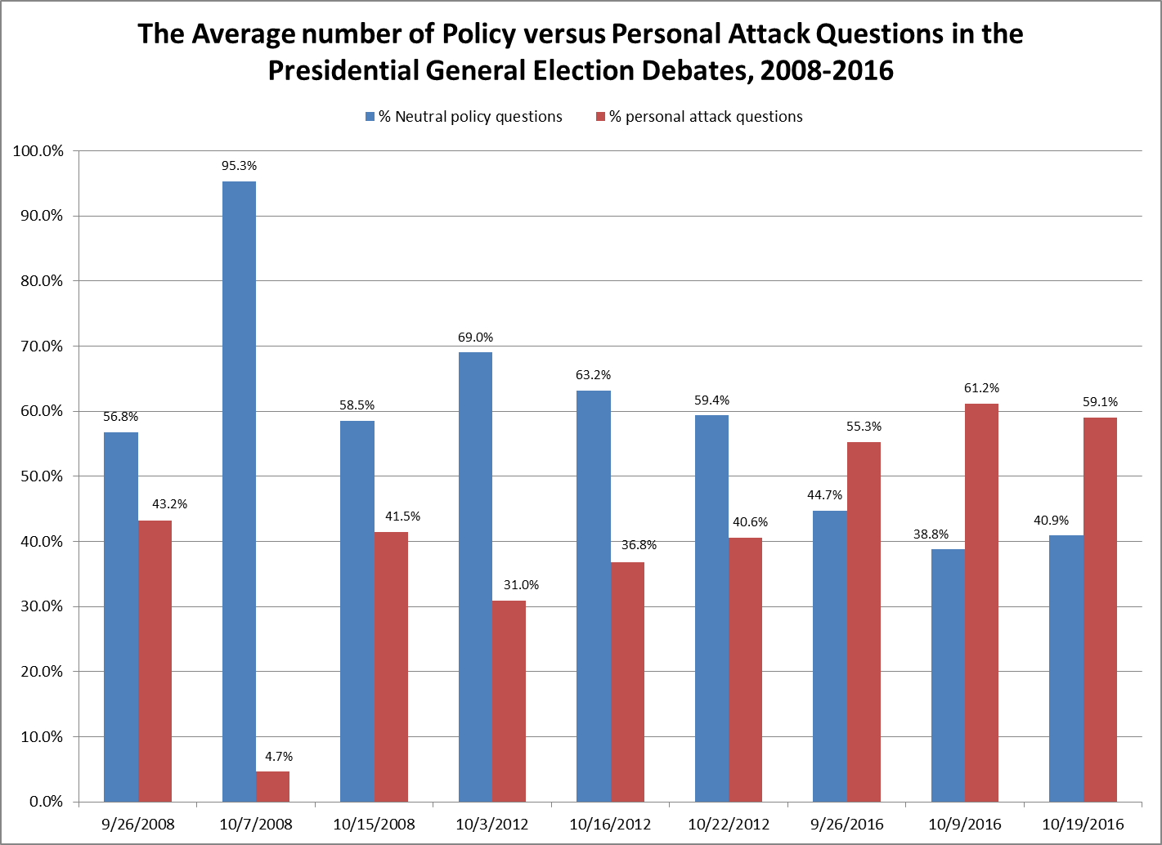

Chart 2:
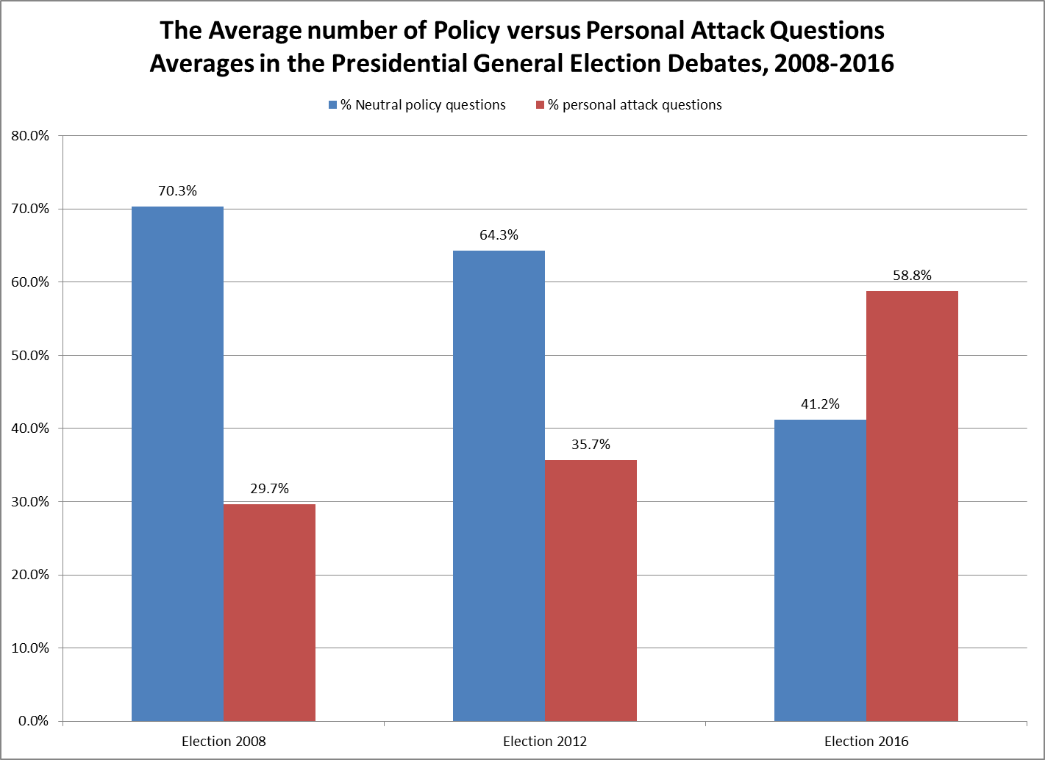

Both Chart 1 and 2 are significant in demonstrating the shift in types of questions asked by the moderator since 2008 in the general election debates. Indeed, in 2008 and 2012, questions tended to examine and seek policy proposals by the candidates. These questions were very similar to those such as Tom Brokaw’s first question to Senator Jon McCain and Senator Barack Obama in the October 7, 2008 general election presidential debate where he asked: “With the economy on the downturn and retired and older citizens and workers losing their incomes, what's the fastest, most positive solution to bail these people out of the economic ruin?” Indeed, in 2008 less than 30% of the questions overall that were asked in the general election debates were of a personal attack or “trap” nature. In 2012, this average number rises, but not necessarily significantly, to 36% personal attack questions. This means that in 2008 and 2012, only about a third of the presidential general election debates engaged personal attack questions .
A major shift has occurred in 2016, however. The percentage of personal attack questions rises to almost 60% of the questions asked during the debates. Americans viewed the 2016 presidential election as one of the most polarizing and negative in history. Is it any wonder that this impression was garnered if, on average, two-thirds of the three debates focused on negativity, conflict and personal attack? The question asked to Donald Trump by Anderson Cooper in the October 9th, 2016 debate demonstrates this shift away from policy differentiation and towards moderators that seek to make themselves (and their interpretations of events and fact-checks) part of the debates. In the very first questions for Trump, he stated “You described kissing women without consent, grabbing their genitals. That is sexual assault. You bragged that you have sexually assaulted women. Do you understand that?” This question already defines the terms of what occurred and how it should be interpreted by viewers before the candidate even has a chance to acknowledge the event and discuss or spin it for themselves. In fact, on the heels of this question, several women came forward prior to the final general election presidential debate and claimed that Trump had sexually assaulted them as well. Cooper did not just present Trump with a personal attack question, he changed the course of discussion for the remaining 2016 campaign through his activism.
The examples above from the general election campaigns are not unique to a single debate, but permeate the shifting tone of almost all of the events. How this changing tone impacted turnout and the election should be an absolute focus of further study. However, more centrally to the impact of narrowing down the party candidates to a single nominee, did this kind of question dichotomy exist within the presidential primary debates as well? With so many candidates on stage, and much less time to respond than in a general election debate with only two candidates, personal attack questions could have significant impact on public perception of candidate differentiation prior to primary elections; therefore, the impact of a shift in tone may suggest voters are making primary voting decisions on sensational personal information of the candidate as opposed to policy proposals and plans for America should they receive the party nomination.

Chart 3:
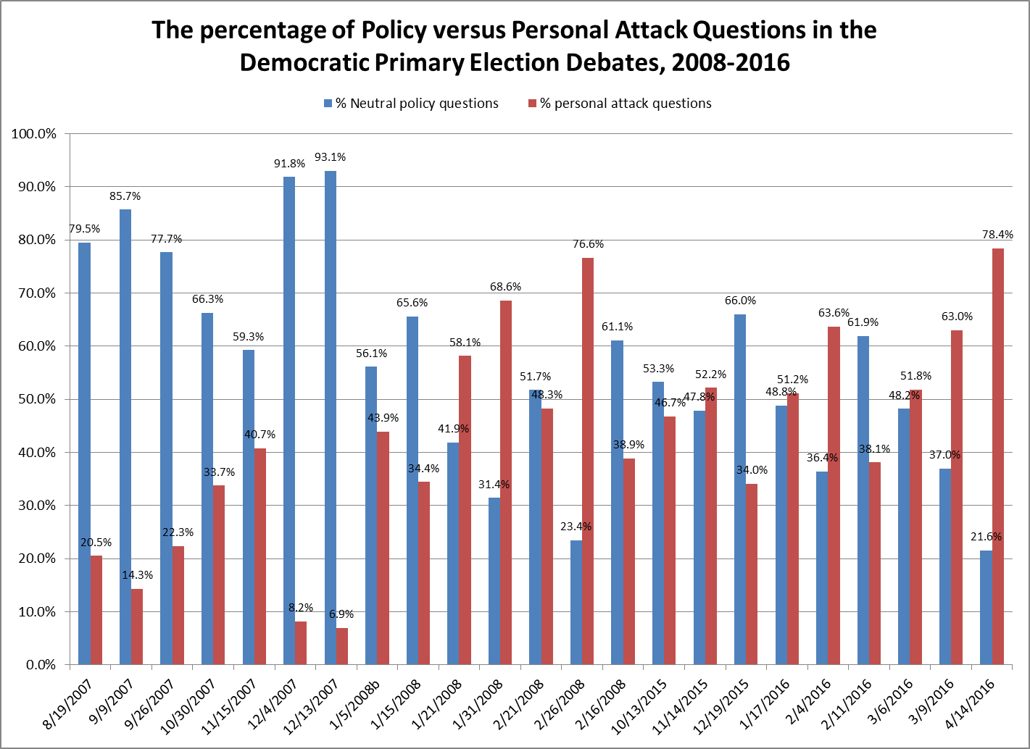

Chart 4
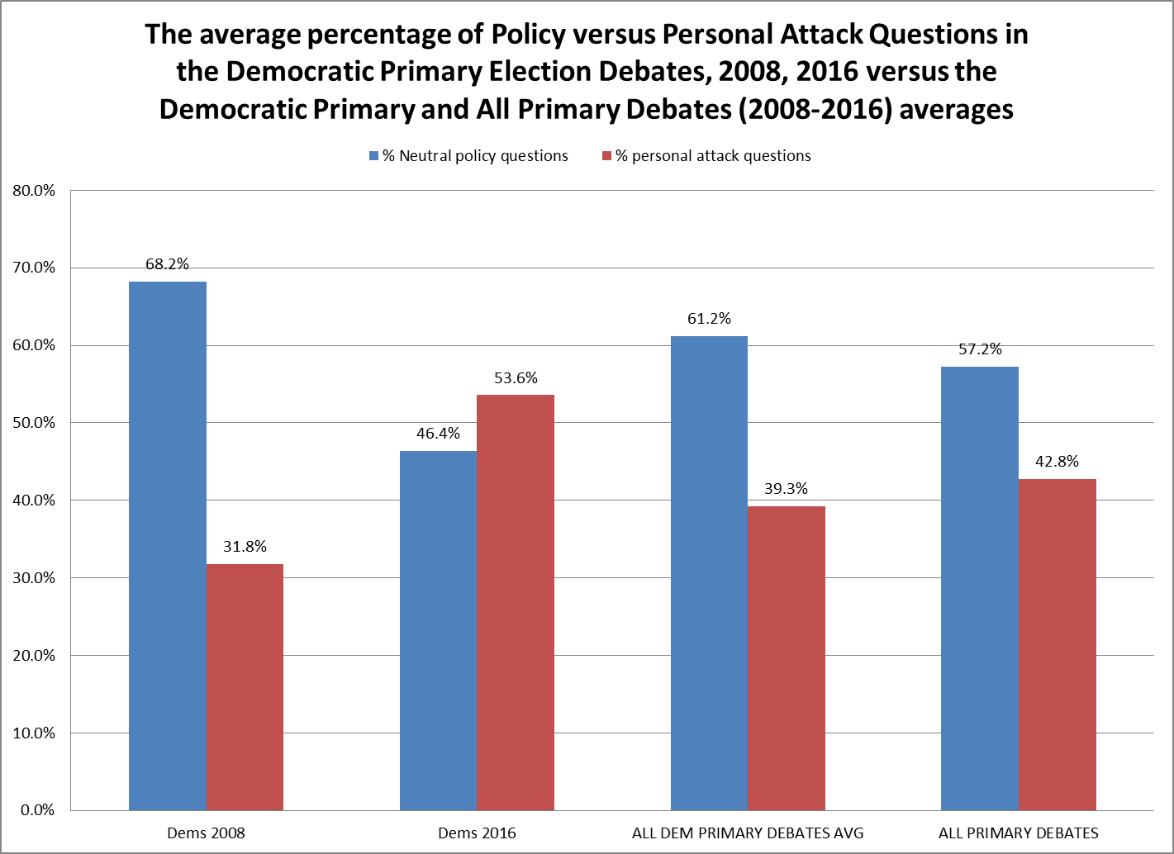

Chart 3 illustrates the percentages of neutral policy questions as opposed to personal attack questions through the 2008 and 2016 Democratic presidential primary debates. The election year of 2012 had no primary debates for the Democrats because sitting incumbent president Obama was the presumptive nominee. Chart 4 provides the average percentages of policy versus personal questions in the 2008-2016 cycles as well as the average of all of the Democratic primary debates and all primary debates over that time period. One of the first major points of observation from the charts above is the general shift in prominence of personal attack questions that can be seen beginning at the end of the 2008 cycle of primary debates and continuing with increased frequency through all of the 2016 primary debates. This rise culminated with the April 4, 2016 primary debate between Hillary Clinton and Bernie Sanders that had almost 80% of the questions asked of a personal attack or conflictual nature. Hosted by CNN, questions posed to the two candidates were aggressive from the first one asked by Wolf Blitzer to begin. He asked, “Senator Sanders, in the last week, you've raised questions about Secretary Clinton's qualifications to be president. You said that something is clearly lacking in terms of her judgment and you accused her of having a credibility gap. So let me ask you, do you believe that Secretary Clinton has the judgment to be president?” Sanders was not exempt from these moderator attacks either as he was soon asked “The daughter of the Sandy Hook Elementary School who was killed back in the 2012 mass shooting, says you owe her and families an apology. Do you?” These questions are tangentially policy related (if at all) and are framed in such a way that there is no way for the candidate to respond without either acknowledging a flaw in themselves or attacking another on stage.
Chart 4 dramatically reiterates this change by showing the increase in personal attack questions in the Democratic primary debates from an average of 32% of the questions asked in 2008 to nearly 54% of the questions moderators posed in 2016. The average of personal attack questions in 2016 is over 10% higher than even the averages of all of the debates or all of the democratic debates from 2008-2016. The Democratic primary debates of 2016 saw moderators ask the highest levels of attack and conflictual questions in history.
After having examined the Democratic party, the question becomes whether or not the Republican Primary debates, which occurred in 2008, 2012 and 2016 might exhibit the same changes in moderator question tone. In addition, were, as many of the candidates claimed in 2016, the Republicans attacked more than their Democratic counterparts?

Chart 5:
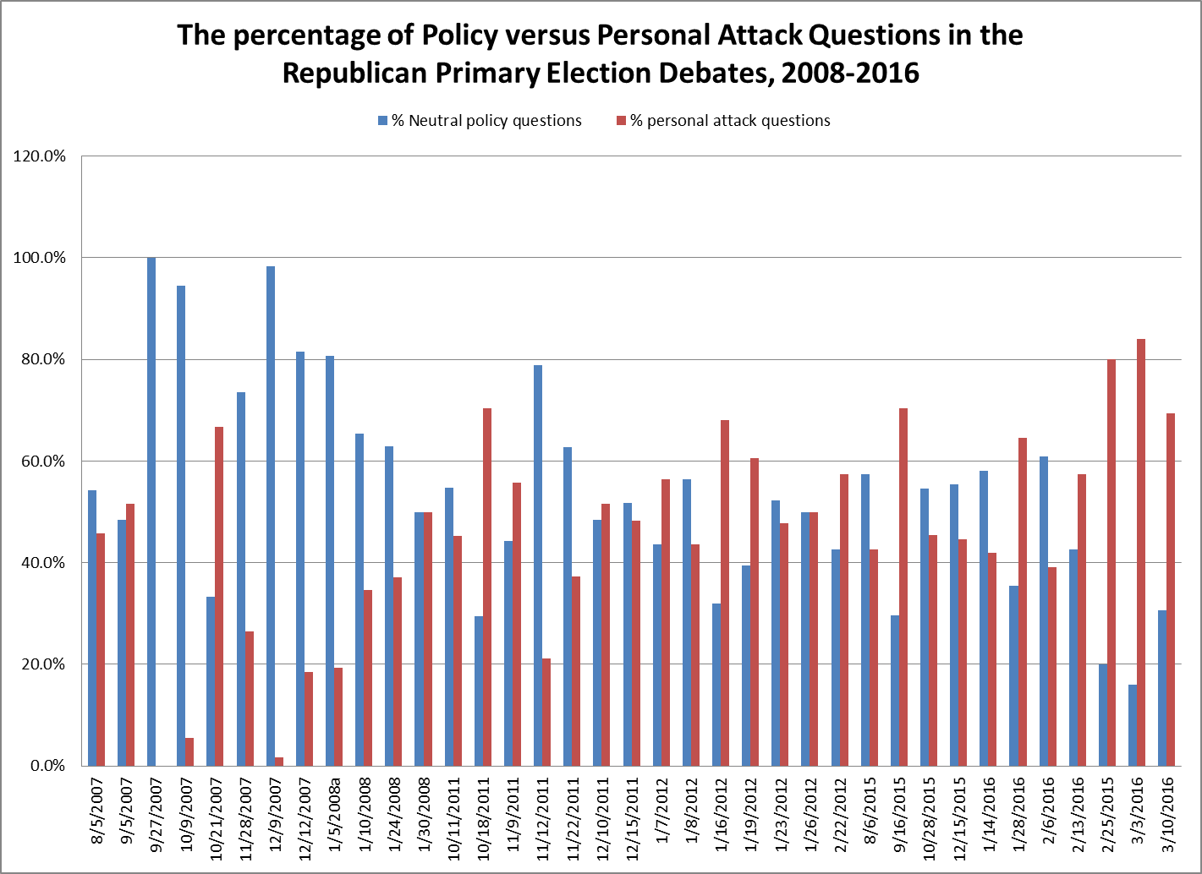

Chart 6:
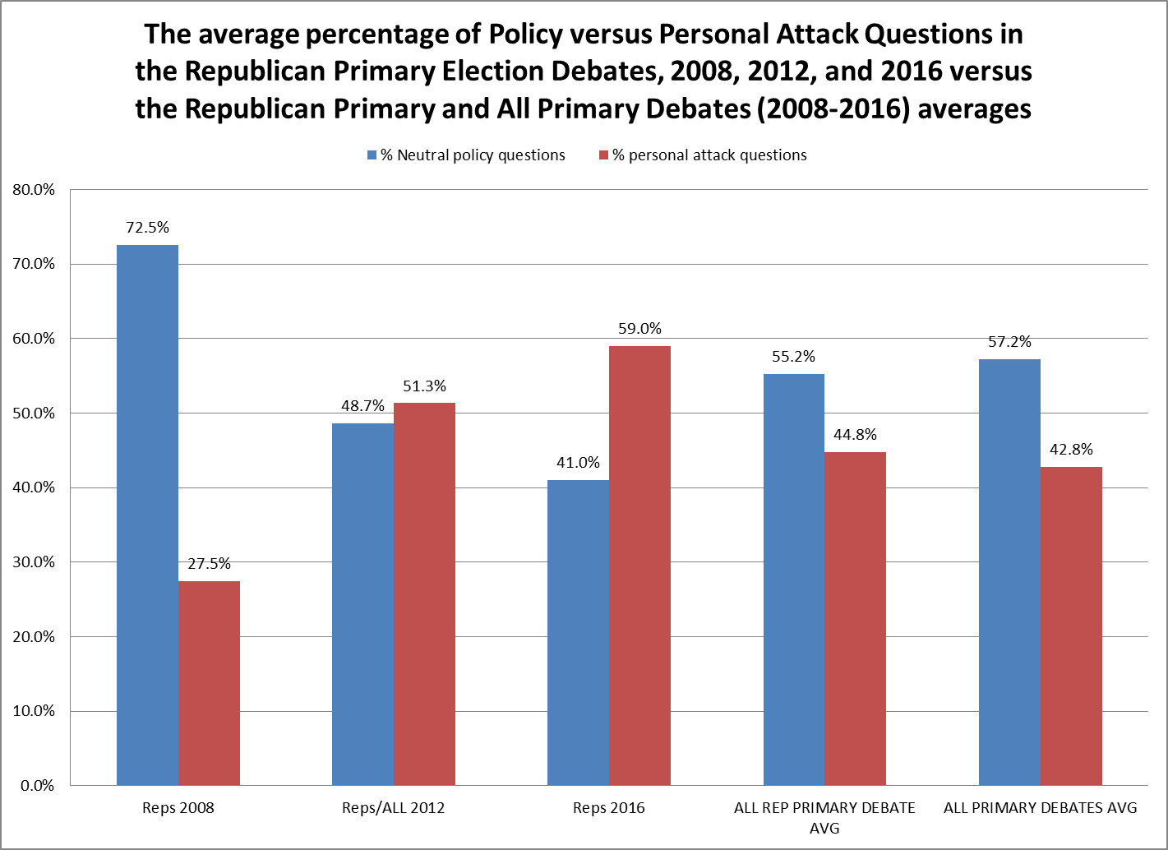

Chart 5 looks at the percentage of neutral policy versus personal attack questions in each of the Republican presidential primary debates from 2008-2016. Chart 6 illustrates the average number of neutral policy questions versus personal attack questions in the 2008, 2012, and 2016 Republican primary debates as well as the overall average of all Republican primary debates from 2008 to 2016 and the overall primary debate average for Republican and Democrat primary debates from 2008-2016. One of the first major observations of Chart 5 is the evolution of the inclusion of personal attack questions in the Republican debates from 2008-2016. In 2008, the overwhelming number of questions that were asked of the candidates was policy related and politically neutral questions. The average is over 70% neutral policy questions and, indeed, Chart 5 shows that fully eight of the twelve Republican Debates had over 60% of the questions that were asked of a neutral policy related nature. Election 2012 saw a significant change where the average of personal attack questions nearly doubled from the 27% level of 2008 to 51% of the inquiries made by the moderators of the candidates in 2012.
This trend continues into the 2016 Republican primary debates where almost 60% of the questions asked were personal attack questions. Further, the last three debates of the 2016 primary cycle had an incredible average of 78% personal attack questions asked by the moderators. The debate transcripts from 2016 are rife with vivid examples of questions which do not touch on policy at all or do so only tangentially. Although all of the candidates at one time or another commented on this shift during the course of the primary season, Ted Cruz, perhaps more than anyone else (save for Trump’s engagement of this trend in the general election debates) engaged the moderators on their tone and the questions they asked. In the Oct 28, 2015 debate, he commented, “You know, let me say something at the outset. The questions that have been asked so far in this debate illustrate why the American people don't trust the media. [applause] This is not a cage match. And, you look at the questions — "Donald Trump, are you a comic-book villain?" "Ben Carson, can you do math?" "John Kasich, will you insult two people over here?" "Marco Rubio, why don't you resign?" "Jeb Bush, why have your numbers fallen?" How about talking about the substantive issues the people care about?” Again in the Jan 28, 2016 debate Cruz engaged moderator Chris Wallace over the personal attack nature of the questions through the following exchange:

“CRUZ: Chris, I would note that that the last four questions have been, "Rand, please attack Ted. Marco, please attack Ted. Chris, please attack Ted. Jeb, please attack Ted..." [audience reaction] Let me just say this...
WALLACE: ... It is a debate, sir.
CRUZ: ... Well, no, no. A debate actually is a policy issue, but I will say this. Gosh, if you guys ask one more mean question I may have to leave the stage. [applause]”

The averages in Chart 6 above suggest a nearly 30% increase in personal attack questions in Republican primary debates from 2008 to 2016. In addition, the 2016 average (nearly 60%) is far above the personal attack question average of all of the Republican primary debates from 2008-2016 (44%) and even more distant from the average attack questions asked in all primary debates (42%). For the Republican candidates for president, the expectation has seemingly become to expect at least 2/3 of the primary debate to focus on personal attacks from the moderators or those that will come from loaded questions directed at them as an attempt at conflict with the other candidates on stage.
Two further questions arise in the examination of the change between neutral policy and personal attack questions in presidential primary debates. Primarily, were either the Democrats or the Republicans attacked by moderators at a higher frequency than the other? And, secondarily, were there any types of media (commercial versus non-profit press) that tended to treat the candidates with greater hostility than others?

Chart 7
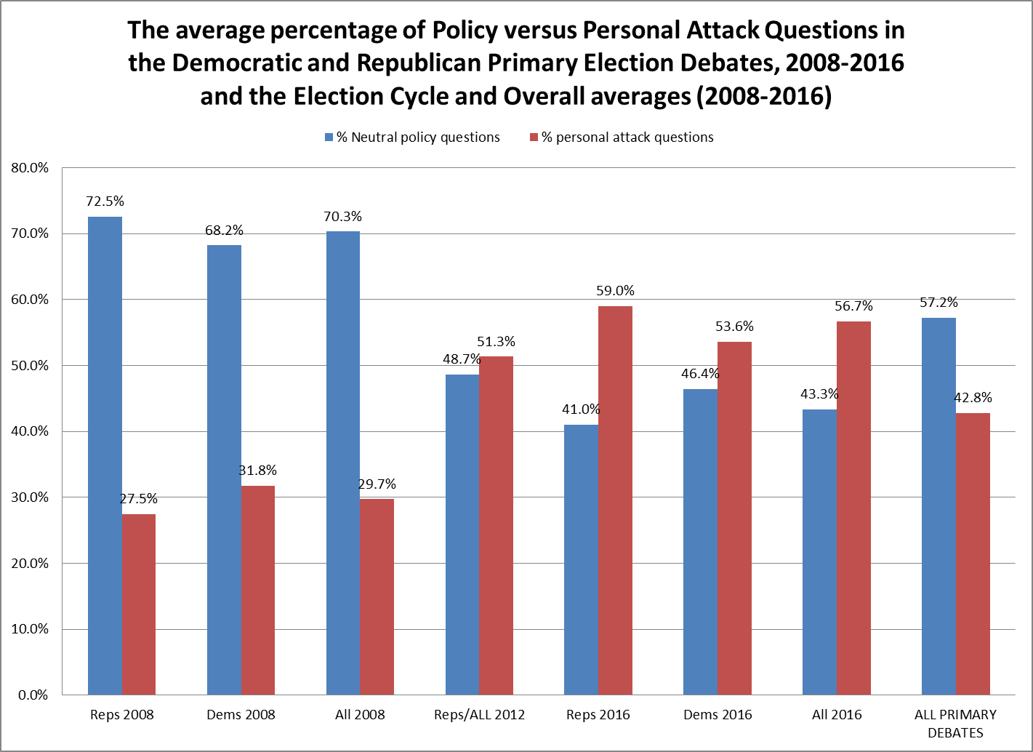

Chart 7 shows the average percentage of neutral policy versus personal attack questions that were asked of both Republicans and Democrat s in the primary debates of 2008, 2012, and 2016. It also shows the average of these questions for the entire period of primary debates from 2008-2016. Although the chart above is consistent with previous data that show a significant increase in personal attack questions over neutral policy questions over the 2008-2016 period, it does not demonstrate that Republicans were necessarily targeted to a significant degree more than Democrats in the primary debates. Although candidate support in the general election came from the branding of many mainsteam outlets as “fake news” that were only targeting the Republican candidate, a lopsided emphasis cannot be found for Republican versus Democrat candidates in the primary debates.
This equal distribution of personal attack questions between Republican and Democrat contenders for their party’s nomination shown above does not, however translate to media outlets or moderators that demonstrate an equal incorporation of personal attack questions for candidates during the course of their debate hostings.

Table 1:
primary debates | Party | moderator | % personal attack questions
3/3/2016 | Rep | Foxnews | 84.0%
2/25/2015 | Rep | CNN | 80.0%
4/14/2016 | Dem | CNN | 78.4%
2/26/2008 | Dem | NBC | 76.6%
10/18/2011 | Rep | CNN | 70.5%
9/16/2015 | Rep | CNN | 70.4%
3/10/2016 | Rep | CNN | 69.3%
1/31/2008 | Dem | CNN | 68.6%
1/16/2012 | Rep | Foxnews | 68.1%
10/21/2007 | Rep | Foxnews | 66.7%
1/28/2016 | Rep | Foxnews | 64.6%
2/4/2016 | Dem | MSNBC | 63.6%
3/9/2016 | Dem | Univision | 63.0%
1/19/2012 | Rep | CNN | 60.6%
1/21/2008 | Dem | CNN | 58.1%
2/13/2016 | Rep | CBS | 57.4%
2/22/2012 | Rep | CNN | 57.4%
1/7/2012 | Rep | ABC | 56.3%
11/9/2011 | Rep | CNBC | 55.7%
11/14/2015 | Dem | CBS | 52.2%
3/6/2016 | Dem | CNN | 51.8%
9/5/2007 | Rep | Foxnews | 51.6%
12/10/2011 | Rep | ABC | 51.6%
1/17/2016 | Dem | NBC | 51.2%
1/30/2008 | Rep | CNN | 50.0%
1/26/2012 | Rep | CNN | 50.0%
2/21/2008 | Dem | CNN | 48.3%
12/15/2011 | Rep | Foxnews | 48.2%
1/23/2012 | Rep | NBC | 47.8%
10/13/2015 | Dem | CNN | 46.7%
8/5/2007 | Rep | ABC | 45.8%
10/28/2015 | Rep | CNBC | 45.5%
10/11/2011 | Rep | PBS | 45.2%
12/15/2015 | Rep | CNN | 44.6%
1/5/2008b | Dem | ABC | 43.9%
1/8/2012 | Rep | NBC | 43.5%
8/6/2015 | Rep | Foxnews | 42.6%
1/14/2016 | Rep | FBN | 41.9%
11/15/2007 | Dem | CNN | 40.7%
2/6/2016 | Rep | ABC | 39.1%
2/16/2008 | Dem | ABC | 38.9%
2/11/2016 | Dem | PBS | 38.1%
11/22/2011 | Rep | CNN | 37.3%
1/24/2008 | Rep | NBC | 37.0%
1/10/2008 | Rep | Foxnews | 34.6%
1/15/2008 | Dem | NBC | 34.4%
12/19/2015 | Dem | ABC | 34.0%
10/30/2007 | Dem | NBC | 33.7%
11/28/2007 | Rep | CNN | 26.5%
9/26/2007 | Dem | NBC | 22.3%
11/12/2011 | Rep | CBS | 21.2%
8/19/2007 | Dem | ABC | 20.5%
1/5/2008a | Rep | ABC | 19.3%
12/12/2007 | Rep | Des Moines Register | 18.5%
9/9/2007 | Dem | Univision | 14.3%
12/4/2007 | Dem | NPR | 8.2%
12/13/2007 | Dem | Des Moines Register | 6.9%
11/10/2015 | Rep | FBN | 6.3%
10/9/2007 | Rep | MSNBC/CNBC/WSJ | 5.5%
12/9/2007 | Rep | Univision | 1.8%
9/27/2007 | Rep | PBS/NPR | 0.0%

Table 1 is an examination of the Presidential Primary debates sorted by the highest level of personal attack questions to the lowest. It shows that of the ten debates with the highest percentages of personal attack questions, 9 of them were conducted by the cable news networks CNN and Foxnews. In fact, of these ten debates, none of the moderators spent more than only 1/3 of the questions on neutral policy related positions of the candidates. Also, both of the final debates of both the democratic and republic primaries of 2016 fall within the top five levels of the highest numbers of personal attack questions asked. Consistent with this seeming connection between the news networks driven by advertising dollars and the high levels of personal attack questions, the lowest levels of personal attack questions from 2008-2016 came from, largely, non-corporate news entities. Networks and moderators from PBS, NPR, and local news affiliates (the Des Moines Register) provided the lion’s share of their questions and coverage to differentiating the policy differences between candidates, by using neutral questions to allow the candidates themselves to frame the issues as they best saw fit. In addition, two of the ten lowest personal attack percentages came from the Hispanic television station Univision as well. This would seem to confirm other scholars’ observations about the need for corporate news to focus on conflict driven stories and controversial approaches to garner ratings and advertising dollars. And, in addition to embracing this approach in regular news coverage, this has also influenced the ways in which the networks as well as the moderators have approached the candidates for president of the United States, with sensationalism and personal attack questions trumping (pun intended) neutral policy questions on the candidates’’ plans for American and their administration.

Conclusion and Directions for Further Study

In the spring of 2016, CNN hosted two debates that pitted the contenders for the Democratic National Committee Chair against each other (which had never been televised in primetime with a moderator before) and saw Senator Bernie Sanders take on Senator Ted Cruz on issues CNN believed to be facing the country. It seemed as though there was a Campaign 2016 hangover that left a void in controversial political debate coverage that corporate networks had been able to fill for the past two years with the Democratic and Republican primary debates, as well as the General election debates.
This study demonstrates the dramatic shift in debate tone and moderator questions from the 2008 to the 2016 presidential elections. Turcotte explains the dangers that “If the infotainment elements plaguing campaign news content influence presidential debates, these elements would limit policy discourse on the agenda—discourse vital for citizens to cast an informed vote.” (2015, 241) In addition, this study suggests that the window for viewing a campaign negatively has widened compared to that proposed by Glantz (2013) who “finds that If voters believe political campaigns are mostly negative, that impression may have been fostered by news coverage which reports on attacks much more often than they occur in presidential primary debates” (283; see also Benoit, Hansen, & Stein, 2004). The evolution of moderator questions has seemingly extended this window of negativity throughout the entire presdiential campaign process instead of just the end. Significantly, “With the apparent shift in how voters judge such debates toward a more theatrical standard and a view of
modestly complicated argument as ‘‘brain bruising television,’’ presidential debates’
educative function is called into question.” (Rowland 2013, 541)
The results above find that both the general election and primary debates have witnessed the replacement of the majority of the questions asked by the moderators from those presented in neutral frame and addressing policy, to questions that embrace the sensationalist (and unconfirmed) issues of the day, questions that trap candidates with no good way to answer the question, questions where the moderators issue blistering attacks on the candidates personal lives or character, and questions where moderators attempt to fact-check candidates according to the ways they personally view the candidates’ policies. Almost two-thirds of contemporary presidential debates involve personal attack questions as opposed to only one-third only eight years ago. This has truly moved from the conclusion that “the public debate agenda is less focused on conflict than the media’s (Carlin et al.,2001; Kaid et al., 2000; Morello, 2005; Schroeder, 2008).” (Turcotte 2015, 244) In addition, the corporate cable news networks lead the way by huge margins in the incorporation of these hostile and conflictual questions into their debate structures, as opposed to public or non-profit networks. This is contrary to Turcotte who “finds that commercial journalists are no more likely to retreat to soft news and infotainment questions than the public and nonprofit journalists. In fact, they outperform nonprofit media in setting a hard news and policy-driven agenda” (Turcotte 2015, 252)
These findings are significantly problematic “if citizens are going to make a reasoned choice based on the ideology or character of the competing candidates [because], they need to know what positions and values the candidates support.” (Rowland 2013, 533). The findings contained herein raise several troubling points as well as essential and immediate questions that must get further study by scholars. The impact of a personal attack driven exchange throughout the course of a presidential election has repercussions for both the candidates and electorate as well. Will this focus on sensationalist questioning impact political candidates’ decisions to even enter the race for President of the United States, in effect keeping people from running who (as was George Washington in seeking a second term) are afraid that the perception of slander will besmirch their families or reputations? Does the focus on questions which encourage candidate hostility towards each other de-stimulate turnout of voters who become disgusted or disillusioned with the process? Will this begin to favor the loudest and most aggressive candidates over those that have innovative policy ideas but either are not asked any questions during the debates or are rolled over by argumentative others? The general election of 2016 saw comparatively low turnout; what impact did the public forum that the debates gave to personal attack and questions built on sensationalism have on the electorate and feelings of political efficacy?
And lastly, and maybe most importantly, what effect did the moderators and the questions that they asked have on the impact of who was selected by each party as the nominee, as well as the results in-total of the presidential election overall? If these debates, largely seen by McKinney (2013) and others as providing an educational function for the general electorate, move away from policy and into the personal attack vein, what impact does this have on the voters’ conceptualization democracy and the election for president of the United States? Indeed, “while much of the presidential debate research on candidate evaluations has been conducted with general campaign debates, a few studies have found that primary debate exposure produces significant changes in viewers' perceptions of candidates” (McKinney 2013, 240; see also Benoit et al.,2002; McKinney et al., 2001; Pfau, 1987). This moderator preference to personal attacks is “troubling not just because it limits the educative function of debates in relation to the issues but also because it limits the capacity of voters and the media to judge the character of the candidates.” (Rowland 241) Indeed, “if the infotainment elements plaguing campaign news content influence presidential debates, these elements would limit policy discourse on the agenda—discourse vital for citizens to cast an informed vote.” (Turcotte 2015, 239) This study hopes to open the door for examination of these topics in the larger context of who, in the end, governs over the American democratic system, and how they got there.

Works Cited (many yet to be included in literature section)
Bennett, W. Lance. 2012. News: The Politics of Illusion. Boston, MA: Longman-Pearson.

Benoit, W. L., McKinney, M. S. and Stephenson, M. T. (2002), Effects of Watching Primary Debates in the 2000 U.S. Presidential Campaign. Journal of Communication, 52: 316–331.

Benoit, William L., and Glenn J. Hansen. 2001. “Presidential Debate Questions and the Public
Agenda.” Communication Quarterly 49 (2): 130–141.

Benoit, William L., Glenn J. Hansen, and Rebecca M. Verser. 2003. “A Meta-Analysis of the Effects of Viewing U.S. Presidential Debates.” Communication Monographs 70 (4): 335–350.

Ben-Porath, Eran N. 2007. “Question Bias and Violations of Comparability in Intraparty Debate:
Iowa and New Hampshire, 2004.” Communication Quarterly 55 (4): 375–396.

Boorstin, Daniel J. 1961. The Image: A Guide to Pseudo-Events in America. New York: Vintage.

Breed, Warren. 1955. “Social Control in the Newsroom: A Functional Analysis.” Social Forces
33 (4): 326–335.

Byers, Dylan. “Crowley Fact-Checks Mitt” Politico.com October 7, 2012. Accessed March 15, 2016.

Cappella, Joseph N., and Kathleen Hall Jamieson. 1997. Spiral of Cynicism: The Press and the
Public Good. New York: Oxford University Press.

Carlin, Diana P., Eric Morris, and Shawna Smith. 2001.“The Influence of Format and Questions
on Candidates’ Argument Choices in the 2000 Presidential Debates.” American Behavioral
Scientist 44 (12): 2196–2218.

Cohen, Jeffrey E. 2008. The Presidency in the Era of 24-Hour News. Princeton, NJ: Princeton
University Press.

Coleman, Stephen. 2013. “Debate on Television: The Spectacle of Deliberation.” Television & New Media 14 (1): 20–30.

Cook, Timothy E. 2006.“The News Media as a Political Institution: Looking Backward and
Looking Forward.” Political Communication 23 (2): 159–171.

Delli Carpini, M. X., & Williams, B. A. (2001). Let us infotain you: Politics in the new media
environment. In W. L. Bennett & R. M. Entman (Eds.), Mediated politics: Communication in
the future of democracy (pp. 160–181). New York, NY: Cambridge University Press.

Delli Carpini, Michael X., and Scott Keeter. 1996. What Americans Know About Politics and Why it Matters. New Haven: Yale University Press.

Druckman, James N. 2003.“The Power of Television Images: The First Kennedy-Nixon Debate
Revisited.” The Journal of Politics 65 (2): 559–571.

Dunaway, Johanna. 2008.“Markets, Ownership, and the Quality of Campaign News Coverage.”
The Journal of Politics 70 (4): 1193–1202.

Eveland, William P., Douglas M. McLeod, and Amy I. Nathanson. 1994.“Reporters vs. Undecided Voters: An Analysis of the Questions Asked During the 1992 Presidential Debates.”
Communication Quarterly 42 (4): 390–406.

Fallows, James. 2008. “Rhetorical Questions.” Atlantic Monthly 302 (2): 34–52.

Farnsworth, Stephen J., and Robert S. Lichter. 2011.The Nightly News Nightmare: Media Coverage of U.S. Presidential Elections, 1988–2008. Lanham, MD: Rowman & Littlefield.

Fishkin, James S. 1991. Democracy and Deliberation: New Directions for Democratic Reform. New Haven, CT: Yale University Press.

Forgette, Richard, and Jonathan S. Morris. 2006. “High Conflict Television News and Public
Opinion.” Political Research Quarterly 59 (3): 447–456.

Glantz, Mark, William Benoit, and David Airne. “A Functional Analysis of 2102 U.S. Presidential Primary Debates.” In Argumentation and Advocacy. 49 (Spring 2013): 275-285.

Graber, Doris A. 2001.Processing Politics: Learning From Television in the Internet Age. Chicago: The University of Chicago Press.

Guthrie, Marisa. “Jim Lehrer Offers Advice to Debate Moderators: It’s Not About You (Q&A).” The Hollywood Reporter.com September 26, 2016. Accessed March 15, 2017.

Halper, Daniel, Marisa Schultz, and Danika Fears. “Nasty Exchanges, personal attacks dominate second debate.” New York Post.com October 9, 2016. Accessed March 10, 2016.

Hamilton, James T. 2004. All the News That’s Fit to Sell: How the Market Transforms Information into News. Princeton, NJ: Princeton University Press.

Hart, Roderick P., and Sharon E. Jarvis. 1997. “Political Debate: Forms, Styles, and Media.”
American Behavioral Scientist 40 (8): 1095–1122.

Hohmann, James. “Debate Moderators get Advice on How to Avoid Clashing with Trump.” The Denver Post.com September 15, 2016. Accessed March 15, 2017.

Holbrook, Thomas M. 1999. “Political Learning from Presidential Debates.” Political Behavior
21 (1): 67–89.

Iyengar, Shanto, and Donald R. Kinder. 1987. News That Matters: Television and American
Opinion. Chicago: The University of Chicago Press.

Iyengar, Shanto, Helmut Norpoth, and Kyu S. Hahn. 2004.“Consumer Demand for Election
News: The Horserace Sells.” Journal of Politics 66 (1): 157–175.

Jamieson, Kathleen H., and David S. Birdsell. 1988. Presidential Debates: The Challenge of Creating an Informed Electorate. New York: Oxford University Press.

Just, Marion R., Ann N. Crigler, Dean E. Alger, Timothy E. Cook, Montague Kern, and Darrell West.1996. Crosstalk. Chicago: University of Chicago Press.

Kaid, Linda L., Mitchell S. McKinney, and John C. Tedesco. 2000. Civic Dialogue in the 1996
Presidential Campaign: Candidates, Media, and Public Voices. Cresskill, NJ: Hampton Press.

Lawrence, Regina G. 2000. “Game-Framing the Issues: Tracking the Strategy Frame in Public
Policy News.” Political Communication 17 (2): 93–114.

Lehrer, Jim. 2011. Tension City: Inside the Presidential Debates, From Kennedy-Nixon to Obama-McCain. New York: Random House.

Matera, Frances R., and Michael B. Salwen. 1996. “Unwieldy Questions? Circuitous Answers?
Journalists as Panelists in Presidential Election Debates.” Journal of Broadcasting &Electronic Media 40 (3): 309–317.

Mazzoleni, Gianpietro, and Winfried Schulz. 1999. “Mediatization of Politics: A Challenge for
Democracy?” Political Communication 16 (3): 247–261.

Mckinney, Mitchell and Benjamin R. Warner. “Do Presidential Debates Matter? Examining a Decade of Campaign Debate Effects.” In Argumentation and Advocacy, 49 (Spring 2013): 238-258

McKinney, Mitchell S. 2005. “Let the People Speak: The Public’s Agenda and Presidential Town
Hall Debates.” American Behavioral Scientist 49 (2): 198–212.

Minow, Newton N., and Craig L. LaMay. 2008. Inside the Presidential Debates: Their Improbable Past and Promising Future. Chicago, IL: The University of Chicago Press.

Morello, John T. 2005. “Questioning the Questions: An Examination of the Unpredictable 2004
Bush-Kerry Town Hall Debate.” Argumentation and Advocacy 41: 211–224.

Prior, Markus. 2007. Post Broadcast Democracy: How Media Choice Increase Inequality in Political Involvement and Polarizes Elections. New York: Cambridge University Press.

Rowland, Robert. “The First 2012 Presidential Campaign Debate: the Decline of Reason in Presidential Debates.” In Communication Studies, 64 (5): 528-547
Schroeder, Alan. 2008. Presidential Debates: Fifty Years of High-Risk TV. New York: Columbia University Press.

Schroeder, Alan. 2012.“The Challenge of Selecting Presidential Debate Moderators.”
The Huffington Post, August 18.

Sparrow, Bartholomew H. 2006.“A Research Agenda for an Institutional Media.” Political
Communication 23 (2): 145–157.

Stromer-Galley, Jennifer, and Lauren Bryant. 2011. “Agenda Control in the 2008 CNN/YouTube
Debates.” Communication Quarterly 59 (5): 529–546.

Trent, Judith S., Robert V. Friedenberg, and Robert E. Denton. 2011. Political Campaign
Communication. Lanham, MD: Rowman & Littlefield.

Turcotte, Jason. 2014. "Debates and the Disincentives of Democracy." Journalism Practice 8, no. 6: 772-788. Communication & Mass Media Complete, EBSCOhost (accessed April 5, 2017). 2014
Turcotte, J. n.d. "The News Norms and Values of Presidential Debate Agendas: An Analysis of Format and Moderator Influence on Question Content." Mass Communication And Society 18, no. 3: 239-258. Social Sciences Citation Index, EBSCOhost (accessed April 5, 2017). 2015
Williams, Bruce A., and Michael X. Delli Carpini. 2011.After Broadcast News: Media Regimes,
Democracy, and the New Information Environment. New York: Cambridge University Press.

