Rural Matters:
Rural Political Identity and Political Behavior and Attitudes

by Timothy Lindberg and Annika Johnson

Prepared for Presentation at the 2019 Annual Western Political Science Association (WPSA) Conference April 17-20, 2019.

This is a draft of the manuscript. Please contact the authors for an updated version.

Abstract:
The longstanding perception of an urban-rural divide was renewed in force after the 2016 Presidential election which saw a significant shift toward Republican voting across rural areas of the country. Efforts to understand the political implications of the rural side of any potential urban-rural divide have been sporadic because research has either focused on the rural aspect, without in-depth political consideration, or has taken a political view without specifically looking at rural Americans. Based upon a unique survey of rural Minnesotans administered prior to the 2018 midterm elections, this project bridges some of that gap by investigating the ways in which rural residents perceive themselves, as well as the places they live, and connecting this directly to their political behaviors and attitudes. The outcome is the construction of measure that can be used to test how rural identity operates as a determinant of political values and beliefs apart from party and ideology. This is important within discussions of political representation, public policy, and political behavior across all levels of governance in the United States to further our understanding of how place-based identification impacts politics.

Introduction

The idea of an urban-rural divide is nothing new in the United States. In 1961, Professor Friedman began an article devoted to the subject with the argument that “‘Urban-rural dichotomy,’ ‘urban-rural continuum,’ and ‘urban-rural conflict’ are terms which have permeated the language of the social sciences for a generation.” (Friedman 1961, 481) The growth in metropolitan areas in the U.S., combined with the relative stagnation of many rural areas’ populations has arguably exacerbated the divide. This has had numerous impacts on American society and culture, but it has also strongly influenced American politics. As rural areas shift political allegiances, despite their relatively smaller share of voters, those shifts can still cause dramatic partisan changes in power. The 2016 presidential election was only one example of this. While Trump’s victory in the Electoral College was surprising to many observers, and unlikely even in the most favorable predictions, his ability to win over strong majorities of mostly rural voters in the Midwest, became arguably the defining feature of the election’s outcome.
The urban-rural divide is even more evident within certain states, particularly those with rapidly growing urban areas in states which had been historically more rural. In Colorado, the 2019 legislative session is rife with obstructionists’ tactics by Republicans because as Senator Sonnenberg noted, the Democrats elected in the Front Range Corridor don’t care about the rural segments of the state. “This is a larger war on rural Colorado,” he told a reporter (Goodland 2019). In Nebraska, Republican Governor Pete Ricketts responded to a town hall question on property taxes by asking a farmer why the people in Lincoln and Nebraska (the only urban centers in the state) would want to raise their taxes in order to provide relief to rural farmers (Editorial Board 2019). A group of Political Scientists from universities in Oregon wrote a paper arguing that economic, social, and technological trends caused a deepening divide between rural and urban areas of the state since the 1980s, concluding that bridging the gap is difficult, although there might be some areas of commonality (Clucas, Henkels, Steel 2009). Even the National League of Cities produced a 2018 report about bridging the economic divide between urban and rural areas, focusing on prosperity growth, high-value business growth, access to broadband, education, and population divides (McFarland 2018). Clearly the urban-rural divide is on the minds of media, non-profit, public, and academic leaders.
Despite these concerns and attention, few efforts have been undertaken to directly tie together the impact of the urban-rural divide on political behavior and attitudes. In particular, very little has been done to investigate the rural side of this issue. In this article we argue that rural identity does have impacts on political behavior and attitudes and that better understanding the ways in which this identity works alongside partisanship and ideology can help to explain what makes rural residents unique from their otherwise similarly politically minded urban or suburban counterparts. We define rural identity as a connection with a rural place that goes beyond just physical location and includes a sense of belonging and importance to one’s self-conception. While we can only analyze the rural aspect of that question here, we find that there are important ways in which rural identity impacts political behavior and attitudes, how it connects with traditional rural concepts regarding hard work, honesty, and morality, and how, in the end, all politics have not been nationalized, and some politics are still arguably local.

Literature Review

Images or values of rural places tend to be thought of as the epitome of what it means to be all-American. That is why many people, no matter where they happen to live, have at least some positive reactions to elements of rural life (Theodori and Willits 2018, 1). These positive images of rural life are what scholars refer to as “the rural mystique” (Theodori and Willits 2018, 2). This image includes highly thought of perceptions such as high religiosity, self-reliance and self-sufficiency (Kellogg Foundation 2001,1). While highly favorable responses of rural areas are the norm, what is important to note is that these reactions might not always be accurate, particularly as most people who do not live in rural places believe that the way of life in such places is centered around farming, when in fact only 11.7 percent of rural jobs are directly tied to agriculture (Kellogg Foundation 2001, 1). This means that when talking about rural places, it is important to make distinctions between the various types of counties that exist. An example of this are rural farming versus rural recreational counties. Those who live in recreational communities tend to have higher levels of education and have been exposed to more diverse groups of people due to influxes of immigrants as well as strength in the “new rural economy” which is driven by visitors and vacationers from all around (Scala, Johnson and Rogers 2015,1). Politically speaking, the differences between these two types of places are important as roots in farming and agriculture tend to lend themselves towards a stronger Republican vote, where as a community centered around a more recreational based economy tends to vote more Democratic (Scala, Johnson and Rogers 2015, 1).
The idea of rural consciousness is a measurable term that can be used to try and understand how being rural ties into voting behavior. In her timely book, A Politics of Resentment, Katherine Cramer coins this term, rural consciousness as, “an identity as a rural person that includes much more than an attachment to place. It includes a sense that decision makers routinely ignore rural places and fail to give rural communities their fair share of resources, as well as a sense that rural folks are fundamentally different from urbanites in terms of lifestyles, values and work ethic” (Cramer 2016, 5-6). From this, we can gather the importance that place plays in understanding one’s own identity as well as the role that being rural more specifically plays.
We know that there is a strong sense of identity that is associated with place. This means that when new people migrate into the community, some may feel as though part of their identity is being lost through the changing of the culture in this community. In her 2012 article, Leitner uses the term “spaces of encounters” in order to capture this idea that rural communities have historically been white and are still made up of long-term white residents who are now being faced with growing diversity and immigrants coming into their small towns (Leitner 2012). With this, she makes the argument that whiteness, has a “historical and geographical contingency” which creates a “racialized production of space” (Leitner 2012, 831). However, the strength of this resentment or negative attitudes towards diversity in the community tends to stem from family longevity in the community as well involvement in agriculture (Gimpel and Lay 2008, 183-185). With this, strong anti-immigrant feelings are being found less and less among adolescents in rural America as they are being exposed to more diversity at a younger age, making it a normal encounter for them (Gimpel and Lay 2008, 182).
Given the longevity many rural residents and their families have lived in their communities and the strong ties they then have to these places, it makes sense that they would have strong feelings towards new people entering in, such as immigrants. However, there tends to be a gap between the issues that are actually important to rural voters and what people who don’t live in these places perceive the important issues to be. Perhaps this comes from how Hollywood and the media tend to portray rural places as being made up of hicks who are uneducated, unsophisticated and uncultured (Lichter and Brown 2011). One of the most common misconceptions is that rural means farms which means economies and belief systems that center around agriculture. However, according to the 2002 Census of Agriculture, 41% of U.S. farms and 24% of farmland is in urban areas (Lichter and Brown 2011). This industry, in many instances, is being offset by manufacturing in rural areas as the share of rural Americans employed in agriculture fell from 41% to 2% between 1990 to 2000 (Lichter and Brown 2011). Given this economic shift towards a more union heavy industry as well as high levels of poverty that many rural communities face, it would seem as though Democratic fiscal policies would be most beneficial (Gimpel and Karnes 2006).
At this point in the discussion, it is important to turn back to Cramer, and how “rural consciousness signals an identification with rural people and rural places and denotes a multifaceted resentment against cities” which in turn shapes political views (Cramer 2016, 5-6). Rural people tend to view themselves as independent business owners whose allocation of resources is going to urban centers rather than blue collar workers who are barely getting by (Gimpel and Karnes 2006). Not only a resentment towards urban areas, but also a heightened importance placed in traditional values and religion makes a strong Republican vote logical for rural places (Gimpel and Karnes 2006). This all combined does not necessarily mean that there is an anti-government sentiment among rural individuals. Instead, as Cramer found through her field research in Wisconsin, the feeling is more of a distrust in government and a perception that the government is too distant, therefore lacking an understanding of rural needs and values. In other words, “a lack of trust in government is not the same as wanting less of it” (Cramer 2016, 213). Given social values and a strong narrative by the GOP, it is no wonder, then, that rural areas tend to vote red.
When looking at the campaign and eventual election of Donald Trump, McQuarrie raises interesting observations of why the rural Midwest voted so strongly for this GOP candidate. As he points out, rural voters were given the choice between a New Democratic party which is increasingly unconcerned with the industrial Midwest, or a Republican candidate, Trump, who was challenging policies that offered little hope for their types of communities (McQuarrie 2017, S121). As high numbers of educated people who grow up in rural places move away, and into more urbanized areas with greater opportunities, these communities really begin to struggle (Wuthnow 2018, 60-61). A lack of educated people tends to lead to issues such as higher rates of teen pregnancies, drug and substance abuse and less job opportunities (Wuthnow 2018, 65-70). When Washington doesn’t understand this, but the GOP all of a sudden produces a candidate who gave rural “voters the opportunity to express their anger and disappointment by exacting revenge on the party that had turned its back on them” it is no wonder that the rural Midwest went red in 2016 (McQuarrie 2017, S144).

Methodology
We sent out a paper survey was mailed out to 4,000 random households throughout greater Minnesota in October 2018. The responses postmarked, or completed online, by the date of the 2018 midterm elections were coded for use in the following analysis. A modified tailored design method (Dillman, Smyth and Christian 2009) was used with a pre-notice letter sent first, followed by the survey about a week later, and finally a thank you and reminder postcard sent about a week after the survey. Also included with the survey was a two-dollar bill as an incentive to fill out and return the survey. This all resulted in a response rate of 22.6% (898) after 18 surveys were removed due to undeliverable mail.
To ensure representation from a range of community types, we utilized the Rural-Urban Commuting Area (RUCA) Codes (USDA 2016). This typology separates geographic places by the existence of urban centers and then by commuting patterns to those urban centers. Using zip code as the base unit, all areas in Minnesota with RUCA codes that indicated the existence or heavy commuting to larger urban centers (greater than 50,000) were omitted from the sample. This was done in order to minimize the influence of urban life and get a more realistic look at the attitudes and feelings on the other side of the divide. Places with a population between 10,00 and 50,000, or those with heavy commuting to places that size, were categorized as “Large Town”. “Small Town” was the label for any zip code containing a place or heavy commuting to a place with between 2,000 and 10,000 persons. A zip code containing places smaller than 2,000 persons and without heavy commuting to a larger urban center were labeled “Rural”.
A total of 1,500 surveys were mailed to random households in a sub-sample of 91 zip codes out of the total of 455 Minnesota zip codes that fit the “Rural” designation. “Small Town” designated zip codes were all included (49 total) with 1,250 surveys being mailed out. The same number was mailed to households across all 34 zip codes designated as “Large Town.” The response rates were relatively similar across the three designations, with rural respondents having the highest response rate (23.9%) and large town residents having the lowest (20.0%).
For reference, the population of Minnesota that was omitted from the sampling procedures was estimated at approximately 3.2 million (ACS 2015). The large town zip codes had roughly 425,000 residents (7.7% of Minnesotans), the small-town zip codes about 300,000 (5.5%) and the rural zip codes 575,000 (10.4%). In all, just under one quarter of Minnesotans live in and/or commute to places with under 50,000 persons and about 1 in 7 live in and/or commute to places smaller than 10,000 persons. While the Twin Cities (Minneapolis/St. Paul) metropolitan area dominates the state’s economy and demographic balance, the rural areas remain a significant portion of the state’s population and make up most of its land area.
Table 1 shows the basic demographics of our (age-adjusted) sample.
Table 1: Respondent Demographics
Variable | Survey
Mean Age (18+) | 51.2
% Male | 56.4
% Bachelor’s or Higher | 43.6
%White | 96.9
% Income above $100k | 22.6

The only post-sampling weight adjustment we used accounted for age. Rural Minnesota, especially those places we classified specifically as rural, are older on average than the state. Yet, between the nature of the survey (mail and substantial in length) we ended up with a sample that was not just older, on average, but strongly overrepresented the oldest (75+) cohort and strongly underrepresented the under 40 cohort.
After adjusting for age, the overall sample was much more representative of rural Minnesota, but still more heavily male, highly educated, and well-off financially. Despite these differences, there is enough diversity in the responses to believe that the survey respondents generally reflect the broader population. The primary exception is in regard to race, which while not far off of the actual ratio of rural Minnesotans who are predominantly white, was small enough that no meaningful analysis can incorporate race as a factor. This was largely due to the scholars not making an explicit effort to sample communities with higher levels of non-white residents and the fact that the survey itself was only available in English.

Data Analysis

There are two components of our rural identity scale. The first assesses the basic idea that a respondent views themselves as a member of a rural area in Minnesota. This is captured by adding together responses from the statements “I live in a rural area” and “I consider myself a rural Minnesotan.” The second component assesses the strength of that rural identity with an actual community to which that identity is tied. For this we use the responses to agreement with the statements “I identify strongly with my local community”, “My local community is an important part of who I am”, and “I feel welcome in my local community.” An identity that is salient to a person is much more likely to have an impact on their behavior than one that is insignificant.

Table 1: Variables Included in Measurements
Rural Residency | Community Identity
“I live in a rural area” | “I identify strongly with my local community”
“I consider myself a rural Minnesotan” | “My local community is an important part of who I am”
 | “I feel welcome in my local community”

Since we are interested in assessing only those respondents who hold a clear rural identity, we removed all those respondents who had rural residency scores below the 3.0 middle of the scale score. In order to score that low a respondent must have marked some level of disagreement with at least one of the two prompts, although they could have signalled neutrality or even partial agreement with the other. After removing all those respondents who were not included in the rural residency identifiers (58 in total), we were left with an unweighted count of 886 respondents. From these, we calculated the community identity score by adding the three variables together and dividing by three to recreate a 1-5 scale. This left us with 815 total respondents who had answered all of the community identification questions and were above a 3 on the rural identity scale. This score was then collapsed for analytical purposes into four groups as outlined in Table 2. The combination of these two components is what will be referred to as rural identity throughout the rest of the paper. We will use both the raw scores (1-5) and the four categories to analyze our data.
Table 2: Rural Identity Categories
Label | Community Identity Questions Score | # of Respondents (unweighted) | Proportion
Strong Rural Identity | 5.0 | 308 | 37.8%
Moderate Rural Identity | 4.0 - 5.0 | 279 | 34.2%
Weak Rural Identity | 3.0 - 4.0 | 180 | 22.1%
Very Weak Rural Identity | 1.0-3.0 | 48 | 5.9%

This provides evidence that most rural Minnesotans have a substantial identifiable connection to their local communities, since over 70% marked agreement, on average, on each of the three items. For the remainder of the analyses here, unless otherwise noted, the data has been weighted for age, as outlined in the methodology section above.
First, we examine what, if any distinctions there are in rural identity levels within basic demographic groups such as age, gender, education, etc. We summarize the findings here, but Appendix 1 contains all of the data. First, there is no distinction by gender, with men (4.204) and women (4.208) having very nearly the exact same mean rural identity scores. Age has a positive relationship with rural identity, although the overall increase is relatively small, rising from around 4.02 on the 1 to 5 point scale, up to 4.36, or about a nine percent difference. There are also slight positive relationships with increasing levels of education, as well as income, and rural identity. Respondents who have guns in the household have statistically significantly higher levels of rural identity (albeit substantively small).
The largest and most striking distinction is related to religiosity. Those who never attend church have much lower rural identity scores on average (3.69) than those who do, which rise up to an average rural identity score of 4.51 among those who attend church weekly or more often. This is driven by the fact that nearly half of the lowest rural identity scores were respondents who never attended church and very few high scorers in that group. While church attendance and community identification are unsurprisingly linked, the strength of that relationship outstrips any other differences we find in this paper.
Next, we turn toward political behavior and attitudes, first examining partisanship. When we look at the relationship with rural identification, we see that partisans (of the two major parties) are more likely to hold higher levels of rural identification (Table 3).
Table 3: Partisanship and Rural Identity
 | DFL | Independent | GOP
Strong Rural Identity | 35.5 | 29.2 | 39.9
Moderate Rural Identity | 38.3 | 34.5 | 35.2
Weak Rural Identity | 18.6 | 28.1 | 21.1
Very Weak Rural Identity | 7.6 | 8.1 | 3.9

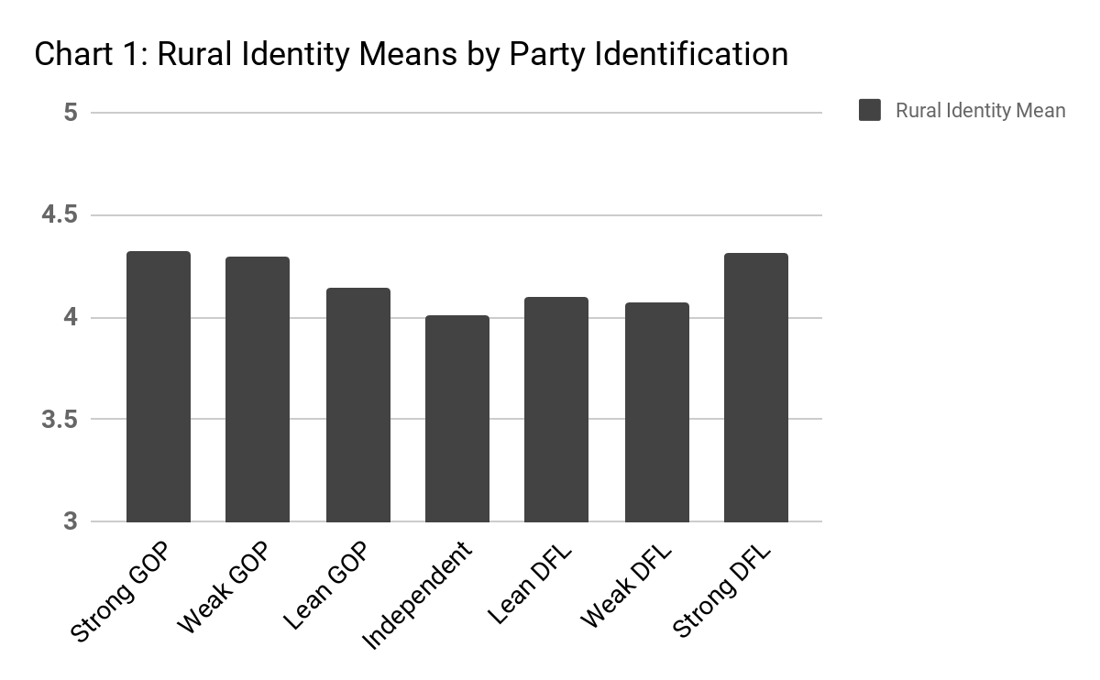
In terms of mean scores, Republicans were the highest (4.32), Democrats second (4.21) and Independents lowest (4.08). The differences between the means of the partisan groups, as well as between Democrats and Independents, was not statistically significant, while the difference between Republicans and Independents was strongly significant. As Chart 1 shows, when we break out the full seven categories of partisanship (with leaners and weak/strong partisans separate) it is those strongest in partisanship that have the highest levels of rural identity, a pattern stronger on the Republican side than the Democratic one.
When we look at the vote choices during the last two presidential elections, voters who were consistent in choosing either the Democratic candidate (4.30) or the Republican candidate (4.31) were significantly higher in mean rural identity than voters who did not vote for the major parties consistently except for the those voters who switched from Obama to Trump (4.40). This finding fits with the narrative that Trump’s rhetoric and policy proposals resonated with voters who strongly identified as rural. When we compare this to actual vote choices in 2012 and 2016, there is no significant difference in rural identity scores between those who voted for the Democratic and Republican candidates, only for those who opted not to vote or voted third party (Table 4).

Table 4: Mean Rural Identity Scores by Vote Choice
Year | Vote | Rural Identity Score Mean | Linearized Std. Error
2016 | Did Not/Could Not | 3.92 | .120
 | Donald Trump | 4.26 | .047
 | Hillary Clinton | 4.23 | .058
 | Other Candidate | 3.93 | .129
2012 | Did Not/Could Not | 3.87 | .127
 | Barack Obama | 4.24 | .048
 | Mitt Romney | 4.27 | .056
 | Other Candidate | 4.15 | .101

When we look at rural identity and a vote choice just between the two major party candidates, we find that there is also no significant relationship between rural identity score and voting for either of the two major party candidates in either 2012 or 2016. Combined with the above data, this indicates that while Trump was able to bring some high rural identifiers to his side that had voted for Obama, the mixture of voters was relatively similar across rural identity for both major party candidates. In other words, while Trump made some high identifiers switch, they must have been replaced by others who voted for Clinton, did not vote for Trump, or did not vote at all.
If we examine ideology instead of partisanship and voting, we see that there appears to be some relationship between rural identity levels and conservative ideology. The survey asked respondents about how liberal or conservative they were on fiscal and social issues. On a one to five scale where higher numbers are more conservative, rural Minnesotans are, overall, much more fiscally conservative (3.41) than they are socially (2.99). Looking at the means on each ideological scale, in both cases those lowest in rural identity are also more likely to have more liberal ideologies. There is also less variation between moderates and liberals than conservatives (Table 5). T-Tests (not shown) demonstrate that there is a significant relationship in both cases between ideology (more conservative direction) and higher levels of rural identity, but the substantive impact is relatively small.
Table 5: Ideology and Rural Identity Mean Scores
 | Fiscal |  | Social
Ideology | Rural ID Mean | Linearized Std. Err | Rural ID Mean | Linearized Std. Err.
Liberal | 4.01 | .083 | 4.05 | .059
Moderate | 4.10 | .056 | 4.06 | .059
Conservative | 4.23 | .047 | 4.33 | .051

Thus far the discussion has been about a rural identity generally and examining how it relates to political behavior. We are interested, primarily, in examining rural political identity, which combines our rural identity with variables that tie together rural Minnesotans as values, above and beyond party or ideology. The survey asked a number of questions related to particular ideals and values other scholars have argued as important to rural identity. These include the concepts that rural communities do not receive a fair share of resources, rural communities reward honesty and hard work, and rural communities are ignored in larger political discussions (Cramer 2016, Wilits, Theodori, and Fortunato 2016, Lichter and Brown 2011, Wuthnow 2018).
In the survey, we utilize four questions regarding sharing of resources, four questions related to the concepts of hard work and honesty, and three questions related to the political efficacy of rural residents, in particular as compared to urban residents of Minnesota. Table 6 outlines each of these three categories of questions.

Table 6: Rural Values Questions
Category | Question | Response Scale
Unfair Sharing of Resources | “My local community receives enough government funding for its needs” | 1-5 (Strongly Disagree to Strongly Agree)
 | “In general, do you believe that efforts by state and federal officials to encourage new business and job creation equally target rural and urban areas or do they target one of these areas more than the other?” | 1-5 (Favor Rural to Favor Urban)
 | “Regardless of whether you believe taxes are too high, too low, or just right, do you believe the tax burdens in Minnesota fall roughly equally on rural and urban areas or do they unfairly fall upon one of those areas more?” | 1-5 (Favor Rural to Favor Urban)
 | “The government provides better services in urban communities” | 1-5 (Strongly Disagree to Strongly Agree)
Hard Work and Honesty | “Members of my local community work harder than do people in most other communities” | 1-5 (Strongly Disagree to Strongly Agree)
 | “My community is a place where honesty and hard work matter” | 1-5 (Strongly Disagree to Strongly Agree)
 | “People who grow up in rural communities are more likely to be morally upstanding” | 1-5 (Strongly Disagree to Strongly Agree)
 | “Rural communities value hard work more than urban communities” | 1-5 (Strongly Disagree to Strongly Agree)
Political Efficacy | “How important do you believe it is that state or national politicians talk about issues specifically affecting rural areas as opposed to more general political problems?” | 1-4 (Not Important at All to Very Important)
 | “Do you agree or disagree that state politicians from rural communities have less power to get things done in the state legislature than their colleagues from urban areas?” | 1-5 (Strongly Disagree to Strongly Agree)
 | “Do you agree or disagree that issues which affect rural Minnesotans are similar to those that affect people who live in the Twin Cities (Minneapolis/St. Paul) metropolitan area?” | 1-5 (Strongly Disagree to Strongly Agree)

Next, we are interested in how the responses to questions listed in Table 6 correlate with rural identity scores. Below, we perform t-tests and look at raw means to investigate the relationship between rural identity scores and the questions regarding rural values. We begin with the four related to resource distribution.

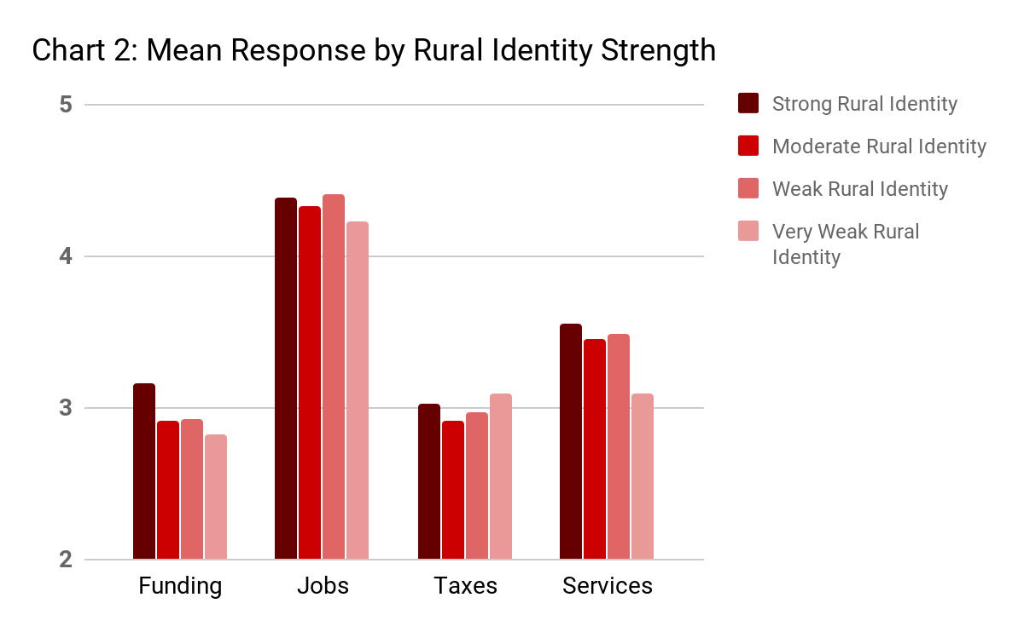

With the reminder that all these resource questions are on a scale ranging from one to five, a few observations are worth noting from Chart 2 and Table 7. The relationship in all these cases does not appear to be very strong. None of the questions here reach significance. The funding question, despite not being significant, is interesting because those highest in rural identity are more likely to believe that their communities receive enough funding. This can partially be explained by the fact that this group is also most likely to hold fiscally conservative viewpoints and arguably, therefore, would be less supportive of the idea that the government should spend more money.

Table 7: T-Test of Rural Identity Score and Resources Variables
Variable | Coefficient | Linearized Std. Err.
Rural Funding | .0733 | .0351
Job Divide | .0377 | .0432
Tax Divide | .0188 | .0356
Divide - Services | .0748 | .0426
**p-value < .01; * p-value < .05; ^ p-value < .10

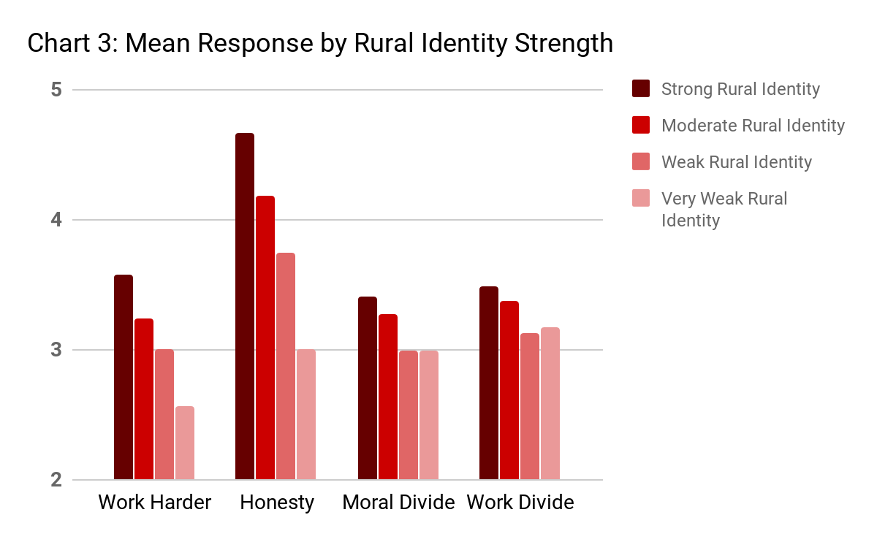
In the second group of questions, there are very clear relationships between the traditional concepts of hard work, honesty, and morality and rural identity as all four variables are significant at the .001 level (rather than just at the .01 level). Chart 3 demonstrates this clearly with significant drop offs in each question from the higher to lower levels of rural identity. One important note is that even those in the weak rural identity category were at or just below the median score on the scale (3 points) on three of the questions. The question related to the value of honesty and hard work in rural communities, shows differences that were extremely stark. Those in the highest category of rural identity had a mean score of 4.67 (on a 1 to 5 scale), which dropped to a mean of 4.18 among the next group and down to just 3.75 among the weak cohort. Those in the weakest category were right at the median for the scale at 3.01.

Table 8: T-Tests of Rural Identity Scores and Values Variables
Variable | Coefficient | Linearized Std. Err.
Rural Work Harder | .3115** | .0374
Rural Honesty | .4769** | .0381
Divide - Moral | .1301** | .0355
Divide - Work | .0980** | .0355
**p-value < .01; * p-value < .05; ^ p-value < .10

One thing to keep in mind is that the scale on the Rural Issues question only went up to a high of “4” meaning that the vast majority of respondents agreed that it is important or very important for politicians to talk about rural issues specifically, and not just general political issues. The other questions were on the one to five scale. Both the Rural Issues and Less Power questions are significant and in the assumed direction where those higher in rural identity hold views that rural areas have less efficacy.

Table 9: T-Tests of Rural Identity Scores and Efficacy Variables
Variable | Coefficient | Linearized Std. Err.
Rural Issues | .2220** | .0610
Less Power | .0751* | .0342
Similar Issues | -.0163 | .0314
**p-value < .01; * p-value < .05; ^ p-value < .10
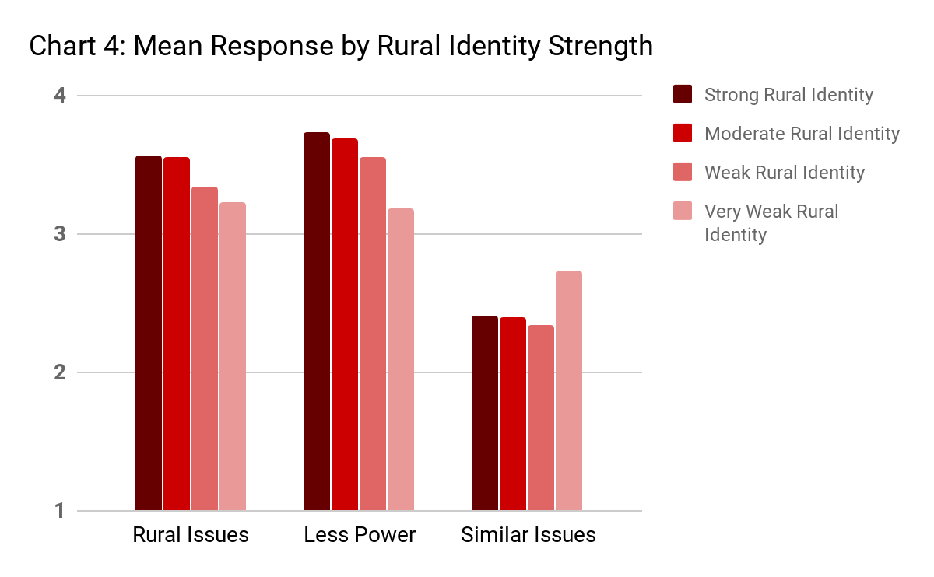

In the third question, asking about the similarity of issues affecting residents of the Twin Cities and rural areas, we do not find significance, but it is unsurprising that overall the scores are well below the median of the scale. While there was little variation among respondents on this question regardless of their rural identity scores, most rural Minnesotans do not agree that issues facing urban Minnesotans are the same as they encounter. Overall just over 63% of respondents disagreed with the statement and just over 27% agreed. Even among the lowest category of rural identity, nearly 52% disagreed and only 32% agreed.
This also highlights the primary takeaway from the rural values examination above, which is that most rural Minnesotans, regardless of their level of rural identity, hold pro-rural stances on questions. In only a few cases, and only among those lowest in rural identity, do we see neutral or even anti-rural mean response values. What is important for this analysis is that despite the general agreement among rural Minnesotans on questions of rural values, those highest in rural identity are also more likely to hold pro-rural attitudes. While this was expected, it indicates that there is value in specifically analyzing rural voters’ political attitudes and beliefs, rather than just assuming they are like their partisan and ideological parallels in suburban and urban areas.
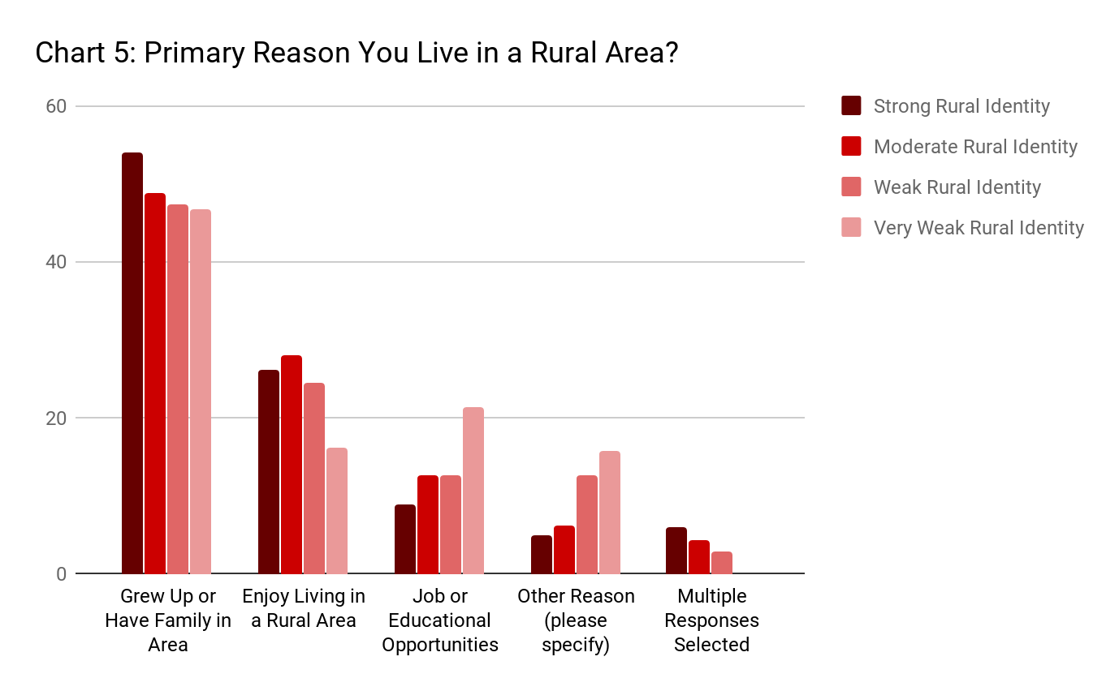
Finally, we will examine the relationship between rural identity and community factors. These include respondents’ reason for living in rural Minnesota, assessment of the strengths and challenges in their local communities as well as the types of living experience respondents have had during their lives and the length of time they have spent in their current communities.
Chart 5 shows respondents’ answers to the primary reason they live in a rural area. The first three responses were provided as options, but respondents could select and write in a different one. A small, but important subset of respondents did not choose just one reason (thus the fifth category). What is clear from this chart is that those who have the weakest rural identity scores are most likely to have moved to a rural area for a job or schooling or they wrote in a separate reason. Among those highest in rural identity, just over 80% noted that they lived in rural Minnesota because of family ties (54%) or because they enjoy it (26.2%). While the sample size for the very weak group was small, over 20% responded they moved because of job or schooling, compared to a high of 12.7% in any other group.

Table 10: Rural Identity and Political Activity
Rural Identity Category | Mean # of Political Acts | Linearized Std. Err
Strong | 1.61 | .0796
Moderate | 1.70 | .0939
Weak | 1.41 | .1028
Very Weak | 1.22 | .1881

Another question is whether rural identity matters for levels of political activity. We gathered data on four types of activity, two of which are directly political and two of which are indirectly political. First, we asked people if they had done any of the following five activities in the past two years: voted in an election, attended a political meeting/rally, displayed a political button, bumper sticker or lawn sign, donated money to a party or candidate, or written a letter to a public official or newspaper regarding politics. We also asked how interested people were in politics, how many days each week they consumed news media, and how often they have volunteered over the past 12 months. Table 10 shows the mean number (out of five) of political acts per respondent within each of the four rural identity groups.
Overall, rural identity doesn’t appear to strongly correlate with political activity, although those in the two higher categories did have slightly higher numbers. Partly this is an artifact of the measure, which only included one common political activity in voting. Over 76% of our sample indicated they had voted in the past two years, but only 23% had publicly displayed their support via a sign, button or sticker, the second highest activity level.
For political interest, mean scores rise along with higher levels of rural identity, but the differences are substantially small as all groups are at least somewhat interested in politics. In terms of media news consumption, there is a relatively sizeable and significant (at 0.1 level) difference between the strong rural identifiers and the next highest group. Strong rural identifiers, on average, consume news 5.7 days a week, while moderate identifiers only average 5.3, and weak identifiers only 5.1. Very weak identifiers only averaged 4.1 days a week but the confidence interval is large given the small sample size. Finally, in terms of volunteering, Chart 6 shows that higher identifiers are much more likely to volunteer, which is unsurprising since they feel a strong connection to their community and identify with it.
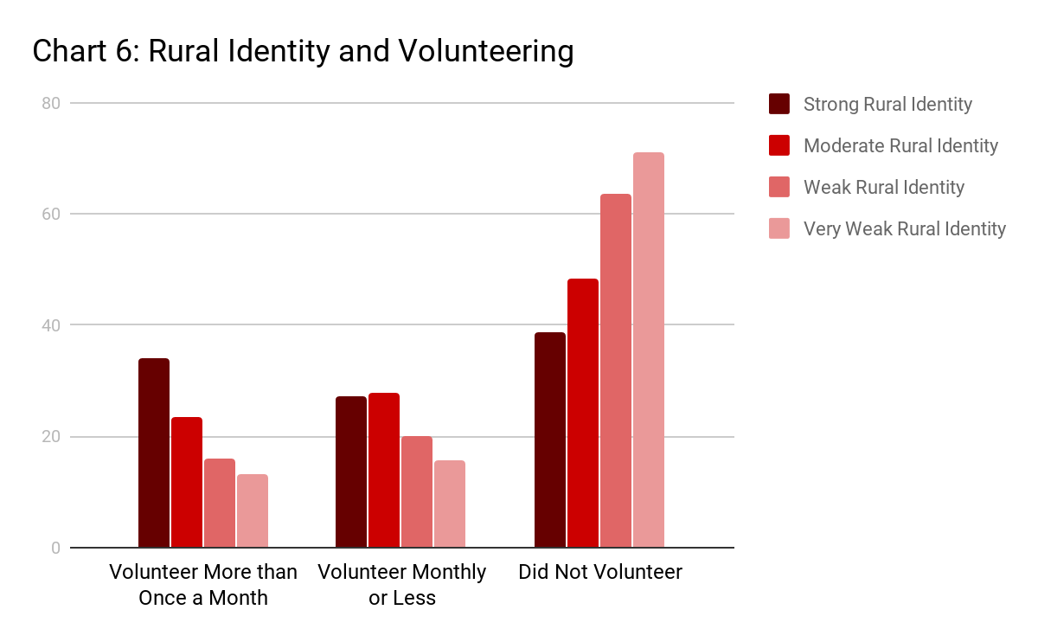
We also asked respondents to identify if a variety of services or topics in their local communities were advantages of that community or challenges the community needed to work on. These included items such as the availability of housing for the elderly, the availability of healthcare, the level of tax burden, and the quality of local public education, among others. The only factor that had a clear relationship with rural identity asked about issues with illegal drug use. In that case, as rural identity gets stronger, respondents are increasingly likely to note that the level of drug use in their local communities is an advantage rather than a challenge, although the average response for all groups is still on the challenge side of the four point scale (i.e. a minor challenge instead of a major one). There is evidently not a strong relationship between what rural Minnesotans perceive their communities to be like and whether they strongly identify with them and feel welcome there.
A final consideration is to examine how rural identity relates to experience living in different types of places. We asked respondents to indicate how long they had lived in their current communities, where they had moved from before, and if they had ever lived in an urban area. There are numerous jokes among rural small-town residents about how long a person must live there before they are accepted, with at least 20 years being a relatively consistent standard. In our survey, we find evidence that this might just be true, as respondents who have lived in their rural communities for less than 10 years (3.97 rural identity mean) and between 10 and 19 years (3.99 rural identity mean) have significantly lower rural identity scores than respondents who had lived at least 20 years there (4.39 mean). Obviously this is also correlated with age strongly, so it’s not clear if age is the more important factor or years spent living in a community, but they are likely additive factors.
In terms of place lived immediately before moving to the current rural community, the highest mean scores were among those who had never moved, then among those who had lived in small towns and rural areas. Respondents who had lived in larger towns or an urban area had significantly lower rural identity scores, but the substantive difference was relatively small (only about 7% of the full scale). Finally, there were small, but statistically significant differences in rural identity mean scores between respondents based upon their experiences living in urban areas. The highest mean scores were among those who spent between six months and five years (designed to capture college or short-term work experiences) at 4.35, followed by those who had never lived in an urban area at all (4.16) and then the lowest scores were among those who had significant (5+ years) experience living in an urban area (4.08).

Partisanship and Rural Identity Intersections
We have examined how partisanship and ideology are related to rural identity and how rural identity relates to a variety of political activities. The question remains, however, if rural identity has an independent effect on political decision making and behavior. It does appear to drive or be driven by, a set of concepts related to the importance of hard work, honesty, and morality, which have very little relationship to party identification and minimal to ideology. It is also, however, connected to some clearly political questions such as voting choice. What we want to do is examine if rural identity has an independent impact on political attitudes regardless of partisanship. We do this in a very basic test, by dividing our respondents’ choices by their partisan affiliation. Here we solely examine all Democratic identifiers and leaners against all Republican identifiers and leaners.
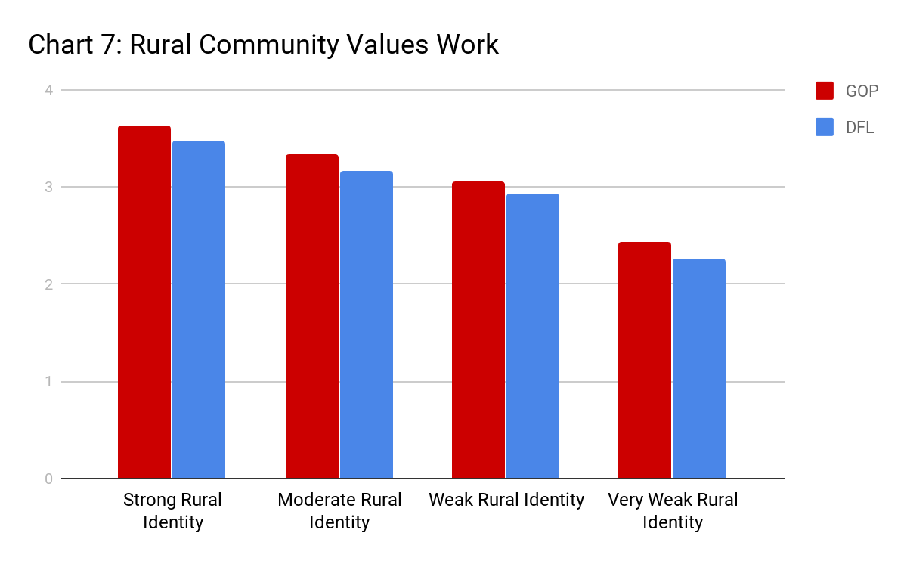
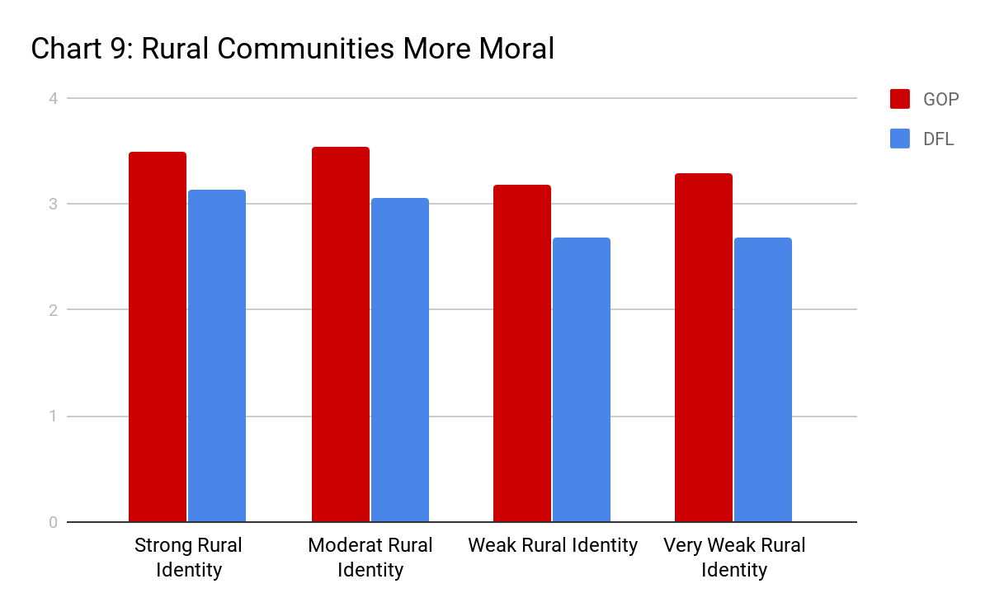
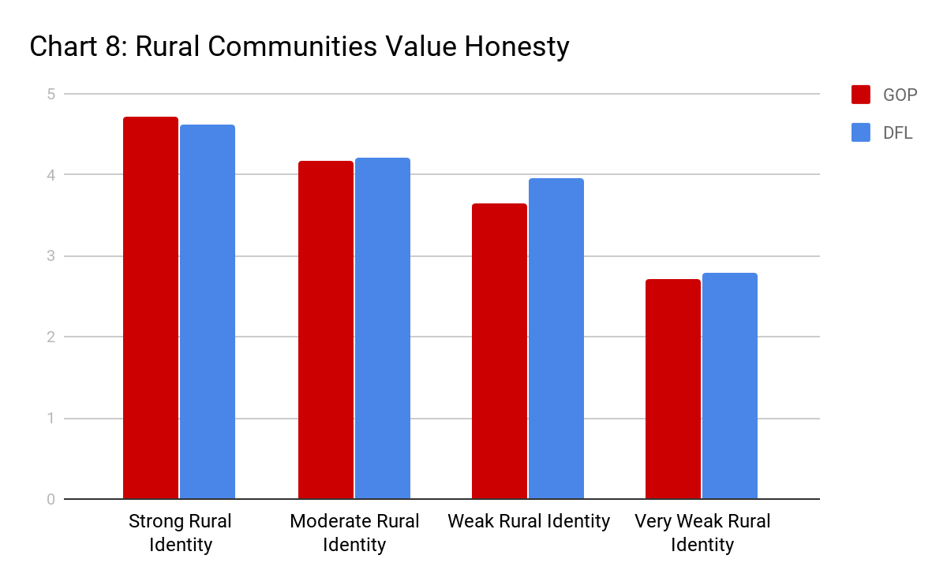
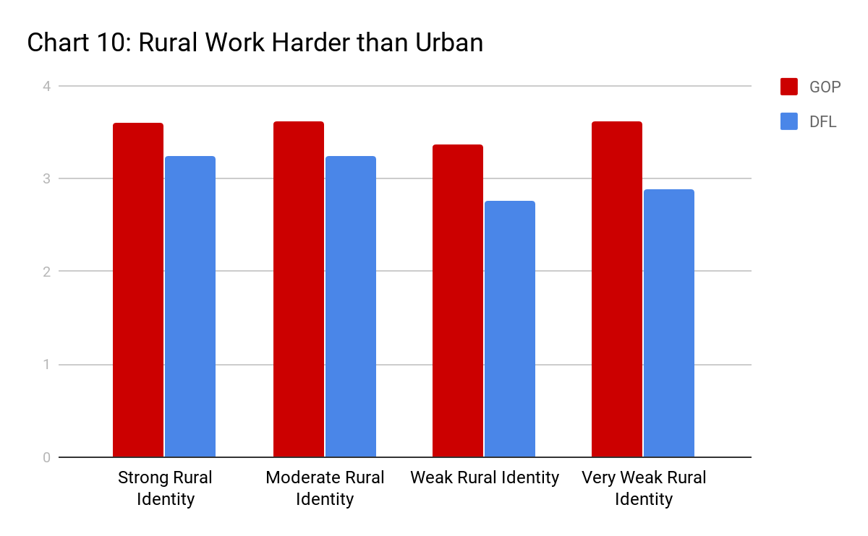
First, let’s revisit some of the rural values questions we found were significant overall when looking at rural identity scores. We start by looking at the four rural values questions related to hard work, honesty and morality.

In Charts 7-10 we see evidence that partisanship has an inconsistent relationship with rural identity as it applies to these four values-based questions. For both parties, there is a clear decrease in agreement with the statement that rural communities value hard work and value honesty as rural identity scores decrease. The relationship is less clear for the questions about rural areas being more moral and
working harder than urban areas, with Republican agreement more even across rural identity than Democratic agreement.
Table 11: Mean Policy Agreement Scores by Party Identification
 | GOP | DFL
Raise Gas Tax | 2.25 | 3.24
Support Mining | 3.57 | 2.55
Require Ag Buffers | 3.31 | 4.18
Local Minimum Wage Control | 3.05 | 3.80

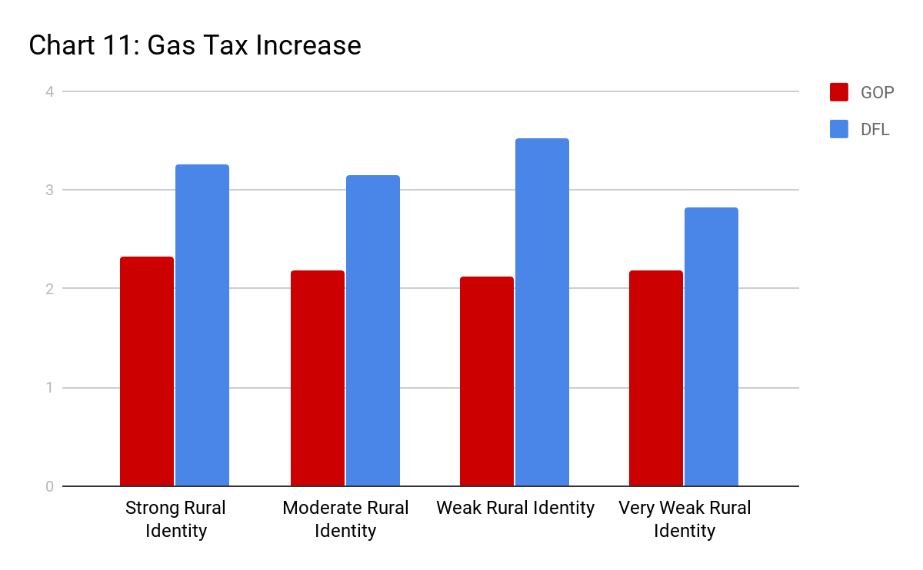
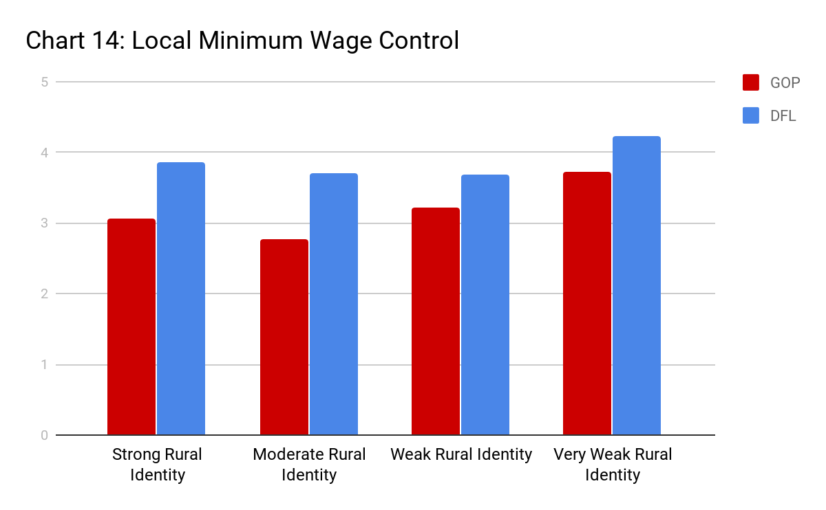
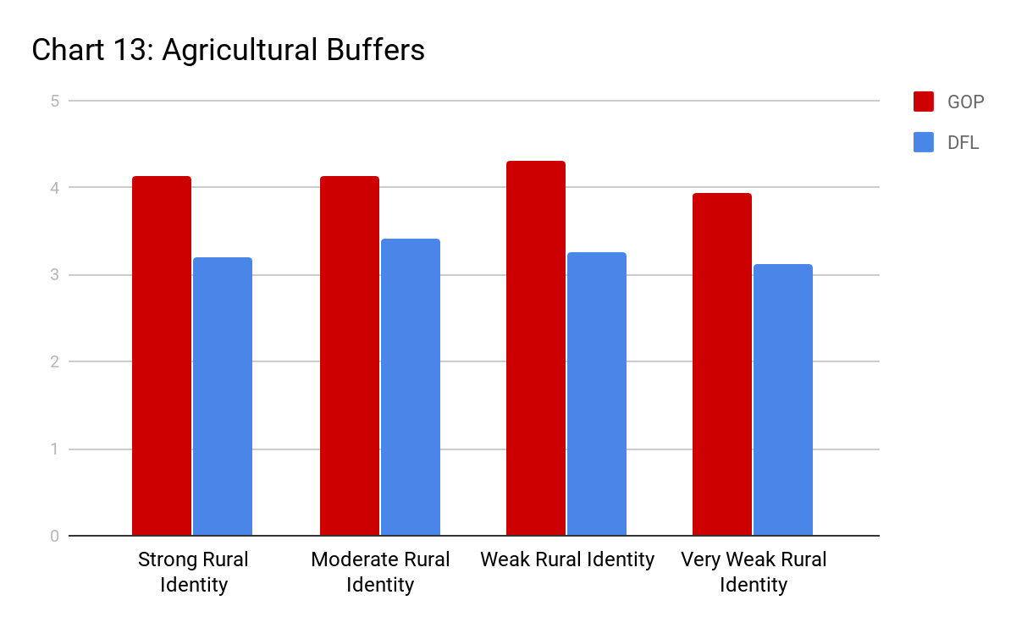
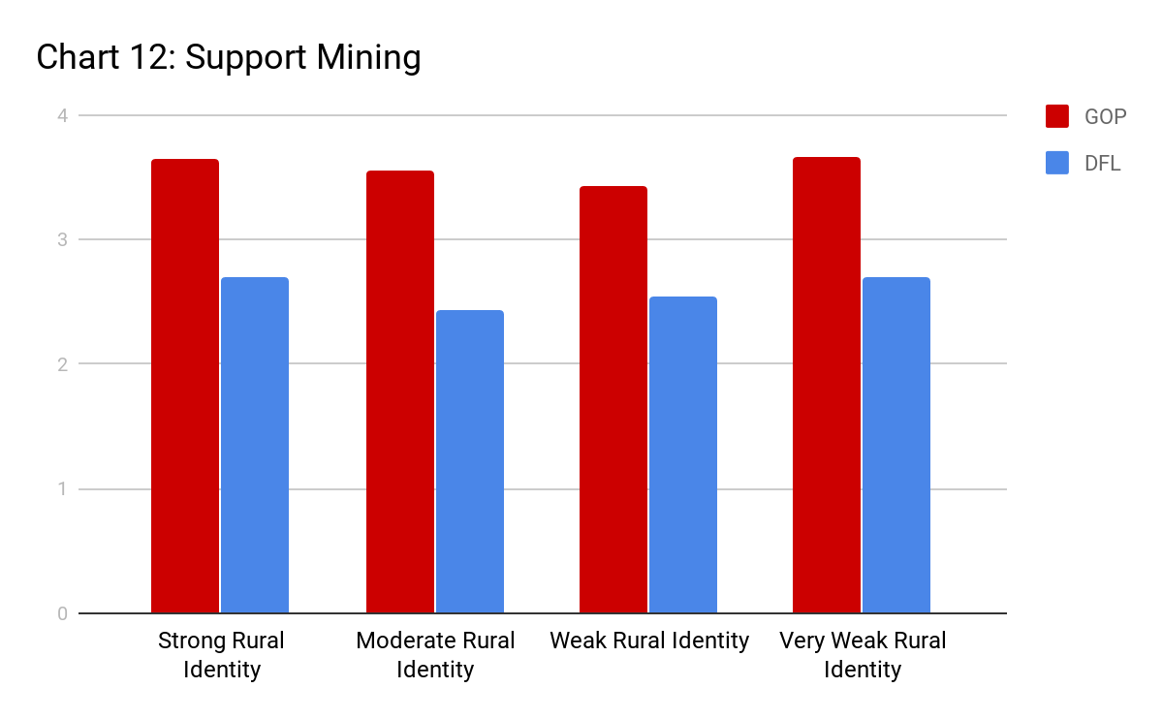
It also makes sense to examine if partisan differences in rural identity occur over clearly partisan policy issues. In our survey we included four policy questions. Those were questions on raising the gas tax, supporting mining projects in Northern Minnesota, requiring farmers to create buffers between agricultural lands and water sources and allowing local governments to raise their own minimum wages. In all four cases, the difference between Republicans’ and Democrats’ mean responses were statistically and substantively significant and, in the direction, we would assume given the party’s stances on those issues. Table 11 shows the mean scores by party on each question (1-5 Likert agreement scale). In Charts 11-14 we see very little evidence that rural identity has a strong impact on policy questions outside of partisanship, with the relationships in each case stable across rural identities and, for the most part, maintaining similar variations between the parties. Most of the exceptions to this pattern come in the very weak rural identity category, which has more volatility due to small sample size.

Conclusions

Overall, we find evidence that most rural residents who have a strong identity with their community are more engaged within and outside politics. They tend to be more likely to espouse partisan identification, rather than independence from the two major parties and are more likely to vote for the major parties in elections. Rural identity levels are also correlated with conservatism, although the size of the relationship is relatively small. We also saw that the group of voters who switched from Obama in 2012 to Trump in 2016 were mostly high in rural identity scores, higher proportions than among either consistent GOP or consistent DFL voters. While there were only a small group of voters in our overall sample that moved from Romney to Clinton, these respondents were generally low in rural identity.
Additionally, higher levels of rural identity are associated with higher levels of agreement with some of the basic values other scholars have found attached to rural ideals. These include concepts that rural communities work harder, value hard work and honesty, and are more moral than urban communities. We also found that rural identity is associated positively with age, length of time spent in a community, household income, and level of education. Religiosity is also highly correlated with rural identity.
We also found some evidence that rural identity is linked to questions of efficacy. There is a positive relationship between rural identity and the belief that politicians should talk about rural issues specifically. Almost all respondents agreed that it was either somewhat or very important that rural issues are discussed, but among the highest rural identity scores, almost 61% of respondents thought it was very important, while only 44% of weak rural identifiers did so. Additionally, we found evidence of a weak relationship between rural identity and the idea that rural politicians have less power than their urban colleagues. Among those in the highest scoring category of rural identity, over 25% strongly agreed with that assessment, while another 42% somewhat agreed with it. In the weak category, these numbers were 15% and 47% respectively. The small sample of very weak identifiers were the outlier, with only 40% agreeing at all with the assessment, and just over 31% disagreeing.
Despite all of these connections, we found limited impact of rural identity when it came to issues of the fairness of distribution of resources and on partisan policy issues. The lack of statistical significance among questions regarding distribution of resources was surprising given the previous literature. This could have been due to the wording of the questions and to the lack of a meaningful distribution of responses. For example, the tax divide question was phrased in such as way that it asked respondents to disregard if they thought taxes overall were too high or low and then only asked about distribution of burden between rural and urban areas. It could be that most rural residents agree that taxes aren’t unfairly placed upon rural versus urban people, but that wouldn’t preclude them from also believing that urban areas get unfair distribution of the taxes collected or that they need them just as much.
The job divide question appeared to suffer from the exact opposite issue. Nearly every respondent agreed with the assertion that efforts at job creation targeted urban areas unfairly. The highest proportion of disagreement was among the lowest rural identifiers, and even then, less than six percent of respondents disagreed. On the other side, 77% of very weak identifiers agreed with the statement, compared to roughly 90% in each of the other three categories. There just wasn’t much differentiation in the responses, with almost all respondents agreeing.
Among the policy questions, however, it is relatively clear that partisanship matters more than rural identity. We see no meaningful or consistent relationship between levels of rural identity and agreement or disagreement with the four policy questions. Different levels of rural identity did not diminish or increase the variation in policy responses between partisans. Given the earlier findings that rural identity was strongest among partisans, regardless of which party, this is not surprising. It is also a reminder that regardless of how rural identification might impact political behavior and attitudes, it is separate from, but not necessarily more important than, partisanship and ideology.

Discussion

There is a standing question on how, if at all, place-based identity matters for political behaviors and attitudes in the modern United States. With the election of Donald Trump in 2016, everyone was reminded that rural voters can have an impact if they significantly shift their partisan voting, even in the context of increasing urbanization. Part of this discussion is whether rural voters shifted to Trump because they are conservative and Republican or because he activated their rural identity in a meaningful way. We have tried, in this paper, to uncover the ways in which rural identity does or does not have an impact on political behavior and attitudes.
The overall goal of this work is to begin a more comprehensive discussion among scholars of rural issues in the United States about what makes up a specifically rural political identity. This implies that there is a difference, however large or small, between rural residents and urban residents simply based upon where they live in terms of politics. What we are most interested in uncovering are the similarities and differences among rural residents across political attitudes and behaviors. This study is just one step toward this effort and we encourage others to expand upon our ideas.
Additionally, we did not ask a battery of policy questions on issues that were more important to urban life, rural life, or are more general. The ones we asked were politically salient and although they would have more impact in rural areas (mines would be built in rural areas, rural residents spend more on gas per capita, and agricultural buffers are specific to farmers), they were not necessarily issues that were limited to rural residents mostly in terms of importance. Future research could attempt to tease out the ways in which place-based identity interacts with policy positions on more clearly urban and rural specific issues as opposed to more general or national questions.
This also brings up the limit of this paper in talking about the urban-rural divide: it focuses on the rural aspect. A next step would be to compare rural and urban (and suburban/exurban) residents to expand an understanding of under what conditions place-based identities become salient for politics. It is unlikely that rural identity matters for rural residents, but a parallel place-based identity wouldn’t exist for urban residents.

Bibliography

Cramer, Katherine. 2016. The Politics of Rural Resentment: Rural Consciousness in Wisconsin and the Rise of Scott Walker. Chicago: University of Chicago Press.

Clucas, Richard, Mark Henkels, and Brent Steel. February 17, 2009. “The Politics of One Oregon: The Causes, Consequences and Prospect of Overcoming the Rural-Urban Divide.” Accessed April 3, 2019. https://ir.library.oregonstate.edu/concern/conference_proceedings_or_journals/np193934k
Presentation and paper from 2008 "Toward One Oregon" Conference

Gimpel, James G, Kimberly A. Karnes. July 2006. “The Rural Side of the Urban-Rural Gap.” Political Science and Politics 39 (3): 467-472.

Gimpel, James G, J Celeste Lay. 2008. “Political Socialization and Reactions to Immigration-Related Diversity in Rural America.” Rural Sociology. 73(2): 180-204.

Goodland, Marianne. March 22, 2019. “Urban-Rural Divide Growing, Say Senate Republicans.” Sterling Journal-Advocate. Accessed April 3, 2019. www.journal-advocate.com/sterling-local_news/ci_32530989/urban-rural-divide-growing-say-senate-republicans.html

Journal-Star Editorial Board. January 29, 2019. “Editorial, 1/30: Urban-Rural Divide Real - But Mustn’t Define State.” Lincoln Journal-Star. Accessed April 3, 2019. https://journalstar.com/opinion/editorial/editorial-urban-rural-divide-real-but-mustn-t-define-state/article_c3a907b2-b2e7-562c-9fbe-4c6d0608aa17.html

Kellogg Foundation. 2001.“Perceptions of Rural America.”

Leitner, Helga. 2012. “Spaces of Encounters: Immigration, Race, Class, and the Politics of Belonging in Small-Town America.” Annals of the Association of American Geographers. 104 (4): 828-864.

Lichter, Daniel and David Brown. “Rural American in an Urban Society: Changing Spatial and Social Boundaries.” Annual Review of Sociology. 2011 (37): 565-92.

McFarland, Christiana. 2018. “Bridging the Urban-Rural Economic Divide.” National League of Cities: Center for City Solutions. Accessed April 12, 2019. https://www.nlc.org/sites/default/files/2018-03/nlc-bridging-the-urban-rural-divide.pdf

McQuarrie, Michael. 2017. “The Revolt of the Rust Belt: Place and Politics in the Age of Anger.” The British Journal of Sociology. 68(S1): S120-S152.

Scala, Dante, Kenneth Johnson, and Luke Rogers. “Red Rural, Blue Rural? Presidential Voting Patterns in a Changing Rural America.” Political Geography. 48:108-118.

Theodori, Gene, Fern Willits. 2018. “Rural and Small Town Residents and the Rural Mystique: Data from Texas.” Rural Sociology. 1-14.
Wuthnow, Robert. The Left Behind: Decline and Rage in Rural America. Princeton University Press, 2018.

Wilits, Fern, Gene Theodori, and Michael Fortunato. “The Rural Mystique in American Society,” in Reinventing Rural: New Realities in an Urbanizing World, editors Alexander Thomas and Gregory Fulkerson. Lexington Books, 2016.

Appendix 1: Rural Identity Mean Scores by Demographic Variables

Variable | Rural Identity Score Mean | Linearized Std. Err.
Male | 4.204 | .0432
Female | 4.208 | .0536
Under 31 | 4.018 | .1463
31-49 | 4.126 | .0665
50-64 | 4.228 | .0524
65+ | 4.355 | .0447
HS Degree only | 4.115 | .0769
Some College | 4.203 | .0577
Bachelor’s Degree | 4.197 | .0622
Graduate Degree | 4.319 | .07229
Gun in Household | 4.264 | .0370
No Gun in Household | 4.101 | .0743
Household Income: $30k or less | 4.022 | .1050
Household Income: $30-60k | 4.204 | .0670
Household Income: $60-100k | 4.235 | .0591
Household Income: $100k+ | 4.275 | .0664
Never Attend Church | 3.692 | .0924
Attend Church Almost Every Week | 4.358 | .0752
Attend Church At Least Once A Week | 4.506 | .0545

It should noted that there are multiple reasons for this growing practical divide between urban and rural areas. First, urban areas have grown at much greater rates. Second, formerly rural or small town areas have become urban, thus further decreasing the rural population. Third, urban areas are now more diverse in terms of development patterns, including suburban, and now, exurban spaces.
73 surveys were completed online (1.83% of total)
We were unable to include direct comparisons here, but plan to do so in a future revision of the paper.

