Rising Titans: China's Ascent and its Influence on Democratic Frameworks

Dishari Rakshit (1)
Wayne State University

Mitchell Gallagher (1)
Wayne State University

Abstract
In world politics, global powers determine the fabric of the world order as democratic and non-democratic forces define the trajectory of nations, embodying a timeless struggle for collective values. The paper examines power transitions and the trajectory of democratic governance, with a focus on the rise of China and its Belt and Road Initiative. Shifting from a unipolar world characterised by US dominance and the spread of liberal democracy, to a more contested bipolar era, marked by China’s ascendancy, we observe significant implications for democratic norms and institutions. Utilising a power transition theory framework, and hegemonic shock concept, this study explores China’s economic strategies, particularly through BRI, and the influence on political structures in participating countries. Our findings show a noticeable trend in democratic backsliding through a quantitative analysis. These conundrums in international economic engagement and possess repercussions for democracy. Our findings underscore the urgent need for a nuanced understanding of global power shifts and their impact on democratic systems, paving the way for more resilient and adaptive strategies in global governance.

Key words : Power Transition Theory, Belt and Road Initiative, hegemonic shock, democratic backsliding

Introduction

Thirty years ago, Fukuyama (1989) famously concluded that democracy is the “end point of mankind’s ideological evolution,” as the “final form of human government.” Since then, the world has experienced a steady decline of democratic attributes, resulting in a new wave of autocratisation. V-Dem (Democracy Report, 2022) reports that democracy levels in 2021 are back to 1989 figures, only 34 countries are now described as liberal democracies. This reduction is most visible among the global south. More strikingly, states in North America and Western Europe have reduced too, which hitherto assumed to be well insulated from such upheaval. Portugal and Austria shrank on access to justice and transparent law indicators, while Poland and Hungary are now regarded as major autocratisers (Democracy Report, 2022). The report (Democracy Report, 2022) also states that electoral autocracy is now the most common regime type, home to 44% of the world population. As evidence against democratic reversal increases over the years, democratic backsliding studies are reappearing in scholarly analysis. Recent scholarship is in consensus over one singular fact - autocratisation processes have changed overtly. Democracies are seldom subsiding due to coup d’état or military takeover, ‘but rather via attrition’ (Levitsky & Ziblatt, 2018).

Current breakdowns in democratic values are led by incumbent political elites. Procedures are applied to study autocratisation from assorted directions within domestic political ambits. Emergency power enactments allow leaders to subvert democratic rules and concentrate power for themselves (Lührmann and Rooney, 2021). President Recep Erdogan’s administration was vehemently lambasted for using emergency as a pretext to transform Turkey into a de-facto presidential dictatorship. Many autocratic leaders use constitutional or other legal means to push for illiberal laws to disguise their autocratic intentions in the ‘pluralism of legitimate legal forms’ (Scheppele, 2018). Indian Prime Minister Narendra Modi passed the controversial Citizens Amendment Act in 2019, to purposefully keep Muslims away from applying for citizenship from neighbouring countries. Additional efforts studied the causes of autocratisation from institutions - presidential systems are more prone to breakdown than parliamentary systems (Linz, 1990); “weak democracies syndrome” are formed by low institutionalisation, poor economic performance, legacies of military takeover (Tresisman, 2023; Haggard & Kaufman, 2016). While scholars are rightly more engrossed in domestic roles in initiating autocratisation, our knowledge is limited on external actors fomenting autocratisation. Yet, external relations with a major foreign policy actor could be another way to assess autocratisation inducements. Our knowledge about the role of external actors in autocratisation currently mostly relies on small case studies geography focussed, and autocracy promotion (Tolstrup, 2015; Bader, 2015 ; Hess and Aidoo, 2019 ; Chou, 2016 ; Way, 2015).

Democracy promotion is a foundational element of not only United States’ foreign policy but also a priority for western countries. Anti-democratic behaviour by probable autocrats was costly as the United States provided economic assistance to developing nations with the condition of maintaining a nominal democratic framework. Studies show a country’s propensity to democratise was dependent on political and economic linkage with western countries (Haggard & Kaufman, 2016). Gunitsky (2014, 2016) argued ‘hegemonic shock’ brings forth a new global order. A declining power faces a new world - their capacity to coerce, influence and maintain allies, regime legitimacy declines substantially. Even now, the United States remains an adroit global force, exerting prodigious influence globally. However, vital to appreciate, the geopolitical backdrop underwent substantial change since the epoch when the US revolutionised the global order following the Gulf War, devoid of unilateral authority to issue explicit warnings for non-alignment post-9/11. Currently, a sophisticated mosaic of regional and global powers materialised, proficient in contesting against American primacy. In this restructured global scenario, it is apt to class American hegemony as 'hallowed hegemony,' (Zakaria, 2019) admitting both enduring durability and the changing dynamics of a multipolar world.

Even though promoting democracy was a cornerstone in post-Cold War world, during this unipolar era, the US turned a blind eye to the rest of the world, synchronising with elevated Chinese power worldwide. For instance, in the 1990s, Washington preoccupied domestic issues and did not fully engage with global challenges, such as the Rwandan genocide, and Balkan conflicts. Meanwhile, China’s remarkable economic expansion and rise as a significant global actor exemplifies the continuous and intricate character of the current geopolitical environment. As polarity is gauged by metrics like population, territorial expanse, military capabilities, political stability, and governance effectiveness (Bekkevold, 2023), China presently ranks as the second most populous nation, possesses one of the largest land areas, boasts the world's second-largest economy, holds the third most powerful military, and retains political stability under one-party rule for decades. These metrics testify that China has levitated to a position of power and influence on par with the US, orientated as a significant global force, hinting at a resurgence of a bipolar world order (Bekkevold, 2023). China’s ascent as an authoritarian capitalist state is often cited as the primary reason for potential declines in liberal democracies. Autocratic countries often export their norms, ideals, practices beyond their beyond as they view liberalisation nearby as a threat to their own stability (Gat, 2007; Bader et al., 2014).

From the ashes of World War II, the US enacted the George Marshall Plan to aid in the recovery of many major global economies, solidifying dominance as the Western world's hegemon (Ikenberry, 1989). Almost seven decades later, China introduced the Belt and Road Initiative (BRI) to dispense infrastructural assistance across the world. Predominantly, the BRI became an opportunity for China to expand its economic reach, facilitate trade, achieve geopolitical strategic objectives, utilise surplus capacity, reap domestic economic benefits, and promote regional development, such that “all roads lead to China” (Gerstl and Wallenböck, 2020). Should the BRI fruitfully attain its aims, the initiative would be positioned to become the most venturesome and extensive development project in history. Both the Marshall Plan and BRI epitomise geopolitical and economic leadership manifestations. The Marshall Plan sought to inhibit communist proliferation and stabilise the international order in a manner conducive to flourishing political democracy and free-market economies, two central tenets of US values and fundamental beliefs. Analogously, BRI can be posited to constitute a strategic geo-economic undertaking orchestrated by China to reinforce economic progress and supremacy globally through facilitating regional amalgamation and cultivating a more inclusive international structure. As a result, BRI has garnered attention due to its implications for international relations, trade dynamics, infrastructural development, and, not least, reconfiguring the global power equilibrium. The White House views the BRI as a form of “debt trap diplomacy” (deListe and Goldstein, 2021), aimed at bolstering China's global influence and undercutting US economic interests and hegemony, while also reconfiguring alliances and the geopolitical-economic landscape between Washington and Beijing. BRI literature perceives the initiative as an indispensable avenue expanding and bolstering Chinese influence through diverse channels (Maçães 2021), while strategically challenging democratic governance foundations (Rolland 2017). Synthesising numerous Chinese programs, the BRI stimulates domestic growth while bolstering security, military, and economic imperatives (Sauvant & Chen 2014, Zeng 2017). Rights restrictions amid BRI investments warrant scrutiny (Faiz 2019), alongside correlations with socio-political turmoil (Mihr 2023).

Notwithstanding the plethora of literature on political economy and autocratisation (Gel'man & Marganiya, 2010; Brunnschweiler & Bulte, 2008; Bhattacharya & Hodler, 2010; Ross, 2012), a discernible limitation resides in examining the relation with an external major power and a country’s autocratisation. This research aims to fill the gap by examining the link between a nation’s trade with China and progression towards autocracy. We intend to explore how trade with China, facilitated by its "no strings attached" policy, may adversely affect a country's democratic institutions. This analysis is further extended to the BRI as it is considered a pivotal aspect of China's foreign strategy. Observations suggest that many BRI participant countries grapple with underinvestment and challenges to their economic and democratic systems. By examining trade interactions and democracy metrics of signatory countries, our study seeks to elucidate the potential relationship between their engagement in the BRI and their move towards autocracy.

Hence our paper poses the following question: how does the ascent of China, as demonstrated through BRI impact democratic governance in participating countries? To tackle this question, our study uses linear regression analysis across several critical periods to explore the relationship between involvement with China’s BRI and varied democracy levels among signatory nations. Our quantitative analysis uncovers a statistically significant correlation between BRI engagement and instances of democratic backsliding in these countries.

A Review of Related Literature

AFK Organski (1958) anticipated China’s rise to power in his book “World Politics”, outlining the Power Transition Theory well ahead of China actual pursuit of the development trajectory. Organski presented China as an ascending challenger and depicted the United States as a waning hegemon (Kim & Gates, 2015). Power transition theory rests on two core premises: first, a nation’s strength is derived from internal growth, and since each country has their own distinct development trajectory and varying growth rates, development is inherently uneven. Consequently, the rise and fall of each nation is relative to others. Second, instead of anarchy, a hierarchical structure among nations exists, with a top hegemon controlling the international order. Organski and Kugler (1980) elaborate, noting that hegemon benefit the most from the extant order, while great powers cooperate with the dominant power as they share the status-quo benefits. Constrastingly, dissatisfied challengers seek a higher position and may turn to conflict owing to perceived inadequacies in allocated benefits. Arguing against balance of power, condition of power parity is more likely to lead to war (DiCicco &Levy, 1999). Transition need not always be conflictual; it was peaceful when US overtook Britain. Both Organski and Kugler (1980) encouraged scholars to develop and participate in sharpening the theoretical and empirical framework of this theory. As a result, Kugler and Lemke (1996) and Lemke (2002) extended their research to regional powers, claiming shifts in capabilities among dominant states can create destabilising effects analogous to those observed in the global arena. Lemke’s (2002) contribution generalised the tenets of this paradigm.

Beginning in 2000 and coinciding with China's rise, power transition scholarship received a new impetus, shifting analytical lens to view China as a dissatisfied challenger (Tammen et al., 2000; Johnston, 2003). Various scholars conforming to the theory’s core tenet, predicting China’s challenge to the US for global hegemonic dominance (Chan, 2009; Friedberg, 2005; Johnstone, 2003). Conversely, scholars like Kaplan (2005) and Shambaugh (2004) interpret China’s rise as filling a geopolitical void left the Soviet Union’s collapse. Kaplan (2004) suggests China will emerge as a significantly stronger opponent than Russia ever could be. Organski and Kugler (1980) wrote in ‘The War Ledger’ that to qualify as a dissatisfied challenger, a state should be eight per cent as powerful as the hegemon. Chan (2008) argues that US - China power parity does not resemble Germany and the United Kingdom ’s at the beginning of the twentieth century. China trails the United States in several key areas- its economy is 61.8% of the US economy, its military expenditure is just 18.1% of the US spending and assessing the ‘extent and breadth of a nation’s global engagement’, the United States continues to stand as the undisputed global leader (Chan, 2008; Jeffrey, 2009). Since 2008, China has been the main driver of the world’s economic growth, accounting for 35 per cent of nominal GDP growth, while the US accounted for 27 % (IMF, 2024). Currently, the US leads by $9,249 billion, while the economy is at $5,948 billion or 1.22x of the US on purchasing power parity (World, Bank, 2022). While SIPRI estimates the China’s military spending at 292 billion USD in 2022, compared to the US spending 887 billion USD in the same year (Tian et al., 2023). Therefore, over last the fourteen years, China narrowed the gap in several key areas. China’s advancement reflects a significant transformation in the global balance of power, underlining its systematic diplomatic operations, effective state apparatus, and enhanced military project capabilities. This evolution augments China’s role in world politics, positioning as a key challenger to the established international order (Mearsheimer, 2001; Lemke & Tammen 2003; Tammen & Kugler, 2006; Kugler& Tammen, 2004).

In power transition theory, international hierarchy affects relations among countries more than anarchy, fixating on nations’ satisfaction or dissatisfaction (Tammen et al., 2017a; Kugler & Lemke, 2000; Tammen et al., 2012; Organski, 1958; Organski & Kugler, 1980). Nations content with global order are more likely to cooperate and trust one another, resulting in cooperation levels directly correlating with their congruence with the status quo (Tammen et al., 2001), Consequently, the Cold War was conspicuously disparate from the US and the UK. Though power parity and superseding the hegemon remains integral, the challenger’s magnitude of discontent determining the war-proneness of a transition (Lim, 2015). China’s press for more prominent functions in the Bretton Woods system manifests a frustration with the prevailing international order, largely moulded by American interest post-1945 endorsing open markets and favouring capitalist democracies. Simultaneously, the Asian Infrastructure Investment Bank (AIIB) creation and International Monetary Fund (IMF) recognising the yuan in the Special Drawing Rights (SDR), enhancing China’s status as an international reserve currency marks a significant move against US global dominance. China’s military modernisation, notably in naval capabilities, counters American influence in East Asia as Beijing views US military presence as “maritime straitjacket” (Yoshihara, 2014, p. 47). Pivoting towards aggressive and pre-emptive strategies, including enhancements in submarine deployment and advanced missile technology, China has increased the risks for US military presence near the East Asian coats. These development signal China’s ambition not for multipolar region but to establish itself as the leading power, reflecting profound displeasure with current order (Lim, 2015).

Dissatisfaction transcends the international arena to domestic structure (Lemke & Reed, 1996). A smooth power transition from the Great Britain to the US occurred as the US embraced international norms set by its predecessor, eschewing a creation of new economic or political frameworks (Lim, 2015; Organski, 1958), paralleling democratic peace theory (Lemke & Reed, 1996). Countries consistent with hegemon’s domestic structure profit from the status quo, fostering contentment. However, the disparity from the hegemon’s model and China’s approach indicates Beijing’s dissatisfaction (Lim, 2015). China’s rise contributes to the sustained instability of the equilibrium and dilutes the US’ control over the system. The appeal of the dissatisfied power's model substantially affects its satisfaction levels, evidenced by shifts from Southeast Asian and sundry developing regions post-2008 financial market crash and the 1990s Asian Financial Crisis (Greskovits 2015; Haggard & Kaufman 2021). Reservations towards the Washington Consensus provoked a burgeoning interest in the ‘Beijing Consensus’, a synthesis of a semi-market economy with an illiberal political system (Wibowo, 2009). This progression towards the China Model symbolises a perpetual decay in US influence over the established global order since 1945. Under Xi Jingping, China’s greatest challenge to American hegemony is the BRI. With 138 signatories as of 2022, including US allies like the UAE, Saudi Arabia, and South Korea, China is instituting a network that upholds a Sino-centric world order. This policy entails promulgating Chinese governance models, norms, and rules, aspiring to overhaul regional and global arrangements and consolidate China’s continental influence (Zhang & James, 2023; Callahan, 2016; Rudd, 2019). The BRI examples how novel hierarchies materialise in world politics (Lake, 2009), hence, the BRI promotes regime entrenchment and Chinese leadership.

Existing scholarship has yet to thoroughly examine the association between the dynamics of global power shift and the trends in autocratisatiom, as well as how these dynamics might relate to the principles of power transition theory. Therefore, we first prioritise studies that explore diverse criteria for delineating a democratic system subsequently followed by an assessment in recent debates on waning democracy. By grasping the democracy’s foundations and democratic backsliding, phenomena, we aim to uncover how heightened economic interdependence on Beijing correlates with a state’s decline in democracy metrics.

Deciphering democracy's primary characteristics is still a matter of considerable disagreement, expressing differing interpretations on the essence and fundamental constituents of democratic governance. Schumpeter’s (1942) minimalist perspective posits competitive elections as the cornerstone of democratic governance. While competitive elections are a necessary condition for democracy, their sufficiency remains a contention. Some scholars argue that competitive elections alone is sufficient for a democracy (Przeworski et al. (2000; Cheibub et al., 2010); while others advocate for broader scope of prerequisites, with a minimum of suffrage or participation requirements beyond electoral competition (Boix et al., 2012; Dahl, 1971; Paxton, 2000). Collier and Levitsky (1997), and Levitsky and Way (2010) refer to effective guarantees for citizens' civil and political rights as mandatory conditions for democracy. However, whether such guarantees are mere operationalisations of competitive elections or if they represent defining features of democracies in their own right remain open to debate. Adcock and Collier (2001) propose that elected governments must execute decisive ruling authority unencumbered by interference from non-elected agencies. Marshall, Gurr, and Jaggers (2018) advocate for constraints on executive decision-making authority by other governmental or civil society entities as a central democracy ideal. Beyond abstracts, Dahl (1956) outlines basic elements, while Sartori (2016) fine-tunes the theoretical framework, addressing methodological queries and ensuring precision in terminology. Lijphart (1999) sets forth concrete benchmarks of democratic qualities, categorising regimes along majoritarian and consensus lines, paving the way for comprehensive comparative assessments of democracy. Coppedge et al. (2011) articulates parameters of democracy, while Munck and Verkuilen (2002) stress methodological imperatives in quantifying democracy. Teorell et al. (2019) lauds V-Dem’s methodological scrupulousness, a prism for unpacking the fluctuations of democratic evolution amidst autocratic challenges to formal democratic institutions. Huntington (1996) defines democracy as a system where powerful decision-makers are chosen through fair and periodic elections, alongside civil and political freedoms in a minimalist sense. Di Palma (1990) asserts that democracy is premised on free and fair suffrage, competitive parties, selection of alternative candidates, and political institutions regulating government and opposition roles. Diamond, Linz, and Lipset (1989) describes democracy as a system satisfying three conditions: competition for governmental power, extensive political participation, and civil and political liberties ensuring integrity in political competition.
Democratic backsliding is a process where democratic institutions and norms erode in established democracies (Bermeo, 2016). This comprises weakened checks and balances, freedom restrictions, manipulated electoral processes, and independent institutions undermined, precipitating a systematic breakdown in democracy’s foundational elements (Haggard & Kaufman, 2021). Current democratic abrasions are labelled as the third wave of autocratisation (Lührmann & Lindberg, 2019). This phenomenon challenges the principles of democracy, threatening fundamental rights and freedoms of citizens (Diamond, 2015). Contemporary democratic backsliding, while fomenting instability, is milder than historical instances like coup d’état, evolving from extra-constitutional power grabs to more subtle actions by elected governments scheming to consolidate power (Bermeo, 2016; Huq & Ginsburg, 2018; Durotoye, 2016) standing in contrast to progressive and consolidated democratic governance, denoting a deterioration in democratic conventions and protocols. Democratic decay is pivotally important because it can potentially hollow out stability and legitimacy of democratic governments. (Hanley & Vachudova, 2018). Coppedge et al., (2011) pinpoint two distinct courses to democratic degradation, one is attacks against civil liberties and free media, with the other corroding horizontal accountability. Conversely, Jee et al. (2022) conceptualises different facets of backsliding, entailing hurdles in the electoral arena, weakening constraints on executive power, and resistance by non-political actors. Maerz et al., (2020; 2021) note that backsliding typically starts with incursions against media autonomy and civil society, ultimately culminating in subverted transparent and equitable elections - the core of democracy. Kneuer (2021) takes an actor-centred approach, deriving a "logic of action" for democratic backsliding based on case studies, yielding knowledge into agency and tactics utilised by actors complicit in democratic backsliding. Treisman (2023) argues that notwithstanding a global democratic decline, the downturn is nonetheless marginal. Similarly, Waldner and Lust (2018) find that existing gauges may underestimate backsliding’s severity. Ethno-populist parties in Hungary, Poland, and the Czech Republic purposefully inflame anti-economic policy and anti-immigrant sentiments, fuelling regional backsliding (Vachudova, 2020). Backsliding predominately arises in developing hybrid regimes, particularly in the global south most palpable (Norris, 2017). Lorch (2021) propounds that civil society insufficiently combats backsliding given preceding illiberalism enabling elite institutional authority. In Africa, the declivity is patent across rule of law, justice, and elections connected to ubiquitous institutional fragility (Akinyetun, 2022). Even American states showed localised backsliding tendencies (Grumbach 2022), questioning participation, police powers, and electoral bodies.

Theoretical Framework:

This paper scrutinises China as a global contender challenging the prevailing international order through power transition theory optics. China’s ascent and promotion of the ‘Beijing Consensus’ represent a momentous adjustment in international dominance or “hegemonic shock” in power balances (Gunitsky, 2014). This transition, departing from a democratic and free-market oriented ‘Washington Consensus’, may encourage autocratic tendencies worldwide. As countries become increasingly trade-dependent on China, leaders might concede democratic values for economic gains predominantly influenced by Beijing’s “no string attached” policy to foreign investment. This situation demonstrates conceivable economic interdependence with China to dismantle democratic institutions and norms, with embracing the Beijing Consensus portraying a notable hegemonic reformation feeding democratic backsliding. Our study sets out to narrow the gap in how hegemonic shifts exerts waves of either democratisation or autocratisation. This inquiry is pertinent amidst the current discourse on the third wave of autocratisation observed. By exploring trade’s impact with an autocratic dissatisfied power, our research strives to enrich the ongoing debate with alternative perspectives on the dynamics at play.

After the USSR’s disintegration, Fukuyama (1989) heralded liberalism as the pinnacle of ideological evolution and liberal democracy as humanity’s ultimate governance form. This showcased the switch from a bipolar to a unipolar world, with Washington as the dominant global leader. Describing this unipolar world, “nothing has ever existed like this disparity of power; nothing” (Kennedy, 2002). In the 1990s, the US stood as a beacon of liberal democracy, triumphing capitalism and free markets over state planning. Illiberal Warsaw Pact regimes toppled, and the American-led liberal democracy wave allured these countries and was then the favoured governance form globally (Gasparini, 2020). As hegemon, Washington promptly became the architect of a new world order built with European and East Asian partners organised on open markets, security alliances, multilateral cooperation, and a democratic community (Ikenberry, 2005). The Clinton administration described the post-Cold War in terms of expanding democracy and open markets and to solidify democratic promotion as a cornerstone of his administration (Ikenberry, 2001, 2004). Furthermore, fostered democratic government facilitates a promotion in free trade and spurs coalition-building among nations to address reciprocal security concerns. Yet, this foreign policy goal was castigated due to the United States’ identifying democracy as an “instrument of domination of capital over people’s democratic aspirations” (Bridoux, 2013, p. 237).

Democracy promotion cemented as a key axiom in the Bush Doctrine, central to the War on Terror and shaping the administration’s wider strategic agenda. Bush’s assertiveness was a byproduct of US dominance, propelled by uninterrupted economic growth post-9/11 and military superiority (Krauthammer, 2003). The Bush administration contended that advancing US political interests and national security hinged on spreading democracy, liberal institutions, and values worldwide. This ‘promotion’ from the Bush Doctrine correlates with 'democratic realism' and 'democratic globalism' theories (Monten, 2005, pp. 112). Finkel et al. (2007) conducted research to examine democracy promotion in 165 countries between 1990 and 2003. The findings showed a striking and persistent impact of USAID assistance on democratisation in recipient countries. Notwithstanding President Bush’s polarising decision to declare war against Saddam Hussein, perceived as bypassing legal standards, his foreign policy was still chiefly geared towards promoting democracy. This juxtaposition underscores the complexity within US foreign policy, where strategic and security objectives sometimes overshadowed, yet did not displace the goal of advancing democratic values globally.

Hypothesis 1: Increased trade with the US in 1995 correlates positively with improvements in democracy indicators within recipient countries.

Hypothesis 2: Increased trade with the US in 2003 correlates positively with improvements in democracy indicators within recipient countries.

Layne (2011) projected an era of Pax-Americana is ending. China’s ascent is ushering in a move from unipolarity to multipolarity due to strategic overreach. Beijing's efforts to maintain a low geopolitical profile and advocating a “peaceful rise” has buttressed the transformation while claiming developing nation status. Former Russian President Medvedev suggested that the financial crisis in 2008 signifies that US hegemony is winding down, while ‘the Wall Street model” lost appeal and cost the White House soft power (Nye, 2010). The Beijing Model received increasing approval over Washington Consensus spanning many states in the developing world. However, its adoption and potency are not replicated in the western hemisphere. In spite of a financial crisis, Washington held firmer than Beijing financially and militarily. By 2010, as the US reduced its military presence in the Middle East, the Obama administration initiated a ‘Pivot to Asia’ strategy. Should China become as a hegemon in East Asia, Beijing would likely guide the region towards a more insular, mercantilist system, antagonistic to American interest (Ikenberry, 2014). A pivotal aspect pivot is to enhance liberal internationalism, consolidating security and well-being of the US and its partners. This pivot did not contain China, instead it compelled China to shore up the South China Sea Islands, and exacerbated belligerence to claims on the Diaoyu Islands. In response to the “Pivot to Asia”, China calculatedly turned westward, acknowledging the competitive, zero-sum nature of its relations with the US in Asia. This reorientation displays Eurasia’s feasibility as a springboard for Sino-American collaboration across domains such as investment, energy, regional stability. This approach seeks to circumvent a military conflict between a reigning hegemon and the challenger (Zhang, 2016). President Xi’s “One Belt, One Road” initiative can be regarded as a prudent reply to the US pivot towards Asia, symbolic for Sino-American relations in the power transition framework. This ambitious project represents China’s strategic efforts to reshape global trade routes and infrastructure, potentially altering the balance of economic and strategic power worldwide.

Hypothesis 3: Increased trade with the US in 2012 is correlates positively with improvements in democracy indicators within recipient countries.

Hypothesis 4: There will be no association (positive or negative) with increased trade with the China and democracy backsliding occurring within recipient countries in 2012.

Under President Trump’s “America-First” policy, US initiated a trade war with China to address issues like currency devaluation, export subsidies and intellectual property theft (Boylan et al., 2021). China implemented reciprocal actions to safeguard its economic and political interests. This tit-for-tat process depicts China’s conviction in protectionism amidst evolving geopolitics. As China’s global clout amplifies, so does the vigour and volume of its international trade. Scholarly work has exhibited that autocratic countries are interested in pre-empting liberalisation in neighbourhood states due to threats towards their domestic stability and altered regime balances. Doing so could mean backing other autocratic regimes in a strategy known as “black-knight support” (Tolstrup, 2015; Bader, 2015). Nevertheless, autocratic proliferation mostly rest on the degree of the two nations ‘linkage’ and their “density of ties”- economic, political, diplomatic, social dimension and organisational (Levitsky & Way, 2010, p. 54).

International linkages can serve as a protective and empowering factor for political elites in autocratic regimes, enabling them to tighten controls on democratic spaces for their citizens (Tansey et al., 2017). Vanderhill (2012) maintains that tight engagement with authoritarian government s raises the probability of consolidating power among incumbents. Intensive autocratic linkages not only facilitate a learning process and emulation among incumbent autocrats (Tansey et al., 2017) but also directly contribute to autocratic durability through consistent military and financial support flows (Tansey, 2016; Tansey et al., 2017; Gandhi & Przeworski, 2007). Consequently, a higher level of linkage correlates with a reduced likelihood of autocratic regime instability. Thus, autocratic linkages with countries like Iran and Russia can reinforce stability by insulating political elites from democratising influences with thriving diplomatic and material support. On China’s relations with Latin American countries, no evidence that China favours autocratic regimes or deliberately works towards an offshore stabilisation of autocracies was found (Brand et al., 2015). Yet, due to a ‘no strings attached’ economic engagement, China influenced autocratisation in Sub-Saharan Africa between 2005-2014 (Hess & Aidoo, 2019). Countries receiving more Chinese foreign aid than the west are likely to experience more ‘backsliding’, and regimes receiving less witnessed improvements in the quality of democratic governance- Sierra Leone, Liberia, and Malawi.

Since initiation, the BRI began as a loosely coordinated infrastructure project to now a cornerstone of President Xi’s foreign policy programme. The initiative is designed to connect various continents connecting vibrant East Asia economies at one end of the spectrum with developed European economic states at the other. Advocating for a new type of globalisation reflecting its interest and government model, the BRI is an illustration of China’s ambition as a dissatisfied power eager to redefine the global structure. Scholars have dubbed BRI as segment of Beijing’s overall desire to establish a Sino-centric network and reconstituting the global order (Zhang & James, 2023). Escalating tensions with China cast a long shadow over the US’ perception of the BRI and engendered deep suspicions about the AIIB, the initiative’s financial arm. The US advised allies against joining AIIB, citing obscurity in Chinese lending practices (Zhang & James, 2023). In the long run, the BRI aims to channel a significant share of the global economy towards China through trade, investment, and connectivity across Eurasia. This may increase regional dependence on China, amplifying economic influence and the ability to dictate economic rules and norms.

The BRI potentially offers political leverage to China with “low income” or “lower middle income” signatories, regularly wrestling with governance and legal robustness. Providing infrastructure loans without stringent requirements usually imposed by the World Bank or IMF, could strengthen China's influence in these nations. With economic interdependence increasing, countries may endure pressures to accommodate Chinese interests in remuneration for economic benefits, possibly diluting a commitment to democratic principles and norms. Elite capture, rent-seeking behaviour, and normative shifts surface among mechanisms through which economic dependencies can sow discord in democratic institutions and practices among signatories.

Hypothesis 5: Increased trade with the China in 2017 is correlates negatively with decreases in democracy indicators in recipient countries.

Hypothesis 6: Increased trade with the China via BRI is correlates negatively with decreases in democracy indicators in recipient countries in 2022.

Research Design and Methodology
Guided by Gunitsky’s (2014) ‘hegemonic shock’, our study connects institutional and systemic changes. We examine the period from 1995 to 2003, designated as the unipolar moment for USA to assess how more trade with the US corresponds to democracy levels in recipient countries. However, since Xi Jingping took office in China 2013, an elevation in China's global confidence transpired with Xi projecting a political ambition to construct a Sinocentric world order. Our second objective is to explore how growing financial reliance on China, through trade, affects democracy metrics in partner countries. To achieve these objectives, we employ a linear regression to explore trade engagement levels with a hegemonic power and resultant systemic changes and domestic reform (2014). This method will help quantify the extent to which increased trade interactions with a hegemon affects political and economic shifts.

- Dependent Variable

Democracy indicators from the Varieties of Democracy (V-Dem) are the dependent variable. We chose V-Dem’s database for its extensive range of indicators covering electoral integrity, civil liberties, and institutional quality, noted for rigorous methodology and regular updates ensuring data readability. V-Dem offers a detailed assessment of democracy, using continuous indices from 0 to 1, unlike other models that use nominal or ordinal scales. We employed nine democracy category indicators from V-Dem, considering each essential for a comprehensive measurement. We argue that no single category outweighs others in determining a country’s democratic status. For instance, though free and fair elections are indispensable, their credibility is disputed if civil liberties in freedom of association are restricted. This perspective acknowledges some developing countries, like India, may hold elections deemed free and fair, yet face curtailed rights outside elections, highlighting difficulties in assessing democratic health. Thus, we opted to average these nine democracy indicators, coining the term ‘Democracy Latent Score’. This latent score is the focal dependent variable in our analysis.

- Independent Variable

Our independent variables are ‘Trade with China’ and ‘Trade with the US’. We sourced our data on export and import trade volumes from the IMF’s Direction of Trade Statistics (DOTS), a dataset highly regarded in international relations (Linsi et al. 2023). By aggregating export and imports, we calculate the total trade volume for each country with China and the US separately. Using data from IMF enhances robustness and analytical reliability for our study, reducing bias and validating our findings' credibility. Our third independent variable is the total trade volume under the Belt and Road Initiative. We compiled this dataset from the American Enterprise Institute, a public policy think tank. The dataset aggregates the total investment for each country participating in the BRI from their joining date until 2022. The aggregated sum for this period is our third independent variable, to see if there is any political impact of the BRI on participating countries. We applied a natural logarithm to trade volumes to address the data’s wide range and variability, ensuring a more uniform scale and improving interpretability in the regression analysis.

- Control Variables

To mitigate potential confounders, we incorporated control variables in our study. First, ‘Liberal Institutions’ is a binary variable classifying countries based on present liberal institutions in a given year, needed for understanding impacts of trade with autocratic nations on democratic structures. For instance, Hungary, was categorised as having liberal institutions until 2011, a classification changed with Viktor Orban’s rise to power and a move towards ‘illiberal democracy’. Incorporating a ‘liberal institutions’ variable helps discern trade influences with autocratic nations. This inclusion helps us evaluate economic interaction effects on countries’ democratic fabric. Our second control variable ‘Total Trade with Russia’; incorporates trade with Russia, allowing us to account for the influence of another significant global player given Russia’s distinct political and economic landscape, and its role in global trade dynamics. Similar to other trade figures, this data was extracted from the IMF to ensure consistency and reliability in our dataset. Lastly, we included unemployment rates as rises in unemployment can frequently precipitate widespread economic discontentment, affecting public confidence effective and responsive democratic institutions. In controlling for unemployment, we can more accurately discover whether observed political transformation are indicative of genuine democratic backsliding or predominantly manifestations of economic dissatisfaction. The data for this was collected from the World Bank.

Empirical Results and Discussion

Before proceeding with our OLS regression results, below is a histogram demonstrating the ‘regime type’ distribution across countries over time adhering to V-Dem’s classification: liberal democracies (score from 1 to 0.6), hybrid regimes (0.59 to 0.3), or authoritarian (0.29 to 0). This visualisation reveals a significant increase in the number of countries identified as liberal democracies between 1995 to 2003, alongside a decline in hybrid and authoritarian regimes. This period, emblematic of the United State’ unipolar dominance, saw democracy promotion as a key policy under both Clinton and Bush presidency, reflecting global influence on government structures during this era. From 2015 onwards, we see a modest, yet consistent rise in hybrid and authoritarian regimes, coinciding with a slight decline in nations classified as liberal democracies. This evidences the third wave of autocratisation currently observed.
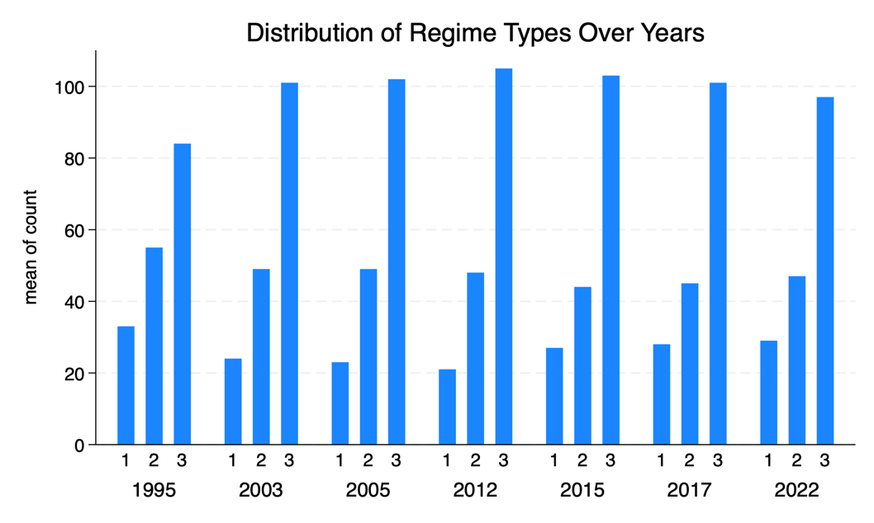

Figure 1: Distribution of Regime Types Over Years

Figure 2 is a bivariate analysis for our hypotheses. Panel I shows a marked increase in links between increased trade with the US and improved democracy indicators, also statistically significant in the OLS regression. Panel II contrast with a less pronounced regression line, suggesting a weaker correlation. Consequently, Hypothesis 2 is not supported; increased trade with the US in 2003 does not correlated with higher democracy indicators, and our OLS regression found no statistically significant relationship at the 0.05 level. Our findings intriguingly highlight that, despite the Bush administration’s concentration on promoting democracy through military force, such strategies did not yield democratic development. The War on Terror exemplified the contradictory nature of US efforts, with priorities shifting among regions. The Bush administration's preoccupation on combating terrorism led to minimised attention to democracy promotion in some areas while augmenting efforts in others. General Musharraf’s Pakistan along with autocratic Central Asian regimes, such as Uzbekistan, became key allies for strategic reasons such as securing military bases (Carothers, 2005). These actions are pragmatic geopolitical strategies, though at the expense of democratic principles, thus, the problem of credibility as promoter of democracy.

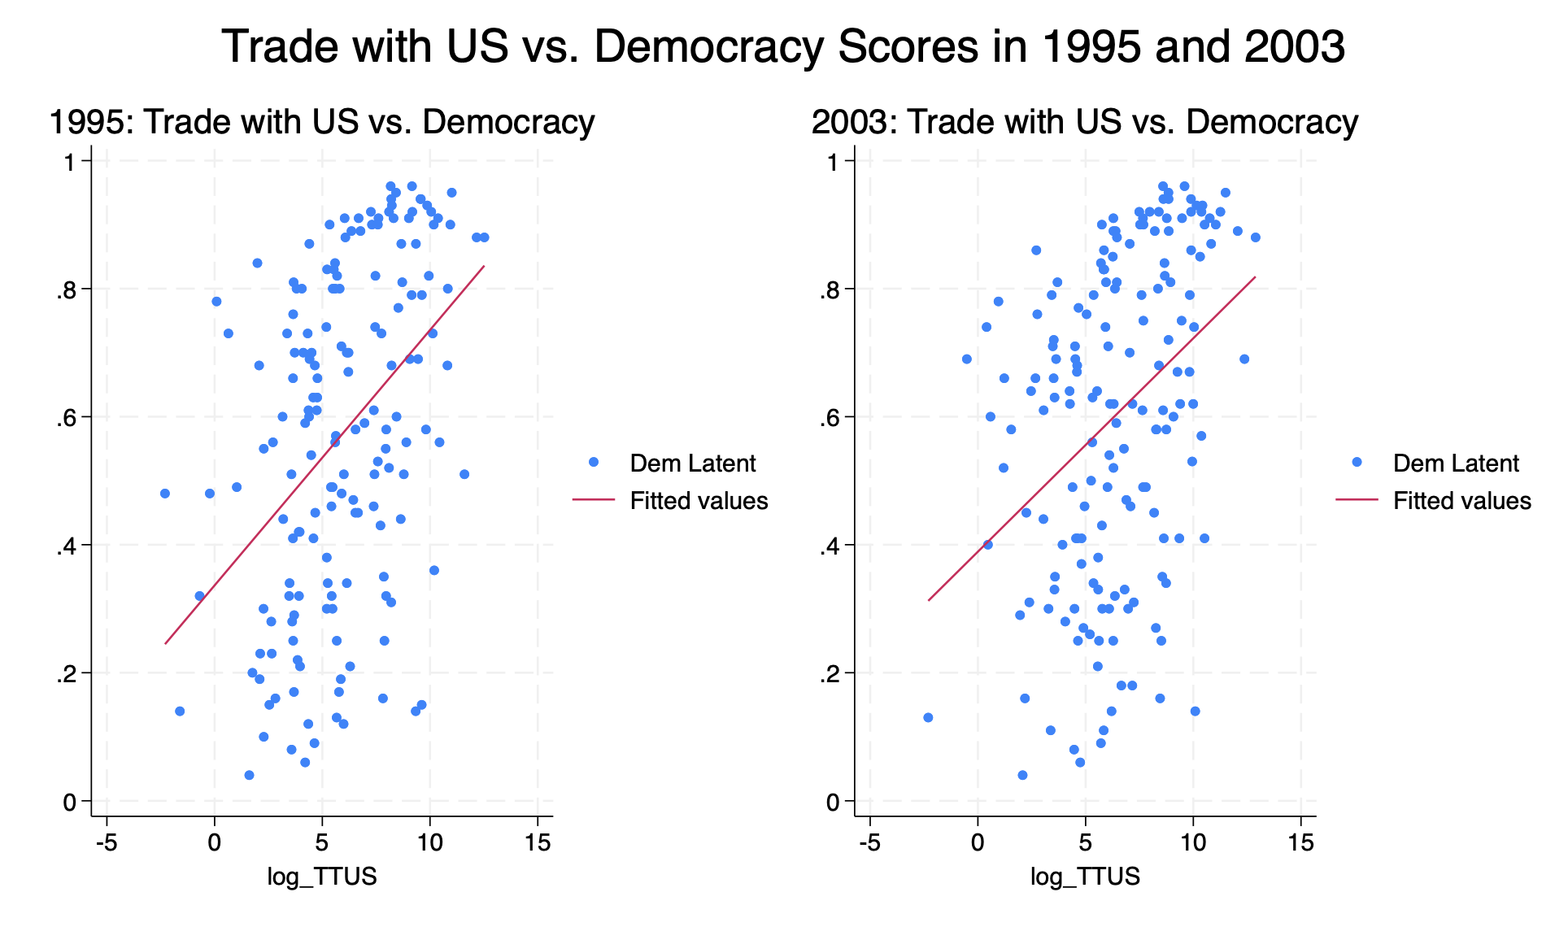
Figure 2: Increase Trade with US and Democracy Growth

Even though our hypothesis anticipated a positive correlation with US and democracy in 2012; the OLS regression, however, indicated otherwise with a 0.054 p-value. A subsequent analysis in 2012 showed a significant correlation (p-value with 0.016). There can be multiple reasons for this - the US trade deficit narrowed to $47.5 billion from $63.1 billion in 2012 (US commerce, 2014), the lowest since 2009. President Obama had proposed the Transatlantic Free Trade Agreement with the EU to remove tariffs and barriers, including on intellectual property rights. This period also witnessed the “pivot to Asia” strategy, designed not only to contain China, but also incorporating democracy promotion as a key component of the strategic framework.

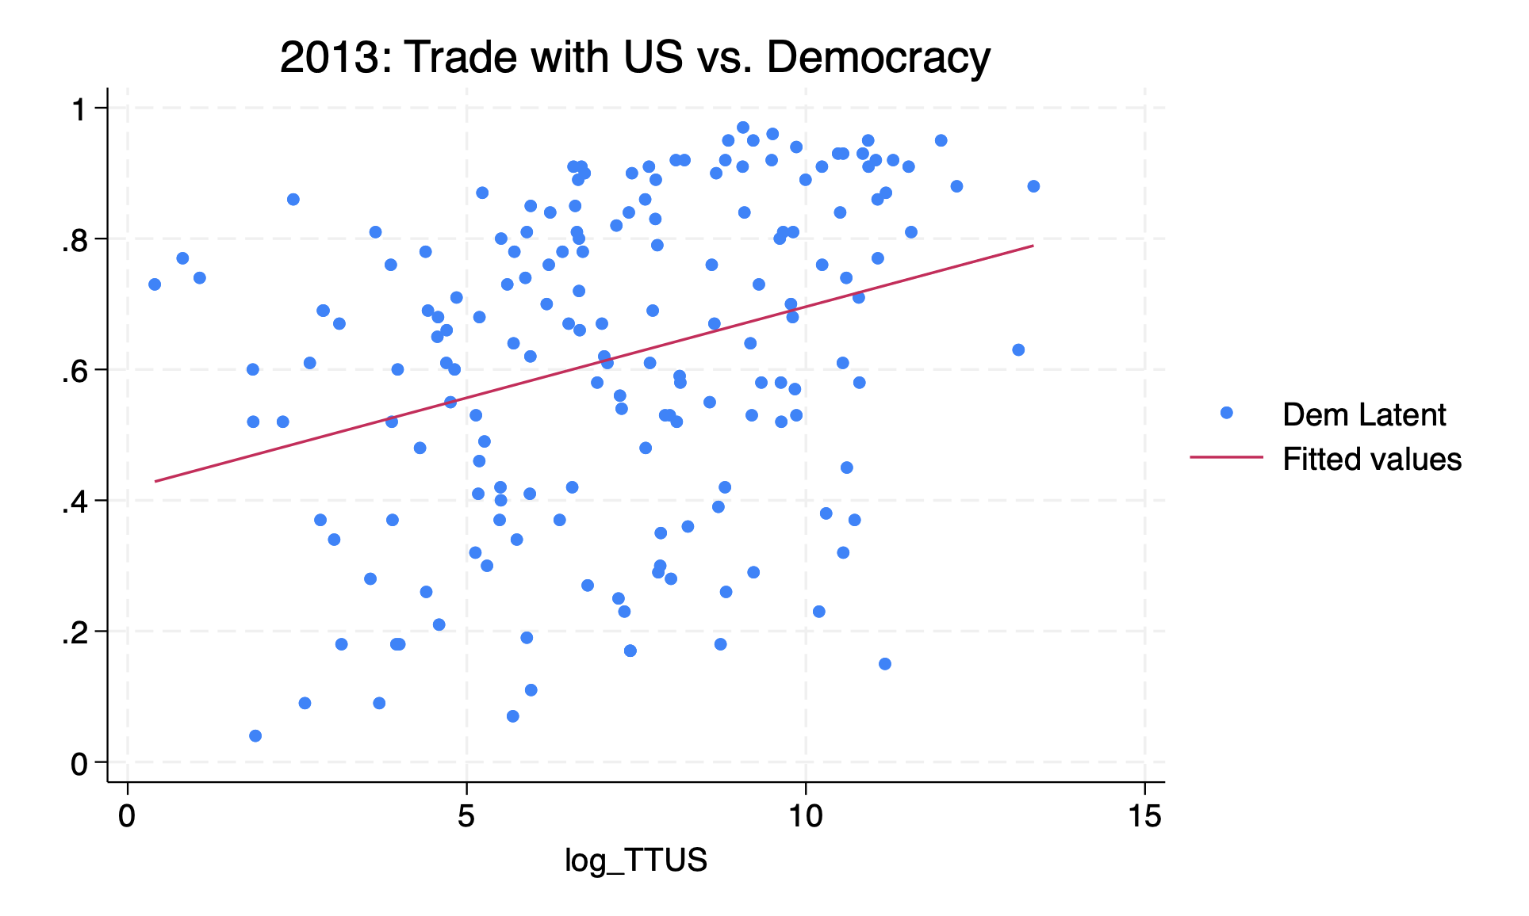

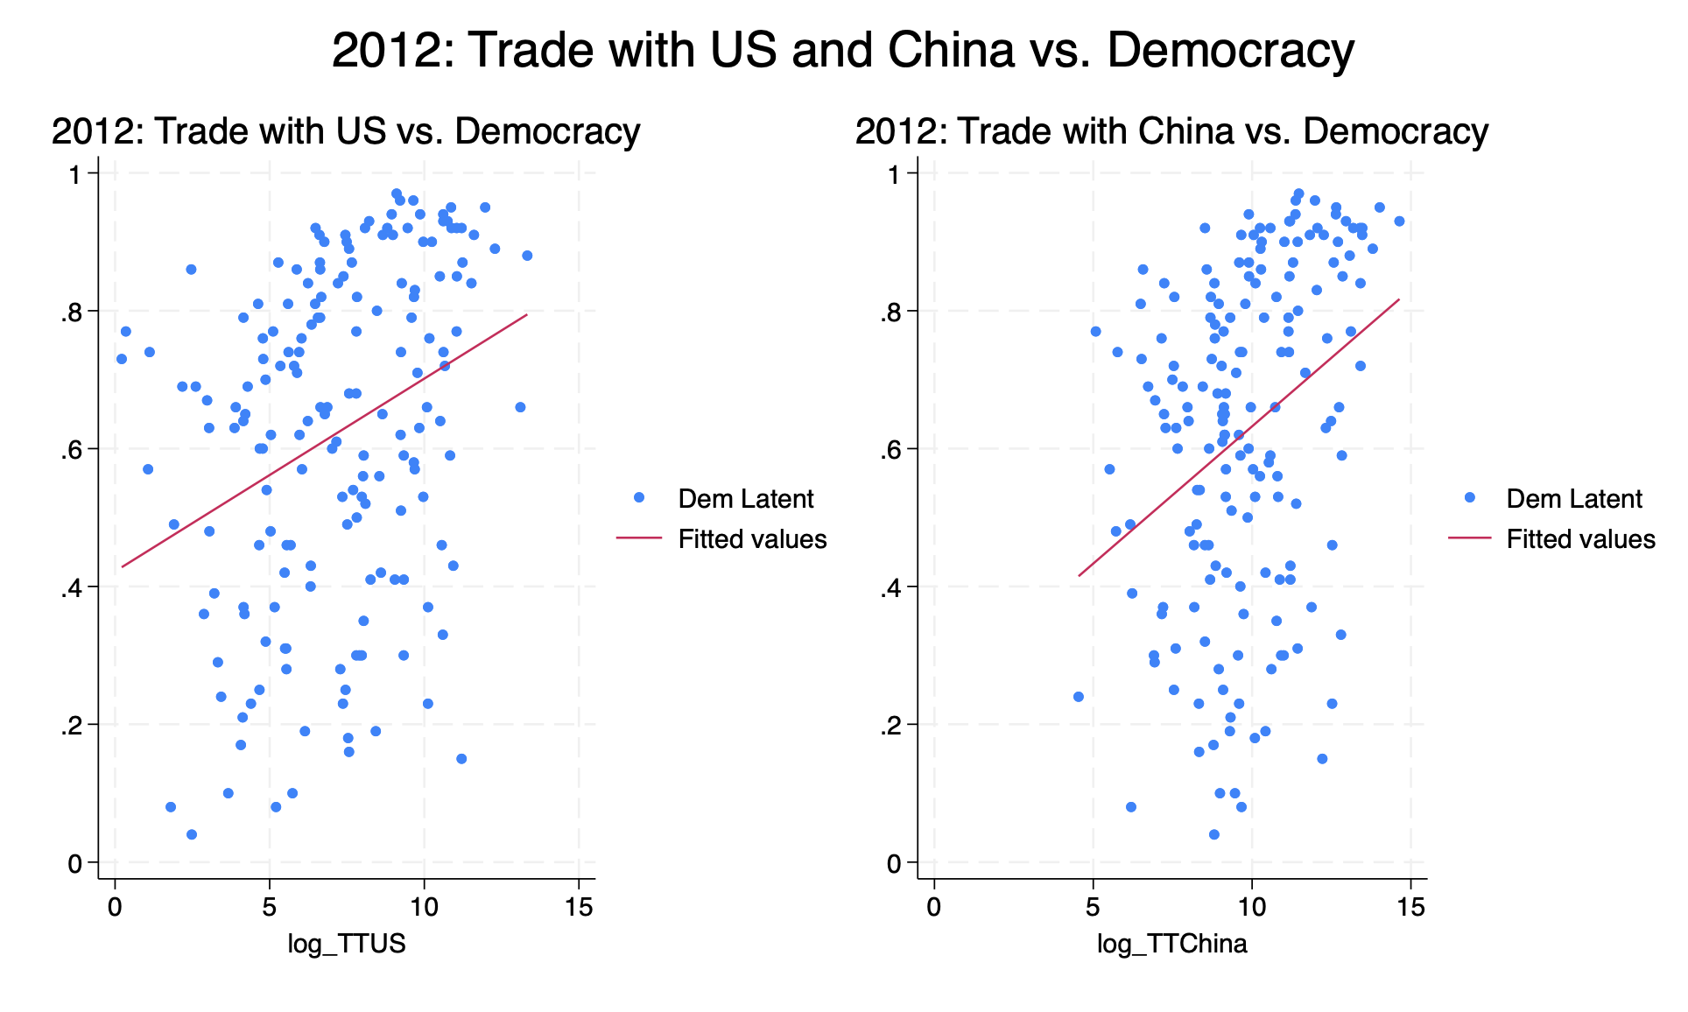
Figure 3: Comparative Analysis of Trade with US and China on Democracy Score in 2012

Table 1: Effects of trade on the democracy indicators of recipient countries
Variables |  | 1995 |  | 2003 |  | 2012 |  | 2017
Trade with US |  | 0.042 |  | 0.125 |  | 0.2 |  | 0.108
 |  | 0.006* |  | 0.198 |  | 0.054 |  | 0.358
 |  | [t=2.82] |  | [t= 1.29] |  | [t=1.94] |  | [t=0.92]
Trade with China |  | -0.0162 |  | 0.193 |  | -7 |  | 0.004
 |  | 0.492 |  | 0.257 |  | 0.704 |  | 0.849
 |  | [t= -0.69] |  | [t= 1.14] |  | [t=0.38] |  | [t=0.19]
Trade with Russia |  | 0.003 |  | -0.009 |  | -0.001 |  | -0.003
 |  | 0.798 |  | 0.257 |  | 0.828 |  | 0.681
 |  | [t=0.26] |  | [t=-1.37] |  | [t=0.22] |  | [t=0.41]
Liberal Institution |  | 0.357 |  | 0.374 |  | 0.353 |  | 0.368
 |  | 0* |  | 0* |  | 0* |  | 0*
 |  | [t=9.83] |  | [t=12.10] |  | [t=12.01] |  | [t=12.19]
Unemployment |  | 0.004 |  | 0.002 |  | 0.002 |  | 0.001
 |  | 0.118 |  | 0.328 |  | 0.273 |  | 0.682
 |  | [t=1.58] |  | [t=0.98] |  | [t=1.10] |  | [t=0.41]
Constant |  | 0.274 |  | 0.245 |  | 0.415 |  | 0.382
 |  | 0.024 |  | 0.009 |  | 0.001 |  | 0.002
 |  | [t=2.29] |  | [t=2.63] |  | [t=3.47] |  | [t=3.13]
No. of Observation |  | 86 |  | 151 |  | 160 |  | 161
R squared |  | 0.689 |  | 0.619 |  | 0.572 |  | 0.552
Adjusted R squared |  | 0.67 |  | 0.606 |  | 0.558 |  | 0.538

Note: Robust standard error clustered in parentheses. *p <0.05
The bold entries indicate main variables of interest.

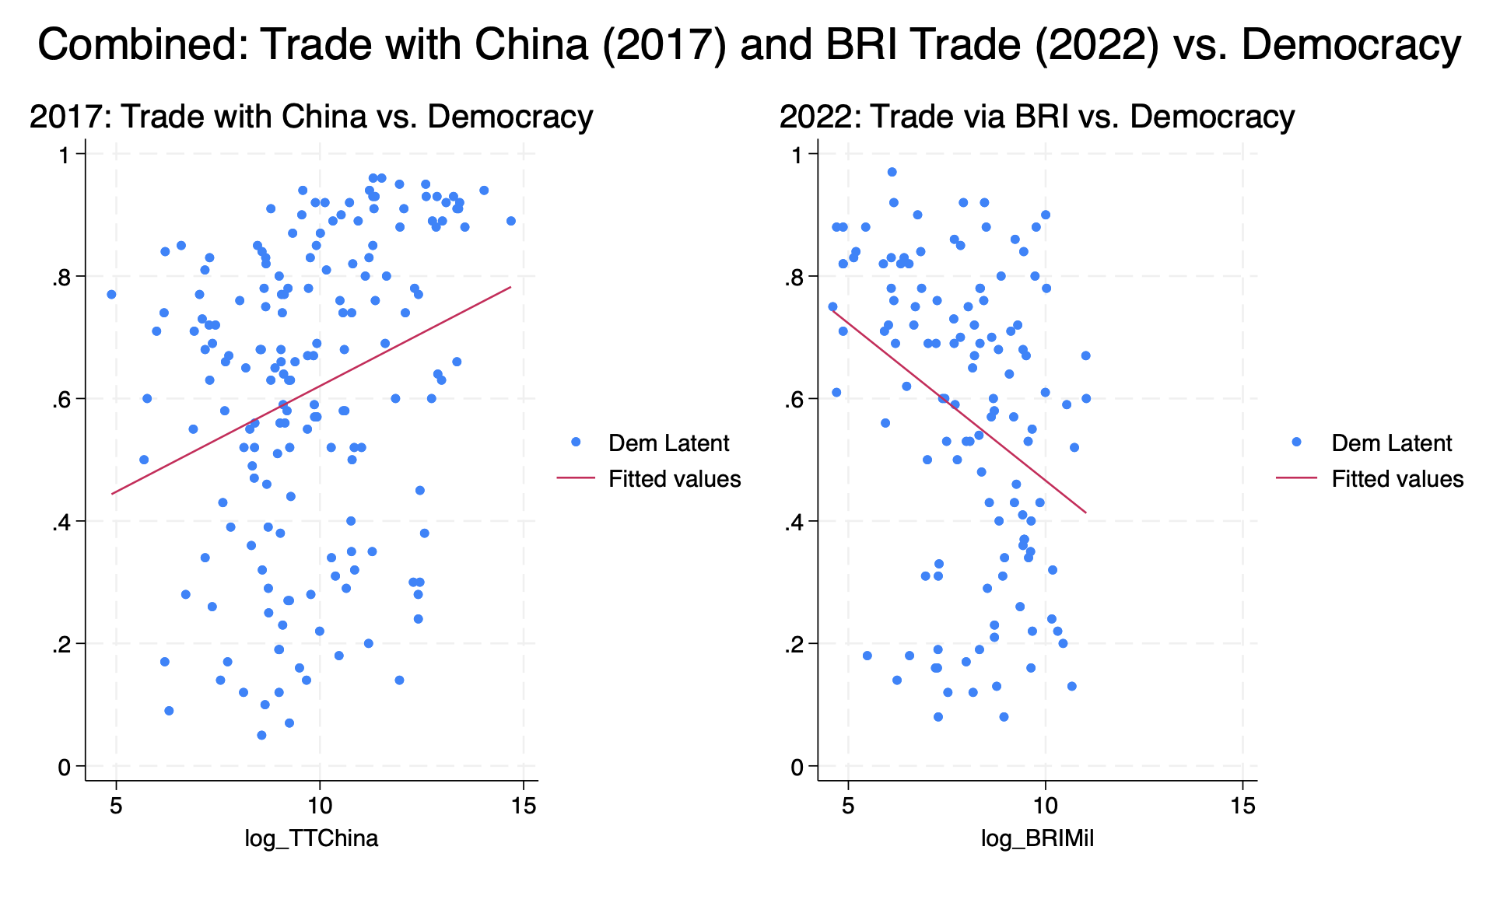
Figure 4: Trade with China and Democracy: A Comparative Analysis, 2017 versus BRI 2022

While our Hypothesis 5 posits that trade with China would negatively impact democracy scores, this was not found to be statistically significant. This could be due to diverse trading relationships China maintains, from liberal democracies like Scandinavian countries to autocratic states in Africa, illustrating complex impacts of economic relations. However, Hypothesis 6, focusing on the BRI’s trade and its negative influence on democracy, was statistically significant. The differentiation in Figure 4 between Panel I and Panel II suggests that while global economies engage with China irrespective of governance level, BRI signatories are mostly developing countries known for higher corruption levels and weaker governance, and are particularly vulnerable to the negative impacts of economic ties with China. Financial loans from China, offered without the IMF or World Bank’s strict conditions, attract autocratic leaders and diminishes their commitments to democratic norms. Economic dependencies create a conducive environment for autocrats to tighten their grip on power, bypass democratic processes, and prioritise personal interests over democratic development, contributing to eroded democratic governance.

The analysis presented in Table 2 reveals a noteworthy shift in the relationship over Russia and democracy levels in 2022. This period, renowned for Russia’s invasion of Ukraine illustrates a statistically significant decline in the democratic standards of countries engaging in trade with Russia. Such a finding diverges from the trend observed from 1995 to 2017, where no significant impact was detected. The critical change in 2022 underlines how the geopolitical landscape, aggravated by global sanctions against Russia influences democratic attributes in trading nations. The dilemma is further convoluted by the fact that the primary sanction proponents are the United States and Washington's liberal allies. This led to a situation where countries continuing trade relations with Russia, in face of such sanctions, exhibit a negative correlation with democratic values..

Table 2: Effects of trade on the democracy indicators of recipient countries
Variable |  | 2017 |  | 2022
Trade with US |  | 0.108 |  | 0.134
 |  | 0.358 |  | 0.389
 |  | [t=0.92] |  | [t=0.87]
Trade with China |  | 0.004 |  | 0.494
 |  | 0.849 |  | 0.92
 |  | [t=0.19] |  | [t=1.70]
BRI Investment |  |  |  | -0.386
 |  |  |  | 0.004*
 |  |  |  | [t=2.92]
Trade with Russia |  | -0.003 |  | -0.023
 |  | 0.681 |  | 0.10*
 |  | [t=0.41] |  | [t=-2.63]
Liberal Institution |  | 0.368 |  | 0.299
 |  | 0* |  | 0*
 |  | [t=12.19] |  | [t=7.13]
Unemployment |  | 0.001 |  | 0.005
 |  | 0.682 |  | 0.102
 |  | [t=0.41] |  | [t=165]
Constant |  | 0.382 |  | 0.298
 |  | 0.002 |  | 0.096
 |  | [t=3.13] |  | [t=1.68]
No. of Observation |  | 161 |  | 108
R squared |  | 0.552 |  | 0.536
Adjusted R squared |  | 0.538 |  | 0.509

Note: Robust standard error clustered in parentheses. *p <0.05
The bold entries indicate main variables of interest.

Conclusion

In light of the power transition theory, the global governance trajectory has undergone a transformation, marked initially by the unipolar moment and a subsequent rise of China as a formidable contender internationally. In the unipolar era, there was a visible enlargement in the sum of countries adopting liberal democracy. This period epitomised the zenith of liberal democracy, the ideological belief heralded by Fukuyama - democracy representing the pinnacle of mankind’s ideological evolution and the ultimate form of governance. The global order, influenced heavily by the US, fostered environment conducive to the spread and reinforcement of democratic values and institutions.

However, this trend encountered headwinds with China's rise, beginning with a pivot in global power dynamics - a phenomenon Gunitsky terms as “hegemonic shock”. A move from a unipolar world dominated by a single hegemon towards a more contested bipolar landscape has profound implications for global structures, especially for democratic institutions and norms In China challenging the current order, Beijing's rise corresponds with increases in democratic backsliding, particularly conspicuous among BRI signatories. This ambitious, strategic effort by China to extend influence through infrastructure and economic investments is linked to eroded democratic standards in participating countries. A “hegemonic shock” brought about by China’s rise disrupts the previous global equilibrium, where promoted and supported liberal democratic values were more lucid under unipolar dominance. Economic entanglement and dependencies created by BRI and the “no string attached” approach to diplomacy and investment present recipient countries with alternatives prioritising economic gains over democratic facets. External actors do influence domestic political landscapes but also exemplifies global power transition with the health of democracy worldwide. Juxtaposing the unipolar moment’s democratic expansion with the multipolar era’s democratic backsliding accentuates power transition theory’s implications in contemporary geopolitics. As such, China and the associated hegemonic shock necessitate us to reassess of strategies strategies in promoting democracy and sustaining global democratic norms amidst these fluctuations.

Bibliography

- Adcock, R., & Collier, D. (2001). Measurement validity: A shared standard for qualitative and quantitative research. American political science review, 95(3), 529-546.
- Bader, J., & Faust, J. (2014). Foreign aid, democratization, and autocratic survival. International Studies Review, 16(4), 575-595.
- Balding, C. (2018). Why democracies are turning against Belt and Road. Foreign Affairs, 24
- Bekkevold, J (2023, March 23). Why China is not a superpower. Analysis. Foreign Policy.
- Boylan, B. M., McBeath, J., & Wang, B. (2021). US–China relations: Nationalism, the trade war, and COVID-19. Fudan Journal of the Humanities and Social Sciences, 14(1), 23-40.
- Bermeo, N. (2016). On democratic backsliding. J. Democracy, 27, 5.
- Bridoux, J. (2013). US foreign policy and democracy promotion: in search of purpose. International Relations, 27(2), 235-240.
- Carothers, T. (2003). Promoting the rule of law abroad: the problem of knowledge.
- Callahan, W. A. (2016). China’s “Asia Dream” the belt road initiative and the new regional order. Asian Journal of Comparative Politics, 1(3), 226-243.
- Chan, S. (2009). China, the US, and the Power-Transition Theory: A Critique [Book Review].
- Collier, D., & Levitsky, S. (1997). Democracy with adjectives: Conceptual innovation in comparative research. World politics, 49(3), 430-451.
- deLisle, J., & Goldstein, A. (2021). Rivalry and security in a new era for US-China relations. After engagement: Dilemmas in US-China security relations, 1-47.
- DiCicco, J. M., & Levy, J. S. (1999). Power shifts and problem shifts: The evolution of the power transition research program. Journal of conflict resolution, 43(6), 675-704.
- Di Palma, G. (1990). To craft democracies: An essay on democratic transitions. Univ of California Press.
- Durotoye, A. (2016). Resurgent backsliding and democracy in Africa. International Journal of African and Asian Studies, 18, 39-46.
- Friedberg, A. L. (2005). The future of US-China relations: Is conflict inevitable?. International security, 30(2), 7-45.
- Finkel, S. E., Pérez-Liñán, A., & Seligson, M. A. (2007). The effects of US foreign assistance on democracy building, 1990–2003. World politics, 59(3), 404-439.
- Gandhi, J., & Przeworski, A. (2007). Authoritarian institutions and the survival of autocrats. Comparative political studies, 40(11), 1279-1301.
- Gat, A. (2007). The return of authoritarian great powers. Foreign Aff., 86, 59.
- GASPARINI, A. Thirty years later: what changed since the US “unipolar moment”?.
- Gerstl, A., & Wallenböck, U. (2020). Making analytic sense of the Belt and Road Initiative: a plea for multi-and trans-disciplinary approaches and eclecticism. In China’s Belt and Road Initiative (pp. 1-20). Routledge.
- Greskovits, B. (2015). The hollowing and backsliding of democracy in East Central Europe. Global policy, 6, 28-37
- Grumbach, J. M. (2023). Laboratories of democratic backsliding. American Political Science Review, 117(3), 967-984.
- Gunitsky, S. (2014). From Shocks to Waves: Hegemonic Transitions and Democratization in the Twentieth Century. International Organization, 68(3), 561–597.
- Haggard, S., & Kaufman, R. R. (2016). Dictators and democrats: Masses, elites, and regime change. Princeton University Press.
- Haggard, S., & Kaufman, R. (2021). Backsliding: Democratic regress in the contemporary world. Cambridge University Press
- Hasenclever, A., Mayer, P., & Rittberger, V. (1996). Interests, power, knowledge: The study of international regimes. Mershon International Studies Review, 40(Supplement_2), 177-228.
- Hess, S., & Aidoo, R. (2019). Democratic backsliding in sub-Saharan Africa and the role of China’s development assistance. Commonwealth & Comparative Politics, 57(4), 421-444.
- Huq, A., & Ginsburg, T. (2018). How to lose a constitutional democracy. UCLA L. Rev., 65, 78.
- Hyde, S. D. (2020). Democracy’s backsliding in the international environment. Science, 369(6508), 1192-1196.
- Huntington, S. P. (1996). Democracy for the long haul. J. Democracy, 7, 3.
- Ikenberry, G. J. (2001). American power and the empire of capitalist democracy. Review of International Studies, 27(5), 191-212.
- Ikenberry, G. J. (2004). Liberalism and empire: Logics of order in the American unipolar age. Review of International Studies, 30(4), 609-630.
- Ikenberry, G. J. (2005). Power and liberal order: America's postwar world order in transition. International Relations of the Asia-Pacific, 5(2), 133-152.
- Ikenberry, G. J. (2014). From hegemony to the balance of power: the rise of China and American grand strategy in East Asia. International Journal of Korean Unification Studies, 23(2), 41-63.
- Jeffery, R. (2009). Evaluating the ‘China threat’: power transition theory, the successor-state image and the dangers of historical analogies. Australian Journal of International Affairs, 63(2), 309-324.
- Jee, H., Lueders, H., & Myrick, R. (2022). Towards a unified approach to research on democratic backsliding. Democratization, 29(4), 754-767.
- Johnston, A. I. (2003). Is China a status quo power?. International security, 27(4), 5-56.
- Levistky, S., Ziblatt, D.(2019) How Democracies die. Crown.
- Lührmann, A., & Lindberg, S. I. (2019). A third wave of autocratization is here: what is new about it?. Democratization, 26(7), 1095-1113.
- Kaplan, R. D. (2005). How we would fight China. The Atlantic, 295(5), 49-64.
- Kennedy, P. (2002). The eagle has landed. Financial Times.
- Kim, W., & Gates, S. (2015). Power transition theory and the rise of China. International Area Studies Review, 18(3), 219-226.
- Krauthammer, C. (2002). The unipolar moment revisited. The national interest, (70), 5-18.
- Kugler, J., & Lemke, D. (2000). The power transition. Handbook of War Studies II, 129.
- Kugler, J., & Tammen, R. L. (2004). Regional challenge : China’s rise to power. The Asia-Pacific: A Region in Transition, Honolulo: Asia-Pacific Center for Security Studies, 33, 53.
- Layne, C. (2011). The unipolar exit: beyond the Pax Americana. Cambridge Review of International Affairs, 24(2), 149-164.
- Lemke, D., & Reed, W. (1996). Regime types and status quo evaluations: Power transition theory and the democratic peace. International Interactions, 22(2), 143-164.
- Lijphart, A. (1999). Patterns of democracy: Government forms and performance in thirty-six countries. Yale university press.
- Lim, Y. H. (2015). How (dis) satisfied is China? A power transition theory perspective. Journal of Contemporary China, 24(92), 280-297.
- Lührmann, A., & Rooney, B. (2021). Autocratization by decree: States of emergency and democratic decline. Comparative Politics, 53(4), 617-649.
- Maerz, S. F., Lührmann, A., Hellmeier, S., Grahn, S., & Lindberg, S. I. (2020). State of the world 2019: autocratization surges–resistance grows. Democratization, 27(6), 909-927.
- Maerz, S. F., & Schneider, C. (2021). Public discourse and autocratization: Infringing on autonomy, sabotaging accountability. V-Dem Working Paper, 112.
- Mearsheimer, J. J. (2001). The tragedy of great power politics. WW Norton & Company.
- Mihr, A. (2023). European democracy’s Response to the BRI. Securitization and Democracy in Eurasia: Transformation and Development in the OSCE Region, edited by Anja Mihr, Paolo Sorbello, and Brigitte Weiffen, 375-392.
- Monten, J. (2005). The roots of the Bush doctrine: Power, nationalism, and democracy promotion in US strategy. International Security, 29(4), 112-156.
- Nye Jr, J. S. (2010). American and Chinese power after the financial crisis. The Washington Quarterly, 33(4), 143-153.
- Organski, A. F., & Kugler, J. (1980). The war ledger. University of Chicago Press
- Organski, A. F. (1958). World politics. (No Title).
- Papaioannou, E., & Siourounis, G. (2008). Democratisation and growth. The Economic Journal, 118(532), 1520-1551
- Peou, S. (2014). The limits and potential of liberal democratisation in Southeast Asia. Journal of Current Southeast Asian Affairs, 33(3), 19-47.
- Rudd, K. (2019). The Avoidable War: Reflections on US-China Relations and the End of Strategic Engagement. Asia Society Policy Institute, 8, 2019-01.
- Sartori, G. (2016). The theory of democracy revisited. In Democracy: A Reader (pp. 192-196). Columbia University Press.
- Sauvant, K. P., & Chen, V. Z. (2014). China’s Regulatory Framework for Outward Foreign Direct Investment. China Economic Journal, 7, 141-163.
- Scheppele, K. L. (2018). Autocratic legalism. The University of Chicago Law Review, 85(2), 545-584.
- Sutherland, D., Anderson, J., Bailey, N., & Alon, I. (2020). Policy, institutional fragility, and Chinese outward foreign direct investment: An empirical examination of the Belt and Road Initiative. Journal of International Business Policy, 3, 249-272
- Shambaugh, D. (2004). China engages Asia: reshaping the regional order. International security, 29(3), 64-99.
- Tammen, R. R., et al. 2000. Power Transitions: Strategies for the 21st Century.
- Tammen, R. L., & Kugler, J. (2006). Power transition and China–US conflicts. The Chinese Journal of International Politics, 1(1), 35-55.
- Tammen, R. L., Kugler, J., & Lemke, D. (2011). Power transition theory. Oxford University Press.
- Tammen, R. L., Kugler, J., & Lemke, D. (2012). Power transition theory. Oxford University Press.

- Tammen, R. R., J. Kugler and D. Lemke. 2017a. “Power Transition Theory.” Oxford Bibliographies in International Relations.

- Tansey, O., Koehler, K., & Schmotz, A. (2017). Ties to the rest: Autocratic linkages and regime survival. Comparative Political Studies, 50(9), 1221-1254.
- Treisman, D. (2023). How great is the current danger to democracy? Assessing the risk with historical data. Comparative Political Studies, 56(12), 1924-1952.
- Tian, N., da Silva, D. L., Liang, X., Scarazzato, L., Béraud-Sudreau, L., & de Oliveira Assis, A. C. (2023). Trends in world military expenditure, 2022. Stockholm International Peace Research Institute.
- Vanderhill, R. (2012). Promoting authoritarianism abroad. Lynne Rienner Publishers.
- Von Soest, C. (2013). Persistent systemic corruption: why democratisation and economic liberalisation have failed to undo an old evil. Zeitschrift für vergleichende Politikwissenschaft, 7(Supplement 1), 57-87.
- Waldner, D., & Lust, E. (2018). Unwelcome change: Coming to terms with democratic backsliding. Annual Review of Political Science, 21, 93-113.
- Wibowo, I. (2009). China’s soft power and neoliberal agenda in Southeast Asia. Soft power: China’s emerging strategy in international politics, 207-23.
- Yoshihara, T. (2014). Chinese Maritime Geography. In : Mahnken TG, Blumenthal D, editors. Strategy in Asia : The Past, Present, and the Future of Regional Security. Standford University Press.
- Zakaria, F. (2019). The self-destruction of American power. Foreign Affairs, 98(4), 10-16.
- Zeng, J. (2017). Does Europe Matter? The Role of Europe in Chinese Narratives of "One Belt One Road" and "New Type of Great Power Relations." Journal of Common Market Studies, 55, 1162-1176.
- Zhang, F. (2016). Challenge accepted: China’s response to the US rebalance to the Asia-Pacific. Security Challenges, 12(3), 45-60.
- Zhang, E., & James, P. (2023). All roads lead to Beijing : Systemism, power transition theory and the belt and road initiative. Chinese Political Science Review, 8(1), 18-44.
- https://2010-2014.commerce.gov/news/press-releases/2014/02/06/us-exports-reach-23-trillion-2013-set-new-record-fourth-straight-year.html

Center for Strategic and International Studies. (2017, April 19). Erdogan Takes Total Control of the New Turkey. CSIS. https://www.csis.org/analysis/erdogan-takes-total-control-new-turkey
Human Rights Watch. (2019, December 11). India: Citizenship Bill Discriminates Against Muslims. HRW. https://www.hrw.org/news/2019/12/11/india-citizenship-bill-discriminates-against-muslims

