Geographic Context and Political Empowerment:
Perception as a Moderator

Western Political Science Association
Winter 2022

Disentangling the participatory effects of coethnic candidates from coethnic jurisdictions has been a longstanding challenge for political scientists interested in minority turnout. While some studies have convincingly isolated the effect of one context from the other, it remains unclear how perceptions of local context interact with an individual’s actual local context in models of voter turnout. To better understand this relationship, I rely on the 2020 Collaborative Multiracial Post-Election Survey (CMPS). First, I examine how perceptions of in-group population share vary across different levels of urbanicity with results suggesting that individuals in rural areas have perceptions closer to reality than their urban counterparts. My main analysis interacts the Latino composition of a respondent’s local geography with their perception of the same geography in predicting feelings of political trust and efficacy. I ultimately find a strong negative interaction effect between these two variables, indicating that people who over-perceive the share of Latinos in their local neighborhood are significantly less empowered by increases in Latino population share than those who under-perceive. Generally speaking however, over perceivers are more empowered than under perceivers.

Michael Herndon
maherndon@ucla.edu
Political Science Department
University of California, Los Angeles

Introduction
More than fifty years after the passage of the Voting Rights Act, nonwhite voter turnout is still lower on average than white turnout. This pattern holds especially true for Latinos. In the 2020 general election, it is estimated that Latino turnout was nearly 20 points behind Anglos, and more than 5 points behind Black and Asian Americans (Current Population Survey 2020). This racial disparity in political participation has meaningful consequences for the distribution of federal pork barrel projects (Martin 2003), state welfare benefits (Hill and Leighley 1992), and at the local level, basic city services like garbage collection and street paving (Keech 1968). In short, Latinos are at a perpetual risk of being overlooked by their representatives due to comparatively low turnout rates. Coupling chronic abstention with the fact that Latinos are the country’s second largest racial/ethnic group in the country behind non-Hispanic whites, it is paramount that social scientists work to develop a detailed understanding of the determinants of minority political participation.
Traditional theories of political participation stress the importance of individual socioeconomic characteristics as being the primary predictor of voting (Teixeira 1987; Verba and Nie 1972). These resource-centered models of participation have been expanded to incorporate certain psychological factors like group consciousness (Miller et al. 1981), but by placing individuals in a vacuum, contextual predictors of participation are left out. For example, intergroup contact has been shown to affect rates of participation but is typically left out of traditional models of political participation (Enos 2017; Key 1949). Other political contexts that can influence participation include policies that suppress the vote (Keele, Cubbison, & White 2021; Hajnal, Lajevardi, & Nielson 2017), social movements (Amenta et al. 2010), and at the center of this study: political empowerment via co-ethnic population share (). In their seminal study of Black mayoralties, Bobo and Gilliam originally define empowerment as: “the extent to which a group has achieved significant representation and influence in political decision making” (1990, 378-79). This increase in representation/influence is argued to affect participation via increased trust, efficacy, and knowledge of politics. In other words, contexts of empowerment affect people’s calculi of participation due to symbolic cues of shared experiences and policy preferences that in turn affect the perceived benefits of participation.
A critical assumption underlying the mechanics of empowerment theory is that individuals must be perceptive of their local context to be empowered by it. For example, a Latino can hardly reap the psychological benefits of living in a Latino jurisdiction unless they are aware of it. I argue that this assumption is widely overlooked and that perceptions of empowerment are just as, if not more important than actual contexts of empowerment - specifically when it comes to empowerment via coethnic districts.
To make this argument, I utilize geocoded data from the 2020 CMPS to first compare people’s perceptions of their neighborhood’s racial composition to the actual racial composition. After finding that most Latinos underestimate the share of Latinos residing in their ZIP code, I explore how these misperceptions condition the relationship between local context and feelings of empowerment. By clarifying the role that perception plays in models of empowerment, this work contributes to the larger literature of contextual participation and the specific debate on the boundaries of Latino group consciousness. The rest of this paper is organized as follows: First I provide a brief review of the empowerment literature. I then outline my own theory and hypotheses concerning perceptions of local context and empowerment. Next, I describe the data used for this study and provide preliminary analysis on key variables. Finally, I provide the results of my main analysis and end with a discussion of how they can be interpreted and avenues for future research.
Empowerment via Candidates
Tests of empowerment theory have typically examined contexts of descriptive representation. At the municipal level, a series of studies find that coethnic mayors increase participation (Barreto 2007; Bobo and Gilliam 1990; Pinderhughes 1987). While this work argues that empowerment affects participation via an internal psychological process, a separate literature shows that external forces are also at play. By spending a disproportionate amount of time and resources on coethnic constituents, candidates themselves have been shown to directly mobilize minority voters (Barreto 2010). Research emphasizing the mobilizing effect of race conscious GOTV techniques compliment this line of work (Bedolla and Michelson 2012). Besides participation, coethnic incorporation into local government has been found to positively influence efficacy (Marschall and Ruhil 2007) and decrease feelings of alienation (Pantoja and Segura 2003).
Studies on empowerment via congressional representation have not been so clear. While Black representation in Congress seems to consistently stymie white participation, Black turnout only rarely increases (Brace et al. 1995; Gay 2001; Tate 2004). One explanation for this discrepancy points to the different role that members of Congress play compared to mayors. Unlike mayors who can “affect anything from neighborhood police patrols to the frequency of trash collection, members of Congress do not have the executive authority to make decisions that directly affect the daily lives of constituents” (Gay 2001, 599). This argument stresses the importance of substantive representation in addition to the purely psychological benefits of symbolic representation.
Empowerment via Districts
Descriptive representation might be the most straightforward operationalization of empowerment, but it was never described to be the exclusive measure of a group’s sway on political decision-making. Barreto et al. for example stress the ability or likelihood of political districts to elect representation of choice as empowering (2004). Similarly, Luke Keele and Ismail White argue that in majority-minority congressional districts, “there is a heightened sense of empowerment because minorities living in these places witness high levels of political power held by members of their racial in-group... but not exclusively in the form of office holding” (2011). This is all to say that one does not necessarily need to have descriptive representation in political office to feel empowered, but by simply living in an area where your in-group comprises a large proportion of the population, there can be empowering effects. There is significant overlap however, between areas with descriptive representation and areas with a large coethnic presence, making it particularly challenging for scholars to measure the distinct empowering effects of each context.
To date, the most comprehensive study of jurisdictional composition as a determinant of participation comes from Bernard Fraga (2016, 2018). By combining millions of voting records with demographic details of congressional candidates, Fraga finds that a district’s ethnic composition is a stronger predictor of participation than coethnic candidates for both general and primary elections (2016). On the surface, this contribution helps to explain why previous studies have found little to no relationship between coethnic congressional candidates and participation. What’s missing though, is a convincing explanation for what a jurisdictional operationalization of empowerment captures differently and why it is more appropriate to use over traditional models that stress descriptive representation.
To this point, Fraga notes that an association between population size and participation “does not obviate a deeper understanding of the processes leading to minority electoral participation”. He goes on to say that the ethnic composition of an electoral jurisdiction may have no causal impact on turnout, but instead simply reflect the underlying features of a neighborhood (2016). Because there are a wide variety of underlying neighborhood features that both encourage participation and are correlated with population share, district composition becomes a powerful catch-all predictor of participation. For example, community resources and social networks boost participation and are likely to be more prominent in areas with large coethnic populations (Spence and McClerking 2010). There are also likely to be nested municipal and state-level majority-minority jurisdictions within certain congressional districts. These jurisdictions and their coethnic representatives significantly increase turnout (Barreto et al. 2004) and the participatory effects are likely being captured by variables that measure population share at a high level of aggregation. Finally, as a population increases in size, election-seeking politicians are more likely to provide targeted appeals that in turn increase participation (Leighley 2001).
On the psychological side of things, there is reason to believe that individuals gain expressive benefits when living in a jurisdiction that is mostly composed of in-group members (Fraga et al. 2021). By residing in a district that is known to the voter as being aligned with their own interests/identities, the voter enjoys the psychological benefit of being a part of the “winning team” when participating in elections - a phenomenon that has been linked to increased turnout. Fraga and colleagues tested the expressive benefits hypothesis in the context of partisanship, but I argue that race can similarly divide voters into “winning” and “losing” teams, especially given the fact that racial identities often correlate with political preferences.
In sum, population share is a proxy for a number of underlying empowering circumstances, but do people benefit from these circumstances if they misperceive themselves to be racially isolated? That is to say, do local contexts of empowerment increase participation amongst individuals who significantly underestimate how influential their ethnic group is in the political arena? Given the fact that most Latinos underestimate their relative group size for local geographies as highlighted later in the paper, insight in this area can shed valuable light on the future of Latino electoral politics.
Racial Innumeracy
It is no secret that most Americans are unable to correctly estimate the racial makeup of their local neighborhood or the country (Wong 2007). When asked about the racial makeup of the country, both white and nonwhite respondents have been shown to overestimate the nonwhite population share and underestimate white population share. These findings are important because racial innumeracy has been linked to important policy preferences such as support for government welfare (Gilens 1999). While these findings are important on their own, they also suggest that racial innumeracy can affect things beyond policy preferences. For example, we might expect voters who underestimate the share of coethnics in their local community as less likely to receive the expressive benefits of voting. This leads me to my first hypothesis:

H1: Latinos that overestimate the proportion of coethnics in their local community are more trustworthy and efficacious towards politics than Latino under estimators.

Perceptions of in-group population share are certainly important when thinking about the psychological benefits associated with living in a context of empowerment, but some of the more tangible benefits of residing in an empowered jurisdiction operate independently from perceptions. Here I am referring to the elite mobilization, community resources, and social networks that are likely to exist in contexts of empowerment. If over estimators are more empowered than under estimators in general as hypothesized in H1, then we might expect the more tangible aspects of empowering contexts to have limited added effects due to a ceiling of empowerment. In other words, the initially high levels of trust and efficacy among over-estimators makes them less responsive to the empowering effects of increased coethnic population share. This leads me to my second hypothesis:

H2: Among Latinos, the effect of increased coethnic population share on feelings of trust and efficacy is weaker amongst over estimators than under estimators.

Data
I test these hypotheses using data from the 2020 CMPS (Barreto et al. 2021). One of the main advantages of survey data is that it allows for the measurement of psychological empowering effects that mediate boosts in participation. Of these psychological effects, political efficacy and political trust capture many of the important psychic benefits generated from contexts of empowerment that also predict participation - making them my preferred dependent variables.
I measure political efficacy by combining two questions. The first question measures internal efficacy and asks respondents how often Latinos have a say in how the government handles important issues. The second question asks respondents how often they believe public officials work hard to help Latinos. By combining these two items I am left with a 9 point scale of efficacy with an average score of 5.1. The Cronbach’s alpha of this scale is .72, indicating a good level of internal consistency.
To measure political trust, I rely on a question that asks respondents how much of the time they can trust the local city to do what is best for Latinos. This measure of trust has a scale of 0-3 with an average of 1.4.
My main independent variable subtracts the 2019 ACS estimate of Latinos population share in a respondent’s ZIP code from the respondent’s estimate of Latinos in their ZIP code, resulting in a scale that goes from -1 to 1 with positive scores being over estimators and negative scores being under estimators. I call this scale subjective perception. I also include controls for income, education, sex, age, ideology, and foreign-born status.
Before testing my main hypotheses, Figure 1 displays my subjective perception scale at varying levels of population density. The key takeaway from this figure is that the average Latino respondent underestimates the proportion of coethnics in their ZIP code.
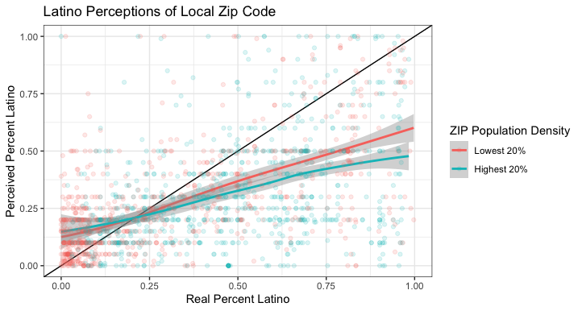
Figure 1

Figure 1 also suggests that under-estimating in-group population share is especially common when respondents live in predominantly Latino ZIP codes. Finally, it appears that respondents in densely populated areas are more likely to underestimate the share of Latinos in their ZIP code than respondents in sparsely populated areas. One reason for this could lie in the intimacy and familiarity of small towns providing more accurate demographic pictures in people’s heads.
Results
For all my models I use multivariate regression with state-level fixed effects. Table 1 displays a summary of how subjective perceptions of Latino context affect political trust.

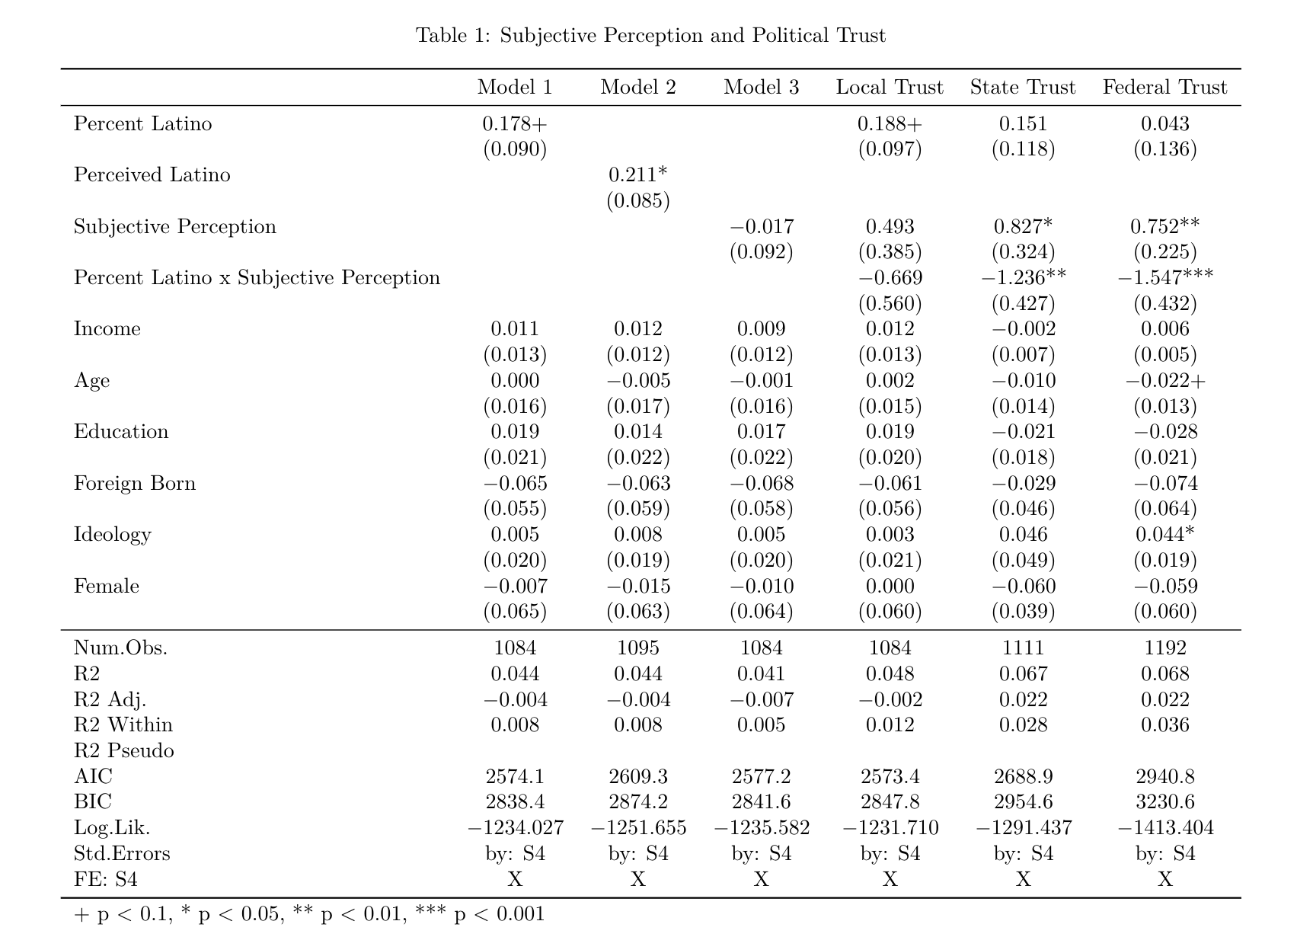

Model’s 1-4 all use trust in local government as the dependent variable. The final two models in Table 1 examine trust in state and federal governments respectively. Interestingly, overperceiving Latino population share at the ZIP code level has a stronger effect on trust in state and federal government than in local government. The CMPS only asks respondents 1 of these 3 trust measures so it is impossible to see whether subjective perception at the ZIP code level has different effects on political trust at different levels of government. Overall, Table 1 suggests that there is a negative interaction effect between objective coethnic population share and subjective perception of population share at the ZIP code level. Furthermore, the last two models in Table 1 show that generally, over perceivers have higher levels of trust in state and federal government than under perceivers.
Table 2 paints a similar picture. When using political efficacy as the dependent variable, the interaction between objective coethnic population share and subjective perception of population share at the ZIP code level is significantly negative. In Model 10, subjective perception is significantly positive, indicating that political efficacy is higher on average amongst over perceivers compared to under perceivers. Taken together, these models provide confirmatory evidence for both of my hypotheses.
Discussion
Contexts of empowerment have long been argued to increase participation rates among minority voters. Indeed, there is some evidence for this when looking at my analysis of Latino ZIP codes and political trust. What this analysis adds to existing studies of empowerment is a consideration of subjective perception. As shown earlier, people’s perception of the racial makeup of their neighborhood varies significantly from reality with most Latinos underestimating the percentage of coethnics in their ZIP code. I show that these misperceptions
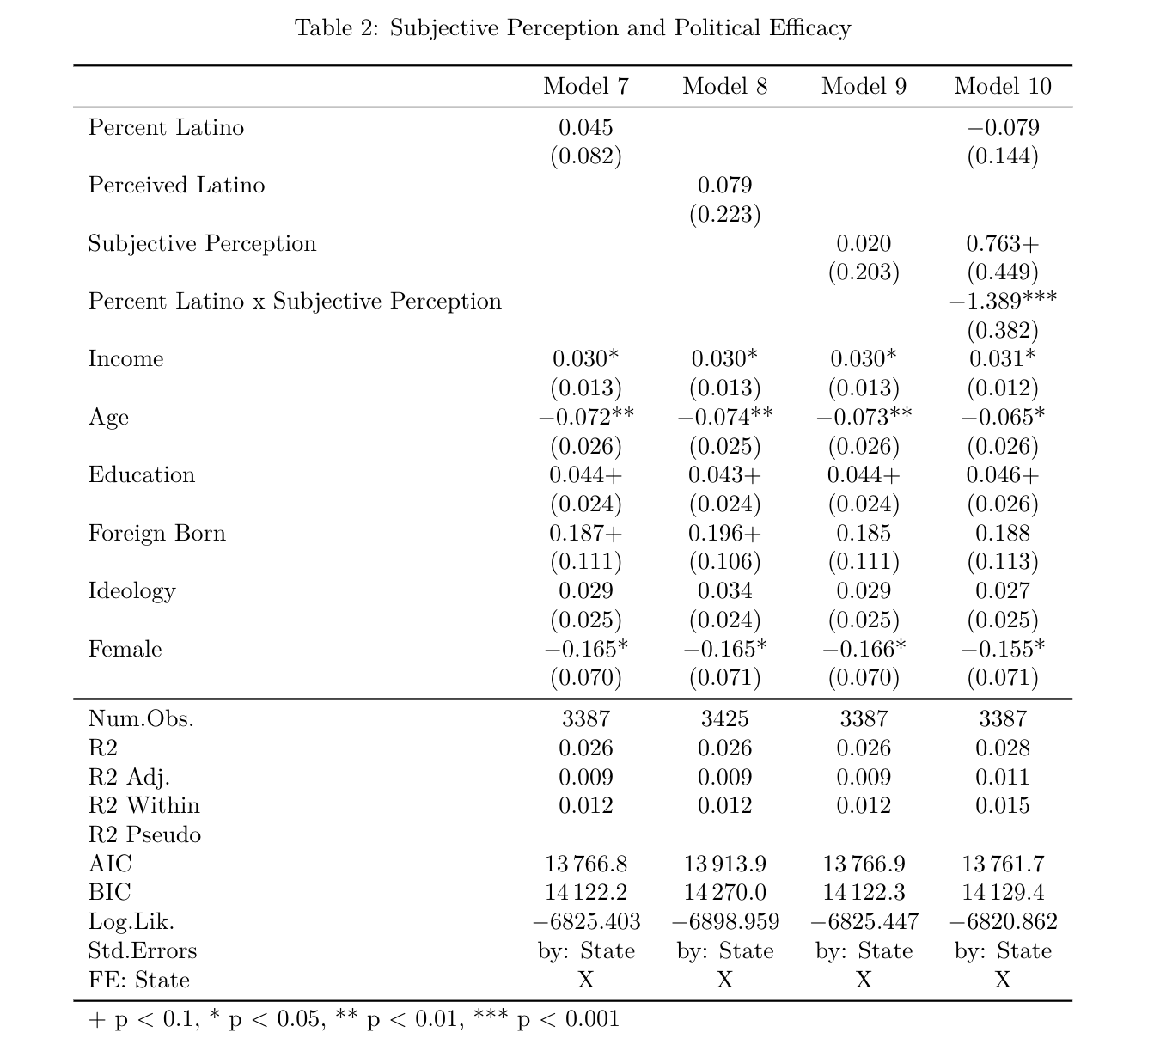
have significant consequences for empowerment. More specifically, I show that generally, over perceivers are more empowered than under perceivers. Because empowerment is at least in part a psychological process, it makes sense that feelings of trust and efficacy are higher amongst those who have more optimistic outlooks on the status of their identity group.
My other main finding has to do with the interaction between subjective perceptions and the objective reality of someone’s context. It isn’t abundantly clear why under perceivers are more sensitive to the empowering effects of living in a coethnic space than over perceivers, but I suspect that ceiling effects of empowerment are at play. Someone that feels empowered in their head might not benefit everything that comes with living in a coethnic space whereas people who feel racially isolated have much more to gain.
To tease out the effect that perception has independent from reality, future work can take an experimental approach that manipulates perceptions through deception and then compare participation rates. Another avenue for future research would look at how perceptions directly influence participation. The CMPS has questions on voting, but social desirability bias prevents a clean relationship from being measured.

