Abstract

Why do central state leaders sometimes choose to rely on local elites for regional governance—delegated rule—while others rely on their own deployed officials? I argue that one answer lies in regime institutions. When the national political regime relies on local elite networks to perform core regime tasks such as vote mobilization, centrally deployed officials have clear drawbacks for central state leaders: they lack connections to local elite networks that can facilitate vote mobilization in national elections. I demonstrate this dynamic using Russia’s 2008 and 2012 presidential elections: when a newly appointed governor has no connections to the prior incumbent (network turnover), the region averages a 16 rank decline in pro-Kremlin support in the 2008 and 2012 presidential elections. By contrast, newly appointed governors connected to their predecessor (network continuity) see no decline in pro-regime support. Thus, the need to win elections by large margins limited the Putin regime’s power over Russian society: the need to win elections by large margins incentivized the Kremlin to delegate power to local elites rather than deploy its own officials. In other words, Russia’s political regime incentivized a reliance on delegated rather than deployed rule.

Moscow Must Pay: Elite Networks and Delegated Rule in Russia’s Periphery
Vladimir Chub’s rule of Rostov Oblast could only be described as hegemonic. Governor of the region since 1991, Chub won his final direct gubernatorial election in 2001 with 79% of the vote. The Kremlin controlled regional executive appointments since 2004, and seemed to prioritize vote delivery to the Kremlin and United Russia (Reuter and Robertson 2012; Rochlitz et al. 2015). To this end, Chub had proven adept at delivering electoral support to Putin and Medvedev: in 2004, the region’s pro-Kremlin support ranked 27th out of 75 regions included in this study, climbing to 14th in 2008. Although Chub was clearly “delivering the goods,” his job was not secure. The Kremlin replaced Chub with one Vasiliy Golubev, a Muscovite with no known connections in Rostov or Rostov’s elites. Golubev went on to purge a significant number of Chub’s high-level Oblast officials under the pretext of anticorruption. Moscow cleaned house.
Placing this vignette in comparative perspective, Chub and Golubev represent two ideal-typical strategies for central state administration. Hillel Soifer’s terminology is illuminating: when officials in the periphery are local elites with significant private power in their communities, the central state employs “delegated rule” (Soifer 2015, 62). By contrast, when officials in the periphery come from outside the community, the central state employs “deployed rule” (Soifer 2015, 62). Because deployed officials derive nearly all of their power from their status as the central state’s representatives, their incentives are more closely aligned with the centre; we should therefore expect deployed rule to produce greater compliance with central state initiatives (Soifer 2015, 63–64). In Soifer’s terms, Chub represented a delegated official, while Golubev was a deployed official.
Soifer is unambiguous about the advantages of delegated over deployed rule: in Latin America, deployed rule explained state building success, while delegated rule explains state building failure (Soifer 2015, 60). Why, then, would central state leaders ever choose delegated rule over deployed rule? The answer, I argue, is that political control comes at a cost, even for autocrats. Rostov Oblast demonstrates this clearly. After Chub’s removal, Rostov’s the regional legislature passed a law guaranteeing Chub and his family $300,000 USD worth of various benefits for life, including a generous pension (60% of the serving governor), an official car, as well as medical and sanatorium services. Golubev—the Kremlin’s man—signed Chub’s benefit package into law on his first day as Rostov’s governor. Although quite generous, this benefit package was probably insignificant to the Kremlin. However, the electoral cost of deployed rule was more significant: despite a seemingly orderly transfer of power, Rostov fell from the 15th in pro-Kremlin support to 49th in 2012. Cleaning house in Rostov was not cheap.
The Rostov episode demonstrates the limits of Putin’s power vertical: despite its enormous coercive advantage over regional politicians, the Kremlin can still face considerable political costs when it interferes in regional politics. One way or another, Moscow must pay. But what determines the costs for Moscow to clean house, as it did in Rostov oblast? In this paper, I quantify the political cost for Moscow to exercise influence over regional politics through gubernatorial appointments. I argue that the continued importance of elections make it costly for the Kremlin to exercise influence over the periphery through executive appointments or dismissals. Putin consolidated power using regional elite networks to accomplish high priority regime goals, such as delivering electoral victories and maintaining social acquiescence. As my empirical results demonstrate, regional elite networks strongly affected the consequences of Kremlin controlled gubernatorial appointments. Replacing well connected regional elites with unconnected deployed officials led to significant declines in pro-Kremlin support during the 2008 and 2012 presidential elections. Thus, political regimes can incentivize delegated rule by altering the balance of power between of peripheral elites vis-à-vis central elites: peripheral elite networks are vital to political regimes that mobilize the population in authoritarian elections; the centre undermines peripheral elite networks at its peril.
In what follows, I provide a literature review examining question of central state weakness in comparative perspective. I identify a rift in the disparate literatures that consider this question: research that emphasizes the effect of political regimes tends to emphasize informational problems while neglecting incentives between central state leaders and their peripheral officials. On the other hand, scholarship that emphasizes incentives tends to ignore how political regimes shape centre and peripheral elites’ incentives vis-à-vis one another. Thus, I position this paper in the literature as one explanation for how political regimes—patterns of access to political power—create relations of dependence between central and peripheral elites. The next section reviews the Russian case. I then describe my theory, hypotheses, empirical methodology and results. In the discussion I reflect on the implications that the Russian case has for broader questions of central state weakness and delegated rule, as well as the portability of my argument.
Dominant Perspectives on State Weakness: Information and Incentives
In this paper, I argue that political regimes can have important consequences for central state strength. I now review several strands of scholarship relating to central state weakness, highlighting how this scholarship accounts for the effect of political regimes. Following Soifer (2015, 60), we have four general explanations for weak state capacity: bureaucratic quality (bureaucrats’ human capital), competing institutions (for instance, peripheral reliance on customary law), information problems, and incentive problems. I identify two interlinked inadequacies for both informational and incentive theories. Informational explanations for state weakness scrutinize political regimes—mostly through the effect of repression—but leave incentives undertheorized. By contrast, scholars emphasizing incentives—such as Soifer (2015) or Finkel and Gehlbach (2020)—tend to neglect how political regimes shape these incentives. I link these two strands of literature by arguing that informational explanations are incomplete without a theory of divergent incentives, while incentive problems cannot be explained without examining the centre’s political regime. Political regimes shape the centre’s interests vis-à-vis peripheral elites. In other words, neglecting regime type leaves important determinates of central state capacity essentially unexplained.
Information
Information is implicated in explanations of state capacity through principal-agent theory. In the principal-agent model, limited monitoring capacity prevents the principal from punishing the agent when the agent acts against the principal’s interests (Kiewiet and McCubbins 1991). In other words, if the principal has perfect information about the agent’s behavior, the agent will always be punished for behaviors undesirable to the principal, making these behaviors less likely. Thus, in principal-agent theory, monitoring capacity is a crucial factor determining whether the agent will pursue their own interests or those of the principal’s (Breton and Wintrobe 1982, 53). Thus, for instance, O’Brien and Li (1999, 173–74) argued that many of the Chinese state’s unpopular policies were transparently quantifiable and easily monitored from above, while popular policies were unquantifiable and difficult to monitor. The result is that Beijing successfully enforced the implementation of unpopular policies but struggled to enforce implementation of popular policies (O’Brien and Li 1999). For his part, Landry (2008, 37) emphasizes the importance of monitoring costs as a factor driving decentralizing administrative reforms in China.
The importance of monitoring in principal-agent theory is also why these scholars have paid close attention to regime type. In autocracies, high levels of repression (or the possibility of it) incentivizes citizens to falsify their preferences (Kuran 1997), discourage accurate reporting upwards through a bureaucracy (Wintrobe 1998, 24–25), and even encourage collusion among agents (Berliner 1957, 162). One solution is for dictators to facilitate grass-roots monitoring of state agents by encouraging ordinary citizens to report malfeasance by state agents to monitoring organizations (Smith 1978), but high levels of repression may still render this strategy less effective as ordinary citizens avoid the risks of speaking out against state agents. Thus, the ever-present possibility of repression in autocratic regimes exacerbates monitoring problems for the centre.
Although principal-agent theory is perfectly capable of analysing the source of preference divergence and proposing payoff schemes that incentivize compliance (Wintrobe 1997, 432; Wedeman 1999, 103), the scholarship reviewed here assigns greater weight to monitoring. This may be due to the fact that it is difficult to tie bureaucratic compensation directly to agents’ performance (see Becker and Stigler 1974, 14) without adequate monitoring mechanisms. Aligning principal and agents’ incentives may therefore require monitoring capacity, rather than serving as its substitute. However, the fact remains that monitoring is only necessary in a principal-agent relationship to the extent that principals and agents have divergent preferences in the first place. The first step, then, is to explain why principals and agents have divergent preferences in the first place. The next section reviews two explanations for why central state leaders and their agents in the periphery tend to have such divergent preferences, arguing that these explanations are incomplete without considering how political regimes shape incentives between central and peripheral elites.
Explaining Mis-Matched Incentives
Mis-matched incentives are to a certain extent inevitable. Principal-agent relationships cause human greed and sloth to collide; principals want agents to work harder, while agents want to shirk. Both principal and agent seek personal gain at the other’s expense. However, mis-matched incentives can be exacerbated by the nature of the relationship between principal and agent. For instance, Soifer (2015, 61) argues that state building efforts in Latin America succeeded or failed depending on whether state building serves peripheral officials’ interests. As he writes, “the relationship between bureaucrats and the communities in which they serve determines the variation in the benefits they perceive from state building, and therefore their inclination to enforce it and to pursue it in their appointed roles as state agents” (Soifer 2015, 60). Similarly, Finkel and Gehlbach (2020, 2) argue that reform often has to be carried out by local actors with a stake in the status quo: “those agents with sufficient expertise to implement reform—or sufficient power to block its local implementation—are often those with the most to lose" (Finkel and Gehlbach 2020, 5–6). For both Soifer, Finkel and Gehlbach (2015; 2020), peripheral agents’ relationships to the state and the community they govern explain why principal and agents’ incentives diverge more than can be explained by sloth and greed.
This leads Soifer (2015, 22) to distinguish between deployed and delegated local officials. As ideal-types, deployed officials have no relation to the community in which they are appointed, while delegated officials are prominent members of the local community. Deployed officials are interested in state building for two reasons: first, deployed officials derive most of their income from their position in the state bureaucracy rather than their pre-existing role in a community, making them more responsive to sanctions by the center (Soifer 2015, 63). By contrast, delegated officials tend to be local elites with significant private wealth (Soifer 2015, 64). Second, deployed bureaucrats' power depends entirely on their position in the state bureaucracy; their power is the state's power, and vice versa (Soifer 2015, 64). By contrast, delegated officials have significant power independent of the central state, and state power even potentially competes with local elites’ private power (Soifer 2015, 64). In economics terminology, delegated officials have a more attractive “outside option,” making dismissal from the state bureaucracy less threatening. Put most simply, Soifer argues that deployed officials are more responsive to central control and interested in its extension because deployed officials’ incentives are closely aligned with the center.
Rather than examining state building as a whole, Finkel and Gehlbach (2020) are concerned with particular instances of reform (in particular, land reform). Local elites are required to implement reform in low state-capacity contexts, but their interest in the status quo leads them to obstruct reform (Finkel and Gehlbach 2020, 14). The gap between expected and actual reform outcomes causes the beneficiaries of reform to rebel (Finkel and Gehlbach 2020, 2). Finkel and Gehlbach’s (2020) argument has important similarities to Soifer’s (2015): in both accounts, the central state is undermined when its agents in the periphery have a personal stake in the local status quo. Although Finkel and Gehlbach’s (2020) argument pertains to specific instances of reform, their mechanism is still divergent interests between the principal central state and elites in the periphery as agents.
We therefore have two accounts of delegated versus deployed rule, both of which emphasize the negative consequences of delegated rule: for Soifer (2015), delegated rule explains weak state capacity, while Finkel and Gehlbach (2020) explain delegated rule with weak state capacity to implement particular reforms. Soifer’s explanation for why central state leaders choose delegated rule only complicates the picture further: Soifer (2015, 87) argues that state weakness cannot explain delegated versus deployed rule, because all three cases he examines had “deeply weak” states prior to state building efforts. Instead, he argues that state leaders opted for delegated rule when indigenous or lower class revolt threatened the stability of the central state, as long as central state leaders did not see local elites as antagonistic to their development projects (Soifer 2015, 107). For Soifer, delegated rule is a choice, explained by ideas that central state officials have about regional elites and development. By contrast, for Finkel and Gehlbach (2020), states rely on delegated rule to implement reform when they are too weak to implement reform directly.
To make matters more puzzling, Soifer’s (2015) own conclusion—that state capacity was stunted by delegated rule—is at odds with the notion that local elites’ interests could be reconciled with state development projects. In Soifer’s (2015, 107) cases, state building was pursued as a developmental project, while Soifer also claims that “state leaders knew that deployed rule would ensure more effective government.” In other words, delegated rule was obviously detrimental to state leaders’ development projects, and all state leaders would have chosen deployed rule if possible. By contrast, Finkel and Gehlbach’s (2020) account is more straightforward: reform through delegated rule was simple necessity rather than choice by central state elites. Regardless, all three scholars treat delegated rule as exogenous to their outcomes of interest.
Thus, neither account fully explains why state leaders choose delegated rule instead of deployed rule. I argue that central state elites’ power over peripheral elites is one potential explanation. Soifer (2015, 97) considers a similar potential explanation, asking whether state capacity explains the decision to rely on delegated versus deployed rule, but rules this out because all states examined in his study weak before their state building projects. However, Soifer (2015, 97) conceptualizes central state power in the same way before and after state building. As such, it is trivially true that all states examined in his study were weak before successful state building efforts.
Thus, we have an important distinction: while Soifer (2015, 9) is concerned with state capacity in terms of infrastructural power, “the state’s ability to exercise control and implement policy choices throughout the territory it claims to govern” (Mann 1984), delegated versus deployed rule may be explained by a more basic conception of state power: the center’s ability to compel local elites (Boucoyanis 2021, 9). In other words, states may be weak in terms of the central pillars of state capacity—taxation, a monopoly of force, and education—while central state leaders may vary in power over local elites. We should not conflate central state leaders’ power with rational-technical state capacity. Both are forms of power, but with quite different causes and consequences. Thus, I argue that central state elites’ power over peripheral elites may explain why some central state leaders rely on delegated rule. Regime institutions—institutions that govern central state leaders’ access to office—are one determinate of power relations between central and peripheral elites. Where peripheral elites are vital to the regime, central elites are incentivized to rely on delegated rule.

Peripheral Elites and National Regime in Putin’s Russia
I now turn to the Russian case to demonstrate how the Putin regime relies on peripheral elite networks. To begin, I highlight several observations for the present analysis: Russia has trouble disciplining and incentivizing its regional cadres, particularly regional governors. Consistent with the broader literature on central control in autocracies reviewed above, this has only been conceptualized in terms of information problems. For reasons I turn to below, informational explanations are inadequate. Rather, I argue that the role that Russia’s regional elites play in mobilizing support for the regime explains Russia’s governor management problem. Though far from free and fair, elections continue to play an important role in Russian politics. The vast majority of Russians—particularly core regime supporters—see Russian elections as free and fair and strongly disapprove of outright voter fraud (Reuter and Szakonyi 2021, 276). This makes vote mobilization a core regime task, responsibility for which usually falls to Russia’s governors who ensure that Putin and United Russia dominate the opposition in the regions (Sidorkin and Vorobyev 2020, 189; Reuter and Turovsky 2022). This incentivizes a more restrictive form of delegated rule, where governors most capable of vote mobilization in the periphery are not just regional elites; they are regional elites with connections to other peripheral elites. In other words, they are network insiders rather than regional insiders. As I will demonstrate empirically, connections to regional elite networks had clear consequences for the Putin regime’s vote mobilization in 2008 and 2012. This, I argue, explains why the Russian state struggles to discipline and incentivize its regional cadres.

Russia’s Governor Management Problem
Although federal in name, Russia’s regional governors were effectively transformed into agents of the centre following the abolition of direct gubernatorial elections in 2004 (Sharafutdinova 2010, 681). This created a unified power vertical from Moscow to the regions, but in doing so created significant problems for Moscow in terms of the selection and management of these officials. This governor management problem has been analysed primarily in terms of information. For instance, Sharafudtinova (2010, 691) asserts that the presidential administration’s limited monitoring capacity may have given regional governors a strong sense of impunity. As she writes, “in the absence of a cadre system comparable to the Soviet style nomenklatura, the gubernatorial appointments were frequently idiosyncratic, driven by personal relations and political considerations rather than concerns for organizational skills and professionalism. Consequently, some of the appointees turned out to be ineffective, while others destabilized regional power balance and became more of a liability for the Kremlin” (Sharafutdinova 2010, 689).
At its core, Sharafutdinova (2010) explains the Moscow’s poor control of regional governors as a screening problem: without adequate institutions, the centre simply lacks sufficient information to select competent appointees. This implies a counterfactual: given sufficient information about candidates, competent candidates would be selected and governors would not act with impunity. However, information deficit is a poor explanation for governor’s seeming impunity: Rochlitz et al (2015) find that the Kremlin tracks regional developmental indicators but simply fails to hold governors accountable to them. Underdeveloped screening institutions may explain why incompetent candidates would receive an initial appointment, but not why incompetent governors are consistently reappointed. Furthermore, China seemed to successfully hold regional cadres accountable using a similar set of regional developmental indicators (Rochlitz et al. 2015). Information does not explain governor impunity within Russia, nor China’s comparative success in managing regional cadres. As I turn to next, the literature on gubernatorial appointments has demonstrated that Russia’s regional governors are instead held accountable for core regime tasks such pro-Kremlin electoral outcomes.
Core Regime Tasks and Delegated Rule in Russia
The Putin regime has been studied extensively through the lens of gubernatorial appointments (Reuter and Turovsky 2022; Reuter and Robertson 2012; Buckley et al. 2014). Generally, these studies attempt to infer the Kremlin’s priorities from gubernatorial appointments: in other words, what predicts gubernatorial dismissal or reappointment? This literature has uncovered several important features of Russian gubernatorial appointments that are directly relevant for Moscow’s central control problem. Reuter and Robertson (2012) find that Russian governors are primarily reappointed for their ability to deliver favourable results to Kremlin presidential candidates and United Russia; Reuter and Turovsky (2022) update these findings by extending their analysis to the entire 2005-2020 period. Consistent with these findings, Sidorkin and Vorobyev (2020) demonstrate that governors nearing the beginning or end of their term delivered higher levels of support to the ruling party, and argue that this increased support was a form of loyalty signalling. In sum, Russia’s regional governors are clearly important to the national regime. But what allows these governors to play such a pivotal role?
Regional governors are important because they are the lynchpins of the Putin regime, linking the Kremlin with regional elite networks that govern the day-to-day affairs of most Russians. Although regional elite networks have played an important role since the beginning of the Soviet period or earlier (Easter 1996; Gorlizki and Khlevniuk 2020), regional elite networks were strongly empowered in the late-Soviet period when a massive devolution of power empowered local elites to construct their own political regimes. By the mid-1990s decentralization had progressed such that regional governments were an independent force in Russian politics, with the constitutional division of powers regularly violated by regional governments (Stoner-Weiss 2006). Under Putin, local political regimes were increasingly integrated into the centralized “power vertical,” formally subordinate to Moscow through governor appointments (Gel’man 2011; Sharafutdinova 2010; Golosov 2011; Demchenko and Golosov 2016). As Reisinger and Moraski argue (2017, 96–97), Putin introduced gubernatorial appointments due to the Kremlin’s inability to significantly influence gubernatorial elections. At the same time, United Russia extended its reach throughout the regions as a centralized ruling party such that most political competition occurred within its ranks (Ross and Turovsky 2015). In summary, the Putin regime consolidated itself in large part by integrating local political regimes, many of which pre-dated the Putin regime.
Patterns of gubernatorial appointments reaffirm the continued importance of local political regimes in supporting Putin. Saikkonen (2021) finds that regions with hierarchical appointed (rather than elected) local officials such as mayors and rayon heads deliver higher support to pro-Kremlin presidential candidates, demonstrating the importance of low-level local officials for voter mobilization. Remington et al. (2022, 612) report differences between China and Russia that demonstrate the greater importance of regional political regimes in Russia: the share of governors staying in their position is much higher, the chances of promotion for a Russian governor is much lower, Russian governors have a negligible chance of transfer to another region, and in most cases a governorship is the last position a governor will hold before retirement. Although the proportion of governors with no connection to their region has grown, a Soviet or Chinese-style system where governors are regularly transferred from region to region remains absent (Remington et al. 2022, 613).
To summarize, governors’ connections to local political regimes are crucial to the Putin regime’s electoral success. Regional political regimes were largely inherited from the pre-Putin era but were successfully coopted into the Putin regime. Governors’ connections to these regional political regimes make them the regime’s lynchpins. In comparative perspective, the importance of governors’ regional connections is characteristic of Soifer’s delegated rule: significant non-salary incomes and status (versus positional) authority (Soifer 2015, 64). Russia’s regional governors clearly possess significant status-based authority derived from their place within regional elite networks. In the next section, I theorize how electoral authoritarianism incentivizes the Kremlin to rely on well-connected regional elites.
How Electoral Authoritarianism Incentivizes Delegated Rule
In descriptive terms, the Putin regime certainly employs delegated rule, but we do not really know why electoral authoritarianism incentivizes Moscow to rely on delegated rule. In this section, I propose a theoretical relationship between Russia’s electoral authoritarianism and delegated rule. To begin, we have a stylized portrait of regional elite network’s role in the Putin regime: appointed governors find themselves at the helm of regional political regimes that are used to guarantee United Russia and Kremlin presidential candidates electoral victories. Consistent with Rundlett and Svolik’s (2016) claim that electoral fraud is an inherently local process, Russia’s vote mobilization apparatus is carried out by regional elite networks. These elite networks likely include not only regional political elites, but also regional economic elites: employers are well equipped to act as vote brokers on behalf of politicians, and most voter intimidation in Russia happens in the workplace (Frye, Reuter, and Szakonyi 2019b; 2019a, 878). Managers of significant state organizations—such as schools and hospitals—may also be implicated in regional elite networks (Forrat 2018).
Regional elite networks are essential to the Putin regime, but also act as oligopolistic suppliers of regime services, particularly vote delivery. This puts Putin in a bind: the “labour market” for capable regional governors is highly constrained. In most cases, the most capable governors must come from within a region’s elite network. This limits competition among “qualified” governors. The Kremlin’s ability to discipline and incentivize its cadres is therefore constrained by the regime’s need to leverage regional elite networks to win federal elections. The Kremlin can choose to prioritize vote delivery or competent administration, but not always at the same time. I now turn to the empirical test of this theory. The next section introduces my variables, research design, and hypotheses applied to the Russian case.
Data, Variables, Hypotheses and Model Specification
To empirically test this theory, I examine how governor turnover affected regional pro-Kremlin voting in the 2004, 2008, and 2012 presidential elections. I utilized a dataset generously provided by Sidorkin and Vorobyev (2020) covering all regional governors with terms between 1999 and 2012. I supplemented this data with my own measure of network turnover, as well as federal presidential election results from the Russian Central Election Commission. Because the dependent variable is the region’s change in pro-Kremlin presidential vote, I excluded any governors that did not hold office during a presidential election. Additionally, I excluded any regions that saw territorial changes between elections the 2000, 2004, 2008 and 2012 presidential elections. My final analysis therefore included 76 regions and 209 governor term-presidential election observations (see Appendix A for excluded regions).
Dependent Variable: Change in Pro-Kremlin Vote Rank
Given that prior scholarship has demonstrated that governors are primarily reappointed delivering favourable pro-Kremlin electoral results (Reuter and Turovsky 2022), I seek to quantify the cost of appointment decisions using a measure of pro-Kremlin support. Specifically, I use the region’s change in pro-Kremlin vote rank. I constructed this variable by ranking each region by level of support for the pro-Kremlin presidential candidate in each election, assigning its ordinal rank, and subtracting the rank in the present election from the rank in the prior election. Change in vote rank offers several theoretical and methodological advantages over other measures. As Reuter and Robertson (2012, 1028) argue, “a governor who generates low vote totals for United Russia may not necessarily be punished for that poor performance if the region is one where, for some structural or idiosyncratic reasons, the opposition is very popular […] Thus, the concept to be measured here is the governor’s ability to generate votes for United Russia above some exogenously set baseline.” Because the overall national level of pro-Kremlin support will vary from election to election, change in pro-Kremlin vote rank holds national level, election specific factors constant. Moreover, change in pro-Kremlin vote rank takes the region’s “exogenously set baseline” of support into account automatically by making the previous electoral performance its point of reference. This makes region fixed effects unnecessary for my model. However, I control for the region’s lagged pro-Kremlin vote rank to control for regression to the mean.
Alternatively, Sidorkin and Vorobyev (2020) use the region’s pro-Kremlin vote share while including election and region fixed effects. This produces similar results to my models employing change in pro regime vote rank (see appendix C). However, change in pro-Kremlin vote rank is more intuitive to interpret and I argue should be closer to how the Kremlin itself assesses governors’ vote delivery performance. Furthermore change in vote rank accounts for election and time invariant regional factors that are out of governors’ control by design. Fixed effects can accomplish this, but uses up valuable degrees of freedom. Regardless, my results were not substantively affected by the use of rank data rather than the more common pro-Kremlin vote share (see Appendix B).
Independent Variable: Network Continuity and Turnover
Where scholarship has considered governors’ local connections, it is operationalized crudely as “local” versus “outsider” status: whether or not the governor has work history in the region (Remington et al. 2022, 602), or “has significant experience in or personal ties with the region, such as experience in local government, business, or other organizations” (Sidorkin and Vorobyev 2020, 194). Sidorkin and Vorobyev are the only scholars to test the effect of “external” governors on pro-Kremlin support, and find that regions with external governors produced 3.3% lower pro-Kremlin support in presidential and legislative elections between 2007 and 2012 (Sidorkin and Vorobyev 2020, 195). These findings hint at the importance of local elite networks.
However, Sidorkin and Vorobyev’s operationalization does not adequately capture the concept of network turnover. Firstly, their measure does not distinguish between an external governor’s first or subsequent terms. Secondly, because many “local” governors with prior work history in a region may be unconnected to their predecessors, Sidorkin and Vorobyev’s measure produces false negatives if used as a proxy for network turnover. Thus, to examine the effect of network turnover more precisely, I supplemented Sidorkin and Vorobyev’s regional governor dataset with my own measure on network turnover. I examined each case of governor turnover to determine whether the new governor had plausible connections with the previous governor. The goal was to minimize false negatives for network turnover using more stringent criteria to establish a connection between new governors and prior incumbents.
To qualify as an instance of network turnover, the new governor could not have work history that linked them directly to a previous incumbent governor. When the new governor had a work history in a prior oblast administration, the case was coded as network continuity. Similarly, when the prior incumbent formally endorsed the new governor, the case was coded as network continuity. Finally, if the new governor served on the federation council during the prior governor’s tenure before 2004, the case was coded as network continuity. If none of these conditions held, the case was coded as network turnover. Additionally, it is worth noting several other coding rules. Service in a regional legislature or other local political organs (such as rayon or city administrations) not clearly and directly associated with a prior governor were insufficient to qualify as a connection; unless these governors had other connections to the previous incumbent, these cases were coded as network turnover. Lastly, connections were considered expired if 10 or more years had passed between any plausible connection and the governor’s appointment; in these instances, the new governor usually held federal appointments suggesting allegiances to the federal centre rather to than an incumbent elite network. In total, the dataset included 92 instances of governor turnover. Of these, 59 cases were coded as network turnover according to the criteria above. For comparison, among these cases Sidorkin and Vorobyev (2020) counted 29 governors as “outsiders.” My measure of network turnover is therefore more restrictive than governor turnover, but less restrictive than simple insider or outsider status.
Prior research has demonstrated that governors are primarily reappointed when they mobilize support for United Russia in national legislative elections (Reuter and Turovsky 2022; Reuter and Robertson 2012; Rochlitz et al. 2015). These scholars’ finding has two implications for the present study: my dependent variable, network turnover, should be predicted by pro-United Russia support if it is relevant for Kremlin strategy as I have theorized. Furthermore, if networks seriously influence Kremlin strategy, pro-United Russia support should predict network turnover with less error than governor turnover, because network turnover is a more restrictive concept with fewer idiosyncratic causes (for instance, governor death or retirement) than governor turnover. Appendix B validates these premises, showing that the probability of network turnover in a region ranked 5th in pro-United Russia support is only 13%. A rank of 38 (the median) has a probability of 29%, while the probability of network turnover in a region ranked 70th (out of 76 regions in the data) is a striking 49%.
Hypotheses
I now present hypotheses for the effect of network turnover on pro-Kremlin vote rank. Whereas governor turnover does not necessarily uproot an entire network of local elites—and often occurs in coordination with the incumbent network of local elites—network turnover is a major disruption to local elite networks. Thus, network turnover should lead to a decline in pro-Kremlin vote rank while governor turnover does not.
H1a: Governor turnover will have no effect on pro-Kremlin vote rank in the subsequent presidential election.
H1b: Network turnover will lead to a decrease in pro-Kremlin vote rank in the subsequent presidential election.
Secondly, elite networks can reform as regional elites form new connections with one another. As a result, any decline in pro-Kremlin support resulting from network turnover should diminish the longer the new incumbent elite network remains in power. In other words, the more time between an instance of network turnover and a presidential election, the smaller the decline in pro-Kremlin support.
H2: The negative effect of network turnover on pro-Kremlin vote rank is reduced with increasing time between network turnover and the subsequent presidential election.
Lastly, if declines in pro-Kremlin vote rank are the result of Kremlin interference with local elite networks, I expect network turnover to have different effects depending on whether Kremlin interference is responsible for network turnover compared to other, local causes. Crucially, Reisinger and Moraski (2017) find that the Kremlin was unable to significantly influence gubernatorial election outcomes, and argue that this lack of control explains why Putin ended direct gubernatorial elections in 2005. While my main models use observations from the 2008 and 2012 presidential elections, when regional governors were appointed by the president, I use the 2004 elections as a placebo test to infer whether Kremlin interference explains the relationship between network turnover and pro-Kremlin support rank.
If Kremlin interference with local elite networks is responsible for the relationship between network turnover and change in pro-Kremlin vote rank, we should observe a negative relationship between network turnover in the appointment period (2008 and 2012) but not in the 2004 presidential election, where nearly all governors were selected through direct election. In other words, network turnover prior to the 2004 presidential election should have no effect on pro-Kremlin support, because these instances of network turnover are unlikely to be the result of Kremlin interference. Thus, my final hypothesis:
H3a: Network turnover will have no effect on pro-Kremlin support rank in the election period (2004).
Model Specification
Thus, I began by specifying the following full model:
$DeltaR_{it}={β_{\begin{aligned}0 \\ \end{aligned}}GovReplaced+ β}_{1}NetworkTurnover_{it}+β_{2}Govtenure_{it}+β_{3}UR_rlag_{it}+ β_{4}URlag_{it}+β_{z}Controls_{it}+μ_{it}$ (1)
Where $DeltaR_{it}$ is region i’s change in pro-Kremlin vote rank in election year t. $GovReplaced$ is simply whether the incumbent governor in region i and election year t has changed from the previous presidential election. $NetworkTurnover_{it}$ is my indicator of network turnover in region i and election year t. $Govtenure_{it}$ is the region i’s governor’s tenure at election t. $Rlag_{it}$ is region i’s pro-Kremlin vote rank in the previous presidential election. I also include $URlag_{it}$, the region’s pro United Russia support in the last governor term. This is meant to control for one source of bias from selection into treatment, as United Russia support predicts network turnover (see appendix B). Lastly, $Controls_{it}$ are a set of controls employed by Sidorkin and Vorobyev: gross regional product per capita, the regional consumer price index, the poverty line, and the unemployment rate. These controls are taken from Rosstat and transformed into change values: the difference between the control variable in the year prior to the election year and its lagged value. Lastly, $μ_{it}$ is the error term.
Additionally, I examined whether the effect of network turnover depends on timing vis-à-vis presidential elections. Here, I expect longer governor tenures between network turnover and the presidential election will gradually reduce the effect of network turnover on change in pro-Kremlin vote rank. Thus, my second model includes an interaction term between network turnover and governor tenure:
$DeltaR_{it}=β_{1}NetworkTurnover_{it}+ β_{2}Govtenure_{it}+β_{3}\left(Turnover_{it}*Govtenure_{it}\right)+β_{4}UR_rlag_{it}+ β_{5}Rlag_{it}+β_{z}Controls_{it}+μ_{it}$ (2)
Results
I now turn to examine the empirical results. Table 2 examines governor turnover vs network turnover. Model (1) does not include $NetworkTurnover_{it}$; in this specification, governor turnover has no effect and is far from statistical significance. In model 2, network turnover is associated with a 16.5 rank decrease in pro-Kremlin support (p < 0.01). Ranks range from 1-76, making a 16-rank decrease substantively significant. Results from models 1, 2 and 3 are consistent with both H1a and H1b: governor turnover has no significant effect on pro-Kremlin vote rank, but network turnover has a significant negative effect.
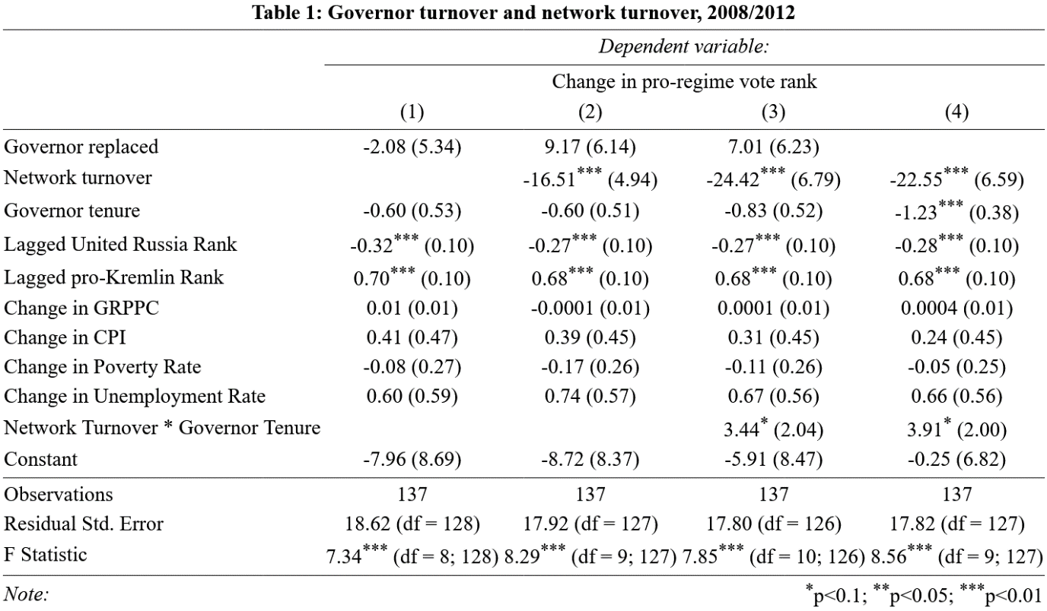
Model 3 and 4 include an interaction term between governor tenure and network turnover. Model 3 and 4 show a positive relationship between governor tenure and pro-Kremlin support rank when network turnover occurs. In cases of network turnover, the negative effect on pro-Kremlin vote rank decreases over time. In Model 4, when governor tenure is 0 years, the expected value of change in pro-Kremlin vote rank is estimated to be -24.4 ranks (p < 0.01). This is consistent with hypothesis H2, that local elite networks re-form with time. Figure 1 shows that this effect is statistically significant (p < .05) until governor is over 3.5 years, nearly a full presidential term. At the 3.5-year mark, network turnover is associated with an approximate -12.5 rank decrease in pro-Kremlin support. The results from model 4, which drops governor tenure from the model, are practically identical to model 3. In other words, the results from model 3 and 4 are consistent with hypothesis H2.
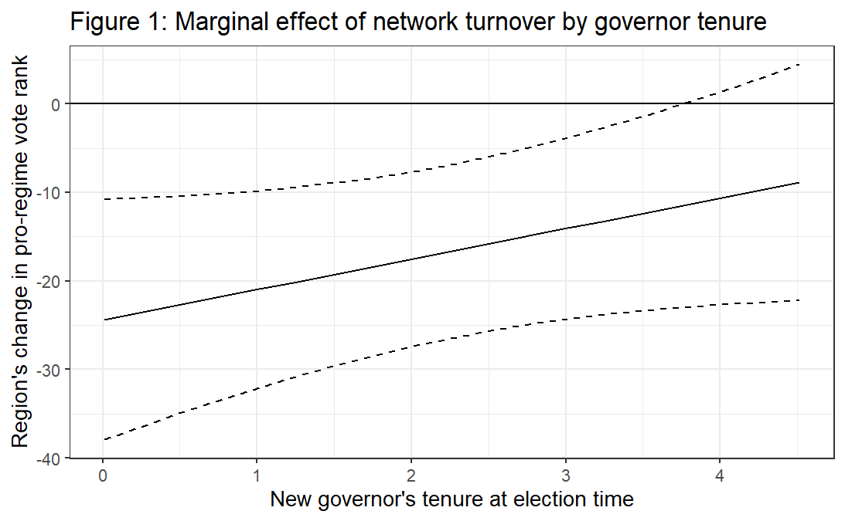
Next I turn to hypothesis H3a and H3b: that network turnover will have no effect on pro-Kremlin support rank during the election period (2004), but a strong negative effect during the appointment period (2008 and 2012). Because the Kremlin did not control governor appointments de jure or de facto until 2005, I should not find a relationship between network turnover and pro-Kremlin support rank in 2004 if network turnover is caused by the Kremlin’s manipulation of local elite networks. Thus, the 2004 presidential election acts as a placebo test. Figure 2 shows the marginal effect of network turnover in the election (2004) versus appointment (2008 and 2012) periods. Indeed, we see that network turnover has no significant effect on pro-Kremlin vote rank in the 2004 presidential election, while it has a strong negative effect (-18.3 ranks, P < .01) in 2008 and 2012. In other words, the data are consistent with hypotheses H3a and H3b, suggesting that the decline in pro-Kremlin electoral support following network turnover is directly related to the Kremlin’s manipulation of regional elite networks.
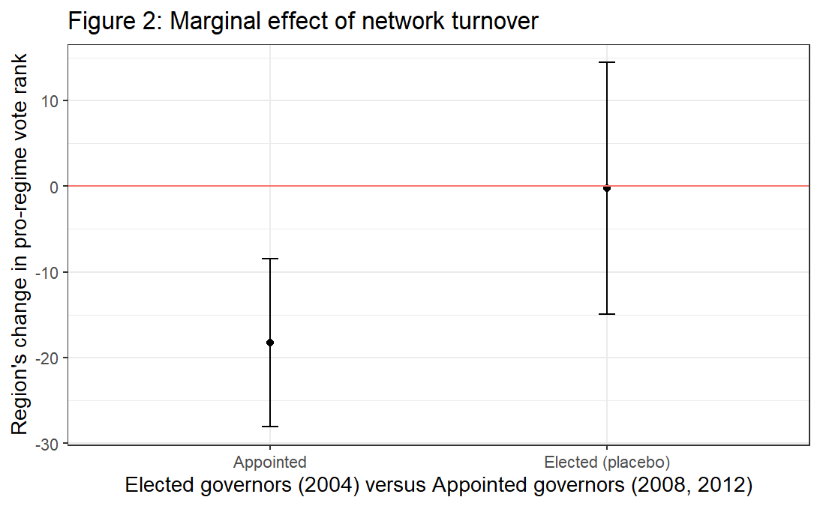
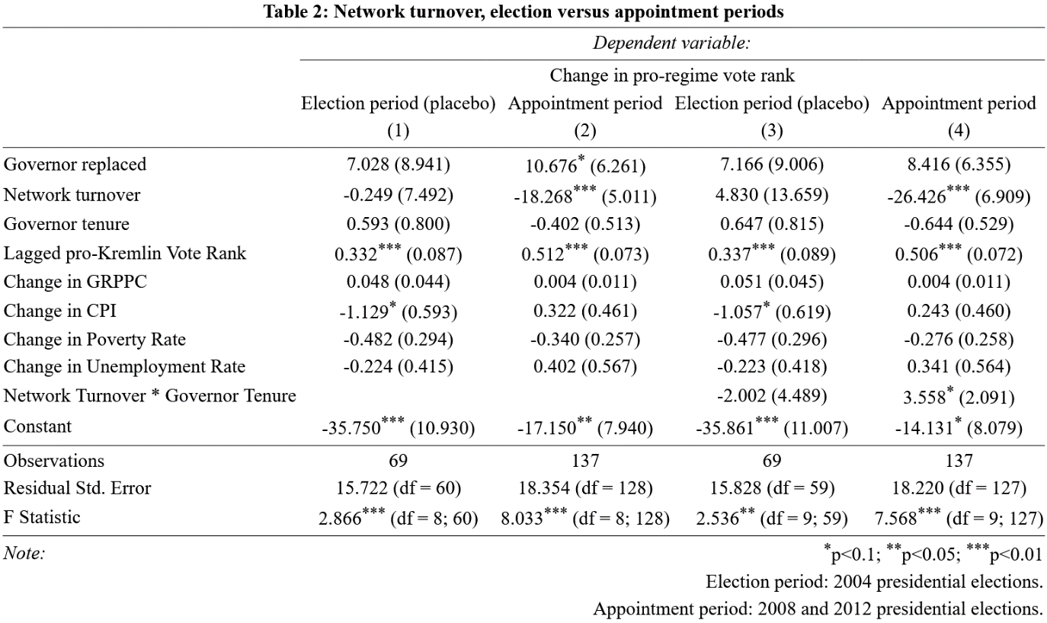
Table 2: the effect of network turnover in the appointment versus election periods. Because lagged United Russia support was not available for the election period, lagged pro-United Russia vote rank has been dropped from all four models. Regardless, results in models 2 and 4 are practically identical to those in table 1.
Selection into treatment
Given that the “treatment” (network turnover) is not randomly assigned, it is possible that the effect of network turnover is actually driven by a third variable that both the Kremlin’s decision to apply network turnover and the associated decline in pro-Kremlin support rank. This possibility is impossible to rule out definitively. The most likely source of selection into treatment relates to the Kremlin’s expectations regarding the incumbent elite network’s performance in the upcoming presidential election. Thus, selection into treatment can take two forms: overestimation, where the Kremlin imposes network turnover on regions where it expects to perform poorly, or underestimation, where the Kremlin applies network turnover where it expects to best absorb the costs. The former would inflate the estimated negative effect of network turnover, while the latter would cause us to underestimate the effect of network turnover.
Previous research has shown that the Kremlin reappointed governors that delivered high levels of support for United Russia, the ruling party (Reuter and Turovsky 2022; Reuter and Robertson 2012). Consistent with this finding, in the preliminary analysis I demonstrated that lower pro-United Russia support predicts network turnover (see Appendix B). Because pro-United Russia support predicts network turnover, I have included lagged United Russia vote rank in all models for which data were available. If selection into treatment is driving an overestimation of network turnover’s effect on pro-Kremlin vote rank, dropping lagged United Russia vote rank from our models should cause the effect to increase. However, as models 2 and 4 of table 2 demonstrate, models without lagged United Russia vote rank offer substantively similar estimates. In other words, my results do not appear to be driven by the most obvious source of selection into treatment.
Nor is there evidence that the Kremlin consistently manipulated governor terms to minimize the effect of network turnover. As my models suggest, the negative effect of network turnover on pro-Kremlin vote rank is mitigated by time in office, and most instances of network turnover occurred more than two years prior the next presidential election. Figures 3 and 4 show a negligible difference in the timing of network turnover versus governor turnover between the election (2004) and appointment periods (2008, 2012). This is most likely because governor elections and appointments follow a nominal schedule; Moscow may prefer to avoid significantly deviating from the schedule, when possible, even if following the schedule impacts a region’s pro-Kremlin electoral support.
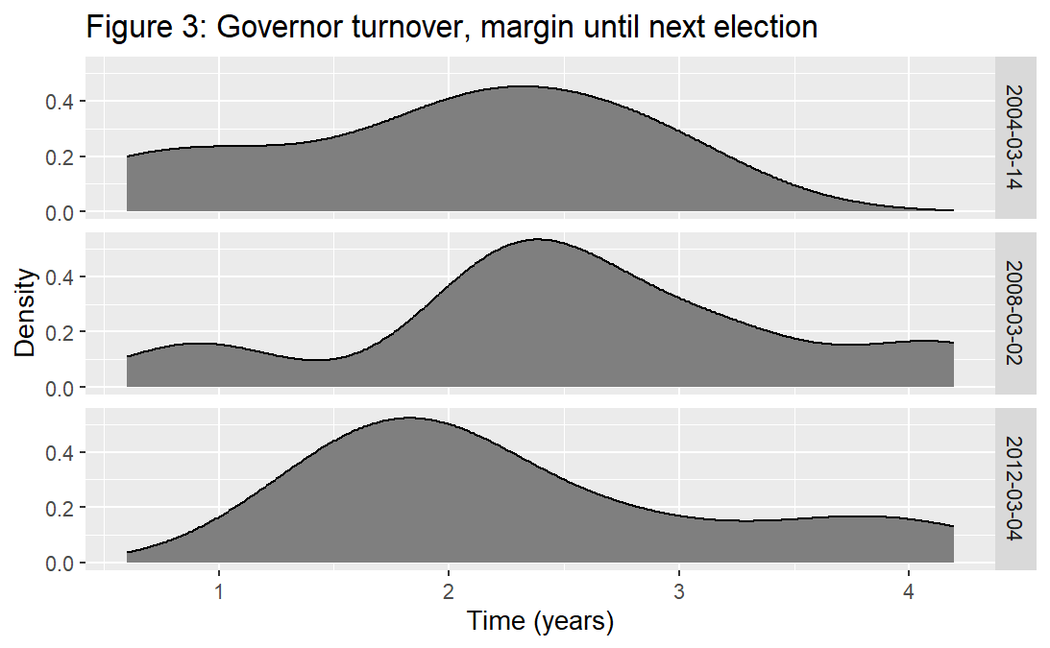
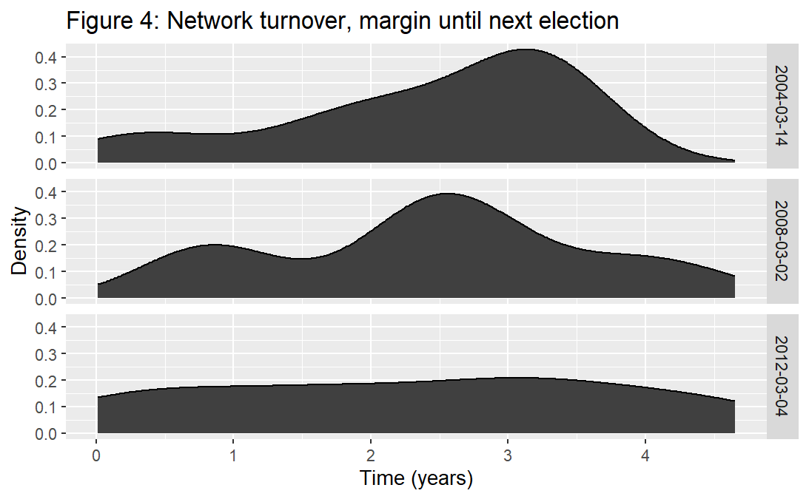

Discussion
These empirical results are broadly consistent with the core theoretical claims I advanced at the start of this paper. More specifically, because the Putin regime’s reliance on vote mobilization creates incentives to rely on delegated rather than deployed rule. Moreover, vote mobilization incentivizes an even more restrictive form of delegated rule: delegation to well-connected peripheral elites rather than peripheral elites in general. Thus, autocrats may struggle to discipline and incentivize their cadres in the periphery not only because of simple information problems, but also because their political regimes constrain the labor market for qualified cadres in the periphery. Even with perfect information, central autocrats may simply choose to tolerate cadre malfeasance in the periphery if they have no better option. In other words, political regimes may undermine a very basic form of central state power: elite compellence (Boucoyanis 2021, 9). Crucially, the importance of incentives does not imply that information does not play a role; my findings are consistent with possibility that peripheral elite networks are themselves constituted by network insiders’ private information. In other words, the incentives that I have identified here may be a proximal cause of central state weakness, but these incentives may still result from informational dynamics.
The most basic argument advanced in this paper is that delegated rule results from incentives relating to national regime institutions. My empirical suggest that delegated rule is no accident in Russia, but rather results from the territorial dimension of a core regime institution, vote mobilization. Although Russia scholars have argued the importance of regional politics for the regime’s consolidation (Gel’man 2011; Golosov 2011; Demchenko and Golosov 2016; Saikkonen 2021), to my knowledge no scholarship has explained to continued importance of delegated rule in Russia, which remained a core feature of the regime through the 2010s (Remington et al. 2022; Buckley et al. 2014). As demonstrated by Figures 1 and 2 above, pro-regime presidential candidates faced precipitous declines in pro-regime electoral support when the Kremlin imposed network turnover.
This provides a clear explanation for the Kremlin’s reliance on delegated rule: the electoral costs of deployed rule are simply too high. If the Kremlin is trying to maximize its odds of winning elections by large margins—an uncontroversial assumption—it is incentivized to select regional governors from among regional elite networks. Electoral autocracy makes disciplining delegated officials or enacting deployed rule costly at the ballot box. Thus, I argue contra Soifer who explains delegated rule through the ideas that central state leaders hold regarding the threat of rebellion, and the relationship between local elites and state development projects (Soifer 2015, 107). In Putin’s Russia, regime type rendered the center dependent on well-connected peripheral elites, incentivizing delegated rule rather than deployed rule. Regime type shapes central-periphery power relations, which in turn influences the choice of delegated versus deployed rule. Where the political regime renders the center dependent on local elites, as in Russia, the regime incentivizes delegated rule.
Of course, this does not prevent the Kremlin from imposing deployed rule in individual regions, but rather prevents a systematic imposition of deployed rule lest the electoral cost grow too large. Electoral costs are one incentive that a central autocrat reliant on vote mobilization—such as Putin—must weigh in its management of peripheral cadres. My results provide a strong congruence of evidence in support of this argument. In addition to precipitous declines following network turnover in the appointment period, I also found that network turnover had no effect in 2004, when the Kremlin did not control gubernatorial appointments. Thus, the electoral cost of network turnover seems to result from the Kremlin’s elite compellence in the periphery. Appendix B provides further corroboration: in my data, ruling party support does not predict governor turnover, but does predict network turnover. This implies that network turnover is a strategically significant concept for the Kremlin, and suggests that the Kremlin deliberately selects from within regional elite networks to maintain high levels of pro-regime support.
However, electoral authoritarianism incentivizes more than simple delegated rule in Soifer’s (2015) sense: the delegation of authority to local elites. Rather, my results demonstrate how electoral authoritarianism incentivizes a more constrained form of delegated rule: a reliance on incumbent elite networks rather than simply regional elites. This form of delegated rule is necessarily more restrictive than Soifer’s: all regional network insiders have ties to the region, but not all regional elites are connected to their region’s incumbent elite network. For instance, out of 45 cases of network turnover in the 2008 and 2012 periods, only 22 of these incoming governors were coded as “externals” according to Sidorkin and Vorobyev (2020). Despite high correlation (.54) between replacement governor’s insider-outsider status vis-à-vis regions and regional elite networks, network connections are of greater importance than connections to a region. In Appendix B, I demonstrate that network turnover’s effect is not driven by incoming governors with no ties to the region; network turnover’s effect is robust to controlling for the new governor’s “external” status, and including external status does not improve model fit. In other words, the congruence of evidence suggests that vote mobilization incentivizes delegating power to regional elite networks rather than regional elites.
At the same time, this evidence begins to shed light on the mechanisms that prevent the Kremlin from selecting officials that are competent across a wide range of performance metrics (Rochlitz et al. 2015). The answer is simple: constrained delegated rule prevents competition between peripheral cadres. Because vote mobilization is best performed by regional governors with connections to regional elite networks, the labor market for “qualified” governors is highly constrained. As a result, regional elite networks are essentially monopoly (or oligopoly) sellers in the “market” for vote mobilization services. The center may simply tolerate incompetence or corruption among peripheral elites because it must prioritize vote mobilization. Crucially, the Kremlin can externalize costs associated with peripheral cadres’ incompetence or corruption in most ways, but not vote mobilization and electoral performance.
Put most simply, I am claiming that vote mobilization strengthens peripheral elite networks’ bargaining power vis-à-vis the center. As a result, the center is unable to compel elites with divergent preferences. Beyond the possibility for divergent incentives between central and peripheral officials as per Soifer (2015) or Finkel and Gehlbach (2020), reliance on regional elite networks for vote mobilization may allow regional elites to extract analogous “monopoly rents” from the center. Thus, electoral autocrats must make informal bargains with local elites: vote mobilization in exchange for non-intervention by the central state. Strictly speaking, this claim remains theoretical. In the present study, I have not demonstrated that vote mobilization follows a market logic. However, my results demonstrate that the selection of regional governors is constrained by the need to appoint from within a narrow stratum of Russia’s regional elites. Monopoly or oligopoly rents are a short theoretical leap from labor market constraints.
However, my empirical results do rule out information about local conditions or cadre capabilities as an explanation for the Kremlin’s toleration of incompetent peripheral officials. If information about local conditions rather than reliance on peripheral elite networks were the proximal causal mechanism for my observation that pro-regime support declines following network turnover, incoming external governors should have a much stronger negative effect on pro-regime support than network turnover, because unconnected regional elites should have better information about local conditions than regional outsiders. Similarly, the center should have better information about outside appointees intrinsic capabilities given that these appointees tend to be former federal bureaucrats with higher educational qualifications (Buckley et al. 2014). Instead, I found that a new governor’s external status has no effect not explained by my measure of network turnover. Thus, if information problems are an operative causal mechanism here, the evidence suggests that they operate through networks. There is a clear congruence of evidence that Moscow’s limited ability to compel peripheral is a result of peripheral elite networks’ importance for vote mobilization
However, this leaves the possibility networks are important to the central regime because they hold private information that is useful for vote mobilization, for instance private information about regional elites’ preferences and capabilities relevant to vote mobilization. In other words, peripheral elite networks may derive power vis-à-vis the center because they control of private information; power is the proximal cause, while information explains power. This explanation is a significant departure from how information problems have been conceptualized in Russia (Sharafutdinova 2010; Paneyakh 2014) or more broadly (Kuran 1997; Wintrobe 1998; Landry 2008; O’Brien and Li 1999). Typically, these explanations do not invoke networks, or do so in terms of collusion against central monitoring (Pei 2016; Berliner 1957). In either case, this scholarship conceptualizes information as a proximal cause of central state weakness. The regional elite networks examined here may have a collusive dimension, but my findings demonstrate that they also serve the regime directly. This draws close parallels to Hough (1969), who argued that information about local conditions gave Soviet regional elite networks headed by regional Communist Party secretaries an important coordinating function in the command-economy, even as this private knowledge facilitated collusion against central directives. Summarized most succinctly, then, my findings suggest that power is the proximal causal mechanism for the Kremlin’s reliance on delegated rule and toleration of incompetent regional governance.
Regime Type and Deployed Rule in Comparative Perspective
In what follows I consider how the broader argument of this paper might travel to other political contexts. To reiterate, my argument is that when political regimes rely on local elites to accomplish core regimes tasks (those relating to gaining and holding political office), they empower local elites and encourage the centre to rely on delegated rule. Thus, my theory’s portability beyond the Russian case is a simple one: to what extent do other political regimes empower local elites vis-a-vis the centre? Here, the question is to what extent the power of local elite networks in Russia is the result of particular historical processes versus contemporary regime dynamics. In other words, are local elite networks privileged directly by vote mobilization, or does vote mobilization in Russia depend on local elite networks because local elite networks established powerful political machines during the Soviet transition?
My findings suggest that regardless of historical causes, regional elite networks are directly empowered by Putin’s reliance on vote mobilization. Yet, there is a case to be made that Putin’s reliance on regional elite networks resulted from the peculiarities of Soviet and early post-Soviet politics, particularly their strong control of local politics during and following the Soviet collapse (Stoner-Weiss 2006; Gel’man 2010). Crucially, my claim that vote mobilization empowers peripheral elite networks does not imply that history has no role in contemporary regime dynamics. The devolution of power that came with the end of communism may have made electoral authoritarianism through vote mobilization more likely, even as the practice of vote mobilization shapes centre-local power relations independent of the historical experience. Regardless, if vote mobilization always empowers local elites, we are likely to observe similar patterns of non-intervention across a wide range of electoral autocracies that rely on similar vote mobilization practices as Russia. This is a promising avenue for future research.
Finally, autocratic regimes that do not rely on practices such as vote mobilization are likely to be much less constrained by local elite networks. For instance, China is not an electoral autocracy, and instead has “purpose built” autocratic institutions. As such, vote mobilization is not core regime goal. From the perspective advanced in this paper, it should be no surprise that appears to be much more capable of incentivizing its regional cadres to implement central state goals (Landry 2008; Landry, Lü, and Duan 2018; Rochlitz et al. 2015). This is not to say that the Chinese state does face its own problems with central control (O’Brien and Li 1999; Liu 2019; Meng and Su 2021), but rather that China’s political regime does not create the same incentives for delegated rule. Instead, China’s central control problems are more likely to be related to limited monitoring capacity for the implementation of particular policies, as O’Brien and Li (1999, 173–74) argue.

Conclusion
In this paper, I used Russia’s 2004, 2008 and 2012 presidential elections to quantify the cost for Moscow to exercise influence over regional elite networks through governor appointments. I introduced a novel distinction between cases of governor turnover where the new governor possesses close connections to the prior governor and cases where the new governor has no such connections. While simple governor turnover had no significant effect on pro-Kremlin support in the next presidential election, network turnover was followed by an estimated 16.5 rank decline in regional pro-Kremlin electoral support in the 2008 and 2012 presidential elections. Consistent with prior scholarship, there was evidence that network turnover is applied strategically by the Kremlin. However, I found no evidence that the effect of network turnover on pro-Kremlin support was driven by selective application of the treatment, either in terms of which regions experienced network turnover or the timing of network turnover.
Network turnover’s negative effect on pro-Kremlin support demonstrates inherent limitations in how the Putin regime wields power over Russian society. Local elite networks are indispensable for electoral victories, but this dependence limits the Kremlin’s influence of regional politics through gubernatorial appointments. In other words, the need to win elections by large margins incentivized the Kremlin to delegate power to local elites rather than deploy its own officials. In comparative terms, these results demonstrate how regime dynamics can shape power relations between central and peripheral elites. Given the ample negative consequences for states that rely on delegated rule (Soifer 2015; Finkel and Gehlbach 2020), we should expect regime dynamics to have downstream effects for the long term development of state capacity.

Bibliography
Becker, Gary S., and George J. Stigler. 1974. ‘Law Enforcement, Malfeasance, and Compensation of Enforcers’. The Journal of Legal Studies 3 (1): 1–18. https://doi.org/10.1086/467507.
Berliner, Joseph S. 1957. Factory and Manager in the USSR. Cambridge: Harvard University Press.
Boucoyanis, Deborah. 2021. Kings as Judges: Power, Justice, and the Origins of Parliaments. Cambridge: Cambridge University Press.
Breton, Albert., and Ronald. Wintrobe. 1982. The Logic of Bureaucratic Conduct: An Economic Analysis of Competition, Exchange, and Efficiency in Private and Public Organizations. Cambridge: Cambridge University Press.
Buckley, Noah, Timothy Frye, Guzel Garifullina, and Ora John Reuter. 2014. ‘The Political Economy of Russian Gubernatorial Election and Appointment’. Europe - Asia Studies 66 (8): 1213–33. https://doi.org/10.1080/09668136.2014.941695.
Demchenko, Oleg, and Grigorii V. Golosov. 2016. ‘Federalism, Gubernatorial Power and the Incorporation of Subnational Authoritarianism in Russia: A Theory-Testing Empirical Inquiry’. Acta Politica 51 (1): 61–79. https://doi.org/10.1057/ap.2014.37.
Easter, Gerald M. 1996. ‘Personal Networks and Postrevolutionary State Building: Soviet Russia Reexamined’. World Politics 48 (4): 551–78. https://doi.org/10.1353/wp.1996.0016.
Finkel, Evgeny, and Scott Gehlbach. 2020. Reform and Rebellion in Weak States. 1st ed. Cambridge University Press. https://doi.org/10.1017/9781108855112.
Forrat, Natalia. 2018. ‘Shock-Resistant Authoritarianism: Schoolteachers and Infrastructural State Capacity in Putin’s Russia’. Comparative Politics 50 (3): 417–49. https://doi.org/10.5129/001041518822704908.
Gel’man, Vladimir. 2010. ‘The Dynamics of Subnational Authoritarianism: (Russia in Comparative Perspective)’. Russian Politics and Law 48 (2): 7–26. https://doi.org/10.2753/RUP1061-1940480201.
———. 2011. ‘State Power, Governance, and Local Regimes in Russia’. Russian Politics and Law 49 (4): 42–52. https://doi.org/10.2753/RUP1061-1940490405.
Golosov, Grigorii V. 2011. ‘The Regional Roots of Electoral Authoritarianism in Russia’. Europe-Asia Studies 63 (4): 623–39. https://doi.org/10.1080/09668136.2011.566427.
Gorlizki, Yoram, and Oleg Khlevniuk. 2020. Substate Dictatorship: Networks, Loyalty, and Institutional Change in the Soviet Union. New Haven: Yale University Press.
Hough, Jerry F. 1969. The Soviet Prefects. Cambridge, Massachusetts: Harvard University Press.
Kuran, Timur. 1997. Private Truths, Public Lies. Harvard University Press. https://doi.org/10.2307/j.ctvt1sgqt.
Landry, Pierre F. 2008. Decentralized Authoritarianism in China: The Communist Party’s Control of Local Elites in the Post-Mao Era. Cambridge: Cambridge University Press.
Landry, Pierre F., Xiaobo Lü, and Haiyan Duan. 2018. ‘Does Performance Matter? Evaluating Political Selection Along the Chinese Administrative Ladder’. Comparative Political Studies 51 (8): 1074–1105. https://doi.org/10.1177/0010414017730078.
Ledyaev, Valeri, and Alla Chirikova. 2019. ‘Governors and Local Elites in Russia: Patterns of Interaction’. European Politics and Society 20 (3): 315–32. https://doi.org/10.1080/23745118.2018.1534041.
Liu, Dongshu. 2019. ‘Punish the Dissidents: The Selective Implementation of Stability Preservation in China’. Journal of Contemporary China 28 (119): 795–812. https://doi.org/10.1080/10670564.2019.1580425.
Mann, Michael. 1984. ‘The Autonomous Power of the State: Its Origins, Mechanisms and Results’. European Journal of Sociology 25 (2): 185–213. https://doi.org/10.1017/S0003975600004239.
Meng, Tianguang, and Zheng Su. 2021. ‘When Top-down Meets Bottom-up: Local Officials and Selective Responsiveness within Fiscal Policymaking in China’. World Development 142 (June). https://doi.org/10.1016/J.WORLDDEV.2021.105443.
O’Brien, Kevin J., and Lianjiang Li. 1999. ‘Selective Policy Implementation in Rural China’. Comparative Politics 31 (2): 167–86. https://doi.org/10.2307/422143.
Paneyakh, Ella. 2014. ‘Faking Performance Together: Systems of Performance Evaluation in Russian Enforcement Agencies and Production of Bias and Privilege’. Post-Soviet Affairs, no. 2–3 (May): 115–36.
Paustyan, Ekaterina. 2023. ‘No Limit on Terms Served?’ Communist and Post-Communist Studies, March, 1–24. https://doi.org/10.1525/cpcs.2023.1815211.
Pei, Minxin. 2016. China’s Crony Capitalism: The Dynamics of Regime Decay. Cambridge, Massachusetts: Harvard University Press.
Reisinger, William M., and Bryon Moraski. 2017. The Regional Roots of Russia’s Political Regime. Ann Arbor: University of Michigan Press.
Remington, Thomas F., Andrei A. Yakovlev, Elena Ovchinnikova, and Alexander Chasovsky. 2022. ‘Career Trajectories of Regional Officials: Russia and China before and after 2012’. Eurasian Geography and Economics 63 (5): 599–624. https://doi.org/10.1080/15387216.2021.1944247.
Reuter, Ora John, and Graeme B. Robertson. 2012. ‘Subnational Appointments in Authoritarian Regimes: Evidence from Russian Gubernatorial Appointments’. Journal of Politics 74 (4): 1023–37. https://doi.org/10.1017/S0022381612000631.
Reuter, Ora John, and David Szakonyi. 2021. ‘Electoral Manipulation and Regime Support: Survey Evidence from Russia’. World Politics 73 (2): 275–314. https://doi.org/10.1017/s0043887120000234.
Reuter, Ora John, and Rostislav Turovsky. 2022. ‘Vote Mobilization, Economic Performance and Gubernatorial Appointments in Russia’. Russian Politics 7 (2): 183–209. https://doi.org/10.30965/24518921-00604017.
Rochlitz, Michael, Vera Kulpina, Thomas Remington, and Andrei Yakovlev. 2015. ‘Performance Incentives and Economic Growth: Regional Officials in Russia and China’. Eurasian Geography and Economics 56 (4): 421–45. https://doi.org/10.1080/15387216.2015.1089411.
Ross, Cameron, and Rostislav Turovsky. 2015. ‘Centralized but Fragmented: The Regional Dimension of Russia’s “Party of Power”’. Demokratizatsiya 23 (2): 205–23.
Saikkonen, Inga A.-L. 2021. ‘Coordinating the Machine: Subnational Political Context and the Effectiveness of Machine Politics’. Acta Politica, no. 4 (March): 658–76.
Sharafutdinova, Gulnaz. 2010. ‘Subnational Governance in Russia: How Putin Changed the Contract with His Agents and the Problems It Created for Medvedev’. Publius 40 (4): 672–96. https://doi.org/10.1093/publius/pjp036.
Sidorkin, Oleg, and Dmitriy Vorobyev. 2020. ‘Extra Votes to Signal Loyalty: Regional Political Cycles and National Elections in Russia’. Public Choice 185 (1–2): 183–213. https://doi.org/10.1007/S11127-019-00747-8.
Smith, Gordon B. 1978. The Soviet Procuracy and the Supervision of Administration. Alphen aan den Rijn: Sijthoff & Noordhoff.
Soifer, Hillel David. 2015. State Building in Latin America. Cambridge: Cambridge University Press. https://doi.org/10.1017/CBO9781316257289.002.
Stoner-Weiss, Kathryn. 2006. Resisting the State: Reform and Retrenchment in Post-Soviet Russia. Cambridge: Cambridge University Press.
Wedeman, Andrew. 1999. ‘Agency and Fiscal Dependence in Central‐provincial Relations in China’. Journal of Contemporary China 8 (20): 103–22. https://doi.org/10.1080/10670569908724338.
Wintrobe, Ronald. 1997. ‘Modern Bureaucratic Theory’. In Perspectives on Public Choice, 429–54. Cambridge: Cambridge University Press. https://doi.org/10.1017/cbo9780511664458.021.
———. 1998. The Political Economy of Dictatorship. Cambridge: Cambridge.

See Appendix A for excluded regions.
When referring to the Russian case, I use the term ”regional” to refer to the Russian Federation’s regional entities: oblasts, republics, and krais. By contrast, when discussing central versus periphery politics and elites in the abstract, I simply use the term “peripheral” as shorthand.
More recently, these high priority goals likely include organizing the mobilization for Putin’s aggressive war in Ukraine.
Although the formal rules for gubernatorial selection have been modified several times between 2004 and 2020, Reuter and Turovsky find no evidence that these formal changes have altered how governors are actually selected (2022, 208).
Several governors presided over two presidential elections in one term. In these cases, I examined the earliest election in the governors’ term.
Notably, Paustyan (2023, 11) has employed a threshold for pro-Kremlin support to explain appointment decisions. This is necessary due to her use of qualitative comparative analysis. However, it is most likely inconsistent with the way that Kremlin decision making regarding pro-regime support occurs. This exogenously set baseline for an acceptable level of support must occur not at the national level, as implied by Paustyan’s use of a single threshold for all regions, but at the regional level based on that region’s past electoral performances.
Regional legislatures, rayons, and city administrations are ambiguous for our purposes: in some cases, these bodies are used as patronage appointments by the governor (Ledyaev and Chirikova 2019). However, these organs may also serve as centres of opposition to the governor. As such, in my main analysis I consider work history in these bodies insufficient for a network connection. However, in table 3 I examine whether treating work history in regional legislatures, rayons, and city administrations as sufficient to indicate connection to the regional governor alters my results. The results from this analysis were practically identical to the main analysis.
Other mechanisms may also be operating: for instance, elite networks may derive their importance through intra-elite trust that facilitates informal exchange (see Breton and Wintrobe 1982). Both explanations—private information and trust—are consistent with my observation that the severity of network turnover’s electoral consequences declines as the new governor’s tenure increases (figure 1).
Within Russia, the relationship between network turnover and pro-regime support does not fully generalize to legislative elections (see Appendix D). The divergence between presidential and legislative elections is a puzzle beyond the scope of this paper.

