The Impact of Vote-By-Mail Policy on Turnout and Vote Share in the 2020 Election

Sharif Amlani and Samuel Collitt*^

March 2021

Abstract
The COVID-19 pandemic spurred many states and counties to reduce public health risks by adopting policies that made voting by mail easier in the 2020 general election. Employing a difference-in-difference research design, this paper investigates how these policy changes affected turnout and presidential vote shares. We find that counties that moved to send registered voters mail-in ballots ahead of Election Day experienced 2.4 percent higher turnout compared to counties that made no change. We also find no evidence that making voting by mail easier – to any degree – conferred any partisan advantage. Our findings suggest an obvious step for policymakers and advocates that seek to improve the democratic quality of elections: make voting by mail as easy as possible.

Keywords: American Elections, Vote-By-Mail Policy, 2020 Election, Turnout, Vote Share, Difference-in-Difference

Introduction
Elected representatives harp to their constituents that exercising the right to vote is the most important democratic action they can perform. Yet most state governments have traditionally made voting more difficult for their residents than in almost all other developed democracies, contributing to relatively lower electoral turnout (Blais, Massicotte, and Dobrzynska 2003; Franklin 1996; Jackman 1987; Powell 1986). A notable reversal occurred as the COVID-19 pandemic precipitated a historic development whereby a majority of states, intending to make voting safer in the 2020 general election, made voting easier through policies aimed at encouraging voters to cast mail-in ballots instead of voting in person.
Our study examines how turnout changes as a function of making voting by mail easier, and whether there was a partisan electoral advantage from doing so. While there is already much work on the subject, previous to the 2020 general election, studies that sought to evaluate these relationships were limited to a handful of states that conducted elections exclusively by mail (Barber and Holbein 2020; Berinsky, Burns, and Traugott 2001; Gerber, Huber, and Hill 2013; Gronke and Miller 2012; Kousser and Mullin 2007; McGhee, Paluch, and Romero 2020; Southwell 2009; Southwell and Burchett 2000a, 2000b). In contrast, 1,664 counties across 30 states made it easier, by varying degrees, for their residents to vote by mail in 2020 general election. Figure 1 panels a and b illustrate the county-level vote-by-mail (VBM) policies in 2016 and 2020, respectively. The unprecedented sample size and variation in the restrictiveness of VBM policies across jurisdictions allows for a unique analysis of making voting by mail easier on turnout and vote share.
[Figure 1 here]
We investigate these relationships using a difference-in-difference (DID) design, evaluating, in turn, how turnout and presidential vote share changed at the county level between the 2016 and 2020 general elections as a function of the change in the restrictiveness of a county’s VBM policy. We find that counties that moved from not requiring an excuse to vote by mail to automatically sending their registered voters mail-in ballots experienced a turnout increase of 2.4 percent compared to those that did not change their VBM policy. In contrast, counties that moved from requiring a valid excuse from residents to vote by mail to not requiring an excuse experienced a smaller increase in turnout, compared to counties that did not change their policy, by about 1.7 percent. We speculate that this may be due to the information costs that changing voting laws may place on prospective voters, counteracting any net benefit that making voting by mail easier may provide (Brady and Mcnulty 2011; Corvalan and Cox 2018). Future studies should seek to determine the effects of these changes in subsequent elections as voters become accustomed to them.
Consistent with previous findings (Barber and Holbein 2020; Southwell and Burchett 2000b; Thompson et al. 2020), we find no partisan advantage associated with making voting by mail easier. Presidential vote share at the county level does not appear to be functionally related to the ease with which voters can cast their ballots by mail.
In sum, we identify costs to voting that can be brought down through less restrictive VBM policy. Policymakers that seek to improve (small “d”) democratic electoral outcomes in their jurisdictions should move to send their voters mail-in ballots. More at stake, our findings should serve as tools for democratic advocates in a political era of growing anti-democratic and authoritarian sentiment (Ballard-Rosa, Jensen, and Scheve 2018; Inglehart and Norris 2017; Malka et al. 2020; Norris and Inglehart 2019).

Literature and Hypotheses
Theoretically, by eliminating a trip to a polling place on Election Day, voting by mail is less costly for a prospective voter than voting in person, making them more likely to turn out (Downs 1957). There is much empirical support for this proposition, with documentations of small and positive impacts of moving to VBM-only elections on turnout in Colorado, Washington, Utah, and Oregon (Barber and Holbein 2020; Berinsky, Burns, and Traugott 2001; Gerber, Huber, and Hill 2013; Gronke and Miller 2012; Kousser and Mullin 2007; McGhee, Paluch, and Romero 2020; Southwell 2009; Southwell and Burchett 2000a, 2000b). However, other than analyzing the effects of moving to a complete VBM system, there is little empirical evidence regarding the different ways voting costs may be reduced by making voting by mail easier. Additionally, there have been no assessments of VBM policy effects outside of four Western states.
While the conventional wisdom is that eligible non-voters, which are primarily poorer, less educated, and nonwhite, would vote for Democratic candidates if they did vote, there is little evidence suggesting that increasing the convenience of voting or, specifically, moving to VBM-only elections, significantly alter parties’ vote shares (Alvarez, Levin, and Sinclair 2012; Barber and Holbein 2020a; Martinez and Gill 2005; Southwell and Burchett 2000a; Thompson et al. 2020a). However, there may be unforeseen partisan effects of adopting other VBM policies, such as sending voters mail-in ballot applications or omitting the need for an excuse to vote by mail. We exploit substantial policy and regional variation, both new to the U.S. in the 2020 presidential general election, to systematically evaluate the effects of VBM policy on turnout and vote share.
Based on existing research, we hypothesize that making voting easier by liberalizing VBM policy will increase turnout. Because there is variation in the degree to which changes in VBM lowered voting costs (“dosage variation”) we are able to analyze the effects of multiple policy interventions. We hypothesize a higher dosage of VBM policy liberalization leads to proportionately higher turnout. Specifically, we expect counties that moved from requiring a valid excuse from voters to vote by mail in 2016 to not requiring one to experience the smallest increase in turnout, relative to counties that made no change. We expect relatively greater change in turnout among counties that moved from not requiring an excuse to sending mail-in ballot applications to registered voters. We expect yet a greater increase in turnout to have been produced in counties that moved from requiring an excuse to sending mail-in ballot applications (and not requiring an excuse to vote by mail). We expect the greatest change in turnout to have occurred in counties that moved from not requiring an excuse in 2016 to sending all registered voters no-excuse-needed mail-in ballots in 2020.
Our second hypothesis is that easing VBM restrictions does not confer an electoral partisan advantage. Specifically, any change to VBM policy should not lead a county to experience a significantly different two-party vote share from its vote share in 2016.

Methodology
In response to the COVID-19 pandemic, many states and counties made it easier to vote-by-mail. The degree to which they made it easier varied considerably. For example, some states enacted a policy to send all registered voters mail-in ballots. Other states did not make it so easy, requiring eligible voters to have a valid excuse to vote-by-mail, such as being at a high risk for contracting COVID-19. In addition, while some states administer elections uniformly, others allow their counties some autonomy. For example, in 2020, New Mexico’s state legislature approved a bill allowing counties to automatically send mail-in ballot applications to voters (Gould 2020). Only ten counties sent applications to their registered voters, while the rest opted out. Thus, in addition to interstate variation, there is also intrastate variation in VBM policies. As a result, we make counties our unit of analysis (N=3,113).
We use a difference-in-difference (DID) design to estimate the effects of changes to VBM policy on turnout and then assess their partisan consequences (Angrist and Pischke 2008; Wing, Simon, and Bello-Gomez 2018). We employ a DID design to account for the non-random assignment of VBM policies to counties. For example, counties with less restrictive VBM policies may differ in observed and unobserved ways from counties with more restrictive VBM policies (e.g., states with Republican-controlled state legislatures have more restrictive VBM policies). Highton (2017) argues that cross-sectional models analyzing variation in voting laws do not account for this source of bias and are highly problematic in accurately estimating the effects of public policy on turnout. Therefore, we estimate a DID model because it accounts for unobserved confounders of turnout, including the strategic selection of VBM policies.
We create our key independent variable, VBM condition by comparing VBM policies in 2016 and 2020 (Table 1). VBM condition includes a control group and four treatment groups. We treat counties whose VBM policy stayed the same between 2016 to 2020 as our control condition (n = 1473). Our treatment conditions are as follows. (1) Counties that changed their VBM policy from requiring a valid excuse from their residents to vote by mail to not requiring such an excuse: excuse-needed in 2016 to no excuse-needed in 2020 (n = 750). (2) Counties that moved from requiring an excuse to sending mail-in ballot applications to their registered voters: excuse-needed in 2016 to applications sent in 2020 (n = 115). (3) Counties that moved from not requiring an excuse to sending mail-in ballot applications: no-excuse-needed in 2016 to applications sent in 2020 (n = 634). (4) Counties that moved from not requiring an excuse to sending their registered voters mail-in ballots: no-excuse-needed in 2016 to ballots sent in 2020 (n = 169). Due to the absence of a single centralized database on these classifications, we derive and cross-validate these changes from a variety of sources: Desliver and Geiger (2016), FiveThirtyEight (2020), National Public Radio (2020), and the National Conference of State Legislatures (2020).
[Table 1 here]
We measure turnout as the percentage of the voting-age population (VAP) that voted (Thompson et al. 2020, Barber and Holbein 2020). While alternative measures might be more desirable (e.g., percentage of eligible or registered voters who cast ballots), they are not reliably available at the county level and we therefore follow the lead of existing research. Turnout data are available from Dave Leip's Atlas of U.S. Elections (Leip 2020), and estimates of the total voting-age population are available from the U.S. Census.
We estimate our DID model using the equation:
$$VAP Turnout= α+β_{1}\left(Vote by Mail Conditions\right)+ β_{2}\left(Year\right)+ β_{3}\left(Vote By Mail Conditions x Year\right)+ {β_{i}(X}_{i})+σ_{c}+ ε$$
The interaction term, $Vote By Mail Conditions x Year$, represents the average treatment effect relative to the control group. The variable $X_{i}$ represents our model’s control variables. We follow the guidance of Ansolabehere and Konisky (2006), Karp and Banducci (2000), Knack and Kropf (2003), Smith (2001) and account for a similar set of potential confounders. We control for vote share at the county level coded in the Democratic direction as our measure of county partisanship, Democratic vote share. We include the average daily change in COVID-19 deaths per 100,000 people one week before the election. We also add census information, such as the percentage of African Americans, median household income, median age, and percentage of individuals with only a high school diploma. Lastly, we include county fixed effects ($σ_{c}$) to control for fixed observed and unobserved heterogeneity between counties, and we cluster our standard errors at the state level.
To analyze the partisan effects, we again employ a DID design. Our DID model estimates the effects of changing VBM policies on changes in Republican presidential vote share while accounting for confounders and non-random assignment of VBM policies to counties.
$$Republican Presidental Vote Share= α+β_{1}\left(Vote by Mail Conditions\right)+ β_{2}\left(Year\right)+ β_{3}\left(Vote By Mail Conditions x Year\right)+ {β_{i}(X}_{i})+σ_{c}+ ε$$
The interaction term, $Vote By Mail Conditions x Year$, represents the average treatment effect. Positive (negative) and significant values suggest that changes in VBM policy benefits Republicans’ (Democrats’) vote share. The variable $X_{i}$ represents our control variables. We control for the counties’ population density, unemployment rate one month before Election Day, average daily change in COVID-19 deaths per 100,000 people one week before the election, the percent of the county’s population with a high school degree, the percent of the county with a bachelor’s degrees, the percent of the county that is Black, multiracial, Latino, and foreign-born. Lastly, we once again include county fixed effects ($σ_{c}$) to control for fixed observed and unobserved heterogeneity between counties, and we cluster our standard errors at the state level.

Results
Overall, the average increase in turnout for all counties between 2016 and 2020 was 6.5 percent. For our purposes, the critical question our DID estimates address is whether VBM policy changes significantly differ from the average increase in the control group’s turnout (5.3 percent).
Figure 2 reports the key results of our DID design, estimating the effect of VBM conditions on election turnout. The point estimates represent the DID estimates across our four treatment conditions and we report the estimates relative to the control group (i.e., counties that did not change their VBM policy in 2020).
[Figure 2 here]
The results reveal three key findings. First, the change in turnout among the two groups of counties that changed their VBM policy to sending applications did not significantly differ (p > 0.05) from the control group. Second, turnout in counties that changed their VBM policy to no excuse-needed was 1.7 percent lower than the control group (p < 0.05), yielding a net gain in turnout of 3.6 percent from 2016. Lastly, turnout in counties that changed their VBM policy to ballots sent was 2.4 percent higher than the control group (p < 0.05), yielding a net gain in turnout of 7.7 percent from 2016.
Our turnout hypothesis was partially borne out; counties that adopted mail-in ballots experienced a relatively higher change in turnout. However, other VBM policy changes did not behave in the way we expected. Change in turnout in counites that moved to send their voters mail-in ballot applications did not differ meaningfully from the control group, while moving from excuse-need to no excuse-need to vote by mail experienced a smaller bump in turnout between 2016 and 2020, compared to the control group.
Figure 3 reports policy change coefficient estimates of the DID model that tests whether there is a partisan advantage to reducing the restrictiveness of VBM policy. The results suggest that Republican vote share in each treatment group does not deviate from the control in a statistically significant manner. Consistent with previous research, this result provides evidence suggesting that any change making VBM easier does not hurt or help a party at the ballot box.
[Figure 3 here]

Discussion
Leading up to the 2020 election, unprecedented changes to the VBM policy landscape in the U.S. fomented endless speculation by politicians and pundits about effects on turnout and partisan electoral prospects. Scholars simultaneously studied previous changes to VBM policies to provide informed predictions about such electoral effects (e.g., Barber and Holbein 2020; Baringer, Herron, and Smith 2020; Bonica et al. 2020; Lockhart et al. 2020b; Thompson et al. 2020; West 2020; Yoder et al. 2020). This body of research provides a near-consensus that less restrictive access to the postal ballot box results in higher turnout. However, these studies' empirics are constrained to universal VBM elections (Gronke 2005; Richey 2008; Southwell 2009; Southwell and Burchett 2000b).
The COVID-19 pandemic incentivized states and counties to decrease the risk of COVID-19 contagion on Election Day. Their actions to reduce the spread of COVID-19 resulted in two useful methodological opportunities. First, it pushed many counties to change their VBM policies. Second, these changes produced novel variation in VBM policy restrictiveness at the national scale. Combined, these opportunities afford our analyses uniquely generalizable and nuanced insight into the electoral effects of VBM policies. We capitalize on these opportunities by using a DID design to estimate the effects of changes to VBM policy on turnout and partisan consequences.
Consistent with previous work, we find no evidence to support the claim that increasing access to VBM ballots offers alters partisan vote share. (Gronke 2005; Richey 2008; Southwell 2009; Southwell and Burchett 2000b). We further generalize on these findings by noting that any change to the restrictiveness of VBM policy does not confer a partisan electoral advantage.
Our results concerning turnout are more nuanced. Our finding – that counties that moved from requiring an excuse to vote by mail to not requiring one experienced a significantly smaller positive change in turnout than counties that made no change – is counterintuitive. We speculate that making new rules can, in some cases, can impose additional informational costs on voters that may dissuade them from voting (Brady and Mcnulty 2011; Corvalan and Cox 2018), especially when those new rules only make voting by mail marginally easier. We also find that moving to sending voters mail-in ballot applications does not produce a bump in turnout. Thus it remains unclear as to whether this policy increases the convenience of voting in practice. While we only assess turnout at the aggregate level, future studies should seek to understand whether voters actually took advantage of these policies. However, we are able to robustly claim that sending voters mail-in ballots increases turnout. If the quality of democracy can be measured, at least in part, by the rate at which individuals vote, then we can safely conclude that sending voters a ballot in the mail produces a notable improvement.

Work Cited
Alvarez, R. Michael, Ines Levin, and J. Andrew Sinclair. 2012. “Making Voting Easier: Convenience Voting in the 2008 Presidential Election.” Political Research Quarterly 65(2): 248–62.
Angrist, Joshua D, and Jörn-Steffen Pischke. 2008. Mostly Harmless Econometrics: An Empiricist’s Companion. 1st ed. Princeton University Press; Illustrated Edition.
Ansolabehere, Stephen, and David M. Konisky. 2006. “The Introduction of Voter Registration and Its Effect on Turnout.” Political Analysis 14(1): 83–100.
Ballard-Rosa, Cameron, Amalie Jensen, and Kenneth Scheve. 2018. “Economic Decline, Social Identity, and Authoritarian Values in the United States.” American Political Science Association, Boston.
Barber, Michael, and John B. Holbein. 2020a. “The Participatory and Partisan Impacts of Mandatory Vote-by-Mail.” Science Advances 6(35): eabc7685.
———. 2020b. “The Participatory and Partisan Impacts of Mandatory Vote-by-Mail.” Science Advances 6(35): eabc7685.
Baringer, Anna, Michael C. Herron, and Daniel A. Smith. 2020. “Voting by Mail and Ballot Rejection: Lessons from Florida for Elections in the Age of the Coronavirus.” Election Law Journal: Rules, Politics, and Policy 19(3): 289–320.
Berinsky, Adam J., Nancy Burns, and Michael W. Traugott. 2001. “Who Votes by Mail?: A Dynamic Model of the Individual-Level Consequences of Voting-by-Mail Systems.” Public Opinion Quarterly 65(2): 178–97.
Blais, André, Louis Massicotte, and Agnieszka Dobrzynska. 2003. Why Is Turnout Higher in Some Countries than in Others? Environment Canada Montreal.
Bonica, Adam, Jocob Grumbach, Charlotte Hill, and Hakeem Jefferson. 2020. “All-Mail Voting in Colorado Increases Turnout and Reduces Turnout Inequality.” https://www.dropbox.com/s/lqz0pae9kx52bl0/AGHJ_VBM_08_26_2020.pdf?dl=0.
Brady, Henry E., and John E. Mcnulty. 2011. “Turning Out to Vote: The Costs of Finding and Getting to the Polling Place.” American Political Science Review 105(1): 115–34.
Chyzh, Olga V., and Robert Urbatsch. 2020. “Bean Counters: The Effect of Soy Tariffs on Change in Republican Vote Share between the 2016 and 2018 Elections.” The Journal of Politics: 000–000.
Corvalan, Alejandro, and Paulo Cox. 2018. “The Impact of Procedural Information Costs on Voting: Evidence from a Natural Experiment in Chile.” Political Behavior 40(1): 3–19.
Desliver, Drew, and A.W. Geiger. 2016. “Millions of Americans Will Vote Early, Absentee in 2016.” Pew Research Center. https://www.pewresearch.org/fact-tank/2016/10/21/for-many-americans-election-day-is-already-here/ (October 6, 2020).
Downs, Anthony. 1957. “An Economic Theory of Democracy.”
Franklin, Mark N. 1996. “Electoral Participation.” Comparing democracies: Elections and voting in global perspective: 216–35.
Gerber, Alan S., Gregory A. Huber, and Seth J. Hill. 2013. “Identifying the Effect of All-Mail Elections on Turnout: Staggered Reform in the Evergreen State*.” Political Science Research and Methods 1(1): 91–116.
Gould, Jens. 2020. “D.C. Nonprofit Sent Ballot Applications to 400,000 New Mexicans.” Santa Fe New Mexican. https://www.santafenewmexican.com/news/coronavirus/d-c-nonprofit-sent-ballot-applications-to-400-000-new-mexicans/article_51633680-dbe5-11ea-bb47-e3c62ca07075.html (November 10, 2020).
Gronke, Paul. 2005. Ballot Integrity and Voting by Mail: The Oregon Experience. the Center for Democracy and Election Management: American University.
Gronke, Paul, and Peter Miller. 2012. “Voting by Mail and Turnout in Oregon: Revisiting Southwell and Burchett.” American Politics Research 40(6): 976–97.
Inglehart, Ronald, and Pippa Norris. 2017. “Trump and the Populist Authoritarian Parties: The Silent Revolution in Reverse.” Perspectives on Politics 15(2): 443–54.
Jackman, Robert W. 1987. “Political Institutions and Voter Turnout in the Industrial Democracies.” The American Political Science Review 81(2): 405–23.
Karp, Jeffrey A., and Susan A. Banducci. 2000. “Going Postal: How All-Mail Elections Influence Turnout.” Political Behavior 22(3): 223–39.
Knack, Stephen, and Martha Kropf. 2003. “Voided Ballots in the 1996 Presidential Election: A County-Level Analysis.” The Journal of Politics 65(3): 881–97.
Kousser, Thad, and Megan Mullin. 2007. “Does Voting by Mail Increase Participation? Using Matching to Analyze a Natural Experiment.” Political Analysis 15(4): 428–45.
Leip, Dave. 2020. “Dave Leip’s Atlas of U.S. Presidential Elections.” https://uselectionatlas.org/ (September 23, 2020).
Lockhart, Mackenzie et al. 2020. “America’s Electorate Is Increasingly Polarized along Partisan Lines about Voting by Mail during the COVID-19 Crisis.” Proceedings of the National Academy of Sciences: 202008023.
Malka, Ariel, Yphtach Lelkes, Bert N. Bakker, and Eliyahu Spivack. 2020. “Who Is Open to Authoritarian Governance within Western Democracies?” Perspectives on Politics: 1–20.
Martinez, Michael D., and Jeff Gill. 2005. “The Effects of Turnout on Partisan Outcomes in U.S. Presidential Elections 1960–2000.” The Journal of Politics 67(4): 1248–74.
McGhee, Eric, Jennifer Paluch, and Mindy Romero. 2020. “How Greater Vote-by-Mail Influences California Voter Turnout.” Public Policy Institute of California. https://www.ppic.org/publication/how-greater-vote-by-mail-influences-california-voter-turnout/ (September 25, 2020).
National Conference of State Legislatures. 2020. “Absentee and Mail Voting Policies in Effect for the 2020 Election.” https://www.ncsl.org/research/elections-and-campaigns/absentee-and-mail-voting-policies-in-effect-for-the-2020-election.aspx (October 27, 2020).
Norris, Pippa, and Ronald Inglehart. 2019. Cultural Backlash: Trump, Brexit, and Authoritarian Populism. Cambridge University Press.
Powell, G. Bingham. 1986. “American Voter Turnout in Comparative Perspective.” The American Political Science Review 80(1): 17–43.
Richey, Sean. 2008. “Voting by Mail: Turnout and Institutional Reform in Oregon*.” Social Science Quarterly 89(4): 902–15.
Smith, Mark A. 2001. “The Contingent Effects of Ballot Initiatives and Candidate Races on Turnout.” American Journal of Political Science 45(3): 700–706.
Southwell, Priscilla L. 2009. “Analysis of the Turnout Effects of Vote by Mail Elections, 1980–2007.” The Social Science Journal 46(1): 211–16.
Southwell, Priscilla L., and Justin I. Burchett. 2000a. “Does Changing the Rules Change the Players? The Effect of All-Mail Elections on the Composition of the Electorate.” Social Science Quarterly 81(3): 837–45.
———. 2000b. “The Effect of All-Mail Elections on Voter Turnout.” American Politics Quarterly 28(1): 72–79.
Thompson, Daniel M., Jennifer A. Wu, Jesse Yoder, and Andrew B. Hall. 2020a. “Universal Vote-by-Mail Has No Impact on Partisan Turnout or Vote Share.” Proceedings of the National Academy of Sciences 117(25): 14052–56.
———. 2020b. “Universal Vote-by-Mail Has No Impact on Partisan Turnout or Vote Share.” Proceedings of the National Academy of Sciences: 202007249.
Thompson, Daniel M., Jennifer Wu, Jesse Yoder, and Andrew B. Hall. 2020c. “No, Voting by Mail Does Not Give Either Party an Advantage. Here’s How We Know.” Washington Post. https://www.washingtonpost.com/politics/2020/04/17/no-voting-by-mail-does-not-give-either-party-an-advantage-heres-how-we-know/ (January 21, 2021).
West, Darrell M. 2020. “How Does Vote-by-Mail Work and Does It Increase Election Fraud?” Brookings. https://www.brookings.edu/policy2020/votervital/how-does-vote-by-mail-work-and-does-it-increase-election-fraud/ (January 21, 2021).
Wing, Coady, Kosali Simon, and Ricardo A. Bello-Gomez. 2018. “Designing Difference in Difference Studies: Best Practices for Public Health Policy Research.” Annual Review of Public Health 39(1): 453–69.
Yoder, Jesse et al. 2020. “Absentee Voting Is Popular During COVID-19 But Does Not Change Turnout or Partisan Rates of Voting.” Election Law Journal: Rules, Politics, and Policy: 289–320.

Figures

Figure 1: (a) U.S. Counties' Vote-by-Mail Policies in the 2016 Presidental Election and (b) U.S. Counties' Vote-by-Mail Policies in the 2020 Presidental Election

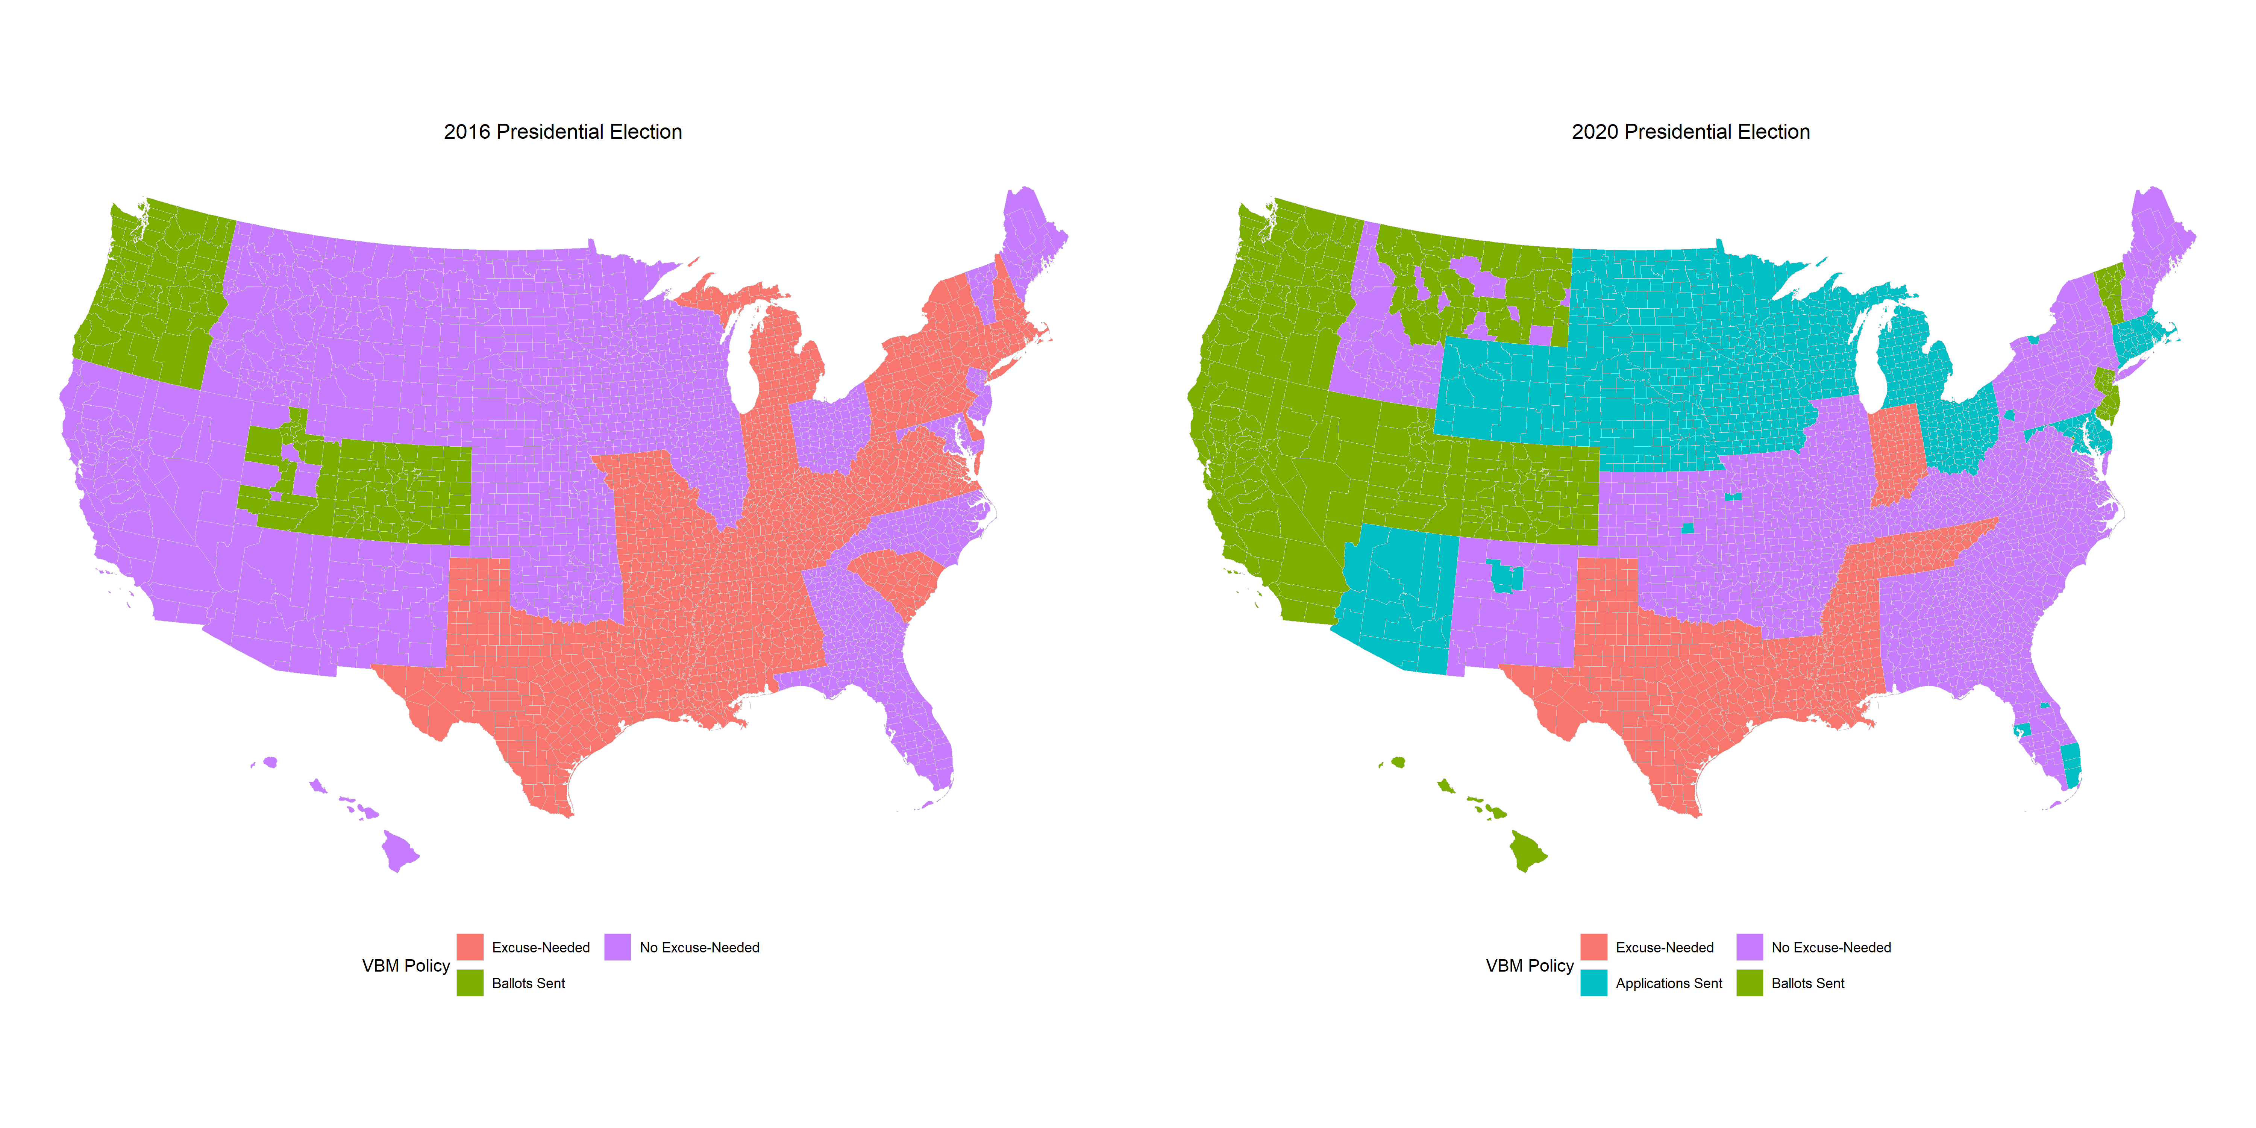
Note: Alaska is excluded from the figure because Alaska does not use counties, but electoral districts, to administer elections. Therefore, turnout data at the county level is unavailable and we omit it from our analysis.

Figure 2: Difference-in-Difference Estimates of the Effects of the Vote-By-Mail Conditions on Turnout
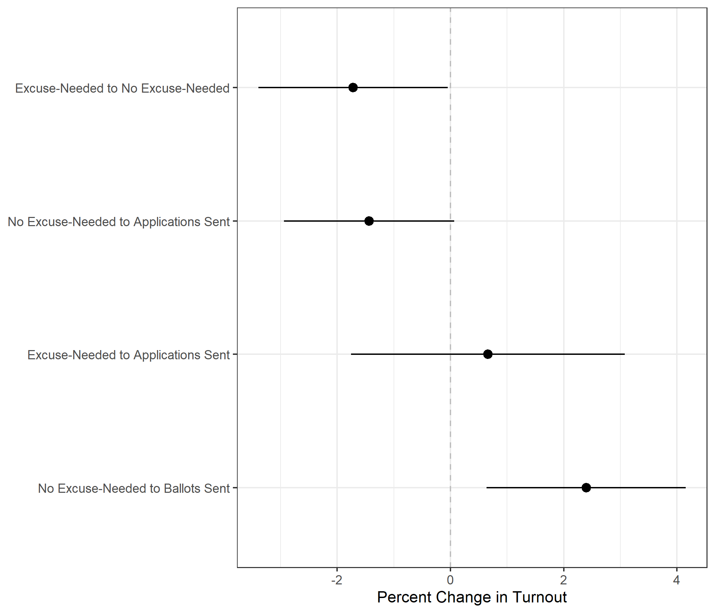
Point estimates are dots with lines indicating 95 percent confidence intervals. The baseline/reference category is no change in VBM laws. Model controls for Democratic vote share, the percentage of African Americans, median household income, median age, and percentage of individuals with only a high school diploma, county fixed effects with standard errors clustered at the state level. See Table 2A in the appendix for model estimates.

Figure 3: Difference-in-Difference Estimates of the Effect of the Vote-By-Mail Conditions on Two-Party Republican Vote Share
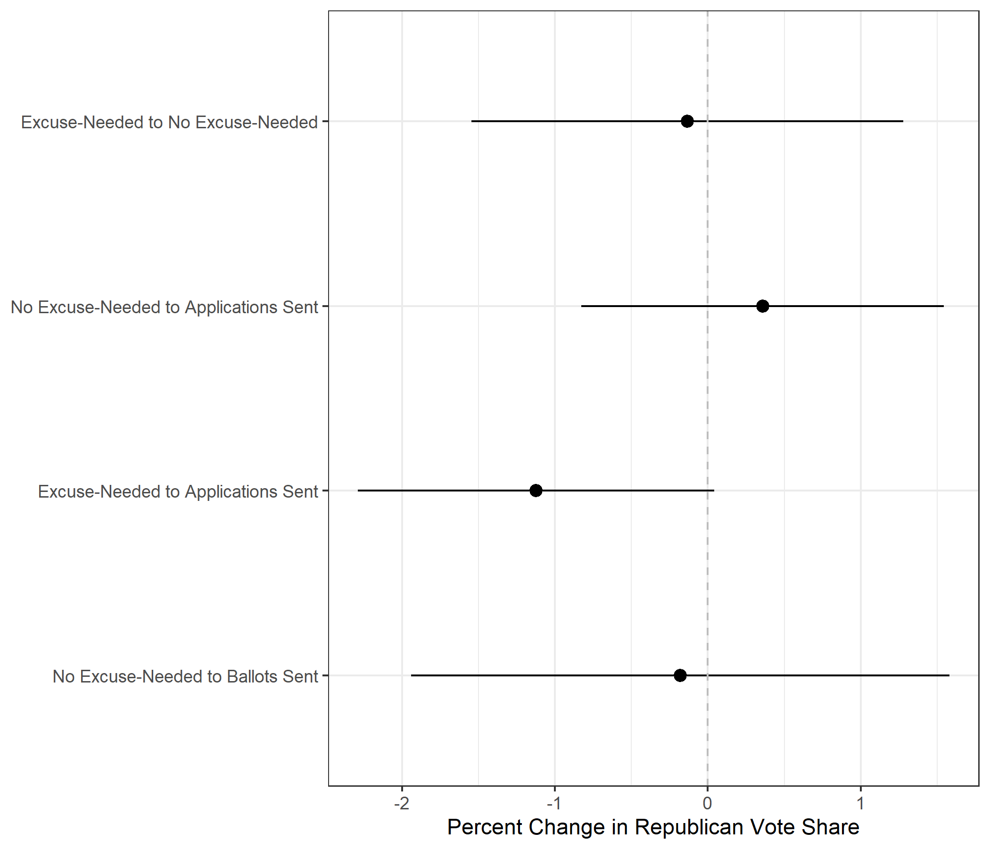
Point estimates are dots with lines indicating 95 percent confidence intervals. The baseline/reference category is no change in VBM laws. Model controls for population density, unemployment one month before Election Day, percent of the county with a high school degree and bachelor’s degrees, the percent of the county that is Black, multiracial, Latino, and foreign-born, county fixed effects with standard errors clustered at the state level. See Table 3A in the appendix for model estimates.

Tables

Table 1: Joint Distribution of Vote-by-Mail Policies in 2016 and 2020
 | 2020 VBM Policies
2016 VBM Policies | Excuse-Needed | No Excuse -Needed | Applications Sent | Ballots Sent
Excuse-Needed | 19%  (587) | 24%  (748) | 4%  (115) | 0%  (0)
No Excuse-Needed | 0%  (0) | 23%  (702) | 20%  (632) | 5%  (169)
Ballots Sent | 0%  (0) | 0%  (0) | 0%  (0) | 5%  (160)
Note: Cell entries report the percentage (and number) of counties in each category.

Table 1A: Treatment Conditions by 2020 Vote-by-Mail Policies for the Difference-and-Difference Analysis as Percentages
 | 2020 Vote-by-Mail Policies
Conditions | Excuse-Needed | No Excuse-Needed | Applications Sent | Ballots Sent | Total
Control | 18.86%  (587) | 22.55%  (702) | 0% | 5.14%  (160) | 46.55%  (1449)
No Excuse-Needed to Applications Sent | 0% | 0% | 20.30%  (632) | 0% | 20.30%  (632)
No Excuse-Needed to Ballot Sent | 0% | 0% | 0% | 5.43%  (169) | 5.43%  (169)
Excuse-Needed to Applications Sent | 0% | 0% | 3.69%  (115) | 0% | 3.69%  (115)
Excuse-Needed to No Excuse-Needed | 0% | 24.03%  (748) | 0% | 0% | 24.03%  (748)
Total | 18.86%  (587) | 46.58%  (1450) | 24.00%  (747) | 10.57%  (329) | 100.00%  (3113)
Note: Cell entries report the percentage (and number) of counties in each category.

Table 2A: OLS Regression Results for the Difference-in-Difference Turnout Analysis
 | Dependent Variable:
 | VAP Turnout (%)
 | Base | Control | County FE | County FE and State Clustered SE
 | (1) | (2) | (3) | (4)
Condition: Excuse-Needed to No Excuse-Needed | -0.609 | -0.503 | 0.167 | 0.167
 | (0.424) | (0.313) | (0.307) | (1.696)
Condition: Excuse-Needed to Applications Sent | 6.049*** | 1.109 | 1.152 | 1.152
 | (0.913) | (0.676) | (0.799) | (1.304)
Condition: No Excuse-Needed to Applications Sent | 6.836*** | 3.917*** | 3.971*** | 3.971***
 | (0.449) | (0.339) | (0.349) | (1.320)
Condition: No Excuse-Needed to Ballots Sent | 3.157*** | -2.386*** | -0.385 | -0.385
 | (0.768) | (0.572) | (0.690) | (2.627)
Year: 2020 | 6.796*** | 5.567*** | 5.341*** | 5.341***
 | (0.350) | (0.298) | (0.247) | (0.681)
% Black |  | 0.040*** | 0.041*** | 0.041
 |  | (0.008) | (0.011) | (0.041)
Democratic Vote Share |  | 2.853*** | 3.994*** | 3.994
 |  | (0.759) | (1.025) | (2.814)
Median Income |  | 0.0003*** | 0.0003*** | 0.0003***
 |  | (0.00001) | (0.00001) | (0.00003)
Median Age |  | 0.950*** | 0.929*** | 0.929***
 |  | (0.018) | (0.023) | (0.070)
% High School Degree |  | -0.329*** | -0.327*** | -0.327***
 |  | (0.017) | (0.020) | (0.050)
Daily Change in COVID-19 Deaths (Per 100K) |  | -0.084*** | -0.068*** | -0.068***
 |  | (0.014) | (0.013) | (0.021)
Condition: Excuse-Needed to No Excuse-Needed x Year: 2020 | -1.419** | -1.695*** | -1.721*** | -1.721**
 | (0.600) | (0.438) | (0.339) | (0.853)
Condition: Excuse-Needed to Applications Sent x Year: 2020 | 1.814 | 0.655 | 0.661 | 0.661
 | (1.291) | (0.936) | (0.723) | (1.232)
Condition: No Excuse-Needed to Applications Sent x Year: 2020 | -1.134* | -1.464*** | -1.436*** | -1.436*
 | (0.636) | (0.463) | (0.358) | (0.766)
Condition: No Excuse-Needed to Ballots Sent x Year: 2020 | 3.514*** | 2.394*** | 2.396*** | 2.396***
 | (1.086) | (0.787) | (0.609) | (0.896)
Constant | 57.932*** | 15.386*** | 14.275*** | 14.275***
 | (0.248) | (1.107) | (3.988) | (5.422)
Observations | 6,222 | 6,181 | 6,181 | 6,181
Adjusted R² | 0.184 | 0.574 | 0.746 | 0.746
Residual Std. Error | 9.422 (df = 6212) | 6.820 (df = 6165) | 5.269 (df = 4325) | 5.269 (df = 4325)
Note: | *p<0.1; **p<0.05; ***p<0.01

Table 3A: Regression Results for the Difference-in-Difference Vote Share Analysis
 | Dependent Variable:
 | Two-Party Republican Vote Share
 | Base | Control | County FE | County FE and State Clustered SE
 | (1) | (2) | (3) | (4)
Condition: Excuse-Needed to No Excuse-Needed | -1.378* | -4.877*** | -2.137*** | -2.137
 | (0.712) | (0.491) | (0.435) | (1.928)
Condition: Excuse-Needed to Applications Sent | -12.340*** | -15.254*** | -11.258*** | -11.258***
 | (1.528) | (1.029) | (1.111) | (2.987)
Condition: No Excuse-Needed to Applications Sent | -0.885 | -7.673*** | -5.881*** | -5.881*
 | (0.753) | (0.529) | (0.493) | (3.050)
Condition: No Excuse-Needed to Ballots Sent | -12.501*** | -7.793*** | -6.339*** | -6.339
 | (1.286) | (0.887) | (0.972) | (4.221)
Year: 2020 | -0.305 | -2.170*** | -0.622 | -0.622
 | (0.589) | (0.509) | (0.385) | (0.586)
% High School Degree |  | 0.584*** | 0.423*** | 0.423***
 |  | (0.028) | (0.029) | (0.093)
% Bachelor's Degree |  | -0.398*** | -0.114*** | -0.114***
 |  | (0.042) | (0.032) | (0.041)
% Black |  | -0.246*** | -0.183*** | -0.183**
 |  | (0.021) | (0.026) | (0.073)
% Multiracial |  | 0.324*** | 0.383*** | 0.383***
 |  | (0.019) | (0.024) | (0.065)
% Hispanic |  | -0.058*** | 0.100*** | 0.100
 |  | (0.016) | (0.024) | (0.091)
% Foreign-Born |  | -0.215*** | -0.385*** | -0.385**
 |  | (0.043) | (0.059) | (0.156)
Median Income |  | -0.0001*** | -0.0001*** | -0.0001***
 |  | (0.00001) | (0.00002) | (0.0001)
Population Density |  | -0.001*** | -0.001*** | -0.001*
 |  | (0.0001) | (0.0002) | (0.001)
Oct. Unemployment Rate |  | -1.209*** | -0.597*** | -0.597**
 |  | (0.082) | (0.080) | (0.242)
Daily Change in COVID-19 Deaths (per 100k) |  | 0.148*** | 0.105*** | 0.105***
 |  | (0.022) | (0.019) | (0.028)
Condition: Excuse-Needed to No Excuse-Needed x Year: 2020 | -0.311 | -0.025 | -0.133 | -0.133
 | (1.008) | (0.676) | (0.475) | (0.720)
Condition: Excuse-Needed to Applications Sent x Year: 2020 | -1.554 | -1.629 | -1.124 | -1.124*
 | (2.161) | (1.443) | (1.012) | (0.594)
Condition: No Excuse-Needed to Applications Sent x Year: 2020 | -0.396 | 0.594 | 0.358 | 0.358
 | (1.065) | (0.714) | (0.502) | (0.604)
Condition: No Excuse-Needed to Ballots Sent x Year: 2020 | -1.029 | -0.594 | -0.181 | -0.181
 | (1.819) | (1.222) | (0.858) | (0.898)
Constant | 68.346*** | 42.460*** | 40.173*** | 40.173***
 | (0.416) | (2.420) | (5.897) | (7.626)
Observations | 6,186 | 6,181 | 6,181 | 6,181
Adjusted R² | 0.050 | 0.576 | 0.792 | 0.792
Residual Std. Error | 15.771 (df = 6176) | 10.505 (df = 6161) | 7.362 (df = 4321) | 7.362 (df = 4321)
Note: | *p<0.1; **p<0.05; ***p<0.01

* Ph.D. Candidate, Department of Political Science, University of California, Davis (Amlani and Collitt)
^ Acknowledgments: We thank Carlos Algara and Erik Engstrom for their support of our research project and the acquisition of data, and Benjamin Highton for his invaluable guidance and expertise.
To our knowledge, in no way was voting by mail made more difficult.
We exclude Alaska from our analysis because turnout and vote share is not measured at the county level. Instead, Alaska uses “electoral districts” that do not overlap with counties.
In addition, Ansolabehere and Konisky (2006) and Highton (2017) argue that liberal and conservative electors may be different themselves: more liberal electorates being more inclined to vote (i.e. more civic-minded).
Prior to 2020, Oregon, Washington, Colorado, and most counties in Utah conducted elections using universal – or “mandatory” – VBM policies. Such policies include automatically sending voters mail-in ballots, but they also include limited opportunities for in-person voting. 7 states and D.C. were new to automatically sending voters mail-in ballots in 2020. While all 12 jurisdictions automatically sent voters mail-in ballots, their in-person voting policies varied greatly. Due to this variation, we avoid using “universal” or “mandatory” language in referencing our least restrictive VBM policy classification and instead refer to the state or county’s decision to send mail-in ballots to registered voters.
Table 1A in the appendix displays the distribution of VBM condition across 2020 VBM policy.
While there is substantial within-group VBM policy variation, we argue that classification based on these four criteria (whether a state or county requires an excuse to apply for a VBM ballot, and, if not, whether residents are sent applications or the ballots themselves) provide the most relevant and substantial between-group variation in terms of the theoretical costs to vote by mail. Because 2020 is the first election year where such variation exists on a national scale, we are unable to follow precedent set by previous work.
VAP turnout is calculated by dividing the total number of ballots cast by the total voting-age population (the number of individuals over 18-years-old) residing in the county.
It is also known as the difference-in-difference estimator.
We also include a base, control, and county fixed effects models in the appendix (see Table 2A).
We follow Chyzh and Urbatsch's (2020) change in vote share model at the county level and employ the same control variables.
We also include a base, control, and county fixed effects models in the appendix (see Table 3A).
Appendix Table 2A model 4 provides the full set of estimates from Figure 2.
When all covariates in our model are held constant.
Appendix Table 3A model 4 provides the full set of estimates from Figure 3.
When all covariates in our model are set to zero, the average change in Republican vote share between 2016 and 2020 is -0.622 percent in the control group.

