Mapping Solidarity Cities and and the legacies of Racial Capitalism

Craig Borowiak, Haverford College, cborowia@haverford.edu,
Maliha Safri, Drew University
Marianna Pavlovskaya, CUNY-Hunter College
Stephen Healy, Western Sydney University

This paper is adapted from our forthcoming book: Solidarity Cities: Confronting Racial Capitalism, Mapping Transformation (University of Minnesota Press, fall 2024). It has been prepared for the Annual Meeting of the Western Political Science Association. Vancouver BC, March 28-30, 2024.

Introduction
The cascade of crises sweeping the globe over the past decade has generated new geographies of economic precarity, both exacerbating existing forms of poverty, hardship and social dislocation and creating new ones. Crisis, however, also has a way of opening horizons. Heightened economic insecurity has been accompanied by more cautious and critical perspectives on conventional capitalist modes of development and by new forms of economic ingenuity as people seek out alternative ways to meet their needs and counteract the socially disembedding consequences of market logics and neoliberal modes of governance. Interest in socialism has certainly risen. And experiments with community gardens, cooperatives, collectives, community supported agriculture (CSAs), community currencies, community land trusts, and other forms of collective, solidarity-based practices have proliferated in recent years in the U.S. and internationally. These diverse forms of economic experimentation share a prioritization of ethical considerations over profit maximization, reorienting themselves towards equity, sustainability, cooperation, inclusive democratic processes, and community-based development. Although such initiatives are altering local economic landscapes, they nevertheless frequently fall out of mainstream studies of the economy, which instead focus on state budgets, for-profit capitalist enterprises, and the capitalist market economy. To the extent that these alternative economic forms are studied, they tend to be treated in isolation from one other. Thus worker cooperatives are studied independently from consumer cooperatives, which are studied independently from CSAs, credit unions and so forth. This piecemeal approach contributes further to their underrepresentation in empirical and theoretical research and to the perception that they occupy at best small niches in the economy.
Against this, we contribute to a growing scholarship that regards such diverse initiatives as constitutive of a larger “solidarity economy.” This literature has done much to draw awareness to the existence of alternative visions and to many examples of successful initiatives. Within this literature, however, we observe two patterns. First, much of the existing literature focuses on individual cases for empirical evidence while neglecting the solidarity economy’s aggregate footprints. There are few macro-level empirical attempts to assess the size of the solidarity economy. Second, little attention has been paid to the divisions within the solidarity economy and how they might reflect underlying racial and class divides. Too often, solidarity economy proponents have ignored the solidarity economy’s racial and class dimensions. Responding to this, critical voices have begun expressing concern that solidarity economy initiatives can actually reproduce and exacerbate entrenched racial and class divisions (Hudson 2020; Hossein et al. 2023; GEO 2015).
In the US, as elsewhere, social conditions are heavily seeded with racial and class divides, which themselves stem from generations of entanglement with racial capitalism. Here, we use the expression “racial capitalism” not to suggest that there is a racial form of capitalism that is distinct from other forms of capitalism but rather to indicate that capitalism and racism are co-constitutive (Kelley et al. 2019; Robinson 1983). Capitalism developed and operates in a racialized order, the legacies of which are imprinted on contemporary political discourse, on patterns of social interaction, on the shapes of economic inequality and opportunity, and on the segregated character of urban geographies. Inevitably, racialized and classed dynamics also shape the practices and social imaginaries of activists seeking to forge solidarity-based economic alternatives.
Our research contributes geographic perspective to such concerns. In our forthcoming book, Solidarity Cities: Confronting Racial Capitalism, Mapping Transformation (University of Minnesota Press), we address these issues directly with a variety of mapping and counter-mapping techniques. This paper is an adaptation of material from that book.
Mapping is a powerful epistemological process that does more than simply display a pre-constituted reality. It also constitutes the social landscapes that it makes visible on the map. It is in this respect ontologically potent (Pavlovskaya 2018). Adapting Cindi Katz's words, we might say that maps, like other forms of knowledge production, “ooze with power” (Katz 1992). One might think, for example, of colonial maps used for exploration, conquest, and extraction, or of 20th-century red-lining maps that segregated cities into racialized zones defined by their presumed (un)suitability for investment (we’ll have more to say on redlining later). The very qualities of maps that make them tools of hegemony can also, however, be deployed in counter-hegemonic agendas. Mapping and counter-mapping techniques can redraw social formations, bring new solidarities into being, and reconfigure hegemonic perceptions of lack into counterhegemonic perceptions of abundance and empowerment. It is in this spirit that we have undertaken to use mapping techniques to examine how solidarity economies are carved by racial and class divisions both within and across cities.
We use geographic information systems (GIS) to map and analyze the solidarity economy in three east coast US cities: Philadelphia, New York City, and Worcester Massachusetts. Elsewhere, we examine detailed sectoral patterns in the three cities. In this paper, we focus on the solidarity economy as a whole: we paint its presence in New York, Philadelphia, and Worcester throughout time and with bold brush strokes. We start by revealing the broad spatial contours of the solidarity economy. In the process, we identify the areas within each city where solidarity economies cluster and have the highest densities. We refer to these as solidarity economy hotspots. In each city, we find that these hotspot patterns often overlap in urban space with low-income neighborhoods of color. There is also a consistent overlap between hotspots and areas that were subject to racist practices enabled through what is commonly known as redlining. This is where our argument about the present connects to the past, and where counter-mapping becomes a way to re-narrate the spatial geography and history of marginalization and solidarity.
Racial capitalist forces shape cities in accordance with profit-driven logics, resulting in polarized urban spaces marked by racialized poverty and wealth. But that is only part of the story. Urban communities also resist these dynamics, using “defend and build” strategies (Akuno 2017). Cities continuously renew themselves through solidarity and cooperation, despite capitalism's destructive influence. In the course of everyday life, solidarity economies continually create livelihoods and community support structures, rooted in diverse traditions, that make it clear the solidarity city has as long a history as the “capitalist city.” Extending this insight, we can understand that the solidarity economies we see in the present can be traced to past forms of human solidarity that sometimes traveled under different names, and came from different communities. People have long been involved in resisting destructive racial capitalist forces, and in doing so, they are also engaged in a world-making process that has vitality and principles of its own. While a full recounting of this history across all three cities and across the full variety of communities is beyond our scope, we simply wish to point towards the fact that solidarity cities exist in our present, are part of our collective past, and point towards a different future.

Spatial distribution of solidarity economies: clustering and density
At the center of our research is a typology of the solidarity economy. It determines what we inventory, map and analyze. In developing this typology, we began with the national-level categorizations generated by the US Solidarity Economy Network. We then adapted these after numerous discussions with local movement leaders and theoretical deliberations about definitions, categories, inclusions, and exclusions. Figure 1 displays this modified typology.

Figure 1: Solidarity Economy Typology^{Ɨ}
Consumption | Production | Finance | Exchange | Governance
Consumer cooperativesª  Co-housing/  Intentional communitiesª  Housing cooperativesª  Community land trustsª | Worker Cooperativesª  Producer cooperatives  Volunteer collectives  Community gardensª  Unpaid household labor  Collectives of self-employedª  Mutual Aid Networks | Credit Unionsª  Community development credit unionsª  Rotating Savings and Credit Associations (ROSCAs) | Fair trade networks  Community supported agriculture and fisheriesª  Complementary currencies*  Barter networks  Free-cycle networksª  Time banksª | Participatory budgetingª  Collective community management of resources
^{Ɨ}All those marked with superscript ª are represented in our detailed urban inventories.

The table divides the solidarity economy into five principal domains of activity, reflecting major economic spheres: consumption, production, finance, exchange and governance. Under these domains, the typology encompasses a diversity of forms. Some, like consumer cooperatives and credit unions, are formal organizations with a paid staff and legal incorporation status. Others, such as ROSCAs, are more informal. Some, like unpaid household labor, are practices rather than formal organizations. Still others, such as fair trade and barter networks, are diffuse networks without a distinct location. Overall, the typology gathers a rich heterogeneity of initiatives cast in opposition to capitalist organization of these spheres of the economy. The variety broadens and deepens a counter-hegemonic framing of the economy.
Using this typology, we compiled inventories of the different initiative types in our three cities. To the extent possible, we then geocoded the different initiatives (including branch locations, if relevant) to produce a novel series of maps. We begin this work with Map 1, where we provide an overarching view of the solidarity economy’s sectoral distributions.

Map 1. Spatial footprint of the Solidarity Economy in Philadelphia, Worcester, and New York City 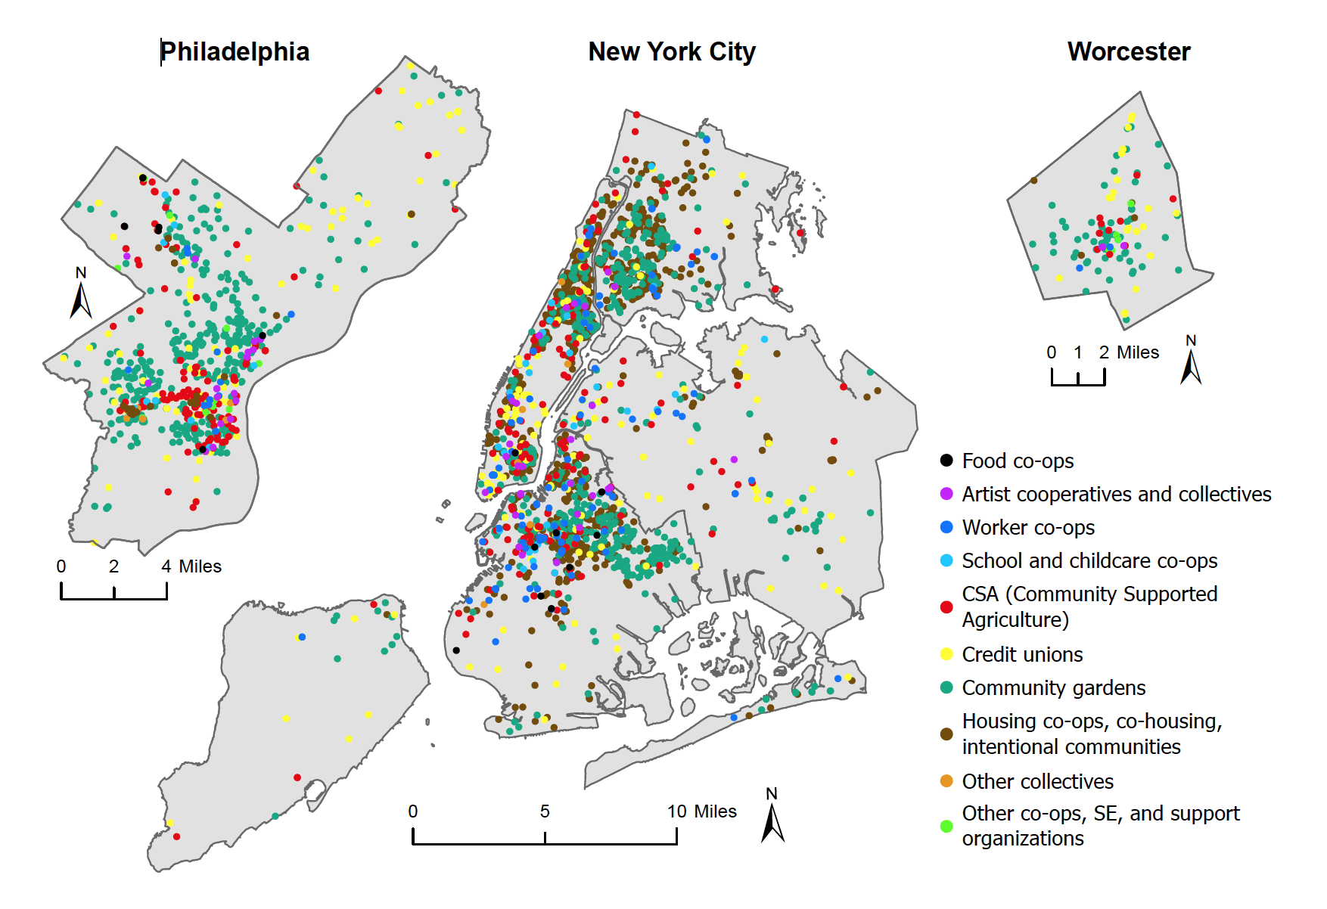
The map contains what we call the spatial footprints of the three solidarity cities. On these maps, solidarity economy locations within city borders are depicted with variously colored dots. Each dot represents one initiative while the color corresponds to its organization type (see Figure 1). The map legend includes details of the categories used. What emerges on those maps is that Philadelphia, Worcester, and New York all contain a large and highly diverse set of solidarity economy initiatives. We can think of those colored dots as representing thousands of flowers of human solidarity already in bloom within the streets of our cities.
This simple mapping exercise transforms the common understanding of US cities as entirely shaped by capitalism and its profit- and competition- centered logics. The maps show that the same cities contain a large array of non-capitalist practices that follow the ethics of solidarity and cooperation. We see hundreds of community gardens, many cooperative enterprises, scores of credit unions, and dozens of community supported agriculture (CSA) programs, among many other initiatives. The maps provide a glimpse into the extent to which solidarity is woven into urban economies. They invite us to consider more fully what role solidarity economy initiatives play in our cities, and what they can offer to urban residents especially in disinvested neighborhoods where capitalism often falls short to support life needs.
The aggregate spatial distribution of the solidarity economy is shown to be both large and uneven. Some parts of the cities (e.g., downtown areas) have many solidarity economy organizations whereas others have only a few. All of this invites questions about the clustering of solidarity economy initiatives, about where they tend to concentrate and settle, and most importantly, for what reasons.
While Map 1 provides an overarching view of the solidarity economy’s sectoral distributions, it nonetheless underrepresents the extent to which initiatives converge in particular spaces. This is because the overlapping of dots masks the full density of solidarity economy clusters. In Map 2, we probe such clusters more fully by presenting the same data via a density surface. This was done by applying a geospatial technique called kernel density estimation. Simply speaking, the density maps show where the solidarity economy activity is more or less dense. Similar to how population density maps show quantities of people per area unit (e.g., persons per acre), our maps show variation in quantities of initiatives per acre. Areas with higher densities are colored with darker shades while areas with lower density have lighter shades.

Map 2: Density of solidarity economy initiatives in Philadelphia, New York City, and Worcester

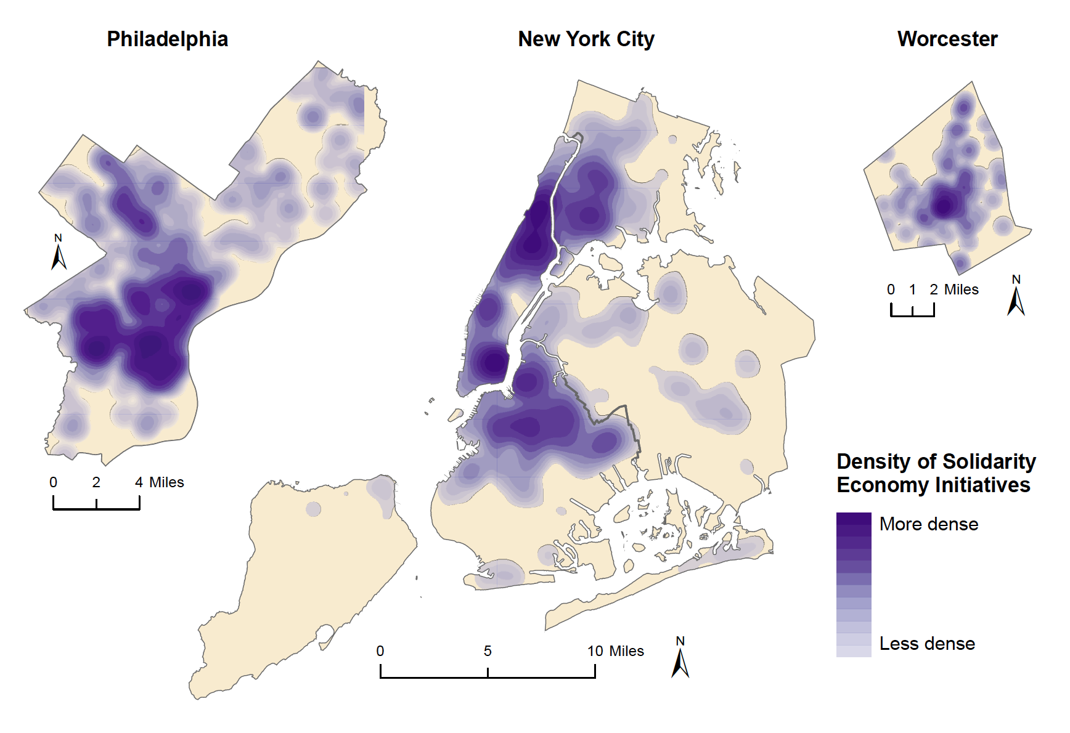
Map 2 offers a two-dimensional look at the landscape. In it, we observe stark contrasts between where the solidarity economy is dense and where it is sparse. But even these maps do not convey the full intensity of those solidarity-economy clusters. Map 3 presents these density surfaces in three dimensions. This perspective further amplifies the solidarity economy’s presence and patterns on the maps.

Map 3. Three-dimensional visualization of solidarity economy density

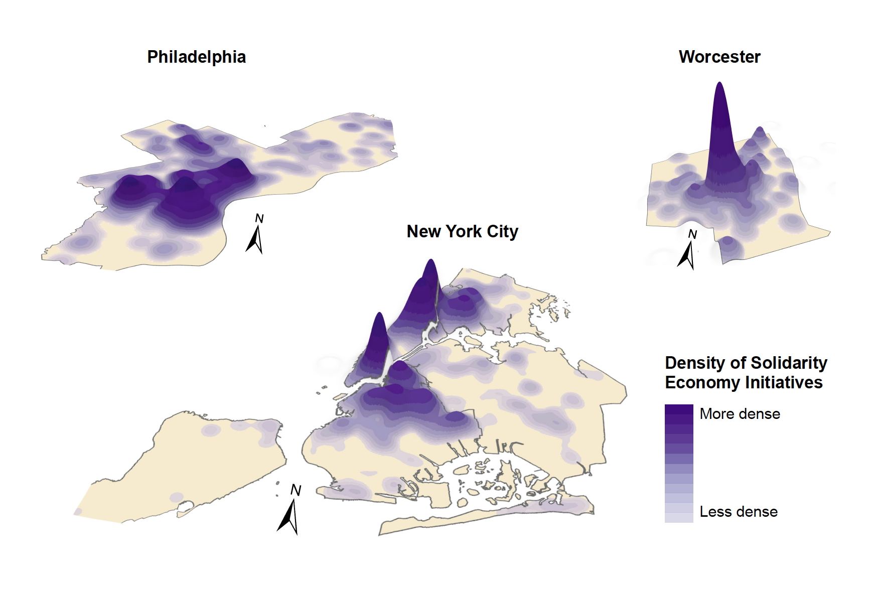
The three-dimensional landscape might remind viewers of a relief composed of mountains, valleys, and plains, with higher densities resembling mountain peaks and lower densities resembling lower elevations. The map images not only display the solidarity economy as a city-wide phenomenon deserving thoughtful consideration but also beckon the viewer to ponder which specific areas of the city align with these most vibrant centers of solidarity economic activity. We want to recognize these specific neighborhoods, find out their names, and explain why those neighborhoods have high densities of the solidarity economy.

Hotspots of solidarity economies in neighborhoods
In spatial statistics, areas of high density of a phenomenon are called “hotspots.” For example, biodiversity hotspots include areas with the highest density and variety of species. Similarly, maps of solidarity economy hotspots would indicate the areas in which solidarity economy activity has the highest density. We can think of these hotspots as spatial anchors of the solidarity city: when more and more solidarity economy initiatives exist in the same neighborhoods, their proximity creates conditions for possible synergies between the initiatives, potentially generating connections that are more likely to endure and sustain each other. These are the most likely sites for the emergence of the solidarity economy ecosystem.
In Maps 4, 5, and 6, we pinpoint the neighborhood locations of hotspots within the three cities. They include the four highest degrees of density in the solidarity economy that are represented by four shades of purple. We identified five hotspots in Philadelphia (P1-P5), seven hotspots in New York City (N1-N7), and one central hotspot in Worcester (W1). Clearly, the quantity of hotspots, along with their density and extent, correlate with city size. The larger the city, the greater the number of neighborhoods with high concentrations of solidarity economy initiatives. At the same time, each city has its own historical trajectory that produces specific contours of the Solidarity City. Thus, the question of where—in which specific neighborhoods of a particular city—we find the solidarity economy hotspots is of great importance to our inquiry. Identifying those neighborhoods is a step towards understanding the formation of those dense clusters that can have generative potential for social transformation towards solidarity cities. We list these neighborhoods in the maps’ margins. As it turns out, many hotspots correspond to historic places and their names ring bells for those familiar with our research cities. This indicates that the solidarity economy is closely intertwined with urban histories and processes that shape urban space. Some of these neighborhood names will reappear later in the book and can be found by looking again on these three maps.

Map 4. Solidarity economy hotspots and Philadelphia neighborhoods

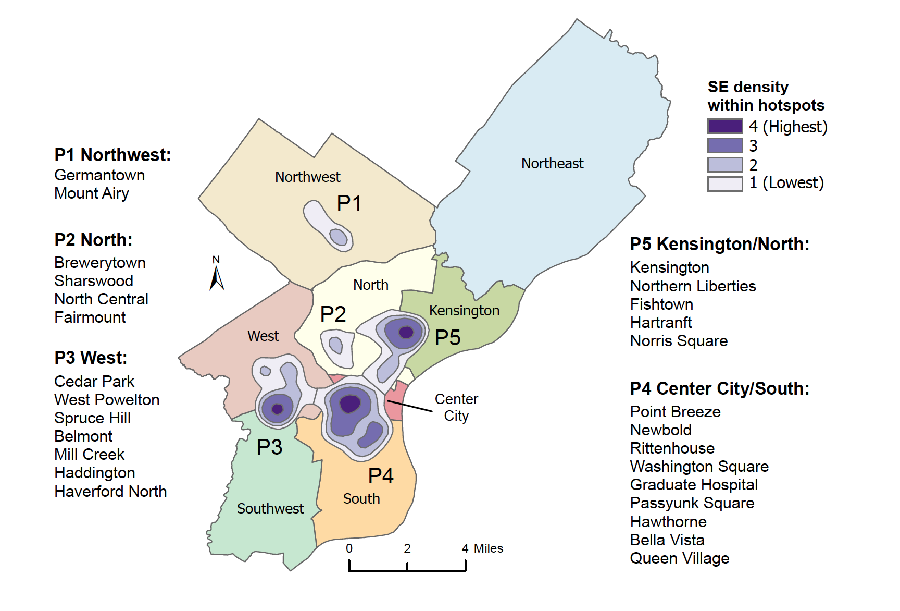

Map 5. Solidarity economy hotspots and New York City neighborhoods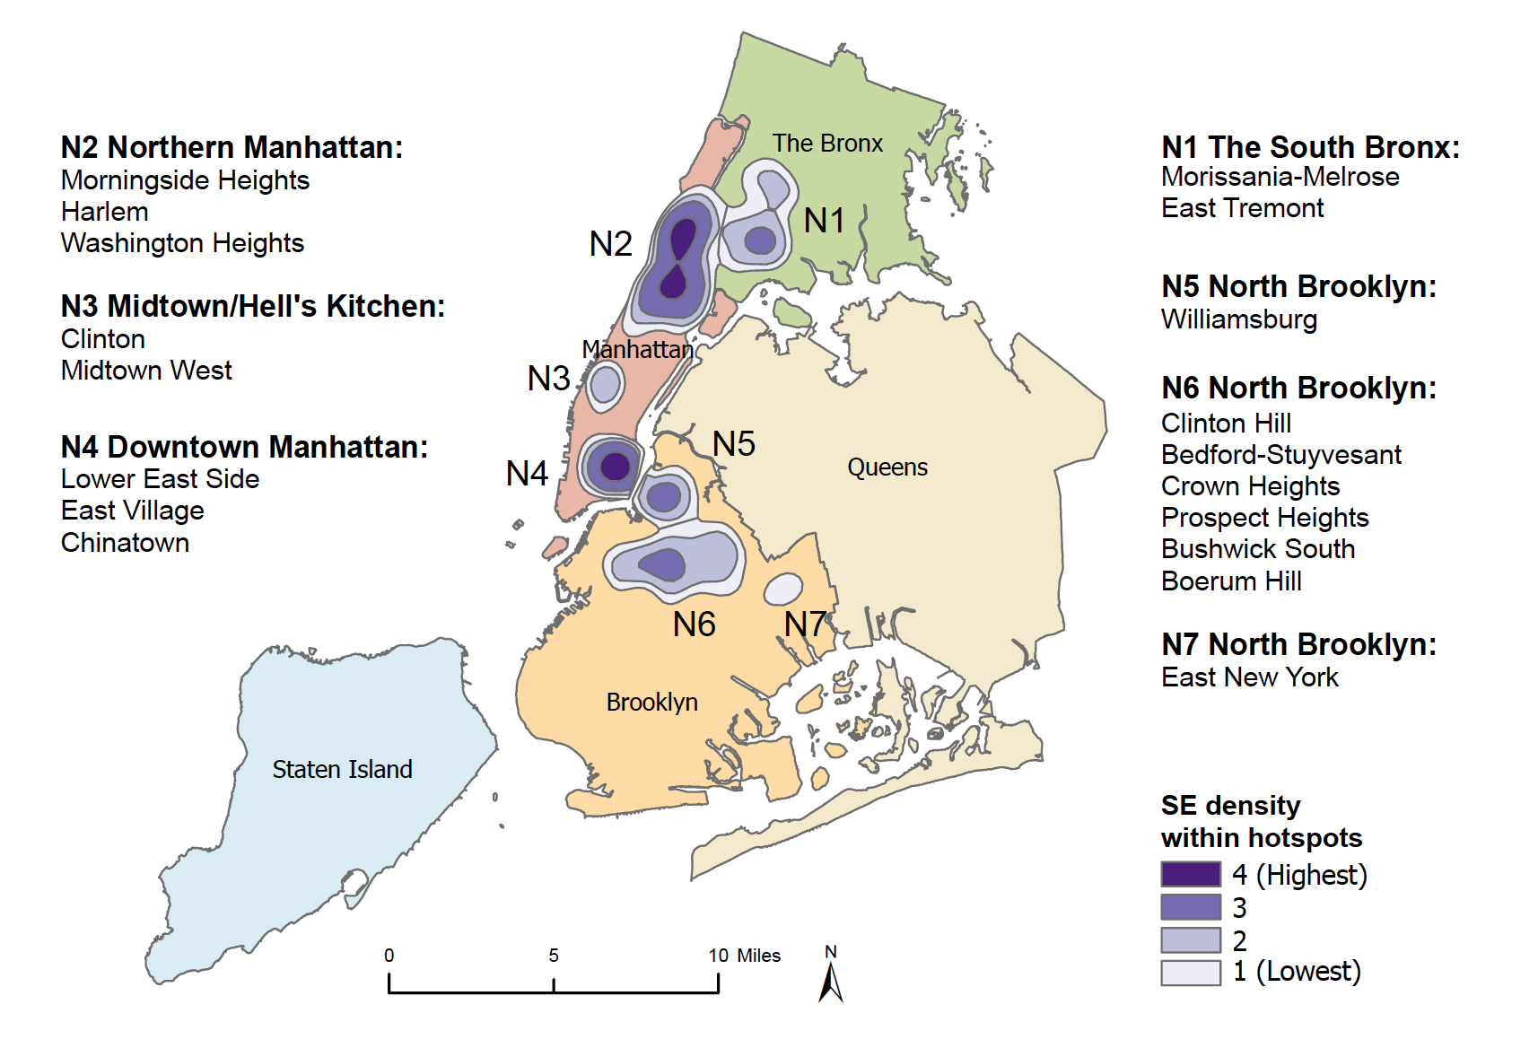
Map 6. Solidarity economy hotspots and Worcester neighborhoods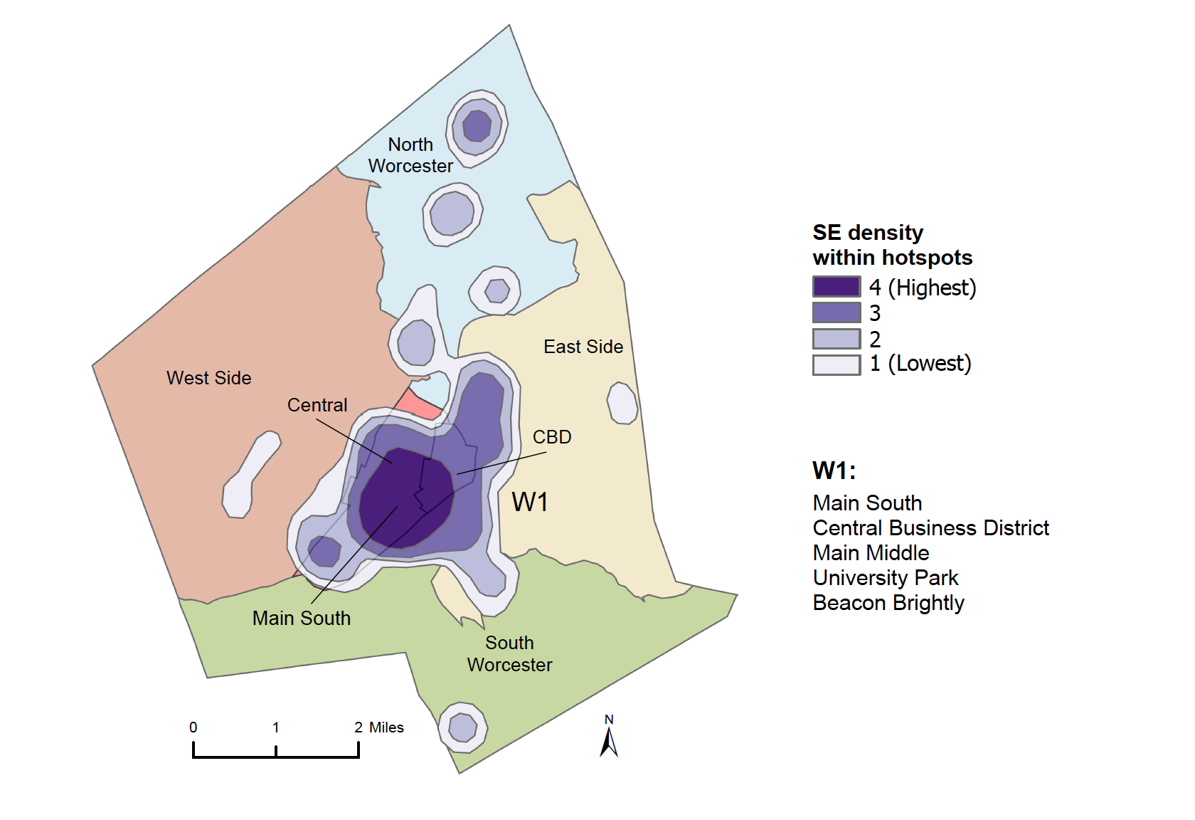
The concentrations of solidarity economy initiatives in hotspot areas are significant: 61% of Philadelphia’s solidarity economy initiatives are in its hotspots, and 69% of New York City’s solidarity economy initiatives are in its hotspots. The density map of Worcester shows a similar pattern, with the bulk of solidarity economy activity taking place in the city center in the area colloquially known as Main South. This is important for a lot of reasons. Certain clustering in central urban locations (e.g., Central Business District areas) is typical of all kinds of economic activities. High transport accessibility, economies of scale, and possibility of face-to-face communication (even in the era of internet conferencing) constitute powerful motives that offset high rents in such locations. In the case of solidarity economy, these factors conjure with those specific to the movement. Political potential widens when solidarity economy initiatives cluster together not only for general access considerations but with the intention to be near each other; they can gain some joint organizing power and leverage with city agencies in negotiating conditions of existence. Additionally, clustering makes it more possible and likely for different households to use and engage in multiple forms of solidarity economies as interest catches fire. To give just one example, in the Bronx hotspot N1, Norwood CSA distributes food at dropoff points in two community gardens (James Baldwin and Bainbridge Community Gardens), which include members who live in nearby Amalgamated Housing Cooperative (the oldest housing co-op in the city), which is serviced by Van Cortlandt Credit Union. Returning to our forest metaphor for the solidarity economy, hotspots can be seen as forest oases in the city—teeming with life and the possibility of sharing resources to grow in mutually supportive ways. In other words, these are the sites where the solidarity economy ecosystem has particularly good chances to grow, diversify, and strengthen. These hotspots are not only where the solidarity city is most visibly present today, but they also have the greatest potential for the future of solidarity cities.
In the sections that follow, we seek to better understand these hotspots by situating them historically and in relation to broader demographic and economic contexts. Our analysis shows that there is a strong relationship between the present spatial distribution of solidarity economic activities and historical patterns of racial-capitalist urbanization.

Solidarity economy hotspots in relation to poverty and race
Like most major US cities, New York, Philadelphia, and Worcester, are spatially segregated by race, poverty, and wealth. These divisions, what we’ve termed “fault line” patterns, are largely products of capitalist development, cultural practices, law, and policy that shape norms and the social order. What can we learn about the spatial distribution of the solidarity economy by mapping hotspot locations in relation to urban space divided in these ways? In order to explore this, we examine what kinds of communities inhabit the neighborhoods with solidarity economy hotspots.
The overlapping geographies of solidarity economies and racialized poverty and wealth are visible in Map 7 for Philadelphia, Map 8 for New York City, and Map 9 for Worcester. In each of these, the maps A (on the left) show how solidarity economies are positioned with respect to income inequalities, while maps B show the relationship to race. These angles touch on the pressing social problems of poverty and racialization that divide urban societies. The resulting fault lines find their expression in urban space.
In order to represent geographies of economic inequality, we used census data on median household income. To make this variable more meaningful as a measure of hardship, we have indexed income values to poverty line levels. We defined four levels of median household income as multiples of a poverty line for a typical three-person urban household. To account for large differences in cost of living, the poverty line levels used are specific to each city. Of the four income levels on the maps, the lowest income range includes areas at or below the cities’ respective poverty lines while the remaining three income ranges correspond to double, triple, and more than triple those levels. Thus, the poorest areas appear as the lightest gray color while darker gray corresponds to areas with higher levels of income. Mapping multiples of the poverty line is important for how we conceive of economic inequality. We see poverty and privilege as mutually constitutive in a sense that poverty is constantly reproduced to assure the surplus continues to flow to the select wealthy few who can continue to amass wealth (Lawson and Elwood 2018). This way of thinking about inequality enables us to link income stratification to the production of poverty, and measure income in relation to poverty levels.
This approach also provides an expanded and more accurate way to conceive of poverty. It is well-known that the official poverty line is woefully inadequate at capturing the full extent of poverty, if by this we mean not a formal income measure but an inability to meet basic needs. It also fails to capture the economic insecurity of households living close to the poverty threshold, one emergency or unexpected bill away from becoming poor. For this reason, many analysts prefer a more encompassing threshold that includes those living “near poverty,” defined in ways ranging from 125% to 200% of the official poverty line, while others use the category “low-income” to refer to households with income 100-199% of the poverty threshold. Mapping multiples of the poverty line enables us to integrate these other perspectives. Given that many solidarity economies are committed to economic and social justice, unmaking poverty and associated suffering and violence is important for accomplishing this goal. Our map series A for each of the next three figures shows how solidarity economies are clustering specifically with respect to poverty levels.
Similar to our maps of poverty, we have taken great care with our categorizations in our maps of racial distribution. Our guiding intention is to provide a more nuanced spatial representation of how racial difference maps onto the city and the solidarity economy. The maps purposefully avoid simple 50% racial majority distributions. Instead, they employ a two-thirds majority threshold, whereby a racial group must constitute 67% or more of the population before a neighborhood is labeled accordingly. We have also developed two additional categories to represent neighborhoods with no single two-third racial majority: one where a mix of people of color (mainly Latinx, Black, and Asian) together constitute a 67% or greater majority of the population, and one where White people constitute between 33 and 67% of the neighborhood. This enables us to further differentiate between largely White and non-White spaces, something that is important given the spatial legacies of White supremacy and racial discrimination. These methodological decisions result in maps that better represent the racial heterogeneity of city-space. Collectively our approach to mapping poverty and racial difference helps to represent the spatial complexity of the city, the context in which communities attempt to forge relations of solidarity.

Map 7. Solidarity economy hotspots and racial and poverty geographies in Philadelphia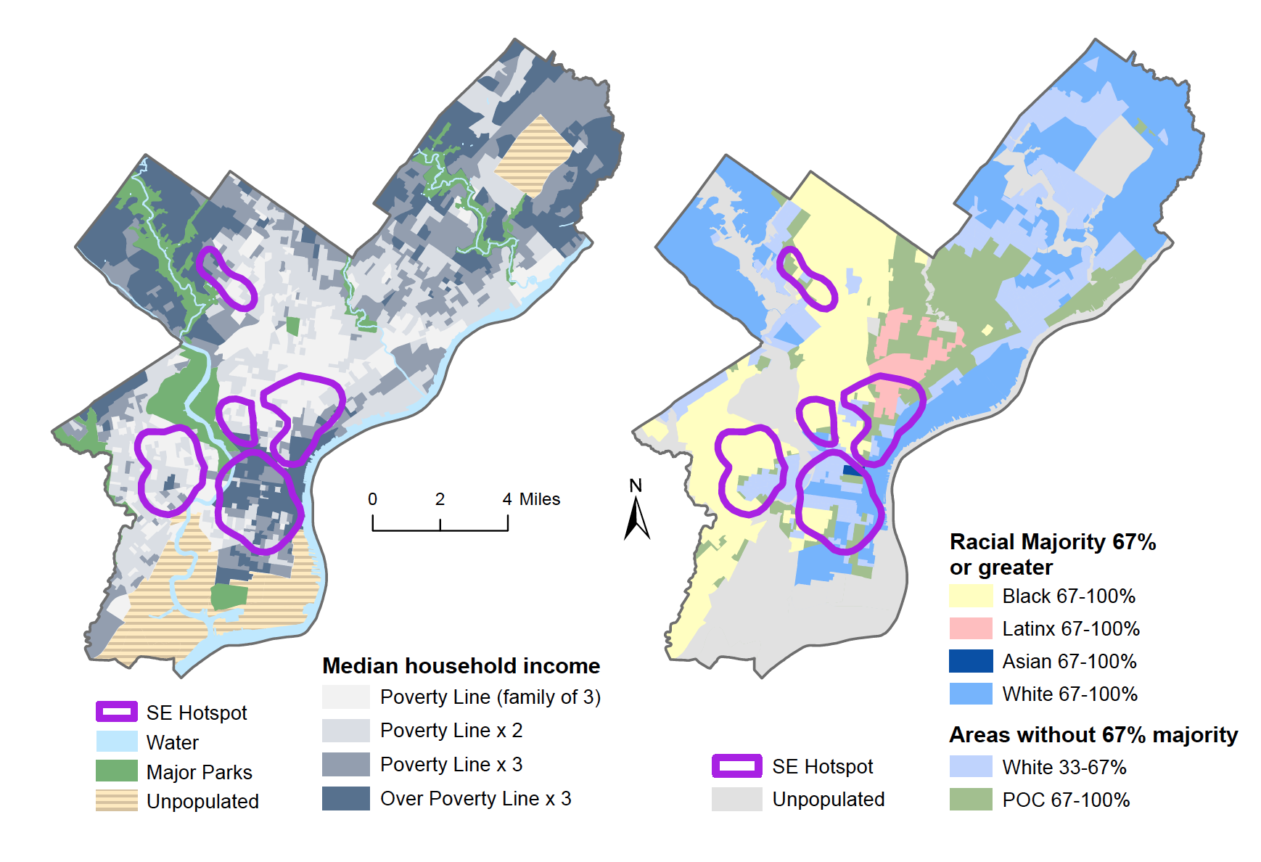

In both Philadelphia and Worcester, the maps show a very evident concentration of poverty in the urban core, shown by lighter shades of gray color. In much larger New York City, areas of concentrated poverty are visible in all boroughs, and especially in Northern Manhattan, South Bronx, and North Brooklyn. This difference notwithstanding, poverty can be seen to cover wide swathes of all three cities in a manner that strongly correlates with race. The distribution of the solidarity economy also corresponds to those patterns. We find that the majority (66% in New York and 54% in Philadelphia) of solidarity economy organizations in each city are in areas with populations that are at least 67% non-White and where the poverty levels are highest.
In Philadelphia, four of the five hotspots are concentrated in poor neighborhoods, which are also neighborhoods with significant communities of color. That kind of overlap is present in the other cities as well. For New York City, Map 8 shows that four of seven hotspots are located in largely poor areas that have high densities of communities of color (either mixed, or with Latinx or Black majorities). Significantly, even the remaining three hotpots (N3, N4, N5) contain considerable racial diversity. Two of these (N4, N5) also encompass areas where very affluent neighborhoods butt up against considerably poorer ones. As we examine elsewhere, solidarity economy initiatives in such areas can serve as protective oases or bulwarks against gentrification and displacement.

Map 8. Solidarity economy hotspots and racial and poverty geographies in New York City

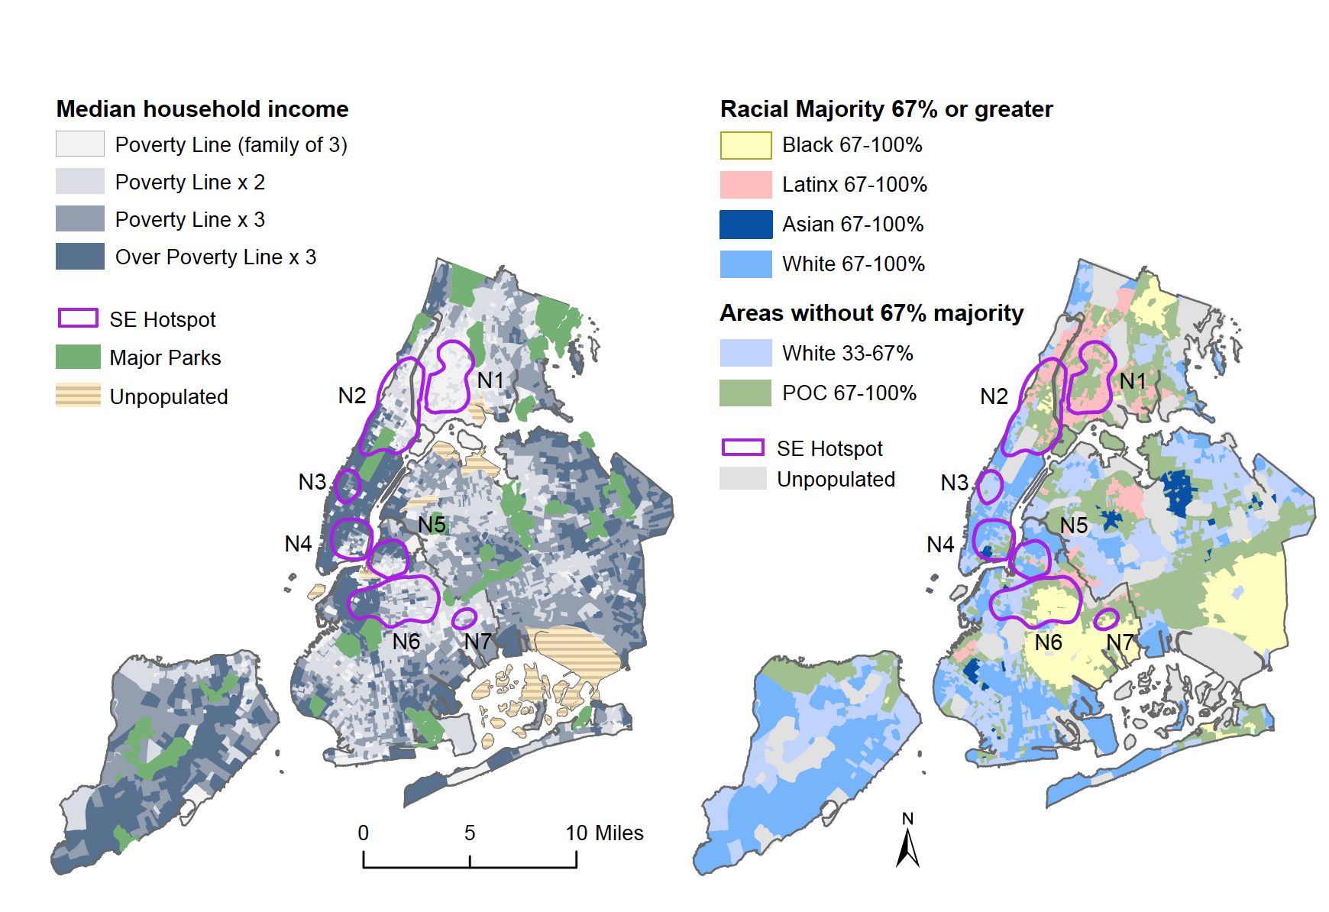

In the case of Worcester, Map 9 shows one hotspot in the center of the city. There are other concentrations of the solidarity economy in Worcester as well (see Map 6), but compared to the W1 cluster, they are considerably smaller owing to the overall smaller size of this city. The largest hotspot is located in a low-income neighborhood—Main South—with a sizable Latinx majority and the city’s highest concentration of people of color.

Map 9. Solidarity economy hotspots and racial and poverty geographies in Worcester, MA.

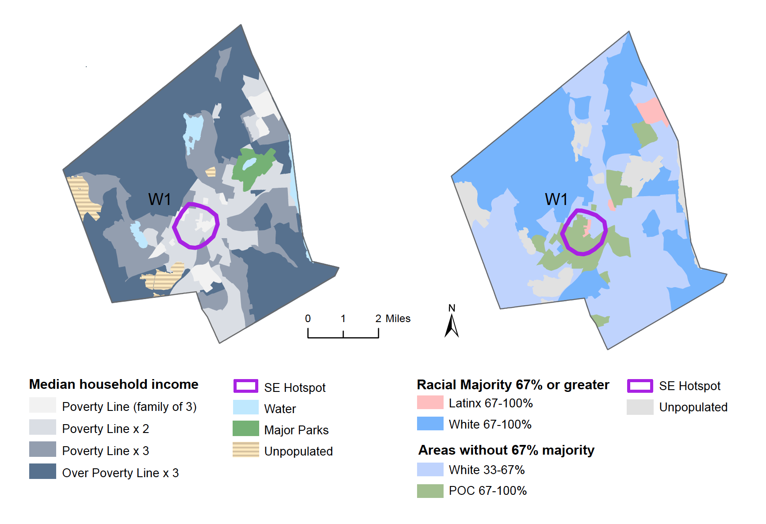
In each city, we also observe that the solidarity economy hotspots encompass neighborhoods in which people of color have historically settled and built communities. Even when solidarity economies do concentrate in contemporary White neighborhoods, those locations tend to correspond to historic working class neighborhoods settled when many European immigrants (e.g., Irish, Jewish, Italian, Polish, etc.) were discriminated against as non-White. This points to the continuation between historical and contemporary trajectories, a continuation that is often obscured by the dynamic remaking of urban space and the layered accumulation of built and institutional fabric within it. Our maps encourage us to go deeper and explore how racialized communities of all kinds have been an important source of the solidarity economies yesterday and today.
In sum, Maps 7, 8, and 9 portray urban space in each city as highly segregated by income and race, where poor areas often overlap with minority neighborhoods, a situation common for many US cities. Although the solidarity economy clearly extends to wealthier parts of cities, including neighborhoods inhabited by a mix of White people and people of color, there appears to be a particularly strong overlap, as already noted, between solidarity economy hotspots and low-income neighborhoods of color. In what follows, we explore some of the historical forces that have given shape to segregated neighborhoods and, by implication, the solidarity economy formations within them.

Solidarity economies inside redlined neighborhoods
Urban landscapes are not produced overnight. The inequalities that we mapped earlier in the chapter are the product of generations of entanglement with racial capitalism, biased government policies, and other forces. The migration of working-class people. The dynamics of industrialization and deindustrialization. Urban neoliberal restructuring. Dislocations through urban renewal, gentrification, and incarceration. These all shaped the cities we now inhabit. Many volumes have been written explaining these dynamics and we will not attempt to review them all here. Instead, we devote special attention to one process in particular commonly known as redlining. Redlining refers to the set of urban practices widely used in the middle part of the 20th century to shape cities in powerful ways. The resulting geographic patterns of urban poverty and organized abandonment continue to define urban space to this day. Notably, redlining worked to racialize and segregate urban communities by poverty through a series of maps. The cartographies of the solidarity economy that we overlay against the borders of redlined neighborhoods make it clear that in the past, like today, urban space has been powerfully created through solidarity as well as through racist policies and capital.
Redlining is the shorthand reference to federal housing policy in the mid-20th century and its effects on urban space. In concert with the actions of urban administrations and real estate developers, federal policies entrenched the spatial dynamics of racial capitalism by re-tracing and carving deeper still fault lines of residential racial segregation in hundreds of US cities. For us, redlining is especially important because it exemplifies how maps have been deployed to sustain and consolidate hegemonic social orders, a theme we discussed in the previous chapter. Redlining brought together race and mapping in a process that helped constitute the racialized and economically stratified urban settings we study and against which we position solidarity economies.
Federal redlining began in the 1930s with the creation of the Home Owners Loan Corporation (HOLC) and the Federal Housing Authority (FHA) as parts of Roosevelt’s New Deal. Ostensibly designed to lower housing foreclosures rates and expand home ownership through government-backed loans to homeowners and developers of new residential areas, the agencies were tasked with assessing investment risk within urban housing markets for the sake of lowering risk for tax-payers-backed loans. Their efforts to codify the risk levels of different neighborhoods ultimately determined where federal subsidies and private investment would flow. The HOLC and FHA produced maps of cities by block, with detailed information about socio-demographic makeup of each mapped neighborhood and the condition of housing stock. Both were used as factors in risk assessment for government investment in housing construction. Areas marked by green and blue colors on the HOLC maps corresponded to “Best” and “Still Desirable” categories for low-risk loans. These areas, assessed as suitable for new construction, like suburbs with room to build, received practically all investment and subsidies. Other, mainly urban, neighborhoods, shown on the maps with yellow and red colors (hence the term “redlining”) and corresponding to “Definitely Declining” and “Hazardous” categories, respectively, could not access new investment, subsidies to builders, and mortgages to residents. We reproduce these maps in Map 10 against the concentrations of the solidarity economy.
Widespread discrimination permeated the dynamics of redlining, influencing local assessors' judgments regarding which neighborhoods posed an investment risk, ultimately leading to their depiction in red on the map. Pervasive racism ensured that the maps consistently associated people of color with social problems. Subsequently, most inner city neighborhoods containing large numbers of people not considered White (a category that variously included Black, Hispanic, Asian, Jewish, 20th century Italian and Irish populations, among many others) were excluded from accessing federally backed loans, often disregarding the economic status of the residents (Wilder 2000; Rothstein 2017). Not being able to purchase a new home elsewhere without mortgage access, residents of these neighborhoods were confined to increasingly segregated and disinvested locations where homeowners and even willing landlords were lacking subsidies for upgrading the dilapidated housing stock. On the other side of this dynamic, middle-class White households were able to retreat from rapidly devaluing neighborhoods into racially exclusionary suburbs or certain less densely built urban neighborhoods where newly built homes were made affordable by massive government mortgage subsidies (Jackson 1980; Rothstein 2017; Wilder 2000; Adams et al. 2008). Redlining thus intensified and entrenched for decades to come the already ongoing spatialization of racialized poverty and wealth. Even after the passage of the Fair Housing Act of 1968, the law that formally prohibited redlining practices, the effects of redlining persist due to intergenerational wealth transfers, the discriminatory workings of present-day real estate markets and development companies, and the everyday processes that reproduce racialized divisions in income, wealth, and opportunity. Recent research shows that practically three quarters of the neighborhoods then designated as “hazardous” by HOLC today remain low-income today and two-thirds of them are minority communities (NCRC 2018).
In these ways, redlining is a potent illustration of the ontological power of mapmaking and how maps have been deployed in support of racial and class hegemony. The color-coded maps did not merely represent pre-existing urban realities; they also helped intensify the existing racial divisions within urban landscapes while contributing to the emergence of new ones.
Neighborhoods categorized as “Best” became more prosperous as a result of redlining and processes it set in motion. Meanwhile, neighborhoods designated as “Hazardous” became more hazardous due to the resultant disinvestment. From its inception, redlining was a form of world-making. The abandonment of particular urban neighborhoods did not just happen; it was organized through creation and widely spread application of those maps (Gilmore 2017; Rothstein 2017; Martinez and Glantz 2018). The intentional segregation of non-White neighborhoods has led to profitable investments elsewhere. Wrapped in normative rhetoric about the importance of homeownership and upward mobility for middle and working class families, redlining was always and everywhere a way to shore up the status of White homeowners at the expense of non-White working class neighborhoods.
In what follows, we relate solidarity economy hotspots to the history and geography of redlining in order to position those two ways to make urban space against each other. Our intentions are twofold. First, we seek new perspectives on the historical conditions that give rise to economic solidarity. Solidarity economies emerge in the context of neighborhoods. We are asking why they concentrate in some neighborhoods and not others and, additionally, whether the solidarity economy has provided communities with the means to resist the devastating effects of redlining. For this, the redlining maps serve as a marker of the racialized modes of disinvestment that many neighborhoods have endured over decades and that influence solidarity pathways. Second, we undertake this as a form of counter-mapping designed to destabilize the normative order reflected in redlining maps. In contrast to those maps, we map the abundance and scarcity of economic solidarity initiatives, something that this hegemonic order either ignores or actively undermines through, for example, organized abandonment of the redlined neighborhoods. Juxtaposing solidarity economy hotspots with redlining maps is a way to illustrate that while neighborhoods have been influenced by the forces of racial capitalism, they are not solely defined by them.
In Map 10, we superimpose the outline of solidarity economy hotspots onto historic redlining maps in the three cities.

Map 10. Solidarity economy hotspots and Home Owners’ Loan Corporation (HOLC), “Residential Security” maps of Philadelphia, New York City, and Worcester, 1935-1968

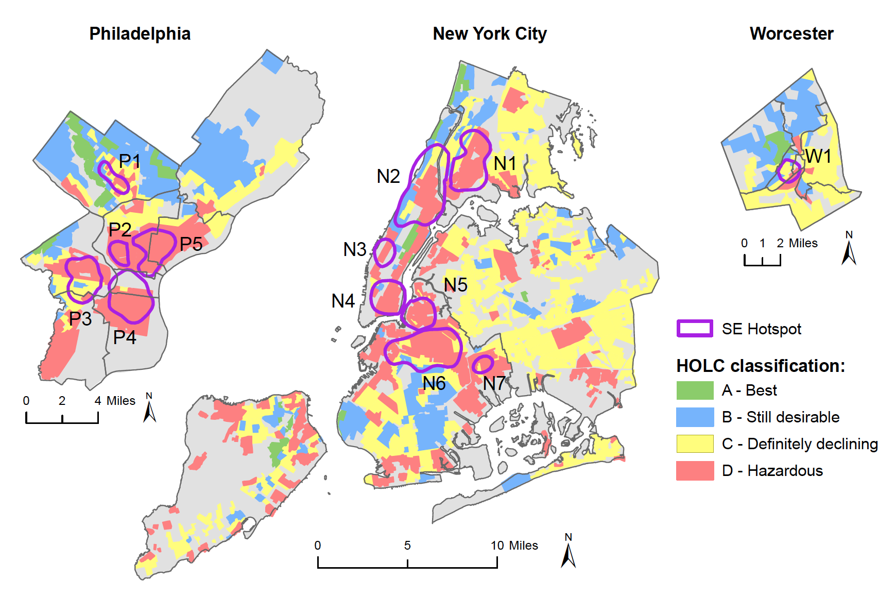

Our maps show the striking manner in which practically all contemporary solidarity economy hotspots coincide with formerly redlined areas, many of which remain home to communities of color living at or below twice the poverty line. Today, for example, we see clusters of solidarity economies in impoverished Black and Latinx communities in formerly redlined areas of West and North Philadelphia (hotspots P3, P2, and P5) and in New York’s Lower East Side (N4), North Manhattan (N2), Harlem (N2), North Brooklyn (N5, N6, and N7), and the South Bronx (N1). In Worcester, the major solidarity economy hotspot in Main South neighborhood (W1) coincides with those red and yellow areas that were deprived of investment in the past and that continue to comprise poor, working class, communities of color.
Conversely, the densities of the solidarity economy are generally lower in the areas that were marked by HOLC in green and blue and thus made accessible for decades to come through mortgage lending to White populations. This is the case, for example, in Northwest and Northeast Philadelphia and in parts of Manhattan, Brooklyn, and Staten Island in New York City. The same holds true for Whiter and wealthier neighborhoods in northern and western Worcester.
Taken together, these findings reveal an interesting inversion of the normative hierarchy. Many of the neighborhoods labeled as the “Best” on the redlining maps, representing areas abundant with capital and investment opportunities, are the very places where solidarity economy initiatives are conspicuously scarce. By contrast, many neighborhoods that were once categorized as “Hazardous” and lacking in opportunity are here shown to be rich in economic solidarity. While many of these latter neighborhoods undoubtedly continue to endure economic
hardship, the maps reveal they are much more than their redlining designation.
A small number of our hotspots appear in areas that used to be redlined but are today areas transformed by gentrification into well-to-do predominantly White neighborhoods. This is perhaps most evident in portions of South Philadelphia (P3), northwest Brooklyn (N6) and western Manhattan (N3), though it has happened elsewhere as well. Redlining and urban abandonment played a role in this too. As urban geographers have argued, and as we discuss in Chapter 6, disinvestment and gentrification (or redevelopment) are often two sides of the same coin (Smith 1979; Marcuse 1985). Disinvestment creates the conditions of profitability that developers seek to capitalize on (known as “rent gap”) encouraged by urban administrations that seek to eradicate the so-called “blight” through displacement. This large-scale condition generates spatially focused consequences. Almost 50% of New York’s urban renewal projects and 70% of public housing projects targeted disinvested neighborhoods, displacing poorer residents from some distressed neighborhoods and further spatially concentrating them in others (Winkler 2016). Similar dynamics played out in Philadelphia. The historic Black neighborhoods of South Philadelphia, for instance, were directly targeted for urban renewal. Between 1950 and 1966, more than 13,000 Philadelphia families were displaced through urban renewal projects. Seventy-two percent of these families were Black (Digital Scholarship Lab 2022). As we will explore in subsequent chapters, the dynamics of organized abandonment, redevelopment, gentrification, and displacement continue to operate in each of these cities. But while displacement of poorer residents remains a distinct possibility in gentrifying neighborhoods, it is not a foregone conclusion. Indeed, the threat of displacement serves to underscore the significance of solidarity economies, both as a potential contributor to urban renewal and gentrification at times and as a potential ballast against displacement. In some neighborhoods, people who would have otherwise been displaced have been able to remain in place because of the infrastructures of solidarity: community gardens, credit unions, and especially through affordable housing cooperatives.
Overall, the foregoing analysis establishes a connection between the historic, racist practices of redlining and the distributions of contemporary urban solidarity economies. This suggests that the solidarity economy provides unique collective ways of coping with racialized poverty and economic injustice. While this is certainly true to a large extent, it would be a mistake to portray the solidarity economy as only reactive, a view that would give all of the power and agency to government policies and oppressive conditions. Credit unions, cooperatives, community gardens and other solidarity economy initiatives may indeed be responses to redlining (and other racial capitalist forces) and its enduring consequences, but they also come from different inspirations and practices that are not just defined by opposition.
While we can only gesture here, we join Hossein, Wright-Austin and Edmonds in seeking to shift the discourse “from one of necessity to one of agency and collective determination, to present to the world collective organizing occurring from the ground up”(Hossein et al. 2023, 12). Such initiatives might often be motivated by necessity, but they are born out of visions of a more just and cooperative economy. Inspiration for envisioning other worlds is generally drawn not from capitalist institutions, but from shared cultural histories of human solidarity. There are different visions of solidarity at work in the ecosystems of those solidarity economy hotspots. They come from different seeds. Those seeds are coming from deeper traditions, from other places, from other forms of world-making that have vitality and principles of their own. Much of the solidarity economy took hold within those redlined neighborhoods and beyond specifically because those who came from other parts of the US and other countries actively made place in non-capitalist ways and built the solidarity cities.

Conclusion
In this paper we closely examined how solidarity economies cluster and form geographic hotspots in particular neighborhoods in all three cities. In most cases, these hotspots are found in low income and minority urban neighborhoods that have been produced through many powerful racial capitalist processes, including redlining. In this pattern we find evidence of the solidarity economy emerging as a widely practiced community response to economic and social marginalization. However, to say that they are only a reaction would be to miss all the different ways that communities are practicing vital collective traditions and enacting their own visions of urban life. Rather than evaluating neighborhoods solely in terms of their suitability for capital investment (as the original redlining maps intended) or conversely in terms of the degree of victimization by racist practices that unfairly denied access to capital (the perspective of many critics of redlining), we use counter-mapping to look at cities through a different lens. We find and make visible on our maps an abundance of economic solidarity at work that has long shouldered various “build and defend” strategies within those marginalized neighborhoods while drawing on traditions of everyday solidarity in different cultures.
Marx once famously said that we make our own history but not under circumstances of our own choosing. People and institutions that are part of today’s solidarity economy movement operate in urban environments that have been powerfully shaped by forces ranging from capitalist development and government housing policy to ongoing police and structural violence. These are the circumstances not of our choosing. But what we wish to emphasize is the tenacity of the solidarity economy movement and the ability of urban communities, in the words of Ruth Wilson Gilmore (2017, 481), “to make where they were into places they wished to be.”

Bibliography
Adams, Carolyn Teich, David Bartlet, David Elesh, and Ira Goldstein. 2008. Restructuring the Philadelphia Region: Metropolitan Divisions and Inequality. Philadelphia Voices, Philadelphia Visions 2. Temple University.
Akuno, Kali. 2017. “Build and Fight: The Program and Strategy of Cooperation Jackson.” In Jackson Rising: The Struggle for Economic Recovery and Black Self-Determination in Jackson, Mississippi. Daraja Press.
Aaronson, Daniel, Bhashkar Mazumder, Daniel Hartley, and Martha Stinson. 2022. “The long-run effects of the 1930s redlining maps on children,” Working Paper, No. WP 2022-13, Federal Reserve Bank of Chicago, Chicago, IL, https://doi.org/10.21033/wp-2022-13
Barnes, Shailly Gupta, Lindsay Koshgarian, and Ashik Siddique. n.d. “Poor People’s Moral Budget: Everybody Has the Right to Live.” Institute for Policy Studies.
Coates, Ta-Nehisi. 2014. “The Case for Reparations.” The Atlantic, May 22, 2014. https://www.theatlantic.com/magazine/archive/2014/06/the-case-for-reparations/361631/.
Digital Scholarship Lab, Robert K. Nelson, and Edward L. Ayers. n.d. “Renewing Inequality: Urban Renewal, Family Displacements, and Race 1950-1966.” American Panorama. Accessed December 23, 2022. https://dsl.richmond.edu/panorama/renewal/#view=0/0/1&viz=cartogram.
Esteves, Ana Margarida Fernandes, Tom Henfrey, Luciane Lucas dos Santos, and Leonardo Leal. 2024. Solidarity Economy: Alternative Spaces, Power and Politics. NY: Routledge.
Fishback, Price, Jonathan Rose, Kenneth Snowden, and Thomas Storrs. 2021. “New Evidence on Redlining by Federal Housing Programs in the 1930s.” National Bureau of Economic Research.
GEO. 2015. “Decolonizing Our Solidarity Economy | Grassroots Economic Organizing.” 2015. https://geo.coop/story/decolonizing-our-solidarity-economy.
Gilmore, Ruth Wilson. 2017. “Abolition Geography and the Problem of Innocence.” In Futures of Black Radicalism, edited by Gaye Theresa Johnson and Alex Lubin. New York: Verso.

Gioielli, Robert. n.d. “The Tyranny of the Map: Rethinking Redlining.” The Metropole: The Official Blog of the Urban History Association.
Hossien, Caroline Shenaz, Sharon D. Wright-Austin, and Kevin Edmonds. 2023. Beyond Racial Capitalism: Co-Operatives in the African Diaspora. Oxford: Oxford University Press.
Hudson, Lauren T. 2020. “Building Where We Are: The Solidarity-Economy Response.” Rethinking Marxism Pandemic and the Crisis of Capitalism: 172–80.
Institute for Research on Poverty. n.d. “How Is Poverty Measured.” Institute for Research on Poverty.
Jackson, Kenneth. 1980. “Race, Ethnicity, and Real Estate Appraisal: The Home Owners Loan Corporation and the Federal Housing Administration.” Journal of Urban History 6: 419–52.
Katz, C. 1992. “All the World Is Staged: Intellectuals and the Projects of Ethnography.” Environment and Planning D: Society and Space 10 (5): 495–510. https://doi.org/10.1068/d100495.
Kelley, Robin D. G., Jack Amariglio, and Lucas Wilson. 2019. “‘Solidarity Is Not a Market Exchange’: An RM Interview with Robin D. G. Kelley, Part 2.” Rethinking Marxism 31 (2): 152–72. https://doi.org/10.1080/08935696.2019.1592407.
Kawano, Emily, Tom Masterson, and Jonathan Teller-Ellsberg (Eds). 2010. Solidarity Economy I: Building Alternatives for People and Planet. Amherst: Center for Popular Economics.
Laville, Jean-Louis. 2023. The Solidarity Economy. Minneapolis: University of Minnesota Press.
Lawson, Victoria A., and Sarah Elwood. 2018. Relational Poverty Politics : Forms, Struggles, and Possibilities. Athens: The University of Georgia Press.Lefebvre, Henri. 1991. The Production of Space. Oxford: Blackwell.
Marcuse, Peter. 1985. “Gentrification, Abandonment, and Displacement: Connections, Causes, and Policy Responses in New York City.” Urban Law Annual ; Journal of Urban and Contemporary Law 28 (1): 195–240.
Martinez, Emmanuel, and Aaron Glantz. 2018. “Modern-Day Redlining: Banks Discriminate in Lending.” Reveal. February 15, 2018. https://revealnews.org/article/for-people-of-color-banks-are-shutting-the-door-to-homeownership/.
NCRC (National Community Reinvestment Coalition), Bruce Mitchell PhD, Senior Research Analyst, Juan Franco, and Senior GIS Specialist. 2018. “HOLC ‘Redlining’ Maps: The Persistent Structure of Segregation and Economic Inequality.” 2018. https://ncrc.org/holc/.
Pavlovskaya, Marianna. 2018. “Critical GIS as a Tool for Social Transformation.” Canadian Geographer-Geographe Canadien 62 (1): 40–54. https://doi.org/10.1111/cag.12438.
Robinson, Cedric J. 2000 (1983). Black Marxism: The Making of the Black Radical Tradition. Chapel Hill, N.C: University of North Carolina Press.
Rothstein, Richard. 2017. The Color of Law: A Forgotten History of How Our Government Segregated America. First edition. New York: Liveright Publishing Corporation, a division of W. W. Norton & Company.
Smith, Neil. 1979. “Toward a Theory of Gentrification A Back to the City Movement by Capital, Not People.” Journal of the American Planning Association 45 (4): 538–48. https://doi.org/10.1080/01944367908977002.
Taylor, Keeanga-Yamahtta. 2019a. Race for Profit: How Banks and the Real Estate Industry Undermined Black Homeownership. University of North Carolina Press.
Wilder, Craig Steven. 2000. A Covenant with Color: Race and Social Power in Brooklyn. The Columbia History of Urban Life. New York: Columbia University Press.
Winkler, Jakob. 2016. “The Legacy of Urban Renewal in New York City.” Methods 3 – Fall 2016 – Student Projects. 2016.

Henri Lefebvre's description of counter-spaces as locales for ‘becoming irregular’ furnishes us with another way of thinking about how solidarity cities are “throwing out of order” conventional capitalist ways of doing and living (Lefebvre 1991).
For Philadelphia and Worcester, we use the federal poverty threshold, which in 2019 was $20,578 for a household with two adults and one child (US Census Bureau). For New York, we use the poverty threshold set by the city, which in 2019 was $30,845 for the same-sized household (New York City Mayor’s Office for Opportunity, “Poverty Thresholds”).
For discussions of such definitions, see the Institute for Poverty Research (nd); Barnes et al. (nd); and the home page of Center on Poverty and Social Policy.
Following Rothstein (2017) and Aronson et al. (2022), we note that HOLC was part of a suite of ostensibly progressive New Deal policies such as the GI Bill and the establishment of the Federal Housing Authority that had the intention of creating a home ownership society. The whole point of the FHA’s investment in “equity” was social stability (rather than social upheaval or revolution), and, as Rothstein argues, the dominant assumption was that racial segregation was key to this stability. Here, we might see these supposedly color-blind progressive policies as working to only benefit people who were considered to be White at the time.
The FHA created similar color-coded maps for city blocks, albeit with a different color scheme and accompanying letter grades ranging from “A” (Best) to “D” (Declining). These were widely used in FHA manuals and guidance to banks on investment risk in cities. For a discussion of the complex relations between HOLC, the FHA, and local actors, see Gioielli (nd); Fishback et al. (2021).
This precipitated the continued credit starvation of these communities by banks, the dramatic devaluation of housing stock, a paucity of green space and shade trees, and underinvestment in health, sanitary, and education services with grave consequences for living conditions for decades to come. See Rothstein (2017), Taylor (2019), and Coates (2014).
This is a point we elaborate on in Chapter 3 of Solidarity Cities.
See Karl Marx, “The Eighteenth Brumaire of Louis Bonaparte.”

