Latent Nationalism, Political Opportunity and the Rise of Europe’s Far Right

***Abstract***

Far-right nationalist parties have enjoyed increasing success across Europe. Both supply-side and demand-side explanations have been advanced to understand this rise. To date, less focus has been placed on who shows up to vote. In this paper, we investigate whether changes in the ideological position of those who abstain is part of the explanatory story of the rise of European far-right parties. Using survey data, we look at abstention rates for individuals that fall into two ideological categories, those associated with nationalist and social democratic party ideologies. We argue that, rather than observing a large increase in the number of nationalist voters, we are observing an increase in the probability that those with nationalist ideologies turn up on election day, while those holding other ideological positions, particularly those with social democratic ideologies, are correspondingly less likely to vote. This has implications, not only for our understanding of far-right nationalist parties, but also the long-term changes in European party systems political scientists have noted.

Geoff Allen

University of Utah

Tzu-Ping Liu

University of Taipei

*This paper was prepared for presentation at the 2021 Western Political Science Association Annual Meeting. This project is a work in progress. Please do not cite or circulate without the permission of the authors.*

**1. Introduction**

The rise of far-right populist parties in Europe has received substantial attention from both scholars and the popular press. In the pages of the New York Times, op-eds from the Editorial Board frequently bring attention to the rise of nationalism in Europe (‘The European Union Must Stand Up to Polish Nationalism’, 2018; ‘Macron, at the Barricades, Warns of Rising Nationalism in Europe,’ 2018; ‘Nationalism and the Brexit Vote,’ 2016). In Spring 2019, *Foreign Affairs* ran a special issue on the topic of The New Nationalism, with articles from numerous experts focused on understanding the rise of this new wave of nationalism.

The populist radical right, meanwhile, has become a major new topic of academic research. Researchers have yet to settle on a conclusion as to what explains the rise of nationalist politics in Europe in the last two decades. Demand side explanations have pointed to the rise of anti-immigrant sentiment, the rise of economic nationalist attitudes, and other attitudinal or sentiment explanations for increased demand for nationalist parties (Semyonov, Raijman and Gorodzeisky 2006). In contrast, supply-side explanations tend to focus on the behavior of political leaders and the supply of nationalist parties and movements, rather than on any increase in nationalist attitudes (Bieber 2018). These demand and supply side explanations are increasingly thought of as complementary rather than competitive explanations (Golder 2016).

While demand side and supply side explanations have tended to dominate the academic discourse, mobilization and turnout has received comparatively little attention. We believe that at least part of the story of nationalism’s reemergence in European politics can be attributed to increased rates of participation among those holding nationalist attitudes. A corresponding story is the increased disillusion among social democratic voters, which has been noted in several studies over the years (Benedetto, Hix and Mastrorocco 2020). Combined, these two phenomena could translate into a substantial increase in the political relevance in nationalism in politics, even as overall nationalist sentiment among the population may be relatively stable.

Using evidence from the European Social Survey, in this study we will set out to establish that at least part of the story of the rise of nationalist parties in Europe is a story of mobilization and turnout. Comparing the first, fifth, and ninth waves of the European Social Survey, we will show that there has been a modest change in the propensity to vote among those with nationalist attitudes, and argue that this change in probability of voting explains, in part, the increasing electoral success of radical right nationalist parties.

**2. Existing Explanations for the Rise of Far-Right Nationalist Parties in Europe (Incomplete)**

Framing paragraph: establish that scholars seem to agree that there are two main schools of thought, demand and supply side theories (Mudde and Kaltwasser 2017, Mudde 2019).

Start with demand side explanations. Not a lot of studies point to a particularly notable rise in nationalist attitudes, but quite a few point to rise of welfare chauvinism, anti-foreigner sentiment, and economic nationalism (Semyonov, Raijman and Gorodzeisky 2006).

Move to supply side explanations. Here you can rely pretty heavily on Bonikowski (2017), Bieber (2018), Halikiopoulou and Vlandas (2019). None find particularly compelling evidence that nationalist attitudes are more prevalent today than in the past, though they may manifest in different ways tody

You can discuss that scholars seem to increasingly agree that a full understanding of the rise of populism must consider supply and demand side factors in conjunction (see Golder 2016, Mudde 2019).

**3. The Missing Story of Mobilization and Turnout**

Despite the increasingly large literature on the emerging electoral success of radical right nationalist parties in Europe, comparatively little of the literature has focused on attempting to understand the role of voter turnout and voter apathy. Part of the reason for this may be the conclusion, reached by several different scholars in a 2007 special issue of Electoral Studies, that differential turnout rarely has a substantial impact on electoral outcomes (see Lutz and Marsh, 2007), particularly with the declining importance of class cleavages in shaping vote choice in advanced industrial democracies (Martinez and Gill 2005).

This omission of turnout seems puzzling when attempting to understand the rise of radical right nationalist parties in part because some evidence exists to suggest that previous non-voters are a part of the equation. For example, after Germany’s 2017 election an analysis featured in *Zeit Online* suggests that up to 1.47 million of the AfD’s nearly 6 million votes came from those who previously had not cast a ballot (Blickle et al 2017).

And it is not the case that scholars of the radical right have entirely ignored turnout as a concept of interest. Immerzeel and Pickup (2015), for example, suggest that the success of radical right parties has a demobilization effect in Eastern Europe, reducing systemic turnout, while in Western Europe that success has a mobilizing effect, particularly on wealthier and more politically interested citizens. Finseraas and Vernby (2014) suggest that increased turnout is a positive for both social democratic and radical right parties, and use evidence from Norway to show that at least in that country there are similarly sized electoral advantages from increased turnout for both types of party.

What we believe is missing from this discussion is any specific analysis of who is voting more often. Why do radical right nationalist parties seemingly benefit from increased turnout? And why do we observe in countries like Germany that the nationalist radical right benefits disproportionately from attracting previous non-voters?

We believe there are two mechanisms that could be at work here. First, we think its likely that radical right parties, which really begin to emerge in 2000s in Europe, are mobilizing nationalist voters at higher rates than these voters were mobilized in the past. In the traditional left-right political system that dominated Western countries during the Cold War and the years immediately afterwards, nationalism was not a clear part of the competitive ideological spectrum. The fading of this traditional spectrum has been blamed for increases in voter apathy in many advanced democracies (Facchini and Jaeck 2019), but we believe it could also have been a spur for the creation of new, nationalist parties attempting to mobilize voters along a different dimension.

The diminishing of the traditional left-right spectrum, and particularly the decline of social democratic parties across Europe more broadly, is the second mechanism we believe could be at play here. If social democracy as an ideological position is declining, as several studies note (see, for example, Benedetto et al 2020, or Berman 2019), even small increases in the likelihood to vote among nationalist voters could lead to a relatively notable increase in vote share for newly emerging radical right nationalist parties.

Another possible mechanism at play could be the emergence of an entirely new cleavage, the anti-immigrant cleavage. Anti-immigrant attitudes are a particularly salient part of identification with the far right in Western Europe (Allen 2017), but we believe it is premature to claim that these anti-immigrant attitudes are a new phenomenon in Europe. Insofar as cultural chauvinism and nationalism have been a long-standing element of political life in Europe, modern nativism we believe is better understood as a manifestation of older ideological structures and attitudes, rather than an entirely new cleavage.

In the countries we have chosen to study here, turnout over the time period analyzed has been generally lower than in decades past, but has slightly rebounded in recent elections, as seen below. Its important to keep in mind these broader turnout trends when considering the changing probability of any group of voters to show up on election day.

*Figure 1 – Turnout in Select European Elections*

|  |  |  |  |  |  |  |  |
| --- | --- | --- | --- | --- | --- | --- | --- |
| **U.K.** | **Turnout** | **France** | **Turnout** | **Sweden** | **Turnout** | **Germany** | **Turnout** |
| 2001 | 71.4% | 2002 | 64.4% | 2002 | 80.1% | 2002 | 79.1% |
| 2005 | 61.8% | 2007 | 60.4% | 2006 | 82.0% | 2005 | 77.7% |
| 2010 | 65.8% | 2012 | 57.2% | 2010 | 84.6% | 2009 | 70.8% |
| 2015 | 66.4% | 2017 | 48.7% | 2014 | 85.8% | 2013 | 71.5% |
| 2017 | 69.0% |  |  | 2018 | 87.2% | 2017 | 76.2% |

**4. Data and Hypotheses**

For this project, we have opted to use data from the European Social Survey (henceforth, ESS). ESS data has some unique advantages for this project. In its core modules, the ESS asks respondents several questions related to politics, political attitudes and nationalism that are essential for this project. While its range of years covered is somewhat smaller than we would like, the bi-annual nature of the survey provides opportunities for close tracking of attitudes. At the same time, the survey covers a wide variety of European countries. While we intend, in this paper, to focus only on 4 – France, Germany, Sweden and the United Kingdom – the breadth of data available means expansion of the study is possible.

That being said, there are drawbacks to using the ESS for this project. Chiefly, there are no direct questions on nationalism or nationalist attitudes in the ESS. Instead, we have to rely on several questions that should be highly correlated with nationalist attitudes.

To track the nationalist attitudes of voters, we focus in on 3 variables we believe capture important elements of nationalism as a political ideology. The first, labeled IMPTRAD, asks how similar a person who tries to follow the traditions and customs of their religion or family is to the respondent, with 1 representing the most similarity, and 6 the least. This question captures the importance of tradition and custom in various conceptualizations of nationalism. Those holding nationalist attitudes we believe should place themselves relatively lower on this scale.

The second variable we track, labeled IPSTRGV, asks how similar a person who wants the state to be strong and able to defend its citizens is to the respondent. Again, 1 represents the highest level of similarity, 6 the least. This question captures to some degree the importance of sovereignty and security for nationalists. We believe those holding nationalist attitudes should place themselves relatively lower on this scale.

Finally, we also track a variable (IMUECLT) that asks respondents about the impact, negative or positive, of immigrants on the cultural life of their country. On a scale of 0-10, lower scores indicate that cultural life is undermined, while higher scores indicate that cultural life is enriched. While not a perfect correlate, we believe that this variable fairly accurately captures the nativist elements of nationalist ideology that have become particularly relevant in the last decades[1].

To test how accurately these variables capture nationalist party voting, we run a logistic regression to establish how much more likely a voter in the 9th wave of the ESS is to identify with a nationalist party in each of the four countries in our study. We then converted these into predicted probabilities, presented below. For ease of interpretation, the variables were transformed into dichotomous bins, with values less than 3 on the respective scales representing more nationalist attitudes, and those over 3 representing less nationalist attitudes. The first column represents the base probability of voting for the nationalist party in each country (the AfD in Germany, the Sweden Democrats in Sweden, the National Front in France, and UKIP in the U.K.[2]), while the named columns represent the predicted probability of voting for the party with that variable held at 1 and the other variables held constant at 0. The final column represents the predicted probability of voting for nationalist party in each country if all 3 variables are held at 1.

*Table 1*

|  |  |  |  |  |  |
| --- | --- | --- | --- | --- | --- |
|  | Base Probability | IMPTRAD | IPSTRGV | IMUECLT | ALL |
| Germany | 3.7% | 6.6% | 1.6% | 24.8% | 19.7% |
| Sweden | 5.5% | 7.3% | 7.4% | 40.5% | 56.3% |
| France | 2.2% | 2.8% | 3.4% | 11.2% | 20.1% |
| UK | 0.9% | 1.2% | 1.6% | 3.9% | 8.4% |

As the table shows, with one outlying exception (IPSTRGV in Germany), the variables seem to do an acceptable job capturing increased probability of voting for nationalist parties in the most recent wave of the ESS. We believe this indicates, at least to some degree, that these variables are fairly accurate reflections of nationalist attitudes insofar as they correlate with voting for nationalist parties.

While the ESS does not have many questions that deal directly with social democratic attitudes, it does ask one fairly directly correlated question. In the GINCDIF question, respondents are asked how much they agree with the statement that the government should take measures to reduce differences in income levels. We believe this question is a fairly strong indicator of social democratic attitudes, as it captures social democrats’ commitment to economic equality and government action to guarantee this outcome[3]. More social democratic oriented voters should place themselves relatively lower on the scale.

In a similar process to the one described above, we test GINCDIF as a correlate of social democratic party voting (SPD in Germany, Social Democrats in Sweden, Socialists in France, and Labour in the U.K.)[4] in the most recent wave of the ESS. The results below indicate that, in all of our countries, GINCDIF is a fairly consistently increases the probability of a voter choosing the social democratic party with their legislative vote[5].

*Table 2*

|  |  |  |  |  |
| --- | --- | --- | --- | --- |
|  | Germany | Sweden | France | United Kingdom |
| Base Probability | 11.4% | 9.7% | 5.4% | 17.7% |
| GINCDIF | 16.4% | 33.5% | 8.3% | 29.8% |

Our main dependent variable for this study is self-reported turnout in the previous election. Drawn from the VOTE variable from ESS, we rescale the variable so that 0 represents abstention, and 1 represents a vote. Ineligible voters, or those who refused or failed to respond to the question are excluded from the analysis.

In this study, we are interested in testing 2 hypotheses. First, we believe that over time, voters with nationalist attitudes have become more likely to vote. Thus:

H1: From the first to the ninth wave of the ESS, the predicted probability of those with nationalist attitudes turning out to vote should go up.

Second, we believe that over time voters with social democratic attitudes have become less likely to vote. Thus:

H2: From the first to the ninth wave of the ESS, the predicted probability of those with nationalist attitudes turning out to vote should go up.

For our analysis, in each of the four countries in each of the waves of the ESS (1 through 9) we estimate a logistic regression, with VOTE as our dependent variable, and IMPTRAD, IPSTRGV, IMUECLT, and GINCDIF as our key independent variables[6]. After getting our results, we estimate a predicted probability for each of the variables of interest across its possible values, with the other variables in the model held constant at their mean value. In the tables and charts below, we present these values across time, from the first wave to the ninth wave, for each country. We conclude the analysis section with a brief discussion of a supplemental predicted probability estimate, that for a voter with high nationalist scores on all three of our nationalist indicators.

**5. Analysis**

Tables 3, 4 and 5 and Figures 2, 3, and 4 below present the predicted probability estimates of showing up to vote for a voter with a self-placement of 1 on the nationalist indicating variable of interest (IMPTRAD, IPSTRGV, and IMUECLT), while holding all other variables at their mean values. Because the logistic model results are not presented directly here, for each country we also present the statistical significance estimate for each variable in each model year in the second column for each country. Thus, for the IMPTRAD table, the variable has a statistically significant impact on the predicted probability of voting in the United Kingdom and Germany, but misses statistical significance in Sweden and France. The full p-values are presented here for convenience; our hypotheses, however, are not dependent on whether the results of the logistic model are significant[7].

For IMPTRAD, IPSTRGV, and IMUECLT, in the United Kingdom, Sweden and Germany, the predicted probability of voting with a high similarity score on the variable in question increases between 2002 and 2018, though the relationship is far from linear. Maybe more importantly, the probability of voting actually peaks in the most recent year for nationalist voters. While the indicators are muddied in the middle across the cases, by the middle of the 2010s there appears to be a quite consistent increase in probability to vote for nationalist voters.

In France, the result is much less clear. On each of our three indicators, the predicted probability peaks in the 5th or 6th wave of the ESS (around 2010-2012) before declining rather precipitously. On the one hand, this should perhaps be expected, as overall turnout in French elections over this period *also* declines precipitously (see Figure 1). Notably, we see a matching decline in probability of voting among those who score highly on our social democratic attitudes-indicating variable, GINCDIF (see Table 6 and Figure 5). On the other hand, declining turnout in general is at least in part likely a product of declining propensity to vote among nationalists; and very notably, those with social democratic attitudes saw a huge increase in their probability of voting in the 9th wave, contrary to what we see among nationalists.

We find generally similar results when we generate predicted probability of voting for individuals with high nationalist leanings on all three of our nationalism variables. In Table 7, we see a somewhat more consistent pattern in the U.K., France and Sweden – after a drop in probability around wave 4 or 5 (2008-2010), nationalists see a relatively strong upswing in probability to vote that, for all three countries, peaks in the most recent 9th wave (2018), with the second highest probability of voting coming in the 8th wave (2016) in Germany and the United Kingdom. France remains an outlier, with predicted probability of voting for these stronger nationalists peaking in Wave 4 before diminishing. Important context is added here, however: the predicted probability for an average French respondent to vote declines substantially (over 12 percentage points) between the 6th and 9th waves, while for our highly nationalist voters, the corresponding rate is just 6 percentage points. So while the nationalists do not appear to be more likely to vote than in the past, they still may represent an increasingly disproportionately large section of the electorate.

These results, while mixed, we believe support our contention that there is an increase in the propensity to vote among those with nationalist leanings on the three indicators we are tracking. If we believe these correlate with increased likelihood to vote for radical right nationalist parties, as we demonstrated in Tables 1 and 2, we believe this is indicative that increased turnout among those with nationalist attitudes is at least part of the story of the emerging electoral success of radical right parties in Europe in the latter half of the 2010s.

In testing for our other hypothesis, that social democratic voters are less likely to turn up now than in the past, we find no support. While those with social democratic leanings did seem increasingly less likely to show up to vote in the United Kingdom and Germany between wave 1 (2002) and wave 6 (2012), that pattern reversed entirely, and social democratic probability to vote actually peaked in both countries in Wave 9. As nationalist attitudes and social democratic attitudes are not necessarily mutually exclusive, its entirely possible these mechanisms are feeding into each other, as Finseras and Vernby (2014) suggest. It could be that the number of social democratic voters is declining (Benedetto et al 2019), but it seems equally plausible that traditional social democratic parties face a mobilization problem, rather than any there being any decline in those who support social democratic policy positions.

*Table 3*



*Table 4*

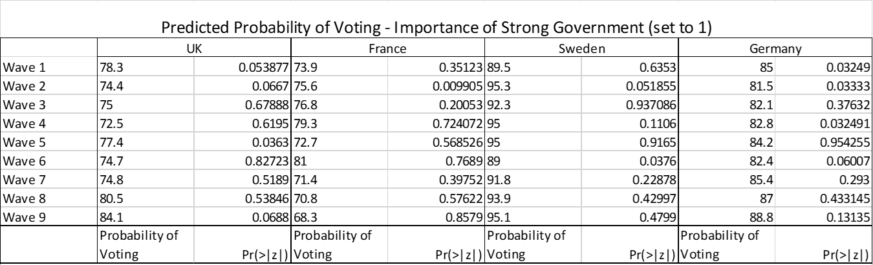

*Table 5*

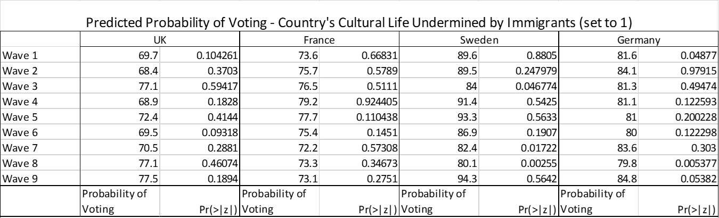

*Table 6*

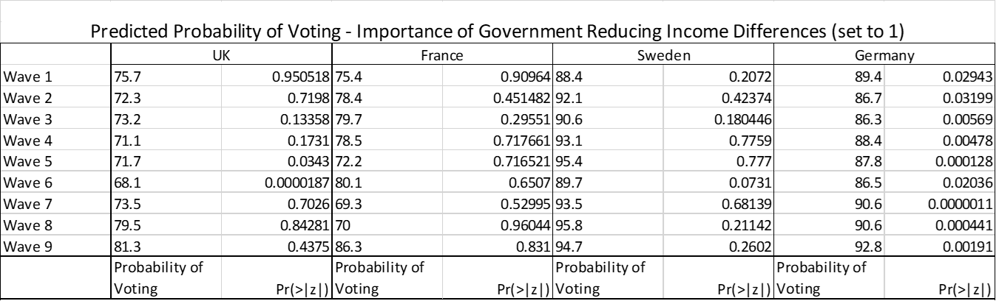

*Table 7*

|  |  |  |  |  |  |  |  |  |
| --- | --- | --- | --- | --- | --- | --- | --- | --- |
|  | France | | Germany | | Sweden | | U.K. | |
|  | Average Probability | Nationalist Probability | Average Probability | Nationalist Probability | Average Probability | Nationalist Probability | Average Probability | Nationalist Probability |
| 1 | 75.5 | 74.8 | 87.2 | 82.1 | 90.1 | 91.2 | 75.6 | 79.1 |
| 2 | 77.7 | 78.3 | 84.1 | 84.3 | 93.4 | 95.9 | 71.7 | 77.6 |
| 3 | 78.8 | 80.1 | 83 | 83.9 | 92.2 | 85.2 | 75.5 | 82.4 |
| 4 | 78.8 | 85.2 | 85.4 | 82.1 | 93.4 | 94.8 | 73.2 | 75.6 |
| 5 | 71.8 | 82.1 | 84.3 | 85 | 95.2 | 94.9 | 74.9 | 81.3 |
| 6 | 80.6 | 83.5 | 84.3 | 80.6 | 91.7 | 84.5 | 75 | 75.9 |
| 7 | 70.1 | 78.3 | 86.3 | 87.9 | 93.1 | 83.5 | 74 | 75.2 |
| 8 | 70 | 77.7 | 87.7 | 83.5 | 94.8 | 80.2 | 79.8 | 81.2 |
| 9 | 68.6 | 77.7 | 90.2 | 87.1 | 95.8 | 95.5 | 82.2 | 81.8 |

*Figure 2*

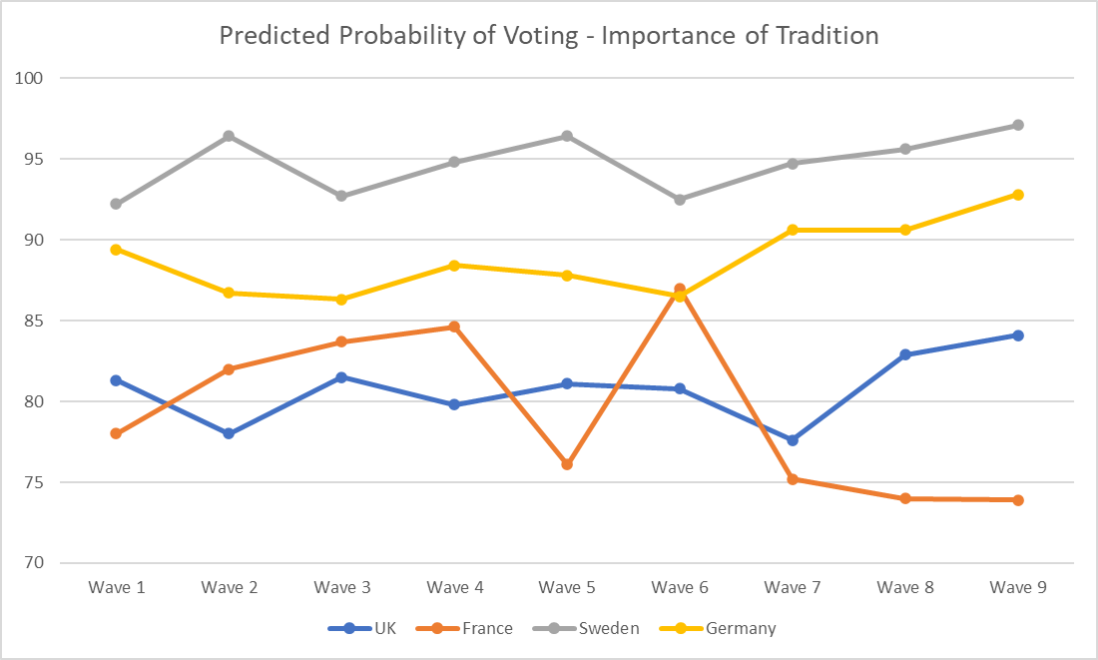

*Figure 3*

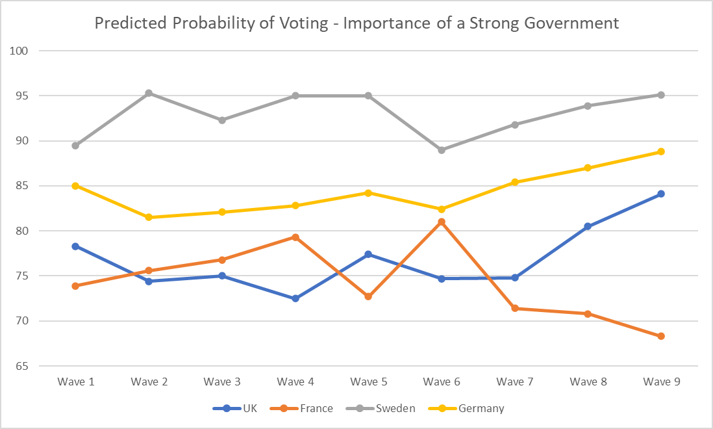

*Figure 4*

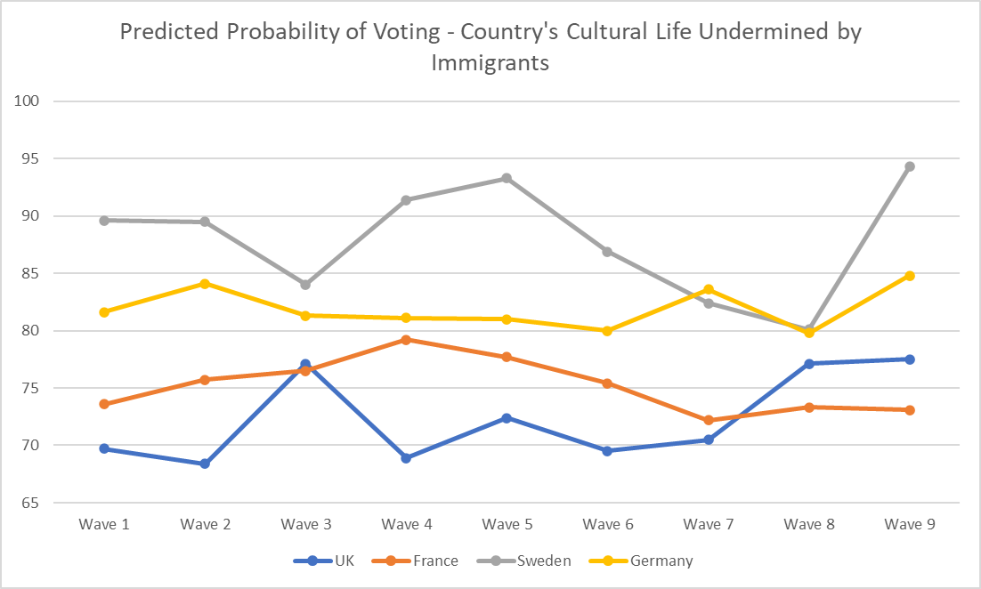

*Figure 5*

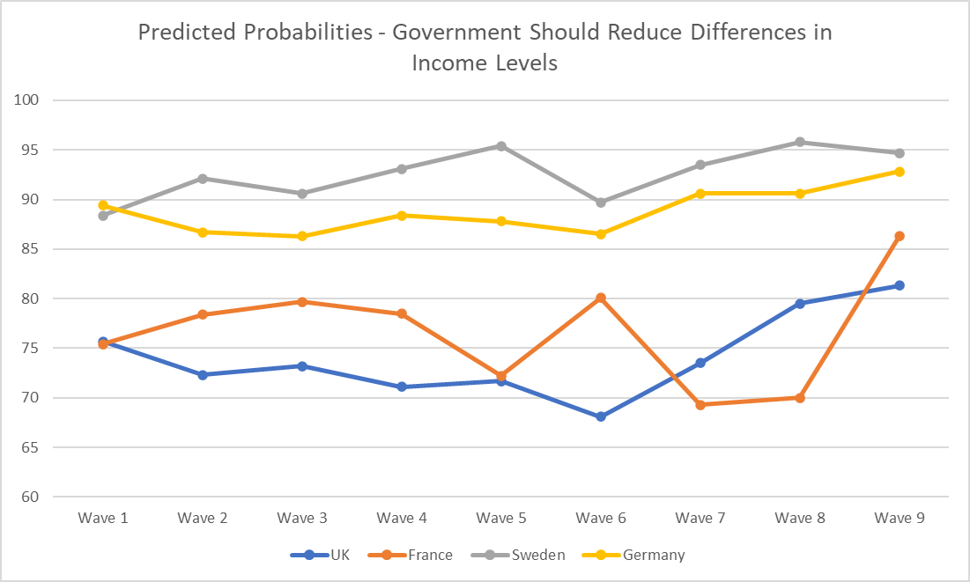

**6. Concluding Thoughts (Incomplete)**

Our results aren’t particularly strong, but we do think they suggest that increased rates of participation among nationalist voters may be part of the explanation for the rise of the radical right in Europe.

Future research could look at particular critical junctures – important events, rise of specific actors or parties – and see if those with nationalist attitudes are more likely to show up when the ideological positions they align with (nationalist) are being activated, either through exogenous shocks like conflict or terrorism, or endogenous shocks like mobilization.

**Works Cited**

DOMMETT, K. (2017). United Kingdom. European Journal of Political Research Political Data Yearbook. 56(1): 275-282.

WIDFELDT, A. (2017). Sweden. European Journal of Political Research Political Data Yearbook. 56(1): 260-266.

FAUCHER, F. & GARCIA, N. (2017). France. European Journal of Political Research Political Data Yearbook. 56(1): 99-106.

POGUNTKE, T. & KINSKI, L. (2017). Germany. European Journal of Political Research Political Data Yearbook. 56(1): 107-114.

Facchini, F., & Jaeck, L. (2021). Populism and the rational choice model: The case of the French National Front. Rationality and Society, 1043463121995969.

Facchini, F., & Jaeck, L. (2019). Ideology and the rationality of non-voting. Rationality and Society, 31(3), 265-286.

Van der Meer, T. W., Van Deth, J. W., & Scheepers, P. L. (2009). The politicized participant: Ideology and political action in 20 democracies. Comparative Political Studies, 42(11), 1426-1457.

Allen, T. J. (2017). All in the party family? Comparing far right voters in Western and Post-Communist Europe. Party Politics, 23(3), 274–285. https://doi.org/10.1177/1354068815593457

Allen, T. J. (2017). Exit to the right? Comparing far right voters and abstainers in Western Europe. Electoral Studies, 50, 103-115.

Cutts, D., Ford, R., & Goodwin, M. J. (2011). Anti‐immigrant, politically disaffected or still racist after all? Examining the attitudinal drivers of extreme right support in Britain in the 2009 European elections. European Journal of Political Research, 50(3), 418-440.

Hjerm, M., & Schnabel, A. (2010). Mobilizing nationalist sentiments: Which factors affect nationalist sentiments in Europe?. Social Science Research, 39(4), 527-539.

de Figueiredo Jr, R. J., & Elkins, Z. (2003). Are patriots bigots? An inquiry into the vices of in‐group pride. American Journal of Political Science, 47(1), 171-188.

Lubbers, M., & Coenders, M. (2017). Nationalistic attitudes and voting for the radical right in Europe. European Union Politics, 18(1), 98-118.

Freeden, M. (1998). Is nationalism a distinct ideology?. Political studies, 46(4), 748-765.

Davidov, E., Schmidt, P., & Schwartz, S. H. (2008). Bringing values back in: The adequacy of the European Social Survey to measure values in 20 countries. Public opinion quarterly, 72(3), 420-445.

Benedetto, G., Hix, S., & Mastrorocco, N. (2020). The rise and fall of social democracy, 1918–2017. American Political Science Review, 114(3), 928-939.

Bieber, F. (2018). Is nationalism on the rise? Assessing global trends. Ethnopolitics, 17(5), 519-540.

Semyonov, M., Raijman, R., & Gorodzeisky, A. (2006). The rise of anti-foreigner sentiment in European societies, 1988-2000. American sociological review, 71(3), 426-449.

Bonikowski, B. (2017). Ethno‐nationalist populism and the mobilization of collective resentment. The British Journal of Sociology, 68, S181-S213.

Rooduijn, M., Bonikowski, B., & Parlevliet, J. (2021). Populist and nativist attitudes: Does ingroup/outgroup thinking spill over across domains?. European Union Politics, 1465116521992876.

Golder, M. (2016). Far right parties in Europe. Annual Review of Political Science, 19, 477-497.

Mudde, C., & Kaltwasser, C. R. (2017). Populism: A very short introduction. Oxford University Press.

Mudde, C. (2019). The far right today. John Wiley & Sons.

Halikiopoulou, D., & Vlandas, T. (2019). What is new and what is nationalist about Europe's new nationalism? Explaining the rise of the far right in Europe. Nations and nationalism, 25(2), 409-434.

Martinez, M. D., & Gill, J. (2005). The effects of turnout on partisan outcomes in US presidential elections 1960–2000. The Journal of Politics, 67(4), 1248-1274.

Lutz, G., & Marsh, M. (2007). Introduction: Consequences of low turnout. Electoral Studies, 26(3), 539-547.

Immerzeel, T., & Pickup, M. (2015). Populist radical right parties mobilizing ‘the people’? The role of populist radical right success in voter turnout. Electoral Studies, 40, 347-360.

Finseraas, H., & Vernby, K. (2014). A mixed blessing for the left? Early voting, turnout and election outcomes in Norway. Electoral Studies, 33, 278-291.

Berman, S. (2019). Populism is a symptom rather than a cause: Democratic disconnect, the decline of the center-left, and the rise of populism in Western Europe. Polity, 51(4), 654-667.

Berman, S., & Snegovaya, M. (2019). Populism and the decline of social democracy. Journal of Democracy, 30(3), 5-19.

ESS Round 9: European Social Survey Round 9 Data (2018). Data file edition 3.1. NSD - Norwegian Centre for Research Data, Norway – Data Archive and distributor of ESS data for ESS ERIC. doi:10.21338/NSD-ESS9-2018.

ESS Round 8: European Social Survey Round 8 Data (2016). Data file edition 2.2. NSD - Norwegian Centre for Research Data, Norway – Data Archive and distributor of ESS data for ESS ERIC. doi:10.21338/NSD-ESS8-2016.

ESS Round 7: European Social Survey Round 7 Data (2014). Data file edition 2.2. NSD - Norwegian Centre for Research Data, Norway – Data Archive and distributor of ESS data for ESS ERIC. doi:10.21338/NSD-ESS7-2014.

ESS Round 6: European Social Survey Round 6 Data (2012). Data file edition 2.4. NSD - Norwegian Centre for Research Data, Norway – Data Archive and distributor of ESS data for ESS ERIC. doi:10.21338/NSD-ESS6-2012.

ESS Round 5: European Social Survey Round 5 Data (2010). Data file edition 3.4. NSD - Norwegian Centre for Research Data, Norway – Data Archive and distributor of ESS data for ESS ERIC. doi:10.21338/NSD-ESS5-2010.

ESS Round 4: European Social Survey Round 4 Data (2008). Data file edition 4.5. NSD - Norwegian Centre for Research Data, Norway – Data Archive and distributor of ESS data for ESS ERIC. doi:10.21338/NSD-ESS4-2008.

ESS Round 3: European Social Survey Round 3 Data (2006). Data file edition 3.7. NSD - Norwegian Centre for Research Data, Norway – Data Archive and distributor of ESS data for ESS ERIC. doi:10.21338/NSD-ESS3-2006.

ESS Round 2: European Social Survey Round 2 Data (2004). Data file edition 3.6. NSD - Norwegian Centre for Research Data, Norway – Data Archive and distributor of ESS data for ESS ERIC. doi:10.21338/NSD-ESS2-2004.

ESS Round 1: European Social Survey Round 1 Data (2002). Data file edition 6.6. NSD - Norwegian Centre for Research Data, Norway – Data Archive and distributor of ESS data for ESS ERIC. doi:10.21338/NSD-ESS1-2002.

1. Because nativism, particularly anti-immigrant nativism, comes in different forms, we also track in our models 3 other variables: IMWBCNT, which asks respondents whether the country is a worse or better place to live due to immigrants (nationalists should have a lower self-placement); IMBGECO, whether immigration is bad or good for the country’s economy (nationalists should have a lower self-placement); and IMPCNTR, whether the country should allow many or few immigrants from poorer countries outside Europe (nationalists should have a higher self-placement). While these alternative variables are important to consider, we believe IMUECLT more closely correlates with nationalist attitudes due to its particular focus on cultural life.
2. These parties are regularly referred to as the definitive nationalist party in their respective countries (see, for instance, Halikiopoulou and Vlandas 2019). The one outlier may be AfD, which competes with the NPD for ultra-nationalist voters, particularly in Eastern Germany.
3. 3 other questions we believe are somewhat related to social democratic attitudes: IPEQOPT, how important is it that people are treated equally and have similar opportunities; IPUDRST, how important is it to understand different people; and IPHLPPL, how important is it to help people and care for others’ well-being. Lower scores on each of these variables should indicate more agreement, and thus more social democratic attitudes. These questions are less direct than GINCDIF, so we focus our analysis on GINCDIF, but they are included in later models.
4. These are the representatives for each country in the Party of European Socialists, the pan-European social democratic party.
5. The logistic regression from which these predicted probabilities are drawn is a bivariate model, with the dependent variable being a vote cast for the social democratic party, and the independent variable being 1 if the GINCDIF score for the respondent is less than 3, and 0 if it is greater than 3.
6. The model also accounts for control variables IMWBCNT, IMBGECO, IMPCNTR, IPEQOPT, IPUDRST, and IPHLPPL, described in footnotes 1 and 2.
7. As a reminder, our hypotheses are about changes over time, rather than whether, for example, nationalist voters vote more than non-nationalist voters. As such, in our attempts to generate predicted probabilities, we care less about statistical significance; the statistical significance is simply a reflection of reliability of the estimate.